Module Assembly - SRM Round Configuration APIs Part 3 Deployment Guide

Revision History
Author | Revision Number | Date
panoptimum | 1.0 | 2014-07-15

Contents

Contents 2
Deployment Instructions 3
1.Organization of Submission 3
2.Application Setup 3
4.Database Setup 3
5.Verification 4
6.Resource Contact List 12

Deployment Instructions

Organization of Submission
All modified and new files are in ./submission/tc-api directory under the submission root.
The test output is in /submission/test_output.
The submission is based on commit e2e671486194c98f172ec366bc81b28a17a0c093

Application Setup
Let's assume the submission is extracted into ./submission.
On a Unix/Linux system the following steps are sufficient to integrate the submission with the existing code.

git clone https://github.com/cloudspokes/tc-api.git
cd ./tc-api
git checkout -b submission e2e671486194c98f172ec366
cd ../submission
tar -cf - tc-api | tar -C ../ -xf -

As long as the issues with node-java@0.4.0 are not fixed,
please edit package.json to change the java version to 0.3.6
Please look at https://github.com/cloudspokes/tc-api/wiki/_pages for instructions
of how to deploy the application in your environment.
For heroku setup, please adjust VM_IP in deploy/development.sh, then follow
the instructions outlined at
https://github.com/cloudspokes/tc-api/wiki/Heroku-Deployment-Guide

Build Scripts Setup
Please follow the standard instructions on https://github.com/cloudspokes/tc-api/wiki/Configure-Environment-Variables for your specific setup.

Database Setup
Login to tc@vm-ip
$ cp -r .ssh/authorized_keys /tmp
$ chmod o+r /tmp/authorized_keys
$ su informix # password 1nf0rm1x
$ cd && cp /tmp/authorized_keys .ssh
$ echo “database informixoltp;” > informixoltp-conn.sql
$ exit
$ exit

On localhost
$ cd tc-api/test/sqls/srmRoundConfig
$ scp * informix@vm-ip:~/
Login as informix@vm-ip
$ ssh informix@vm-ip
$ mv informixoltp__insert informixoltp__insert.sql && mv informixoltp__insert informixoltp__insert.sql
$ dbaccess – informixoltp-conn.sql informixoltp__insert.sql # fill db
$ dbaccess – informixoltp-conn.sql informixoltp__clean.sql # clean db

Verification

JSlint
With https://github.com/FND/jslint-reporter, please do
$ find ./tc-api -iregex '.*\.js$' -print|xargs jslint-reporter

Mocha
You may change the API endpoint by exporting the environment variable
API_ENDPOINT before running the tests, e.g. to check heroku deployment.
Its default value is 'http://localhost:8080'.

The test output is in submission/test_output/mocha.log
$ cd ./tc-api
$ ./node_modules/.bin/mocha -R tap \
./test/test.srmRoundConfig.js \
> ../submission/test_output/mocha.log
1..51
...
# tests 51
# pass 51
# fail 0

Postman
To use Postman you need to create an admin-jwt first:
$ node test/helpers/manualJwt.js admin

Add an authorization header and enter “Bearer jwt“ into the value field.
Follow the steps from 4. Database Setup

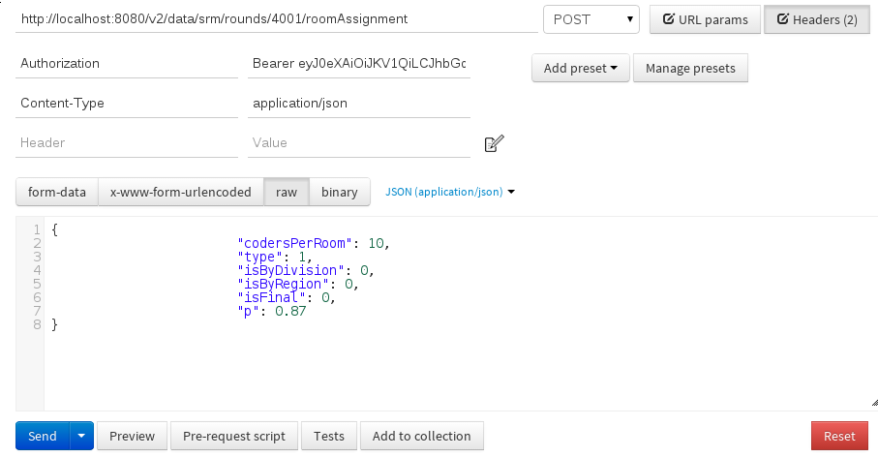Set Round Room Assignment API - Postman Form

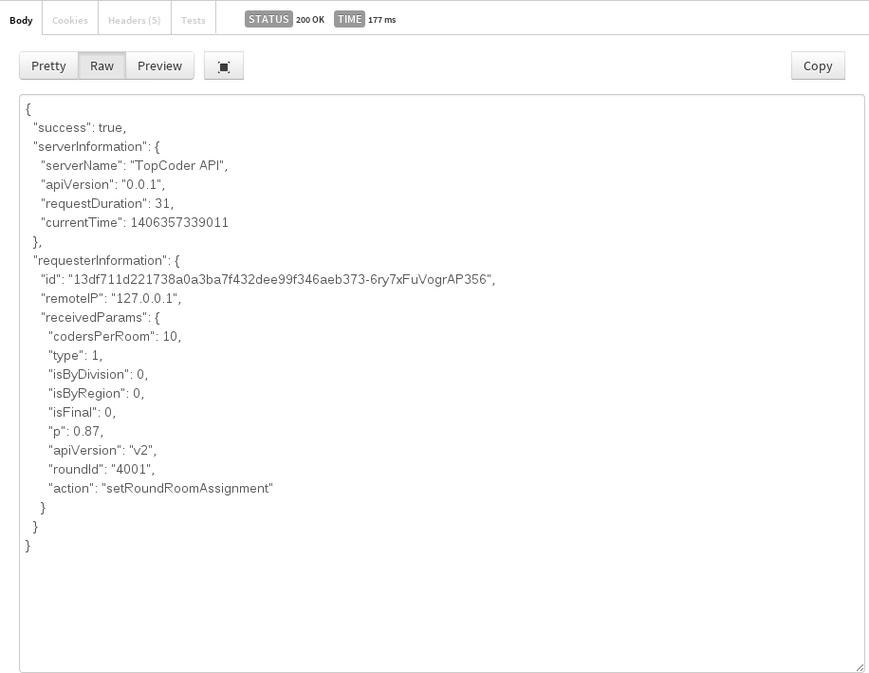Set Round Room Assignment - Postman Result

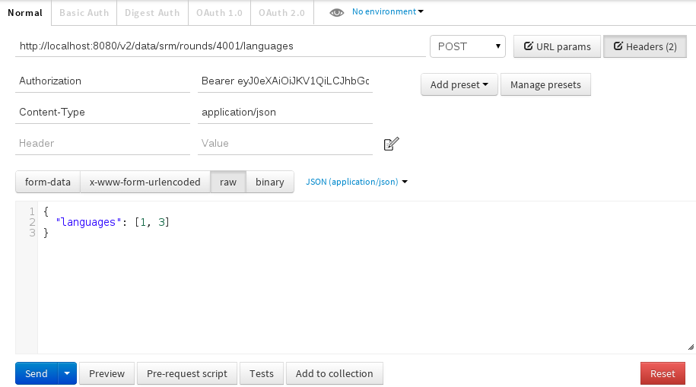Set Round Language API - Postman form

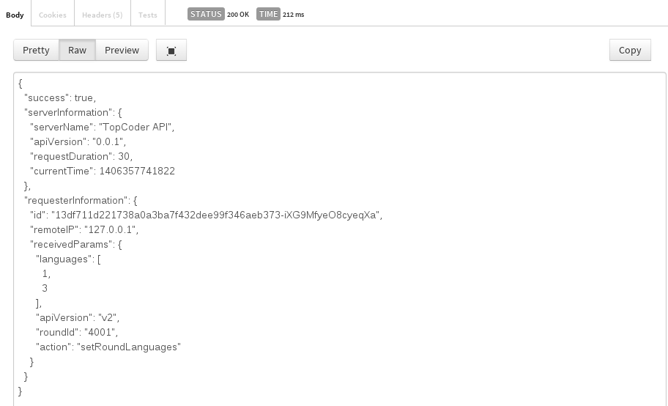Set Round Language API - Postman Result
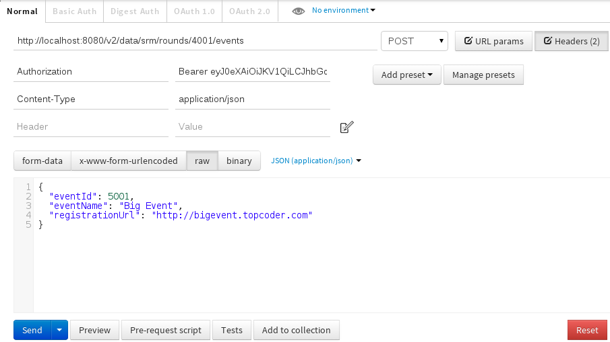Set Round Events API - Postman form
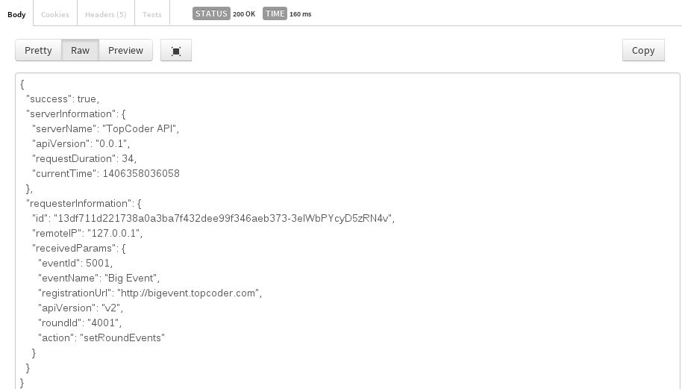Set Round Events API - Postman Result
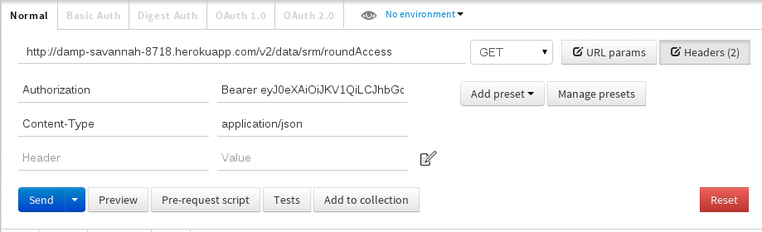Load Round Access API - Postman form (heroku deployment)
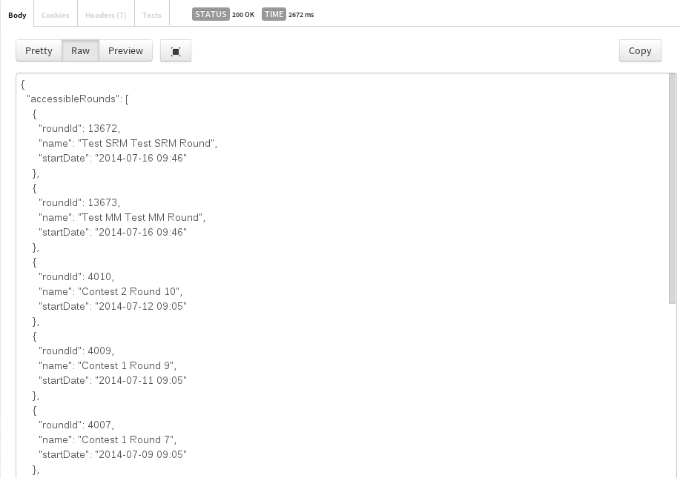Load Round Access API - Postman result snippet (heroku deployment)

6. Resource Contact List
Name | Resource Email
panoptimum

