Module Assembly – Topcoder NodeJS Referral Leaderboard API
Deployment Guide

Revision History
Author | Revision Number | Date
panoptimum | 1.0 | 2014-07-21

Contents

Deployment Instructions 3
1.Organization of Submission 3
2.Application Setup 3
3.Build Scripts Setup 3
4.Database Setup 3
5.Verification 3
6 Resource Contact List 8

Deployment Instructions

Organization of Submission
All modified and new files are in ./submission/tc-api directory under the submission root.
The test output is in /submission/test_output.
The submission is based on commit 4f5661bdbd4f96ef41b1a0e66a1014f92a54dac1

Application Setup
Let's assume the submission is extracted into ./submission.
On a Unix/Linux system the following steps are sufficient to integrate the submission with the existing code.

wget -O tc-api.zip \ https://codeload.github.com/cloudspokes/tc-api/zip/4f5661bdbd4f96ef41b1a0e66a1014f92a54dac1
unzip tc-api.zip
mv tc-api-4f5661bdbd4f96ef41b1a0e66a1014f92a54dac1 tc-api
cd ../submission
tar -cf - tc-api | tar -C ../ -xf -

Please look at https://github.com/cloudspokes/tc-api/wiki/_pages for instructions
of how to deploy the application in your environment.

Build Scripts Setup
Please follow the standard instructions on https://github.com/cloudspokes/tc-api/wiki/Configure-Environment-Variables for your specific setup.

Database Setup
- Login as user informix on db host
- cd scripts && ant drop_db && ant setup_db

Verification

JSlint
With https://github.com/FND/jslint-reporter, please do
$ jslint -nomen -unparam tc-api/actions/platform.js
$ jslint -nomen -unparam tc-api/routes.js
$ jslint -nomen -unparam tc-api/test/test.referralLeaderboard.js

Mocha
The test output is in submission/test_output/mocha.log
$ cd ./tc-api
$ ./node_modules/.bin/mocha -R tap \
./test/test.referralLeaderboard.js \
> ../submission/test_output/mocha.log
1..6
...
# tests 6
# pass 6
# fail 0
On my linux machine everything works smoothly with the standard settings. There might be issues
with the jvm not being able to allocate a sufficient amount of memory in some environments leading to
seemingly unexpected test failures. If you encounter those issues, please try to increase maximum heap
size.
I used a test system with the following properties:
uintx ErgoHeapSizeLimit = 0 {product}
uintx HeapSizePerGCThread = 87241520 {product}
uintx InitialHeapSize = 65006080 {product}
uintx LargePageHeapSizeThreshold = 134217728 {product}
uintx MaxHeapSize = 1040187392 {product}
java version "1.7.0_65"
Java(TM) SE Runtime Environment (build 1.7.0_65-b17)
Java HotSpot(TM) 64-Bit Server VM (build 24.65-b04, mixed mode)

Postman
There are two scripts provided in directory submission/db
If you use TC-VM as db-host you can follow a procedure like this:
- ssh tc@yourvm
- cp -r .ssh /tmp && chmod 755 -R /tmp/.ssh
- su informix (password is 1nf0rm1x)
- cd && cp /tmp/.ssh/authorized_keys ./.ssh
- exit
- exit
- scp insert.sql clean.sql informix@yourvm
- ssh informix@yourvm
- dbaccess – insert.sql # to setup test data
- dbaccess – clean.sql # to remove test data

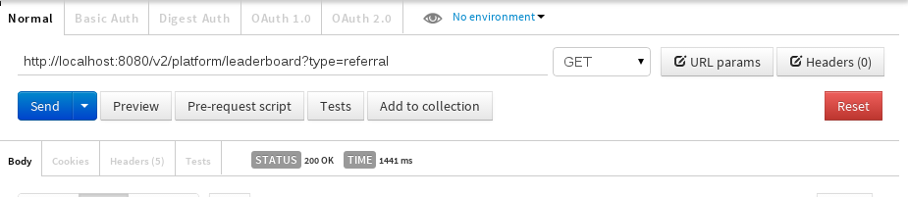Referral leaderboard (non-appirio) - postman form
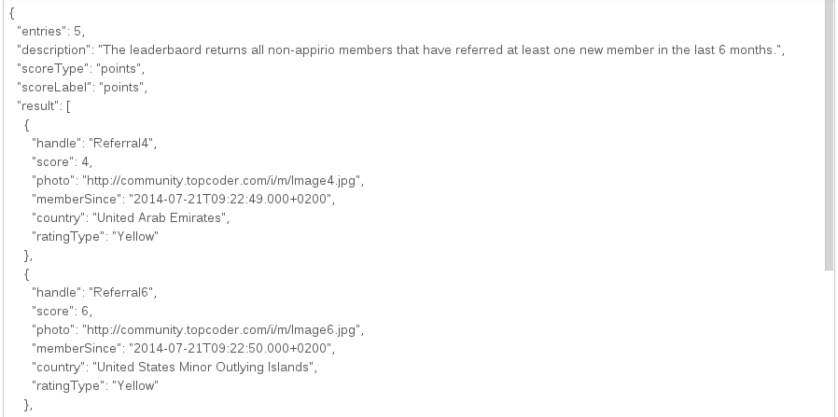Referral leaderboard (non-appirio) - postman results snippet

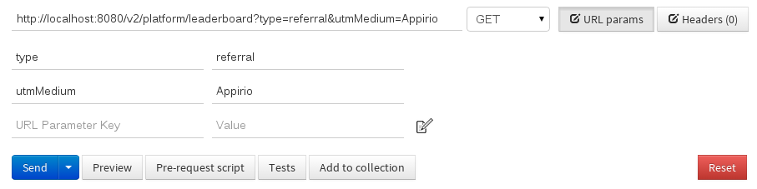Referral leaderboard (appirio) - postman form

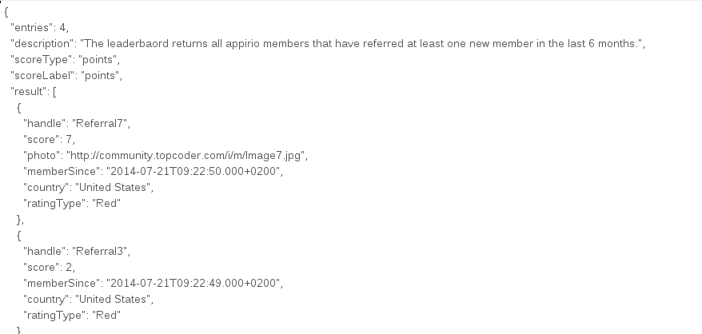Referral leaderboard (appirio) - postman result snippet

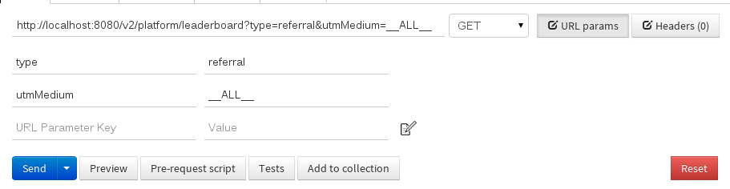Referral leaderboard (all results) - postman form

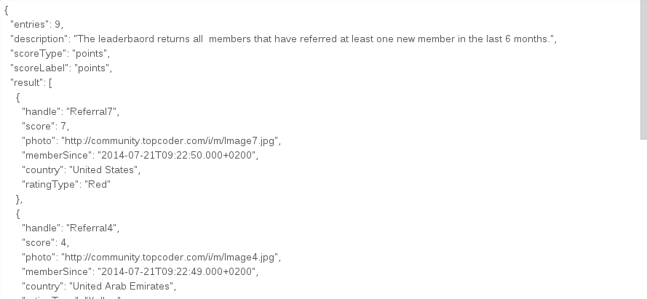Referral leaderboard (all results) - postman results snippet

6 Resource Contact List

Name | Resource Email
panoptimum

