Module Assembly - reporting tool refactor and load user json data to Postgres Deployment Guide

Revision History
Author | Revision Number | Date
TCSASSEMBLER | 1.0 | 11/5/2014

Deployment Instructions 3
1. Organization of Submission 3
2. Application Setup 3
2.1 Extractor Configurations (conf/DataExtractor.properties) 3
2.2 Big Query configuration files 4
2.3 Postgres related configurations 5
2.4 Build Scripts Setup 6
3. Database Setup 6
4. Deployment Instructions 6
5. Starting 7
6. Verification 7
6.1 Big Query 7
6.2 Postgres 9
7. Resource Contact List 11

Deployment Instructions

Organization of Submission

The submission follows directory structure provided below:

doc
Contains the Deployment Guide Document of this assembly.

conf
Contains all the configuration related files like extractor properties, loader properties file, log4j properties and private key, the schema files, the sql scripts etc

data
Contains the test data to load
lib
Contains all the 3rd java jar libraries
log
Contains the log output file.
src
Contains all the source codes including the loader source codes which can load the extracted data to test.

Application Setup

The application is expected to be deployed to the following environment:

- JDK 1.6
- ANT 1.7.0
- Postgres 9.3.3
- Informix 11.5.0

Extractor Configurations (conf/DataExtractor.properties)

tcs_dw_connection_str=jdbc:informix-sqli://localhost:2021/tcs_dw:INFORMIXSERVER=informixoltp_tcp;user=informix;password=1nf0rm1x
topcoder_dw_connection_str=jdbc:informix-sqli://localhost:2021/topcoder_dw:INFORMIXSERVER=informixoltp_tcp;user=informix;password=1nf0rm1x

Please update the connection string to suite your environment

The extractor sql scripts are under conf/extractorSQL

Big Query related configuration files

Big Query Loader Configurations (conf/bigquery/TableLoader.properties)

service_account_id=762162804421-hkiiplllvntri45198hserlh5bt2ii3q@developer.gserviceaccount.com
# make sure the private key is put under class path
private_key_file=private_key.p12

Log4j Configurations (config/log4j.properties)

# Root logger option
log4j.rootLogger=DEBUG, stdout, file

# Direct log messages to stdout
log4j.appender.stdout=org.apache.log4j.ConsoleAppender
log4j.appender.stdout.Target=System.out
log4j.appender.stdout.layout=org.apache.log4j.PatternLayout
log4j.appender.stdout.layout.ConversionPattern=%d{yyyy-MM-dd HH:mm:ss} %-5p %c{1}:%L - %m%n

# File appender
log4j.appender.file=org.apache.log4j.RollingFileAppender
log4j.appender.file.layout=org.apache.log4j.PatternLayout
log4j.appender.file.layout.ConversionPattern=%d{yyyy-MM-dd HH:mm:ss} %-5p %c - %m%n
log4j.appender.file.file=log/log.log
log4j.appender.file.MaxFileSize=10000KB
log4j.appender.file.Threshold=DEBUG

Big Query jobs configuration (conf/bigquery/jobs.json)
{
"logFilePerRunning":true,
"jobs":[
{
"bigQueryProjectId":"tc-data-accessibility-30044673",
"bigQueryDatasetId":"competitionTestDataSet",
"bigQueryTableId":"user",
"tableSchemaFile":"bigquery/schema/userSchema.json",
"extractorClassName":"com.topcoder.utitlities.reporting.extractor.UserDataExtractor",
"dataFileName":"user_data.json",
"rowNumberPerQuery":100,
"extractFileNameWithDate":true
},
{
"bigQueryProjectId":"tc-data-accessibility-30044673",
"bigQueryDatasetId":"competitionTestDataSet",
"bigQueryTableId":"challenge",
"tableSchemaFile":"bigquery/schema/challengeSchema.json",
"extractorClassName":"com.topcoder.utitlities.reporting.extractor.ChallengeDataExtractor",
"dataFileName":"challenge_data.json",
"rowNumberPerQuery":100,
"extractFileNameWithDate":true
},
{
"bigQueryProjectId":"tc-data-accessibility-30044673",
"bigQueryDatasetId":"competitionTestDataSet",
"bigQueryTableId":"issue",
"tableSchemaFile":"bigquery/schema/issueSchema.json",
"extractorClassName":"com.topcoder.utitlities.reporting.extractor.JiraIssueDataExtractor",
"dataFileName":"issue_data.json",
"rowNumberPerQuery":100,
"extractFileNameWithDate":true
},
{
"bigQueryProjectId":"tc-data-accessibility-30044673",
"bigQueryDatasetId":"competitionTestDataSet",
"bigQueryTableId":"userNotification",
"tableSchemaFile":"bigquery/schema/userNotificationSchema.json",
"extractorClassName":"com.topcoder.utitlities.reporting.extractor.UserNotificationDataExtractor",
"dataFileName":"user_notification_data.json",
"rowNumberPerQuery":100,
"extractFileNameWithDate":true
}
]
}

The big query table schema configurations

All of them are under conf/bigquery/schema

- userSchema.json
- userNotificationSchema.json
- issueSchema.json
- challengeSchema.json

Postgres related configurations

The postgres table loader properties (conf/postgres/TableLoader.properties)

It configures the completed JDBC string to connect to the postgres database

jdbc_connection_str=jdbc:postgresql://localhost:5432/report?user=postgres&password=postgres

The postgres runner jobs configuration (conf/postgres/jobs.json)

{
"logFilePerRunning":true,
"jobs":[
{
"extractorClassName":"com.topcoder.utitlities.reporting.extractor.UserDataExtractor",
"dataFileName":"user_data.json",
"rowNumberPerQuery":100,
"extractFileNameWithDate":true,
"loaderConfig": {
"tableName": "user",
"setupScript": "postgres/script/user/setup.sql",
"clearScript": "postgres/script/user/clear.sql",
"insertScript": "postgres/script/user/insert.sql",
"schema": "postgres/schema/userSchema.json"

}
}
]
}

Build Scripts Setup

The ANT build script for compiling the source codes and running the runners (build.xml) provides the following targets which are to be used:

- compile – compiles all the source codes
- dist– dist the build classes into jar
- loadBigQuery – run the big query runner which reads the jobs from configuration and run the job one by one
- loadPostgres – run the postgres runner which reads the jobs from configuration and run the job one by one

Database Setup

- Insert the test_files/test_data.sql to before running any demo. It inserts the challenge test data in the database.
- Login into the VM with account ‘tc’ to load the challenge test data insert data warehouse
  - cd /mnt/shared/glue
  - svn up –r 84889
  - cd /mnt/shared/shared
  - svn up –r 85038
  - cd web
  - ant –f build_tc.xml deploy
  - ant –f build_data_loader.xml dist
  - ant –f build_data_loader.xml tcs_dw

Please refer to the deployment guide in doc/old directory to see details on how to prepare DW test data for each load type. Or you can use my VM directly 107.20.84.160

Deployment Instructions
- Make sure you JAVA_HOME is set to the path of JDK 1.6
- Extra all the files in the submission into any folder
- Run ‘ant loadBigQuery’
- Run ‘ant loadPostgres’

To be able to view the loaded data in big query, please request an access to project tc-data-accessibility-30044673 in the contest forum

Starting

- Run ‘ant loadBigQuery’
- Run ‘ant loadPostgres’

Verification

Big Query

After run the ant command ‘ant loadBigQuery’, you will see output in console, or you can check the log too

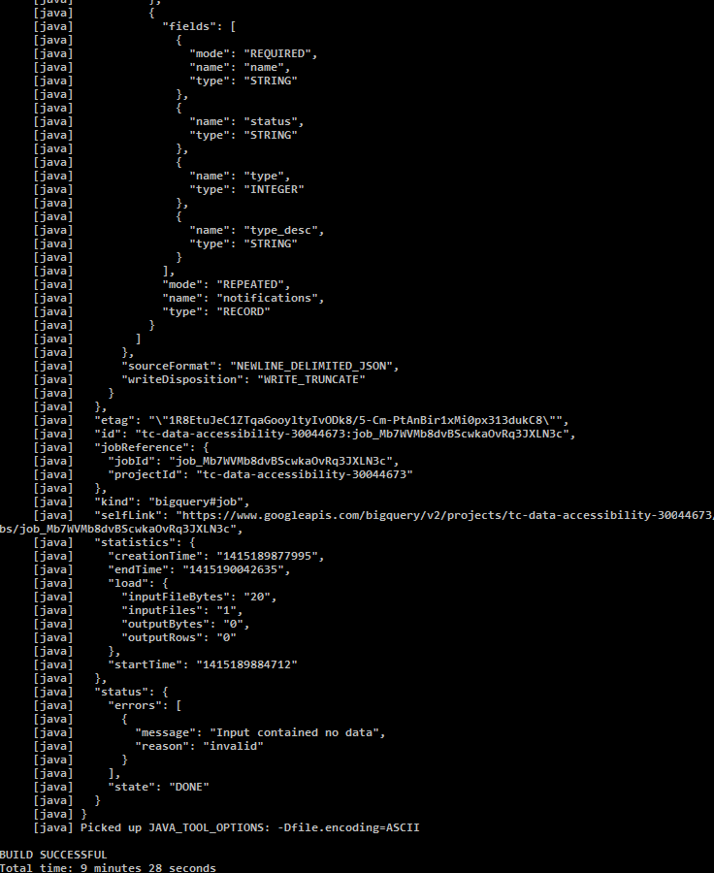

Check the data folder, you can see the generated json data and the compressed gzipped version.

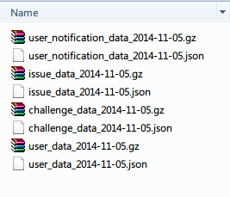

Check the big query project you will see

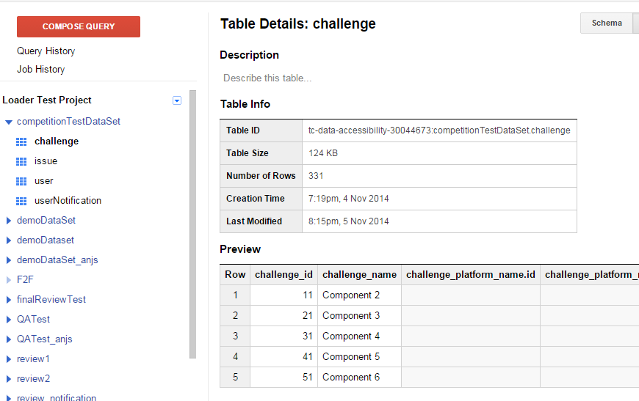

Postgres

Run ‘ant loadPostgres’

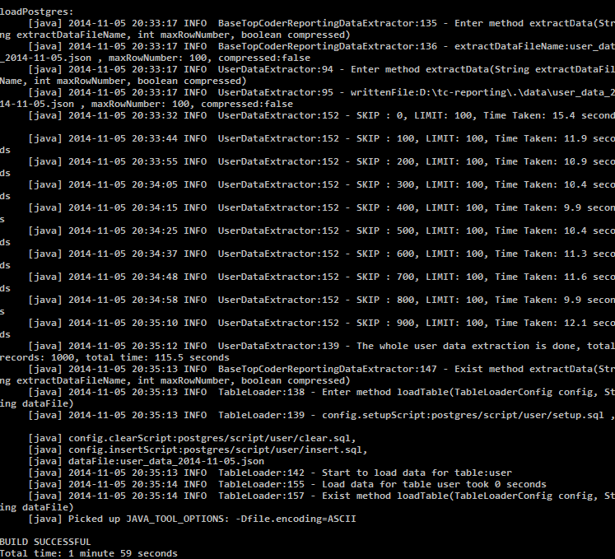

Connect to the postgres database and run

SELECT * FROM “user”

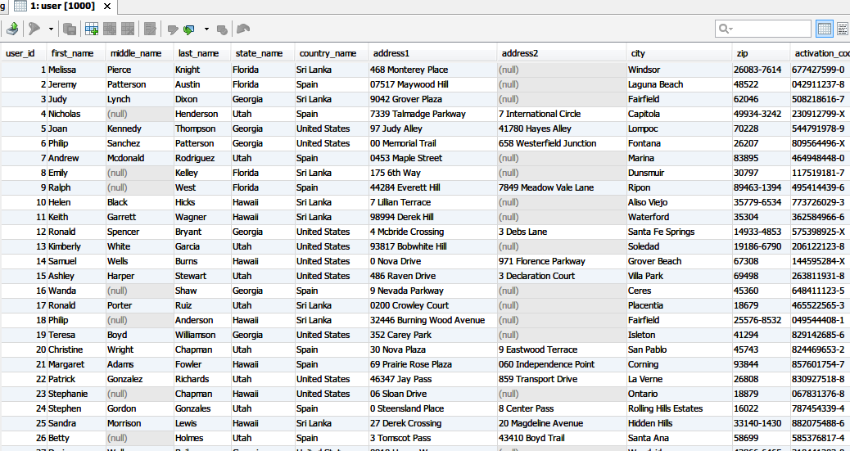

Resource Contact List

Name | Resource Email
TCSASSEMBLER

