Release Assembly - Update TopCoder Design Challenge Forum Deployment Guide

Revision History
Author | Revision Number | Date
TCSASSEMBLER | 1.0 | 7/21st/2014

Deployment Instructions 3
1. Organization of Submission 3
2. Application Setup 3
2.1 Ant .Properties File 4
2.2 Direct Configurations 4
2.3 Build Scripts Setup 4
3. Database Setup 5
4. Deployment Instructions 5
4.1 Deploy Direct 5
4.2 Deploy Forum EJB 5
4.3 Deploy Studio 6
4.4 Deploy Online Review 6
5. Starting 6
6. Verification 6
6.1 Verify Direct and Forum instances 7
6.2 Verify Online Review 12
6.3 Verify Studio 16
6.4 Verify the database 18
7. Resource Contact List 19

Deployment Instructions

Organization of Submission

The submission follows directory structure provided below:

doc
Contains the Deployment Guide Document of this assembly.

conf
Contains the configuration files like loader properties file, log4j properties and private key etc
data
Contains the test data to load
lib
Contains all the 3rd java jar libraries
log
Contains the log output file.
schema
Contains the table schema for the big query table.
src
Contains all the source codes

Application Setup

The application is expected to be deployed to the following environment:

JDK 1.6
ANT 1.7.0

Ant .Properties File
N/A

Big Query Configurations (BigQueryLoaderUtility.properties)

service_account_id=762162804421-hkiiplllvntri45198hserlh5bt2ii3q@developer.gserviceaccount.com
# make sure the private key is put under class path
private_key_file=private_key.p12

Log4j Configurations (log4j.properties)

# Root logger option
log4j.rootLogger=DEBUG, stdout, file

# Direct log messages to stdout
log4j.appender.stdout=org.apache.log4j.ConsoleAppender
log4j.appender.stdout.Target=System.out
log4j.appender.stdout.layout=org.apache.log4j.PatternLayout
log4j.appender.stdout.layout.ConversionPattern=%d{yyyy-MM-dd HH:mm:ss} %-5p %c{1}:%L - %m%n

# File appender
log4j.appender.file=org.apache.log4j.RollingFileAppender
log4j.appender.file.layout=org.apache.log4j.PatternLayout
log4j.appender.file.layout.ConversionPattern=%d{yyyy-MM-dd HH:mm:ss} %-5p %c - %m%n
log4j.appender.file.file=log/loaderLog.log
log4j.appender.file.MaxFileSize=10000KB
log4j.appender.file.Threshold=DEBUG

Build Scripts Setup

The ANT build script for compiling the source codes and running the demo (build.xml) provides the following targets which are to be used:

- compile – compiles all the source codes
- dist– dist the build classes into jar
- runDemo – run the demo program

Database Setup

N/A

Deployment Instructions
- Make sure you JAVA_HOME is set to the path of JDK 1.6
- Extra all the files in the submission into any folder and Run ‘ant runDemo’

Starting

- Run ‘ant runDemo’

Verification

After run the ant command ‘ant runDemo’, you will see output in console, or you can check the log too

The utility provides the method public static boolean isJsonDataFileValid(String fileName) to validate the upload file before uploading. For example, for the bad upload file large_data_bad.json, the utility will output and log

[java] 2014-08-08 01:00:05 INFO BigQueryLoaderUtility:? - Validates the json data file large_data_bad.json
[java] 2014-08-08 01:00:10 ERROR BigQueryLoaderUtility:? - Errors detected in the json data file:large_data_bad.json
[java] 2014-08-08 01:00:10 ERROR BigQueryLoaderUtility:? - Line 24 Error Message: \u255]
[java] 2014-08-08 01:00:10 ERROR BigQueryLoaderUtility:? - Line 86433 Error Message: \u324]
[java] 2014-08-08 01:00:10 ERROR BigQueryLoaderUtility:? - Line 97255 Error Message: com.google.gson.stream.MalformedJsonException: Unterminated object at line 1 column 231
[java] 2014-08-08 01:00:10 ERROR BigQueryLoaderUtility:? - Line 100000 Error Message: java.io.EOFException: End of input at line 1 column 246

If the file is ok, the loader will create dataset, create table and upload the file, if the file is not compressed, it can optionally compress the json file to gz format first. You can see the job details in the log like

[java] 2014-08-08 00:59:14 INFO BigQueryLoaderUtility:? - Create new file to put compressed file:/home/tc/loader/data/large_data.gz

[java] 2014-08-08 00:59:17 INFO BigQueryLoaderUtility:? - The file : large_data.gz to upload has size 4 MB
[java] 2014-08-08 00:59:21 INFO BigQueryLoaderUtility:? - The job creation and upload data file took 4 seconds

[java] 2014-08-08 00:59:24 INFO BigQueryLoaderUtility:? - Job status (3001ms) job_McCUj6eewrxGSxykGU85IqQC1PM: PENDING
[java]
[java] 2014-08-08 00:59:28 INFO BigQueryLoaderUtility:? - Job status (6272ms) job_McCUj6eewrxGSxykGU85IqQC1PM: PENDING
[java]
[java] 2014-08-08 00:59:31 INFO BigQueryLoaderUtility:? - Job status (9618ms) job_McCUj6eewrxGSxykGU85IqQC1PM: PENDING
[java]
[java] 2014-08-08 00:59:34 INFO BigQueryLoaderUtility:? - Job status (12949ms) job_McCUj6eewrxGSxykGU85IqQC1PM: PENDING
[java]
[java] 2014-08-08 00:59:38 INFO BigQueryLoaderUtility:? - Job status (16696ms) job_McCUj6eewrxGSxykGU85IqQC1PM: PENDING
[java]
[java] 2014-08-08 00:59:41 INFO BigQueryLoaderUtility:? - Job status (20162ms) job_McCUj6eewrxGSxykGU85IqQC1PM: PENDING
[java]
[java] 2014-08-08 00:59:45 INFO BigQueryLoaderUtility:? - Job status (23263ms) job_McCUj6eewrxGSxykGU85IqQC1PM: RUNNING
[java]
[java] 2014-08-08 00:59:48 INFO BigQueryLoaderUtility:? - Job status (26483ms) job_McCUj6eewrxGSxykGU85IqQC1PM: RUNNING
[java]
[java] 2014-08-08 00:59:51 INFO BigQueryLoaderUtility:? - Job status (29777ms) job_McCUj6eewrxGSxykGU85IqQC1PM: RUNNING
[java]
[java] 2014-08-08 00:59:55 INFO BigQueryLoaderUtility:? - Job status (33369ms) job_McCUj6eewrxGSxykGU85IqQC1PM: RUNNING
[java]
[java] 2014-08-08 00:59:58 INFO BigQueryLoaderUtility:? - Job status (36626ms) job_McCUj6eewrxGSxykGU85IqQC1PM: RUNNING
[java]
[java] 2014-08-08 01:00:01 INFO BigQueryLoaderUtility:? - Job status (39960ms) job_McCUj6eewrxGSxykGU85IqQC1PM: RUNNING
[java]
[java] 2014-08-08 01:00:05 INFO BigQueryLoaderUtility:? - Job status (43613ms) job_McCUj6eewrxGSxykGU85IqQC1PM: RUNNING

After running, you can check in the big query console

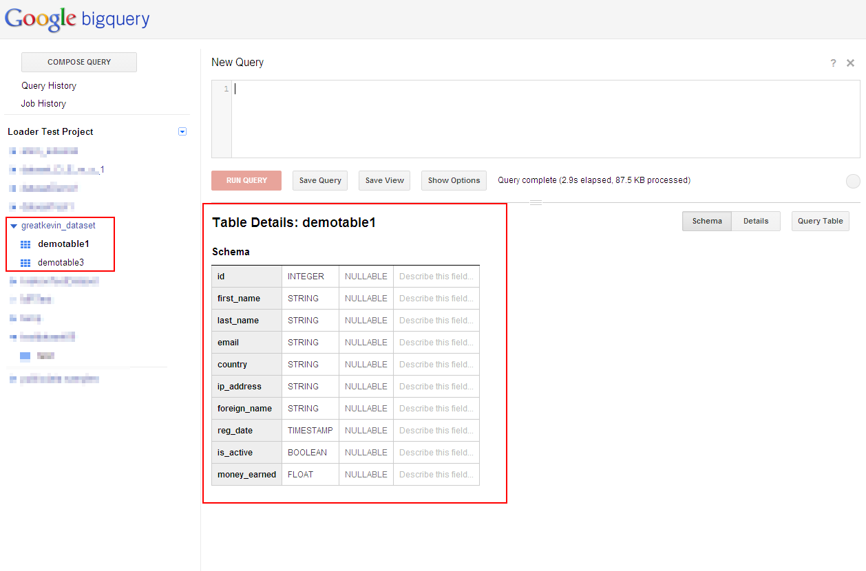

Click Details, you can see

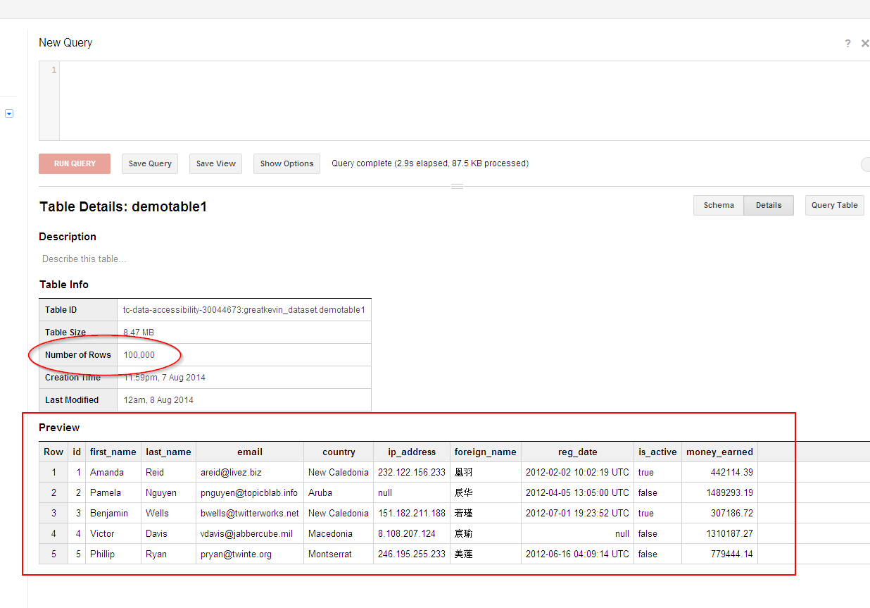

The 100,000 records in the large data have all been loaded.

You can run query to test like

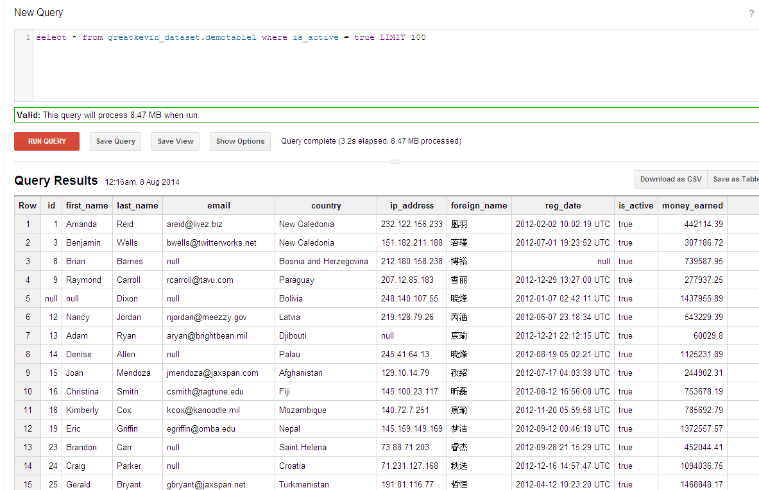

You can also check the other table which has small data loaded, has 1000 rows

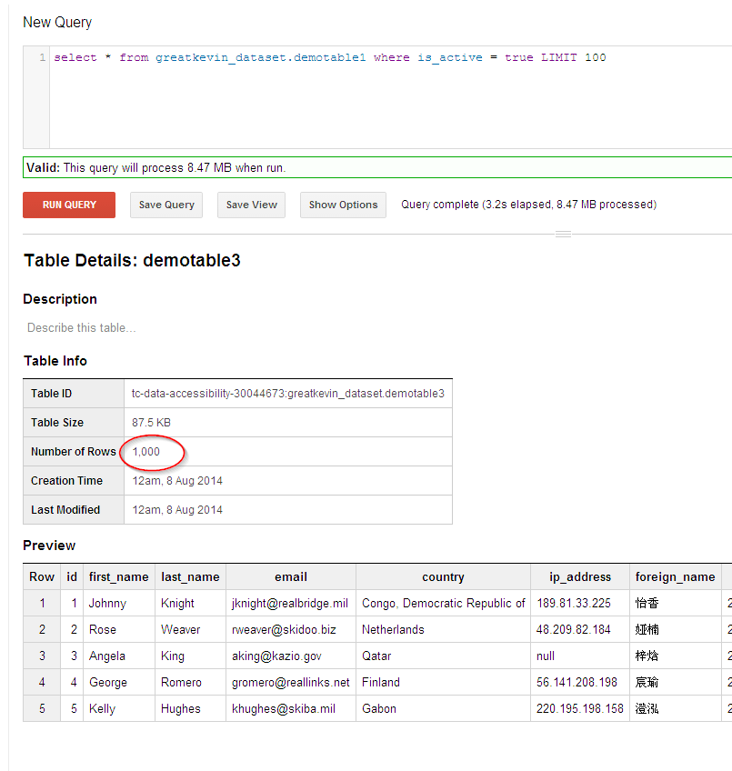

Please note that the timestamp accepts NULL, unlike described in RS, you can check by running

select * from greatkevin_dataset.demotable3 where reg_date is null LIMIT 100
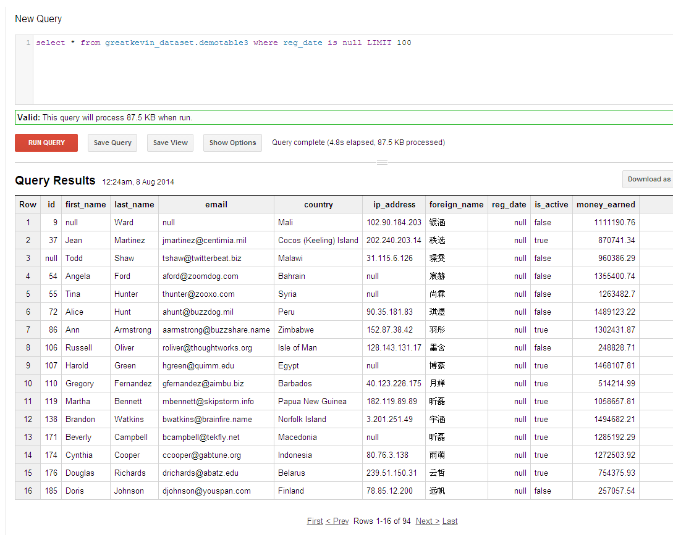

Resource Contact List

Name | Resource Email
TCSASSEMBLER

