TopCoder Data Warehouse Data Big Query Extractor – Challenge data Deployment Guide

Revision History
Author | Revision Number | Date
TCSASSEMBLER | 1.0 | 8/12/2014

Deployment Instructions 3
1. Organization of Submission 3
2. Application Setup 3
2.1 Ant .Properties File 3
2.2 Extractor Configurations (BigQueryDataExtractor.properties) 3
2.3 Big Query Loader Configurations (BigQueryLoaderUtility.properties) 4
2.4 Log4j Configurations (log4j.properties) 4
2.5 Build Scripts Setup 4
3. Database Setup 4
4. Deployment Instructions 5
5. Starting 5
6. Verification 5
7. Resource Contact List 11

Deployment Instructions

Organization of Submission

The submission follows directory structure provided below:

doc
Contains the Deployment Guide Document of this assembly.

conf
Contains the configuration files like extractor properties, loader properties file, log4j properties and private key etc

data
Contains the test data to load
lib
Contains all the 3rd java jar libraries
log
Contains the log output file.
schema
Contains the challenge table schema for the big query table.
src
Contains all the source codes including the loader source codes which can load the extracted data to test.

Application Setup

The application is expected to be deployed to the following environment:

JDK 1.6
ANT 1.7.0

Ant .Properties File
N/A

Extractor Configurations (BigQueryDataExtractor.properties)

tcs_dw_connection_str=jdbc:informix-sqli://localhost:2021/tcs_dw:INFORMIXSERVER=informixoltp_tcp;user=informix;password=1nf0rm1x
topcoder_dw_connection_str=jdbc:informix-sqli://localhost:2021/topcoder_dw:INFORMIXSERVER=informixoltp_tcp;user=informix;password=1nf0rm1x

Please update the connection string to suite your environment

Big Query Loader Configurations (BigQueryLoaderUtility.properties)

service_account_id=762162804421-hkiiplllvntri45198hserlh5bt2ii3q@developer.gserviceaccount.com
# make sure the private key is put under class path
private_key_file=private_key.p12

Log4j Configurations (log4j.properties)

# Root logger option
log4j.rootLogger=DEBUG, stdout, file

# Direct log messages to stdout
log4j.appender.stdout=org.apache.log4j.ConsoleAppender
log4j.appender.stdout.Target=System.out
log4j.appender.stdout.layout=org.apache.log4j.PatternLayout
log4j.appender.stdout.layout.ConversionPattern=%d{yyyy-MM-dd HH:mm:ss} %-5p %c{1}:%L - %m%n

# File appender
log4j.appender.file=org.apache.log4j.RollingFileAppender
log4j.appender.file.layout=org.apache.log4j.PatternLayout
log4j.appender.file.layout.ConversionPattern=%d{yyyy-MM-dd HH:mm:ss} %-5p %c - %m%n
log4j.appender.file.file=log/log.log
log4j.appender.file.MaxFileSize=10000KB
log4j.appender.file.Threshold=DEBUG

Build Scripts Setup

The ANT build script for compiling the source codes and running the demo (build.xml) provides the following targets which are to be used:

- compile – compiles all the source codes
- dist– dist the build classes into jar
- runDemo – run the demo program to extract the challenge data
- runBigQueryLoad – run the demo program to create the table in big query and loaded the extracted data after ‘ant runDemo’

Database Setup

- Insert the test_files/test_data.sql to before running any demo. It inserts the challenge test data in the database.
- Login into the VM with account ‘tc’ to load the challenge test data insert data warehouse
  - cd /mnt/shared/glue
  - svn up –r 84889
  - cd /mnt/shared/shared
  - svn up –r 85038
  - cd web
  - ant –f build_tc.xml deploy
  - ant –f build_data_loader.xml dist
  - ant –f build_data_loader.xml tcs_dw

Deployment Instructions
- Make sure you JAVA_HOME is set to the path of JDK 1.6
- Extra all the files in the submission into any folder and Run ‘ant runDemo’
- After ‘ant runDemo’, you can optional run ‘ant runBigQueryLoad’ to load the data.

To be able to view the loaded data in big query, please request an access to project tc-data-accessibility-30044673 in the contest forum

Starting

- Run ‘ant runDemo’
- Run ‘ant runBigQueryLoad’

Verification

After run the ant command ‘ant runDemo’, you will see output in console, or you can check the log too

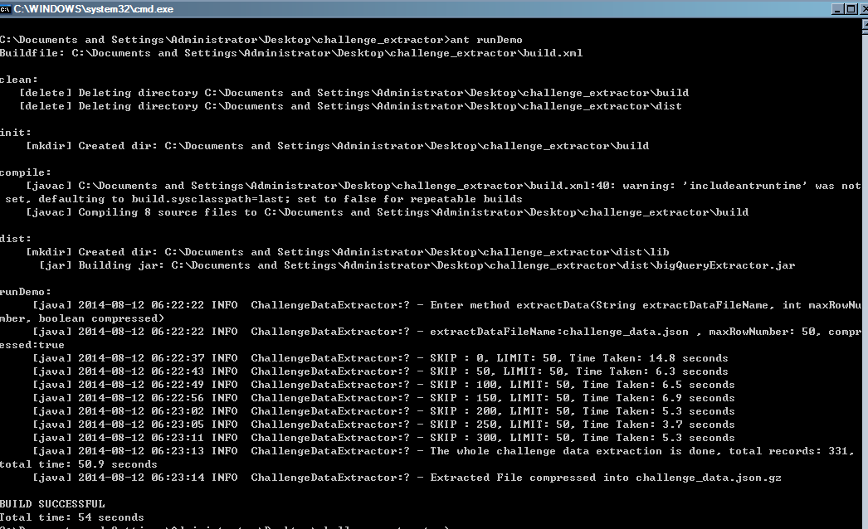

Check the data folder, you can see the generated json data and the compressed gzipped version.

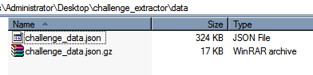

Open the challenge_data.json, you can each row contains a challenge json object as required by the big query and the date are correctly formatted.

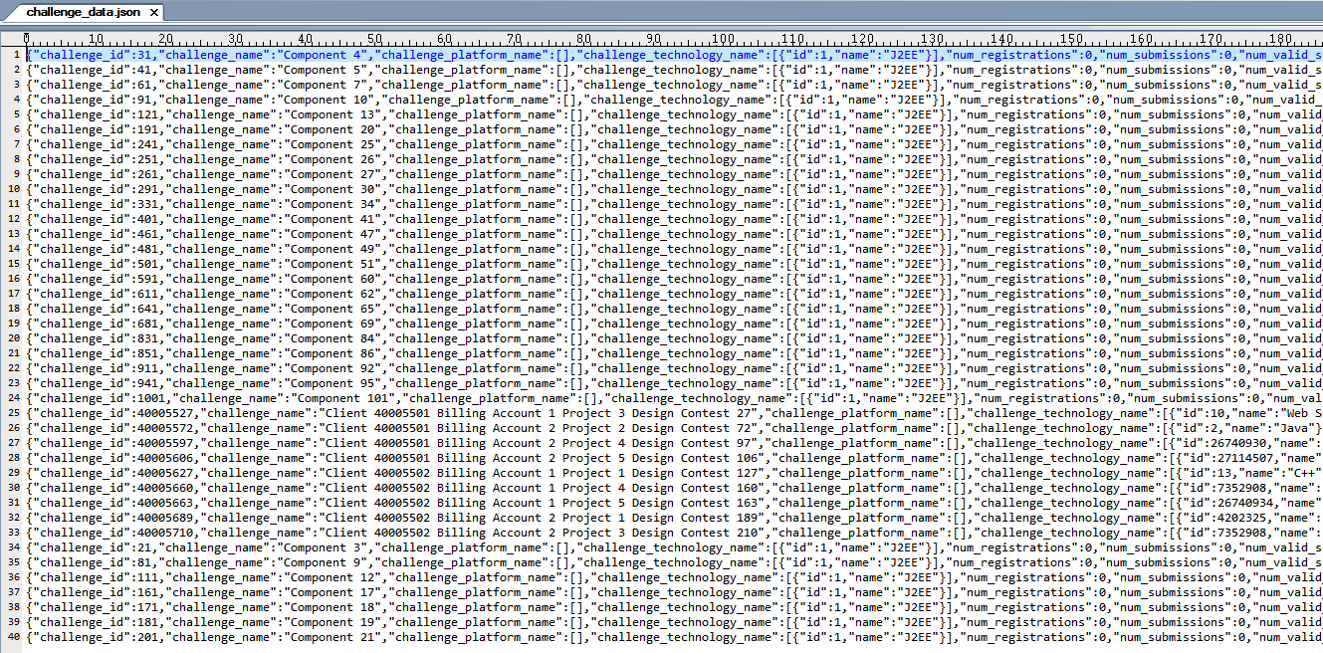

Run ‘ant runBigQueryLoad’ to load the data into big query

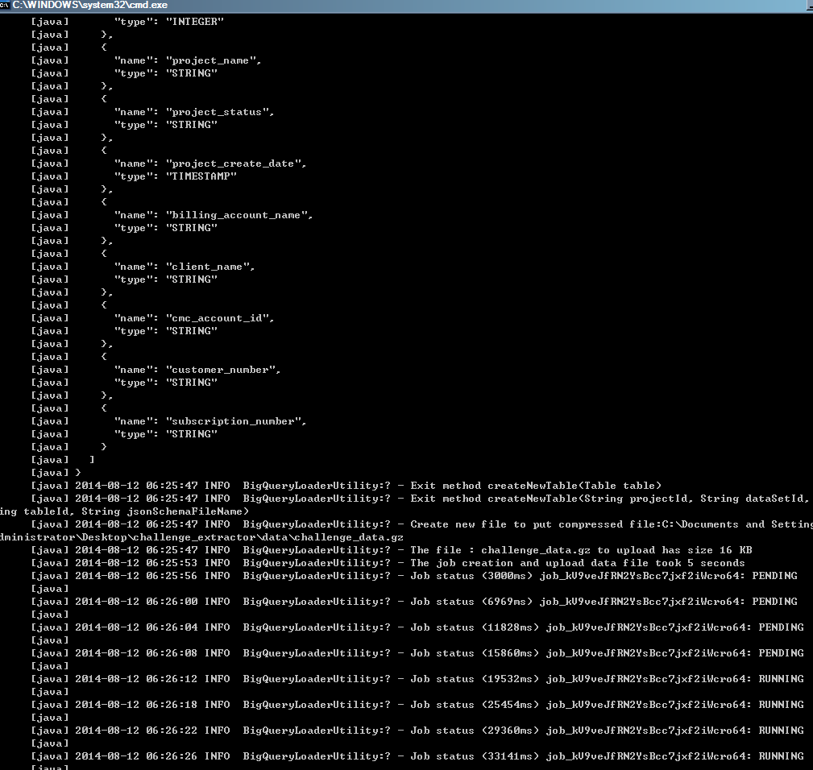

Go to https://bigquery.cloud.google.com/table/tc-data-accessibility-30044673:challengeDataset.challenge

(To be able to view the loaded data in big query, please request an access to project tc-data-accessibility-30044673 in the contest forum)

You can see

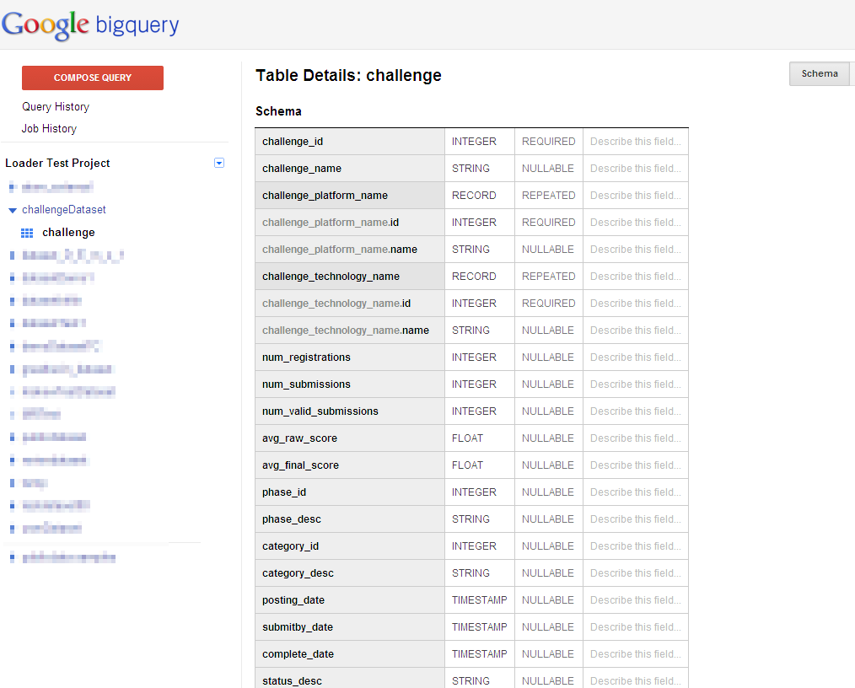

Check details

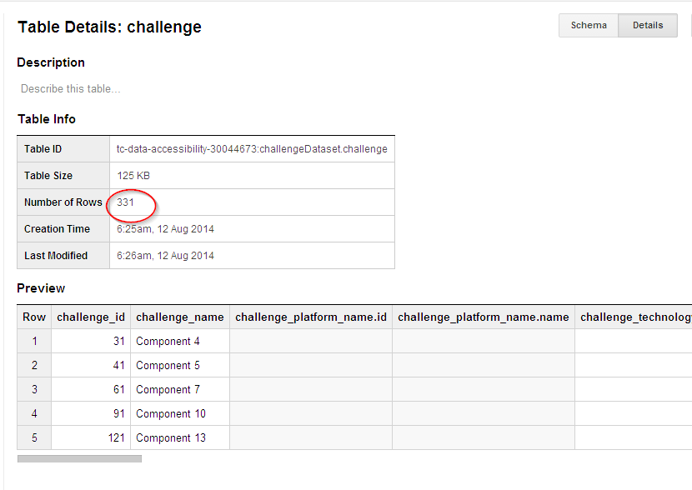

You can see all the 331 records in challenge_data.json were loaded.

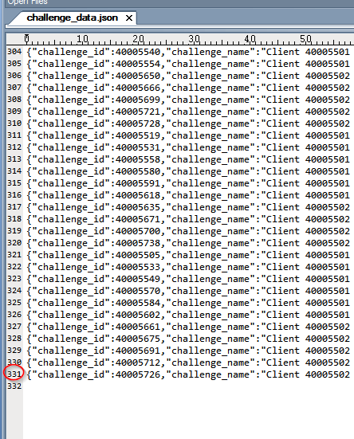

Run some queries to test, for example

SELECT challenge_id, challenge_name,
COUNT(challenge_technology_name.id) WITHIN record as numberTech,
COUNT(challenge_platform_name.id) WITHIN record as numberPlatform
FROM publicdataset.c
LIMIT 1000

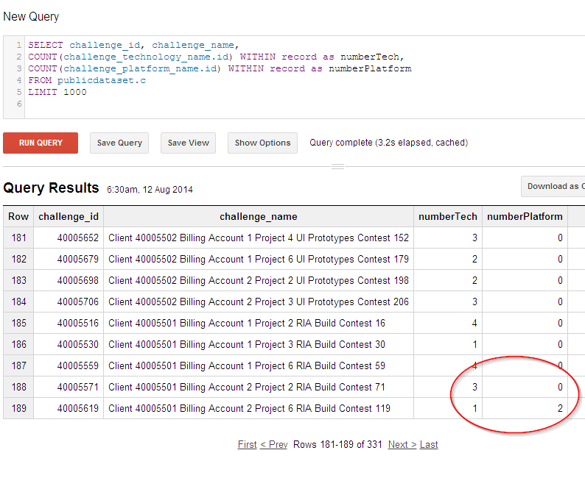

Resource Contact List

Name | Resource Email
TCSASSEMBLER

