topcoder Google Big Query Extractor and Loader Hooker Utility Deployment Guide

Revision History
Author | Revision Number | Date
TCSASSEMBLER | 1.0 | 8/28/2014

Deployment Instructions 3
1. Organization of Submission 3
2. Application Setup 3
2.1 Ant .Properties File 3
2.2 Extractor Configurations (BigQueryDataExtractor.properties) 3
2.3 Big Query Loader Configurations (BigQueryLoaderUtility.properties) 4
2.4 Log4j Configurations (log4j.properties) 4
2.5 Json configuration for extract and load utility 4
2.6 Build Scripts Setup 5
3. Database Setup 5
4. Deployment Instructions 5
5. Starting 5
6. Verification 5
7. Resource Contact List 10

Deployment Instructions

Organization of Submission

The submission follows directory structure provided below:

doc
Contains the Deployment Guide Document of this assembly.

conf
Contains the configuration files like extractor properties, loader properties file, log4j properties and add json configuration for the utility with jobs definitions and private key etc

data
Contains the test data to load
lib
Contains all the 3rd java jar libraries
log
Contains the log output file.
schema
Contains the challenge table schema for the big query table.
src
Contains all the source codes including the loader source codes which can load the extracted data to test.

Application Setup

The application is expected to be deployed to the following environment:

JDK 1.6
ANT 1.7.0

Ant .Properties File
N/A

Extractor Configurations (BigQueryDataExtractor.properties)

tcs_dw_connection_str=jdbc:informix-sqli://localhost:2021/tcs_dw:INFORMIXSERVER=informixoltp_tcp;user=informix;password=1nf0rm1x
topcoder_dw_connection_str=jdbc:informix-sqli://localhost:2021/topcoder_dw:INFORMIXSERVER=informixoltp_tcp;user=informix;password=1nf0rm1x

Please update the connection string to suite your environment

Big Query Loader Configurations (BigQueryLoaderUtility.properties)

service_account_id=762162804421-hkiiplllvntri45198hserlh5bt2ii3q@developer.gserviceaccount.com
# make sure the private key is put under class path
private_key_file=private_key.p12

Log4j Configurations (log4j.properties)

# Root logger option
log4j.rootLogger=DEBUG, stdout, file

# Direct log messages to stdout
log4j.appender.stdout=org.apache.log4j.ConsoleAppender
log4j.appender.stdout.Target=System.out
log4j.appender.stdout.layout=org.apache.log4j.PatternLayout
log4j.appender.stdout.layout.ConversionPattern=%d{yyyy-MM-dd HH:mm:ss} %-5p %c{1}:%L - %m%n

# File appender
log4j.appender.file=org.apache.log4j.RollingFileAppender
log4j.appender.file.layout=org.apache.log4j.PatternLayout
log4j.appender.file.layout.ConversionPattern=%d{yyyy-MM-dd HH:mm:ss} %-5p %c - %m%n
log4j.appender.file.file=log/log.log
log4j.appender.file.MaxFileSize=10000KB
log4j.appender.file.Threshold=DEBUG

Json configuration for extract and load utility

{
"logFilePerRunning":true,
"jobs":[
{
"bigQueryProjectId":"tc-data-accessibility-30044673",
"bigQueryDatasetId":"veveDataset",
"bigQueryTableId":"user",
"tableSchemaFile":"userSchema.json",
"extractorClassName":"com.topcoder.utilities.bigqueryload.extractor.UserDataExtractor",
"dataFileName":"user_data.json",
"rowNumberPerQuery":100,
"extractFileNameWithDate":true
},
{
"bigQueryProjectId":"tc-data-accessibility-30044673",
"bigQueryDatasetId":"veveDataset",
"bigQueryTableId":"challenge",
"tableSchemaFile":"challengeSchema.json",
"extractorClassName":"com.topcoder.utilities.bigqueryload.extractor.ChallengeDataExtractor",
"dataFileName":"challenge_data.json",
"rowNumberPerQuery":100,
"extractFileNameWithDate":false
}
]
}

Build Scripts Setup

The ANT build script for compiling the source codes and running the utility (build.xml) provides the following targets which are to be used:

- compile – compiles all the source codes
- dist– dist the build classes into jar
- load – Run all the extract and load jobs defined in default configuration file jobs.json or specify the config file name as argument like:
ant load -DconfigurationFile=loadConfig.json

Database Setup

- Insert the test_files/test_data.sql to before running any demo. It inserts the challenge test data in the database.
- Login into the VM with account ‘tc’ to load the challenge test data insert data warehouse
  - cd /mnt/shared/glue
  - svn up –r 84889
  - cd /mnt/shared/shared
  - svn up –r 85038
  - cd web
  - ant –f build_tc.xml deploy
  - ant –f build_data_loader.xml dist
  - ant –f build_data_loader.xml tcs_dw

Deployment Instructions
- Make sure you JAVA_HOME is set to the path of JDK 1.6
- Extra all the files in the submission into any folder and Run ‘ant load’ to use the default configuration file or run ‘ant load -DconfigurationFile=loadConfig.json’

To be able to view the loaded data in big query, please request an access to project tc-data-accessibility-30044673 in the contest forum

Starting

- Run ant load

Verification

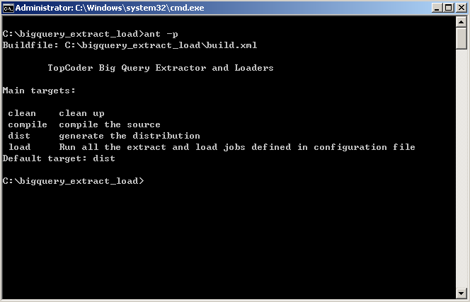

After ant load

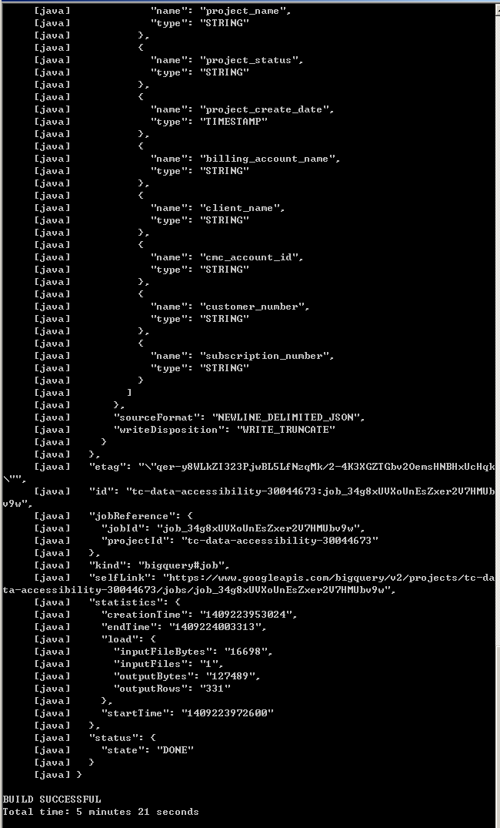

Check the log file

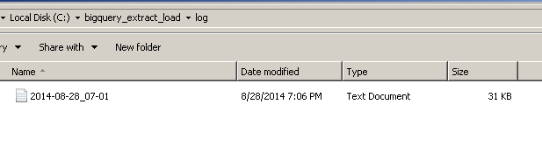

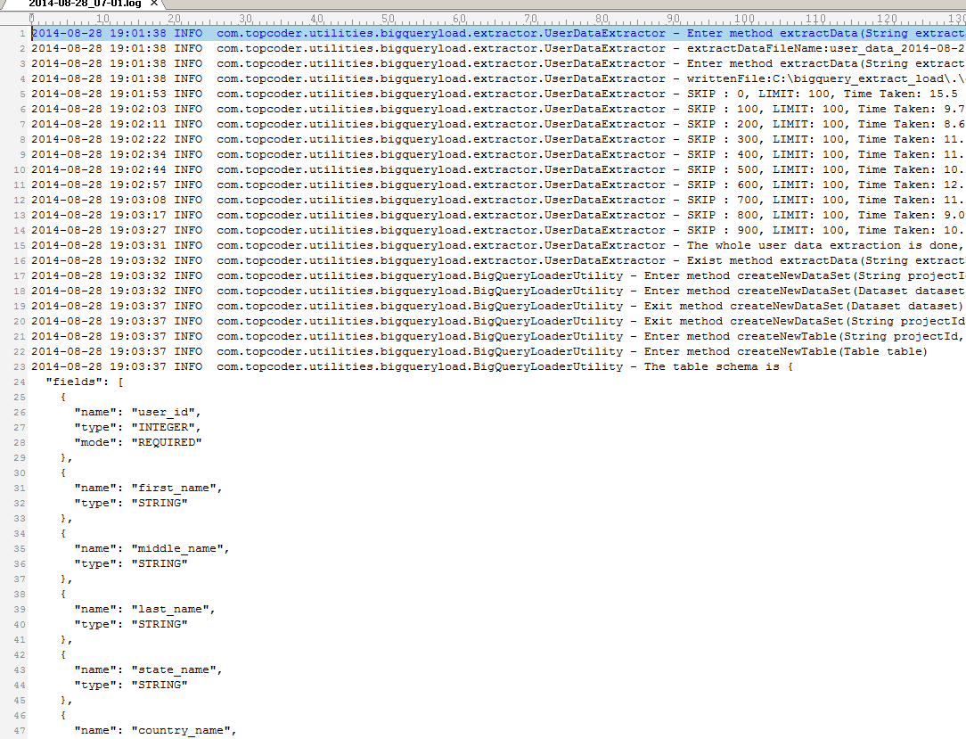

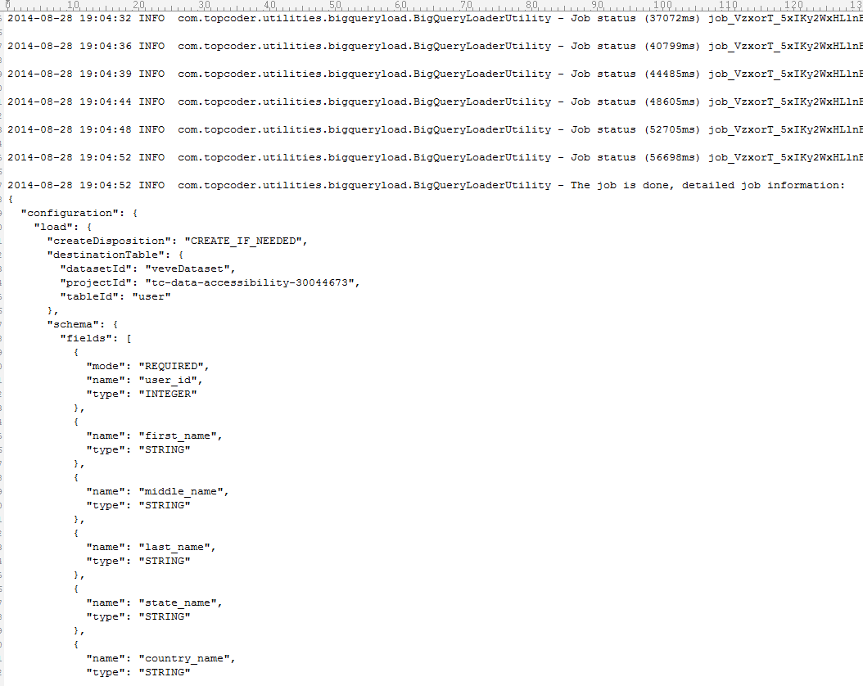

Check the extracted data

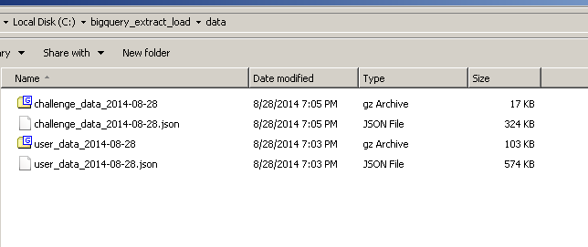

Go to big query project to check the result

https://bigquery.cloud.google.com/project/tc-data-accessibility-30044673

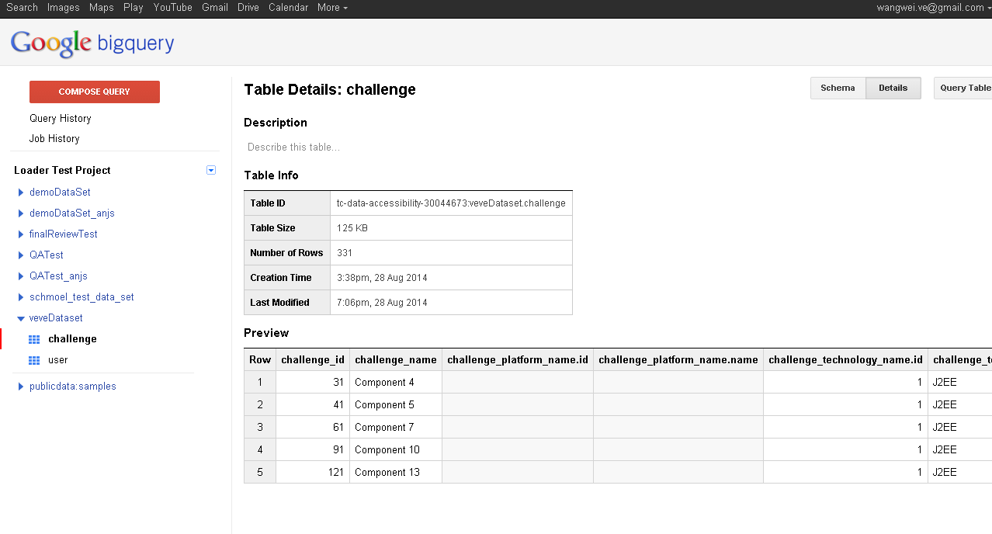

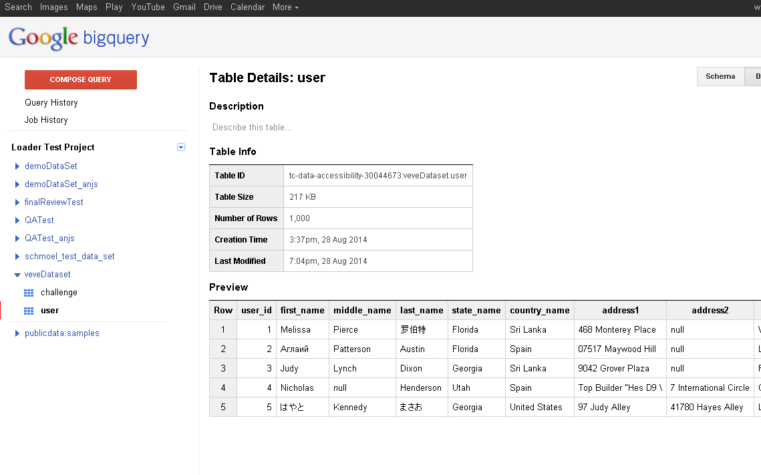

Resource Contact List

Name | Resource Email
TCSASSEMBLER

