**Requirements Documentation**

**SECTION 1 :**

**REQUIREMENT #1**

URL –  [https://phpwebdevelopmentservices.com/development/willandmore/willandmore_code/register](%20https://phpwebdevelopmentservices.com/development/willandmore/willandmore_code/register)

Current webpage –

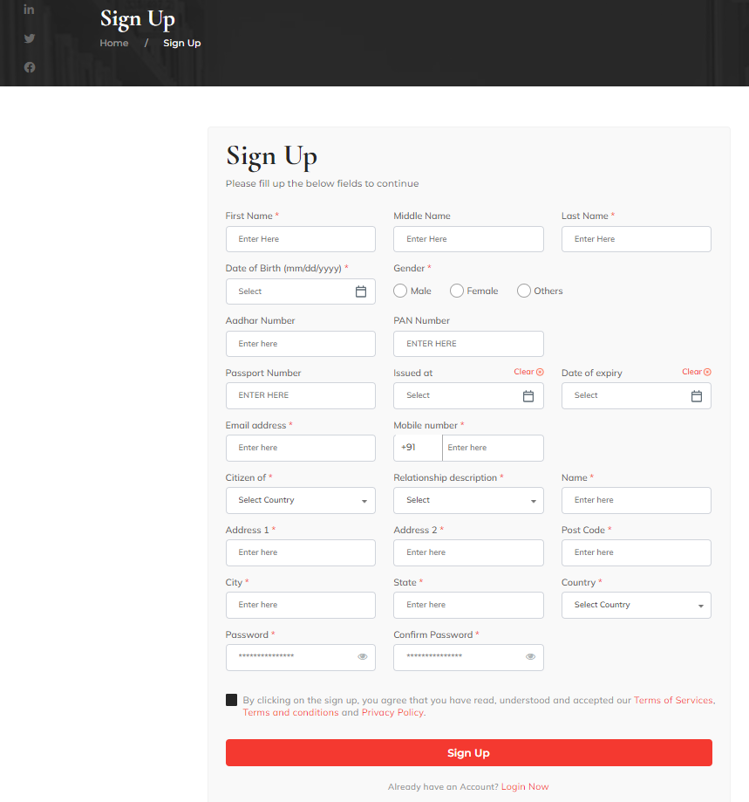

**Change to be done –**

1. Limit fields on the Signup screen to the below listed fields –

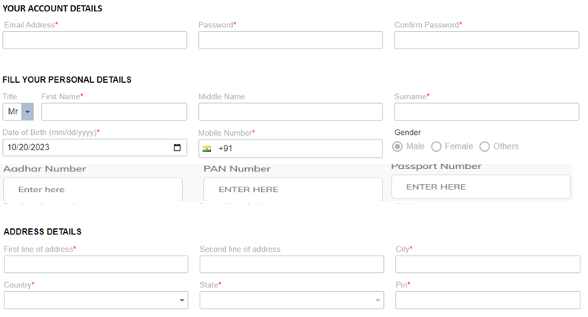

1. The remaining fields currently being removed from the existing screen will be moved to new screen as part of requirement #5.
2. Email will be used for login –
   1. Remove *“slug”* column in *user* tableand functionality in app where username is currently being created
   2. Form Validation (existing fn) – check if email address already exists in the database
   3. Form Validation (existing fn) – check if phone number already exists in the database
   4. Update both username & email address field in DB with the email address
   5. Add a “*client id*” column varchar – use fn similar to existing website to auto-populate when new client is created
   6. Email column to be made NOT NULL in the database (*users* table)

Add This Commands

[ALTER](http://localhost/phpmyadmin/url.php?url=https://dev.mysql.com/doc/refman/8.0/en/alter-table.html) [TABLE](http://localhost/phpmyadmin/url.php?url=https://dev.mysql.com/doc/refman/8.0/en/alter-table.html) `users` CHANGE `email` `email` VARCHAR(255) [CHARACTER](http://localhost/phpmyadmin/url.php?url=https://dev.mysql.com/doc/refman/8.0/en/charset.html) [SET](http://localhost/phpmyadmin/url.php?url=https://dev.mysql.com/doc/refman/8.0/en/charset.html) utf8mb4 [COLLATE](http://localhost/phpmyadmin/url.php?url=https://dev.mysql.com/doc/refman/8.0/en/charset-collations.html) utf8mb4_unicode_ci [NOT](http://localhost/phpmyadmin/url.php?url=https://dev.mysql.com/doc/refman/8.0/en/logical-operators.html%23operator_not) NULL;

1. For Country and State Fields- populate drop-down using Lookup API –

Country & State API – (<https://www.universal-tutorial.com/rest-apis/free-rest-api-for-country-state-city>)

**REQUIREMENT #2**

**Login Page**

URL – <https://willsnmore.in/login>

1. Cross-check if Username is validated from correct column and is using email address to login
2. Introduce ***reCaptcha*** in Login Page

(Validate that captcha is not already implemented for Login – as per code captcha is only on “Contact Us” page)

1. Introduce OTP sending & validation capability – email & mobile OTP both sent together to user’s registered email address & phone number

[Templates of text to be used for OTP is already available]

1. Nominee/Executor Login capability – Remove this line (as shown in screenshot below) from the page and ***disable*** (don’t delete) the functionality in the application



**REQUIREMENT #3**

**Edit Profile Page**

URL – <https://willsnmore.in/edit-profile>

1. Disable ability to change/update/Edit the **Email address** (as this is the user id). This should be View-only field (email displayed but greyed out)
2. Add below fields that can be updated by user –
   1. Use same validation as Signup Page
   2. Data to be updated in the database to corresponding fields in the table

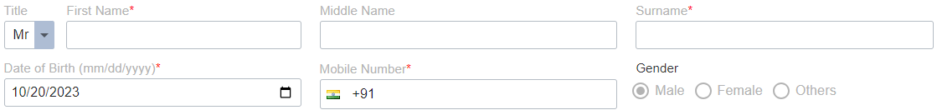



1. Existing address related fields to be updated to match the name & validation as in Sign-up page & Country/State Lookup API

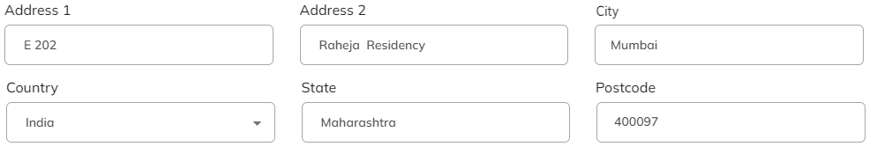

1. On “Save” – send confirmation ***email & SMS*** that Profile has been updated

(SMS & email templates available)

**REQUIREMENT #4**

**Screen Resolution Issue**

1. After Successful Login, the Top Bar expands when viewed on a smaller screen (laptop screen). This hides the top left portion of the left-hand side panel.

This needs to be fixed.

**Fix –REMOVE the phone number from the top panel**

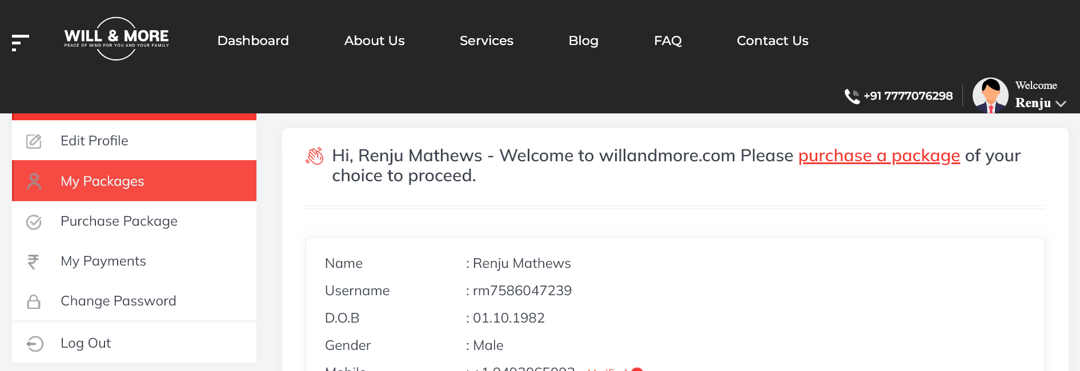

**REQUIREMENT #5**

**Online Will Creation Functionality**

URL – <https://willsnmore.in/introduction/28>

1. Add new tab after ***Introduction*** and before ***Executor*** tabs –

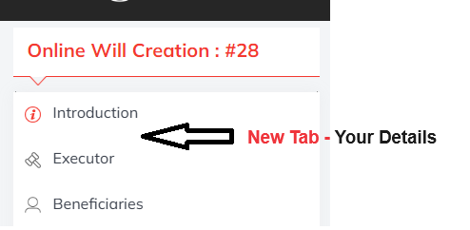

1. Look & Feel as well as functionality similar to ***Add Beneficiaries*** tab

<https://willsnmore.in/add-beneficiaries/28>

1. Add Name & Address details from Profile tab – show as pre-populated
   1. Add a text – “To edit your personal information, please go to “My Profile” page
2. Also, fields as shown below –

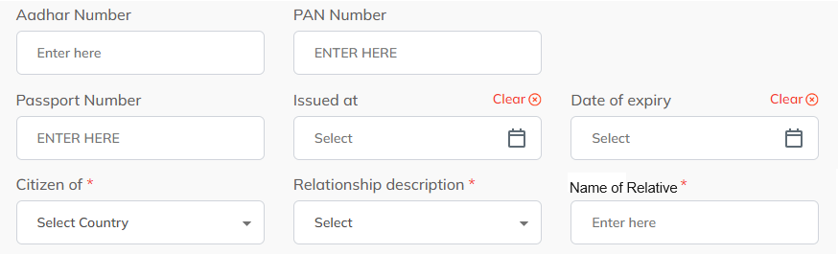

1. *Issued at* – should be changed to a Text field & rename to “Place of Issue” (in webpage & database)
2. Field Validations & drop-down values as currently implemented in ***Sign Up*** page.
3. Database insert as implemented in Sign Up page

**REQUIREMENT #7**

Issue – Currently user is unable to go back to Dashboard after completing a product (or in the midst of working on a product)

1. Add Link “***Return to Dashboard***” on the left side panel for all the Products

**REQUIREMENT #8**

**Minor Text Modifications/Changes –**

1. After creating Online Will –

“You will be uploading an executed copy of your Will to a secure server at www.willandmore.com.”  
**Remove the full statement of uploading the executed Will copy**.

1. In Letter of Instructions –

“Please either select at least one person to authorize him to access your LOI or ADD a Nominee.”

Replace with “Please either select at least one person to authorize them to access your LOI or ADD a Nominee.”

1. Validate all file uploads are being sent to S3 bucket instead of local server folder – define S3 bucket folder structure
2. Validate GST calculation
3. Change email sending capability to ***SES*** instead of current setting
4. OTP – Firehose
5. **Change all references of 10 years to 5 years**

**REQUIREMENT #9**

## Add Nominee & Add Trusted Person –

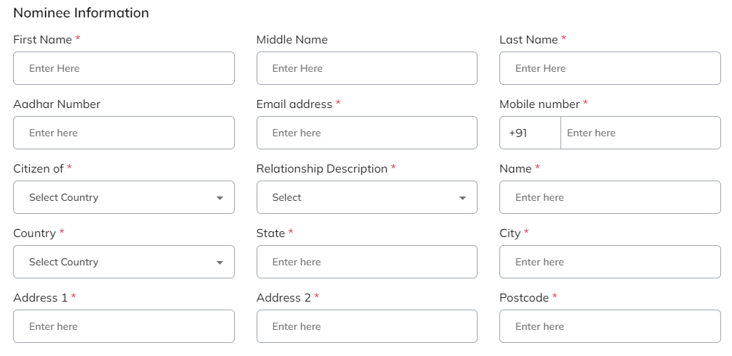

1. Can the Aadhar field be replaced with “***Aadhar OR Passport OR PAN***” and have a drop-down for user to select which one and an open text field that will accept Alpha-numeric chars –

*No need of* ***Validation*** *of Aadhar/PAN format*

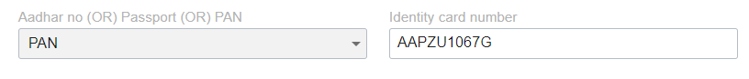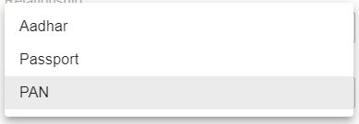

**REQUIREMENT #10**

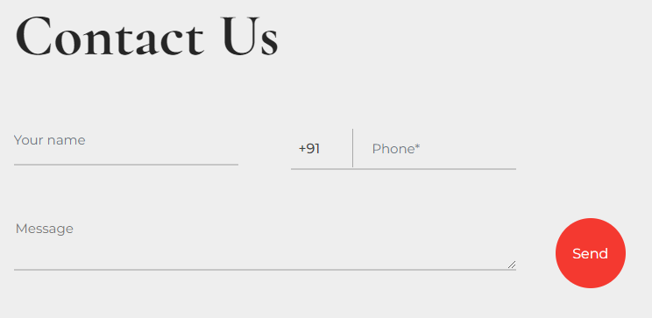

1. Add *Email Address* as a field – in **UI** and **Database**

**SECTION 2 :**

**REQUIREMENT #11**

***Final Upload Will* Functionality Button to *Consultation &* *Review* –**

1. Replace the button to ***Upload Final Will*** – screenshot below – with ***Consultation***

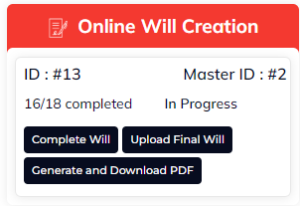

1. In the email sent to users after Will is created – **REMOVE the reference to Uploading the Will**
2. New Page – ***Consultation*** page – add **Calendly** functionality.
3. This is supposed to be Free 1-time – add a **flag** to database to track
   1. Second time onwards route to **Payment Gateway** – ***Rs. 500+GST***

**REQUIREMENT #12**

**Add New Service – Will template Download –**

1. Add new Service to the ***Services*** page [1]
2. Follow same path for “***Buy Now***” as followed in other Services -*Payment Gateway*
3. Under My Packages – add “***Will Template Download***” with detail page as shown below
4. When user click on single/multiple *Check Boxes* and clicks on *Download button* the corresponding files should be downloaded to the local file system & an email should be sent to the user’s registered email address with the corresponding files attached.

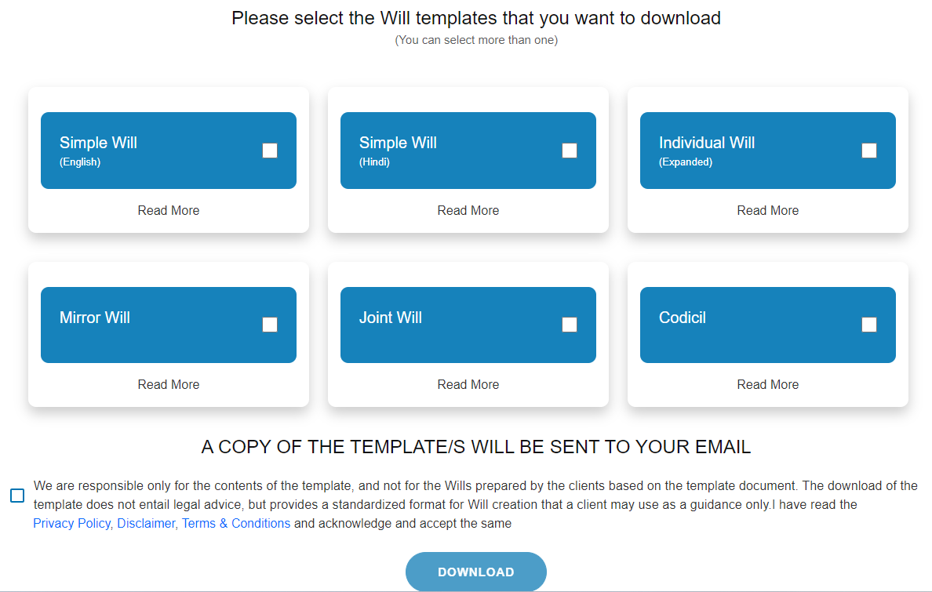

**SECTION 3 :** **Split cost for Section 3**

**REQUIREMENT #13**

**Add New Service – Will Location Search –**

**Option 1 –** Create a tile in *Services* page, and add description page (content - Introduction page from Old Website)

**Option 2** – Create a tile in *Services* page, and add description page (content - Introduction page from Old Website)

+ Build full service – 2 forms + 1 Payment gw + Receipt page

**Please provide cost & time estimates for both above options.**

1.