Programming assignment #1 sorting b03901155黃安
 | IS |  | MS |  | Random_QS
inputs | CPU time(ms) | Memory(KB) | CPU time(ms) | Memory(KB) | CPU time(ms) | Memory(KB)
1000.bc | 0 | 11876 | 0 | 11876 | 0 | 11696
1000.wc | 0 | 11876 | 0 | 11876 | 0 | 11696
1000.ac | 0 | 11876 | 0 | 11876 | 0 | 11696
2000.bc | 0 | 11876 | 0 | 11876 | 0 | 11696
2000.wc | 0 | 11876 | 0 | 11876 | 4 | 11696
2000.ac | 0 | 11876 | 0 | 11876 | 0 | 11696
4000.bc | 0 | 11876 | 0 | 11876 | 8 | 11696
4000.wc | 10 | 11876 | 0 | 11876 | 8 | 11696
4000.ac | 0 | 11876 | 0 | 11876 | 4 | 11696
8000.bc | 0 | 11876 | 0 | 11876 | 16.001 | 11696
8000.wc | 70 | 11876 | 0 | 11876 | 16 | 11696
8000.ac | 30 | 11876 | 0 | 11876 | 12.001 | 11696
16000.bc | 0 | 12020 | 0 | 12020 | 32.002 | 11840
16000.wc | 290 | 12020 | 0 | 12020 | 28.002 | 11840
16000.ac | 140 | 12020 | 0 | 12020 | 28.002 | 11840
32000.bc | 0 | 12020 | 0 | 12020 | 56.004 | 11840
32000.wc | 1160 | 12020 | 0 | 12020 | 56.004 | 11840
32000.ac | 580 | 12020 | 0 | 12020 | 60.004 | 11840
1000000.bc | 4 | 17864 | 260.016 | 19716 | 1416.09 | 17860
1000000.wc | 1005090 | 17864 | 272.017 | 19716 | 1512.09 | 17860
1000000.ac | 502631 | 17864 | 348.021 | 19716 | 1552.1 | 17860
3000000.bc | 12 | 36296 | 836.052 | 39816 | 4448.28 | 36292
3000000.wc |  |  | 868.054 | 39816 | 4604.29 | 36292
3000000.ac |  |  | 1108.07 | 39816 | 4680.29 | 36292
500000.bc | 24.001 | 60872 | 1416.09 | 64016 | 7580.47 | 60868
500000.wc |  |  | 1468.09 | 64016 | 7496.47 | 60868
500000.ac |  |  | 1932.12 | 64016 | 7860.49 | 60868
8000000.bc | 44.003 | 60872 | 2212.14 | 75732 | 11796.7 | 60868
8000000.wc |  |  | 2372.15 | 75732 | 12208.8 | 60868
8000000.ac |  |  | 3028.19 | 75732 | 12556.8 | 60868
10000000.bc | 60.004 | 110024 | 2888.18 | 116312 | 14924.9 | 110020
10000000.wc |  |  | 3088.19 | 116312 | 15189 | 110020
10000000.ac |  |  | 3916.24 | 116312 | 15773 | 110020
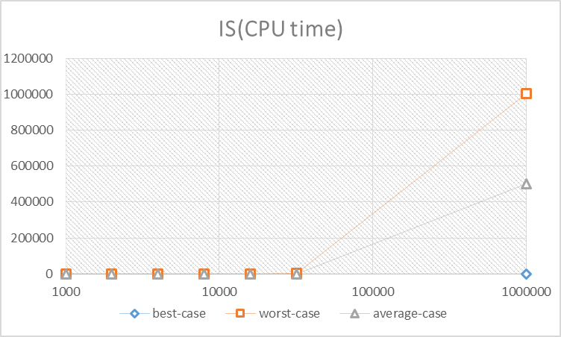
From the graph, we can obviously see that IS needed much time to sort the worst-case, and it could deal with the best-case in a short time. In the best-case, IS was the fastest between the three kinds of sorts. Compared with MS and QS, the CPU time it needed was extremely low.
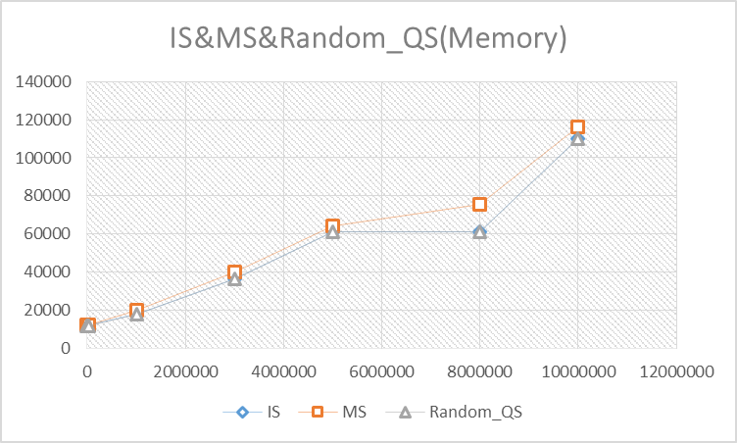
At the aspect of memory, IS and QS were almost identical because they are in-place. On the other hand, MS used much memory for it needs to take advantage of another two vectors to merge.

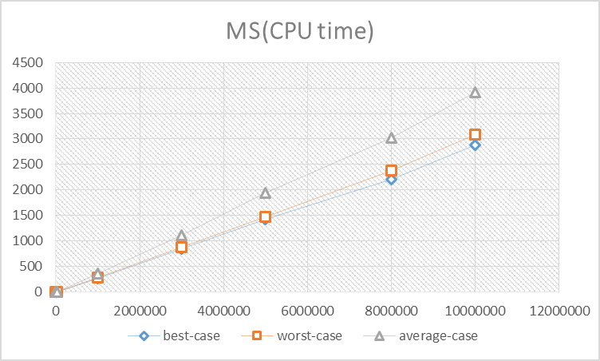
There was not a big difference between the three kinds of cases in MS. But I have no idea about why average-case used more time than others.

 | QS
inputs | CPU time(s) | Memory(KB)
1000.bc | 0 | 11876
1000.wc | 0 | 11876
1000.ac | 0 | 11876
2000.bc | 0 | 11876
2000.wc | 0 | 11876
2000.ac | 0 | 11876
4000.bc | 20 | 11944
4000.wc | 10 | 11876
4000.ac | 0 | 11876
8000.bc | 110 | 12128
8000.wc | 80 | 11940
8000.ac | 0 | 11876
16000.bc | 470 | 12644
16000.wc | 350 | 12268
16000.ac | 0 | 12020
32000.bc | 1860 | 13396
32000.wc | 1380 | 12632
32000.ac | 0 | 12020
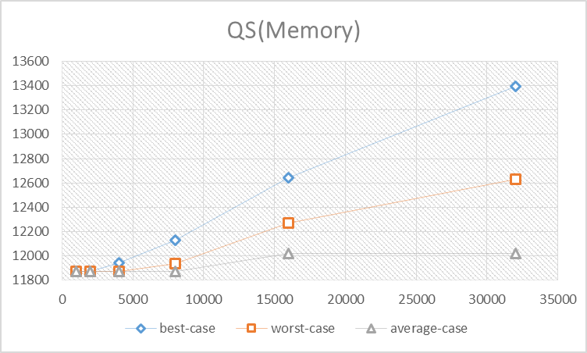
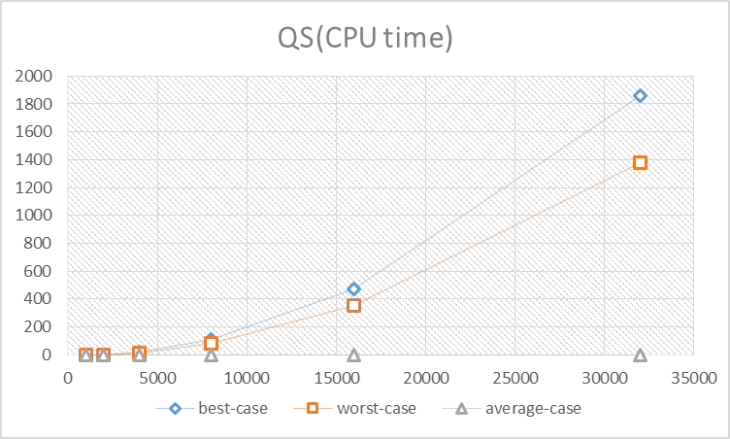
Firstly, I made QS without random. That mean, I picked the last element as a pivot instead of choosing a random number in the case. Therefore, in the best-case and the worst-case, it always cost a lot of time and memory to sort numbers. Besides, I think the reason why the best-case was slower and larger than the worst-case was that the pivot is always bigger than unsorted numbers in the best-case, so it needs to exchange many time and cost time and memory.
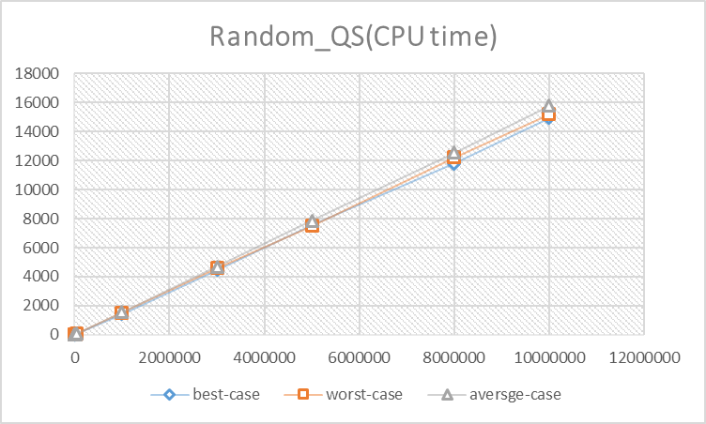
However, as data became huger, segmentation fault was easy to appear. Thus, it couldn’t complete sorting without problems. As a result, I made Random_QS to deal with large cases.
Although the average-case behaved not so well in original QS, Random_QS had ability to sort plenty of numbers and wasn’t affected by the order of the data.

