UML Class Diagram

|  |
| --- |
| Bird |
|  |
| <<constructor>>+Bird(x: float, y: float, radius: float, timer: QTimer *, pixmap: QPixmap, world: b2World*, scene: QGraphicsScene*)  +setLinearVelocity(velocity: b2Vec2)  +getBirdXPos(): float  +getBirdYPos(): float |

|  |
| --- |
| Button |
| -text: QGraphicsTextItem* |
| <<constructor>>+Button(name: QString, parent: QGraphicsItem*)  +mousePressEvent(event: QGraphicsSceneMouseEvent*)  +hoverEnterEvent(event: QGraphicsSceneHoverEvent*)  +hoverLeaveEvent(event: QGraphicsSceneHoverEvent*) |

|  |
| --- |
| Gameitem |
| g_body: b2Body  g_pixmap: QGraphicsPixmapItem  g_size: QSizeF  g_world: b2World *  g_worldsize: QSizeF  g_windowsize: QSizeF |
| <<constructor>>+GameItem(world: b2World*)  +~GameItem()  +setGlobalSize(worldsize: QSizeF, windowsize: QSizeF) |

|  |
| --- |
| Land |
|  |
| <<constructor>>+Land(x: float, y: float, w: float, h: float, timer: QTimer *, pixmap: QPixmap, world: b2World*, scene: QGraphicsScene*) |

|  |
| --- |
| MainWindow |
| - ui: MainWindow *  - scene: QGraphicsScene *  - world: b2World *  - itemList: QList<GameItem *>  - timer: QTimer  - slingshot: QGraphicsPixmapItem *  - score: Score *  - invisibleBox: Wood *  - species: int  - redBirdie: Bird *  - blueBirdie: Bird *  - newBlueBirdie: Bird *  - yellowBirdie: Bird *  - whiteBirdie: Bird *  - newEgg: Bird *  - verticalWood1: Wood *  - verticalWood2: Wood *  - verticalWood3: Wood *  - verticalWood4: Wood *  - verticalWood5: Wood *  - horizontalWood1: Wood *  - horizontalWood2: Wood *  - piggy1: Pig *  - piggy2: Pig *  - piggy3: Pig *  - piggy4: Pig *  -ground: Land* |
| <<constructor>>+MainWindow(parent: QWidget*)  +~ MainWindow ()  + showEvent()  + eventFilter(event: QEvent *): bool  + closeEvent()  +gameOver()  +start()  +drawPanel(x: int, y: int, width: int, height: int, color: QColor, opacity: double) |

|  |
| --- |
| Pig |
| +eliminate: bool |
| <<constructor>>+Pig(x: float, y: float, radius: float, timer: QTimer *, pixmap: QPixmap, world: b2World*, scene: QGraphicsScene*) |

|  |
| --- |
| Score |
| -score: Integer |
| <<constructor>>+Score(parent: QGraphicsItem*)  +increase()  +getScore(): Integer |

|  |
| --- |
| Wood |
| +bodydef: b2BodyDef |
| <<constructor>>+Wood (x: float, y: float, w: float, h: float, timer: QTimer *, pixmap: QPixmap, world: b2World*, scene: QGraphicsScene*) |

Screen Shot

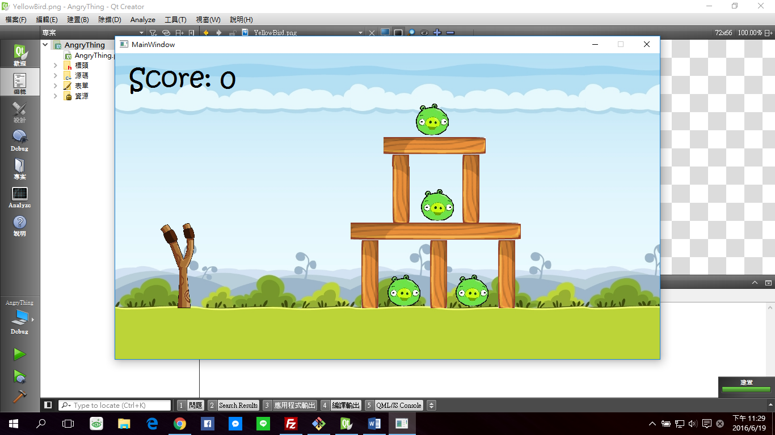

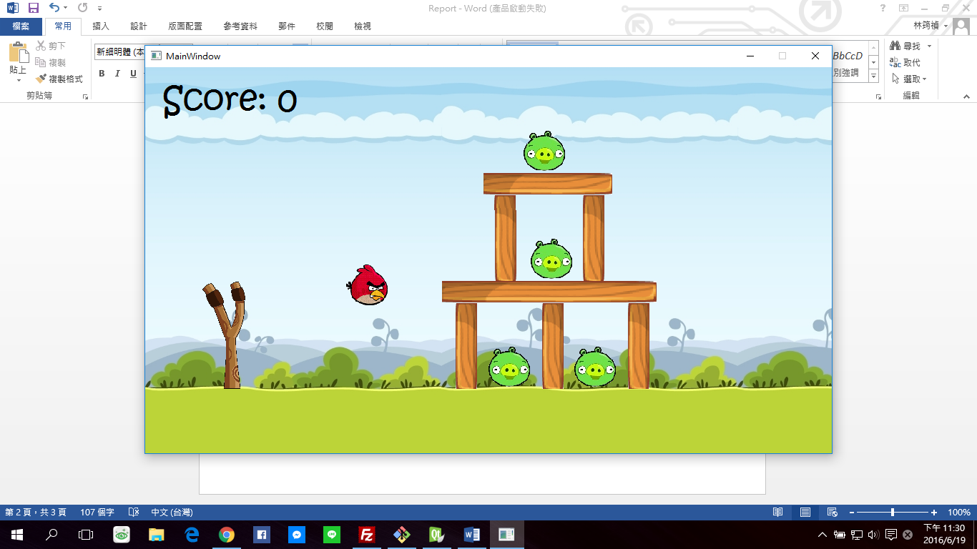

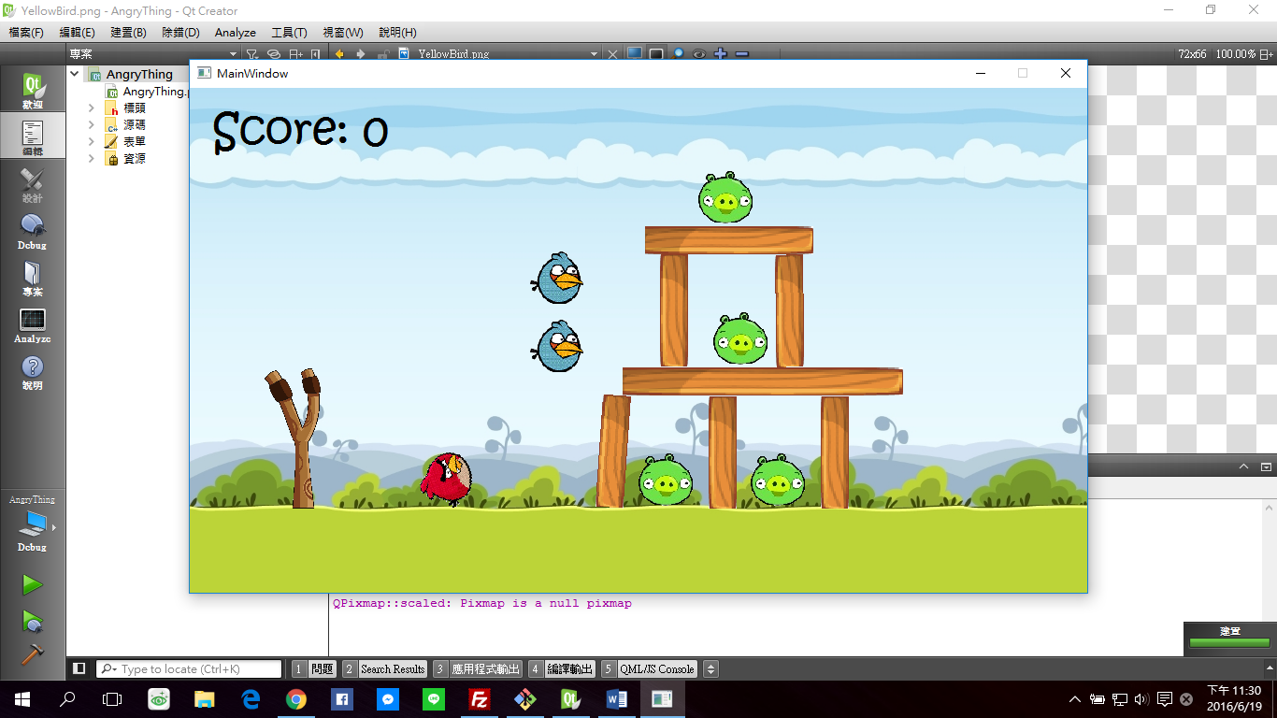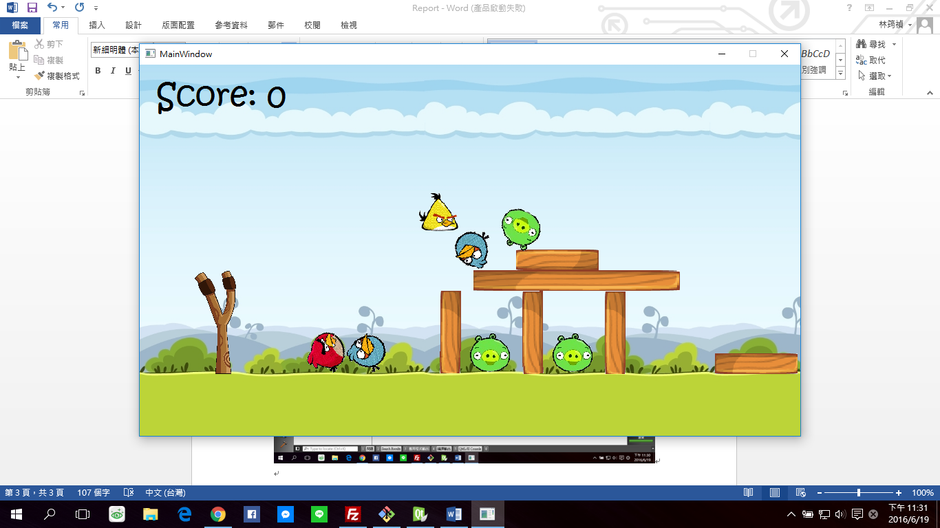



How To Play

Press mouse button to shoot the bird and press key button to show the abilities of different kinds of birds.

Bonus

1. Backgound music
2. Sound effect when shooting birds
3. Buttons change color when the cursor hovers over them