Overall Flow: https://cdn.botpress.cloud/webchat/v3.6/shareable.html?configUrl=https://files.bpcontent.cloud/2026/03/28/13/20260328131013-PU7I9QAI.json
(Github:
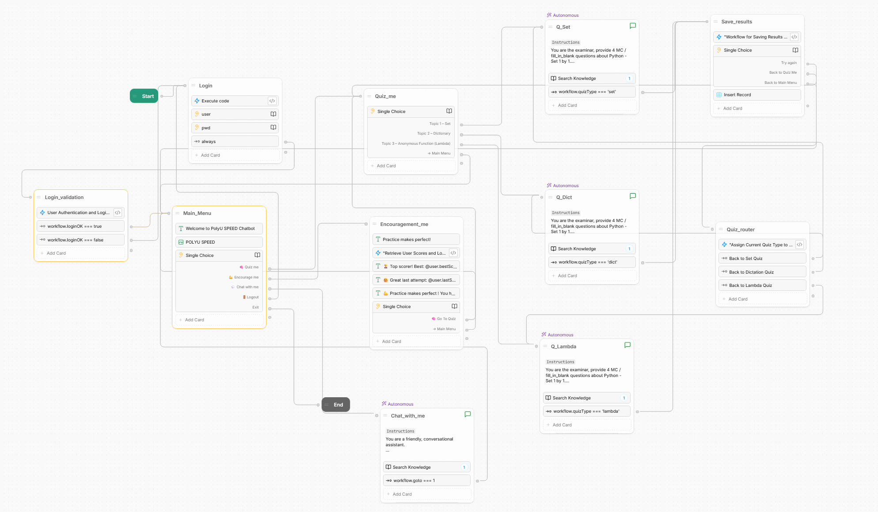
Knowledge Base:
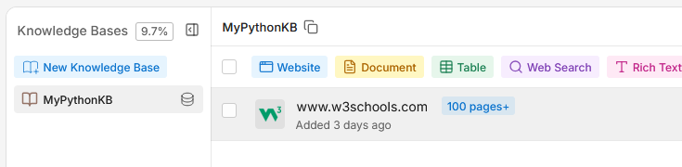

Login Flow:
Logic: Preset loginOK = false when login node. Whenever enter username and password, enter login_validation to execute the code to find the records from userTable, if username and password is not match, back to login; if username and password is match userTable, set loginOK to true and go to Main_menu node.
Login - Execute code: workflow.loginOK = false
Login_validation – Execute code:
const rltUser = workflow.rlt_user as any
// Default: assume login fails
workflow.loginOK = false
// Query UserTable for matching credentials
const results = await UserTable.findRecords({
filter: {
user: { $eq: workflow.user },
pwd: { $eq: workflow.pwd }
}
})
if (results?.length !== 0) {
// Set login success flag for Expression card routing
workflow.loginOK = true
// Clear password from memory immediately
workflow.pwd = ''
// Store matched user info into Object variable
rltUser.uid = results[0].id
rltUser.user = results[0].user
workflow.rlt_user = rltUser
// Increment login counter (persists across sessions)
user.loginCount = (user.loginCount || 0) + 1
// Log this login session
try {
await loginLogTable.createRecord({
uid: workflow.rlt_user.uid
})
} catch (error) {
console.error('Failed to insert login log:', error)
}
}
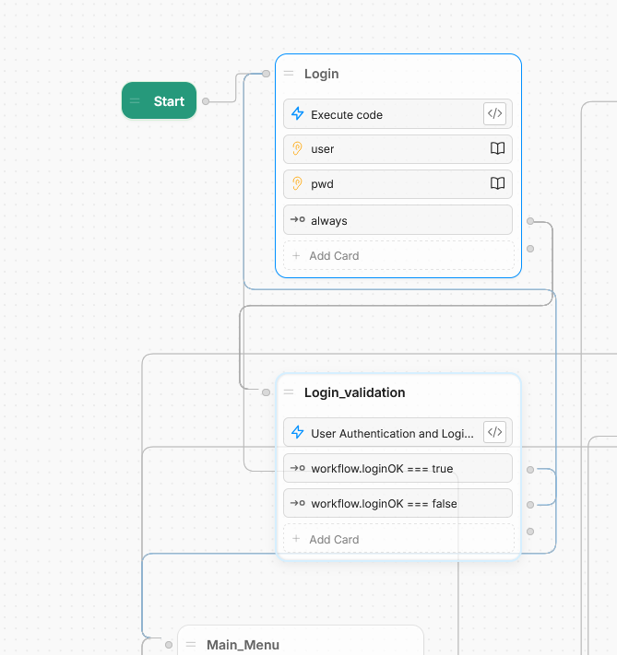
- Login Failed:
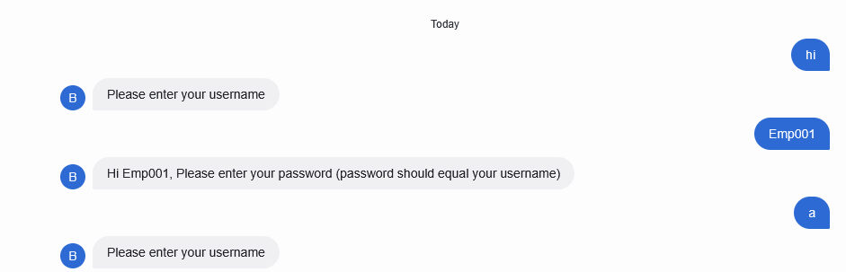
- Login success:
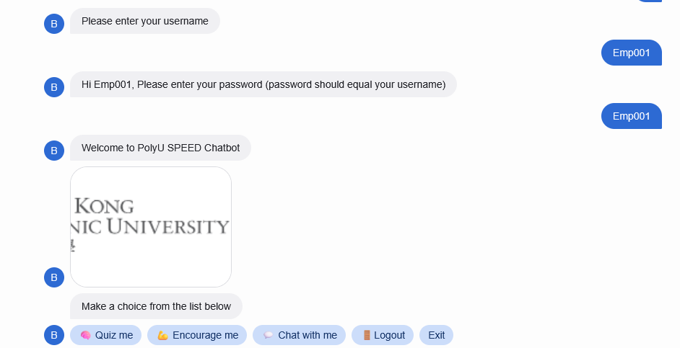
Main Flow:
Logic: There are 5 options: Quiz, Encourage, Chat, Logout (back to Login), Exit is end the bot.
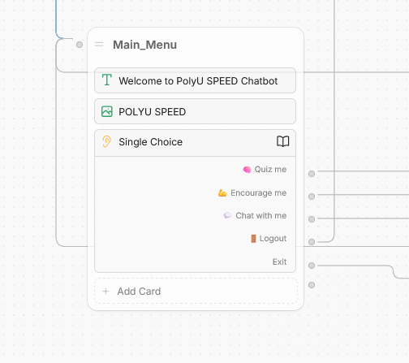
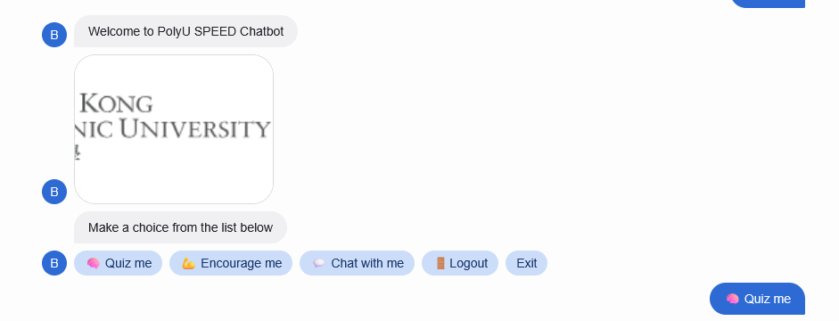
Quiz Flow:
Logic: there are 4 options to choose: set, dictionary, lambda, Main Menu(back to Main Menu). There are 3 topic of autonomous (same knowledge base with “Chat with Me”) nodes, each node provide 4 questions, after complete 4 question, the marks and the quiz topic will be recorded to the variables workflow.score and workflow.quizType respectively . And default the workflow.quizType is null. After workflow.quizType is recorded , it will go to save_results to save the workflow.score, workflow.quizType, workflow.rlt_user.uid to scoreTable. After that, if user choose “Try again”, it will go to Quiz_router to see whats the quiz type then router back to the quiz that previous step do.
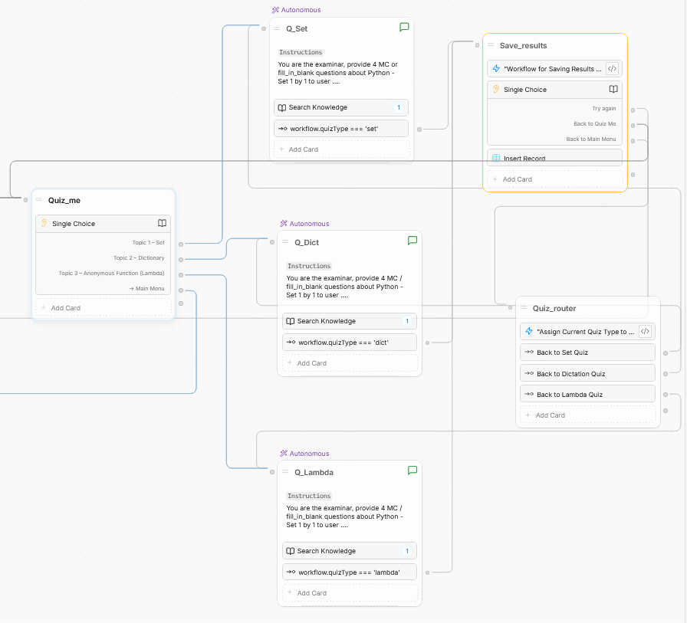
Save_results – execute code:
workflow.quizTypeTmp = ''
Quiz_router - execute code:
workflow.quizTypeTmp = workflow.quizType
workflow.quizType = '';
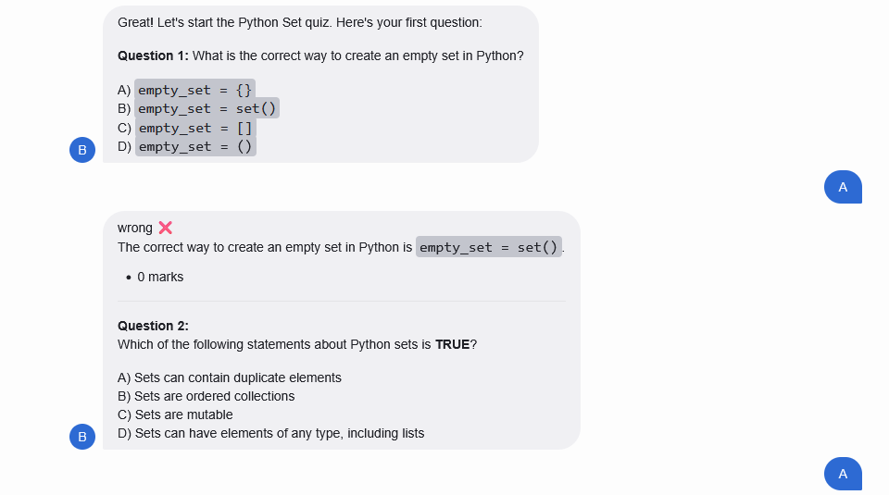
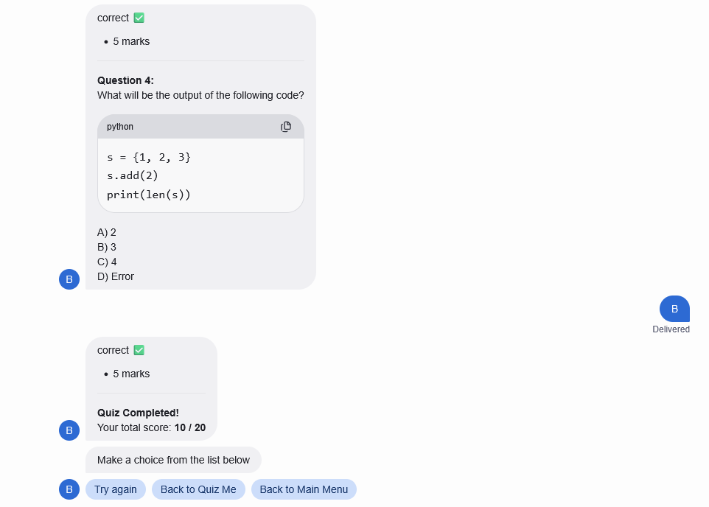
Encourage Me Flow:
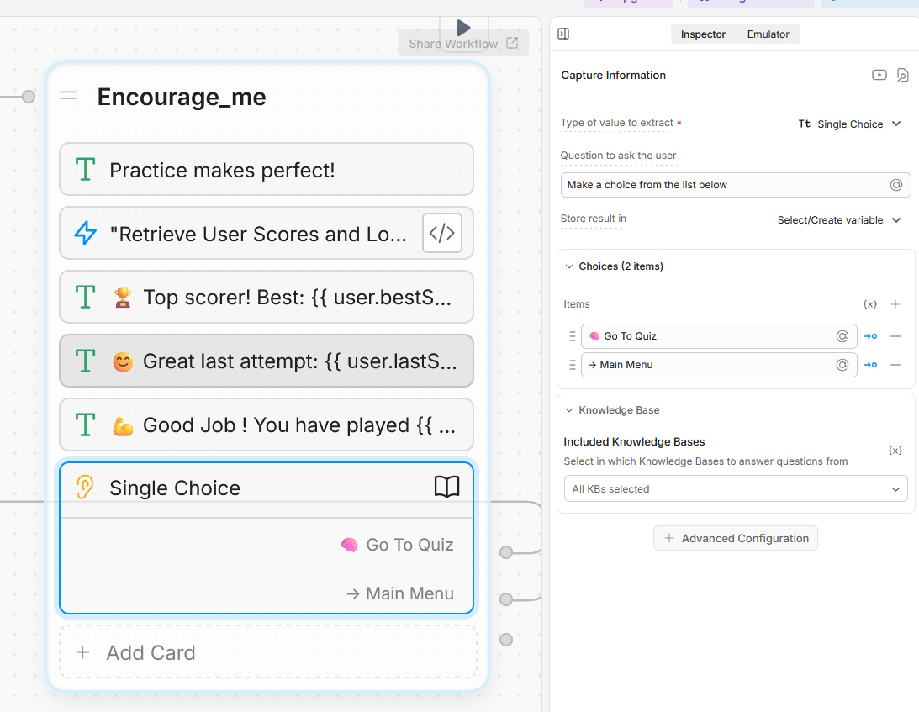
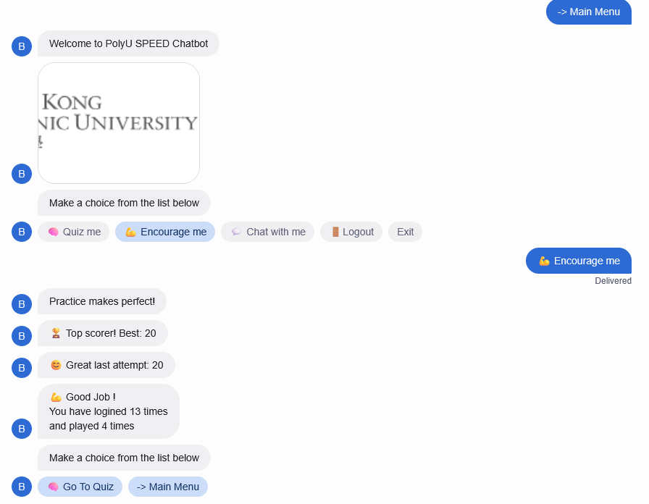
Encourage_me -execute code:
const bestScore = await scoreTable.findRecords({
filter: { uid: { $eq: workflow.rlt_user.uid } },
group: {
uid: 'key',
score: ['max']
}
})
user.bestScore = bestScore[0]?.scoreMax ?? 0
const recent = await scoreTable.findRecords({
filter: { uid: { $eq: workflow.rlt_user.uid } },
orderBy: 'Created At',
orderDirection: 'desc',
limit: 1
})
user.lastScore = recent[0]?.score ?? 0
const played = await scoreTable.findRecords({
filter: {uid:{$eq: workflow.rlt_user.uid}}
})
user.playedTimes = played.length
const logs = await loginLogTable.findRecords({
filter: { uid: { $eq: workflow.rlt_user.uid } }
})
user.loginCount = logs.length // total login records for this user

Chat with Me Flow:
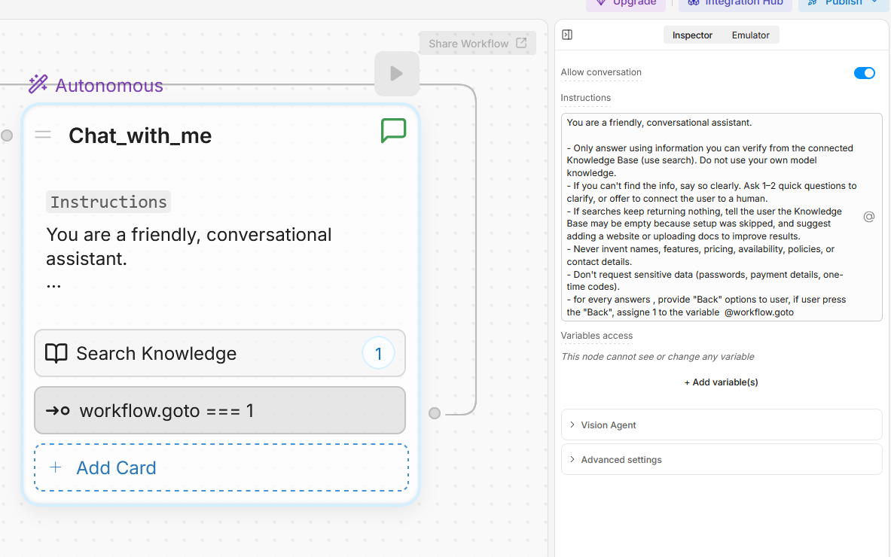
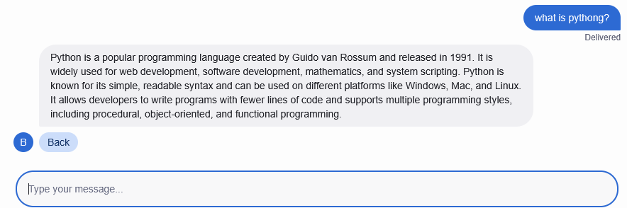
LoginLogTable:
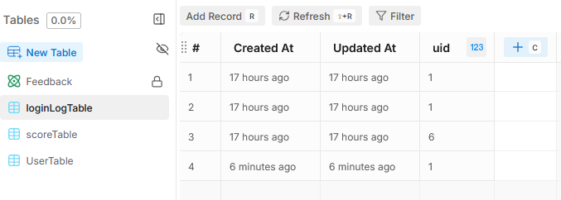
UserTable:
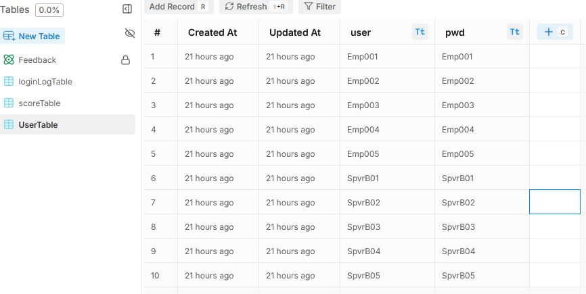
ScoreTable:
