Contents
- Terminologies used – Pg 3
- Introduction – Pg 4
- Features – Pg 6
- Screenshots of LANSim – Pg 7
- Design of LANSim – Pg 8
- Architecture of LANSim – Pg 9
- Class Hierarchy – Pg 13
- What we learnt – Pg 14
- Conclusion – Pg 15
- Bibliography – Pg 16
Terminologies used in this report
We have used few self invented terminologies to describe the parts and various aspects of LANSim properly, in an unambiguous manner. They are as follows:-
- Module: We use the term module to describe nodes, end stations or terminals. Anything that connects to wire is known as module.

- Client Area: This is the area at the centre of LANSim window, which is below the menu bar and at the side of toolbar, where the modules, wires and all such stuffs are drawn, created and simulated.

- Framework: This is the backbone of LANSim which consists of codes, divided into two parts, to handle the backend and frontend. The backend handles the intercommunication of modules and the physical layer of OSI model, while the frontend handles the intricacies of SWING.

- Module writer: One who knows nothing of the internals of LANSim’s framework, but uses the interfaces provided by framework to program a new module in JAVA language. A casual module writer is one who just wants to code the backend of the module and doesn’t want the framework to handle the rest.
Introduction
Network simulators are very popular tools for testing out new protocols. They are also used for educational purpose. This is an excellent way to obtain a grasp on the operation of communication protocols and network configurations, and to study and appreciate some of the design trade-off and performance implications, is by simulating key elements.
CNet is a very popular network simulator. Designed by Chris McDonald, this has a nice graphical user interface which is one of the reasons that is appealing for educational purpose. This is also used by students to test and debug newly developed protocols. The limited visualization of data flow animation in CNet is a good debugging tool.
We started developing a similar network simulator, which we call LANSim, to learn the concepts of the internals of how simulators work and brushing of our skills to use SWING as an efficient graphical system. During the process of learning we have ended up making LANSim to have few advantages over CNet. First is that, since LANSim is made in JAVA hence it can run any platform for which JVM is available. CNet requires interconnections among devices (nodes) to be ‘programmed’ in a file in a C-like language, called topology file. LANSim has GUI drag and drop interface which lets a user to create these connections, so, no need to learn new languages.
LANSim boasts some more features. It is a complete network simulation tool that will offer a good component database, schematic entry, completely structured pluggable modules (using class loader feature of Java), and simulation at the physical level of OSI model using any protocol of user’s choice. It can also be extended to include latency, errors, packet collision etc. Moreover it will offer single easy to use graphical interface with real time packet flow, graphs and statistics. Thus, behavior of different devices like hubs, gateways, bridges, switches, routers (Transparent bridging –learning, flooding, filtering, forwarding, aging) can be studied in detail. Spanning tree protocol (STP) to avoid ‘redundancy’ and ‘broadcast storms’ will also be incorporated as module in later semesters. It can also be used to study the functioning, efficiency and bottle necks in projected network architectures, before they are actually implemented.

Features
The intended project has been taken up as a learning tool for network simulation, with an easy to use user-interface. Today, a number of professional tools for network simulation are available, but they are rarely useful for novice and students because of their complex interface and also because they emphasize more on the simulated results than on showing how the simulation is actually progressing.
It is has a pluggable interface which allows module (node) writers to write new modules which when placed into a particular folder will be automatically loaded into LANSim during its execution. The modular design of LANSim allows module writers to show their custom graphics icon or anything they wish into the client area at the allocated position. It is so flexible that a module writer can even display a 3D animated figure. The module writers also have the ability to display their custom property page in the general property page of modules which is displayed by LANSim. Module writers also have the ability to create and display completely custom shaped data packets for data flow animation, as described later. A casual module writer has the option of just implementing the backend of a module and leaving everything else to be managed by LANSim’s framework.
LANSim boasts of advanced data flow animation, where data packets ‘flow’ all along the wire to give a visual cue of flowing of data. These data packets can be colour coded or their looks completely changed by modules to denote packets of different types. This serves as an excellent way to demonstrate the actions of a protocol or to debug a protocol in development.
LASim is completely written in JAVA so it is highly portable.
Since LANSim implements only the physical layer hence the module writers have a flexible system where they decide what goes in all other layers. Later LANSim may provide an optional Application layer (as CNet provides) to ease the burden of casual module writers.

Screenshots from LANSim

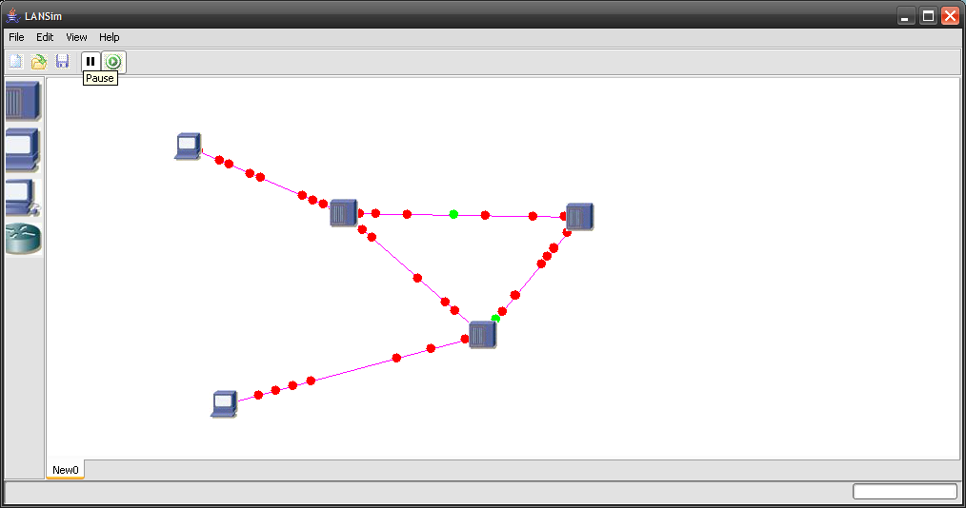
Screenshot showing ‘broadcast storm’ simulation in LANSim when three hubs are connected in cycle. The red packets are corrupted packets and the green ones are healthy one.
Design of LANSim
The interface of LANSim is completely made using SWING libraries. The interactive objects inside the client area ^{(see definition 2 on Pg3)} have been completely made by us without the help any other libraries. As already mentioned above that the modules are given the graphics context of the client area using which they are free to display any graphics (even 3D) onto the client area. The modules are also free to display any graphics for data packets by extending the DataUI class and overriding the getNewDataUI() method of ModuleUI class.
The backend framework consists of a Clock class which is acts as the conceptual clock of the program. This is used by simulation (and later will be used for statistics collection) by the framework.
LANSim has only physical layer implemented which allows greater flexibility. Later an optional Application layer later could be added to ease the programming of modules.
LANSim polls for data at modules, which makes its simulation closer to real world situations. Adding to the closeness to real world situation, LANSim introduces random errors in wire, while CNet introduces errors from inside an error layer which is hidden in every module just above the physical layers.
Architecture of LANSim
The software has a well designed architecture, with the Application Framework, the network components and their User Interface being completely separated from each other.
The Framework: The framework provides virtualization of the Real World and provides interface for the components to interconnect with each other.
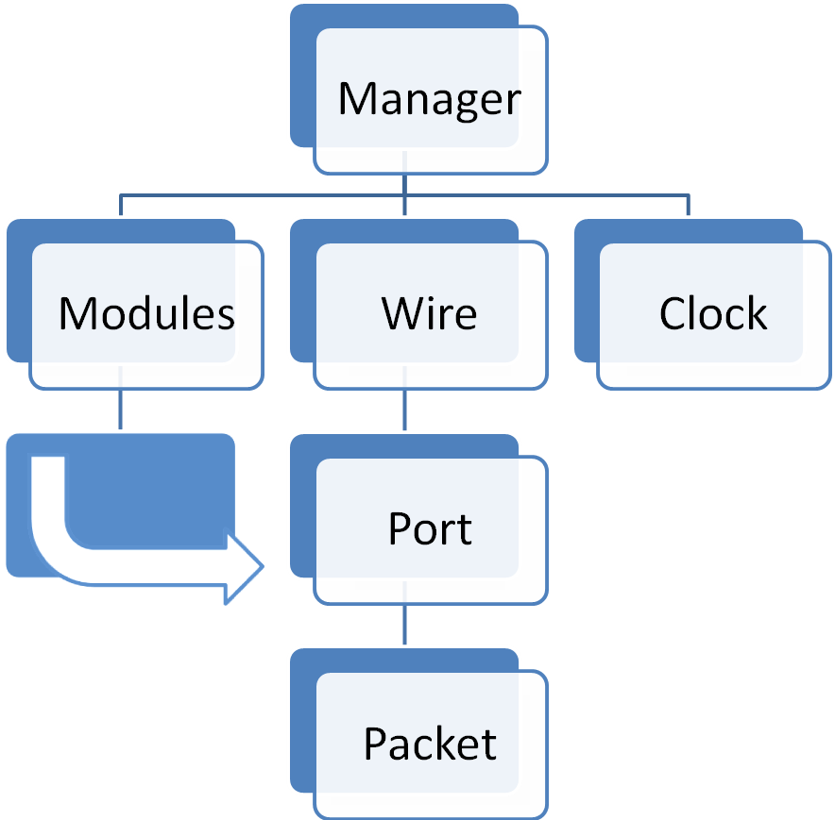
The Hierarchy of components in the Application Framework

Clock: It is used to digitize the real world time into discrete time steps (10⁻⁶ ~ 10⁻³ s) depending upon the speed of the network and the results required. The clock-tick event is used to synchronize the simulation of all the modules.
Manager: The manager is entrusted with the role of synchronization and controlling of the whole simulation process. It is the central authority which contains the reference of all the modules and wires. It allocates time to each of the modules and wires in turn, after every clock-tick event is generated.
Modules: It is an abstract base class from which all the components of the network including the workstations, hubs and gateways will derive. It contains some generic data members and member functions like stepSimulation() which is common to all the modules present in the environment. At any time (t), the state of the module is S(t). At this instant, the stepsimulation() method gets a parameter (δt), which defines the time interval, the behavior for which has to be simulated in that particular call. After simulating it’s behavior for the time interval (δt) , it reaches the state S(t+ δt). It saves its new State variables in a buffer and returns the control to the Manager. Any dependencies in the other modules still get to see the previous state S(t), till the whole simulation reaches the state S(t+ δt). Now all the components are promoted to the new state S(t+δt) simultaneously.
Wire: It is a generic representation of all kinds of wired links present in the network. Specific types of connection links in, particular implementations will derive from this base class.
Port: It is the base class for all types of ports that will be present on different modules. The ports are full duplex and maintain an input and output queue of their own, by default, this behavior can be overridden in specific implementations.
Packet: It is the class representing data packets being exchanged by different modules across the network. It contains fields like the source and destination IPs and MAC Addresses, the header for each layer of the protocol, the actual data from the application layer and the packet trailer.

The GUI: The GUI is another system in the application headed by the Application Manager and working in close association with the Framework .It is responsible for all frontend interactions with the user .It handles tasks like controlling the visual designer , accepting data and commands from the user, displaying packet flow animations ,real time graphs and the final results.
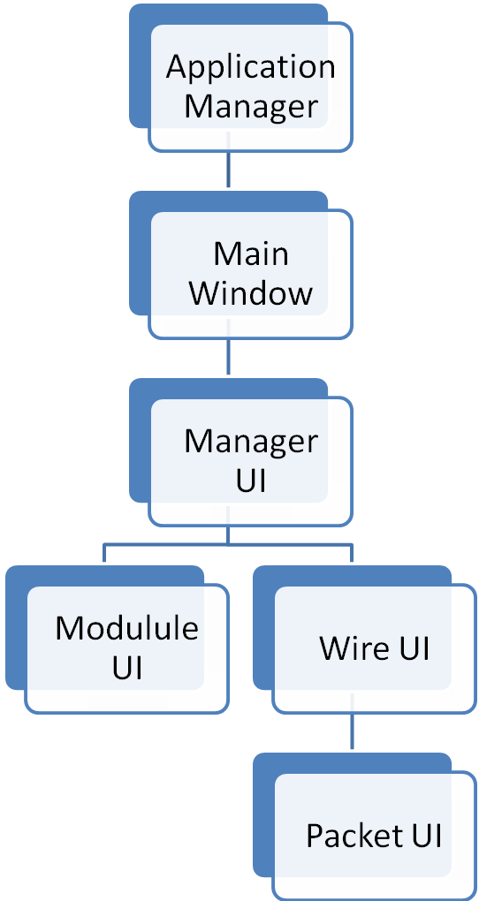
The Hierarchy of components in the Application GUI

Application Manager: This is the starting point of the application and contains the main() function. It is entrusted with the task of handling the events generated by the Main Window and all the components contained by it. It taps the user’s response and passes them down to appropriate classes for which the specific event is meant.
Main Window: It is the interface of the program with the user. All visible components, including the graphical designer, the component toolbox, the menu bar, toolbar, real time graphs etc. will be members of this class.
Manager UI: It is the front end of the Manager of the Application Framework. It is the prime interfacing link between the GIU in the front end and the framework in the backend. It contains a reference of the Manager, which controls the whole backend simulation.
Module UI: It is the front end of the Module of the Application Framework. It handles the rendering of different component modules, their interaction with the user, display of module specific statistics, and their overall functioning and interaction with the incoming and outgoing packets.
Wire UI: It is the front end of the Wire of the Application Framework. It handles the rendering of the interconnection network. It plays a pivotal role in determining architecture and protocol followed by the network. The Packet flow animation is also carried out by Wire UI, with assistance from Packet UI.
Packet UI: It handles the rendering of the flow of packets across the network. The position of the packet at any instant of time is depicted by an object moving beside the wire, in the direction of the packet flow.
Class Hierarchy
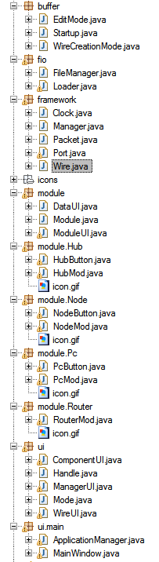

What we learnt from this project
- To provide pluggable interface to our program we needed to dynamically load classes. For this we had to invent our own method. We created a new class Loader which extends ClassLoader class. This class is responsible for loading the modules from their respective class files and returning an instance.
- To make the data flow animation efficient (in terms of processing needed) and flicker-free we had to use the advanced concepts used in game programming, viz. – double buffering, active rendering and displaying at constant FPS (frame per second).
- Since everything inside the client area has been drawn by our own code hence, now we have learnt the tricks to create and draw interactive graphical objects.
- LANSim uses threads heavily. During the making of LANSim we got to clear our concepts regarding efficient and proper use of threading. The initial version of LANSim’s data flow animation caused 100% utilization of CPU, resulting in freezing of computer system. Now periodic well calculated sleeping of thread has done away with this problem, without affecting the frame rate of animation.
Conclusion
Given the complex nature the framework of LANSim has, since we tried to emulate real world situation very closely, has lots of work to be done to implement all the ideas we have. LANSim aims to be a much generalized platform where any kind of network or node type can be implemented without tampering the core of the program. Its pluggable interface for modules makes it easier for users to add new components to LANSim, and its data flow animation will make visualization much easier.
Bibliography
- www.csse.uwa.edu.au/cnet
- Fundamentals of Data Communication by William Stallings
- Core JAVA 2 (Pearson Education)
- O’Reilly Killer Game Programming in Java

