Paper Title* (use style: *paper title*)

*Note: Sub-titles are not captured in Xplore and should not be used

line 1: 1st Given Name Surname   
line 2: *dept. name of organization (of Affiliation)*  
line 3: *name of organization (of Affiliation)*line 4: City, Country  
line 5: email address or ORCID  
  
line 1: 2nd Given Name Surname  
line 2: *dept. name of organization (of Affiliation)*  
line 3: *name of organization (of Affiliation)*line 4: City, Country  
line 5: email address or ORCID  
  
line 1: 3rd Given Name Surname  
line 2: *dept. name of organization (of Affiliation)*  
line 3: *name of organization (of Affiliation)*line 4: City, Country  
line 5: email address or ORCID  
  
line 1: 4th Given Name Surname  
line 2: *dept. name of organization (of Affiliation)*  
line 3: *name of organization (of Affiliation)*line 4: City, Country  
line 5: email address or ORCI

*Abstract*—We have proposed a set of procedures for robot to paint based on a given Chinese sentence, article and image, utilizing natural language processing, sentiment analysis, image segmentation, cycle-GAN, trajectory planning and robot control to produce emotional drawing. In this paper, we demonstrated the success of our work with various experiments. Our work consists of three parts, including emotion processing, image processing and robot controlling. The emotion processing part is implemented by LSTM model, from which its output is fed to the classifier composed of naïve bayes and BM25 function, enabling us to understand users’ emotional expressions. The image processing part is implemented using color segmentation techniques and cycle-GAN model, which showed us a brand new color style based on the results. Combining them altogether, we generated an image with emotional painting corresponding to our input. With our view-in-hand robot arm (LuoLiBot) equipped with camera feedback in real time, we can paint any picture just like artists.

Keywords—Robot Painting, NLP, LSTM, Sentiment Analysis, cycle-GAN

# Introduction

Pure functional robots, rationally completing specific tasks, are well developed by human beings, while robots with artificial intelligence perform sensually is a very challenging problem till now. For instance, ~~For instance~~, in the works of {Dan Li, 2016 #12}, {Zhou, 2019 #13}, ~~They want~~ they intend to summarize long paragraphs and extract useful and essence parts from ~~it under~~ the huge data of which ~~by using~~ with (bidirection) LSTM ~~method~~. ~~Besides, we even more want to get what we like, so~~ Furthermore, works of {Yenter, 2017 #11} ~~they~~ help people to choose their own favorite movies ~~by using~~ with CNN-LSTM ~~method~~ to analyze sentiment of IMDb reviews. {Omata, 2013 #14} Not only on the words, but also on the images, people want to what they show to us by estimating the emotion. Generally, it is ~~people~~ human that passively extract emotion and express it from ~~words~~ corpus or images given in advance ~~to analyze~~. However, what if a robot can understand ~~human’s~~ emotions and show to humans as well? Based on these thoughts, we ~~make~~ developed a painting robot ~~to~~ that understands ~~people saying and show how people’s angry~~ anger, melancholy, enjoyment ~~or~~ and cheer~~ful~~ through ~~the image~~ paintings. It ~~is very distinctive~~ distinguishes itself from others’ works ~~that we~~ by applying emotions on the ~~images and~~ robot’s painting. Artists always like to create brand new ~~funny~~ things to attract people’s eyes. Our works are inspired by their creativity because most of the time their emotions influence their painting. In addition, color is the most important and representative parts in their painting. According to studies in cognitive neuroscience, color chosen by people while they paint ~~is great~~ corresponds a lot to their emotion ~~then~~. Therefore, we want to apply these concepts on robot.

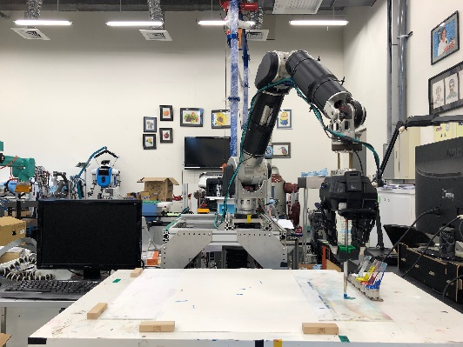 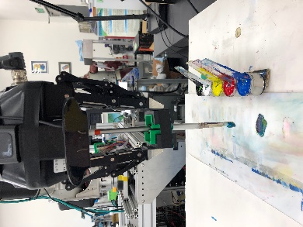

Fig. 1. (a) Top: robot painting configuration setup. (b) Bottom: color mixing.

Natural Language Processing(NLP) {Zong1, 2018 #5} on English is prevailing in early stage, ~~however~~ meanwhile, more and more people ~~are~~ focus on Chinese NLP {Tao1, 2009 #6} as well ~~now~~. Long short term memory (LSTM) {Yao, 2018 #2} is a well-performed model ~~for~~ with its advantage of ~~solving common~~ addressing problems ~~of~~ involving previous ~~things~~ information remembered on recurrent neural network (RNN) while training NLP, but it is still short on ~~getting~~ retrieving particular emotional score on sentiment analysis while merely classifying sentence into major emotional types. Others try to calculate the probability of sentence’s positivity by developing algorithms ~~combined~~ combining bayes and BM25. By applying LSTM model or bayes and BM25, respectively, we can’t get ~~a~~ good emotional score due to the complementarity of positive probability prediction of sentence, so ~~here~~ in our work, we try to combine both of them to determine how the emotional level the sentence is and give it an individual score. In addition, most of the models are designed for either short sentence or long article. They can’t perform well on ~~whatever~~ arbitrary length of words in the paragraph, so this issue is also considered in our model designing.

After ~~getting~~ retrieving the emotional score, we ~~masterly~~ apply it on the images’ color. The main inspiration for the color transforming is from recent works in neural transfer {Virtusio, 2018 #7}, where they transfer one’s drawing style to another. ~~Moreover~~ However, they can only get one style at a time. We use deep learning convolution neural network (CNN) with emotional score as one of the weight to generate distinctive image and paint by our robot.

Our contributions are creating a new way to express people’s feeling while they talk, in contrast to extracting sentiment from objects.

# EXPERIMENTAL SETUP

## Data preparation

For the LSTM model training while classifying the sentence into three different kinds of emotional classes, we prepare the Chinese scripts for each classes ~~first marked artificially~~ manually labeled by three people. The contents of scripts are related to ~~the~~ social media and news reviews for products trading, videos ~~watching~~ streaming and ~~events~~ comment~~ing~~ from social networks ~~websites~~, ~~i.g~~ e.g. ptt, facebook. On the other hand, for the image color style transfer while coloring images with emotional characteristics, we prepare a thousand pictures ~~for~~ with each emotional class labeled ~~artificially~~ by people from unsplash website. We search symbolic positive and negative words, for instance, happy, optimistic, depressed and melancholy, to get the results as our training image datasets. We don’t limit the contents of the pictures here.

## Painting robot setup

Identify applicable funding agency here. If none, delete this text box.

{Luo1, 2018 #17} We’ve developed a seven Degree-of-Freedom (DOF) robot arm to perform these experiments. The robot arm with three fingers manipulated by single motor equipped with an external camera holds~~ing~~ a brush and paints in negative feedback. A 3D printed clamp is attached to two of the three fingers helping gripper of arm to grasp the brush, as shown in Fig. . Through the negative feedback view-in-hand system establishing by the camera on the top of gripper, the robot arm can mix color automatically and draw in the right place while we give it five acrylic pigments including three primary colors, black and white. Furthermore, we provide a cleaning machine for washing the brush ~~beside~~ on the side of the robot’s arm ~~while~~ otherwise it makes it impossible to get the right color without being contaminated.

The experiments we ~~make~~ conducted ~~are~~ focus on the color style of images, so calibration ~~performing~~ before ~~starting~~ the experiments is relatively important. A lamp is set to ensure environmental light keeps almost the same ~~for each~~ all the time. Also, relative to the robot, the position of every equipment, painting board, canvas, five pigments and cleaning machine, remains fixed. In order to reduce the impact of sensitivity of camera itself, we sacrifice little accuracy of luminance and saturation by regulating some of the camera’s parameters.

# IMPLEMENTATION

The flowchart in Fig. shows how the robot paints an emotional painting when receiving a sentence or an article and an image as inputs. The entire operation is divided into four parts. First is processing and classifying the sentence or article into an emotional class consisting of positive sentiment, negative sentiment or neutral sentiment class by LSTM model. After that, we get emotional score by applying Bayes and BM25 algorithms on sentences to calculate the positive probability, and combine it to the emotional class. The Third is transforming the emotional score into a special color style by deep learning model based on CNN. While getting the result of color style, robot will paint the image after we make trajectory planning.

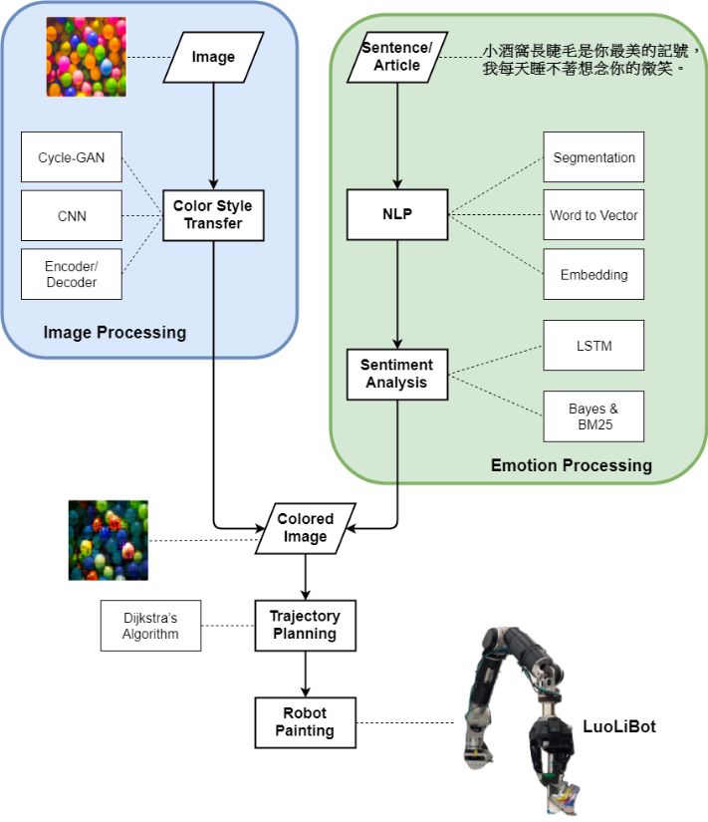

Fig. 2. Illustration of the proposed structure.

## Sentence or article processing and classifying

Our task here is to classify the sentence or article into three classes, positive sentiment class, negative sentiment class, or neutral sentiment class. If the input is a short sentence, with the task here, we ~~segment~~ split the sentence by jieba segmentation and transform each word to vector. After word embedding, through the LSTM model, we use deep learning to train a classifier. Output is a class prediction. However, If the input is a long article, we predict the sentiment class first by LSTM model and segment article into several parts to calculate the emotional score. Every parts are composed of about ten sentences and scores are predicted by the classifier. After getting each score, we average them to get the final emotional score.

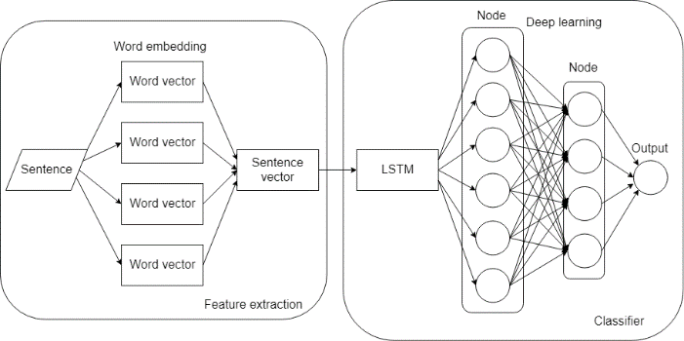

## Positive probability calculating and mapping

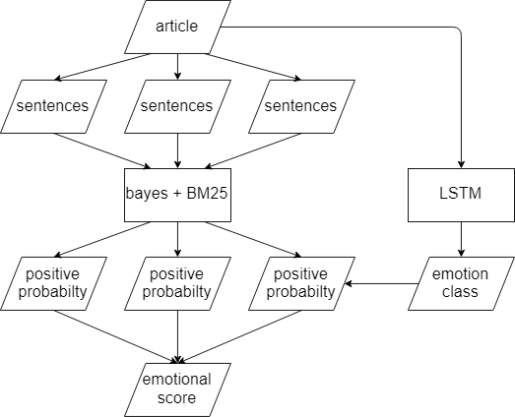

~~For We get~~ After having the main emotional type for the sentence from the LSTM model, the major goal here is about to get more detailed emotional information. We set a range from -100 to 100 as our emotional score to judge how positive or negative the sentence is. By naïve Bayes conditional probability ~~model~~ distribution, a common classified model,

x = (x1, …, xn) is a vector representing n independent features, and Ck is one of K outcomes, the probability of Ck occurring is

While ~~under~~ given condition x, the probability of Ck occurring is

The largest probability represents the most possible class mapping to positive, neutral or negative class. The result class here helps us calculate the probability of positive emotion. According to BM25 probabilistic retrieval framework, a TF-IDF (term frequency-inverse document frequency) ranked function estimating the relevance of documents to a given search feature, we can calculate the emotional probability of feature F in the document D as follow,

where IDF(fi) represents IDF weight of feature term fi, f(fi, D) is term frequency of fi in the document D, |D| is the length of the document D in words, and avgdl is the average document length from collecting. Both of k1 and b are free parameters set by 1.5 and 0.75, respectively. In details,

~~where~~ N represents total number of documents, and n(fi) is number of documents containing feature fi.

The probability could be any real number from 0 to 1. However, it may appear the positive probability is very high though it is a very negative ~~class~~ sentence in fact, so we ~~get~~ still remain a very small negative probability. Because there are only two classes in the classifier, positive and negative, the negative probability will be one minus positive probability due to ~~the~~ complementarity, as following formula.

In order to solve the error caused by wrong classification and its complementarily, we first use LSTM model to give it a more probable class, and combine the result probability after processed by bayes and BM25 model. If first we get the class of sentence is more like a positive class, but the positive probability is very little, we complement it. We view it as a misclassified in the bayes model, vice versa.

After ~~getting~~ having the class and probability, we map it to a large number by exponential distribution and normalize it by Gaussian distribution to avoid extreme value. Moreover, we adjust the emotional score to the range from -100 to 100 in order to let people sense the sentiment better. The classes score mapping are as follow.

Based on these, we can transform the image’s color style after.

## Color style from the emotional score

Once we get the emotional score, we use cycle-GAN (cycle generative adversarial network) to train the transfer model. It mainly ~~contains~~ consists of two models. One is generative model, and the other is discriminative model. We use generative model to generate predicted image and discriminative model to check whether the result is similar to the original one or not. The most different part is we add an emotional score as a weight in the training process to measure how positive or negative ~~level~~ the image should transfer. Also, we pre-label a thousand image for each class as supervised learning. In order to make sure our model is moving toward the right way, we use output as input for training each time as a cycle and compare with the real image. Once we can’t determine which one is real or fake, we stop training and save the model. Three distinctive weights of model are trained by us because our goal is to generate image with three types of emotion. Hence, if the input is an emotional score with positive sentiment, we select an image arbitrarily and feed to the model trained by positive impression images. While the input is an emotional score with negative sentiment, we choose an image arbitrarily and feed to the model trained by negative impression images.

## Robot painting

1) Color segmentation: In order to make our painting ~~with~~ have unlimited possibilities, we use acrylic pigments as the only painting materials. However, we have to limit the painting time so as to make an intelligent balance between time consuming and performance, so we process the image by segmenting first. Similar color will be cluster to a group if their differences are under the minimum threshold and we choose a color as the representative of cluster by applying K-means algorithm.

2) Trajectory planning: How to make an efficient trajectory planning is what we care about too. Therefore, order of mixing and coloring and painting route are the ~~most~~ two main considerations in this part. Once the mixed color is too deep and can’t be recovered, painting robot must ~~go to cleaning machine to~~ wash the brush. It will waste lots of time on this work, so we avoid it happening as much as possible. We make the robot paint from shallow color to deeper and start from three primary colors, especially from yellow while it is included in the image because ~~of~~ the low sensitivity to yellow of our camera feedback.

Following these concepts, we can then decide the order of painting sequence. We use object detection to extract the instance first, then we can know where the background is. After distinguishing objects and background, we compare the major color between them. If the color in the bigger area exceeds forty percent, we paint it first in straight line with thickest brush, No. 18. Apart from this, most of the background are composed of similar colors, so we also paint them in straight line but different size of brushes based on the scope. However, if there’s no one exceeding forty percent of total areas, we skip this step. Once we finish deciding the order of painting for the major parts, we ~~make~~ generate trajectory planning for the remains in order from shallow color to deeper. Color in the same cluster can be painted in a sequence. Since the strong coverage of pigments, the mis-painting regions for the convenience of trajectory planning for background can be ignored. In addition, because the pigments on the brush could be used up, we make brush go back to the mixing place to dip color after finishing drawing a straight line or seven points. Hence, we also consider the mixing place as a ~~point~~ factor to ~~design~~ find our optimal path. Finally, we use Dijkstra’s algorithm to plan the painting path. The route is decided based on the shortest distance from the previous point, so we can ~~make sure~~ guarantee the path is ~~the most~~ optimal.

3) Color mixing: Based on ~~the~~ chromatology, theoretically, every color can be mixed by three primary colors, cyan, magenta, and yellow. Although we can get darker color by mixing more and more different pigments together, we use black as one of the pigments to accelerate mixing process. For lighter color, white pigment is provided to robot for mixing. We can confirm the color immediately ~~due to~~ with our feedback system and adjust color whenever necessary.

4) Stroke control: Under rules of trajectory planning, we must determine other important factors as well to generate a sequence of hand-painted stoke, including orientation of brush moving, staying time, length, radius, width, and depth of brush painting. Because we use canvas with good fixability and pigments with poor diffusion as our materials, the staying time of brush can be ignored. The orientation of stroke influence vary little on our painting by gradient direction based on previous work, (fine grained control of robotic calligraphy). The footprint width is proportional to the pressing depth and irrelated to the deflection angle of brush. While painting the arc, the width of footprint is related to the pressing depth of brush and irrelated to the radius of stroke. For the straight line, we use interpolation method between two points to generate the straight line. Therefore, the robot arm goes to the target point and push down the same depth each time, then lift up after staying the same period.

5) Feedback system: View in hand feedback system helps robot arm compare the mixing color and the target color in real time. While finishing first round painting, the camera will detect whether there are flaws on the canvas. Once it gets the flaws after scanning the whole image, it will recalculate the painting path to patch up them.

# Result

Here we show three symbolic results of sentiment analysis first, as shown in table1. They are selected arbitrarily. The first two testing data are lyrics from JJ Lin’s songs, “小酒窩” and “可惜沒如果” and the last one is a short paragraph from yahoo news.

1. RESULT OF SENTIMENT ANALYSIS

| Testing  Sentence | Sentiment Analysis | |
| --- | --- | --- |
| Sentiment  Class | Emotional  Score |
| 小酒窩長睫毛是你最美的記號，我每天睡不著想念你的微笑。 | positive | 54.7689 |
| 全都怪我，不該沉默時沉默，該勇敢時軟弱，如果不是我，誤會自己灑脫，讓我們難過。 | negative | -87.6312 |
| 隨著無人機科技發展越來越成熟，能結合農業科技的發展，空拍機更幾乎快要人手一台，但卻常常傳出，誤闖禁地的事故，現在想學專業的知識，終於有地方去了，東部首座無人機培訓基地，可以提供飛手的證照考取，也有對外開課，教導民眾如何正確安全的使用空拍機。 | neutral | 29.9997 |

After getting the emotional score, we arbitrary choose an image combined to the score as inputs for the cycle-GAN model trained by us. The output of model and robot painting results are shown in fig. .

|  |  |  |
| --- | --- | --- |
| (a) | (b) | (c) |
| (d) | (e) | (f) |
| (g) | (h) | (i) |

Fig. 2. Results of experiments

(a), (d), (g) The original images selected randomly from testing data. (b), (e), (h) The image generated by cycle-GAN while input a sentence in table1, respectively. (c), (f), (i) The image painting by our robot for (b), (e) and (h), respectively.

# Discussion and future work

For ~~the~~ sentiment analysis, we randomly select lyrics ~~song by a singer~~ from JJ Lin’s song and a short paragraph from yahoo news to test for the performance of our model. Because most of our training data we use are crawled from social networks, the model will show good performance on social news and reviews, theoretically. Hence, we want to ~~use~~ examine other kinds of testing data ~~instead~~ as well. On the other hand, we want to discuss ~~about~~ whether the results are influenced by word length. As shown in results, we think the results predicted for testing data appear to be well. The sentiment classes fit our feeling. Also, the values of emotional scores measuring the feeling of sentences said by people correspond to their expression.

For the image processing parts, we select three colorful images as testing data because we focus more on the color changing, as shown in Fig. . Although we can see there are some color difference between target and the real one, we still can realize color changing from violet to bright pink while emotion of sentence given is positive and color changing from bright multicolor to dark blue while emotion of sentence given is negative. Generally, it meets our visual feelings. The image result of neutral mood changes a little but it tends to be a positive one. Therefore, the robot painting results ~~are~~ have proven that out experiment was successfully ~~present in this paper~~ conducted.

The most challenging part is robot painting. We ~~meet~~ encountered several problems when we ~~make~~ produce our robot paint. For the image with positive emotion, we segment the image color first and find the flower region, the pink color place, exceeds forty percent of total areas, so robot arm first paints it in straight line with thickest brush, No. 18. Afterwards, it mixes deeper pink color to draw the details in flower with thinner brush, No. 6. Finally, the darkest background is painted in straight line with thinner brush as well. Because most of the color in image is bright pink, we almost get the same pink color after segmenting. Also, the deviation between adjacent color is too little for our camera to discriminate it, so we can’t feel strong contour in the image. Visually, we can only see about two different pink in image. Therefore, its resolution is rough while it takes about an hour for robot to finish painting.

In order to increase resolution for robot painting, we adjust camera’s parameters, sensitivity to color and light in environment, trying to get more detailed painting. We decrease the threshold between adjacent color and increase the sensitivity to light so that robot will paint more color. The experiment is implemented on the image with negative emotion. Because there are no regions exceed forty percent of total areas, we paint it with thinner pointed brush, No. 6, directly. As we can see in the fig. , the painting color is much more like the original image but it takes us 10 hours to finish painting. For the brighter color, we can

We would like to collect more other fields of training data to boost all our models and add more ways for people to interacting with our robot. Also, we want to improve the color feedback from camera to make the painting image more similar to predicted image. In addition, the replacement of different sizes of brushes may be automatic by robot itself in the near future.

# Conclusion

We provide an innovative and interdisciplinary experiment on robot painting, image processing, natural language processing and sentiment analysis. ~~This paper~~ we successfully present a sequence of robot painting as we give it a Chinese sentence or article and image as input. As the hardware develops rapidly, the computing speed of GPU increases significantly, so we can create much more interactive robot in real time.

## Authors and Affiliations

**The template is designed for, but not limited to, six authors.** A minimum of one author is required for all conference articles. Author names should be listed starting from left to right and then moving down to the next line. This is the author sequence that will be used in future citations and by indexing services. Names should not be listed in columns nor group by affiliation. Please keep your affiliations as succinct as possible (for example, do not differentiate among departments of the same organization).

### For papers with more than six authors: Add author names horizontally, moving to a third row if needed for more than 8 authors.

### For papers with less than six authors: To change the default, adjust the template as follows.

#### Selection: Highlight all author and affiliation lines.

#### Change number of columns: Select the Columns icon from the MS Word Standard toolbar and then select the correct number of columns from the selection palette.

#### Deletion: Delete the author and affiliation lines for the extra authors.

## Identify the Headings

Headings, or heads, are organizational devices that guide the reader through your paper. There are two types: component heads and text heads.

Component heads identify the different components of your paper and are not topically subordinate to each other. Examples include Acknowledgments and References and, for these, the correct style to use is “Heading 5”. Use “figure caption” for your Figure captions, and “table head” for your table title. Run-in heads, such as “Abstract”, will require you to apply a style (in this case, italic) in addition to the style provided by the drop down menu to differentiate the head from the text.

Text heads organize the topics on a relational, hierarchical basis. For example, the paper title is the primary text head because all subsequent material relates and elaborates on this one topic. If there are two or more sub-topics, the next level head (uppercase Roman numerals) should be used and, conversely, if there are not at least two sub-topics, then no subheads should be introduced. Styles named “Heading 1”, “Heading 2”, “Heading 3”, and “Heading 4” are prescribed.

## Figures and Tables

#### Positioning Figures and Tables: Place figures and tables at the top and bottom of columns. Avoid placing them in the middle of columns. Large figures and tables may span across both columns. Figure captions should be below the figures; table heads should appear above the tables. Insert figures and tables after they are cited in the text. Use the abbreviation “Fig. 1”, even at the beginning of a sentence.

1. Table Type Styles

| Table Head | Table Column Head | | |
| --- | --- | --- | --- |
| Table column subhead | Subhead | Subhead |
| copy | More table copya |  |  |

1. Sample of a Table footnote. (*Table footnote*)
2. Example of a figure caption. (*figure caption*)

Figure Labels: Use 8 point Times New Roman for Figure labels. Use words rather than symbols or abbreviations when writing Figure axis labels to avoid confusing the reader. As an example, write the quantity “Magnetization”, or “Magnetization, M”, not just “M”. If including units in the label, present them within parentheses. Do not label axes only with units. In the example, write “Magnetization (A/m)” or “Magnetization {A[m(1)]}{Zong1, 2018 #5}”, not just “A/m”. Do not label axes with a ratio of quantities and units. For example, write “Temperature (K)”, not “Temperature/K”.

##### Acknowledgment *(Heading 5)*

The preferred spelling of the word “acknowledgment” in America is without an “e” after the “g”. Avoid the stilted expression “one of us (R. B. G.) thanks ...”. Instead, try “R. B. G. thanks...”. Put sponsor acknowledgments in the unnumbered footnote on the first page.

##### References

The template will number citations consecutively within brackets [1]. The sentence punctuation follows the bracket [2]. Refer simply to the reference number, as in [3]—do not use “Ref. [3]” or “reference [3]” except at the beginning of a sentence: “Reference [3] was the first ...”

Number footnotes separately in superscripts. Place the actual footnote at the bottom of the column in which it was cited. Do not put footnotes in the abstract or reference list. Use letters for table footnotes.

Unless there are six authors or more give all authors’ names; do not use “et al.”. Papers that have not been published, even if they have been submitted for publication, should be cited as “unpublished” [4]. Papers that have been accepted for publication should be cited as “in press” [5]. Capitalize only the first word in a paper title, except for proper nouns and element symbols.

For papers published in translation journals, please give the English citation first, followed by the original foreign-language citation [6].

1. G. Eason, B. Noble, and I. N. Sneddon, “On certain integrals of Lipschitz-Hankel type involving products of Bessel functions,” Phil. Trans. Roy. Soc. London, vol. A247, pp. 529–551, April 1955. *(references)*
2. J. Clerk Maxwell, A Treatise on Electricity and Magnetism, 3rd ed., vol. 2. Oxford: Clarendon, 1892, pp.68–73.
3. I. S. Jacobs and C. P. Bean, “Fine particles, thin films and exchange anisotropy,” in Magnetism, vol. III, G. T. Rado and H. Suhl, Eds. New York: Academic, 1963, pp. 271–350.
4. K. Elissa, “Title of paper if known,” unpublished.
5. R. Nicole, “Title of paper with only first word capitalized,” J. Name Stand. Abbrev., in press.
6. Y. Yorozu, M. Hirano, K. Oka, and Y. Tagawa, “Electron spectroscopy studies on magneto-optical media and plastic substrate interface,” IEEE Transl. J. Magn. Japan, vol. 2, pp. 740–741, August 1987 [Digests 9th Annual Conf. Magnetics Japan, p. 301, 1982].
7. M. Young, The Technical Writer’s Handbook. Mill Valley, CA: University Science, 1989.

**IEEE conference templates contain guidance text for composing and formatting conference papers. Please ensure that all template text is removed from your conference paper prior to submission to the conference. Failure to remove template text from your paper may result in your paper not being published.**

1. Zong1, Z. and C. Hong2, *On Application of Natural Language Processing in Machine Translation.* International Conference on Mechanical, Control and Computer Engineering, 2018: p. 5.

<https://tw.news.yahoo.com/%E9%A3%9B%E6%89%8B-%E5%9F%B9%E8%A8%93%E5%9F%BA%E5%9C%B0-%E6%9D%B1%E9%83%A8%E9%A6%96%E5%BA%A7%E7%84%A1%E4%BA%BA%E6%A9%9F%E9%A3%9B%E8%A1%8C%E5%A0%B4-142438858.html>