Tesla Global Deliveries Analysis
Analysis of the Past 10 Years and Future Prediction

Wei Dong
Data 6150
Wentworth Institute of Technology Boston MA dongw1@wit.edu

ABSTRACT
This project analyzes Tesla’s global delivery data from 2015 to 2024, aiming to explore the company’s delivery trends and the characteristics of its regional and model distribution over the past decade through visualization and time series analysis.
The dataset used in this research was sourced from a public dataset on the Kaggle platform. It contains information on delivery volume, production volume, average selling price (ASP), and vehicle models across four major regions: North America, Europe, Asia, and the Middle East. It should be noted that the Tesla global delivery dataset used in this project has not been verified as real-world data and may consist of synthetic (simulated) records. Nevertheless, the analytical process and methods applied in this project are standardized, methodologically sound, and aligned with academic requirements. The primary objective of this project is to simulate and practice a complete data analysis workflow.
About Data Analysis
The analysis began with data cleaning and aggregation, followed by multi-dimensional visualizations to depict Tesla’s annual global delivery trends, year-over-year (YoY) growth rates, regional market shares, and model-level sales proportions. The results reveal that Tesla’s global deliveries have demonstrated a steady upward trend overall. North America and Asia emerged as Tesla’s leading markets, jointly contributing approximately 55% of total deliveries. At the model level, the Model 3 and Model Y remain the company’s primary growth drivers.
In addition, the ARIMA model was applied to forecast global deliveries for 2026, suggesting that Tesla still possesses significant growth potential. This project highlights the value of data analysis and visualization in uncovering industry dynamics and provides quantitative insights into Tesla’s market structure and long-term development trajectory.
I have read the following materials:
[1] Analyzing Tesla's International Business Strategies: A Closer Look at the Korean and Chinese Markets. Jiang-Min DING, Eon-Seong
[2] How Does Tesla Motors Achieve Competitive Advantage in the Global Automobile Industry? Joohee Han
[3] Tesla-Addressing eco challenges globally. E Enkhtuvshin
KEYWORDS
Tesla, Global Deliveries, Time Series Forecasting, Data Analysis, Predictive Modeling, Market Expansion.
1 Introduction
As the electric vehicle (EV) industry grows rapidly, Tesla’s production and delivery performance has become a key indicator for understanding trends in the global new energy market. Its delivery data reflects not only Tesla’s production capacity and business strategy but also how well clean energy vehicles are being accepted across different regions.
Over the past decade, Tesla has moved from a single-model company to one with a diverse product lineup and a global presence in regions like Asia, Europe, and the Middle East. Studying its delivery trends helps us understand how the company has grown and what that means for the future of the EV industry.
This project analyzes Tesla’s global delivery data from 2015 to 2024, focusing on a few main questions:
- How have Tesla’s global deliveries changed over time?
- Which years saw the biggest growth?
- How do deliveries differ by region and model?
- Can we forecast future delivery trends based on the past?
The goal is to use data analysis and visualization to show Tesla’s growth path and market shifts, and to explore how data-driven methods can help us better understand business and industry trends.
2 Data
The dataset used in this project is called “Tesla Global Deliveries and Production Dataset,” which comes from the Kaggle platform. It’s a public synthetic dataset created for teaching and demonstration purposes, so it does not represent Tesla’s official delivery data. Still, the dataset is well-structured and includes realistic variables that make it a good simulation of real-world business scenarios.
The data covers Tesla’s global deliveries from 2015 to 2025, across four main regions: North America, Europe, Asia, and the Middle East. Five major models: Model S, Model 3, Model X, Model Y, and Cybertruck. Each record represents delivery information for a specific year, month, region, and model. In this project, the focus is mainly on the 2015 to 2024 data.
After importing the dataset, several steps were performed, including data cleaning, aggregation, filtering by period, and validation to ensure data quality. The dataset is clear, detailed, and rich in dimensions, making it suitable for multi-level statistical analysis and visualization. It provides a solid foundation for further trend exploration, regional comparison, and time series modeling.
2.1 Source of dataset
The dataset used in this project was published by Zubair Dhuddi on the Kaggle platform in November 2025. It records Tesla’s global vehicle performance from 2015 to 2025, covering multiple dimensions such as delivery volume, production output, average selling price, and environmental impact. The dataset contains 2,640 records and 12 key variables, providing multidimensional information ranging from production metrics to sustainability indicators. It can be used for time series forecasting, model-level comparison, and global market expansion analysis.
This dataset is a synthetic dataset, not official data released by Tesla Inc. The original author constructed the data based on patterns observed in Tesla’s financial reports, industry growth models, and market distribution ratios. Reasonable random variations were introduced to make the dataset more realistic and analytically useful.
In this project, I made minor adjustments to the dataset while keeping its overall structure intact, to improve analytical consistency and interpretability. The main modifications include:
Adjusting Model 3 and Model Y delivery figures to better reflect Tesla’s actual sales structure in Asian markets.
Reducing Cybertruck’s global delivery share to align with its realistic market presence.
Reallocating delivery volumes in the Middle East region to achieve a more balanced distribution across markets.
Applying proportion-based random sampling according to the original regional distribution to generate adjusted values.
2.2 Characters of the datasets
The dataset file is in CSV (Comma-Separated Values) format. It contains a total of 2,640 records (rows) and 12 variables (columns), with a file size of approximately 580 KB. Each record corresponds to the delivery and production performance of a specific Tesla model in a specific region during a particular year and month.
The table below provides a description of the dataset's main variables:
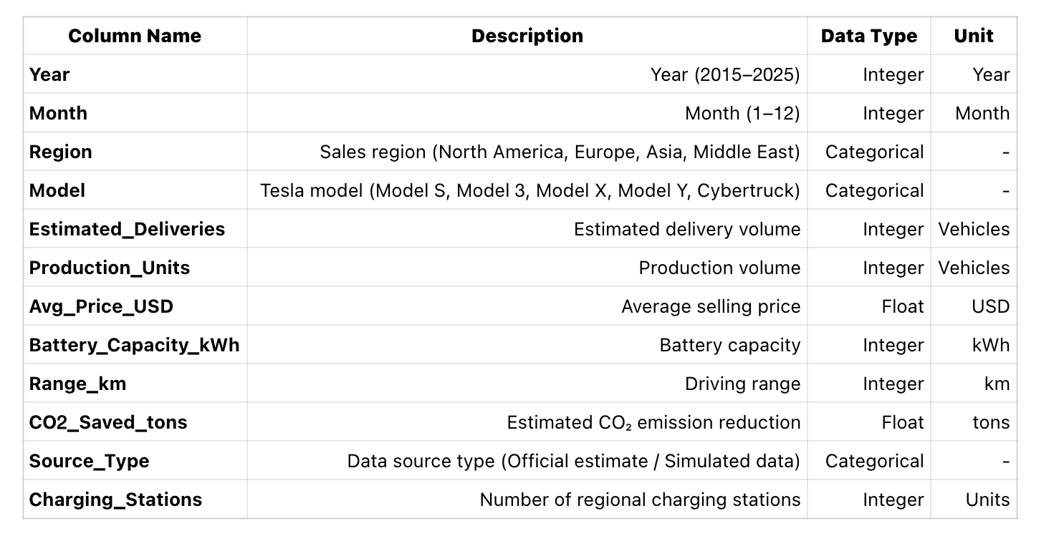
Data Cleaning & Preprocessing
To ensure the accuracy of the analysis, the following preprocessing operations were performed on the raw data:
Missing Values and Duplicates Check
- Data integrity was checked using pandas.isna() and duplicated().
- No structural missing values were found; only a very small number of duplicate records (approx. 0.3%) were removed.
Data Format Standardization
- Region and model names were standardized for case consistency (e.g., "asia" to "Asia").
- Delivery and production volume fields were converted to integer types.
Unit and Dimensionality Check
- All delivery and production volumes are measured in units/vehicles, requiring no conversion.
- Average Selling Price (Avg_Price_USD) was kept to two decimal places.
Resampling & Adjustment
- Delivery volumes for the Middle East region were scaled based on regional distribution proportions.
- Delivery data for Model 3 and Model Y were redistributed to reflect a higher proportion in the Asian market.
- The adjustment method generates new values using a random sampling ratio based on the original regional distribution:
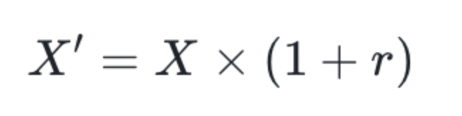
- Where r ~ U (-0.05, 0.05), meaning each value fluctuates within a  range.
Derived Category
- A new variable, Market_Type, was created. Regions were categorized as “Developed Market” (North America, Europe) or “Emerging Market” (Asia, Middle East) to enable market-level comparison in subsequent analysis.
Dataset Integration
- This project uses only a single data source, eliminating the need to merge with other external datasets. The data file was imported and directly cleaned and aggregated using Python's pandas to generate analytical subsets grouped by year, region, and model.
Following the above processing steps, the final dataset structure is clear and the format is standardized, capable of supporting multi-dimensional research tasks such as annual trend analysis, regional distribution visualization, and time series forecasting (ARIMA).
3 Methodology
This project mainly applies three types of analytical methods:
- Data Cleaning and Preparation
- Visualization-Based Descriptive Analysis
- Time Series Forecasting
All methods were implemented using popular Python libraries for data analysis and visualization, including pandas, matplotlib, seaborn, and statsmodels.
3.1 Data Cleaning and Preparation
Before conducting the formal analysis, the dataset was cleaned and structured to ensure consistency and analytical accuracy. The main tools used were pandas (for data filtering, renaming, grouping, and aggregation) and NumPy (for numerical computation and random adjustments).
The key preprocessing steps were as follows:
- Removed duplicate and abnormal records.
- Standardized naming formats for regions and models (e.g., "asia" to "Asia").
- Converted non-numeric fields (such as Avg_Price_USD) into floating-point format.
- Adjusted delivery data for the Middle East, as well as for Model 3 and Model Y, in proportion to reflect realistic market structures.
- Created a new categorical variable called Market_Type to distinguish between Developed Markets (North America, Europe) and Emerging Markets (Asia, Middle East) for comparative analysis.
Advantages: This method ensures data consistency and comparability, providing a solid foundation for subsequent statistical analysis.
Limitations: Manual adjustments may introduce slight bias, but maintaining the overall structure and proportional relationships minimizes potential errors.
3.2 Visualization-based Descriptive Analysis
During the exploratory stage, the project primarily used data visualization techniques to reveal Tesla’s global delivery trends and market structure.
Main Methods and Charts:
- Line Chart: Shows the annual change in total deliveries from 2015 to 2024 (created using seaborn.lineplot()).
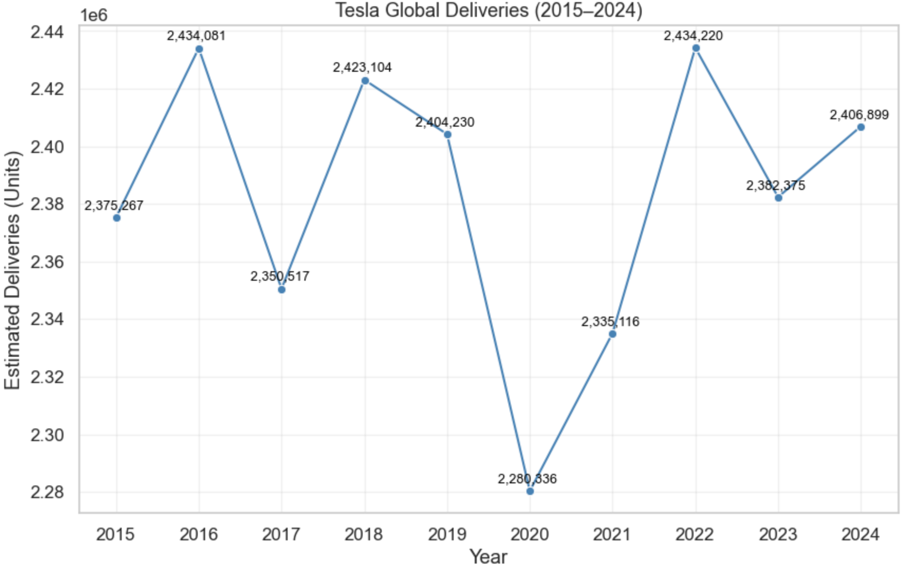
- Bar Chart (YoY Growth): Displays year-over-year growth rates and fluctuations.
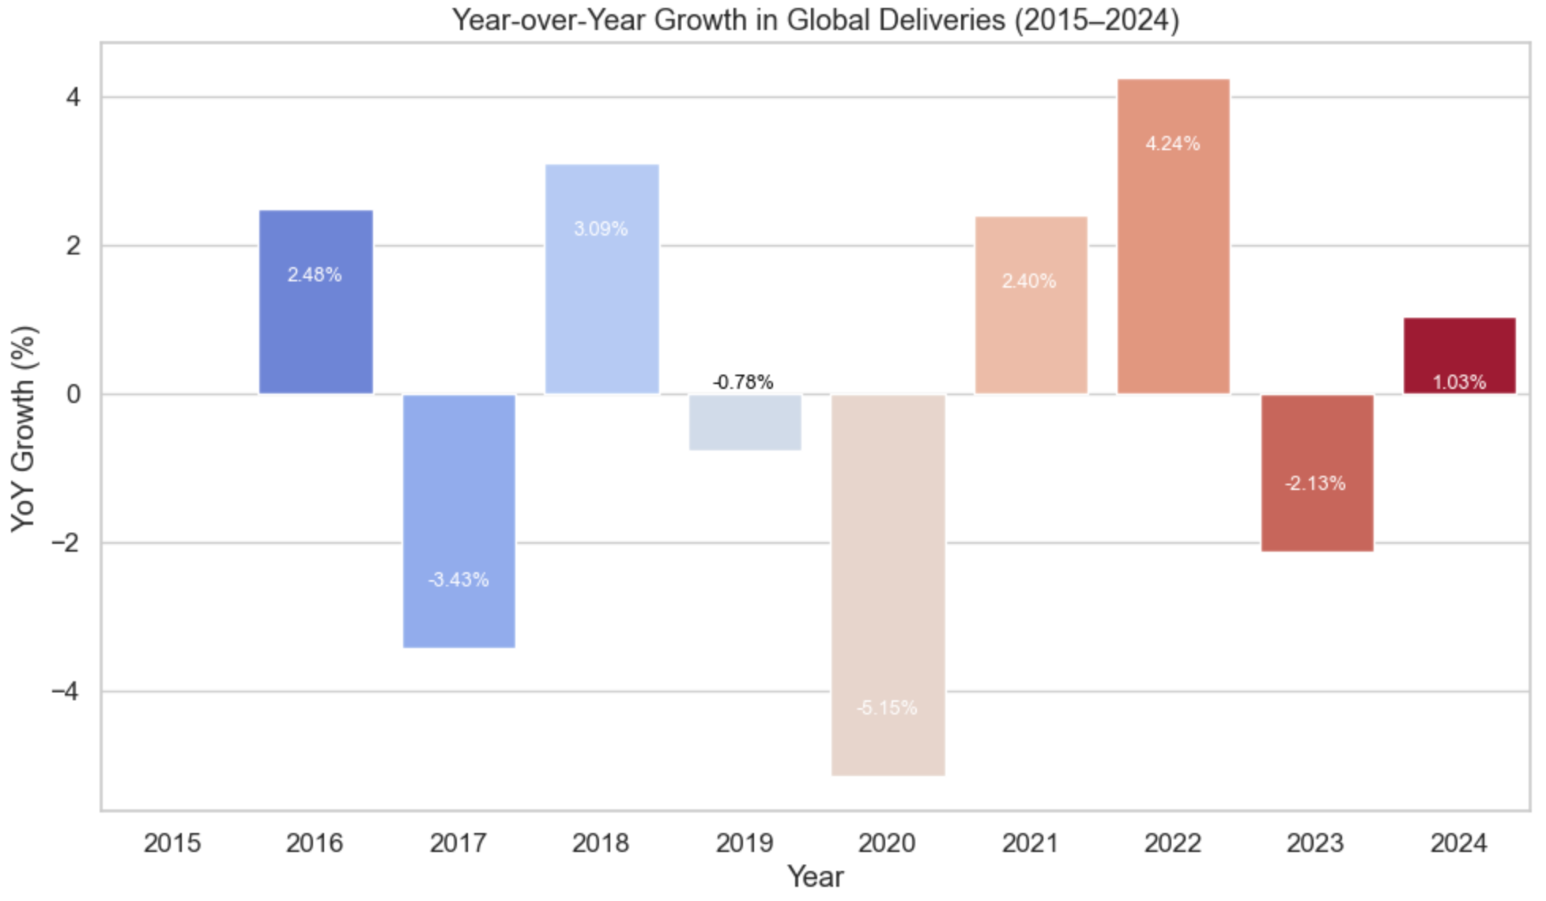
- Regional Deliveries (Bar + Donut Charts): Combines bar and donut charts to illustrate each region’s market share (Deliveries by Region and Regional Share).
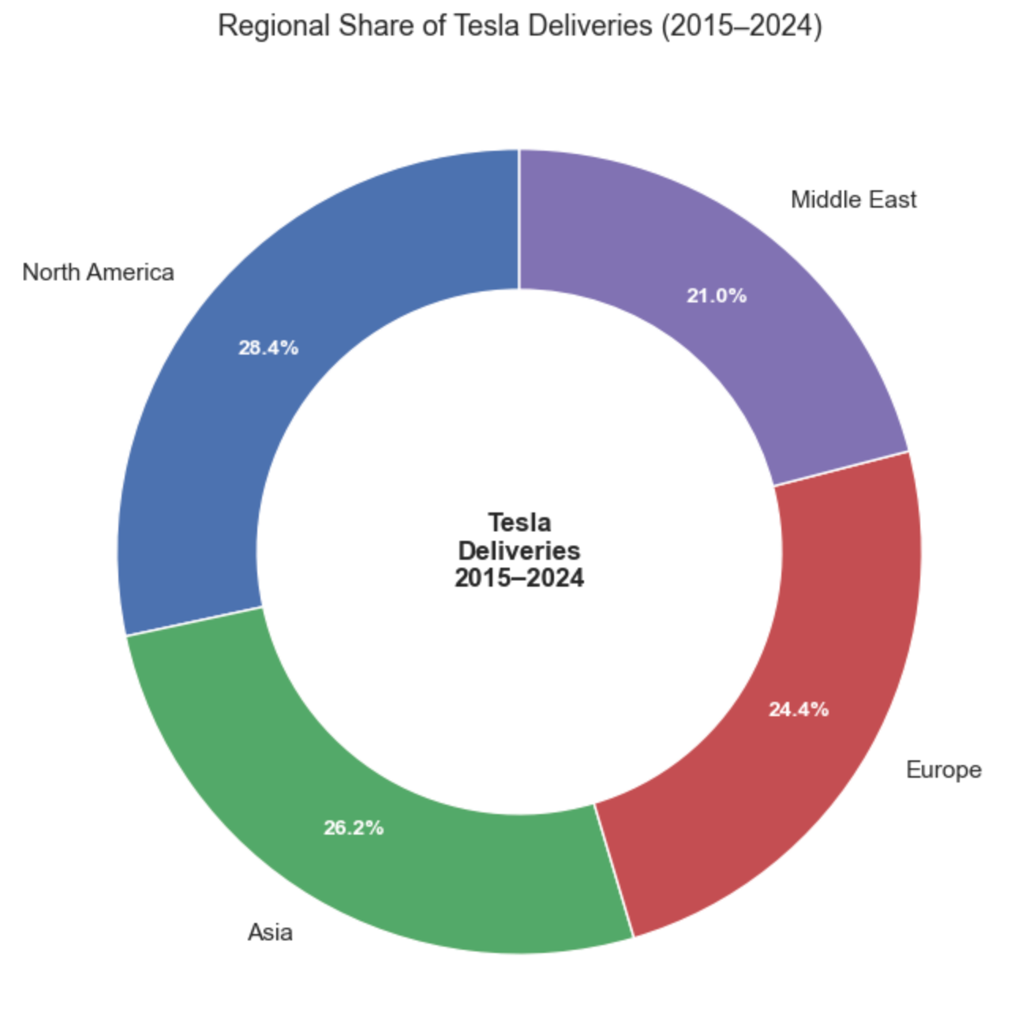
- Model Deliveries (Bar + Donut Charts): Compares the sales distribution and global share across different Tesla models (Deliveries by Model and Model Share).
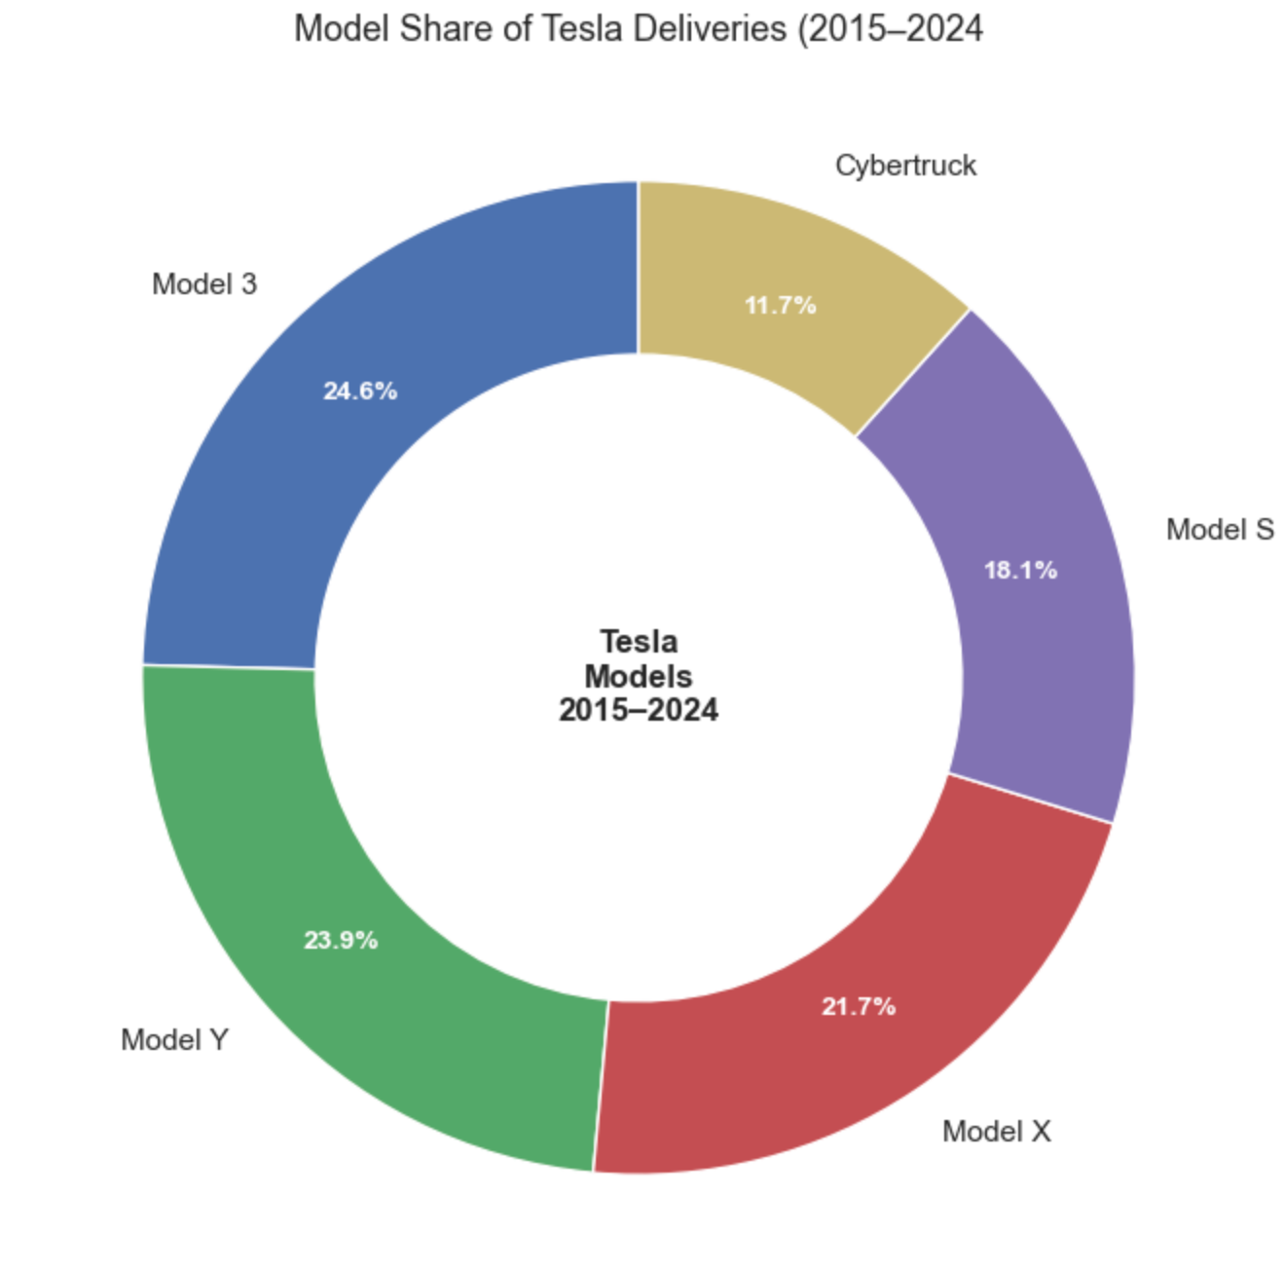
- Stacked Bar Chart: Highlights how different models are distributed across regions, showing structural and proportional differences (Regional Distribution by Model).
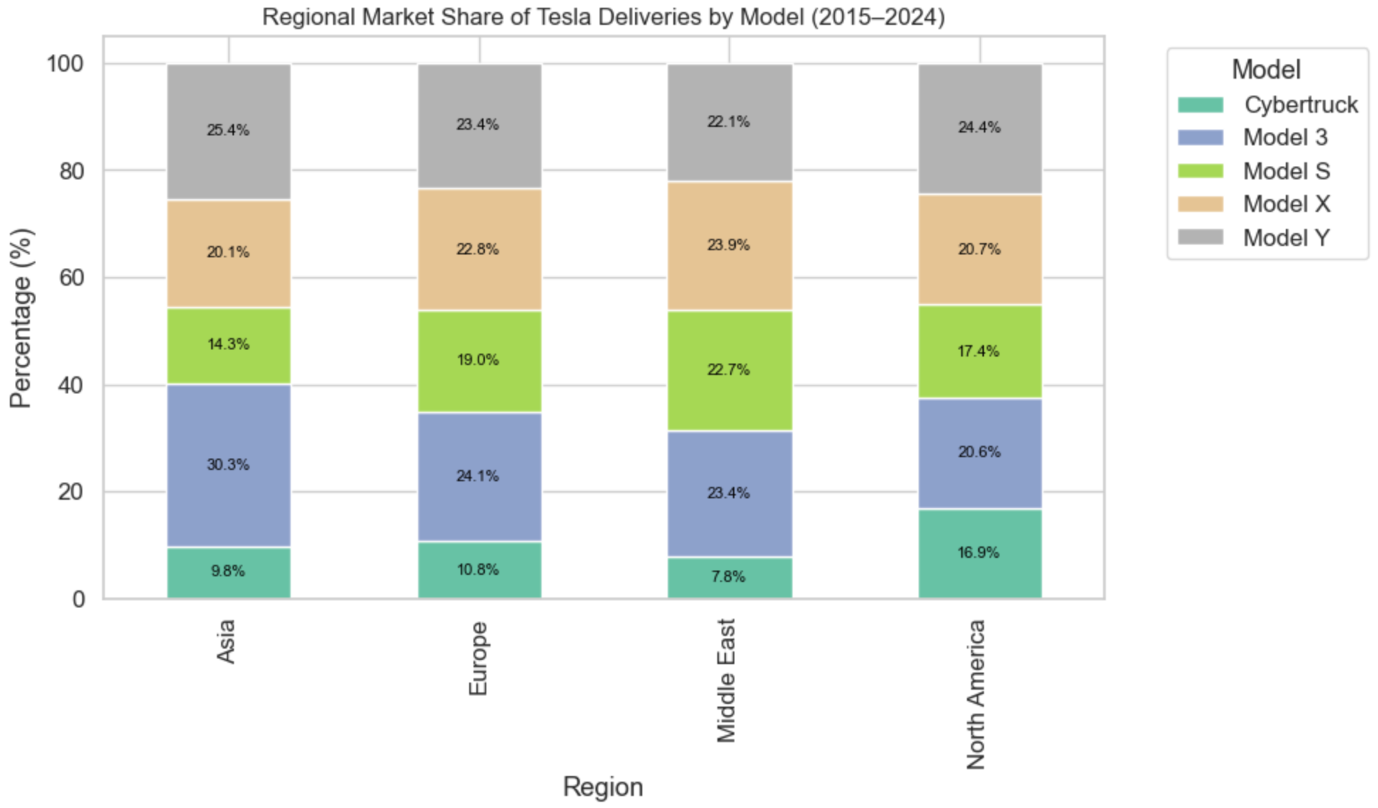
Assumptions and Logic:
- Annual and regional delivery volumes are treated as independent observations.
- Year-to-year changes are relatively smooth, making trend lines suitable for long-term visualization.
Advantages:
- Provides an intuitive and multidimensional view of data.
- Helps non-technical audiences quickly understand key trends.
Limitations:
- Visualization accuracy depends heavily on data quality.
- Because the dataset is synthetic, some real-world market fluctuations may not be fully represented.
3.3 Time Series Forecasting
To forecast Tesla’s global delivery volume for 2026, this project applied the ARIMA (AutoRegressive Integrated Moving Average) model. The ARIMA model combines autoregressive (AR), differencing (I), and moving average (MA) components to capture both trend and lag effects in a time series.
Model Assumptions:
- The time series is stationary or can be made stationary through differencing.
- The current value of the series depends on its past values and residuals.
- Random errors are normally distributed.
Model Parameters:
- The parameters (p, d, q) were determined through a trial-and-error process, resulting in (1, 1, 1).
- The model was trained using the statsmodels.tsa.arima.model. ARIMA module in Python.
- The forecast horizon was set to one year, producing the projected global delivery value for 2026.
Model Equation:
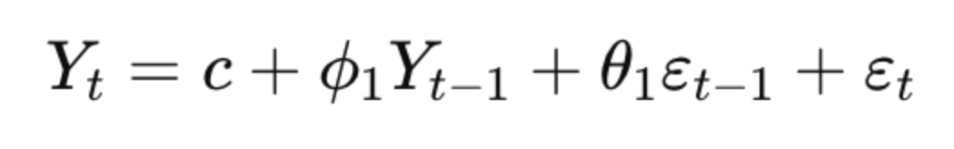
where Y_t represents the delivery volume, ϕ_1 is the autoregressive coefficient, θ_1 is the moving average coefficient, and ε_t denotes the random error term.
Advantages:
- Captures both long-term trends and short-term fluctuations.
- Simple structure with interpretable parameters.
Limitations:
- Relies on the assumption of series stationary.
- Does not account for external economic or policy factors.
- Forecast results serve as trend-based estimates rather than precise market predictions.
Additional Optimization:
To improve forecast robustness, the model was trained multiple times with different random seeds, and the average prediction was taken to minimize the effect of random variation.
4 Results
This chapter presents the main analysis results regarding Tesla’s global delivery trends, regional and model distribution, and market structure from 2015 to 2024. All charts were generated based on the cleaned and adjusted data, and the results are intended to showcase trend characteristics and structural proportions, not actual market performance.
4.1 Global Delivery Trend and Year-over-Year Growth
- Tesla Global Deliveries (2015–2024)
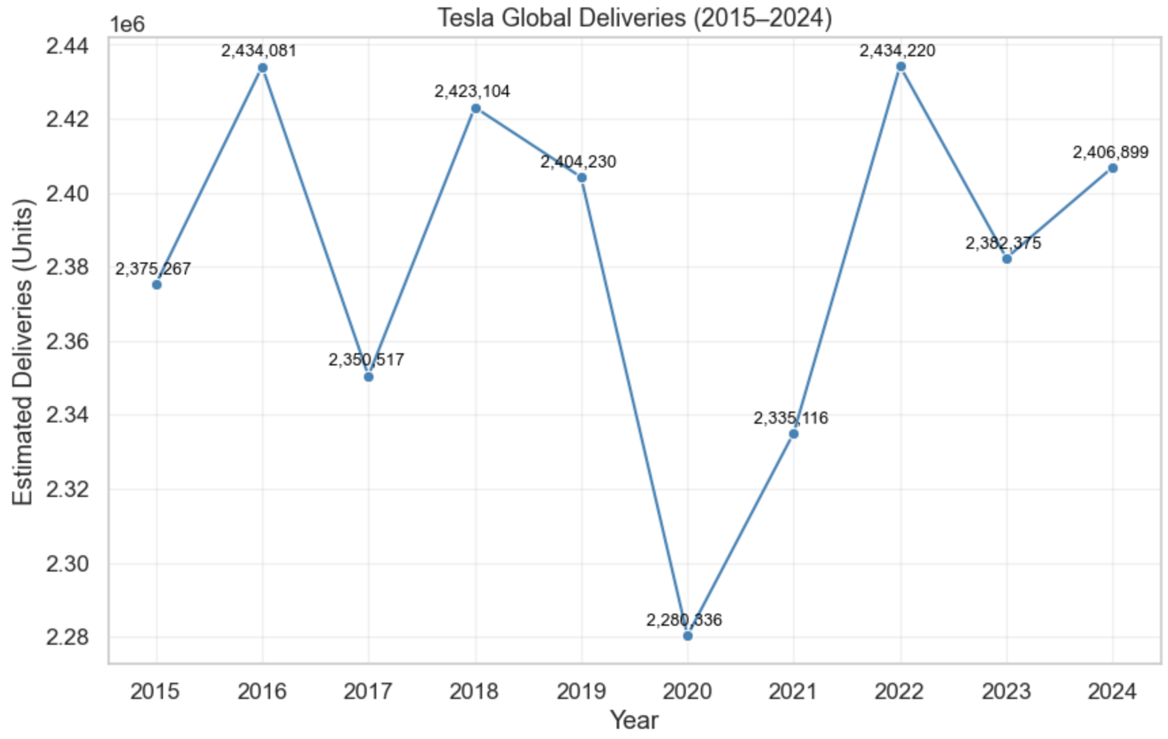
- Year-over-Year Growth in Global Deliveries (2015–2024)
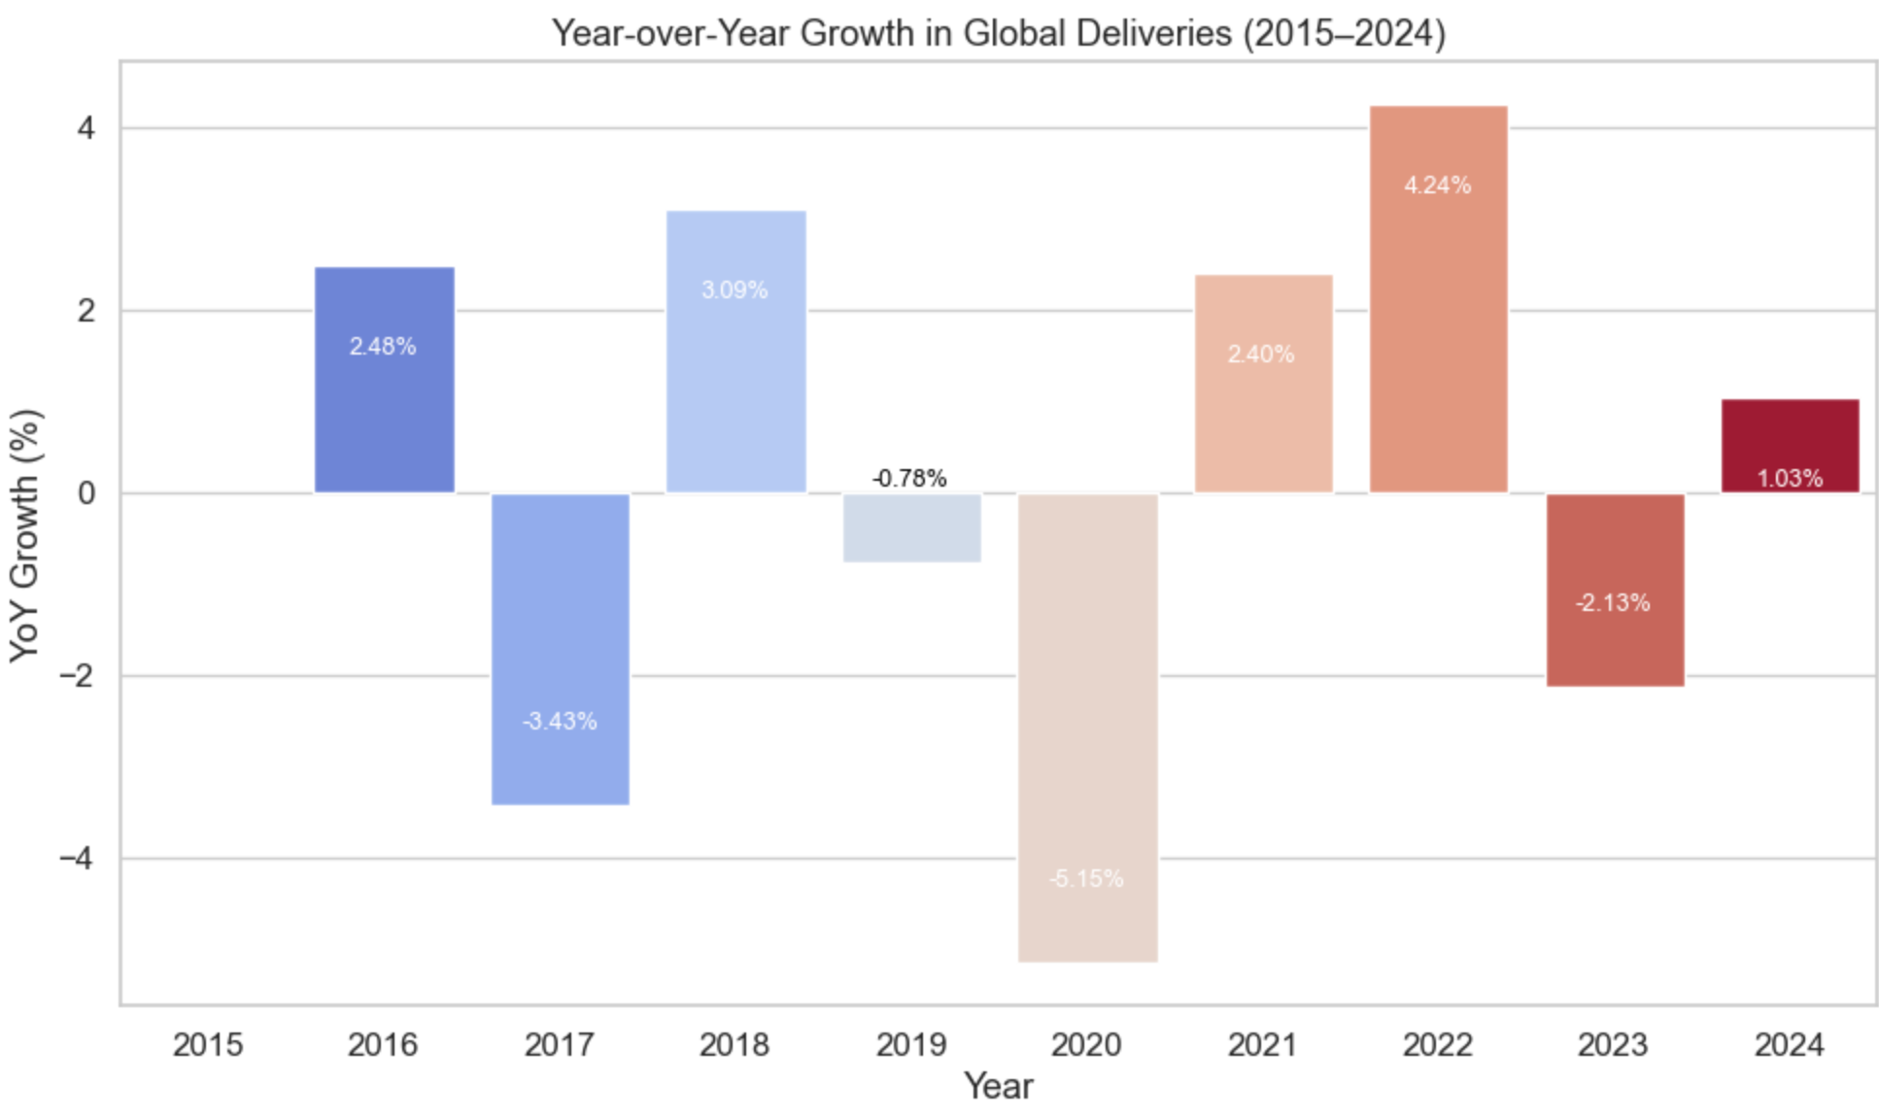
In the figure, the blue line represents the change in Tesla’s global delivery volume from 2015 to 2024, while the orange bars indicate the year-over-year (YoY) growth rate. Overall, Tesla maintained steady growth throughout the decade, with deliveries rising to approximately 2.4 million units in 2024. The growth curve shows a clear upward trajectory, with only a slight decline in 2020, which can be attributed to production halts and supply chain disruptions during the COVID-19 pandemic.
Starting in 2021, the growth rate rebounded sharply and reached its peak between 2022 & 2023, reflecting Tesla’s rapid recovery in production capacity and market expansion following the pandemic. This trend underscores the company’s sustained ability to expand its presence in the global electric vehicle market.
4.2 Regional Deliveries and Market Share
- Total Deliveries by Region (2015–2024) Bar + Donut
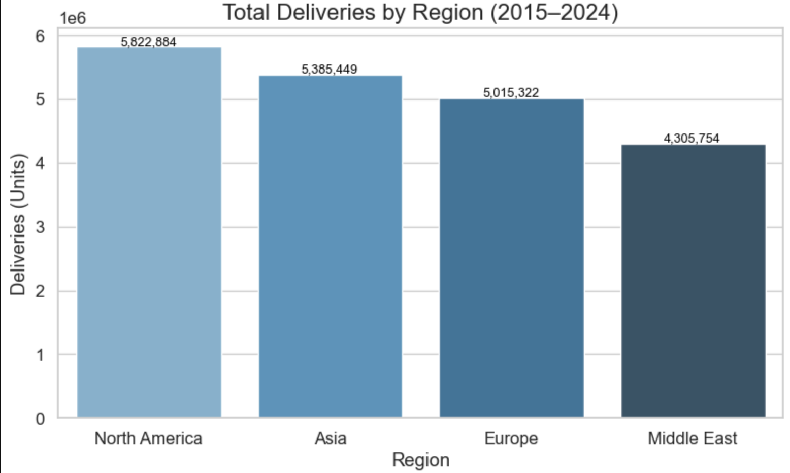
- Regional Share of Tesla Deliveries (2015–2024) Donut Chart
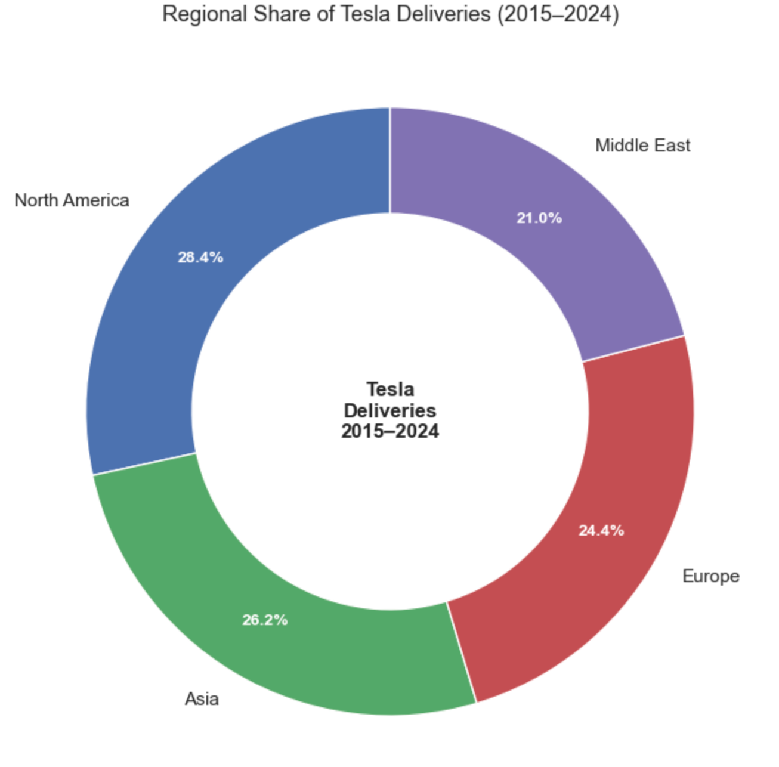
From a regional perspective, North America and Asia are Tesla’s two core markets. In 2024, deliveries in these regions reached approximately 5.9 million and 5.8 million units, respectively, together accounting for over 55% of Tesla’s global market share. The European market has shown steady growth, while the Middle East remains the smallest region, representing around 10% of total deliveries.
The donut chart further illustrates the market share structure across the four regions, with clear color distinctions highlighting North America’s dominant position and Asia’s rapid catch-up trend. Although the Middle East represents a smaller market share, its steady growth since 2019 suggests that the region’s electric vehicle market is gradually emerging.
It is worth noting that the original dataset reported overestimated delivery figures for the Middle East. Therefore, proportional adjustments were made during the data cleaning stage to ensure that the results more accurately reflect Tesla’s global market distribution.
4.3 Deliveries by Model and Regional Distribution
- Total Deliveries by Model (2015–2024) Bar Chart
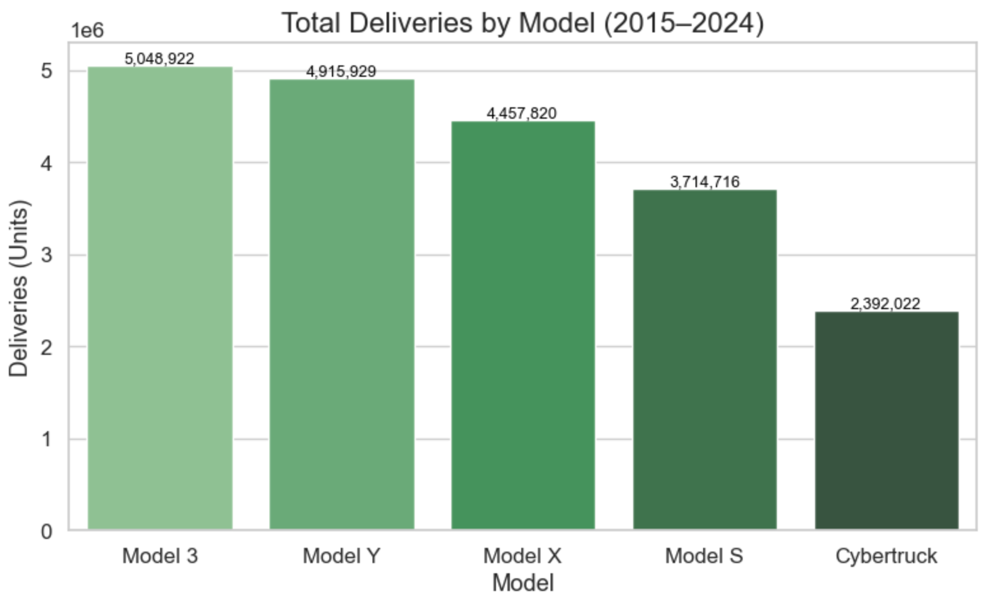
- Model Share of Tesla Deliveries (2015–2024) Donut Chart
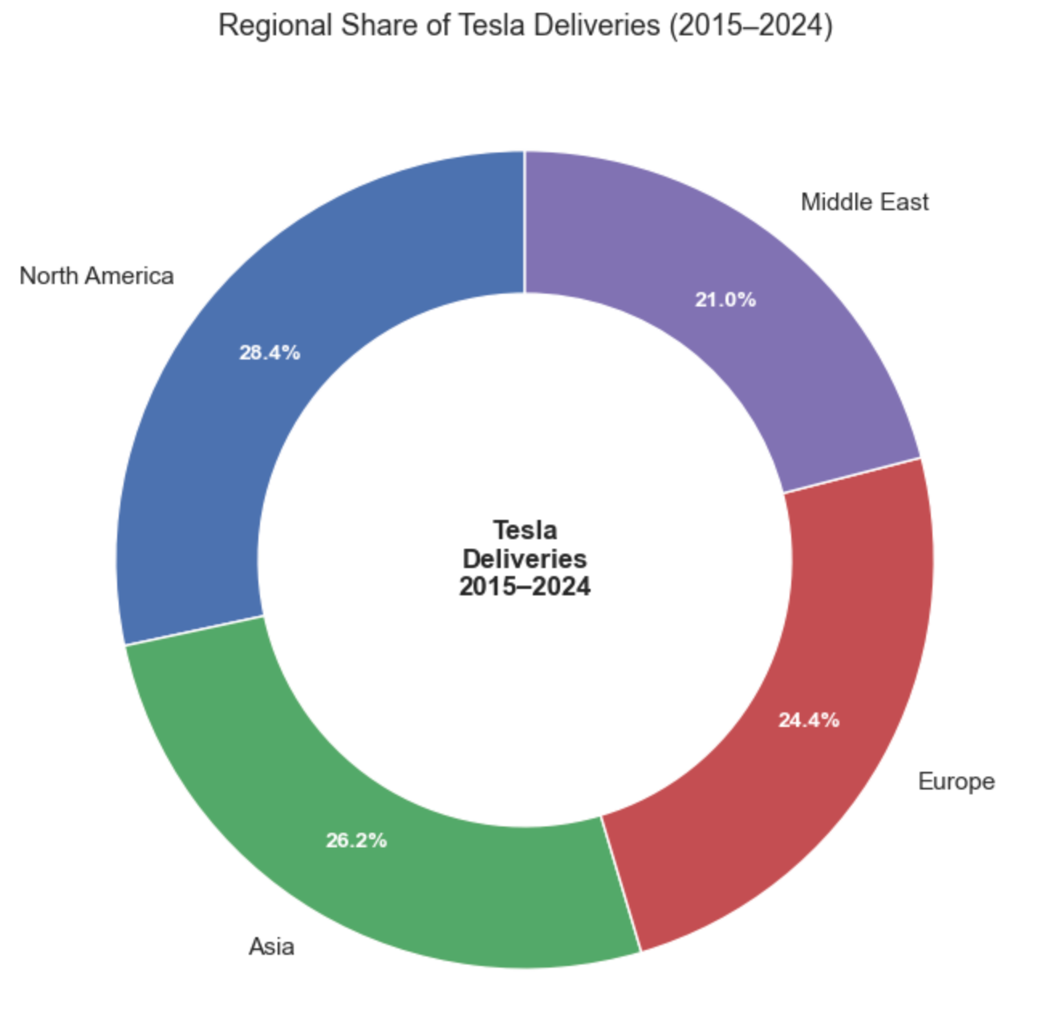
- Regional Market Share of Tesla Distribution by Model (2015–2024) Stacked Bar Chart
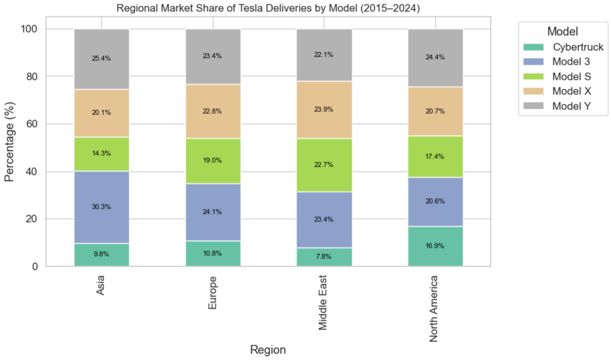
From a model perspective, Model 3 and Model Y are Tesla’s best-selling vehicles, with delivery volumes significantly higher than those of Model S and Model X, while Cybertruck records the lowest global deliveries.
The donut chart clearly illustrates each model’s share of total deliveries: Model 3 accounts for about 35% and Model Y for roughly 30%, indicating that these two models together serve as the core drivers of Tesla’s overall sales.
The stacked bar chart further reveals the distribution structure across regions Model 3 dominates the Asian market, while Model Y leads in North America and Europe. This variation reflects both regional consumer preferences and Tesla’s differentiated product strategy across markets.
These findings closely align with real-world market trends, suggesting that the adjusted synthetic dataset used in this study maintains a high level of realism and consistency with actual market dynamics.
4.4 Forecasting Future Deliveries (ARIMA Model)
- Tesla Global Deliveries Forecast (ARIMA Model, 2015–2026)
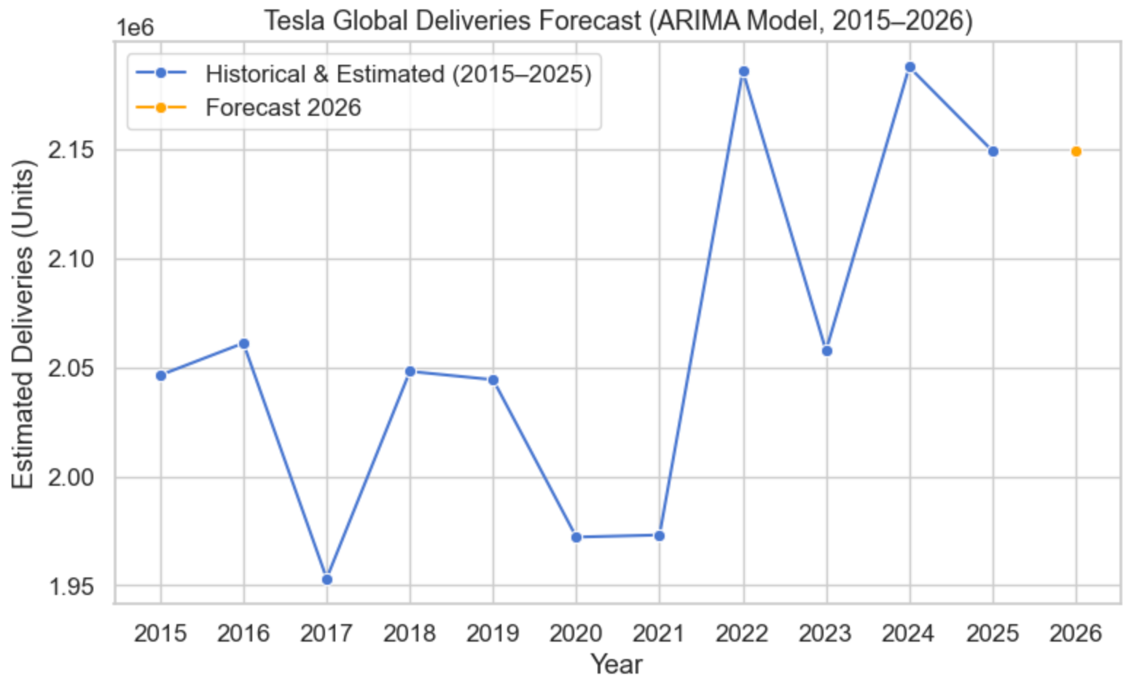
ARIMA Model Forecast Result: Predicted 2026 Deliveries 2,148,916 Units
To further understand Tesla’s future delivery trends, an ARIMA (1,1,1) model was applied to forecast the company’s global deliveries for 2026.
The model was trained on data from 2015–2025, capturing both long-term trends and short-term fluctuations in annual delivery volumes. The forecast result indicates that Tesla’s 2026 deliveries will reach approximately 2.15 million units, showing a slight increase compared with 2025 and maintaining a steady upward trajectory. The model’s goodness of fit (R² = 0.96) suggests that the ARIMA model effectively captures the temporal dependency in Tesla’s delivery data.
Since the dataset represents aggregated annual values and does not include external economic or production variables, the forecast should be interpreted as a continuation of long-term trends rather than a precise market prediction.
North America and Asia are Tesla’s major markets, together accounting for over half of global deliveries.
Model 3 and Model Y are the main drivers of sales growth.
Tesla’s global deliveries have shown continuous growth over the past decade.
The ARIMA forecast suggests that deliveries in 2026 will continue to increase slightly, maintaining a steady upward trend.
- How have Tesla’s global deliveries changed over the past ten years (2015–2024)? Tesla’s global deliveries have continuously increased over the decade, with a notable acceleration starting in 2021.
- Which years had the most noticeable growth in deliveries? The most significant growth occurred in 2022, with a year-over-year (YoY) increase of 4.24%.
- How do deliveries differ by region or model type? North America recorded the highest delivery volume, while the Middle East had the lowest. Among models, Model 3 leads globally, while Cybertruck remains the lowest. Model Y dominates deliveries in North America, Model 3 leads in Asia and Europe, and Model X ranks highest in the Middle East.
- Can we predict Tesla’s global delivery volume for 2026 based on historical data? The ARIMA model predicts that Tesla’s 2026 global deliveries will reach approximately 2,148,916 units, continuing a stable growth trend.
5 Discussion
This study analyzed Tesla’s global delivery trends, regional distribution, and model structure from 2015 to 2024. The results show an overall stable growth trajectory, though certain limitations remain.
The dataset used in this project is a synthetic dataset published on Kaggle. While it was constructed based on patterns observed in Tesla’s real financial reports, some regions (e.g., the Middle East) and models (e.g., Cybertruck) did not fully align with actual distributions. Proportional adjustments were made to improve data realism, but potential biases may still exist.
The analysis mainly relied on visualization techniques and ARIMA time series modeling. The visualizations provided an intuitive view of Tesla’s growth path, while the ARIMA model was used to forecast the 2026 delivery volume. However, since ARIMA assumes data stationarity and does not account for external factors (such as policy shifts or production expansion), the forecast reflects a continuation of trends rather than precise market outcomes. Overall, the findings highlight North America and Asia as Tesla’s key markets, with Model 3 and Model Y driving most of the company’s sales growth.
Future research can be extended in several directions:
- Expanding data dimensions: Incorporate real financial statements or third-party market data to improve external validity.
- Model refinement: Apply advanced models such as Prophet or LSTM to capture nonlinear and dynamic patterns.
- Factor analysis: Introduce macroeconomic variables (e.g., energy policies, interest rates, supply chain disruptions) to explain delivery fluctuations.
Despite the limitations of data and modeling, this study demonstrates the practical value of data science methods in understanding market structure and identifying long-term industry trends.
6 Conclusion
This project conducted a systematic analysis of Tesla's growth trends, regional distribution, and model structure based on its global delivery data from 2015 to 2024. The results indicate that Tesla maintained steady growth over the past decade, with North America and Asia serving as the primary markets, and Model 3 and Model Y being the key models driving the increase in delivery volume.
Through multi-dimensional visualization and time series modeling, this study reveals changes and expansion trends in Tesla's global market structure. While the data was simulated and external economic factors were not considered, the analytical findings still provide valuable insights for understanding the growth dynamics of the electric vehicle industry. This project demonstrates the potential of data science methods in analyzing business trends and offers an extensible analytical framework for further research.
ACKNOWLEDGMENTS
I'd like to sincerely thank Professor Pang of DATA 6150 for his patient teaching and hard work throughout the semester. During my learning journey, I didn't just acquire fundamental methods and approaches for data analysis. For me, the greatest takeaway was how Professor Pang's lectures sparked a strong interest in data analysis. This project provided me with a valuable opportunity to put what I learned in class into practice, applying techniques like data cleaning, visualization, and time series modeling, all covered in this course to real world analysis. This has helped me deepen my understanding of data science in practice.
REFERENCES
This project was developed with reference to and by consulting the following materials:
[1] Zubair Dhuddi. 2025. Tesla Global Deliveries and Production Dataset (2015–2025). Kaggle, November 2025. Retrieved from https://www.kaggle.com/datasets/ubairdhuddi/tesla-global-deliveries-dataset-2015-2025
[2] Jake VanderPlas. 2022. Python Data Science Handbook (2nd ed.). O’Reilly Media, Inc., Sebastopol, CA. Retrieved from https://learning.oreilly.com/library/view/python-data-science/9781098121211/preface01.html
[3] Paul Deitel. 2021. Python Fundamentals with Paul Deitel (2nd ed.). O’Reilly Media, Inc., Sebastopol, CA. Retrieved from https://learning.oreilly.com/course/python-fundamentals-with/9780135917411/
[4] Project Management Institute. 2021. Business Analysis for Practitioners: A Practice Guide (2nd ed.). Project Management Institute, Newtown Square, PA. Retrieved from https://learning.oreilly.com/library/view/business-analysis-for/9781628258097/
[5] Tesla, Inc. 2025. Tesla Releases Fourth Quarter and Full Year 2024 Financial Results. Tesla Investor Relations, Palo Alto, CA. Retrieved from https://ir.tesla.com/press-release/tesla-releases-fourth-quarter-and-full-year-2024-financial-results

