Additional file 1
Endothelial responses in acute EAE show limited overlap with those in chronic multiple sclerosis

Supplementary methods and figures

Focused function comparison
For focused functions, we retained all eleven existing gene sets before calculating the new comparisons. The primary scores used only genes in the common set of 6,611, with nonconstant expression in every cohort. A composite required at least three genes and at least 40% of its original membership. Within each cohort, genes were standardized across the included disease and control subjects and averaged with equal weight. Other disease stages did not contribute to this scaling. The same genes were used for each function in every cohort. We estimated Hedges' g, exact subject permutation P values and descriptive subject bootstrap ranges with gene scaling held fixed. FDR correction covered all eligible function and cohort tests together. A separate sensitivity analysis used commonly measured uppercase gene symbols with the same coverage rule. This broader comparison was not treated as strict orthology validation. Unscored functions, missing genes and both matching schemes are reported in Table S22.

Uncertainty and fixed scaling
New focused scores standardize each gene across only the eligible disease and control subjects in each cohort. Those means and standard deviations are held fixed during resampling. This differs from original stage summaries, which retain their original scaling. Eight strict panels yield 40 exact tests across five cohorts. The broader symbol analysis yields 55. FDR correction is applied separately to these two stated families. Program membership overlaps and direction counts are descriptive. A score with fewer than three usable genes or less than 40 percent coverage is not estimated. This full transcriptome rule is distinct from the four gene threshold used for the targeted MERFISH panel.

Orthology and sampling
The archived HCOP procedure assesses reciprocal symbol uniqueness across the downloaded predictions, then requires Ensembl and NCBI support and identical uppercase mouse and human symbols. This is a conservative sensitivity subset. The 6,611 gene universe was fixed from previously eligible validation genes before calculating the complete five cohort matrix. Bootstrap draws remove undefined gene effects jointly across all pairs, with no replacement of failed draws. There were 1,841 usable draws out of 2,000. The gene counts in these draws ranged from 6,380 to 6,611. Conditional percentile ranges can be unstable in small groups and are not interpreted as calibrated confidence intervals.

Supporting treatment and barrier assays
The original GSE210776 treatment analysis compared three CFA samples, four untreated acute EAE samples and three BEVAC samples using the same program scores and exact permutation of group labels. We considered the results from all selected endothelial cells alongside the source study's venous cell analysis. We retained the deposited bevacizumab label because the metadata did not link these samples to the separate r84 experiment. These treatment results are presented in the supplementary material to help interpret the relationship between endothelial gene expression and barrier function. We analyzed the published r84 experiments in chronic EAE separately [1]. Microscopic fields were averaged within each mouse, leaving nine mice per treatment group for the vascular remodeling and leakage analyses. We compared groups using exact permutation of mouse labels and Hedges' g. FDR correction was applied separately to the two leakage outcomes and the five vascular outcomes. The published electrical resistance data did not identify which wells came from independent experiments. Similarly, the human vascular immunohistochemistry data did not link individual images to donors. We therefore summarized these measurements descriptively (Figs. S7 and S8). The published r84 data showed reduced venous endothelial proliferation, with g of negative 1.19 (exact P = 0.0031). Neither IgG nor fibrinogen leakage showed a statistically detectable reduction. The leakage intervals were wide, so the results also could not establish that leakage was unchanged. The venous transcriptional results, electrical resistance measurements and vascular protein data are presented in Figs. S7 and S8. These experiments illustrate why a change in endothelial gene expression needs to be assessed alongside direct measurements of barrier function. They did not determine how closely EAE resembled human MS.

Cell source and composition
GSE279183 regional PROGENy scores combine signals from several cell types. The retained regional summaries do not include the original region by cell type counts needed for an additional cell source adjustment. No such adjustment is claimed in this revision. GSE208747 abundance adjustment addresses endothelial enrichment but does not remove every compositional contribution. GSE284005 uses published endothelial cell labels for donor paired regions and separates the fraction of stress or inflammatory cells from gene program scores. The Macnair analysis retains source annotated endothelial subtypes and compares capillary nuclei with all endothelial nuclei in the same donors. These checks address distinct compositional questions and do not measure vessel density.

Reproduction and file contents
Additional file 2 contains the complete revision results and scripts. The README gives the order of execution, file locations, software versions and limits of the derived data. Tables S19 and S20 preserve the previous benchmark and additional human analyses. Tables S21 and S22 contain the five cohort matrix and focused function comparisons. Additional file 3 retains the original Tables S1 to S18 and their source calculations. Original source matrices must be obtained from their repositories to repeat cell selection from raw inputs. The supplied biological sample profiles reproduce the new effect comparisons without downloading whole studies.

Supplementary table descriptions
Supplementary Table S1. Dataset inventory, platforms, study groups, analytical roles and statistical units.
Supplementary Table S2. Prespecified focused endothelial signatures, constituent genes and biological interpretations.
Supplementary Table S3. Archived acute EAE endothelial module contrasts, with the effect and significance fields retained in the source table.
Supplementary Table S4. Archived acute EAE endothelial gene contrasts, with the effect and significance fields retained in the source table.
Supplementary Table S5. Exploratory summaries of selected signaling genes in mouse cell types. These summaries do not establish causal interactions between ligands and receptors.
Supplementary Table S6. GSE95401 contrasts for individual genes across stages, with the original log2 fold change, P value and FDR fields.
Supplementary Table S7. Contrasts between deposited EAE samples labeled as bevacizumab and untreated acute EAE samples by endothelial subtype, including sample means, sample sizes and FDR within each subtype.
Supplementary Table S8. GSE279183 endothelial subset from single-nucleus data and contrasts between disease groups.
Supplementary Table S9. GSE279183 spatial pathway comparisons between inflammatory vascular regions, periplaque white matter and control white matter.
Supplementary Table S10. GSE208747 comparisons among lesion groups across thresholds for selecting endothelial spots and score definitions.
Supplementary Table S11. GSE163005 contrasts characterizing the immune environment in cerebrospinal fluid retained as supporting information [2]. These data do not contribute to the main vascular conclusions.
Supplementary Table S12. GSE163194 contrasts characterizing the immune environment in cerebrospinal fluid retained as supporting information [3]. These data do not contribute to the main vascular conclusions.
Supplementary Table S13. Infection data screened separately from the vascular analysis. The table retains standardized effects from GSE163005 and GSE163194 for transparency [2, 3]. The EAE and MS vascular conclusions use the seven main datasets described in the study design.
Supplementary Table S14. Audit of the revised analyses and their interpretation. The table records the statistical unit, limitations of each source dataset and the interpretation assigned to each result.
Supplementary Table S15. Sensitivity analysis using strict orthology. The table reports gene counts, Spearman correlations, uncertainty intervals, P values and agreement in direction. Results based on matching gene symbols are compared with results based on reciprocal HCOP mapping with unique matches in both species.
Supplementary Table S16. Spatial endothelial assessment for each GSE284005 donor. The table reports gene set coverage, paired regional differences, consistency of direction and exact P values from sign permutation tests. Inflammatory vascular regions were compared with demyelinated white matter.
Supplementary Table S17. Assessment of public dataset eligibility. GSE168202 was excluded from the EAE meta-analysis because its brain data lacked biological replication within each stage. GSE284005 was used only for spatial questions that could be answered with its targeted panel and donor replication.
Supplementary Table S18. Prespecified endothelial gene sets and their coverage in each dataset. The workbook lists the broad and focused gene sets, the genes measured in each dataset and whether each set met the scoring rule. For GSE284005, a composite score required at least four measured genes and at least 40% coverage. CLDN5 was reported separately because it was the only BBB specialization gene measured by the targeted panel.
Table S19. Comparisons of gene changes across cohorts. The table includes reconstructed effects on 7,705 strict orthologues, correlations between cohorts, the number of evaluable animal and donor resamples, and analyses omitting each subject in turn.
Table S20. Additional human endothelial analysis. The table includes donor selection, fixed gene scaling, program scores, exact donor tests, endothelial subtype proportions, resampling of subjects across cohorts, comparisons of capillary cells and all endothelial cells from the same donors, and assessment of other candidate datasets.
Table S21. Unified five cohort reference. Gene effects, all ten cohort pairs, means and differences, subject bootstrap draws and omission analyses use the same fixed target set of 6,611 genes.
Table S22. Focused endothelial functions. The files contain membership and coverage, subject scores, effect estimates, exact tests, FDR families and conditional bootstrap ranges for strict and broader common symbol comparisons.

Supplementary figures

Figure S1. Filtering of raw GSE210776 droplets and endothelial cell yield. The panels show barcodes that passed the thresholds for unique molecular identifiers and detected genes. They also show the number of endothelial cells selected from each mouse.
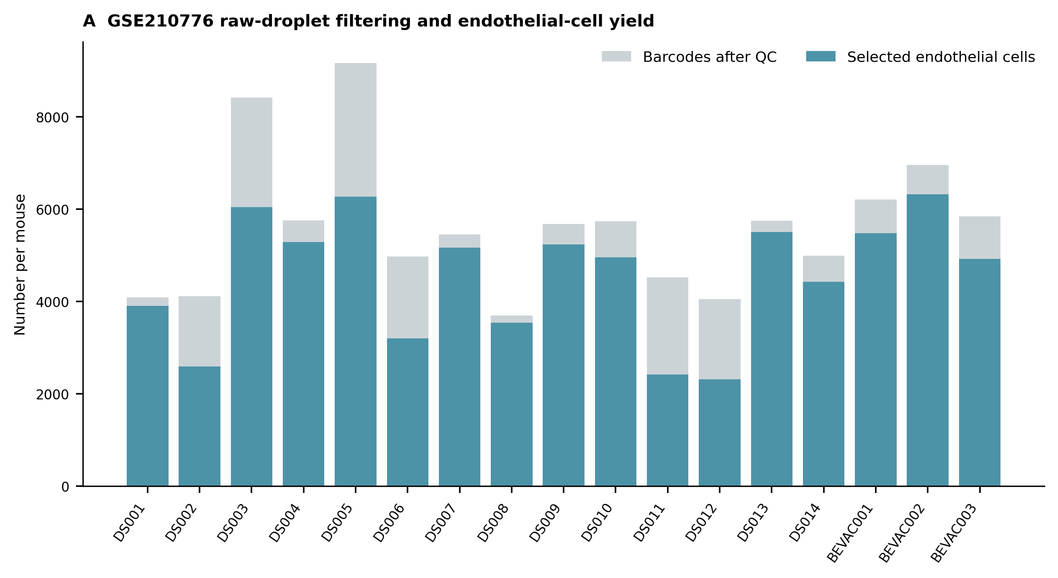

Figure S2. Scores for acute EAE programs in biological samples from three cohorts. Each point represents one biological sample. Horizontal lines show group means.
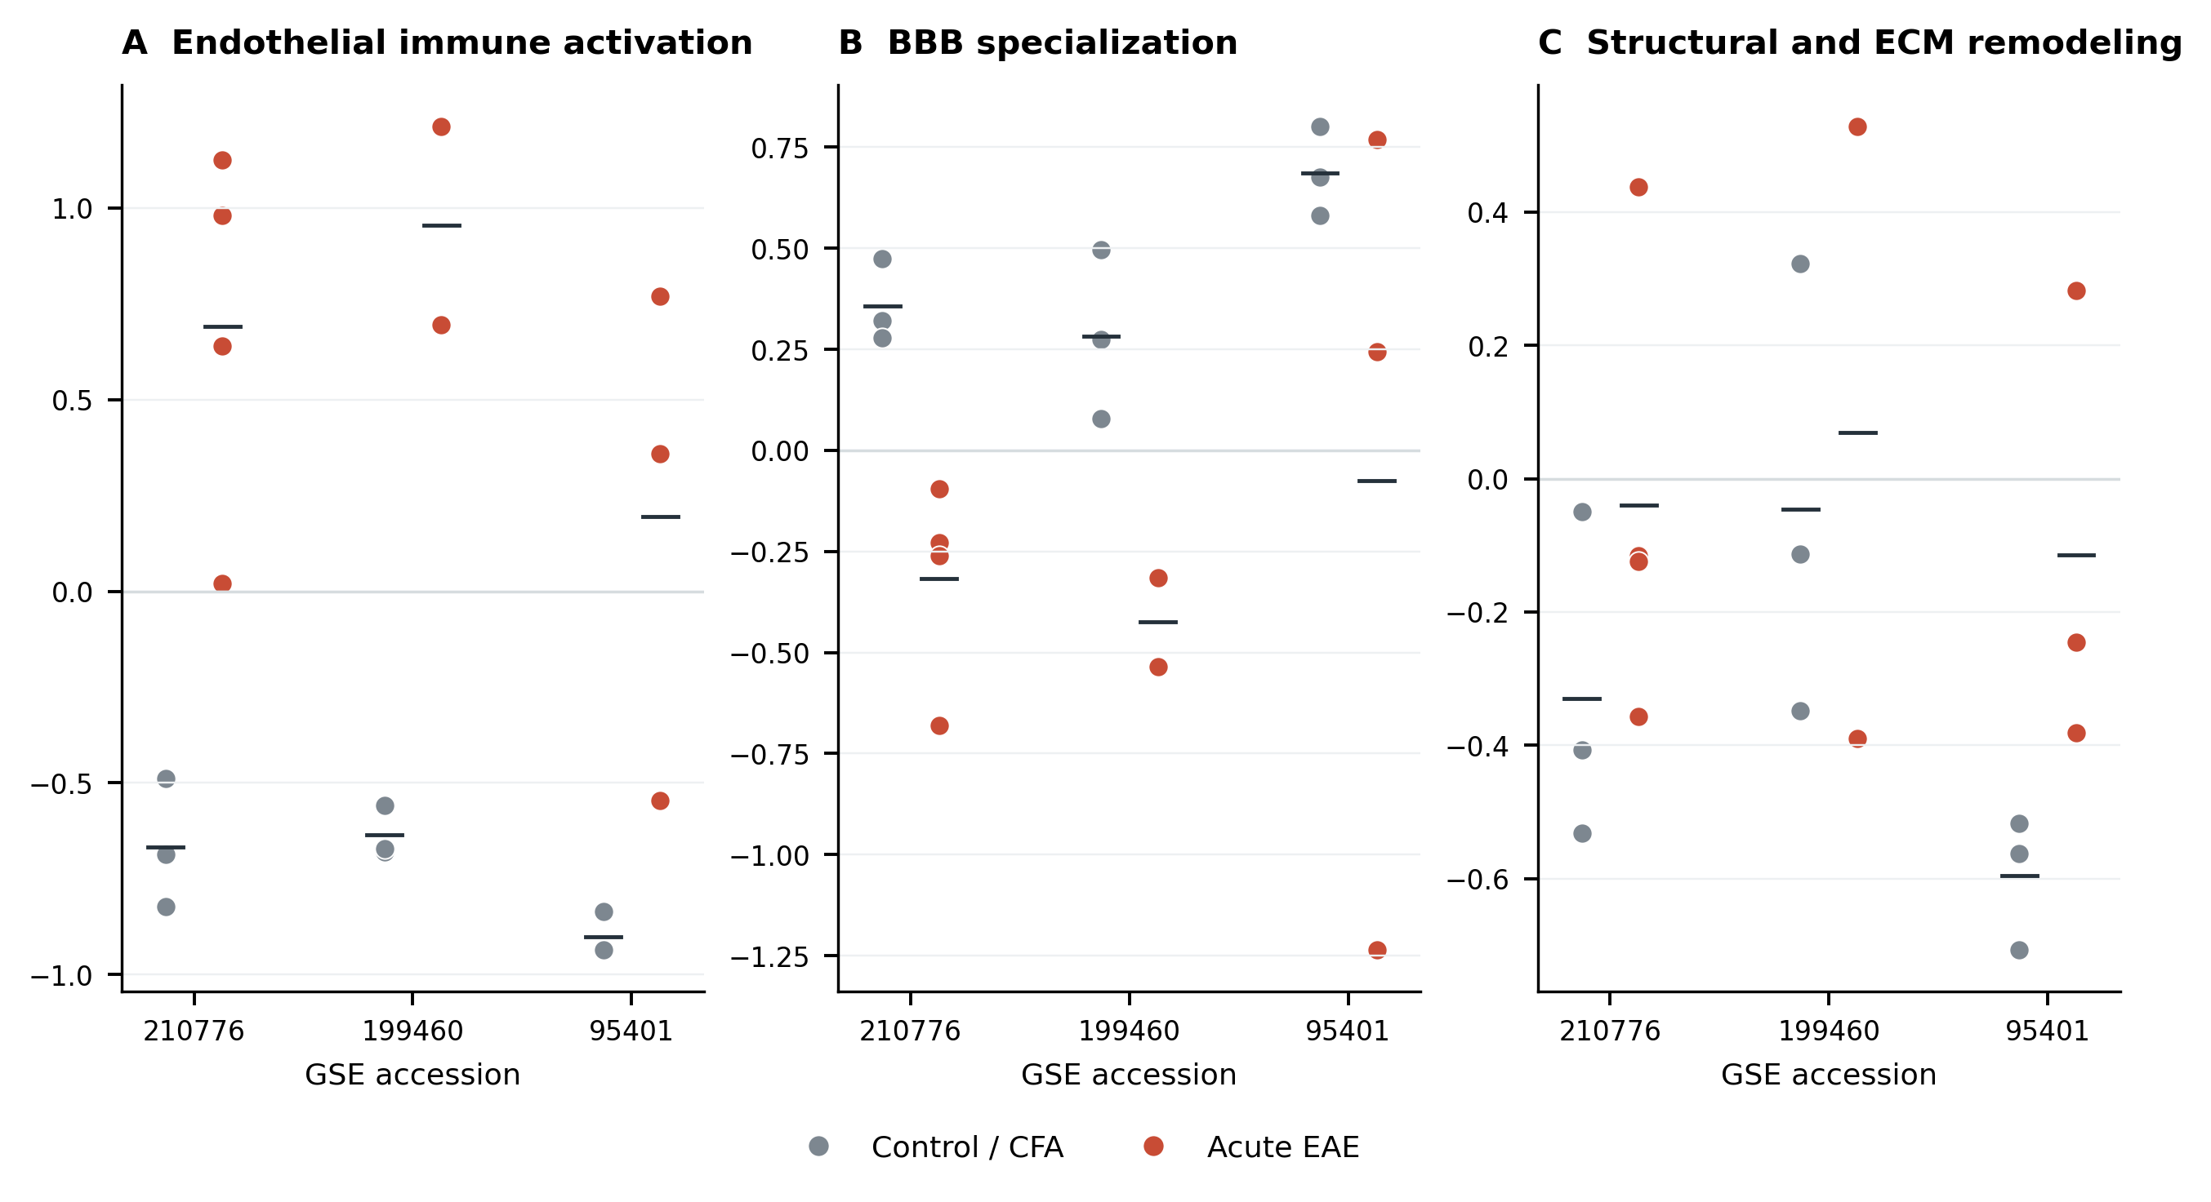

Figure S3. Sensitivity analysis of all endothelial cells and the venous subset in GSE199460. Hedges' g estimates had similar directions in both analyses. Only the estimate from all endothelial cells entered the meta-analysis, so the dataset was counted once.
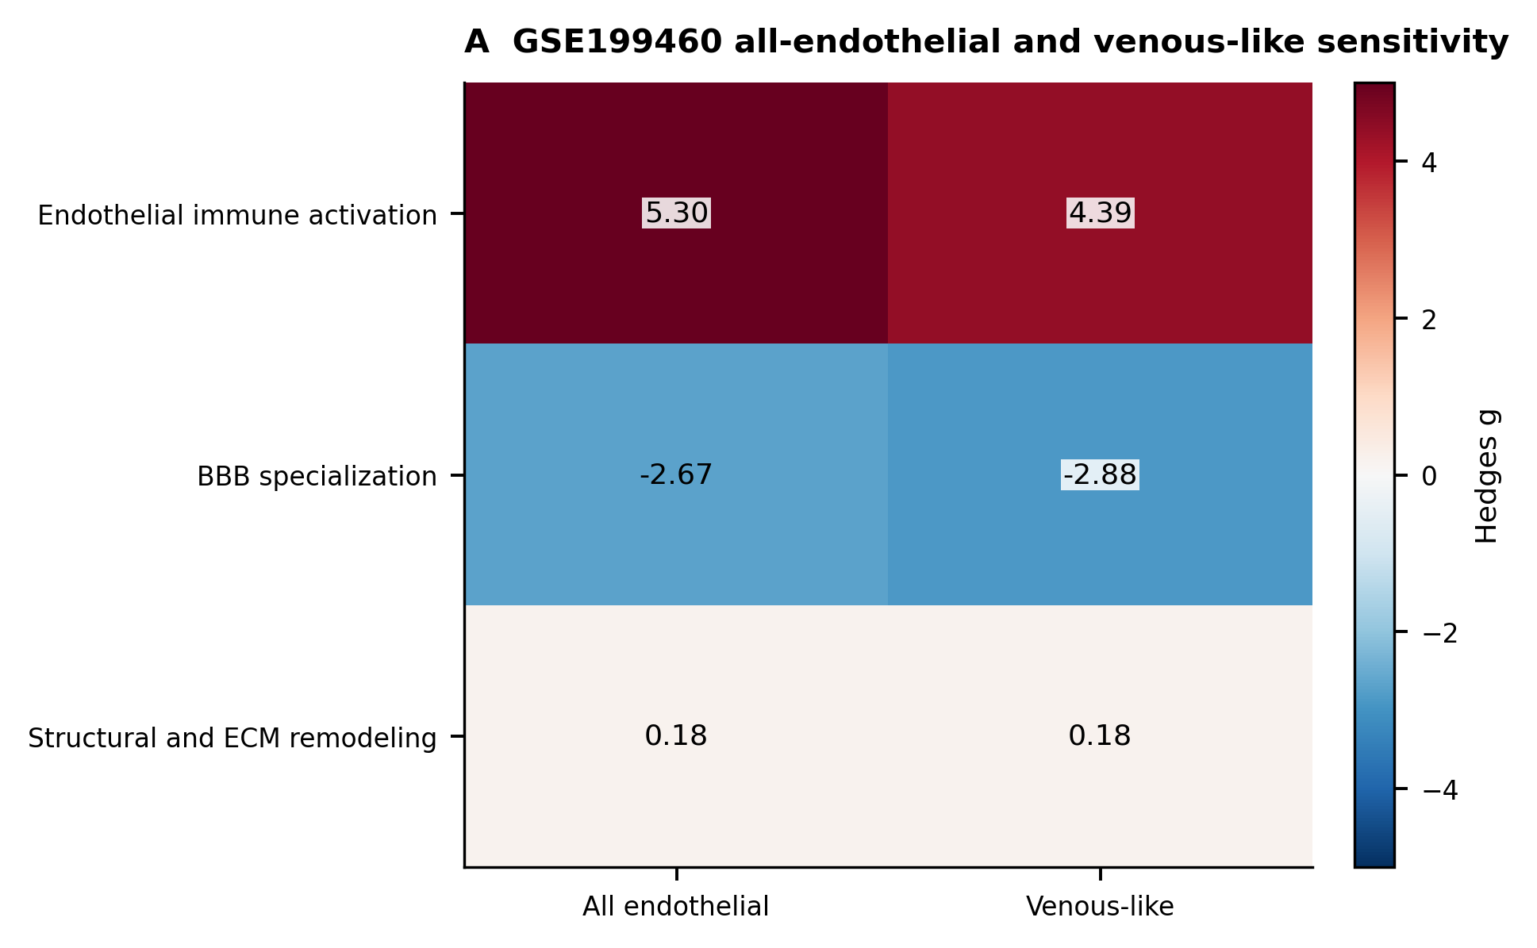

Figure S4. Endothelial programs across the sampled GSE95401 stages. Control, acute, subacute and chronic EAE groups each contained three independent samples. Each point represents a sample and horizontal lines show group means. These comparisons are descriptive and do not establish a temporal course.
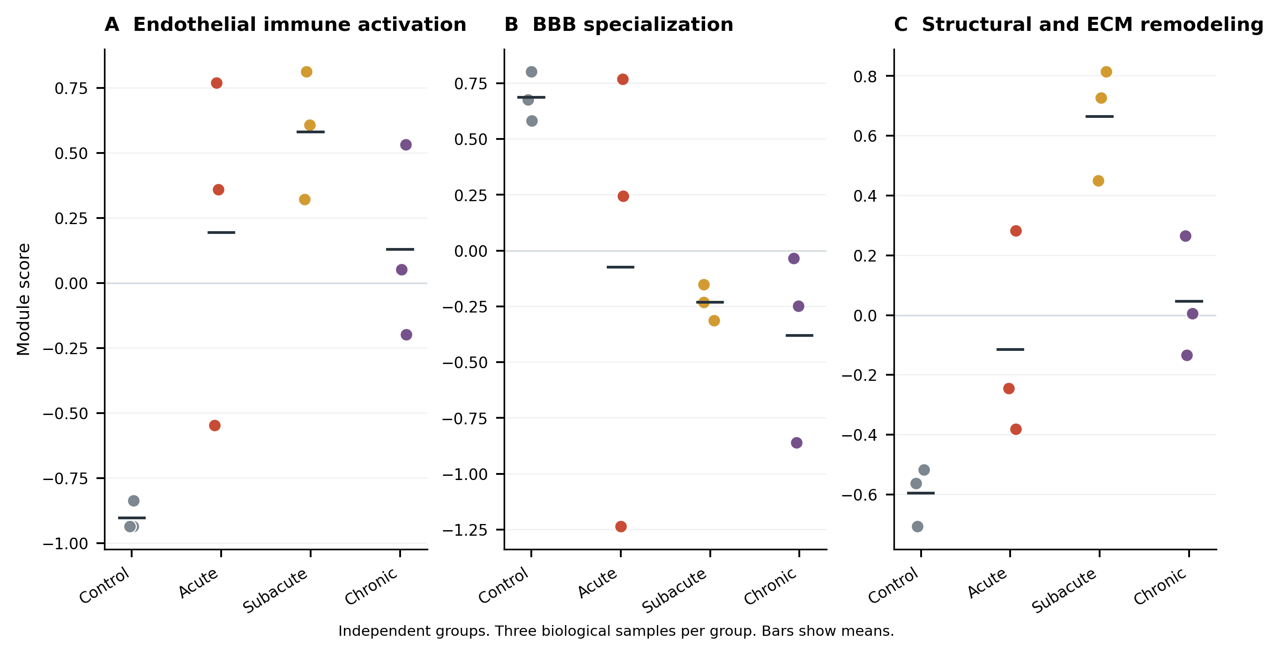

Figure S5. Selection of endothelial nuclei in GSE279183. The figure shows the number of selected endothelial nuclei in each tissue sample. Colors indicate the lesion group.
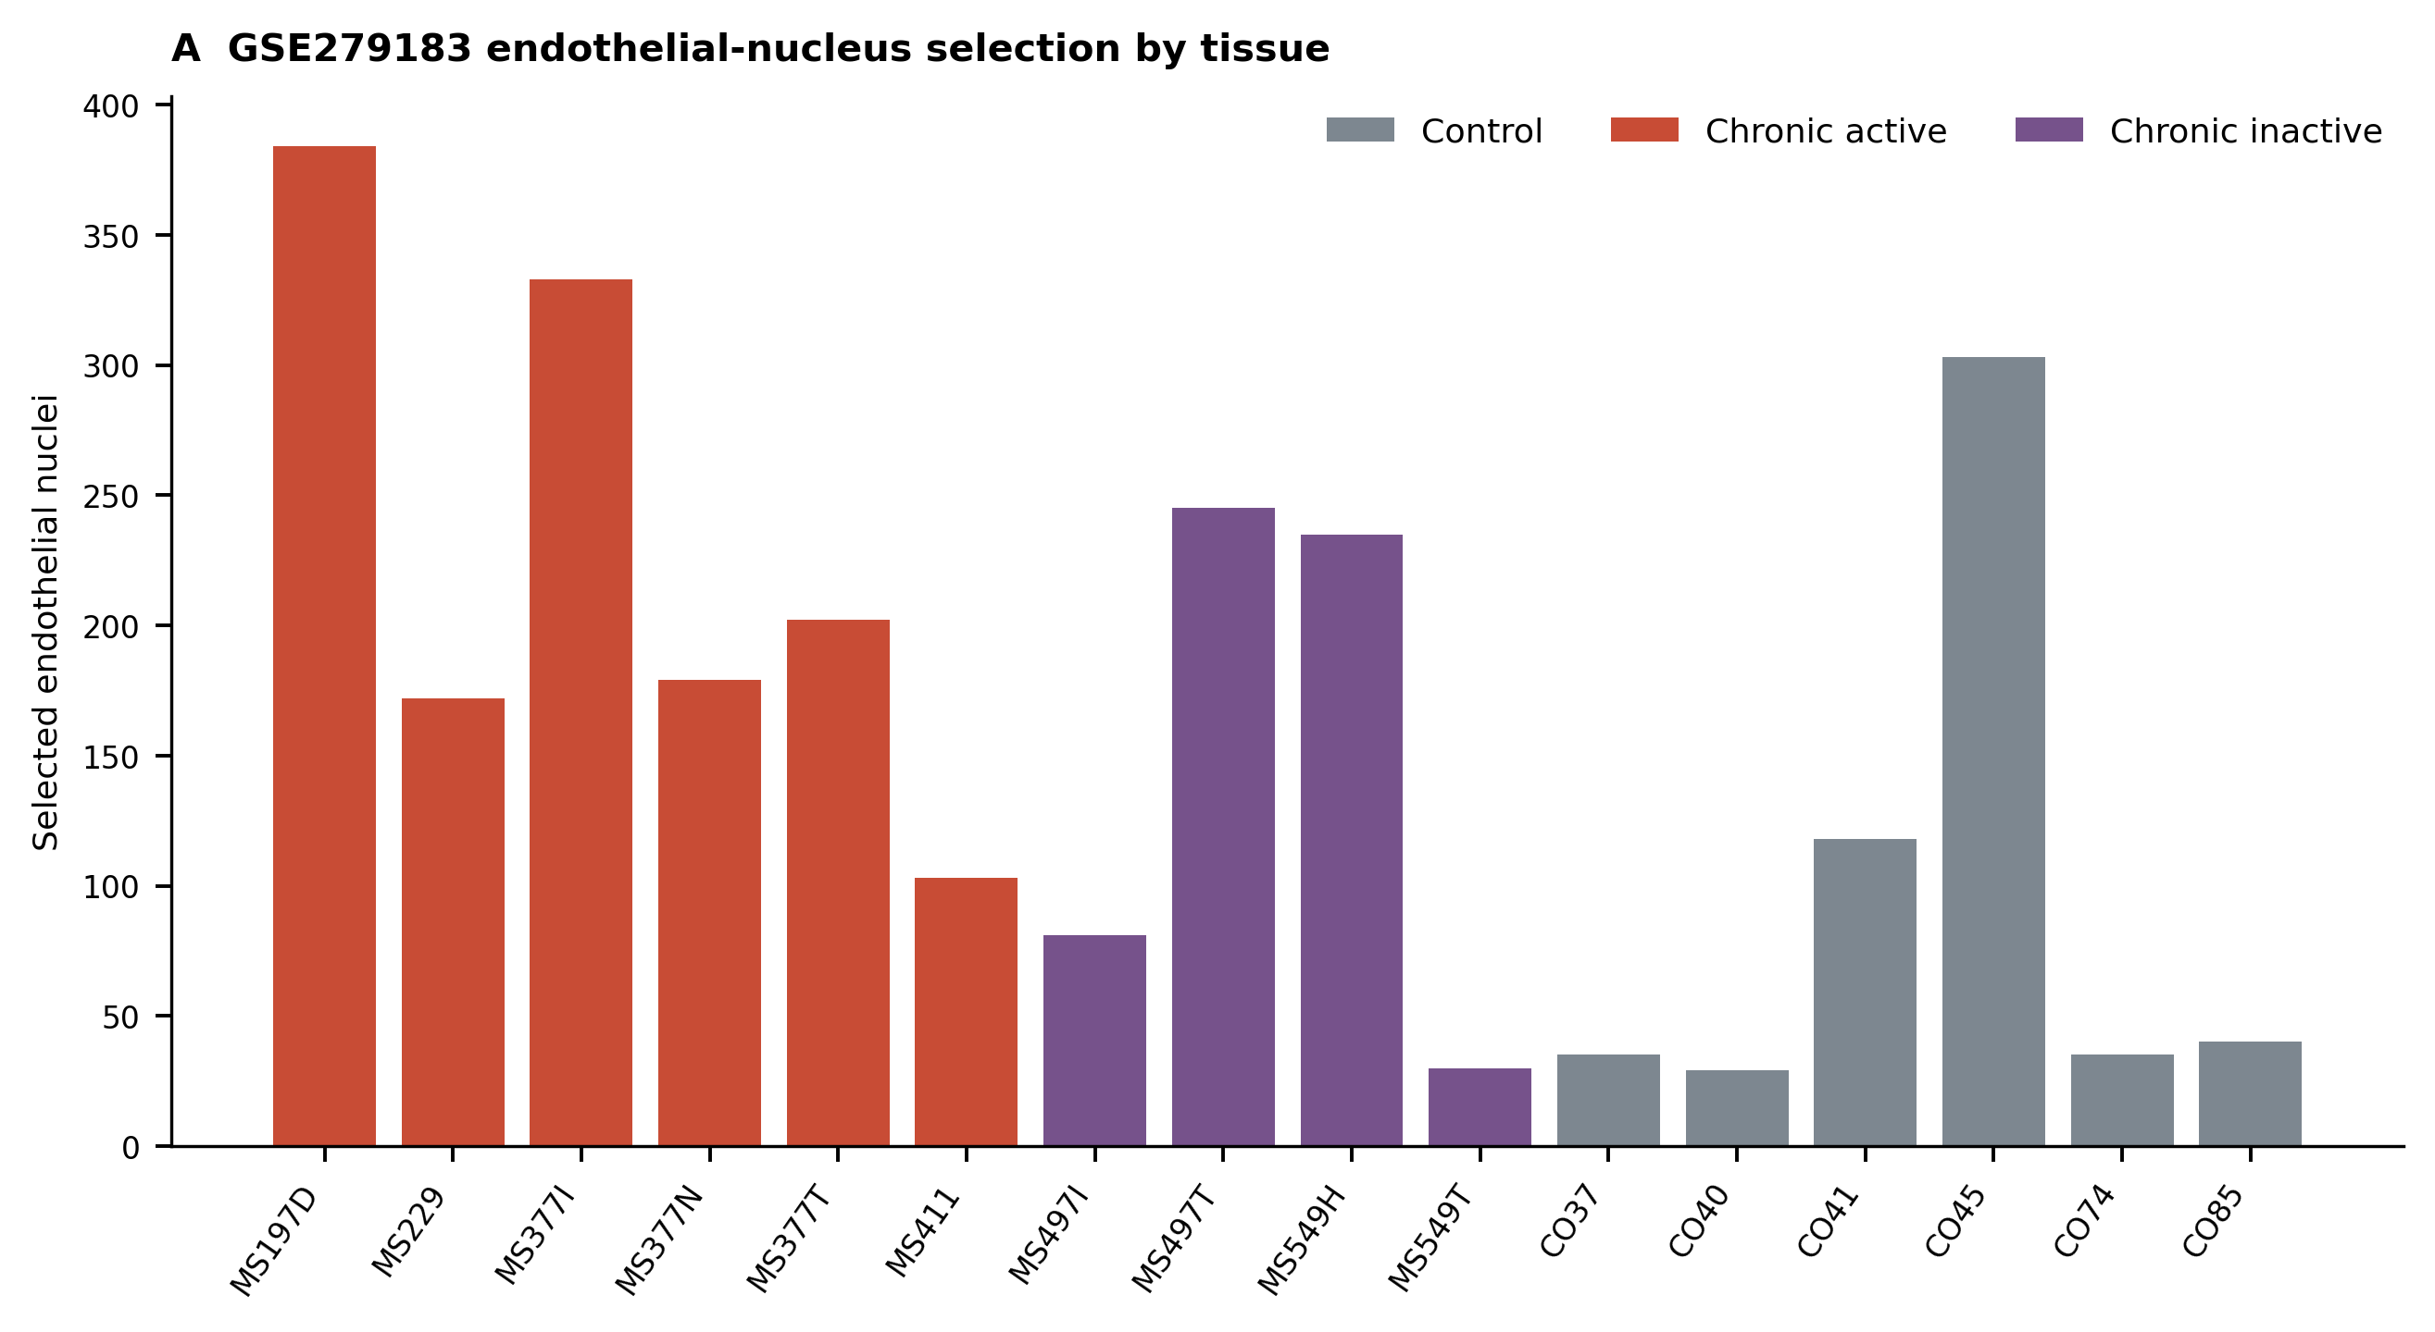

Figure S6. Sensitivity to the threshold used to select spots with high endothelial abundance in GSE208747. Differences among lesion groups are shown after adjustment for endothelial abundance. Thresholds of 20%, 30% and 40% were examined.
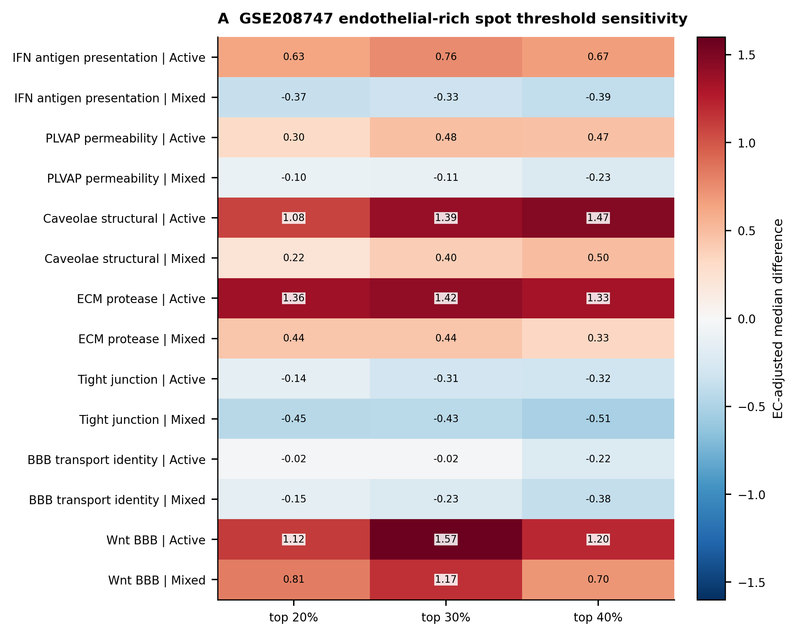

Figure S7. Analysis of CFA, acute EAE and bevacizumab in GSE210776 across all gene sets. The heatmap separates the disease change, the treatment change and the remaining difference from control.
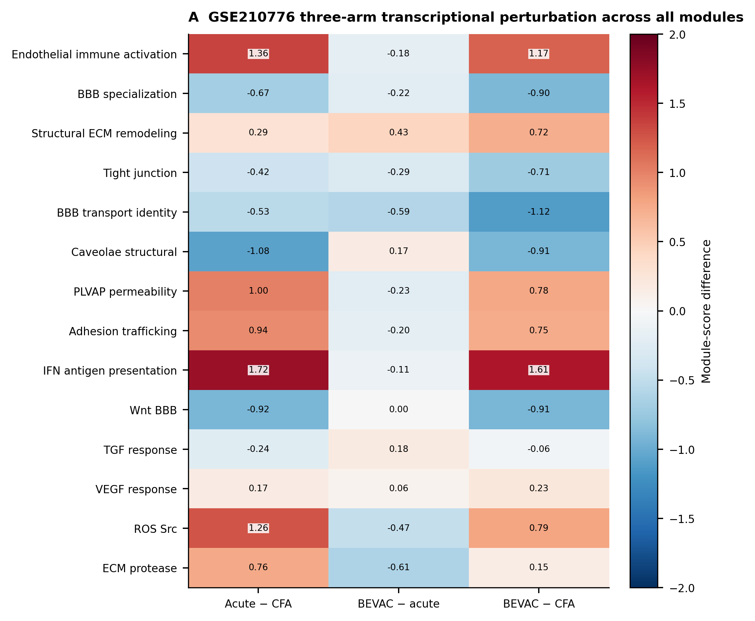

Figure S8. Published source data for barrier function and vascular proteins. Values from mice treated with r84 or IgG during chronic EAE are shown after microscopic fields were averaged within each mouse. Electrical resistance is summarized across wells because the source file did not identify independent experiments. Human CD31, EGFL7 and MCAM measurements are descriptive because donor identifiers were unavailable for individual images.
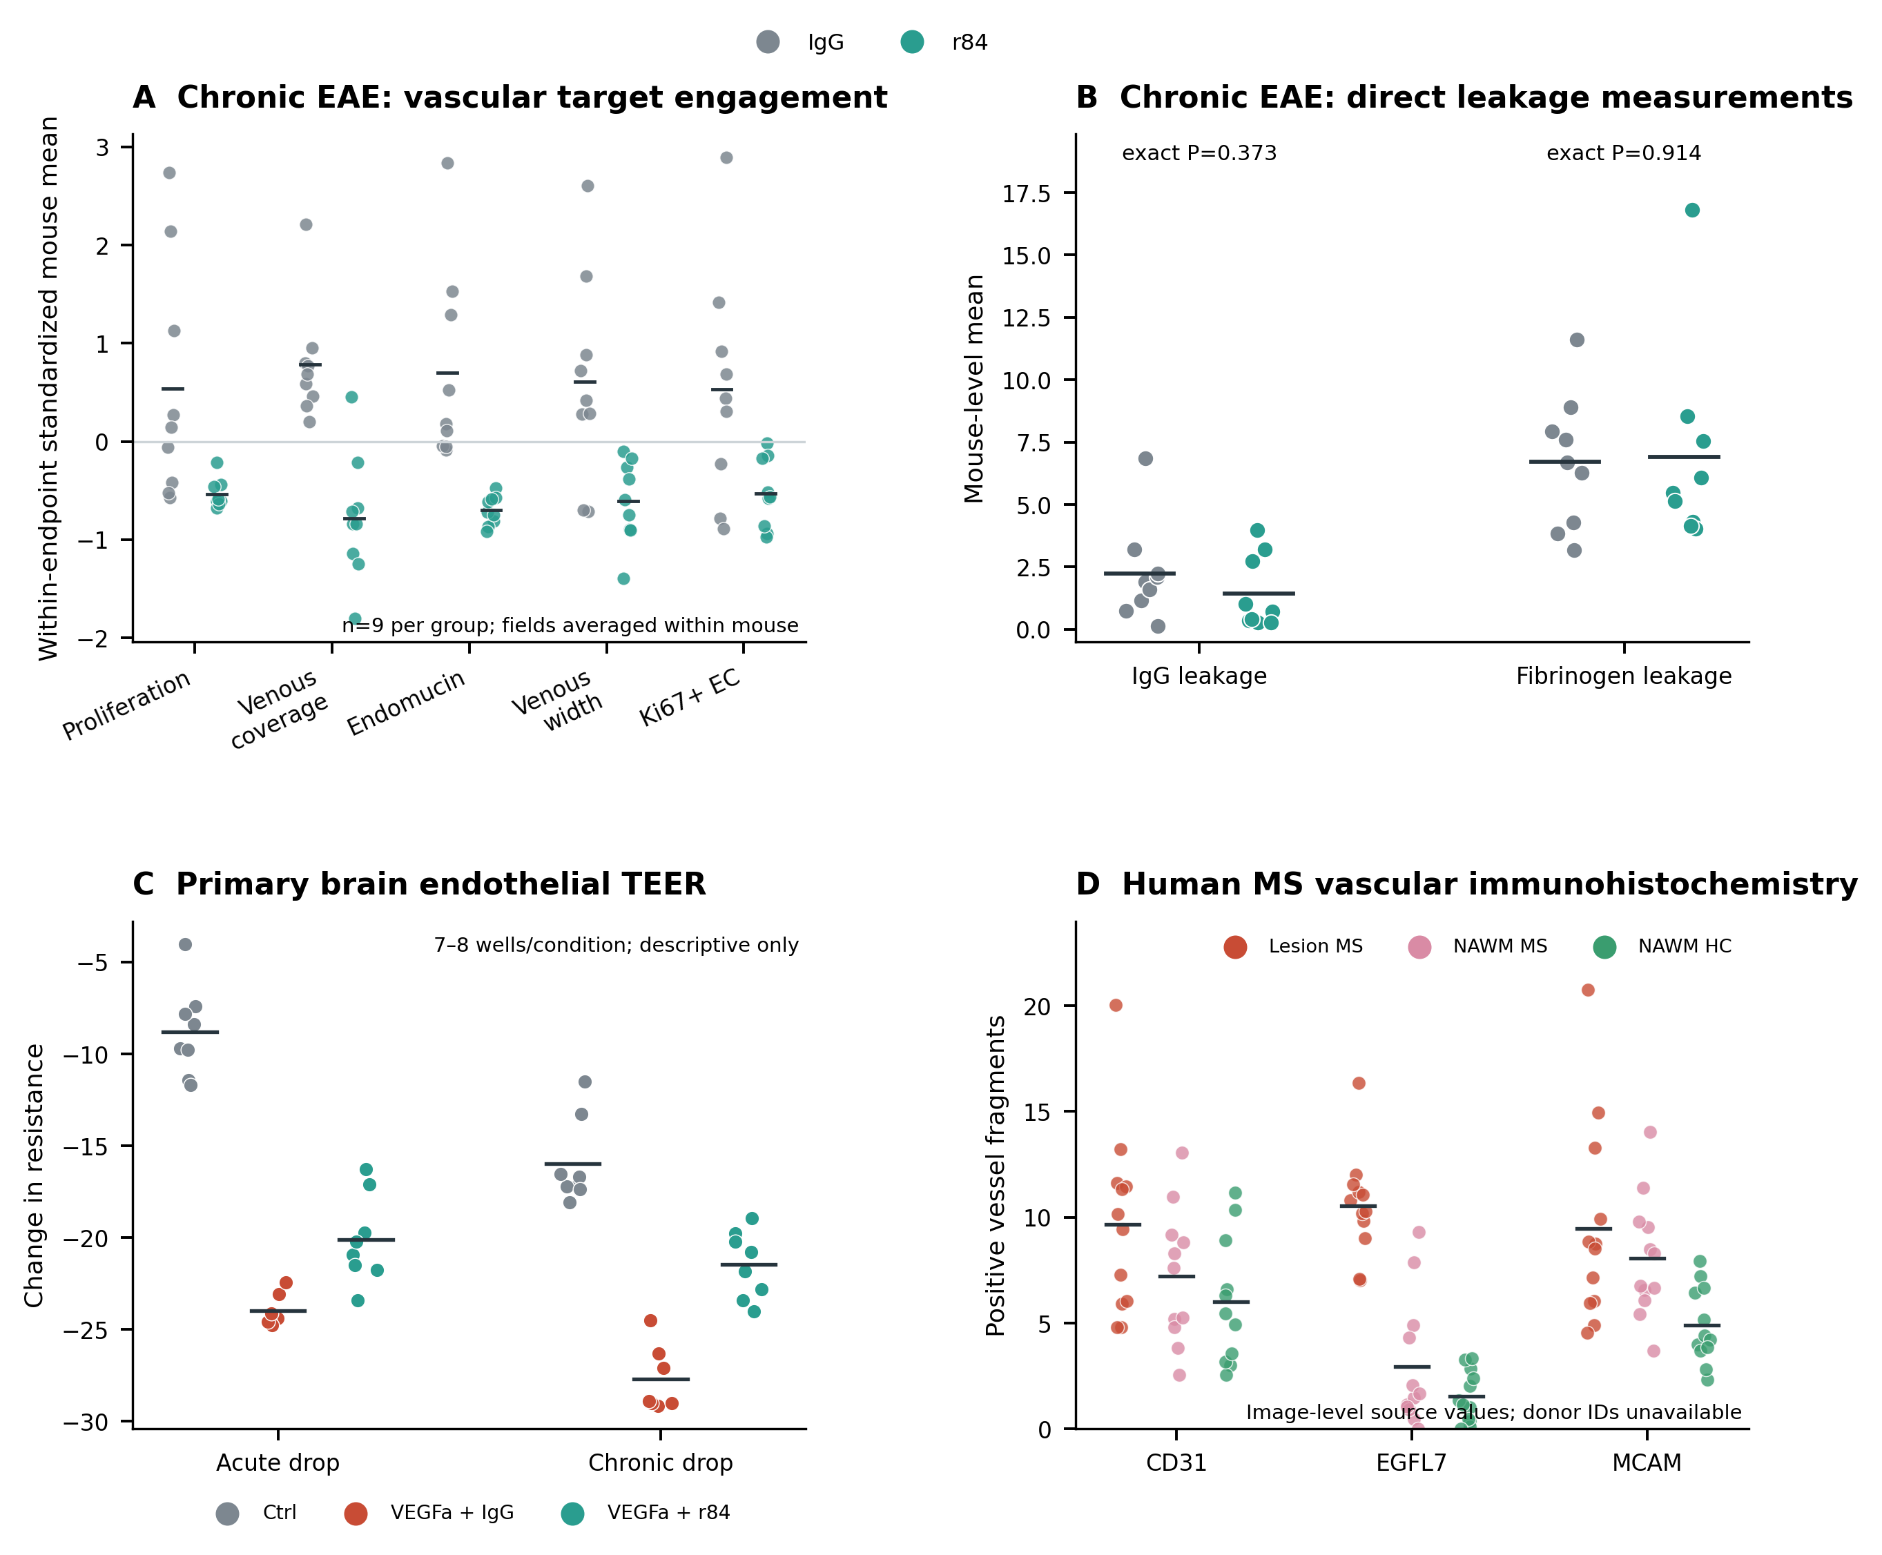

Figure S9. Expanded spatial assessment of GSE284005. (A) shows coverage of three prespecified inflammatory programs in the targeted panel. CLDN5 represented the BBB specialization program as an individual gene because the panel lacked sufficient coverage for a composite score. (B) shows how many of the five paired donors had higher expression of each measured gene in inflammatory vascular regions than in demyelinated white matter. (C) shows mean paired differences for genes at the positive and negative extremes. Individual gene directions and effect sizes are presented descriptively.
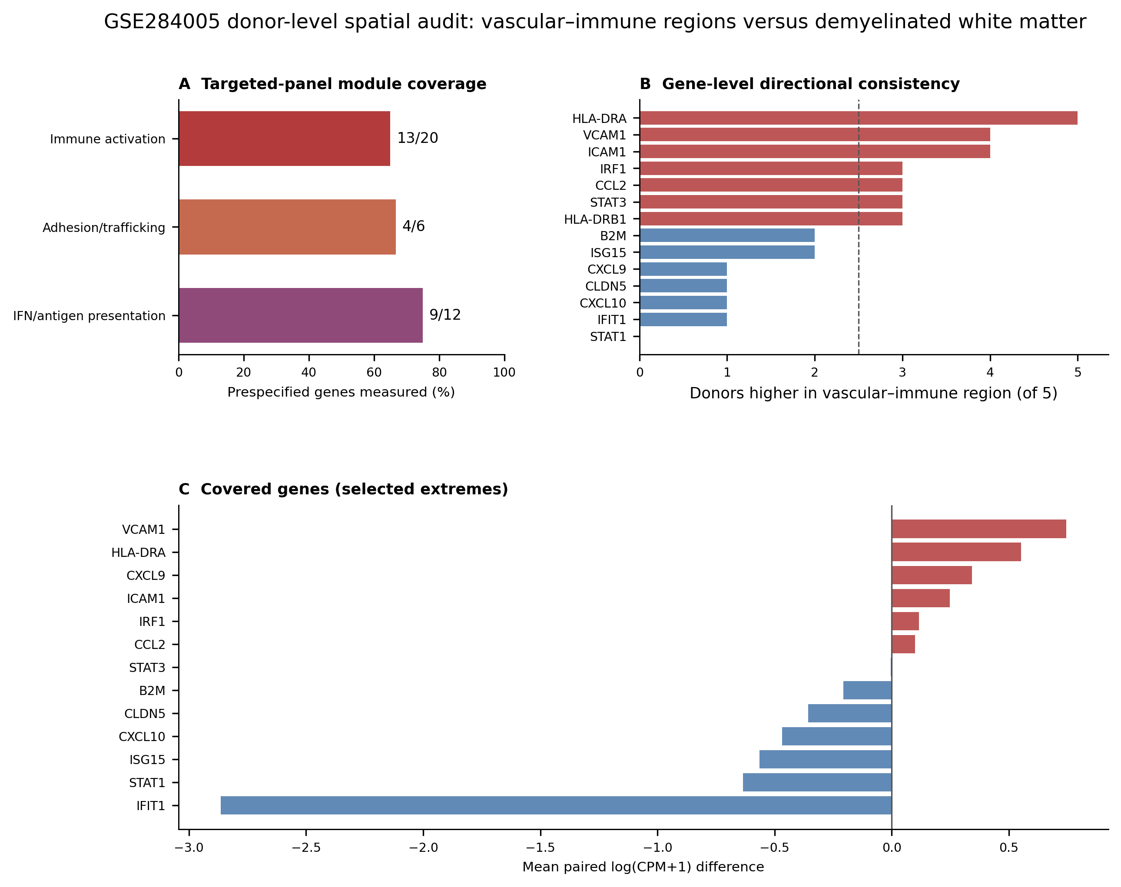

Figure S10. Focused functions using common gene symbols. The same measured genes contribute to each function in every cohort. Parentheses show the number included out of the original membership. This analysis broadens coverage and does not claim strict one to one orthology. Values show Hedges' g, with colors limited to negative five and five. No comparison survived correction across 55 tests. Table S22 supplies all genes and exact results.
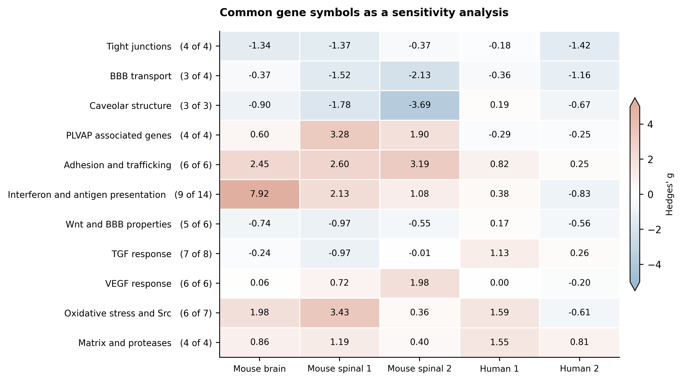

Supplementary references
1. Shahriar S, Biswas S, Zhao K, Akcan U, Tuohy MC, Glendinning MD, et al. VEGF-A-mediated venous endothelial cell proliferation results in neoangiogenesis during neuroinflammation. Nat Neurosci. 2024;27:1904–1917. https://doi.org/10.1038/s41593-024-01746-9
2. Heming M, Li X, Räuber S, Mausberg AK, Börsch AL, Hartlehnert M, et al. Neurological Manifestations of COVID-19 Feature T Cell Exhaustion and Dedifferentiated Monocytes in Cerebrospinal Fluid. Immunity. 2021;54:164–175.e6. https://doi.org/10.1016/j.immuni.2020.12.011
3. Xiao H, Xiao H, Zhang Y, Guo L, Dou Z, Liu L, et al. High-throughput sequencing unravels the cell heterogeneity of cerebrospinal fluid in the bacterial meningitis of children. Front Immunol. 2022;13:872832. https://doi.org/10.3389/fimmu.2022.872832

