Immune gene and protein profiles across blood, cerebrospinal fluid and peripheral nerve in inflammatory neuropathies
Yuan Feng¹, Fang Feng², Shuxiao Ma¹, Shuman Feng¹, Chao Jiang¹*, Yibin Hao¹*
¹ Department of Neurology, Henan Provincial People’s Hospital, People’s Hospital of Zhengzhou University, Zhengzhou 450003, China
² Department of Neurology, The First Affiliated Hospital of Zhengzhou University, Zhengzhou 450002, China
* Correspondence: Yibin Hao, haoyibin999@163.com, and Chao Jiang, chaoj@zzu.edu.cn. Postal address: No. 7 Weiwu Road, Jinshui District, Zhengzhou, Henan, China.
Research article for Human Genomics
Abstract 298 words. Main text 4332 words. Five figures and three tables.

Abstract

Background
Blood, cerebrospinal fluid and peripheral nerve capture different aspects of inflammatory neuropathy. We examined immune gene and protein profiles in Guillain Barré syndrome and chronic inflammatory demyelinating polyradiculoneuropathy using public transcriptomic datasets and published proteomic and genetic findings. We compared gene modules across three acute blood cohorts, pooled published cerebrospinal fluid protein coefficients from two cohorts, and analysed nerve expression by donor. The nerve comparison included nine donors with chronic inflammatory demyelinating polyradiculoneuropathy and 11 with chronic idiopathic axonal polyneuropathy. Published genetic candidates were mapped to nerve cell groups.

Results
CXCL8 recruitment and complement scores were higher in acute disease in all three blood cohorts. Pooled Hedges g estimates were 1.08 (95% confidence interval −0.63 to 2.78) and 1.11 (−1.73 to 3.95), respectively. Nine of ten selected cerebrospinal fluid proteins had positive coefficients in both cohorts and pooled q values below 0.05. CD5 differed in direction between cohorts and had a pooled q value of 0.984. In nerve macrophages, the Fc receptor module score was lower in inflammatory demyelinating neuropathy than in the axonal disease comparator. Its q value was 0.0087 across eight macrophage modules and 0.087 across all 80 nerve module comparisons. The difference persisted after adjustment for age and centre and decreased after adjustment for macrophage composition. Four signalling and receptor genes contributed to the lower score. Correlations among nerve modules and with disability had q values above 0.05. CDH4 expression was strongest in Schwann cell states, whereas GNG7 expression was strongest in B cells.

Conclusions
These datasets show recurring recruitment and complement expression in acute blood, inflammatory protein changes in cerebrospinal fluid, and distinct cellular expression patterns in peripheral nerve. The macrophage Fc receptor finding depends on the scope of multiple testing correction and on cellular composition. Genetic candidate localization identifies nerve cell populations for further study.

Keywords
Inflammatory neuropathy, transcriptomics, proteomics, blood nerve barrier, macrophages, genetic susceptibility

Background
Guillain Barré syndrome (GBS) and chronic inflammatory demyelinating polyradiculoneuropathy (CIDP) differ in clinical course and diagnostic criteria [1,2,3]. Antibodies, complement and macrophages contribute to nerve injury, with their roles varying across diseases and subtypes [4,5,6,7,8,9]. Peripheral nerve atlases and experimental studies have also described diverse immune and Schwann cell responses to inflammation and injury [10,11,12,13]. Leukemia inhibitory factor (LIF), for example, influences Schwann cell survival, proliferation and migration in experimental systems [14,15]. Together, these findings provide a basis for examining immune and repair gene expression in inflammatory neuropathies.
The blood nerve barrier (BNB) regulates exchange between the circulation and the endoneurium. Endothelial junctions and associated mural cells help maintain its specialized properties [16,17,18]. Experimental studies have implicated leukocyte integrins, endothelial adhesion molecules and chemokines in immune cell trafficking across this interface [19,20,21]. Changes in junctional protein expression have also been reported in CIDP nerve [22]. The BNB therefore provides an anatomical setting in which circulating immune cells can interact with the peripheral nerve environment.
Blood transcriptomic studies describe systemic immune responses in GBS using whole blood, leukocytes and peripheral blood mononuclear cells (PBMCs) [23,24,25]. Cerebrospinal fluid (CSF) proteomics provides information about inflammation and molecular injury, while nerve transcriptomics identifies the cell populations expressing related genes [26,27]. Other studies have reported monocyte changes in acute inflammatory demyelinating polyradiculoneuropathy (AIDP), altered peripheral immune profiles in CIDP and associations between blood expression and treatment response [28,29,30]. Experiments with patient immunoglobulin further support a role for the BNB in inflammatory neuropathy [31]. Genetic studies offer a complementary way to identify candidate genes [32]. Bringing these resources together can help relate systemic immune expression to the cells and pathways represented in peripheral nerve.
We compared immune gene modules across acute GBS blood cohorts, synthesized selected published CSF protein findings, and examined immune and repair modules in CIDP nerve. We then mapped published CIDP genetic candidates to nerve cell groups. Each dataset contributed measurements from its own participants, allowing us to compare recurring biological themes while accounting for differences in diagnosis, specimen and assay.

Methods

Study design and datasets
We analysed human data from blood, CSF, peripheral nerve and genetic studies. GSE211225 contained six whole blood profiles from acute GBS, ten from the postacute phase and six from healthy controls [23]. GSE31014 contained leukocyte microarrays from seven patients with GBS and seven healthy controls [24]. PRJNA1293757 contained PBMC transcriptomes from three untreated patients with AIDP and two healthy controls [25]. We used the acute disease and control groups from these three datasets to compare blood module effects.
The study associated with PXD002911 reported CSF protein and endogenous peptide identifications by diagnostic group [26]. GSE285983 comprised 365,708 nuclei from 37 sural nerves, including nine donors with CIDP and 11 with chronic idiopathic axonal polyneuropathy (CIAP) [27]. The published human BNB transcriptome associated with GSE107574 provided a reference for interpreting endothelial expression [17]. We selected genetic candidates from the genome association, Mendelian randomization and colocalization results reported by Du et al. [32]. Additional CSF reports described complement, quantitative proteomics and inflammatory proteins [33,34,35]. We extracted adjusted protein coefficients from the independent CSF discovery and replication cohorts reported by Kmezic et al. [36]. Published findings associated with PXD056286 supplied histological and proteomic observations from 55 nerve biopsies in CIDP and its variants [37]. Table 1 summarizes the resources and their analytical roles. Supplementary Data 1 lists database names, accession identifiers, original filenames and source links.

Gene modules
Seven blood modules represented CXCL8 recruitment through CXCR1 and CXCR2, LIF and oncostatin M (OSM) signalling through gp130, complement, Fc receptors, interferon signalling through JAK and STAT, inflammatory monocytes and transendothelial migration. Eight nerve modules represented BNB identity, leukocyte transmigration, CXCL8 recruitment, LIF signalling, complement, Fc receptors, macrophage state and Schwann cell myelin repair. The analysis scripts specify the genes in each module. Module scores summarize the expression of these gene sets. We assigned CSF findings to biological categories using annotations in the source publications.

Blood cohort analysis
Within each blood cohort, we standardized gene expression across participants and averaged the available genes in each module. Hedges g quantified differences between acute GBS and healthy controls. Exact label permutation tests compared mean scores, and the Benjamini and Hochberg procedure corrected P values across seven modules within each cohort [38]. We combined effects from whole blood, leukocytes and monocyte pseudobulk using a model with random effects. The DerSimonian and Laird estimator quantified variance between studies. Confidence intervals used the modified Hartung and Knapp method, with the residual variance scale bounded below by one and a t distribution with one fewer degree of freedom than the number of cohorts. We reported τ² and I² to describe heterogeneity [39,40]. We repeated the synthesis after omitting each cohort in turn. Postacute profiles contributed to the original preprocessing, but the inferential comparisons concerned acute GBS and controls. Donor independence between the acute and postacute phases could not be established from the archived design.

CSF protein synthesis
We assembled CSF evidence from selected published reports. The quantitative synthesis included all ten proteins other than IL8 that had coefficients and standard errors for both cohorts in Table 4B of Kmezic et al. [36]. Eligibility depended on the availability of paired estimates, irrespective of direction or significance. The source models adjusted for age, sex and sample handling. We pooled coefficients using inverse variance weights in a model with a fixed effect, calculated 95% confidence intervals using a normal approximation, and applied the Benjamini and Hochberg procedure to the ten pooled tests. We also reported the DerSimonian and Laird estimates, Q and I² to assess heterogeneity. IL8 was reported separately in the source study and provided contextual evidence. Protein and peptide identifications from PXD002911 and three additional reports formed a descriptive evidence map [26,33,34,35]. Counts in this map indicate the number of selected studies and assay platforms covering each biological category. The CSF analyses used published summary results.

Nerve pseudobulk analysis
We grouped GSE285983 nuclei by donor and annotated cell state. The groups included macrophages, T and natural killer cells, B cells, granulocytes, endoneurial endothelial cells, other endothelial cells, pericytes, perineurial cells, endoneurial stroma, and Schwann cells in myelinating, nonmyelinating, and repair and damage states. Groups with at least 20 nuclei per donor were eligible. We summed counts within each donor and cell group, calculated counts per million (CPM) using the total counts across all genes, and transformed expression as log2(CPM + 0.5). Donors were the biological replicates in comparisons between CIDP and CIAP [41,42,43].

Nerve modules and macrophage sensitivity analyses
Within each cell group, we standardized each gene across eligible donors from all diagnostic categories and averaged the available gene z scores to obtain module scores. We compared CIDP with CIAP using the Mann and Whitney U test and expressed the difference as the mean CIDP score minus the mean CIAP score. Multiple testing correction covered eight modules within each cell group. We also applied correction across all 80 eligible nerve module comparisons. Cell fractions were compared separately at donor level, with correction across cell groups. These fractions describe the relative representation of each population in the sampled nuclei [44].
The macrophage Fc receptor module contained 11 measured genes. FCGR2C, the twelfth specified gene, was absent from the expression matrix. We assessed individual genes with correction across 11 tests and four functional summaries with a separate correction. Sensitivity analyses restricted the comparison to male donors, standardized genes within the 20 CIDP and CIAP donors, adjusted for age and centre, and added sex to the adjusted model. Linear models used HC3 covariance estimates and residual degrees of freedom for confidence intervals. An exact permutation test preserved the number of CIDP donors within each centre. Supplementary Methods provides the model specifications.
We matched the original macrophage annotations to refined immune annotations using nucleus barcodes. Composition summaries retained nuclei with unmatched labels and those reassigned to other categories. We represented donor composition using centred log ratios and added its first two principal components to the model containing age and centre. We also reaggregated raw counts for all 20 CIDP and CIAP donors under alternative macrophage definitions. Tests of refined subtypes required at least 20 nuclei per donor and at least three eligible donors in each diagnosis group. Multiple testing correction covered the nine eligible refined subtypes.

Nerve module and disability correlations
We paired five module scores within each of the nine CIDP donors. These were endothelial LIF, endothelial leukocyte transmigration, macrophage complement, macrophage Fc receptors, and myelin repair in Schwann cells annotated as repair and damage states. Spearman correlations described their ten pairwise relationships. We also tested 15 combinations of cell group and module for associations with Inflammatory Neuropathy Cause and Treatment (INCAT) disability scores. Multiple testing correction was applied separately to the ten intermodule correlations and the 15 disability correlations.

Comparison across compartments
We compared recurring biological programs across compartments. A program entered the evidence map if it had a consistent effect direction across blood cohorts, a corresponding published CSF protein or peptide annotation, or expression in a relevant nerve cell population. The map presents blood effects, pooled CSF coefficients, descriptive protein findings and nerve expression as separate measurements. This approach compares biological themes across independently sampled cohorts without calculating a single combined score.

Genetic candidate localization
We selected CDH4, DIRAS1, GNG7 and SLC39A3 from the genetic study of 516 CIDP cases and 403,545 controls [32]. Candidate selection used the CDH4 locus reported in women and the published Mendelian randomization and colocalization findings for the other three genes. We examined their expression across nerve cell groups and compared CIDP with CIAP. CellBender counts from GSE285983 were normalized to 10,000 counts per nucleus, transformed as log2(CP10k + 1), and summarized by donor and cell group. We calculated mean expression and the proportion of nuclei with detectable expression for each donor. For each gene and cell group, 5,000 bootstrap resamples of CIDP donors provided intervals around mean expression. Differences between CIDP and CIAP were tested using the Mann and Whitney U test, with correction within each cell group. Genetic association estimates were taken from the source publication, and the analyses performed here concerned cellular expression.

Statistical analysis
Participants and nerve donors were the units of statistical inference. All hypothesis tests used both tails. We denote P values adjusted by the Benjamini and Hochberg procedure as q and use q < 0.05 within each stated testing family. The Fc component and sensitivity analyses were planned after the initial macrophage association had been observed and are exploratory. Scripts and software specifications are provided with the analysis archive. Supplementary Methods describes the inputs and intermediate tables needed to reproduce each component.

Writing and code support
ChatGPT (OpenAI) assisted with manuscript editing, reference checking, formatting and preparation of analysis and plotting code. The authors retain responsibility for the work.

Results

Datasets and analytical roles
The three blood cohorts provided estimates from whole blood, leukocytes and monocytes. Published CSF studies contributed protein measurements, and the sural nerve atlas provided expression profiles by donor and cell group. The BNB reference and genetic findings supported the interpretation and selection of nerve genes (Fig. 1 and Table 1).

Immune gene modules in acute GBS blood
Acute GBS was associated with higher scores for six of the seven modules in GSE211225 after multiple testing correction. These were CXCL8 recruitment through CXCR1 and CXCR2 (Hedges g = 1.25, q = 0.045), LIF and OSM signalling through gp130 (g = 2.19, q = 0.0076), complement (g = 2.49, q = 0.0076), Fc receptors (g = 1.36, q = 0.038), interferon signalling through JAK and STAT (g = 1.07, q = 0.045), and inflammatory monocytes (g = 1.93, q = 0.015). The transendothelial migration score was also higher (g = 0.92, q = 0.126). Together, these results describe a broad increase in immune gene expression in acute GBS whole blood.
Six of the seven module effects were positive in the independent leukocyte cohort GSE31014. CXCL8 recruitment, complement, Fc receptors, transendothelial migration, interferon signalling and inflammatory monocytes changed in the same direction as in whole blood. In PRJNA1293757 monocytes, CXCL8 recruitment had the largest positive effect (g = 1.97), followed by a positive complement effect. The remaining module effects varied in direction.
CXCL8 recruitment and complement had positive effects in all three cohorts. The pooled Hedges g was 1.08 for CXCL8 recruitment (95% confidence interval −0.63 to 2.78, P = 0.114, I² = 0%) and 1.11 for complement (95% confidence interval −1.73 to 3.95, P = 0.234, I² = 57.2%). All seven pooled confidence intervals included zero. Four other modules had positive effects in two cohorts, while LIF and OSM signalling was positive only in whole blood (Fig. 2 and Table 2).
Omitting each cohort in turn left the pooled direction positive for CXCL8 recruitment (g = 0.97 to 1.41) and complement (g = 0.48 to 1.55). Both individual effects in each retained pair were positive, although the intervals based on two cohorts were wide. Every other module had at least one cohort with a discordant effect direction.
Heterogeneity differed across modules. I² was 0% for CXCL8 recruitment and interferon signalling, 1.1% for transendothelial migration, 49.5% for inflammatory monocytes, 57.2% for complement, 72.7% for Fc receptors and 81.2% for LIF and OSM signalling. The largest variation therefore concerned pathways with strong effects in whole blood and smaller or opposite effects in the other blood populations. With three cohorts, platform, cell composition and clinical differences remain overlapping explanations for this variation.

Published CSF protein findings
Nine of the ten selected CSF proteins had positive coefficients in both cohorts. They were SELE, IL2RA, CCL3, CR2, CD1C, THBD, NRP1, CD38 and IL6. Each had a pooled q value below 0.05 after correction across ten proteins. CD5 had a discovery coefficient of −0.0882 and a replication coefficient of 1.51, giving a pooled coefficient of 0.0024 (95% confidence interval −0.237 to 0.242, q = 0.984). Heterogeneity was greatest for IL2RA (I² = 94.9%), CD5 (89.0%), IL6 (80.7%) and THBD (79.5%). In the source study, SELE and IL2RA were the two proteins in this subset that met the adjusted significance threshold in both cohorts [36]. Panels A and B of Figure 3 present the individual and pooled coefficients.
Four additional CSF reports described complementary protein findings. The study associated with PXD002911 contributed protein and peptide identifications and functional annotations [26]. D’Aguanno et al. described complement and inflammatory proteins [33], Ding et al. reported proteins related to protein handling and neural structure [34], and Sun et al. reported inflammatory proteins alongside routine CSF measurements [35]. Local inflammation was represented in three reports and protein accumulation in two. Structural proteolysis, complement, and protein handling and neural structure were each represented in one report (Fig. 3C).

Immune and repair gene expression in CIDP nerve
The sural nerve atlas localized immune and repair genes to distinct cell populations. Macrophages expressed C3, C3AR1 and FCGR2A. Endoneurial endothelial cells expressed CLDN5, ICAM1, VCAM1, LIFR, IL6ST and OSMR. Schwann cell states expressed gp130 receptor components together with genes related to myelin, stress and repair (Fig. 4A). Endothelial CLDN5 and adhesion gene expression was consistent with the cellular context described in the published human BNB transcriptome [17].
The largest statistical difference between CIDP and CIAP concerned the macrophage Fc receptor module. Its mean score was lower in CIDP by 0.673 z score units (P = 0.0011, q = 0.0087 across eight macrophage modules). Macrophage leukocyte transmigration and macrophage state scores were also lower, with differences of −0.345 (P = 0.0185, q = 0.074) and −0.368 (P = 0.0334, q = 0.089), respectively. In perineurial cells, the macrophage state and complement scores were higher by 0.758 and 0.348, respectively, with q = 0.109 for both. The endothelial BNB identity score was lower by 0.404 (P = 0.0276, q = 0.221). Correction across all 80 eligible nerve module comparisons gave q = 0.087 for the macrophage Fc receptor result (Fig. 4B).
All nine CIDP donors were male, compared with seven of the 11 CIAP donors. The Fc receptor score remained lower in the comparison restricted to male donors (difference −0.687, P = 0.0007). Adjustment for age and centre gave a difference of −0.690 (95% confidence interval −1.040 to −0.339, P = 0.0008). The exact permutation test within centres gave P = 0.0048. Estimates also remained negative after individual donors, centres or genes were omitted in turn (Supplementary Fig. 3).
Four of the 11 measured genes had lower expression with q < 0.05. These were FCGR2A, FCER1G, TYROBP and HCK. FCGRT had q = 0.713, while FCGR1A had a positive estimate with q = 0.148. The summary of signalling components was lower (q = 0.039). The activating receptor, inhibitory receptor and neonatal Fc receptor summaries had q values above 0.05. The lower composite score thus reflected differences among particular receptor and signalling genes.
Adding two macrophage composition components to the model containing age and centre reduced the estimated difference to −0.310 (95% confidence interval −1.038 to 0.419, P = 0.375). The refined macrophage union also had a lower score (P = 0.0062). All nine eligible individual refined subtype tests and all 32 annotation fraction tests had q values above 0.05 (Supplementary Fig. 4).
Cell fraction comparisons across the broad nerve groups all had q values above 0.05. The largest numerical increases in CIDP were in nonmyelinating Schwann cells (0.064), endoneurial stroma (0.027) and myelinating Schwann cells (0.013), with q = 0.515 for each (Fig. 4C).
Among the nine CIDP donors, the strongest association with INCAT disability concerned the myelin repair score in Schwann cells annotated as repair and damage states (Spearman ρ = 0.840, P = 0.0046, q = 0.069). Endothelial LIF scores had a weaker positive association (ρ = 0.602, P = 0.086). All 15 disability correlations had q values above 0.05 (Fig. 4D).
Published tissue findings provided further context for the nerve expression results. Stascheit et al. reported terminal complement complex deposition on endoneurial capillaries in 52 of 55 biopsies from patients with CIDP or its variants [37]. This count corresponds to 94.5%, with a calculated Wilson 95% confidence interval of 85.1% to 98.1%. The source study also described macrophages expressing CD68, T cells expressing CD8, and increased abundance of C3 and C6. Supplementary Figure 2 summarizes these published observations.

Relationships among nerve modules
Within the nine CIDP donors, endothelial LIF scores correlated positively with endothelial leukocyte transmigration scores (ρ = 0.667, P = 0.0499, q = 0.166) and Schwann cell myelin repair scores (ρ = 0.783, P = 0.0125, q = 0.125). Endothelial transmigration scores also correlated with macrophage complement scores (ρ = 0.683, P = 0.0424, q = 0.166). All ten intermodule correlations had q values above 0.05.
The evidence map brings these nerve findings together with the blood and CSF results. CXCL8 recruitment and complement had consistent blood effect directions and corresponding inflammatory or complement annotations in CSF. The Fc receptor module score was higher in acute GBS whole blood than in healthy controls and lower in CIDP nerve macrophages than in CIAP macrophages. Endothelial adhesion and Schwann cell repair genes localized related programs within nerve, while CSF studies described protein accumulation and proteolysis (Fig. 5 and Table 3).

Cellular expression of genetic candidates
The four genes selected from Du et al. represented two forms of published genetic evidence [32]. CDH4 was linked to the locus reported in women at 20q13.33. DIRAS1, GNG7 and SLC39A3 were selected from the Mendelian randomization and colocalization findings. Figure 5C displays the source estimates used for this selection.
In CIDP donor summaries, CDH4 expression was highest in nonmyelinating Schwann cells and Schwann cells in repair and damage states. GNG7 expression was highest in B cells and was also detected in macrophages and BNB endothelial cells. SLC39A3 expression was low, with its highest mean in BNB endothelium, while DIRAS1 was sparsely expressed. Bootstrap intervals describe variation among donors for each cell group (Supplementary Fig. 1). All displayed comparisons between CIDP and CIAP had q values above 0.05 (Fig. 5B and D).

Discussion
This analysis describes immune gene and protein profiles in blood, CSF and peripheral nerve using complementary public resources. CXCL8 recruitment and complement were the most consistent blood modules in acute GBS. Selected CSF proteins showed concordant increases across two cohorts. In nerve, immune and repair genes were distributed across macrophages, endothelium and Schwann cells, and the macrophage Fc receptor score was lower in CIDP than in CIAP. Published genetic candidates showed distinct cellular expression patterns. Together, these findings connect recurring immune themes with the nerve populations in which relevant genes are expressed.
The blood results suggest that recruitment and complement expression recur across different blood preparations in acute GBS. Six modules were significant within the whole blood cohort, whereas CXCL8 recruitment and complement retained positive directions in all three cohorts and after successive cohort omissions. Their pooled confidence intervals were wide. This pattern is compatible with the importance of chemokines and leukocyte trafficking described in experimental studies and with published CSF findings concerning IL8 [19,36,45,46,47]. Blood module scores and CSF protein concentrations nevertheless represent different measurements. Their agreement is most useful for selecting pathways to examine in paired specimens.
The CSF findings provide protein evidence for inflammation and related vascular processes. Nine of the ten selected proteins had positive coefficients in both cohorts, with SELE and IL2RA also meeting the source study’s adjusted significance threshold in each cohort [36]. The large heterogeneity for several proteins shows that the estimated magnitude varied substantially between cohorts. The complementary proteomic and peptidomic reports described inflammation, complement and molecular injury [26,33,34,35]. These findings broaden the biological context of the transcriptomic results, while retaining the distinction between the pooled analysis of ten reported proteins and the wider literature on CSF changes.
The anatomical setting also matters when interpreting these profiles. CSF samples the environment surrounding nerve roots and the neuraxis, whereas the BNB is formed by microvascular endothelial cells within peripheral nerve. Endothelial adhesion genes, immune cell expression and Schwann cell repair programs place the nerve findings within a plausible sequence of recruitment and tissue response. Because the specimens came from separate cohorts, the timing of these events remains an open question. Paired blood and CSF measurements, spatial nerve profiling and endothelial permeability assays could establish how they relate within individual patients.
The macrophage Fc receptor result was the clearest nerve module association within the original cell group analysis. Its direction persisted after demographic adjustment and omission analyses, and four receptor or signalling genes contributed to the lower score. The smaller estimate after composition adjustment indicates that the result depends partly on how macrophage populations are represented in the model. This is relevant in light of the diverse macrophage states described in the source atlas [27]. Published complement deposition on endoneurial capillaries and peripheral B cell and CD8 effector changes in CIDP add further evidence of immune involvement at different sites [29,37]. The lower Fc score relative to CIAP should therefore be interpreted as a feature of this particular macrophage comparison.
The positive association between Schwann cell myelin repair scores and disability suggests a relationship between the tissue response to injury and clinical impairment. Greater repair gene expression could accompany more extensive damage or a greater demand for repair. The q value of 0.069 and the small number of donors make its magnitude uncertain. Correlations with endothelial modules offer related questions for studies that combine transcript expression, tissue organization and clinical follow up.
Genetic candidate localization adds another perspective to the nerve atlas. The concentration of CDH4 expression in Schwann cell states and GNG7 expression in B cells helps identify cell populations in which these candidates can be studied. The CDH4 association originated from an analysis of women [32], whereas the CIDP nerve donors were all male. This difference makes the cellular findings relevant to expression context while leaving sex dependent genetic effects to be resolved. Low expression of DIRAS1 and SLC39A3 also limits precise localization. Testing the effects of these genes in appropriate cell populations is the next step in relating the published associations to nerve biology.

Limitations
The study has several limitations. The blood cohorts were small and differed in cell composition and assay platform, producing wide pooled intervals. The CSF synthesis covered ten proteins selected for reporting in the source publication, and the broader evidence map was assembled from four selected studies. Its coverage is therefore restricted to those reports. The pooled CSF tests used a normal approximation, which differs from the regression tests used in the original small cohorts.
The nerve comparison included nine CIDP donors and 11 donors with an axonal neuropathy. It therefore describes differences between two disease groups. All CIDP donors were male, recruitment centres were imbalanced, and treatment or other clinical differences could influence expression. The Fc receptor association had q = 0.087 across all 80 nerve module comparisons and became smaller after composition adjustment. The component and sensitivity analyses followed the initial observation, and subtype estimates were based on few eligible donors. These features call for evaluation in a larger independent nerve cohort.
Blood, CSF and nerve came from separate cohorts, with diagnosis partly linked to specimen type. The design thus compares disease and tissue profiles together. The companion spatial panel contained none of the specified Fc receptor module genes, leaving that association without spatial confirmation. Genetic estimates came from the published study, while our analyses measured cellular expression. Mechanistic relationships among the compartments remain to be tested with matched samples and functional experiments.

Conclusions
Public blood, CSF and nerve datasets reveal complementary immune expression patterns in inflammatory neuropathies. CXCL8 recruitment and complement recur across acute GBS blood cohorts, while CSF protein findings describe inflammation and related vascular changes. The nerve atlas places immune and repair genes in specific cell populations and identifies lower macrophage Fc receptor expression in CIDP than in CIAP. The estimate varies with cellular composition, and its statistical support depends on the scope of multiple testing correction. Localization of published genetic candidates adds a cellular basis for further investigation. These results identify specific pathways and nerve populations for studies using paired specimens and independent cohorts.

List of abbreviations
AIDP, acute inflammatory demyelinating polyradiculoneuropathy. BNB, blood nerve barrier. CIAP, chronic idiopathic axonal polyneuropathy. CIDP, chronic inflammatory demyelinating polyradiculoneuropathy. CPM, counts per million. CP10k, counts per 10,000. CSF, cerebrospinal fluid. FDR, false discovery rate. GBS, Guillain Barré syndrome. GWAS, genome wide association study. INCAT, Inflammatory Neuropathy Cause and Treatment. LIF, leukemia inhibitory factor. OSM, oncostatin M. PBMC, peripheral blood mononuclear cell.

Declarations

Ethics approval and consent to participate
This study analysed publicly available deidentified data and published results. The source studies reported their ethics approvals and consent procedures. No new participants were recruited and no new specimens were collected.

Consent for publication
Not applicable. The manuscript contains no identifiable personal information.

Availability of data and materials
Database names, accession identifiers, original filenames and source links are listed in Supplementary Data 1, together with aggregate data underlying the figures and tables. Supplementary Methods describes the analysis procedures and reconstruction of intermediate tables. Acquisition dates and checksums are provided where they were recorded.
Analysis code and aggregate results are available in the GitHub repository and in the version 2.3.0 archive on Zenodo [48,49]. This release contains the CSF coefficient synthesis, macrophage sensitivity analyses, annotation comparisons and source documentation used in this manuscript. Complete recalculation requires the original inputs. The genetic localization scripts additionally require the donor expression intermediate described in Supplementary Methods.

Competing interests
The authors declare that they have no competing interests.

Funding
This work was supported by the Henan Medical Science and Technology Talent Overseas Training Program (HNMOT2024022) and the Henan Provincial Medical Science and Technology Research Program (LHGJ20250063 and SBGJ202401001).

Authors' contributions
YF conceived the study, developed the analytical framework, performed the analyses and drafted the manuscript. FF curated data, validated results and revised the manuscript. SXM contributed to validation, interpretation and manuscript revision. SMF contributed to data curation, literature evaluation and manuscript revision. CJ supervised the methodology and critically revised the manuscript. YH supervised the study, coordinated the project and critically revised the manuscript.

Acknowledgements
We thank the participants and investigators who generated and shared the datasets.

Supplementary information
Additional file 1. Supplementary_Data_1_v41.xlsx. Excel workbook containing the aggregate source tables, sensitivity results and database access documentation cited as Supplementary Data 1.
Additional file 2. Supplementary_Methods_v41.docx. Detailed analytical procedures and reconstruction instructions, cited as Supplementary Methods.
Additional file 3. Supplementary_Figures_v41.docx. Supplementary Figures 1 to 4 with their legends, showing candidate gene localization, published nerve findings and macrophage sensitivity analyses.

References
1. Willison HJ, Jacobs BC, van Doorn PA. Guillain-Barré syndrome. Lancet. 2016;388(10045):717-727. https://doi.org/10.1016/S0140-6736(16)00339-1.
2. van Doorn PA, Van den Bergh PYK, Hadden RDM, Avau B, Vankrunkelsven P, Attarian S, et al. European Academy of Neurology/Peripheral Nerve Society Guideline on diagnosis and treatment of Guillain-Barré syndrome. Eur J Neurol. 2023;30(12):3646-3674. https://doi.org/10.1111/ene.16073.
3. Van den Bergh PYK, van Doorn PA, Hadden RDM, Avau B, Vankrunkelsven P, Allen JA, et al. European Academy of Neurology/Peripheral Nerve Society guideline on diagnosis and treatment of chronic inflammatory demyelinating polyradiculoneuropathy: Report of a joint Task Force-Second revision. Eur J Neurol. 2021;28(11):3556-3583. https://doi.org/10.1111/ene.14959.
4. Quast I, Cueni F, Nimmerjahn F, Tackenberg B, Lünemann JD. Deregulated Fcγ receptor expression in patients with CIDP. Neurol Neuroimmunol Neuroinflamm. 2015;2(5):e148. https://doi.org/10.1212/NXI.0000000000000148.
5. Hafer-Macko CE, Sheikh KA, Li CY, Ho TW, Cornblath DR, McKhann GM, et al. Immune attack on the Schwann cell surface in acute inflammatory demyelinating polyneuropathy. Ann Neurol. 1996;39(5):625-635. https://doi.org/10.1002/ana.410390512.
6. Koike H, Nishi R, Ikeda S, Kawagashira Y, Iijima M, Katsuno M, et al. Ultrastructural mechanisms of macrophage-induced demyelination in CIDP. Neurology. 2018;91(23):1051-1060. https://doi.org/10.1212/WNL.0000000000006625.
7. Susuki K, Rasband MN, Tohyama K, Koibuchi K, Okamoto S, Funakoshi K, et al. Anti-GM1 antibodies cause complement-mediated disruption of sodium channel clusters in peripheral motor nerve fibers. J Neurosci. 2007;27(15):3956-3967. https://doi.org/10.1523/JNEUROSCI.4401-06.2007.
8. Kiefer R, Kieseier BC, Stoll G, Hartung HP. The role of macrophages in immune-mediated damage to the peripheral nervous system. Prog Neurobiol. 2001;64(2):109-127. https://doi.org/10.1016/s0301-0082(00)00060-5.
9. Shen D, Chu F, Lang Y, Geng Y, Zheng X, Zhu J, et al. Beneficial or Harmful Role of Macrophages in Guillain-Barré Syndrome and Experimental Autoimmune Neuritis. Mediators Inflamm. 2018;2018:4286364. https://doi.org/10.1155/2018/4286364.
10. Wolbert J, Li X, Heming M, Mausberg AK, Akkermann D, Frydrychowicz C, et al. Redefining the heterogeneity of peripheral nerve cells in health and autoimmunity. Proc Natl Acad Sci U S A. 2020;117(17):9466-9476. https://doi.org/10.1073/pnas.1912139117.
11. Arthur-Farraj PJ, Latouche M, Wilton DK, Quintes S, Chabrol E, Banerjee A, et al. c-Jun reprograms Schwann cells of injured nerves to generate a repair cell essential for regeneration. Neuron. 2012;75(4):633-647. https://doi.org/10.1016/j.neuron.2012.06.021.
12. Jessen KR, Mirsky R. The repair Schwann cell and its function in regenerating nerves. J Physiol. 2016;594(13):3521-3531. https://doi.org/10.1113/JP270874.
13. Napoli I, Noon LA, Ribeiro S, Kerai AP, Parrinello S, Rosenberg LH, et al. A central role for the ERK-signaling pathway in controlling Schwann cell plasticity and peripheral nerve regeneration in vivo. Neuron. 2012;73(4):729-742. https://doi.org/10.1016/j.neuron.2011.11.031.
14. Dowsing BJ, Morrison WA, Nicola NA, Starkey GP, Bucci T, Kilpatrick TJ. Leukemia inhibitory factor is an autocrine survival factor for Schwann cells. J Neurochem. 1999;73(1):96-104. https://doi.org/10.1046/j.1471-4159.1999.0730096.x.
15. Chen Q, Liu Q, Zhang Y, Li S, Yi S. Leukemia inhibitory factor regulates Schwann cell proliferation and migration and affects peripheral nerve regeneration. Cell Death Dis. 2021;12(5):417. https://doi.org/10.1038/s41419-021-03706-8.
16. Ubogu EE. Biology of the human blood-nerve barrier in health and disease. Exp Neurol. 2020;328:113272. https://doi.org/10.1016/j.expneurol.2020.113272.
17. Palladino SP, Helton ES, Jain P, Dong C, Crowley MR, Crossman DK, et al. The Human Blood-Nerve Barrier Transcriptome. Sci Rep. 2017;7(1):17477. https://doi.org/10.1038/s41598-017-17475-y.
18. Yosef N, Xia RH, Ubogu EE. Development and characterization of a novel human in vitro blood-nerve barrier model using primary endoneurial endothelial cells. J Neuropathol Exp Neurol. 2010;69(1):82-97. https://doi.org/10.1097/NEN.0b013e3181c84a9a.
19. Yosef N, Ubogu EE. α(M)β(2)-integrin-intercellular adhesion molecule-1 interactions drive the flow-dependent trafficking of Guillain-Barré syndrome patient derived mononuclear leukocytes at the blood-nerve barrier in vitro. J Cell Physiol. 2012;227(12):3857-3875. https://doi.org/10.1002/jcp.24100.
20. Dong C, Greathouse KM, Beacham RL, Palladino SP, Helton ES, Ubogu EE. Fibronectin connecting segment-1 peptide inhibits pathogenic leukocyte trafficking and inflammatory demyelination in experimental models of chronic inflammatory demyelinating polyradiculoneuropathy. Exp Neurol. 2017;292:35-45. https://doi.org/10.1016/j.expneurol.2017.02.012.
21. Langert KA, Von Zee CL, Stubbs EB Jr. Tumour necrosis factor α enhances CCL2 and ICAM-1 expression in peripheral nerve microvascular endoneurial endothelial cells. ASN Neuro. 2013;5(1):e00104. https://doi.org/10.1042/AN20120048.
22. Kanda T. Chronic inflammatory demyelinating polyneuropathy: decreased claudin-5 and relocated ZO-1. J Neurol Neurosurg Psychiatry. 2004;75(5):765-769. https://doi.org/10.1136/jnnp.2003.025692.
23. Lima MFdO, Nogueira VB, Maury W, Wilson ME, Júnior METD, Teixeira DG, et al. Altered Cellular Pathways in the Blood of Patients With Guillain-Barre Syndrome. J Peripher Nerv Syst. 2025;30(1):e70012. https://doi.org/10.1111/jns.70012.
24. Chang KH, Chuang TJ, Lyu RK, Ro LS, Wu YR, Chang HS, et al. Identification of gene networks and pathways associated with Guillain-Barré syndrome. PLoS One. 2012;7(1):e29506. https://doi.org/10.1371/journal.pone.0029506.
25. Shi P, Diao Y, Yang H, Li R, Ye M, Liu D, et al. Single cell transcriptome profiling of peripheral blood mononuclear cells in Guillain-Barré syndrome patients. Sci Data. 2026;13(1):843. https://doi.org/10.1038/s41597-026-07489-5.
26. Ziganshin RH, Ivanova OM, Lomakin YA, Belogurov AA Jr, Kovalchuk SI, Azarkin IV, et al. The Pathogenesis of the Demyelinating Form of Guillain-Barre Syndrome (GBS): Proteo-peptidomic and Immunological Profiling of Physiological Fluids. Mol Cell Proteomics. 2016;15(7):2366-2378. https://doi.org/10.1074/mcp.M115.056036.
27. Heming M, Börsch AL, Wolbert J, Thomas C, Mausberg AK, Szepanowski F, et al. Multi-omic identification of perineurial hyperplasia and lipid-associated nerve macrophages in human polyneuropathies. Nat Commun. 2025;16(1):7872. https://doi.org/10.1038/s41467-025-62964-8.
28. Li M, Song J, Yin P, Chen H, Wang Y, Xu C, et al. Single-cell analysis reveals novel clonally expanded monocytes associated with IL1β-IL1R2 pair in acute inflammatory demyelinating polyneuropathy. Sci Rep. 2023;13(1):5862. https://doi.org/10.1038/s41598-023-32427-5.
29. Kim H, Chun J, Cha DH, Lee JS, Seo D, Shin W, et al. Integrated peripheral immune profiling reveals B-cell dysregulation and CD8 effector signatures in chronic inflammatory demyelinating polyneuropathy. Front Immunol. 2026;17:1888882. https://doi.org/10.3389/fimmu.2026.1888882.
30. Richard A, Corvol JC, Debs R, Reach P, Tahiri K, Carpentier W, et al. Transcriptome Analysis of Peripheral Blood in Chronic Inflammatory Demyelinating Polyradiculoneuropathy Patients Identifies TNFR1 and TLR Pathways in the IVIg Response. Medicine (Baltimore). 2016;95(19):e3370. https://doi.org/10.1097/MD.0000000000003370.
31. Shimizu F, Sato R, Mizukami Y, Watanabe K, Maeda T, Kanda T, et al. Blood-Nerve Barrier Breakdown Induced by Immunoglobulin G in Typical and Multifocal Chronic Inflammatory Demyelinating Polyneuropathy and Multifocal Motor Neuropathy. Int J Mol Sci. 2026;27(2):1088. https://doi.org/10.3390/ijms27021088.
32. Du Z, Lessard S, Iyyanki T, Chao M, Hammond T, Ofengeim D, et al. Genetic analyses of inflammatory polyneuropathy and chronic inflammatory demyelinating polyradiculoneuropathy identified candidate genes. HGG Adv. 2024;5(3):100317. https://doi.org/10.1016/j.xhgg.2024.100317.
33. D’Aguanno S, Franciotta D, Lupisella S, Barassi A, Pieragostino D, Lugaresi A, et al. Protein profiling of Guillain-Barrè syndrome cerebrospinal fluid by two-dimensional electrophoresis and mass spectrometry. Neurosci Lett. 2010;485(1):49-54. https://doi.org/10.1016/j.neulet.2010.08.060.
34. Ding Y, Shi Y, Wang L, Li G, Osman RA, Sun J, et al. Potential biomarkers identified by tandem mass tags based quantitative proteomics for diagnosis and classification of Guillain-Barré syndrome. Eur J Neurol. 2022;29(4):1155-1164. https://doi.org/10.1111/ene.15213.
35. Sun S, Li M, Song J, Zhong D. Using Olink Proteomics to Identify Inflammatory Biomarkers in the Cerebrospinal Fluid in Guillain-Barré Syndrome. J Inflamm Res. 2025;18:6703-6717. https://doi.org/10.2147/JIR.S507515.
36. Kmezic I, Gustafsson R, Fink K, Svenningsson A, Samuelsson K, Ingre C, et al. Validation of elevated levels of interleukin-8 in the cerebrospinal fluid, and discovery of new biomarkers in patients with GBS and CIDP using a proximity extension assay. Front Immunol. 2023;14:1241199. https://doi.org/10.3389/fimmu.2023.1241199.
37. Stascheit F, Roos A, Schroeter CB, Thomas JK, Hahn K, Preßler H, et al. Complement profiling of sural nerves in chronic-inflammatory demyelinating polyneuropathy. Acta Neuropathol. 2025;150(1):32. https://doi.org/10.1007/s00401-025-02936-w.
38. Benjamini Y, Hochberg Y. Controlling the False Discovery Rate: A Practical and Powerful Approach to Multiple Testing. J R Stat Soc Series B Methodol. 1995;57(1):289-300. https://doi.org/10.1111/j.2517-6161.1995.tb02031.x.
39. Higgins JPT, Thompson SG, Deeks JJ, Altman DG. Measuring inconsistency in meta-analyses. BMJ. 2003;327(7414):557-560. https://doi.org/10.1136/bmj.327.7414.557.
40. IntHout J, Ioannidis JP, Borm GF. The Hartung-Knapp-Sidik-Jonkman method for random effects meta-analysis is straightforward and considerably outperforms the standard DerSimonian-Laird method. BMC Med Res Methodol. 2014;14(1):25. https://doi.org/10.1186/1471-2288-14-25.
41. Squair JW, Gautier M, Kathe C, Anderson MA, James ND, Hutson TH, et al. Confronting false discoveries in single-cell differential expression. Nat Commun. 2021;12(1):5692. https://doi.org/10.1038/s41467-021-25960-2.
42. Crowell HL, Soneson C, Germain PL, Calini D, Collin L, Raposo C, et al. muscat detects subpopulation-specific state transitions from multi-sample multi-condition single-cell transcriptomics data. Nat Commun. 2020;11(1):6077. https://doi.org/10.1038/s41467-020-19894-4.
43. Zimmerman KD, Espeland MA, Langefeld CD. A practical solution to pseudoreplication bias in single-cell studies. Nat Commun. 2021;12(1):738. https://doi.org/10.1038/s41467-021-21038-1.
44. Aitchison J. The Statistical Analysis of Compositional Data. J R Stat Soc Series B Methodol. 1982;44(2):139-160. https://doi.org/10.1111/j.2517-6161.1982.tb01195.x.
45. Breville G, Lascano AM, Roux-Lombard P, Vuilleumier N, Lalive PH. Interleukin 8, a Biomarker to Differentiate Guillain-Barré Syndrome From CIDP. Neurol Neuroimmunol Neuroinflamm. 2021;8(5):e1031. https://doi.org/10.1212/NXI.0000000000001031.
46. Heming M, Schulte-Mecklenbeck A, Brix T, Wolbert J, Ruland T, Klotz L, et al. Immune Cell Profiling of the Cerebrospinal Fluid Provides Pathogenetic Insights Into Inflammatory Neuropathies. Front Immunol. 2019;10:515. https://doi.org/10.3389/fimmu.2019.00515.
47. Xia RH, Yosef N, Ubogu EE. Selective expression and cellular localization of pro-inflammatory chemokine ligand/receptor pairs in the sciatic nerves of a severe murine experimental autoimmune neuritis model of Guillain-Barré syndrome. Neuropathol Appl Neurobiol. 2010;36(5):388-398. https://doi.org/10.1111/j.1365-2990.2010.01092.x.
48. Feng Y. gbs-cidp-blood-nerve-barrier. Version 2.3.0. GitHub. https://github.com/applepie567/gbs-cidp-blood-nerve-barrier/releases/tag/v2.3.0. Accessed 7 September 2026.
49. Feng Y, Feng F, Ma S, Feng S, Jiang C, Hao Y. Immune gene and protein profiles across blood, cerebrospinal fluid and peripheral nerve in inflammatory neuropathies. Version 2.3.0. Zenodo. 2026. https://doi.org/10.5281/zenodo.22641099.

Figures and legends

Figure 1. Study design and analytical roles
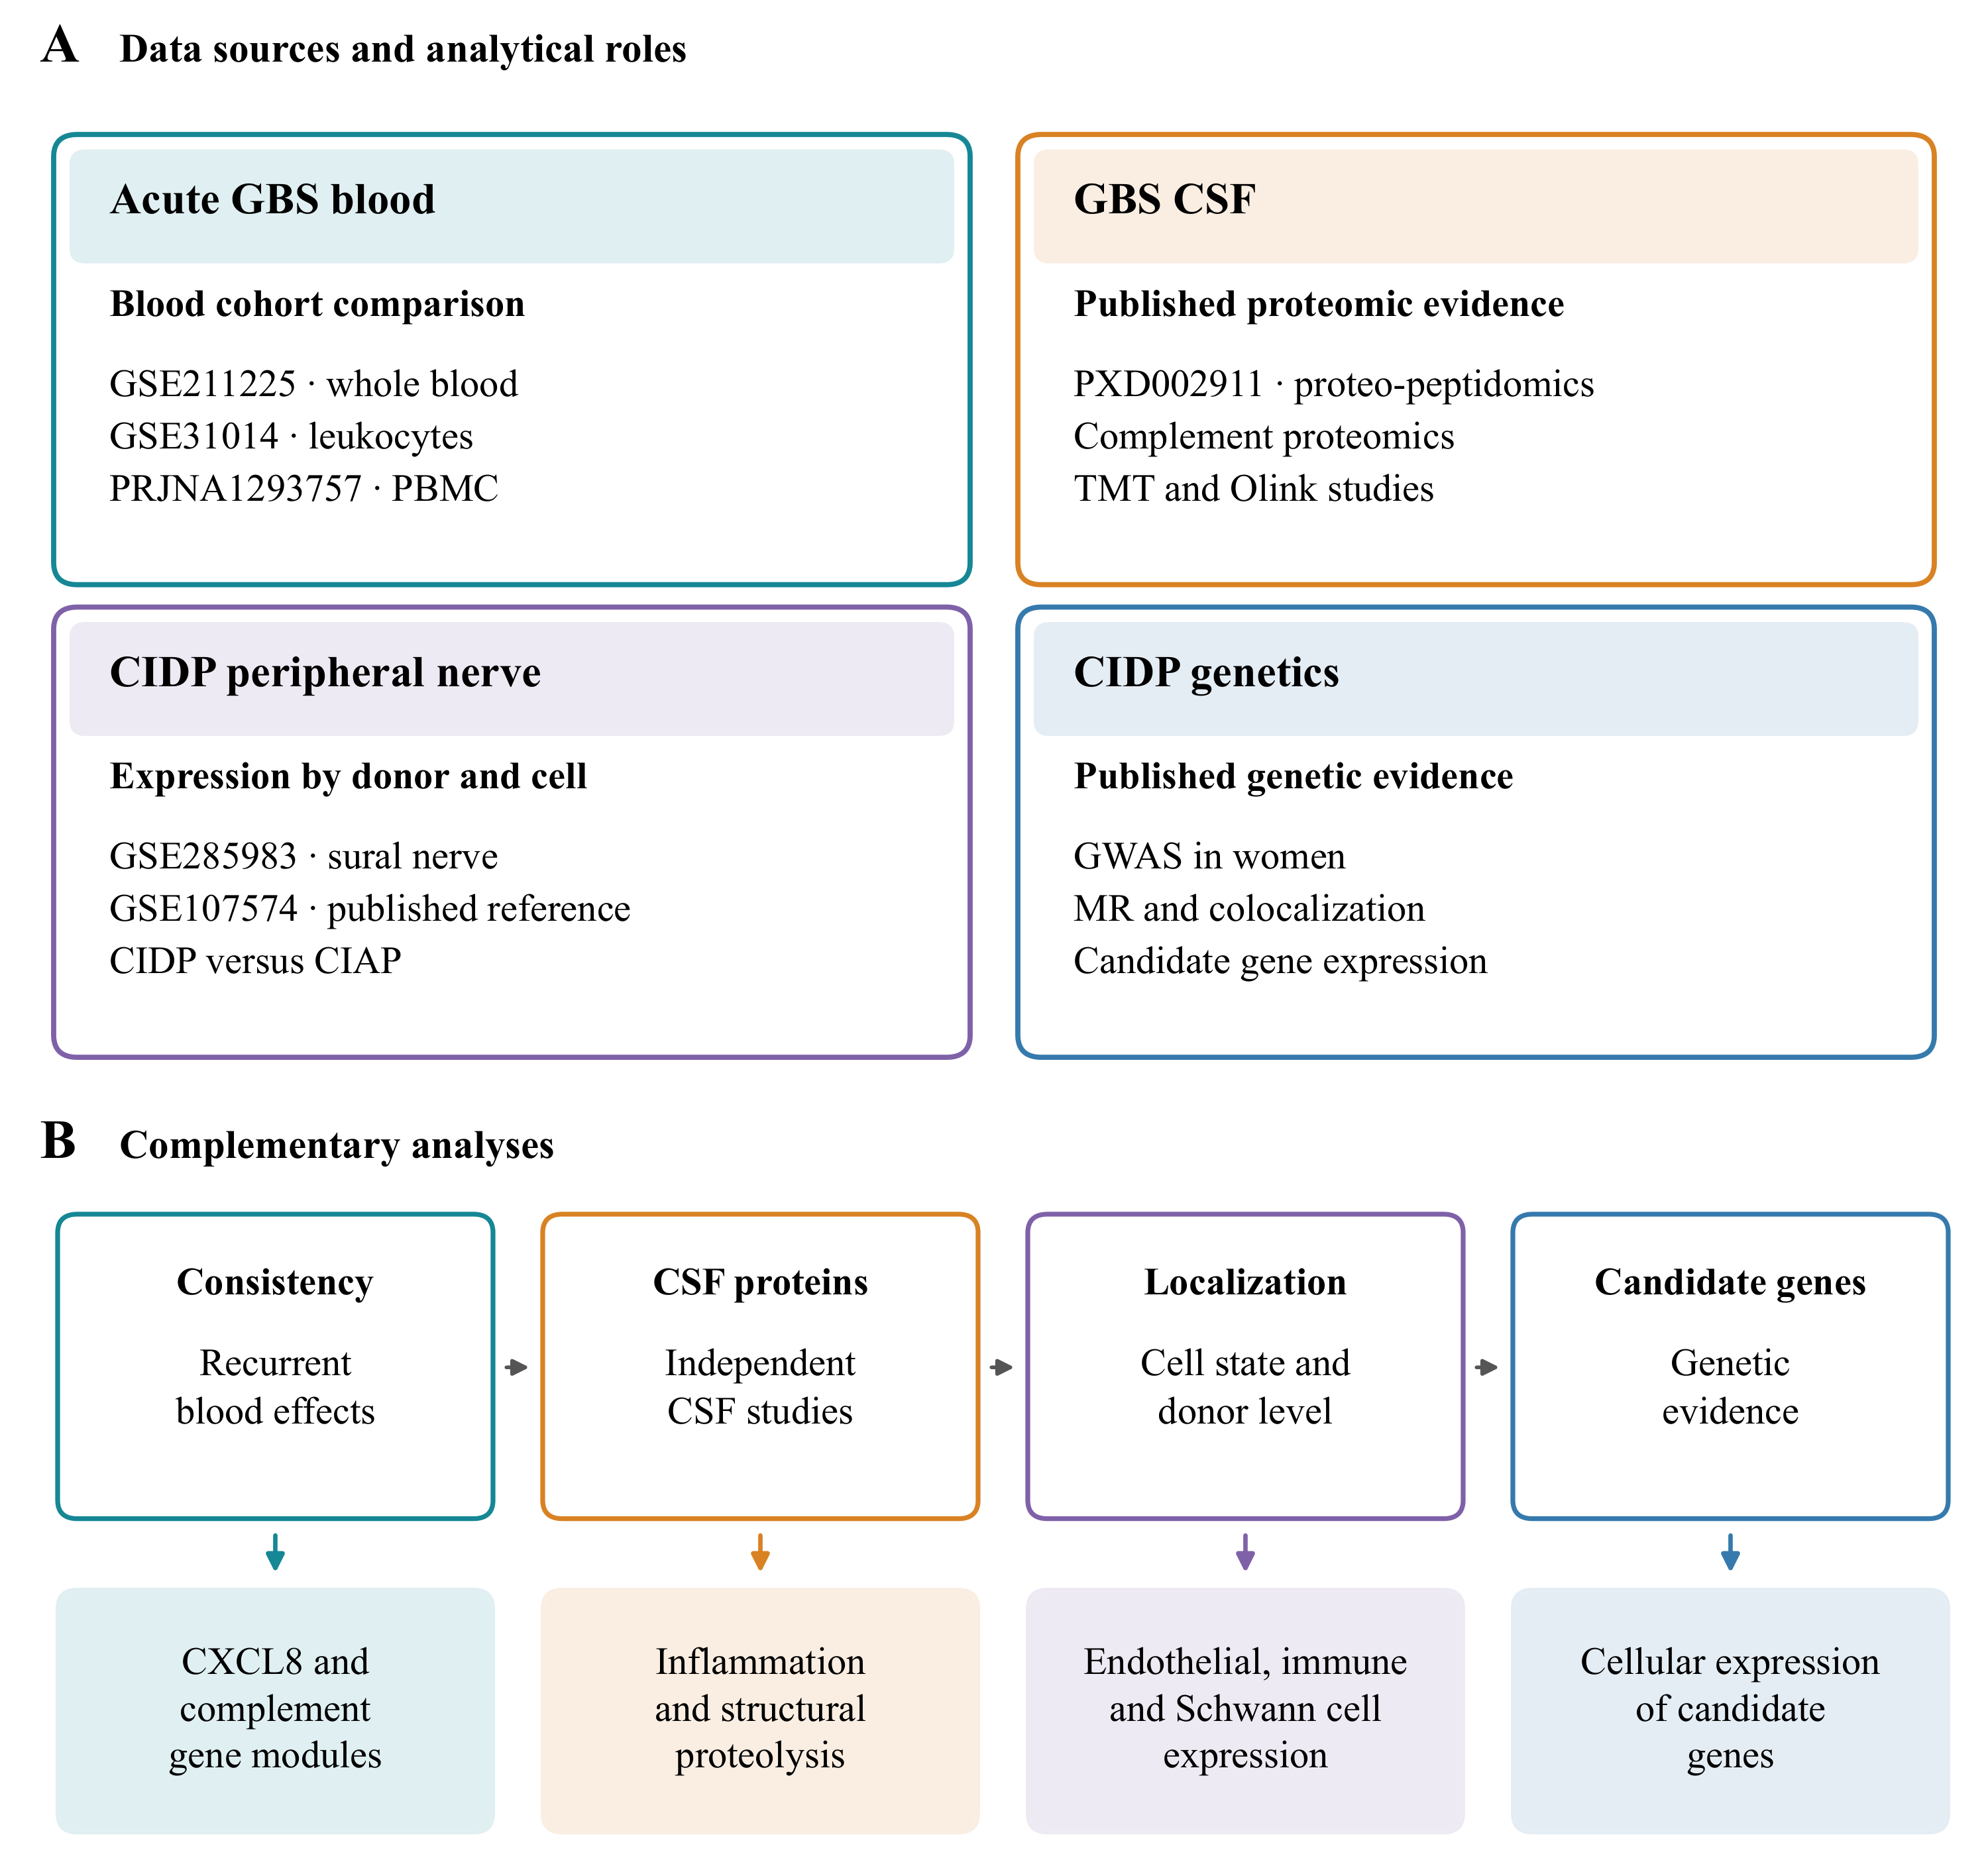
Public blood, CSF, peripheral nerve and genetic resources contributed complementary measurements. Blood cohorts provided gene module effects, CSF reports provided protein and peptide findings, and the nerve atlas provided expression by donor and cell group. Published genetic associations guided candidate selection for nerve expression analysis. Arrows summarize analytical connections and biological questions.

Figure 2. Acute GBS blood modules across cohorts
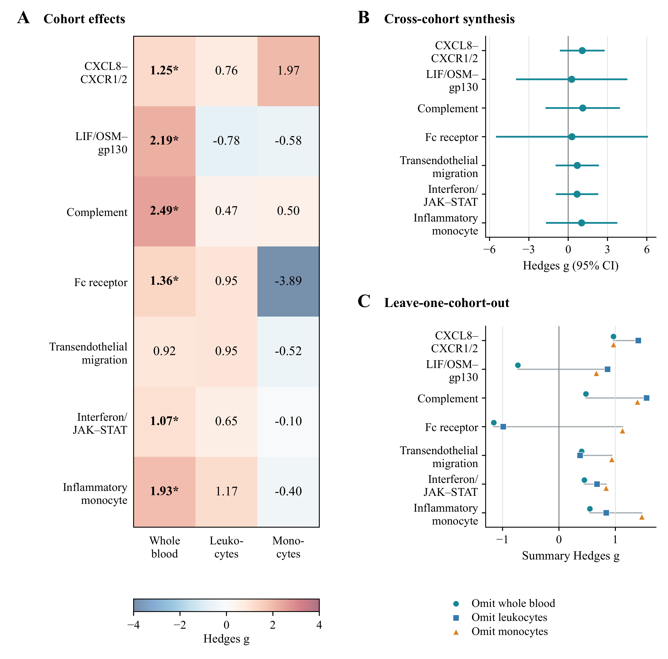
(A) Hedges g for seven gene modules in whole blood, leukocytes and monocyte pseudobulk. Asterisks indicate q < 0.05 after correction within each cohort. (B) Pooled estimates from models with random effects and 95% confidence intervals calculated using the modified Hartung and Knapp method. (C) Pooled estimates after each cohort was omitted in turn. CXCL8 recruitment and complement retained positive estimates in all subsets, and both effects in each retained pair were positive. All pooled intervals in B include zero.

Figure 3. Synthesis of published CSF protein coefficients
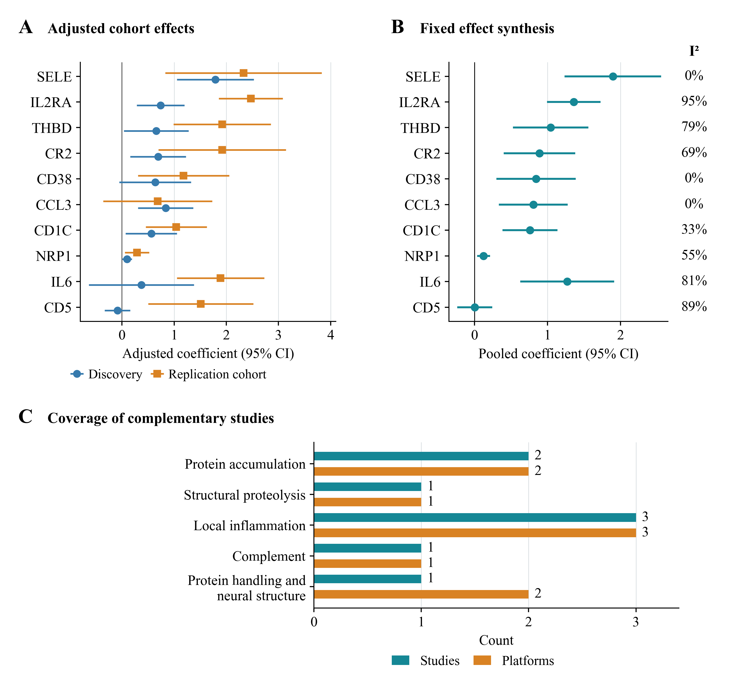
(A) Coefficients from the discovery and replication cohorts of Kmezic et al., adjusted for age, sex and sample handling [36]. Error bars show 95% confidence intervals calculated from the reported standard errors using a normal approximation. (B) Estimates pooled with inverse variance weights in a model with a fixed effect. The analysis includes all ten proteins other than IL8 with paired coefficients in source Table 4B. Nine pooled tests have q < 0.05, while CD5 has q = 0.984. I² describes heterogeneity. The source study found adjusted significance in both cohorts for SELE and IL2RA. (C) Numbers of selected studies and assay platforms covering each biological category, based on four complementary reports [26,33,34,35]. These counts describe the coverage of the evidence map.

Figure 4. Immune and repair modules in CIDP nerve
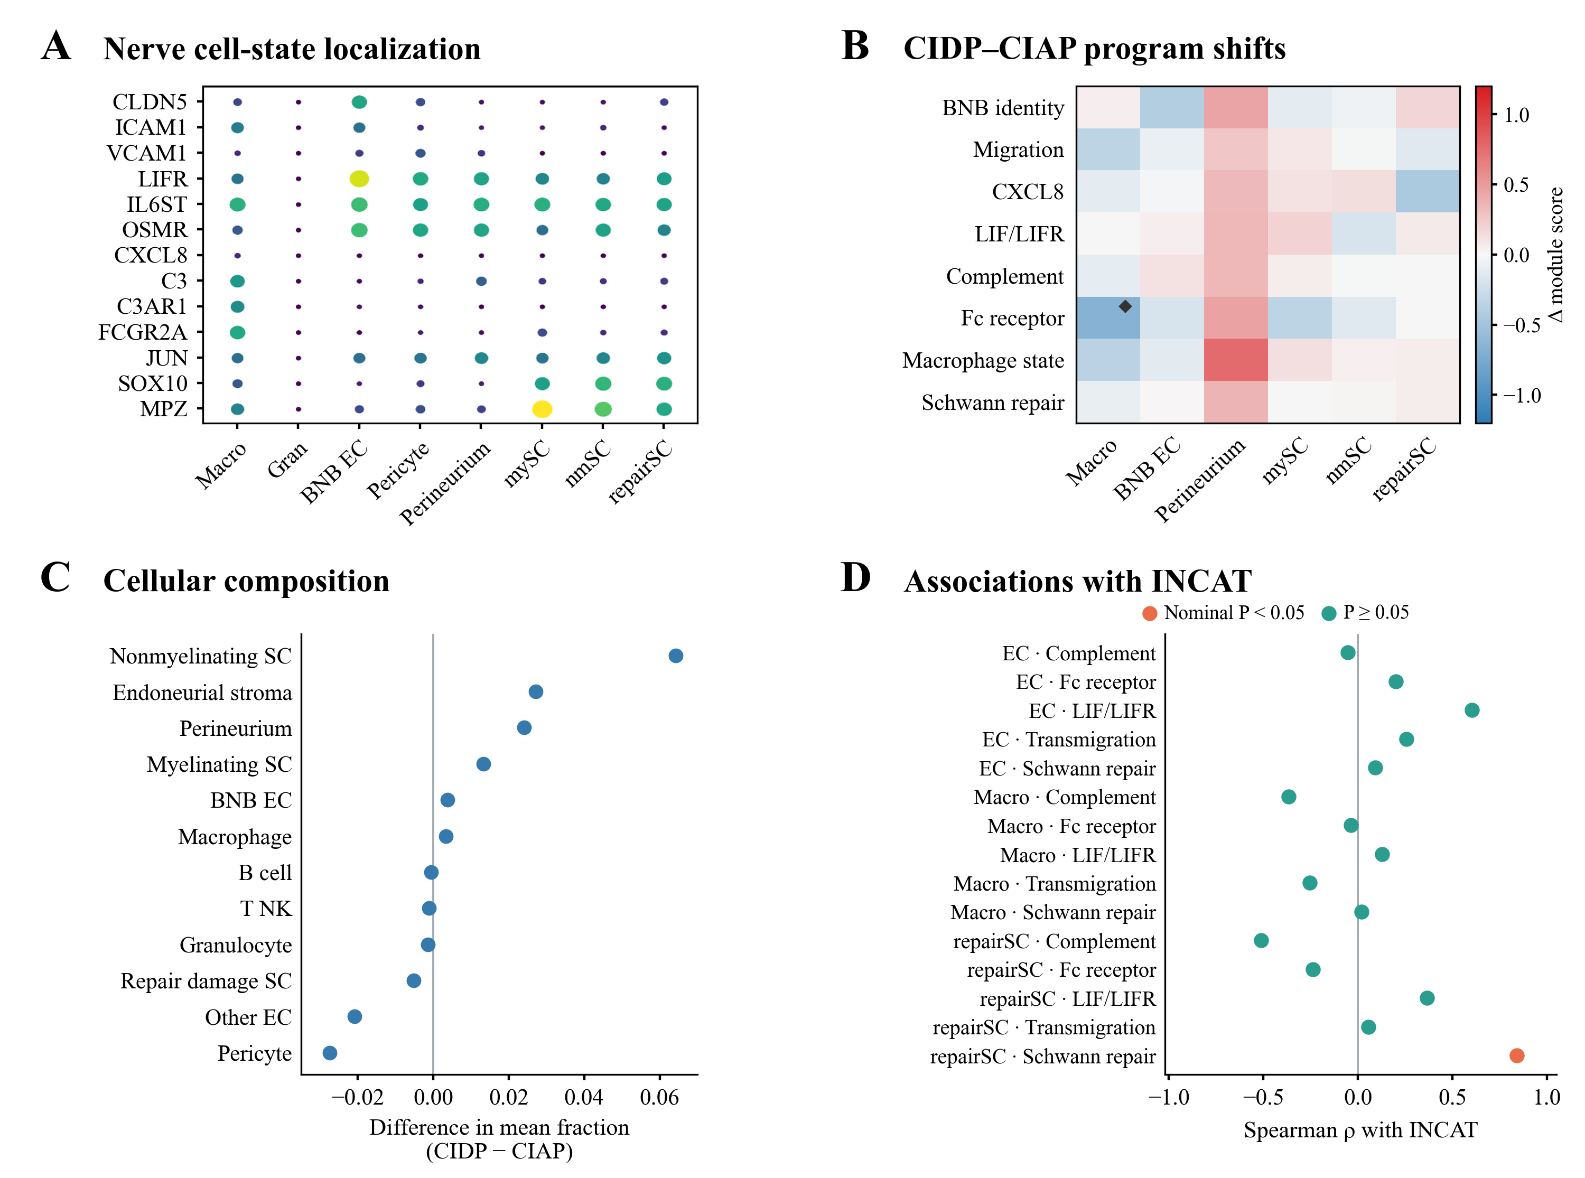
(A) Gene expression across nerve cell states. Dot size indicates the proportion of nuclei with detected expression, and colour indicates scaled mean expression. (B) Differences in donor module scores between CIDP and CIAP. Diamonds indicate q < 0.05 after correction within a cell group. The macrophage Fc receptor result has q = 0.087 after correction across all 80 eligible comparisons. (C) Differences in mean cell fractions, calculated as CIDP minus CIAP. The comparisons in B and C use the Mann and Whitney U test with donors as independent samples. (D) Spearman correlations between donor module scores and INCAT disability. Orange indicates P < 0.05 and teal indicates P ≥ 0.05. All disability correlations have q > 0.05 after correction. BNB EC denotes endoneurial microvascular endothelial cells. Supplementary Figures 3 and 4 present the macrophage sensitivity analyses.

Figure 5. Evidence across compartments and expression of genetic candidates
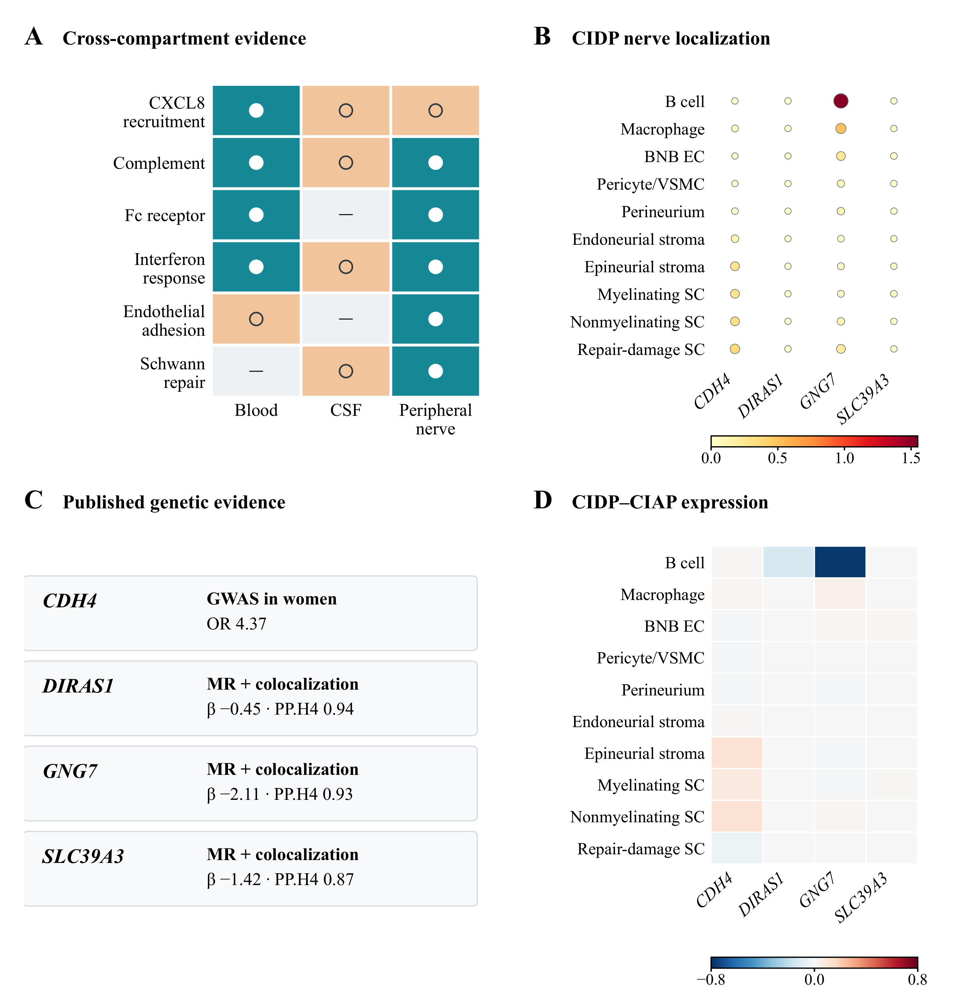
(A) Descriptive evidence map. Filled white circles denote significance within an individual blood cohort or the original nerve cell group testing family, or direct nerve expression localization. Open circles denote recurring directions or representation in published findings. Horizontal marks indicate programs that were not evaluated. The symbols summarize different forms of evidence. Blood pooled effects have P > 0.05, and the nerve macrophage Fc receptor result has q = 0.087 across all 80 module comparisons. (B) Expression of CDH4, DIRAS1, GNG7 and SLC39A3 across CIDP nerve cell groups. Dot size indicates the percentage of nuclei expressing a gene, and colour indicates mean log2(CP10k + 1), summarized by donor. (C) Published genetic estimates from Du et al. that guided candidate selection [32]. (D) Differences in donor mean expression between CIDP and CIAP. Red indicates higher expression in CIDP and blue indicates lower expression. All displayed comparisons have q > 0.05. The colour scales show mean expression in B and differences between diagnoses in D.

Table 1. Datasets and analytical roles
Resource | Material | Participants or samples | Analytical role
GSE211225 | Whole blood transcriptomics | 6 acute GBS, 10 postacute, 6 controls | Primary blood effects for individual participants
GSE31014 | Leukocyte microarray | 7 GBS, 7 controls | Independent assessment of blood effect direction
PRJNA1293757 | PBMC transcriptomics | 3 AIDP, 2 controls | Monocyte localization and assessment of effect direction
PXD002911 | CSF proteomics and peptidomics | GBS (AIDP), MS and controls, with pooled discovery material | Published CSF identifications and functional annotations
GSE285983 | Sural nerve nuclear transcriptomics | 9 CIDP, 11 CIAP in focused comparison | Donor gene module scores, cell fractions and expression localization
GSE107574 | Human endoneurial endothelial transcriptomics | Cultured cells and microvessels | Published BNB expression reference
Kmezic et al. 2023 | CSF Olink proteomics | Discovery cohort with 6 GBS and 20 controls. Replication cohort with 6 GBS and 6 controls. | Synthesis of ten paired CSF protein coefficients from source Table 4B
PXD056286 | Sural nerve histology and proteomics | 55 biopsies from CIDP or its variants | Published tissue observations and calculated Wilson interval
GBS, Guillain Barré syndrome. AIDP, acute inflammatory demyelinating polyradiculoneuropathy. CIDP, chronic inflammatory demyelinating polyradiculoneuropathy. CIAP, chronic idiopathic axonal polyneuropathy. CSF, cerebrospinal fluid. MS, multiple sclerosis. PBMC, peripheral blood mononuclear cell. BNB, blood nerve barrier. Eligible nerve donor numbers vary by cell group.

Table 2. Pooled effects of acute GBS blood modules
Gene module | Summary Hedges g | 95% CI lower | 95% CI upper | Modified Hartung and Knapp P | I², % | Cohorts, n
CXCL8 signaling via CXCR1 and CXCR2 | 1.075 | −0.634 | 2.785 | 0.114 | 0.0 | 3
LIF and OSM signaling via gp130 | 0.271 | −3.978 | 4.519 | 0.810 | 81.2 | 3
Complement | 1.111 | −1.728 | 3.950 | 0.234 | 57.2 | 3
Fc receptor | 0.288 | −5.510 | 6.086 | 0.851 | 72.7 | 3
Transendothelial migration | 0.694 | −0.958 | 2.347 | 0.212 | 1.1 | 3
Interferon signaling via JAK and STAT | 0.677 | −0.943 | 2.297 | 0.214 | 0.0 | 3
Inflammatory monocyte | 1.026 | −1.702 | 3.754 | 0.247 | 49.5 | 3
Positive Hedges g indicates a higher score in acute GBS. Variance between cohorts was estimated by the DerSimonian and Laird method. Confidence intervals and P values use the modified Hartung and Knapp procedure, with residual scale bounded below by one. Each estimate combines three cohorts. CI, confidence interval.

Table 3. Evidence across blood, CSF and peripheral nerve
Program | Blood evidence | CSF evidence | Peripheral nerve evidence | Interpretation
CXCL8 recruitment | Positive in 3 cohorts. Pooled P = 0.114. whole blood q < 0.05 | Published innate immune and inflammatory protein findings | Myeloid localization and endothelial trafficking context | Recurring recruitment expression
Complement | Positive in 3 cohorts. Pooled P = 0.234. whole blood q < 0.01 | Published complement protein findings | Macrophage localization | Complement gene and protein findings
Fc receptor | Whole blood q < 0.05, with mixed directions across cohorts | Not directly evaluated | Macrophage q = 0.0087 within eight modules and q = 0.087 across 80 nerve comparisons | Lower macrophage score, attenuated after composition adjustment
Interferon response | Whole blood q < 0.05, with mixed directions across cohorts | Published evidence of antiviral defense | Macrophage, endothelial and Schwann cell states | Expression across different sampled populations
Endothelial adhesion | Positive blood direction | Not directly evaluated | ICAM1 and VCAM1 localization to BNB endothelial cells | Endothelial expression of adhesion genes
Schwann repair | Not evaluated | Published evidence of axonal domain peptide degradation | Repair and stress programs localized to Schwann cells | Structural injury and Schwann cell repair context
Blood comparisons concern acute GBS and healthy controls. The nerve comparison concerns CIDP and CIAP. q denotes the adjusted P value within the stated testing family. The evidence map describes findings from independently sampled cohorts.

