Immune recruitment across blood cohorts and macrophage composition in inflammatory neuropathies
Yuan Feng¹†, Fang Feng²†, Shuxiao Ma¹†, Shuman Feng¹, Chao Jiang¹*, Yibin Hao¹*
¹ Department of Neurology, Henan Provincial People’s Hospital, People’s Hospital of Zhengzhou University, Zhengzhou 450003, China
² Department of Neurology, The First Affiliated Hospital of Zhengzhou University, Zhengzhou 450002, China
† Yuan Feng, Fang Feng and Shuxiao Ma contributed equally to this work.
* Correspondence: Yibin Hao, haoyibin999@163.com, and Chao Jiang, chaoj@zzu.edu.cn. Postal address: No. 7 Weiwu Road, Jinshui District, Zhengzhou, Henan, China.

Abstract
Immune expression in inflammatory neuropathies varies with the cells sampled, complicating the interpretation of recurring signals. We asked whether blood signals recur in independent patients and whether macrophage composition helps explain immune expression differences in nerve. We analysed three Guillain–Barré syndrome (GBS) blood cohorts, tested selected programmes in an independent monocyte cohort of four patients and three controls, and examined an additional peripheral blood mononuclear cell (PBMC) dataset. Published cerebrospinal fluid (CSF) estimates and two nerve datasets extended the comparison. CXCL8 recruitment and complement scores were higher in the three initial blood cohorts and in external monocytes, with Hedges g of 0.71 and 0.88, respectively. CXCL8 estimates were negative in whole PBMCs from the same external donors and in the additional PBMC dataset. Both CSF cohorts reported elevated IL8, SELE and IL2RA. The macrophage Fc receptor score was lower in chronic inflammatory demyelinating polyradiculoneuropathy (CIDP) than in chronic idiopathic axonal polyneuropathy, and this difference decreased after adjustment for macrophage composition. An independent whole nerve comparison with vasculitic neuropathy showed the same direction (g = −1.20, exact P = 0.076). This difference also decreased after adjustment for a separate macrophage marker index. The external monocyte tests had q = 0.343, and pooled blood intervals included zero. Together, these findings prioritise recruitment and complement for study in defined blood cell populations and identify macrophage composition as a key consideration in nerve Fc expression. The agreement and differences across preparations make cellular resolution a priority for understanding these inflammatory signals.

Keywords
Inflammatory neuropathy, Guillain–Barré syndrome, CIDP, immune recruitment, macrophages, cellular composition

Introduction
Guillain–Barré syndrome (GBS) and chronic inflammatory demyelinating polyradiculoneuropathy (CIDP) both cause inflammatory peripheral nerve injury, but their clinical course and diagnostic criteria differ [1,2,3]. Antibodies, complement and macrophages contribute to injury, with roles that vary across diseases and subtypes [4,5,6,7,8,9]. Nerve tissue also contains immune and Schwann cell states involved in the response to injury and subsequent repair [10,11,12,13]. Interpreting an immune expression difference therefore requires knowing which cells were sampled and what their expression represents.
Immune recruitment offers a way to examine related responses in circulating cells and nerve tissue. At the blood–nerve barrier (BNB), endothelial junctions and mural cells regulate exchange between blood and the endoneurium [14,15,16]. Chemokines, leukocyte integrins and endothelial adhesion molecules help immune cells cross this interface [17,18,19]. Altered junctional proteins have been reported in CIDP nerve, and patient immunoglobulin can affect the BNB in experimental systems [20,21]. These observations motivate studying recruitment signals together with the cell populations that express them.
Public datasets make it possible to compare immune programmes across whole blood, leukocytes and peripheral blood mononuclear cells (PBMCs) [22,23,24]. Studies of monocyte states, peripheral immune profiles and treatment associated expression further show the range of systemic responses in inflammatory neuropathies [25,26,27]. A signal that recurs across preparations may provide a stronger basis for follow up than a large effect in a single cohort. The next question is whether that signal persists when a specific cell population is examined. Published cerebrospinal fluid (CSF) protein estimates provide a related molecular comparison, while nerve transcriptomes locate expression within individual cell populations [28,29].
We asked which blood signals recur in new patients and how the sampled cells influence their interpretation. We first compared immune programmes across three acute GBS blood cohorts, then tested the two recurring programmes in an independent monocyte dataset and an additional public PBMC dataset [30,31]. Published CSF proteins provided a related molecular comparison. We then examined nerve expression in CIDP versus chronic idiopathic axonal polyneuropathy (CIAP), focusing on whether macrophage composition could explain the Fc receptor difference. We evaluated the same Fc gene set in an independent whole nerve cohort and used the original atlas to examine its vasculitic neuropathy comparator [32]. Separate endothelial and Schwann cell programmes extended the analysis. Blood, CSF and nerve came from different participants, so each dataset retained its own disease comparison.
Figure 1 shows the analysis sequence, and Table 1 summarises the datasets. Supplementary Information contains the full source catalogue and supporting analyses. The original aggregate results are in Supplementary Data 1. External blood sample mappings, pseudobulk counts, scores and analysis code are in Supplementary Data 5. The nerve macrophage marker analysis and its source data are in Supplementary Data 6.

Results

CXCL8 recruitment and complement recur in the initial blood cohorts
CXCL8 recruitment and complement were the only modules with positive estimates in all three cohorts. Their pooled Hedges g values were 1.08 (95% confidence interval −0.63 to 2.78, P = 0.114, I² = 0%) and 1.11 (95% confidence interval −1.73 to 3.95, P = 0.234, I² = 57.2%), respectively. Four other modules were positive in two cohorts. Leukaemia inhibitory factor (LIF) and oncostatin M (OSM) signalling was positive only in whole blood. All seven pooled confidence intervals included zero (Fig. 2 and Table 2).
Whole blood showed why a large effect in one cohort need not recur across preparations. Six of seven modules were higher in acute GBS after correction, yet several changed direction in the leukocyte or monocyte datasets. LIF and OSM signalling had a strong effect in whole blood but was positive only in that preparation. Fc receptor and LIF and OSM effects showed the greatest variation between cohorts. Supplementary Results gives the cohort specific estimates and heterogeneity statistics.
The positive pooled directions for CXCL8 recruitment and complement persisted when each cohort was omitted in turn. These estimates ranged from g = 0.97 to 1.41 for CXCL8 recruitment and from g = 0.48 to 1.55 for complement. Both effects were positive in every retained pair, although intervals based on two cohorts were wide. Every other module had at least one cohort with an effect in the opposite direction.

External blood results vary by cell population
We next asked whether the two recurring signals were present in independent patients. In GSE304872, both fixed module scores were higher in monocytes from four early AIDP donors than in three controls. Hedges g was 0.71 for CXCL8 recruitment and 0.88 for complement, with q = 0.343 for both tests. The mean score differences were 0.439 (95% confidence interval −0.714 to 1.592) and 0.292 (−0.275 to 0.858), respectively. The estimates agreed in direction with the original cohorts but remained imprecise (Fig. 3A and B).
Analysing all PBMCs from these same donors gave a negative CXCL8 estimate (g = −0.60), while complement remained positive (g = 0.60). Both whole PBMC comparisons had q = 0.657 within the secondary family. Complement estimates were positive in all four monocyte clusters, whereas CXCL8 estimates varied in direction. Results from the overlapping sorted cell samples also varied by preparation, and none passed correction (Fig. 3C and D, Supplementary Fig. S10 and Supplementary Table S4).
The additional PRJNA1174992 analysis compared 12 acute GBS samples with five controls. CXCL8 recruitment again had a negative estimate (g = −0.40), while complement was positive (g = 0.41). Both had q = 0.439. We kept this dataset outside the pooled analysis because its independence from GSE211225 could not be established. Adding only the independent GSE304872 monocyte cohort gave targeted four cohort estimates of g = 1.00 for CXCL8 recruitment and 1.03 for complement. Both intervals still included zero. The paired follow up and sensitivity analyses are reported in Supplementary Results, Supplementary Fig. S11 and Supplementary Table S5.

Published CSF proteins show related recruitment signals
The published CSF results provided a protein comparison for the recruitment findings. IL8, SELE and IL2RA met the source study’s adjusted significance threshold in both cohorts [28]. Ten of the 11 proteins with paired estimates had positive GBS coefficients in both cohorts and fixed effect pooled q values below 0.05. The fixed effect estimate for IL8 was 2.089 log2 normalised protein expression (NPX) units (95% confidence interval 1.484 to 2.694, I² = 58.2%). CD5 differed in direction between cohorts and had a pooled q value of 0.984. Pooled estimates were less precise under random effects models. Normal approximation intervals included zero for IL2RA, NRP1, IL6 and CD5. Modified Hartung–Knapp intervals included zero for all 11 proteins, with an IL8 interval of −3.974 to 8.211 and P = 0.142 (Fig. 4A and B).
Within the replication cohort, direct comparisons helped distinguish the diagnostic groups. The source reported ten adjusted GBS versus CIDP coefficients and six CIDP versus healthy control coefficients. IL8, ITGAM, IL2RA, IL6 and NRP1 were higher in GBS than in CIDP at source q < 0.05. For CIDP versus healthy controls, only IL8 met that threshold, with a coefficient of 1.13, standard error of 0.181 and q = 0.0081 (Fig. 4C and D). Four descriptive reports provided further findings on inflammation, complement, protein handling and molecular injury [33,34,35,36].

Macrophage Fc receptor expression is sensitive to composition adjustment
The nerve atlas allowed us to examine which cells expressed the relevant genes. Macrophages expressed C3, C3AR1 and FCGR2A. Endoneurial endothelial cells expressed CLDN5, ICAM1, VCAM1, LIFR, IL6ST and OSMR. Schwann cell states expressed gp130 receptor components alongside genes involved in myelination, stress and repair (Fig. 5A). Endothelial CLDN5 and adhesion gene expression was consistent with the published human BNB transcriptome [15].
The macrophage Fc receptor score showed the strongest statistical evidence of a difference between CIDP and CIAP. The mean CIDP minus CIAP difference was −0.673 (P = 0.0011), with q = 0.0087 across eight macrophage modules and q = 0.099 across all 91 nerve tests (Fig. 5B). Supplementary Results reports the other original module contrasts. Source tables also retain the earlier corrections across 80 and 89 tests.
We first examined whether donor characteristics explained the lower Fc receptor score. All nine CIDP donors were male, compared with seven of the 11 CIAP donors. The comparison restricted to men gave a difference of −0.687 (P = 0.0007). Adjustment for age and centre gave a similar estimate of −0.690 (95% confidence interval −1.040 to −0.339, P = 0.0008), and the exact within centre permutation test gave P = 0.0048. The score remained lower in CIDP when individual donors, centres or module genes were removed in turn (Supplementary Fig. S3).
The gene level results showed that selected parts of the module contributed to this difference. Four of the 11 measured genes, FCGR2A, FCER1G, TYROBP and HCK, were lower in CIDP with q < 0.05 in rank tests. FCGRT had q = 0.713, while FCGR1A had a positive estimate with q = 0.148. The signalling component summary was lower (q = 0.039). The activating receptor, inhibitory receptor and neonatal Fc receptor summaries all had q > 0.05.
No broad cell fraction comparison met q < 0.05 (Fig. 5C). We then examined whether differences among states within the macrophage population could help explain its Fc receptor score.
Adding two macrophage composition components to the age and centre model reduced the Fc receptor difference to −0.310 (95% confidence interval −1.038 to 0.419, P = 0.375) (Fig. 5D). Combining the refined macrophage subtypes also gave a lower score (P = 0.0062), but all nine individual subtype tests and all 32 annotation fraction tests had q > 0.05 (Supplementary Fig. S4). None of the 18 subtypes contained at least 20 nuclei in every disease donor. Comparing all donors at the same subtype proportions would therefore have required estimating missing expression values. Comparisons of each disease group with the four graft reference donors were imprecise and are reported in Supplementary Results.

An independent nerve cohort shows the same Fc score direction
The independent GSE213455 dataset showed a lower Fc score in four CIDP nerve biopsies than in nine vasculitic neuropathy biopsies. All 11 target genes were represented. The mean difference was −0.837 (95% confidence interval −1.764 to 0.090, exact P = 0.076). Estimates remained negative after adjustment for age and sex, use of the mean instead of the median to combine probes, and removal of each donor in turn (Supplementary Fig. S9A and B).
We used the original atlas to ask whether its macrophages showed the same direction against the vasculitic neuropathy comparator. The difference between nine CIDP and five vasculitic neuropathy donors was also negative (−0.533, exact P = 0.029). All five vasculitic neuropathy donors came from one centre. Adjustment for age and centre, and a comparison restricted to that centre, retained negative estimates with intervals spanning zero (Supplementary Fig. S9C and D and Supplementary Table S3).
To examine the macrophage contribution to the independent tissue result, we constructed a 20 gene marker index that excluded the Fc genes. The index tracked macrophage nucleus fractions in held out atlas donors (Spearman ρ = 0.933). In GSE213455, it correlated with the Fc score (ρ = 0.907). Adding the index to the disease model changed the Fc difference from −0.837 to 0.208 (95% confidence interval −0.916 to 1.332). Combining probes by their mean gave a similar conditional estimate. Thus, accounting for the broader macrophage expression profile substantially changed the whole tissue comparison (Supplementary Fig. S12 and Supplementary Table S6).

Exploratory endothelial and Schwann cell results
We separately examined endothelial junction, transport and adhesion programmes and Schwann cell myelin maintenance and injury responses. None of the nine new disease comparisons was significant after correction, either within this group or within the expanded 91 test family, where all nine had q > 0.05. In nine CIDP donors, both Schwann cell scores correlated positively with disability, but neither association passed correction across all 17 clinical tests. Supplementary Results and Supplementary Figures S6–S8 give the effect estimates, clinical correlations and normal BNB expression reference.

Discussion
The external analyses show how the cellular source of an immune score changes its interpretation. CXCL8 recruitment and complement had positive estimates in independent monocytes, yet CXCL8 was negative when PBMCs from the same donors were analysed together. In nerve, the Fc receptor difference became smaller after accounting for macrophage states in the atlas and for a macrophage marker index in the independent tissue cohort. The shared question across these analyses is therefore which cells contribute to a recurring immune expression signal.
CXCL8 recruitment and complement recurred more consistently across the original blood cohorts than several larger whole blood effects. The external monocyte results extend that observation, while the whole PBMC and sorted cell comparisons show its dependence on the population analysed. A mixed cell score combines expression within each population with the proportions of cells contributing RNA. It can therefore differ from a monocyte score in the same patients. The small external cohort leaves sampling variation, gene coverage and preparation as other possible explanations. Paired measurements of defined cell populations in a larger cohort would help explain the CXCL8 direction change. Experimental work on leukocyte trafficking provides a biological basis for testing this recruitment programme [17,37].
IL8 connects the selected blood recruitment programme with published CSF findings, while the PBMC results show why the specimen analysed matters [28,38,39]. Within the CSF replication cohort, IL8 was higher in GBS than in CIDP and higher in CIDP than in healthy controls [28]. Measuring CSF IL8 and sorted blood populations in the same patients would establish whether these signals vary together over time.
The nerve results bring the composition question into the affected tissue. The lower macrophage Fc receptor score in CIDP persisted after demographic adjustment and after individual donors, centres or genes were removed. Its reduction after composition adjustment suggests that the distribution of macrophage states contributes to the difference. Sparse sampling of the refined subtypes prevented us from separating differences in state proportions from expression changes within a state.
The independent nerve cohort provided a further way to examine this explanation. Fc scores were lower in CIDP than in vasculitic neuropathy in both atlas macrophages and whole nerve biopsies. In the external biopsies, the Fc score closely followed a separate macrophage marker index, and adjustment for that index left a small, imprecise disease difference. This pattern is consistent with variation in the macrophage contribution to tissue expression. Because marker expression can also change with cell state, the index cannot isolate cell abundance. The external cohort contained only four CIDP cases, and the internal comparator analysis was affected by centre imbalance. Measuring cell proportions together with expression within macrophages would distinguish these contributions more directly.
The genes contributing to the Fc difference also matter. Selected receptor and signalling genes were lower, while other components did not follow the same pattern. The score therefore represents a particular expression profile rather than a general measure of macrophage activation or antibody mediated injury. Peripheral immune profiles and nerve complement deposits describe related aspects of CIDP, but they measure different processes [26,40]. Supplementary Table S1 places these observations alongside their original diagnoses, comparators and cell preparations.
The endothelial and Schwann cell analyses addressed a related question about local tissue responses. Separating junction, transport and adhesion genes made the endothelial scores easier to interpret, although none of the disease contrasts passed correction. Both myelin maintenance and injury response scores rose with disability in the exploratory analysis. Their coexistence could reflect residual myelin expression alongside a response to injury, but neither association passed the broader correction. Direct measurements will be needed to relate these expression patterns to barrier function or subsequent repair.
The precision of the external blood results remains a central limitation. The monocyte cohort contained four patients and three controls, and both fixed module tests had q = 0.343. Intervals from both the original blood synthesis and the targeted four cohort analysis included zero. We analysed the additional Brazilian PBMC dataset separately because the public records did not exclude overlap with GSE211225. Its follow up comparison also lacked the batch information needed to separate biological and technical effects. The CSF synthesis was limited to estimates reported from the original protein screen. Four proteins lacked an estimate in one cohort, and the conservative pooled intervals were wide.
The nerve comparison included nine CIDP and 11 CIAP donors, and all CIDP donors were male. Treatment and other unmeasured clinical differences may have contributed to the expression patterns. The four graft reference donors came from one centre and provided insufficient precision to define a normal Fc receptor level. The functional, clinical and reference analyses were added after inspection of the original results. Under the expanded testing scopes, the Fc receptor, endothelial, Schwann cell and new disability findings were not significant.
Blood, CSF and nerve were sampled from separate participants, and diagnosis partly coincided with specimen type. These comparisons cannot establish a sequence of changes across tissues or progression from GBS to CIDP. Independent replication of the macrophage specific CIDP versus CIAP result is still needed. Public nerve protein files could be quantified, but reliable links between samples and diagnoses and adequate coverage of the Fc module were unavailable. This prevented a validation test and does not constitute a negative validation result. Supplementary Results documents the availability assessment.
Taken together, the analyses identify recruitment and complement as candidates for further study in defined blood cell populations and show that macrophage composition is central to interpreting the nerve Fc signal. The next step is to measure cell proportions and expression within those populations in the same patients. This would determine whether the observed signals reflect a change in immune cell abundance, a response within the cells, or both.

Methods

Study design and datasets
We analysed human blood and nerve transcriptomes together with published CSF protein estimates. The original blood datasets represented three preparations. GSE211225 contained six acute GBS, ten postacute and six healthy control whole blood profiles [22]. GSE31014 contained leukocyte microarrays from seven patients with GBS and seven healthy controls [23]. PRJNA1293757 contained PBMC transcriptomes from three untreated patients with acute inflammatory demyelinating polyradiculoneuropathy (AIDP) and two healthy controls [24]. Each blood comparison used the acute disease and healthy control samples from that dataset.
GSE304872 supplied the external single cell blood data from four early untreated AIDP donors and three retained healthy controls. The deposited object contained 107,656 cells, including 22,592 author annotated monocytes. GSE304871 supplied sorted cell profiles from overlapping participants. CD11b and CD8 each included two GBS and three control donors, while CD4 included three per group. These datasets belong to a separate study reported as a preprint [30]. PRJNA1174992 supplied 12 acute GBS samples, eight paired follow up samples and five controls. We analysed it separately because the public metadata could not exclude overlap with GSE211225 [31].
The quantitative CSF synthesis used adjusted protein coefficients from the independent discovery and replication cohorts of Kmezic et al. [28]. Other reports supplied descriptive protein and peptide findings, as documented in Supplementary Information [33,34,35,36].
The nerve dataset, GSE285983, contained 365,708 nuclei from 37 sural nerves, including nine donors with CIDP and 11 with CIAP [29]. Four donors had contributed residual sural nerve autograft tissue during surgery for traumatic nerve injury [29]. GSE107574 supplied expression data for selected endothelial genes in normal human BNB preparations [15].
GSE213455 provided an independent whole nerve microarray dataset with four CIDP, nine vasculitic neuropathy and three neurolymphomatosis biopsies. The GEO label “inflammatory neuropathy” corresponds to the four CIDP cases described in the source study. We used CIDP versus vasculitic neuropathy for the external Fc comparison and excluded neurolymphomatosis from scoring and testing [32].
Supplementary Methods describes the supporting genetic localisation and published nerve protein analyses, including the assessment of PXD056286 for independent nerve validation.

Gene modules
The seven blood gene modules represented CXCL8 recruitment through CXCR1 and CXCR2, LIF and oncostatin M (OSM) signalling through gp130, complement, Fc receptors, interferon signalling through JAK and STAT, inflammatory monocytes, and transendothelial migration. The eight nerve modules represented BNB identity, leukocyte transmigration, CXCL8 recruitment, LIF and related gp130 signalling, complement, Fc receptors, macrophage state, and Schwann cell myelin and repair. The analysis scripts list the genes in each module. Because the original BNB and Schwann cell modules combined several functions, we later examined more specific gene sets. These scores summarise gene expression. They do not directly measure barrier function or nerve repair.

Blood cohort analysis
In PRJNA1293757, marker gene scores assigned quality controlled PBMCs to broad cell lineages. We summed monocyte counts for each donor to produce pseudobulk profiles, normalised them to counts per million (CPM), and transformed them as log₂(CPM + 0.5). Within each blood cohort, we standardised each gene across participants and averaged the available gene values within each module. We expressed the difference between acute GBS and healthy controls as Hedges g and compared mean module scores using exact label permutation tests. Benjamini and Hochberg correction covered the seven modules in each cohort [41].
We pooled effects from whole blood, leukocytes and monocytes using a random effects model. Between cohort variance was estimated by the DerSimonian and Laird method, with heterogeneity described by τ² and I² [42]. Modified Hartung and Knapp confidence intervals used a residual variance scale of at least one and a t distribution with degrees of freedom equal to the number of cohorts minus one [43]. We repeated the synthesis after omitting each cohort to assess its influence. Postacute profiles contributed to the original preprocessing but were excluded from the reported comparisons. The archived study design did not establish whether the acute and postacute samples came from independent donors.

External blood tests
The external analysis plan fixed the original CXCL8 recruitment and complement gene sets before the new disease effects were calculated. In GSE304872, we retained the deposited donor and cell labels and summed unintegrated RNA counts for each donor and population. The primary analysis used the author’s Monocyte group, requiring at least 20 cells per donor. Platelet–monocyte aggregates were a separate author category. We calculated log2(CPM + 0.5), standardised each variable gene across the seven donors and averaged the available gene values. All three CXCL8 genes and 15 of 18 complement genes were available. The two primary tests used exact donor label permutations and Benjamini and Hochberg correction. Whole PBMCs and the four monocyte clusters formed a separate family of ten tests. The twelve broad cell fraction comparisons were corrected as another family.
For GSE304871, the gene names in the deposited files did not consistently match their Ensembl identifiers. We therefore mapped the row identifiers to GENCODE release 38. We used log2(normalised counts + 0.5), standardised genes within each preparation and corrected the six module by preparation tests together. For PRJNA1174992, we summed 87 technical columns into 25 biological samples. The acute comparison used median ratio normalisation and gene standardisation across the 12 acute and five control samples only, with correction across two modules. Sensitivity analyses used CPM normalisation and adjustment for age and sex. The eight paired comparisons were normalised separately across their 16 samples and tested using all 256 sign assignments, with correction across two tests.
Confidence intervals for the new mean differences used HC3 covariance and residual t degrees of freedom. We reported these model intervals separately from exact permutation P values. We retained the original three cohort synthesis and added a targeted sensitivity analysis that included GSE304872 monocytes. This used the same random effects method, with correction across the two selected modules. Sorted cells and whole PBMCs from those donors, and PRJNA1174992, were not counted as additional independent studies. Supplementary Data 5 contains the gene coverage, sample mappings and annotation checks.

CSF protein synthesis
We extracted all GBS versus healthy control coefficients adjusted for age, sex and CCL19 in Tables 3 and 4B of Kmezic et al. [28]. Eleven of the 15 reported proteins had coefficients and standard errors in both independent cohorts, including IL8 in Table 3. Four proteins lacked an estimate in one cohort and were recorded but not imputed. We pooled the 11 pairs on the log₂ normalised protein expression (NPX) scale using inverse variance fixed effect models, with Benjamini and Hochberg correction across 11 tests. Sensitivity analyses used DerSimonian and Laird random effects models with normal approximation intervals. We also calculated modified Hartung–Knapp intervals with a variance scale of at least one and one degree of freedom. The original study P and q values were retained separately from the pooled tests.
We extracted all adjusted coefficients for GBS versus CIDP and CIDP versus healthy controls in source Tables 3, 5 and 6 [28]. These comparisons use participants from the same replication cohort. We presented them with the original P and q values and did not count them as additional independent cohorts. Four other reports contributed descriptive findings on CSF proteins, peptides and functional annotations [33,34,35,36]. Protein identification counts were kept separate from concentration measurements.

Nerve pseudobulk analysis
We grouped nerve nuclei by donor and annotated cell state. These groups comprised macrophages, T and natural killer cells, B cells, granulocytes, endoneurial and other endothelial cells, pericytes, perineurial cells, endoneurial stroma, and myelinating, nonmyelinating, and repair and damage Schwann cells. A donor entered a cell group analysis only when that group contained at least 20 nuclei. We summed counts within each donor and cell group, normalised to CPM using counts across all genes, and applied log2(CPM + 0.5). CIDP versus CIAP comparisons treated donors as the independent observations [44,45,46].

Nerve module comparisons and macrophage composition
Within each cell group, we standardised gene expression across eligible donors from all diagnostic categories and averaged the available gene z scores for each module. We compared CIDP with CIAP using the Mann and Whitney U test and reported the mean CIDP score minus the mean CIAP score. We corrected for testing eight modules within each cell group and separately for all 80 nerve module comparisons. For cell composition, we calculated the proportion of each donor’s sampled nuclei assigned to each group. We compared these proportions between diagnoses and corrected across cell groups.
The macrophage Fc receptor module contained 11 measured genes. FCGR2C, the twelfth specified gene, was absent from the matrix. To identify the genes contributing to the score difference, we tested each gene using the Mann and Whitney U test, with correction across 11 tests. Four functional summaries formed a separate testing family. For comparisons without covariate adjustment, q values came from rank tests. Separate HC3 models supplied confidence intervals for mean differences. Sensitivity analyses restricted the comparison to men, standardised genes within the 20 CIDP and CIAP donors, adjusted for age and centre, and added sex to the adjusted model. Linear model intervals used HC3 covariance estimates and residual degrees of freedom. An exact permutation test kept the number of CIDP donors within each centre unchanged. Model specifications are given in Supplementary Methods.
To examine variation within macrophages, we used nucleus barcodes to link the original labels to refined immune annotations. Composition summaries retained unmatched nuclei and those reassigned to other categories. We calculated centred log ratios of donor composition and added their first two principal components to the age and centre model [47]. We also reaggregated raw counts for all 20 CIDP and CIAP donors under alternative macrophage definitions. A refined subtype was tested when at least three donors in each diagnosis contributed at least 20 nuclei. We corrected across the nine eligible subtypes. We then checked whether any subtype contained at least 20 nuclei in all 20 disease donors. Only this level of coverage would allow every donor to be compared at the same subtype proportions without estimating missing expression values.
To place the CIDP versus CIAP difference alongside the graft reference samples, we reconstructed the original 11 gene Fc receptor score using the same standardisation across all 37 atlas donors. We compared each diagnosis with the four graft donors. The CIDP versus reference comparison had been included in the original pipeline and was reexamined here. Two sided exact Mann and Whitney tests were corrected across the two reference comparisons. Adding them to the 89 module and programme tests gave an expanded family of 91 tests. Confidence intervals for mean differences used 20,000 bootstrap replicates, resampling donors independently within each group with fixed score standardisation and seed 20260921.

External nerve comparison
We fixed the 11 measured Fc genes and the external analysis plan before examining their values in GSE213455. The deposited expression was already quantile normalised and was used without a further log transformation. Probes matching a single gene symbol were combined by their median. We standardised each gene across the 13 eligible donors and averaged the gene scores. An exact two sided Mann and Whitney test compared diagnoses, while separate HC3 models provided confidence intervals for mean differences. Sensitivity analyses adjusted for age and sex, combined probes by their mean, and removed each donor in turn. The 11 gene level rank tests formed a separate correction family.
After obtaining the external result, we reconstructed macrophage Fc scores for all 37 donors in GSE285983 and checked the original CIDP versus CIAP estimate. We then compared CIDP with vasculitic neuropathy on the original score scale. Sensitivity analyses adjusted for age and centre and restricted the comparison to Würzburg. This analysis checked the external comparator within the original atlas. We did not pool the whole tissue and atlas macrophage effects. Supplementary Methods gives the full specifications and timing.
A further exploratory analysis asked whether the external Fc difference depended on broader macrophage expression. We selected markers from donor level counts in the nerve atlas, excluding all 11 Fc genes. Selection was repeated after leaving out each donor and each centre. Once the index met the specified calibration criteria, we fixed its final 20 genes and calculated the index from within sample ranks in GSE213455. We added this single index to the diagnosis model and used HC3 confidence intervals. Supplementary Methods details the selection rules, feasibility criteria and probe aggregation sensitivity. The index measures relative marker expression and was not converted to an absolute cell fraction.

Exploratory endothelial and Schwann cell analyses
Follow up gene sets separated endothelial junction structure, transport and inflammatory adhesion, and Schwann cell myelin maintenance and injury response [11,12,15]. Membership was fixed before calculating these extension results and is listed in Supplementary Methods. Counts were reaggregated for all 20 CIDP and CIAP donors, with at least 20 nuclei required for each donor and cell group. The three endothelial and six Schwann cell comparisons formed a nine test family and were also included in the expanded 91 test family. Unadjusted rank tests, HC3 model intervals, demographic adjustment and a repair cell fraction adjustment are detailed in Supplementary Methods.
We used Spearman correlations to examine ten pairs of nerve modules and 15 original associations with Inflammatory Neuropathy Cause and Treatment (INCAT) disability. The two sets were corrected separately. For the two additional Schwann cell score correlations, we used exact two sided tests across all 362,880 assignments of INCAT ranks in nine CIDP donors. We reported correction both for these two tests and for all 17 clinical tests. Supplementary Methods describes the donor omission checks and records when these exploratory analyses were added.

Comparison across compartments
We mapped biological programmes across compartments in Supplementary Table S1. A programme was included if it showed a consistent direction across blood cohorts, had a corresponding published CSF protein or peptide annotation, or was expressed in a relevant nerve cell population. Each entry identifies the evidence type and its original testing family. For interferon related nerve genes, we used cell cluster markers from Supplementary Data 3 and polyneuropathy versus control results from Supplementary Data 9 of Heming et al. [29]. Those controls were residual sural nerve autografts from patients with traumatic nerve injury. The map relates separately sampled cohorts while retaining their individual comparisons.

Statistical analysis
All tests were two sided and used donors or biological samples as the independent units. We denote Benjamini and Hochberg adjusted P values by q and apply q < 0.05 within each stated testing family. The new blood analysis had two fixed primary monocyte tests, with secondary families reported separately. The external tests and the Fc sensitivity, CSF, reference and functional analyses followed the original findings and remain exploratory. Original analyses retain their correction scopes, and dated plans document the sequence of extensions. Supplementary Tables S1–S6, Figures S1–S12 and Supplementary Data 1–6 contain the complete results, including nonsignificant comparisons, source records and code.

Ethics approval and consent to participate
This study analysed publicly available, deidentified transcriptomes and published proteomic and genetic results. Ethics approvals and consent procedures were reported by the source studies where applicable. No participants were recruited, no specimens were collected, and no identifiable information was accessed for this secondary analysis. Additional ethical approval was therefore not required.

Consent for publication
Not applicable. The manuscript contains no identifiable personal information.

Data availability
The original blood and nerve datasets are available under GSE211225, GSE31014, PRJNA1293757, GSE285983, GSE213455 and GSE107574. Supplementary Information lists the published CSF estimates and public protein sources, including PXD002911 and PXD056286. The Zenodo v2.4.0 archive (https://doi.org/10.5281/zenodo.22885750) preserves the earlier analysis release. The accompanying Supplementary Data 3 and 4 provide the subsequent external nerve analyses. External blood data are available under GSE304872, GSE304871 and PRJNA1174992. Supplementary Data 5 contains sample mappings, the recovered donor pseudobulk matrix, public bulk inputs, fixed gene mappings and the external blood results. The complete Seurat object is available from GEO, with its URL and checksum recorded in the package. Supplementary Data 6 contains donor and lineage counts for the nerve reference, marker selections, composition benchmarks and external conditional models. These later blood and composition analyses are supplied with this manuscript and extend the material in v2.4.0.

Code availability
Analysis scripts and reconstruction instructions are provided at https://github.com/applepie567/gbs-cidp-blood-nerve-barrier and in the accompanying supplementary data. Supplementary Data 2 preserves the earlier v2.4.0 Zenodo release. Supplementary Data 4 contains the subsequent external nerve analysis. Supplementary Data 5 contains the external blood analysis plan, extraction and scoring scripts, figure code, input manifest and source tables. Supplementary Data 6 provides the composition analysis plan, reference reconstruction, held out evaluation and figure code. The original three cohort blood synthesis is retained, with the four cohort synthesis reported as a targeted sensitivity analysis. The figure source index maps the archived figure labels to the current manuscript, and the final display scripts document the presentation changes.

References
1. Willison, H. J., Jacobs, B. C. & van Doorn, P. A. Guillain-Barré syndrome. Lancet 388, 717-727 (2016). https://doi.org/10.1016/S0140-6736(16)00339-1.
2. van Doorn, P. A. et al. European Academy of Neurology/Peripheral Nerve Society Guideline on diagnosis and treatment of Guillain-Barré syndrome. Eur. J. Neurol. 30, 3646-3674 (2023). https://doi.org/10.1111/ene.16073.
3. Van den Bergh, P. Y. K. et al. European Academy of Neurology/Peripheral Nerve Society guideline on diagnosis and treatment of chronic inflammatory demyelinating polyradiculoneuropathy: Report of a joint Task Force-Second revision. Eur. J. Neurol. 28, 3556-3583 (2021). https://doi.org/10.1111/ene.14959.
4. Quast, I., Cueni, F., Nimmerjahn, F., Tackenberg, B. & Lünemann, J. D. Deregulated Fcγ receptor expression in patients with CIDP. Neurol. Neuroimmunol. Neuroinflamm. 2, e148 (2015). https://doi.org/10.1212/NXI.0000000000000148.
5. Hafer-Macko, C. E. et al. Immune attack on the Schwann cell surface in acute inflammatory demyelinating polyneuropathy. Ann. Neurol. 39, 625-635 (1996). https://doi.org/10.1002/ana.410390512.
6. Koike, H. et al. Ultrastructural mechanisms of macrophage-induced demyelination in CIDP. Neurology 91, 1051-1060 (2018). https://doi.org/10.1212/WNL.0000000000006625.
7. Susuki, K. et al. Anti-GM1 antibodies cause complement-mediated disruption of sodium channel clusters in peripheral motor nerve fibers. J. Neurosci. 27, 3956-3967 (2007). https://doi.org/10.1523/JNEUROSCI.4401-06.2007.
8. Kiefer, R., Kieseier, B. C., Stoll, G. & Hartung, H. P. The role of macrophages in immune-mediated damage to the peripheral nervous system. Prog. Neurobiol. 64, 109-127 (2001). https://doi.org/10.1016/s0301-0082(00)00060-5.
9. Shen, D. et al. Beneficial or Harmful Role of Macrophages in Guillain-Barré Syndrome and Experimental Autoimmune Neuritis. Mediators Inflamm. 2018, 4286364 (2018). https://doi.org/10.1155/2018/4286364.
10. Wolbert, J. et al. Redefining the heterogeneity of peripheral nerve cells in health and autoimmunity. Proc. Natl Acad. Sci. USA 117, 9466-9476 (2020). https://doi.org/10.1073/pnas.1912139117.
11. Arthur-Farraj, P. J. et al. c-Jun reprograms Schwann cells of injured nerves to generate a repair cell essential for regeneration. Neuron 75, 633-647 (2012). https://doi.org/10.1016/j.neuron.2012.06.021.
12. Jessen, K. R. & Mirsky, R. The repair Schwann cell and its function in regenerating nerves. J. Physiol. 594, 3521-3531 (2016). https://doi.org/10.1113/JP270874.
13. Napoli, I. et al. A central role for the ERK-signaling pathway in controlling Schwann cell plasticity and peripheral nerve regeneration in vivo. Neuron 73, 729-742 (2012). https://doi.org/10.1016/j.neuron.2011.11.031.
14. Ubogu, E. E. Biology of the human blood-nerve barrier in health and disease. Exp. Neurol. 328, 113272 (2020). https://doi.org/10.1016/j.expneurol.2020.113272.
15. Palladino, S. P. et al. The Human Blood-Nerve Barrier Transcriptome. Sci. Rep. 7, 17477 (2017). https://doi.org/10.1038/s41598-017-17475-y.
16. Yosef, N., Xia, R. H. & Ubogu, E. E. Development and characterization of a novel human in vitro blood-nerve barrier model using primary endoneurial endothelial cells. J. Neuropathol. Exp. Neurol. 69, 82-97 (2010). https://doi.org/10.1097/NEN.0b013e3181c84a9a.
17. Yosef, N. & Ubogu, E. E. α(M)β(2)-integrin-intercellular adhesion molecule-1 interactions drive the flow-dependent trafficking of Guillain-Barré syndrome patient derived mononuclear leukocytes at the blood-nerve barrier in vitro. J. Cell. Physiol. 227, 3857-3875 (2012). https://doi.org/10.1002/jcp.24100.
18. Dong, C. et al. Fibronectin connecting segment-1 peptide inhibits pathogenic leukocyte trafficking and inflammatory demyelination in experimental models of chronic inflammatory demyelinating polyradiculoneuropathy. Exp. Neurol. 292, 35-45 (2017). https://doi.org/10.1016/j.expneurol.2017.02.012.
19. Langert, K. A., Von Zee, C. L. & Stubbs, E. B. Jr. Tumour necrosis factor α enhances CCL2 and ICAM-1 expression in peripheral nerve microvascular endoneurial endothelial cells. ASN Neuro 5, e00104 (2013). https://doi.org/10.1042/AN20120048.
20. Kanda, T., Numata, Y. & Mizusawa, H. Chronic inflammatory demyelinating polyneuropathy: decreased claudin-5 and relocated ZO-1. J. Neurol. Neurosurg. Psychiatry 75, 765-769 (2004). https://doi.org/10.1136/jnnp.2003.025692.
21. Shimizu, F. et al. Blood-Nerve Barrier Breakdown Induced by Immunoglobulin G in Typical and Multifocal Chronic Inflammatory Demyelinating Polyneuropathy and Multifocal Motor Neuropathy. Int. J. Mol. Sci. 27, 1088 (2026). https://doi.org/10.3390/ijms27021088.
22. Lima, M. F. O. et al. Altered Cellular Pathways in the Blood of Patients With Guillain-Barre Syndrome. J. Peripher. Nerv. Syst. 30, e70012 (2025). https://doi.org/10.1111/jns.70012.
23. Chang, K. H. et al. Identification of gene networks and pathways associated with Guillain-Barré syndrome. PLoS ONE 7, e29506 (2012). https://doi.org/10.1371/journal.pone.0029506.
24. Shi, P. et al. Single cell transcriptome profiling of peripheral blood mononuclear cells in Guillain-Barré syndrome patients. Sci. Data 13, 843 (2026). https://doi.org/10.1038/s41597-026-07489-5.
25. Li, M. et al. Single-cell analysis reveals novel clonally expanded monocytes associated with IL1β-IL1R2 pair in acute inflammatory demyelinating polyneuropathy. Sci. Rep. 13, 5862 (2023). https://doi.org/10.1038/s41598-023-32427-5.
26. Kim, H. et al. Integrated peripheral immune profiling reveals B-cell dysregulation and CD8 effector signatures in chronic inflammatory demyelinating polyneuropathy. Front. Immunol. 17, 1888882 (2026). https://doi.org/10.3389/fimmu.2026.1888882.
27. Richard, A. et al. Transcriptome Analysis of Peripheral Blood in Chronic Inflammatory Demyelinating Polyradiculoneuropathy Patients Identifies TNFR1 and TLR Pathways in the IVIg Response. Medicine (Baltimore) 95, e3370 (2016). https://doi.org/10.1097/MD.0000000000003370.
28. Kmezic, I. et al. Validation of elevated levels of interleukin-8 in the cerebrospinal fluid, and discovery of new biomarkers in patients with GBS and CIDP using a proximity extension assay. Front. Immunol. 14, 1241199 (2023). https://doi.org/10.3389/fimmu.2023.1241199.
29. Heming, M. et al. Multi-omic identification of perineurial hyperplasia and lipid-associated nerve macrophages in human polyneuropathies. Nat. Commun. 16, 7872 (2025). https://doi.org/10.1038/s41467-025-62964-8.
30. O’Brien, J. A. et al. Peripheral nerve-targeting and pain-promoting transcriptomic signatures in early Guillain-Barré syndrome. bioRxiv (2025). https://doi.org/10.1101/2025.09.24.678413 (preprint).
31. Negreiros Neto, T. da S. et al. Peripheral immune gene expression partially converges toward control profiles after clinical recovery from Guillain-Barré syndrome. Sci. Rep. (2026). https://doi.org/10.1038/s41598-026-71564-5.
32. Cerri, F. et al. Clinical and pathological findings in neurolymphomatosis: Preliminary association with gene expression profiles in sural nerves. Front. Oncol. 12, 974751 (2022). https://doi.org/10.3389/fonc.2022.974751.
33. Ziganshin, R. H. et al. The Pathogenesis of the Demyelinating Form of Guillain-Barre Syndrome (GBS): Proteo-peptidomic and Immunological Profiling of Physiological Fluids. Mol. Cell. Proteomics 15, 2366-2378 (2016). https://doi.org/10.1074/mcp.M115.056036.
34. D’Aguanno, S. et al. Protein profiling of Guillain-Barrè syndrome cerebrospinal fluid by two-dimensional electrophoresis and mass spectrometry. Neurosci. Lett. 485, 49-54 (2010). https://doi.org/10.1016/j.neulet.2010.08.060.
35. Ding, Y. et al. Potential biomarkers identified by tandem mass tags based quantitative proteomics for diagnosis and classification of Guillain-Barré syndrome. Eur. J. Neurol. 29, 1155-1164 (2022). https://doi.org/10.1111/ene.15213.
36. Sun, S., Li, M., Song, J. & Zhong, D. Using Olink Proteomics to Identify Inflammatory Biomarkers in the Cerebrospinal Fluid in Guillain-Barré Syndrome. J. Inflamm. Res. 18, 6703-6717 (2025). https://doi.org/10.2147/JIR.S507515.
37. Xia, R. H., Yosef, N. & Ubogu, E. E. Selective expression and cellular localization of pro-inflammatory chemokine ligand/receptor pairs in the sciatic nerves of a severe murine experimental autoimmune neuritis model of Guillain-Barré syndrome. Neuropathol. Appl. Neurobiol. 36, 388-398 (2010). https://doi.org/10.1111/j.1365-2990.2010.01092.x.
38. Breville, G., Lascano, A. M., Roux-Lombard, P., Vuilleumier, N. & Lalive, P. H. Interleukin 8, a Biomarker to Differentiate Guillain-Barré Syndrome From CIDP. Neurol. Neuroimmunol. Neuroinflamm. 8, e1031 (2021). https://doi.org/10.1212/NXI.0000000000001031.
39. Heming, M. et al. Immune Cell Profiling of the Cerebrospinal Fluid Provides Pathogenetic Insights Into Inflammatory Neuropathies. Front. Immunol. 10, 515 (2019). https://doi.org/10.3389/fimmu.2019.00515.
40. Stascheit, F. et al. Complement profiling of sural nerves in chronic-inflammatory demyelinating polyneuropathy. Acta Neuropathol. 150, 32 (2025). https://doi.org/10.1007/s00401-025-02936-w.
41. Benjamini, Y. & Hochberg, Y. Controlling the False Discovery Rate: A Practical and Powerful Approach to Multiple Testing. J. R. Stat. Soc. B 57, 289-300 (1995). https://doi.org/10.1111/j.2517-6161.1995.tb02031.x.
42. Higgins, J. P. T., Thompson, S. G., Deeks, J. J. & Altman, D. G. Measuring inconsistency in meta-analyses. BMJ 327, 557-560 (2003). https://doi.org/10.1136/bmj.327.7414.557.
43. Röver, C., Knapp, G. & Friede, T. Hartung-Knapp-Sidik-Jonkman approach and its modification for random-effects meta-analysis with few studies. BMC Med. Res. Methodol. 15, 99 (2015). https://doi.org/10.1186/s12874-015-0091-1.
44. Squair, J. W. et al. Confronting false discoveries in single-cell differential expression. Nat. Commun. 12, 5692 (2021). https://doi.org/10.1038/s41467-021-25960-2.
45. Crowell, H. L. et al. muscat detects subpopulation-specific state transitions from multi-sample multi-condition single-cell transcriptomics data. Nat. Commun. 11, 6077 (2020). https://doi.org/10.1038/s41467-020-19894-4.
46. Zimmerman, K. D., Espeland, M. A. & Langefeld, C. D. A practical solution to pseudoreplication bias in single-cell studies. Nat. Commun. 12, 738 (2021). https://doi.org/10.1038/s41467-021-21038-1.
47. Aitchison, J. The Statistical Analysis of Compositional Data. J. R. Stat. Soc. B 44, 139-160 (1982). https://doi.org/10.1111/j.2517-6161.1982.tb01195.x.

Acknowledgements
We thank the participants and investigators who generated and shared the datasets.

Funding
This work was supported by the Henan Medical Science and Technology Talent Overseas Training Program (HNMOT2024022) and the Henan Provincial Medical Science and Technology Research Program (LHGJ20250063 and SBGJ202401001).

Author contributions
YF conceived the study, developed the analytical framework, performed the analyses and drafted the manuscript. FF curated data, validated results and revised the manuscript. SXM contributed to validation, interpretation and manuscript revision. SMF contributed to data curation, literature evaluation and manuscript revision. CJ supervised the methodology and critically revised the manuscript. YH supervised the study, coordinated the project and critically revised the manuscript. All authors read and approved the final manuscript.

Competing interests
The authors declare that they have no competing interests.

Supplementary information
Supplementary Data 1. Source data workbook containing figure and table data, complete exploratory results, gene coverage, sensitivity analyses and source access records.
Supplementary Information. Supplementary Methods, Supplementary Results, Tables S1–S6 and Figures S1–S12, with source attribution and reconstruction requirements.
Supplementary Data 2. The archived v2.4.0 analysis package, including scripts, source tables, figures, the dated analysis plan and the PXD056286 quantitative exports and usability assessment.
Supplementary Data 3. External nerve results, sample mapping, gene expression, probe coverage, atlas comparator scores and the public blood data availability audit.
Supplementary Data 4. Reproducible external nerve analysis, atlas comparator reconstruction, public input manifest, dated analysis plan and Figure S9 source data.
Supplementary Data 5. External blood source data and reproducible analyses, including donor pseudobulk counts, sample and gene mappings, module scores, complete tests, targeted synthesis, Figures 1 and 3 and Supplementary Figures S10 and S11.
Supplementary Data 6. Nerve macrophage marker analysis, including donor and lineage aggregate counts, the fixed and held out marker sets, feasibility results, external conditional models and Supplementary Figure S12 source data.

Tables

Table 1. Primary datasets and analytical roles
Resource | Material | Participants or samples | Analytical role
GSE211225 | Whole blood transcriptomics | 6 acute GBS, 10 postacute, 6 controls | Whole blood module differences between GBS and controls
GSE31014 | Leukocyte microarray | 7 GBS, 7 controls | Recurrence of blood effects in an independent leukocyte cohort
PRJNA1293757 | PBMC transcriptomics | 3 AIDP, 2 controls | Monocyte expression and recurrence of blood effects
GSE304872 / GSE304871 | PBMC single cell and sorted cell transcriptomics | Single cell: 4 GBS, 3 controls; sorted subsets overlap these donors | Independent monocyte test; within cohort preparation comparisons
PRJNA1174992 | PBMC bulk RNA sequencing | 12 acute GBS, 5 controls; 8 paired follow up samples | Separate external reanalysis; overlap with GSE211225 unresolved
Kmezic et al. 2023 | CSF Olink proteomics | Discovery with 6 GBS and 20 controls. Replication with 6 GBS, 6 CIDP, 6 controls and 4 noninflammatory neuropathy cases. | 11 paired GBS coefficients and 16 direct disease comparison coefficients from source Tables 3 to 6 [28].
GSE285983 | Sural nerve nuclear transcriptomics | 9 CIDP and 11 CIAP in the primary comparison, 5 VN in the comparator check and 4 graft reference donors | Donor expression, specific functional gene sets, and the contribution of cell composition
GSE213455 | Whole sural nerve microarray | 4 CIDP and 9 VN. Three neurolymphomatosis samples excluded. | Independent comparison of the fixed 11 gene Fc score [32].
GBS, Guillain–Barré syndrome. AIDP, acute inflammatory demyelinating polyradiculoneuropathy. CIDP, chronic inflammatory demyelinating polyradiculoneuropathy. CIAP, chronic idiopathic axonal polyneuropathy. CSF, cerebrospinal fluid. PBMC, peripheral blood mononuclear cell. Eligible nerve donor numbers vary by cell group. Supplementary Table S2 lists the additional reference sources. VN, vasculitic neuropathy.

Table 2. Pooled effects of acute GBS blood modules
Gene module | Hedges g | 95% CI | P value | I² (%) | Cohorts
CXCL8 signalling via CXCR1 and CXCR2 | 1.075 | −0.634 to 2.785 | 0.114 | 0.0 | 3
LIF and OSM signalling via gp130 | 0.271 | −3.978 to 4.519 | 0.810 | 81.2 | 3
Complement | 1.111 | −1.728 to 3.950 | 0.234 | 57.2 | 3
Fc receptor | 0.288 | −5.510 to 6.086 | 0.851 | 72.7 | 3
Transendothelial migration | 0.694 | −0.958 to 2.347 | 0.212 | 1.1 | 3
Interferon signalling via JAK and STAT | 0.677 | −0.943 to 2.297 | 0.214 | 0.0 | 3
Inflammatory monocyte | 1.026 | −1.702 to 3.754 | 0.247 | 49.5 | 3
Positive Hedges g values indicate higher scores in acute GBS than in healthy controls. Each estimate combines three cohorts. Between cohort variance was estimated by the DerSimonian and Laird method. Confidence intervals and P values use the modified Hartung and Knapp procedure, with a residual scale of at least one. CI, confidence interval.

Figures and legends

Figure 1. Study questions and data sources
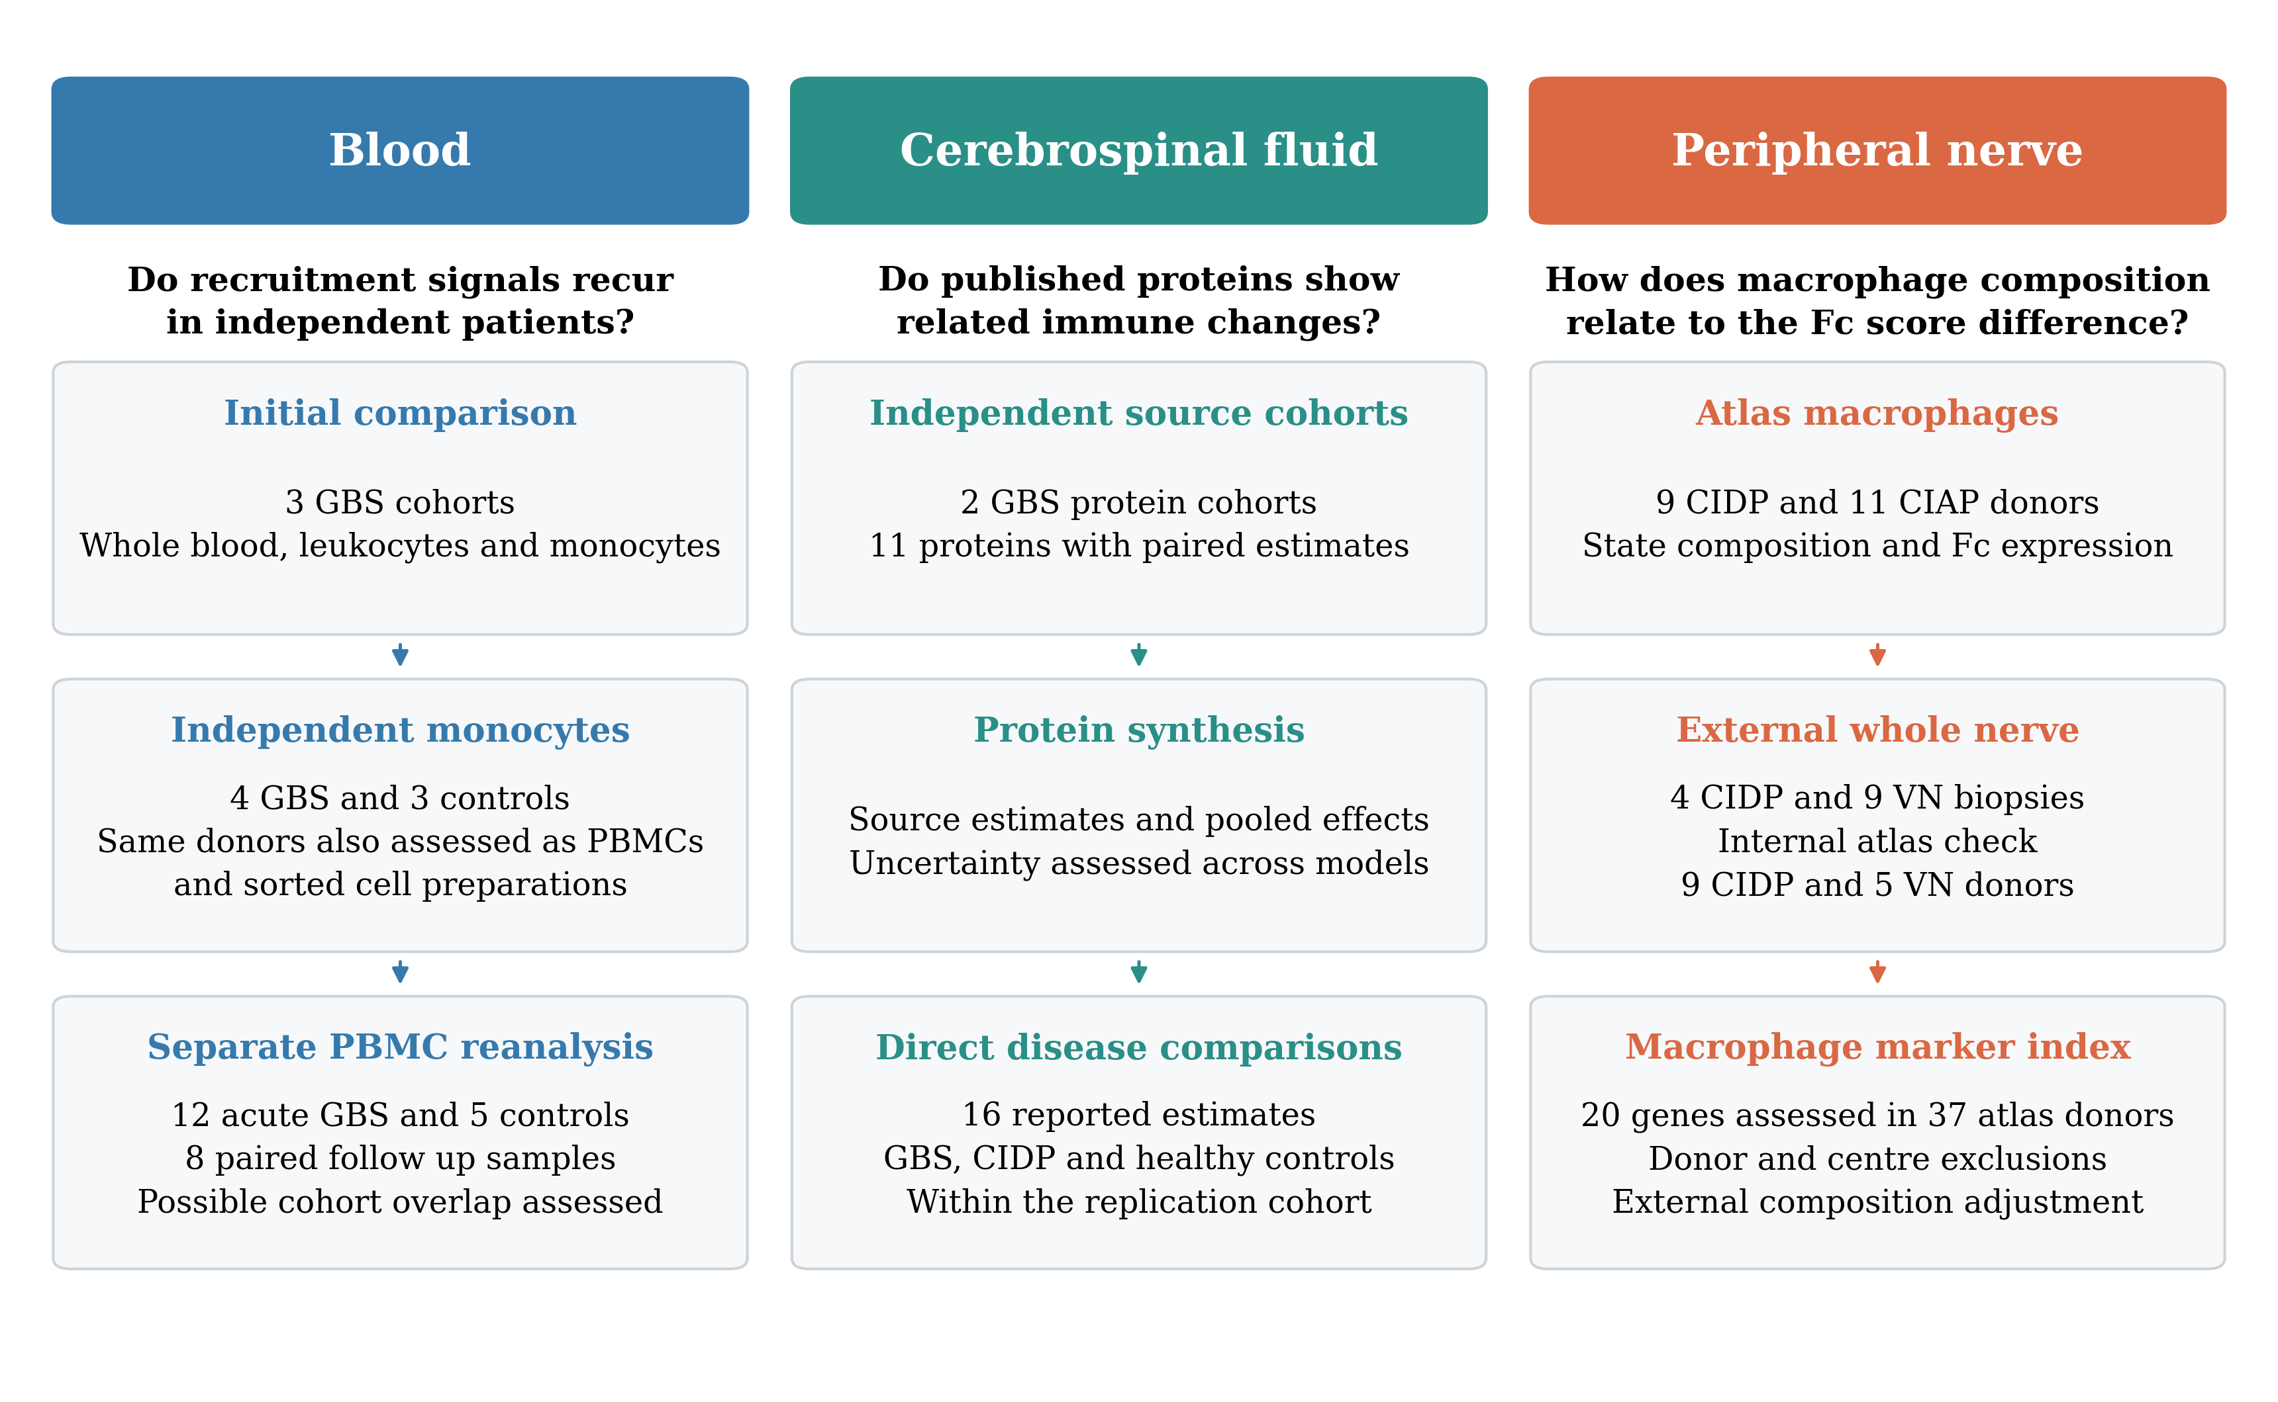
The blood analysis identifies recurring programmes in three original cohorts and tests the two selected programmes in an independent monocyte cohort. The same external patients provide whole PBMC and sorted cell comparisons. An additional Brazilian PBMC reanalysis is kept separate because donor independence from GSE211225 is unresolved. Published CSF coefficients provide a related protein comparison. The nerve analysis examines macrophage Fc expression and its response to composition adjustment, followed by an independent whole nerve comparison of four CIDP and nine vasculitic neuropathy cases. The original atlas provides an internal comparison with five vasculitic neuropathy donors. A separate macrophage marker index is evaluated in held out atlas donors and used to adjust the external tissue comparison. Each component retains its own participants and disease comparison. Arrows indicate the analysis sequence. VN, vasculitic neuropathy.

Figure 2. Acute GBS blood modules across cohorts
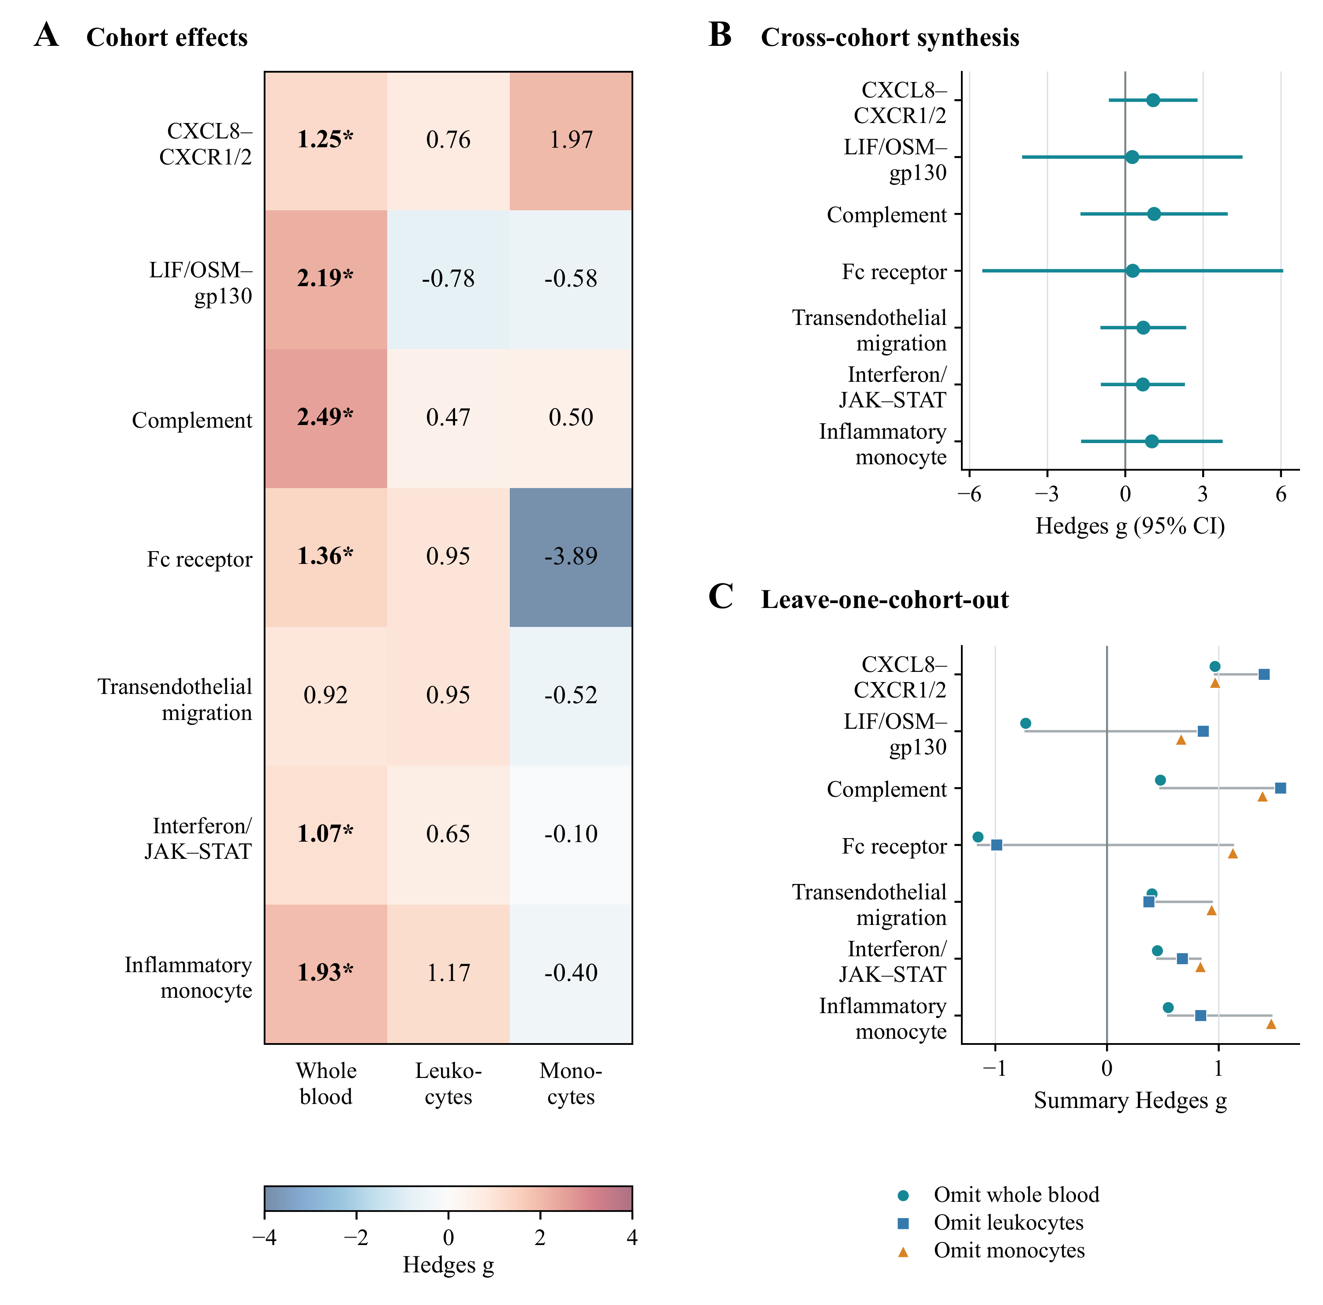
(A) Hedges g for seven gene modules in the three original blood cohorts, comprising whole blood, leukocytes and monocyte pseudobulk. Asterisks mark q < 0.05 after correction within each cohort. (B) Random effects pooled estimates with modified Hartung and Knapp 95% confidence intervals. All intervals include zero. (C) Pooled point estimates after each original cohort was omitted. Grey horizontal lines span the smallest to largest of these estimates and are not confidence intervals. CXCL8 recruitment and complement remained positive in every retained pair. Figure 3 shows the external blood data. Supplementary Table S5 reports the targeted four cohort sensitivity synthesis.

Figure 3. External GBS scores in monocytes and whole PBMCs
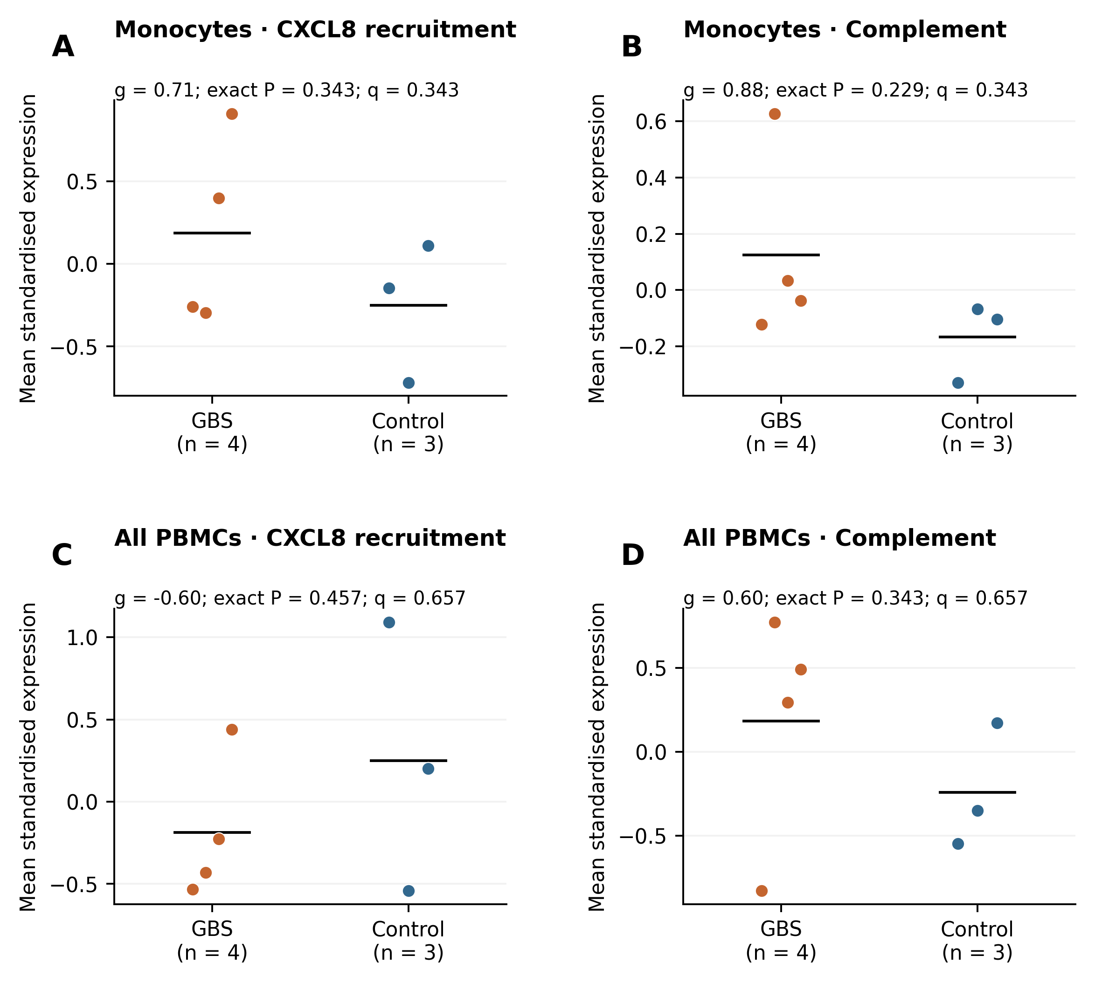
(A, B) CXCL8 recruitment and complement scores in author annotated monocytes from four early AIDP donors and three healthy controls in GSE304872. (C, D) Scores from all retained PBMCs in the same seven donors. Each point represents one donor. Orange indicates GBS, blue indicates controls, and black bars show group means. Gene expression is standardised separately within each cell population. The primary monocyte tests are corrected across two fixed modules. Whole PBMC tests belong to a separate family of ten tests that also includes both modules in four monocyte clusters. Displayed P values come from two sided exact donor label permutation tests. The CXCL8 score includes all three specified genes. The complement score includes 15 of 18 genes, with C4A, C4B and CFI absent from the deposited assay. Panels A and C show different CXCL8 directions in these sampled populations. A disease by cell population interaction was not tested. Supplementary Data 5 supplies the full scores, counts and gene coverage.

Figure 4. Synthesis of published CSF protein coefficients
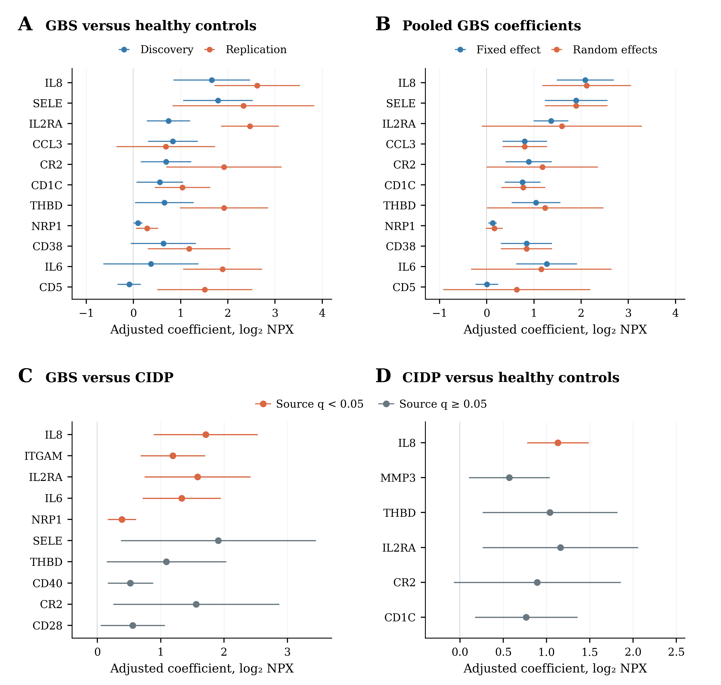
(A) All 11 proteins with paired GBS versus healthy control coefficients in source Tables 3 and 4B, adjusted for age, sex and CCL19 [28]. (B) Fixed effect and DerSimonian and Laird random effects pooled estimates. Panels A and B display normal approximation 95% intervals. All 11 modified Hartung–Knapp intervals include zero and are listed in Supplementary Data 1. (C) All ten reported GBS versus CIDP coefficients. (D) All six reported CIDP versus healthy control coefficients. Panels C and D use participants from the same replication cohort. In C and D, orange marks source q < 0.05 and grey marks source q ≥ 0.05. Their intervals were reconstructed from the published standard errors using a normal approximation and may differ from the original small sample tests. NPX, normalised protein expression.

Figure 5. Immune and repair modules in CIDP nerve
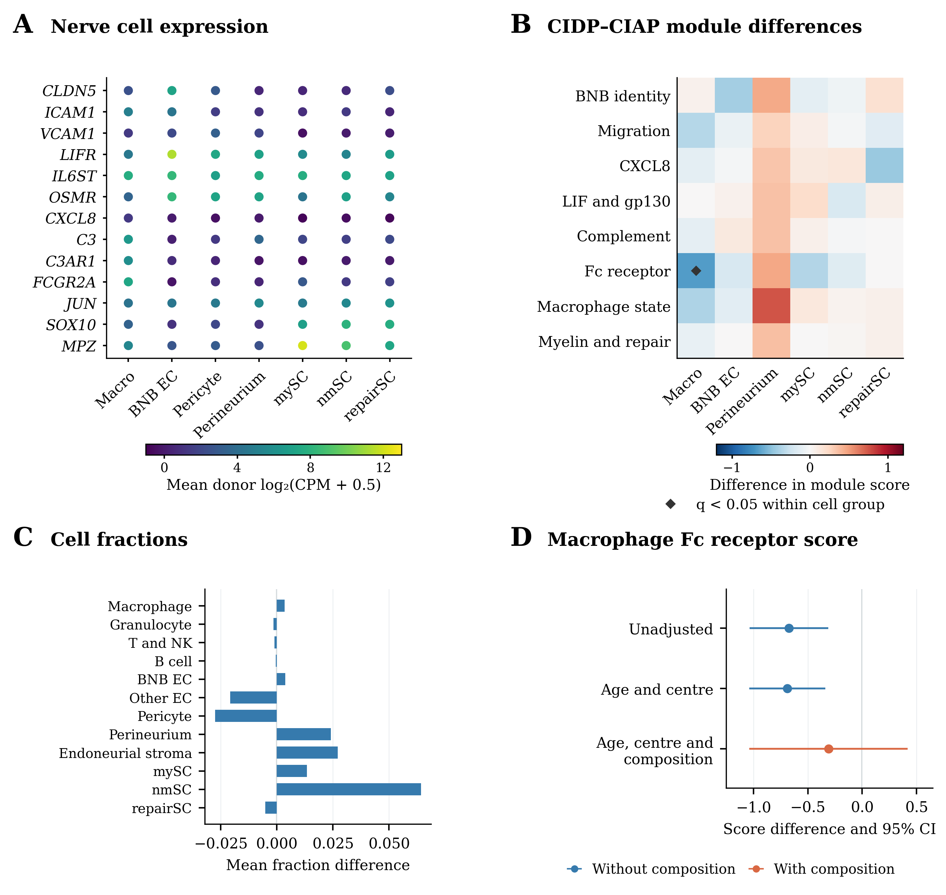
(A) Mean donor log2(CPM + 0.5) expression in seven CIDP cell groups. Dots have equal area and share one colour scale. (B) Mean CIDP minus CIAP differences for the original modules. Diamonds mark q < 0.05 across eight modules within a cell group. The macrophage Fc receptor result has q = 0.099 across the expanded 91 test family. Source tables retain the earlier corrections. (C) Mean differences in cell fractions. Rank tests in B and C treat donors as independent samples. (D) Macrophage Fc receptor differences with HC3 95% intervals. Blue marks the unadjusted and age and centre models. Orange marks the model that also includes two macrophage composition components. These model intervals are distinct from the rank tests used to calculate module q values. BNB EC, endoneurial microvascular endothelium. mySC, nmSC and repairSC, myelinating, nonmyelinating and pooled repair and damage Schwann cells. Supplementary Figures S3 and S4 give the full sensitivity analyses.

