Immune gene and protein profiles across blood, cerebrospinal fluid and peripheral nerve in inflammatory neuropathies
Yuan Feng¹†, Fang Feng²†, Shuxiao Ma¹†, Shuman Feng¹, Chao Jiang¹*, Yibin Hao¹*
¹ Department of Neurology, Henan Provincial People’s Hospital, People’s Hospital of Zhengzhou University, Zhengzhou 450003, China
² Department of Neurology, The First Affiliated Hospital of Zhengzhou University, Zhengzhou 450002, China
† Yuan Feng, Fang Feng and Shuxiao Ma contributed equally to this work.
* Correspondence: Yibin Hao, haoyibin999@163.com, and Chao Jiang, chaoj@zzu.edu.cn. Postal address: No. 7 Weiwu Road, Jinshui District, Zhengzhou, Henan, China.

Abstract
Background
Blood, cerebrospinal fluid (CSF) and peripheral nerve provide complementary views of immune changes in inflammatory neuropathies. We characterised immune gene and protein profiles in Guillain–Barré syndrome (GBS) and chronic inflammatory demyelinating polyradiculoneuropathy (CIDP) using public transcriptomic datasets and published proteomic and genetic findings. Gene modules were compared across three acute GBS blood cohorts, and published CSF protein coefficients were pooled across two cohorts. Nerve expression was analysed at the donor level in nine individuals with CIDP and 11 with chronic idiopathic axonal polyneuropathy, with published genetic candidates mapped to nerve cell populations.
Results
CXCL8 recruitment and complement scores were higher in acute GBS across all three blood cohorts, with pooled Hedges g estimates of 1.08 (95% confidence interval −0.63 to 2.78) and 1.11 (−1.73 to 3.95), respectively. Nine of ten selected CSF proteins had positive coefficients in both cohorts and pooled q < 0.05 under the fixed effect model, whereas CD5 showed opposite directions between cohorts (pooled q = 0.984). In nerve macrophages, the Fc receptor module score was lower in CIDP than in the axonal disease comparator, with q = 0.0087 after correction across eight macrophage modules and q = 0.087 across all 80 nerve module comparisons. This difference persisted after adjustment for age and centre but was attenuated after adjustment for macrophage composition. Correlations among nerve modules and with disability did not survive multiple testing correction (all q > 0.05). Among the genetic candidates, CDH4 expression was highest in Schwann cell states, whereas GNG7 expression was highest in B cells.
Conclusions
These findings highlight recurring recruitment and complement expression patterns in acute GBS blood, inflammatory protein changes in CSF, and distinct cellular expression patterns in CIDP nerve. Interpretation of the macrophage Fc receptor difference depends on cellular composition and the scope of multiple testing correction. Genetic candidate localisation provides a cellular context for published CIDP associations.

Keywords
Inflammatory neuropathy; transcriptomics; proteomics; blood–nerve barrier; macrophages; genetic susceptibility

Background
Guillain–Barré syndrome (GBS) and chronic inflammatory demyelinating polyradiculoneuropathy (CIDP) are inflammatory neuropathies with distinct clinical courses and diagnostic criteria [1,2,3]. Antibodies, complement and macrophages contribute to peripheral nerve injury, although their relative roles vary across diseases and subtypes [4,5,6,7,8,9]. Peripheral nerve atlases and experimental studies have further characterised diverse immune and Schwann cell responses to inflammation and injury [10,11,12,13]. These responses extend to processes involved in nerve repair, as illustrated by the effects of leukaemia inhibitory factor (LIF) on Schwann cell survival, proliferation and migration in experimental systems [14,15]. Examining immune and repair gene expression together may therefore provide a broader view of the molecular changes associated with inflammatory neuropathies.
The blood–nerve barrier (BNB) provides an anatomical interface between circulating immune cells and the peripheral nerve environment. It regulates exchange between the circulation and the endoneurium, with endothelial junctions and associated mural cells helping maintain its specialised properties [16,17,18]. Experimental studies have implicated leukocyte integrins, endothelial adhesion molecules and chemokines in immune cell trafficking across this interface [19,20,21]. Altered junctional protein expression in CIDP nerve further supports examining the BNB in the context of local inflammation [22].
Molecular studies of blood, cerebrospinal fluid (CSF) and peripheral nerve offer complementary perspectives on these processes. Blood transcriptomic studies using whole blood, leukocytes and peripheral blood mononuclear cells (PBMCs) characterise systemic immune responses in GBS [23,24,25]. CSF proteomics provides information on inflammation and molecular injury, while nerve transcriptomics identifies the cell populations expressing related genes [26,27]. Additional studies have described monocyte changes in acute inflammatory demyelinating polyradiculoneuropathy (AIDP), altered peripheral immune profiles in CIDP, and associations between blood gene expression and treatment response [28,29,30]. Experiments using patient immunoglobulin further implicate the BNB in inflammatory neuropathy [31], and genetic studies nominate candidate genes for investigation [32]. Considering these resources together offers an opportunity to examine how systemic immune expression relates to the pathways and cell populations represented in peripheral nerve.
Here, we compared immune gene modules across acute GBS blood cohorts, synthesised selected published CSF protein findings, and examined immune and repair modules in CIDP nerve. We also mapped published CIDP genetic candidates to nerve cell populations to establish their cellular expression context. These comparisons drew on separate participant cohorts to identify recurring biological themes, with differences in diagnosis, specimen type and assay informing the interpretation of patterns across datasets.

Methods

Study design and datasets
We examined immune profiles across blood, CSF and peripheral nerve using human transcriptomic datasets and published proteomic and genetic findings. GSE211225 provided six whole blood profiles from acute GBS, ten from the postacute phase and six from healthy controls [23]. GSE31014 included leukocyte microarrays from seven patients with GBS and seven healthy controls [24], and PRJNA1293757 provided PBMC transcriptomes from three untreated patients with AIDP and two healthy controls [25]. Blood module comparisons used the acute disease and healthy control groups from all three datasets.
Published CSF evidence included protein and endogenous peptide identifications by diagnostic group from the study associated with PXD002911 [26], together with reports on complement, quantitative proteomics and inflammatory proteins [33,34,35]. For quantitative synthesis, we extracted adjusted protein coefficients from the independent discovery and replication cohorts reported by Kmezic et al. [36].
Peripheral nerve expression was examined using GSE285983, which comprised 365,708 nuclei from 37 sural nerves and included nine donors with CIDP and 11 with chronic idiopathic axonal polyneuropathy (CIAP) [27]. The published human BNB transcriptome associated with GSE107574 served as a reference for interpreting endothelial expression [17]. Additional tissue evidence came from the publication associated with PXD056286, which reported histological observations from 55 nerve biopsies in CIDP and its variants, with proteomic findings from a smaller subset [37]. To examine the cellular expression of genetic candidates, we selected genes from the genetic association, Mendelian randomisation and colocalisation results reported by Du et al. [32].
Table 1 summarises the resources and their analytical roles, and Additional file 1 provides database names, accession identifiers, original filenames and source links.

Gene modules
We evaluated seven blood gene modules representing CXCL8 recruitment through CXCR1 and CXCR2, LIF and oncostatin M (OSM) signalling through gp130, complement, Fc receptors, interferon signalling through JAK and STAT, inflammatory monocytes and transendothelial migration. Nerve analyses used eight modules representing BNB identity, leukocyte transmigration, CXCL8 recruitment, LIF and related gp130 signalling, complement, Fc receptors, macrophage state and Schwann cell myelin and repair. Module scores summarised expression across the corresponding gene sets, whose constituent genes are specified in the analysis scripts. The BNB module combined endothelial and junctional genes, while the Schwann cell module combined myelin and injury response genes. These scores summarised gene expression rather than directly measuring barrier integrity or repair capacity.

Blood cohort analysis
For PRJNA1293757, we assigned quality controlled PBMCs to broad lineages using marker gene scores. We then generated monocyte pseudobulk profiles by summing counts within each donor, normalising them to counts per million (CPM) and applying a log₂(CPM + 0.5) transformation. Within each blood cohort, we standardised gene expression across participants and calculated module scores by averaging the standardised expression of available genes in each module. Differences between acute GBS and healthy controls were quantified using Hedges g, and mean module scores were compared using exact label permutation tests. P values were adjusted across the seven modules within each cohort using the Benjamini and Hochberg procedure [38].
Effects from whole blood, leukocytes and monocyte pseudobulk were pooled using a random effects model, with variance between cohorts estimated by the DerSimonian and Laird method and heterogeneity summarised by τ² and I² [39]. Confidence intervals were calculated using the modified Hartung and Knapp method, with the residual variance scale constrained to be at least one and a t distribution with degrees of freedom equal to the number of cohorts minus one [40]. We assessed the influence of each cohort on the pooled estimates by repeating the synthesis after omitting one cohort at a time. Postacute profiles contributed to the original preprocessing but were excluded from the inferential comparisons reported here, and the archived study design did not establish whether donors were independent across the acute and postacute phases.

CSF protein synthesis
The quantitative CSF synthesis included the ten proteins with coefficients and standard errors reported for both cohorts in Table 4B of Kmezic et al. [36]. These coefficients compared GBS with healthy controls on the log₂ normalised protein expression (NPX) scale and were adjusted for age, sex and the CSF sample handling marker CCL19. All paired estimates in this reported subset were included, regardless of their direction or statistical significance. For this exploratory synthesis, we pooled coefficients using inverse variance weighting under a fixed effect model, calculated 95% confidence intervals using a normal approximation, and adjusted P values across the ten pooled tests using the Benjamini and Hochberg procedure. DerSimonian and Laird random effects estimates were also reported alongside Q and I² to assess heterogeneity.
For the descriptive synthesis, we summarised CSF protein concentrations, protein and peptide identifications, and functional annotations from four reports [26,33,34,35]. We grouped findings by biological category and counted the studies and assay types represented in each category. Concentration measurements were grouped as one broad assay type.

Nerve pseudobulk analysis
We grouped GSE285983 nuclei by donor and annotated cell state. The groups included macrophages, T and natural killer cells, B cells, granulocytes, endoneurial endothelial cells, other endothelial cells, pericytes, perineurial cells, endoneurial stroma, and Schwann cells in myelinating, nonmyelinating, and repair and damage states. Groups with at least 20 nuclei per donor were eligible. We summed counts within each donor and cell group, calculated counts per million (CPM) using the total counts across all genes, and transformed expression as log₂(CPM + 0.5). Comparisons between CIDP and CIAP used donors as independent observations [41,42,43].

Nerve modules and macrophage sensitivity analyses
Within each cell group, we standardised each gene across eligible donors from all diagnostic categories and averaged the available gene z scores to obtain module scores. We compared CIDP with CIAP using the Mann and Whitney U test and expressed the difference as the mean CIDP score minus the mean CIAP score. Multiple testing correction covered eight modules within each cell group. We also applied correction across all 80 eligible nerve module comparisons. Cell fractions were compared separately at donor level, with correction across cell groups. These fractions describe the relative representation of each population in the sampled nuclei.
The macrophage Fc receptor module contained 11 measured genes. FCGR2C, the twelfth specified gene, was absent from the expression matrix. We assessed individual genes using the Mann and Whitney U test with correction across 11 tests, and four functional summaries with a separate correction. The q values for these comparisons without covariate adjustment were derived from the rank tests, whereas confidence intervals for mean differences were obtained from separate HC3 models. Sensitivity analyses restricted the comparison to male donors, standardised genes within the 20 CIDP and CIAP donors, adjusted for age and centre, and added sex to the adjusted model. Linear models used HC3 covariance estimates and residual degrees of freedom for confidence intervals. An exact permutation test preserved the number of CIDP donors within each centre. Additional file 2 provides the model specifications.
We matched the original macrophage annotations to refined immune annotations using nucleus barcodes. Composition summaries retained nuclei with unmatched labels and those reassigned to other categories. We represented donor composition using centred log ratios [44] and added its first two principal components to the model containing age and centre. We also reaggregated raw counts for all 20 CIDP and CIAP donors under alternative macrophage definitions. Tests of refined subtypes required at least 20 nuclei per donor and at least three eligible donors in each diagnosis group. Multiple testing correction covered the nine eligible refined subtypes.

Nerve module and disability correlations
We paired five module scores within each of the nine CIDP donors. These were endothelial LIF, endothelial leukocyte transmigration, macrophage complement, macrophage Fc receptors, and myelin and repair in Schwann cells annotated as repair and damage states. Spearman correlations described their ten pairwise relationships. We also tested 15 combinations of cell group and module for associations with Inflammatory Neuropathy Cause and Treatment (INCAT) disability scores. Multiple testing correction was applied separately to the ten intermodule correlations and the 15 disability correlations.

Comparison across compartments
We compared recurring biological programmes across compartments. A programme entered the evidence map if it had a consistent effect direction across blood cohorts, a corresponding published CSF protein or peptide annotation, or expression in a relevant nerve cell population. Each cell identifies the evidence type, and statistical comparisons retain their own testing families. For nerve interferon related genes, we extracted cell cluster marker results from Supplementary Data 3 and polyneuropathy versus control results from Supplementary Data 9 of Heming et al. [27]. The source controls were residual sural nerve autograft tissue from patients with traumatic nerve injuries. The map compares biological themes across independently sampled cohorts without calculating a single combined score.

Genetic candidate localisation
We selected CDH4, DIRAS1, GNG7 and SLC39A3 from the genetic study of 516 CIDP cases and 403,545 controls [32]. Candidate selection used the CDH4 locus reported in women and the published Mendelian randomisation and colocalisation findings for the other three genes. We examined their expression across nerve cell groups and compared CIDP with CIAP. CellBender counts from GSE285983 were normalised to 10,000 counts per nucleus, transformed as log2(CP10k + 1), and summarised by donor and cell group. We calculated mean expression and the percentage of nuclei with detectable expression for each donor. Figure 5B shows the arithmetic mean of each measure across the nine CIDP donors, with equal weight given to each donor. For each gene and cell group, 5,000 bootstrap resamples of eligible CIDP donors provided intervals around mean expression, using the random seed 20260904. Differences between CIDP and CIAP were tested using the Mann and Whitney U test, with P values adjusted across the 11 genes in the archived genetic candidate screen within each cell group, including the four CIDP candidates reported here.

Statistical analysis
Participants and nerve donors were the units of statistical inference. All disease contrasts and correlation tests were two sided. We denote P values adjusted by the Benjamini and Hochberg procedure as q and use q < 0.05 within each stated testing family. The Fc component and sensitivity analyses were planned after the initial macrophage association had been observed and are exploratory. Additional file 2 describes the inputs and intermediate tables needed to reproduce each component. Additional file 3 contains Supplementary Figures 1 to 4, which present candidate gene expression, published nerve observations and macrophage sensitivity analyses.

Results

Datasets and analytical roles
The three blood cohorts provided estimates from whole blood, leukocytes and monocytes. Published CSF studies contributed protein measurements, and the sural nerve atlas provided expression profiles by donor and cell group. The BNB reference and genetic findings supported the interpretation and selection of nerve genes (Fig. 1 and Table 1).

Immune gene modules in acute GBS blood
Acute GBS was associated with higher scores for six of the seven modules in GSE211225 after multiple testing correction. These were CXCL8 recruitment through CXCR1 and CXCR2 (Hedges g = 1.25, q = 0.045), LIF and OSM signalling through gp130 (g = 2.19, q = 0.0076), complement (g = 2.49, q = 0.0076), Fc receptors (g = 1.36, q = 0.038), interferon signalling through JAK and STAT (g = 1.07, q = 0.045), and inflammatory monocytes (g = 1.93, q = 0.015). The transendothelial migration score was also higher (g = 0.92, q = 0.126). These results indicate higher expression across several immune gene sets in acute GBS whole blood.
Six of the seven module effects were positive in the independent leukocyte cohort GSE31014. CXCL8 recruitment, complement, Fc receptors, transendothelial migration, interferon signalling and inflammatory monocytes changed in the same direction as in whole blood. In PRJNA1293757 monocytes, CXCL8 recruitment had the largest positive effect (g = 1.97), followed by a positive complement effect. The remaining module effects varied in direction.
CXCL8 recruitment and complement had positive effects in all three cohorts. The pooled Hedges g was 1.08 for CXCL8 recruitment (95% confidence interval −0.63 to 2.78, P = 0.114, I² = 0%) and 1.11 for complement (95% confidence interval −1.73 to 3.95, P = 0.234, I² = 57.2%). All seven pooled confidence intervals included zero. Four other modules had positive effects in two cohorts, while LIF and OSM signalling was positive only in whole blood (Fig. 2 and Table 2).
Omitting each cohort in turn left the pooled direction positive for CXCL8 recruitment (g = 0.97 to 1.41) and complement (g = 0.48 to 1.55). Both individual effects in each retained pair were positive, although the intervals based on two cohorts were wide. Every other module had at least one cohort with a discordant effect direction.
Heterogeneity differed across modules. I² was 0% for CXCL8 recruitment and interferon signalling, 1.1% for transendothelial migration, 49.5% for inflammatory monocytes, 57.2% for complement, 72.7% for Fc receptors and 81.2% for LIF and OSM signalling. The largest variation therefore concerned pathways with strong effects in whole blood and smaller or opposite effects in the other blood populations. With three cohorts, platform, cell composition and clinical differences remain overlapping explanations for this variation.

Published CSF protein findings
Nine of the ten selected CSF proteins (SELE, IL2RA, CCL3, CR2, CD1C, THBD, NRP1, CD38 and IL6) had positive coefficients in both cohorts and pooled q values below 0.05 under the fixed effect model after correction across all ten proteins. Within this subset, SELE and IL2RA were the only proteins that met the adjusted significance threshold in both cohorts in the source study [36]. CD5 showed opposite directions in the discovery and replication cohorts, with coefficients of −0.0882 and 1.51, respectively, yielding a pooled coefficient of 0.0024 (95% confidence interval −0.237 to 0.242, q = 0.984). Individual and pooled coefficients are presented in Figure 3A and B. Heterogeneity was greatest for IL2RA (I² = 94.9%), CD5 (I² = 89.0%), IL6 (I² = 80.7%) and THBD (I² = 79.5%). Under the DerSimonian and Laird random effects model, the 95% confidence intervals for IL2RA, NRP1 and IL6 included zero, indicating sensitivity to the pooling model.
Four additional CSF reports provided complementary descriptive evidence. The study associated with PXD002911 reported protein and peptide identifications with functional annotations [26]. D’Aguanno et al. described complement and inflammatory proteins [33], Ding et al. reported proteins related to protein handling and neural structure [34], and Sun et al. examined inflammatory proteins alongside routine CSF measurements [35]. Across these reports, local inflammation was represented in three. Protein accumulation was represented in two reports by elevated total CSF protein concentrations [26,35]. Structural proteolysis, complement, and protein handling and neural structure were each represented in one report (Fig. 3C).

Immune and repair gene expression in CIDP nerve
The sural nerve atlas revealed distinct cellular distributions of immune and repair gene expression. Macrophages expressed C3, C3AR1 and FCGR2A, while endoneurial endothelial cells expressed CLDN5, ICAM1, VCAM1, LIFR, IL6ST and OSMR. Schwann cell states expressed genes encoding gp130 receptor components alongside genes involved in myelination, stress responses and repair (Fig. 4A). The expression of CLDN5 and adhesion genes in endothelial cells was consistent with findings from the published human BNB transcriptome [17].
The macrophage Fc receptor module showed the strongest statistical evidence of a difference between CIDP and CIAP, with a mean module score difference of −0.673 (CIDP minus CIAP, P = 0.0011). The corresponding q value was 0.0087 after correction across eight macrophage modules and 0.087 after correction across all 80 eligible nerve module comparisons. Macrophage leukocyte transmigration and macrophage state scores were also lower in CIDP, with differences of −0.345 (P = 0.0185, q = 0.074) and −0.368 (P = 0.0334, q = 0.089), respectively. In perineurial cells, the macrophage state and complement module scores were higher in CIDP by 0.758 and 0.348, respectively (both q = 0.109). The endothelial BNB identity score was lower by 0.404 (P = 0.0276, q = 0.221). These comparisons are shown in Figure 4B.
All nine CIDP donors were male, compared with seven of the 11 CIAP donors, and the Fc receptor score remained lower in CIDP when the comparison was restricted to male donors (difference −0.687, P = 0.0007). Adjustment for age and centre yielded a similar estimate (difference −0.690, 95% confidence interval −1.040 to −0.339, P = 0.0008), and an exact permutation test within centres gave P = 0.0048. Estimates remained negative after individual donors, centres or module genes were omitted in turn (Supplementary Fig. 3).
At the gene level, four of the 11 measured genes, FCGR2A, FCER1G, TYROBP and HCK, showed lower expression in CIDP with q < 0.05 in the rank based comparisons. The q value for FCGRT was 0.713, while FCGR1A had a positive estimate with q = 0.148. The summary score for signalling components was lower (q = 0.039), whereas the activating receptor, inhibitory receptor and neonatal Fc receptor summaries all had q values above 0.05. The lower composite score therefore reflected differences in particular receptor and signalling genes.
Adding two macrophage composition components to the model containing age and centre attenuated the estimated difference to −0.310 (95% confidence interval −1.038 to 0.419, P = 0.375). A lower score was also observed in the combined group of refined macrophage subtypes (P = 0.0062), although all nine eligible tests of individual refined subtypes and all 32 annotation fraction tests had q values above 0.05 (Supplementary Fig. 4).
Across the broad nerve groups, no cell fraction comparisons met the threshold after multiple testing correction (all q > 0.05). The largest numerical increases in CIDP were observed in nonmyelinating Schwann cells (0.064, q = 0.515), endoneurial stroma (0.027, q = 0.515) and perineurial cells (0.024, q = 0.892) (Fig. 4C).
Among the nine CIDP donors, the strongest association with INCAT disability was observed for the myelin and repair score in Schwann cells annotated as repair and damage states (Spearman ρ = 0.840, P = 0.0046, q = 0.069). Endothelial LIF scores showed a weaker positive association (ρ = 0.602, P = 0.086), but none of the 15 disability correlations met the threshold after multiple testing correction (all q > 0.05, Fig. 4D).
Published tissue findings provided additional context for these expression patterns. Stascheit et al. reported terminal complement complex deposition on endoneurial capillaries in 52 of 55 biopsies from patients with CIDP or its variants [37], corresponding to 94.5% (calculated Wilson 95% confidence interval 85.1% to 98.1%). The source study also described macrophages expressing CD68 and T cells expressing CD8. In the proteomic subset of nine CIDP cases and two controls, the authors reported higher C3, C5 and C9 abundance, whereas C6 was elevated in only two cases. These published observations are summarised in Supplementary Figure 2.

Relationships among nerve modules
Within the nine CIDP donors, endothelial LIF scores correlated positively with endothelial leukocyte transmigration scores (ρ = 0.667, P = 0.0499, q = 0.166) and Schwann cell myelin and repair scores (ρ = 0.783, P = 0.0125, q = 0.125). Endothelial transmigration scores also correlated positively with macrophage complement scores (ρ = 0.683, P = 0.0424, q = 0.166), although none of the ten intermodule correlations met the threshold after multiple testing correction (all q > 0.05).
The evidence map placed these nerve findings alongside the blood and CSF results (Fig. 5 and Table 3). CXCL8 recruitment and complement showed consistent effect directions across blood cohorts, with related inflammatory or complement annotations represented in CSF. Fc receptor module scores were higher in acute GBS whole blood than in healthy controls but lower in CIDP nerve macrophages than in CIAP macrophages. Within nerve, the expression of adhesion genes in endothelial cells and repair genes in Schwann cells defined the cellular context of these programmes, while CSF studies described protein accumulation and proteolysis. Published source atlas markers showed OAS1 enrichment in macrophages and MX1 enrichment in arterial endothelial cells, while the source polyneuropathy versus control comparison showed lower MX1 expression in nonmyelinating Schwann cells [27].

Cellular expression of genetic candidates
Four genetic candidates were selected from two forms of evidence reported by Du et al. [32]. CDH4 was linked to the 20q13.33 locus reported in women, while DIRAS1, GNG7 and SLC39A3 were selected from the Mendelian randomisation and colocalisation findings. The published estimates underlying this selection are presented in Figure 5C.
Expression summaries across CIDP donors showed distinct cellular patterns among these candidates. CDH4 expression was highest in Schwann cells annotated as repair and damage states and nonmyelinating Schwann cells. GNG7 showed the highest expression in B cells, with additional expression detected in macrophages and BNB endothelial cells. SLC39A3 expression was low overall, with the highest mean in BNB endothelial cells, whereas DIRAS1 was sparsely expressed (Fig. 5B). Bootstrap intervals summarised uncertainty in the expression estimates for each cell group (Supplementary Fig. 1). None of the displayed expression comparisons between CIDP and CIAP reached significance after multiple testing correction (all q > 0.05, Fig. 5D).

Discussion
Using complementary public resources, we characterised immune gene and protein profiles across blood, CSF and peripheral nerve in inflammatory neuropathies. CXCL8 recruitment and complement showed the most consistent effect directions in acute GBS blood, and most selected CSF proteins had positive coefficients in both cohorts. In nerve, immune and repair gene expression was distributed across macrophages, endothelial cells and Schwann cells, with a lower macrophage Fc receptor score in CIDP than in CIAP. Published genetic candidates also showed distinct cellular expression patterns. These findings relate recurring immune themes to the nerve cell populations expressing the relevant genes.
Recruitment and complement emerged as recurring expression patterns across different blood preparations in acute GBS. Six modules were significant in the whole blood cohort, while CXCL8 recruitment and complement retained positive effect estimates across all three cohorts and after each cohort was omitted in turn, albeit with wide pooled confidence intervals. This pattern is consistent with experimental evidence implicating chemokines and leukocyte trafficking and with published CSF findings concerning interleukin 8 (IL8) [19,36,45,46,47]. Blood module scores and CSF protein abundance measurements capture different aspects of these processes, making their concordance useful for prioritising pathways to investigate in paired blood and CSF specimens.
The CSF findings add protein evidence for inflammation and associated vascular processes. Nine of the ten selected proteins had positive coefficients in both cohorts, and SELE and IL2RA were the two proteins in this subset that also met the source study’s adjusted significance threshold in each cohort [36]. Substantial heterogeneity for several proteins indicates that the estimated magnitudes varied considerably between cohorts. Complementary proteomic and peptidomic reports described inflammation, complement and molecular injury [26,33,34,35], broadening the biological context beyond the ten proteins included in the quantitative synthesis.
CSF samples the environment surrounding nerve roots and the neuraxis, whereas the BNB regulates exchange across the microvascular endothelium within peripheral nerve. The distribution of endothelial adhesion genes, immune transcripts and Schwann cell repair programmes suggests a plausible connection between immune cell recruitment and local tissue responses. Their temporal relationship remains unresolved because the specimens came from separate cohorts. Paired blood and CSF measurements, spatial nerve profiling and endothelial permeability assays could help clarify how these processes relate within individual patients.
Within the original analysis of nerve cell groups, the macrophage Fc receptor module showed the strongest statistical evidence of a difference between CIDP and CIAP. The estimated difference remained negative after demographic adjustment and omission analyses, with four receptor or signalling genes contributing to the lower score. Attenuation after composition adjustment indicates that the estimate is sensitive to how macrophage populations are represented in the model, an issue relevant to the diverse macrophage states described in the source atlas [27]. Published findings of complement deposition on endoneurial capillaries and altered peripheral B cell and CD8 effector profiles in CIDP provide broader context for immune involvement at different anatomical sites [29,37]. The lower Fc receptor score therefore characterises this particular comparison with CIAP, with its interpretation depending on macrophage composition and the scope of multiple testing correction.
The nominal positive association between the combined Schwann cell myelin and repair score and disability may reflect changes in the tissue response to injury. Because this module includes both myelin and injury response genes, a higher score does not establish greater repair capacity. The association did not meet the threshold after multiple testing correction (q = 0.069), and the small number of donors limits the precision of the estimate. Studies combining gene expression profiling, analysis of tissue organisation and longitudinal clinical assessment could clarify how vascular and Schwann cell responses relate to clinical impairment.
CDH4 expression was concentrated in Schwann cell states and GNG7 expression in B cells, highlighting populations for further investigation. The reported CDH4 association was identified in women [32], whereas all CIDP nerve donors were male. Although these expression data inform cellular localisation, potential sex dependent genetic effects remain unresolved. Low expression of DIRAS1 and SLC39A3 also limited their precise localisation. Functional studies in the relevant cell populations could help clarify how these genetic candidates relate to peripheral nerve biology.

Limitations
The blood cohorts were small and differed in cell composition and assay platform, resulting in wide confidence intervals for the pooled estimates. The CSF synthesis was restricted to ten proteins selected for reporting in the source publication, while the broader evidence map drew on four selected studies. Both analyses therefore capture only part of the available evidence. Correction across the ten pooled protein tests does not account for selection during the original protein screen. Several CSF estimates were also sensitive to the pooling model. In addition, the pooled CSF tests relied on a normal approximation, whereas the original studies used regression tests in small cohorts.
The nerve analysis compared nine donors with CIDP and 11 with axonal neuropathy, limiting interpretation to differences between these disease groups. All CIDP donors were male, recruitment was uneven across centres, and treatment and other clinical differences may have influenced gene expression. The Fc receptor association yielded q = 0.087 after correction across all 80 nerve module comparisons, and the effect estimate was attenuated after adjustment for cellular composition. Component and sensitivity analyses were conducted after the initial observation, and subtype estimates were based on few eligible donors. These findings therefore require evaluation in a larger independent nerve cohort.
Blood, CSF and nerve data came from separate cohorts, with diagnosis partly linked to specimen type, so disease related differences could not be fully separated from tissue specific variation. The companion spatial panel contained none of the specified Fc receptor module genes, preventing spatial assessment of this association. Genetic estimates were drawn from the published study, whereas our analyses assessed cellular expression. Matched samples and functional experiments are needed to test potential mechanistic links across compartments.

Conclusions
Analysis of public blood, CSF and nerve datasets reveals complementary immune expression patterns in inflammatory neuropathies. CXCL8 related recruitment and complement programmes recur across acute GBS blood cohorts, while CSF protein findings point to inflammatory and vascular processes. The nerve atlas maps immune and repair genes to specific cell populations and identifies a lower macrophage Fc receptor module score in CIDP than in CIAP. The magnitude of this association is sensitive to cellular composition, and its statistical support depends on the scope of multiple testing correction. Together with the cellular localisation of published genetic candidates, these findings identify pathways and nerve cell populations for further investigation in independent cohorts and studies using paired specimens.

List of abbreviations
AIDP, acute inflammatory demyelinating polyradiculoneuropathy. BNB, blood–nerve barrier. CIAP, chronic idiopathic axonal polyneuropathy. CIDP, chronic inflammatory demyelinating polyradiculoneuropathy. CPM, counts per million. CP10k, counts per 10,000. CSF, cerebrospinal fluid. FDR, false discovery rate. GBS, Guillain–Barré syndrome. GWAS, genome-wide association study. INCAT, Inflammatory Neuropathy Cause and Treatment. LIF, leukaemia inhibitory factor. NPX, normalised protein expression. OSM, oncostatin M. PBMC, peripheral blood mononuclear cell.

Declarations

Ethics approval and consent to participate
This study analysed publicly available deidentified data and published results. The source studies reported their ethics approvals and consent procedures. No new participants were recruited and no new specimens were collected.

Consent for publication
Not applicable. The manuscript contains no identifiable personal information.

Availability of data and materials
Database names, accession identifiers, original filenames and source links are provided in Additional file 1, together with aggregate analysis results. Additional file 2 describes the analysis procedures and the reconstruction of intermediate tables. Analysis code and aggregate results for version 2.3.1 are available in the GitHub repository [48] and are archived on Zenodo [49]. This release includes the CSF coefficient synthesis, macrophage sensitivity analyses, annotation comparisons and source documentation. The donor expression table required by the genetic localisation scripts is supplied in Additional file 4, with instructions for using it with the archived scripts.

Competing interests
The authors declare that they have no competing interests.

Funding
This work was supported by the Henan Medical Science and Technology Talent Overseas Training Program (HNMOT2024022) and the Henan Provincial Medical Science and Technology Research Program (LHGJ20250063 and SBGJ202401001).

Authors' contributions
YF conceived the study, developed the analytical framework, performed the analyses and drafted the manuscript. FF curated data, validated results and revised the manuscript. SXM contributed to validation, interpretation and manuscript revision. SMF contributed to data curation, literature evaluation and manuscript revision. CJ supervised the methodology and critically revised the manuscript. YH supervised the study, coordinated the project and critically revised the manuscript. All authors read and approved the final manuscript.

Acknowledgements
We thank the participants and investigators who generated and shared the datasets.

Supplementary information
Additional file 1. Additional file 1 Source Data.xlsx. Aggregate source data and database documentation. This Excel workbook contains 49 worksheets with figure and table source data, sensitivity results and database access records.
Additional file 2. Additional file 2 Methods.docx. This Word document describes the analytical procedures, source attribution and reconstruction of intermediate tables.
Additional file 3. Additional file 3 Figures.docx. Supplementary Figures 1 to 4. This Word document contains the four supplementary figures and legends on genetic candidate expression, published nerve observations and macrophage sensitivity analyses.
Additional file 4. Additional_file_4_Genetic_localisation_input.zip. This archive contains Genetic_donor_celltype.csv, a data dictionary, validation records and instructions for using the donor expression summaries with the version 2.3.1 genetic localisation scripts.

References
1. Willison HJ, Jacobs BC, van Doorn PA. Guillain-Barré syndrome. Lancet. 2016;388(10045):717-727. https://doi.org/10.1016/S0140-6736(16)00339-1.
2. van Doorn PA, Van den Bergh PYK, Hadden RDM, Avau B, Vankrunkelsven P, Attarian S, et al. European Academy of Neurology/Peripheral Nerve Society Guideline on diagnosis and treatment of Guillain-Barré syndrome. Eur J Neurol. 2023;30(12):3646-3674. https://doi.org/10.1111/ene.16073.
3. Van den Bergh PYK, van Doorn PA, Hadden RDM, Avau B, Vankrunkelsven P, Allen JA, et al. European Academy of Neurology/Peripheral Nerve Society guideline on diagnosis and treatment of chronic inflammatory demyelinating polyradiculoneuropathy: Report of a joint Task Force-Second revision. Eur J Neurol. 2021;28(11):3556-3583. https://doi.org/10.1111/ene.14959.
4. Quast I, Cueni F, Nimmerjahn F, Tackenberg B, Lünemann JD. Deregulated Fcγ receptor expression in patients with CIDP. Neurol Neuroimmunol Neuroinflamm. 2015;2(5):e148. https://doi.org/10.1212/NXI.0000000000000148.
5. Hafer-Macko CE, Sheikh KA, Li CY, Ho TW, Cornblath DR, McKhann GM, et al. Immune attack on the Schwann cell surface in acute inflammatory demyelinating polyneuropathy. Ann Neurol. 1996;39(5):625-635. https://doi.org/10.1002/ana.410390512.
6. Koike H, Nishi R, Ikeda S, Kawagashira Y, Iijima M, Katsuno M, et al. Ultrastructural mechanisms of macrophage-induced demyelination in CIDP. Neurology. 2018;91(23):1051-1060. https://doi.org/10.1212/WNL.0000000000006625.
7. Susuki K, Rasband MN, Tohyama K, Koibuchi K, Okamoto S, Funakoshi K, et al. Anti-GM1 antibodies cause complement-mediated disruption of sodium channel clusters in peripheral motor nerve fibers. J Neurosci. 2007;27(15):3956-3967. https://doi.org/10.1523/JNEUROSCI.4401-06.2007.
8. Kiefer R, Kieseier BC, Stoll G, Hartung HP. The role of macrophages in immune-mediated damage to the peripheral nervous system. Prog Neurobiol. 2001;64(2):109-127. https://doi.org/10.1016/s0301-0082(00)00060-5.
9. Shen D, Chu F, Lang Y, Geng Y, Zheng X, Zhu J, et al. Beneficial or Harmful Role of Macrophages in Guillain-Barré Syndrome and Experimental Autoimmune Neuritis. Mediators Inflamm. 2018;2018:4286364. https://doi.org/10.1155/2018/4286364.
10. Wolbert J, Li X, Heming M, Mausberg AK, Akkermann D, Frydrychowicz C, et al. Redefining the heterogeneity of peripheral nerve cells in health and autoimmunity. Proc Natl Acad Sci U S A. 2020;117(17):9466-9476. https://doi.org/10.1073/pnas.1912139117.
11. Arthur-Farraj PJ, Latouche M, Wilton DK, Quintes S, Chabrol E, Banerjee A, et al. c-Jun reprograms Schwann cells of injured nerves to generate a repair cell essential for regeneration. Neuron. 2012;75(4):633-647. https://doi.org/10.1016/j.neuron.2012.06.021.
12. Jessen KR, Mirsky R. The repair Schwann cell and its function in regenerating nerves. J Physiol. 2016;594(13):3521-3531. https://doi.org/10.1113/JP270874.
13. Napoli I, Noon LA, Ribeiro S, Kerai AP, Parrinello S, Rosenberg LH, et al. A central role for the ERK-signaling pathway in controlling Schwann cell plasticity and peripheral nerve regeneration in vivo. Neuron. 2012;73(4):729-742. https://doi.org/10.1016/j.neuron.2011.11.031.
14. Dowsing BJ, Morrison WA, Nicola NA, Starkey GP, Bucci T, Kilpatrick TJ. Leukemia inhibitory factor is an autocrine survival factor for Schwann cells. J Neurochem. 1999;73(1):96-104. https://doi.org/10.1046/j.1471-4159.1999.0730096.x.
15. Chen Q, Liu Q, Zhang Y, Li S, Yi S. Leukemia inhibitory factor regulates Schwann cell proliferation and migration and affects peripheral nerve regeneration. Cell Death Dis. 2021;12(5):417. https://doi.org/10.1038/s41419-021-03706-8.
16. Ubogu EE. Biology of the human blood-nerve barrier in health and disease. Exp Neurol. 2020;328:113272. https://doi.org/10.1016/j.expneurol.2020.113272.
17. Palladino SP, Helton ES, Jain P, Dong C, Crowley MR, Crossman DK, et al. The Human Blood-Nerve Barrier Transcriptome. Sci Rep. 2017;7(1):17477. https://doi.org/10.1038/s41598-017-17475-y.
18. Yosef N, Xia RH, Ubogu EE. Development and characterization of a novel human in vitro blood-nerve barrier model using primary endoneurial endothelial cells. J Neuropathol Exp Neurol. 2010;69(1):82-97. https://doi.org/10.1097/NEN.0b013e3181c84a9a.
19. Yosef N, Ubogu EE. α(M)β(2)-integrin-intercellular adhesion molecule-1 interactions drive the flow-dependent trafficking of Guillain-Barré syndrome patient derived mononuclear leukocytes at the blood-nerve barrier in vitro. J Cell Physiol. 2012;227(12):3857-3875. https://doi.org/10.1002/jcp.24100.
20. Dong C, Greathouse KM, Beacham RL, Palladino SP, Helton ES, Ubogu EE. Fibronectin connecting segment-1 peptide inhibits pathogenic leukocyte trafficking and inflammatory demyelination in experimental models of chronic inflammatory demyelinating polyradiculoneuropathy. Exp Neurol. 2017;292:35-45. https://doi.org/10.1016/j.expneurol.2017.02.012.
21. Langert KA, Von Zee CL, Stubbs EB Jr. Tumour necrosis factor α enhances CCL2 and ICAM-1 expression in peripheral nerve microvascular endoneurial endothelial cells. ASN Neuro. 2013;5(1):e00104. https://doi.org/10.1042/AN20120048.
22. Kanda T, Numata Y, Mizusawa H. Chronic inflammatory demyelinating polyneuropathy: decreased claudin-5 and relocated ZO-1. J Neurol Neurosurg Psychiatry. 2004;75(5):765-769. https://doi.org/10.1136/jnnp.2003.025692.
23. Lima MFO, Nogueira VB, Maury W, Wilson ME, Júnior METD, Teixeira DG, et al. Altered Cellular Pathways in the Blood of Patients With Guillain-Barre Syndrome. J Peripher Nerv Syst. 2025;30(1):e70012. https://doi.org/10.1111/jns.70012.
24. Chang KH, Chuang TJ, Lyu RK, Ro LS, Wu YR, Chang HS, et al. Identification of gene networks and pathways associated with Guillain-Barré syndrome. PLoS One. 2012;7(1):e29506. https://doi.org/10.1371/journal.pone.0029506.
25. Shi P, Diao Y, Yang H, Li R, Ye M, Liu D, et al. Single cell transcriptome profiling of peripheral blood mononuclear cells in Guillain-Barré syndrome patients. Sci Data. 2026;13(1):843. https://doi.org/10.1038/s41597-026-07489-5.
26. Ziganshin RH, Ivanova OM, Lomakin YA, Belogurov AA Jr, Kovalchuk SI, Azarkin IV, et al. The Pathogenesis of the Demyelinating Form of Guillain-Barre Syndrome (GBS): Proteo-peptidomic and Immunological Profiling of Physiological Fluids. Mol Cell Proteomics. 2016;15(7):2366-2378. https://doi.org/10.1074/mcp.M115.056036.
27. Heming M, Börsch AL, Wolbert J, Thomas C, Mausberg AK, Szepanowski F, et al. Multi-omic identification of perineurial hyperplasia and lipid-associated nerve macrophages in human polyneuropathies. Nat Commun. 2025;16(1):7872. https://doi.org/10.1038/s41467-025-62964-8.
28. Li M, Song J, Yin P, Chen H, Wang Y, Xu C, et al. Single-cell analysis reveals novel clonally expanded monocytes associated with IL1β-IL1R2 pair in acute inflammatory demyelinating polyneuropathy. Sci Rep. 2023;13(1):5862. https://doi.org/10.1038/s41598-023-32427-5.
29. Kim H, Chun J, Cha DH, Lee JS, Seo D, Shin W, et al. Integrated peripheral immune profiling reveals B-cell dysregulation and CD8 effector signatures in chronic inflammatory demyelinating polyneuropathy. Front Immunol. 2026;17:1888882. https://doi.org/10.3389/fimmu.2026.1888882.
30. Richard A, Corvol JC, Debs R, Reach P, Tahiri K, Carpentier W, et al. Transcriptome Analysis of Peripheral Blood in Chronic Inflammatory Demyelinating Polyradiculoneuropathy Patients Identifies TNFR1 and TLR Pathways in the IVIg Response. Medicine (Baltimore). 2016;95(19):e3370. https://doi.org/10.1097/MD.0000000000003370.
31. Shimizu F, Sato R, Mizukami Y, Watanabe K, Maeda T, Kanda T, et al. Blood-Nerve Barrier Breakdown Induced by Immunoglobulin G in Typical and Multifocal Chronic Inflammatory Demyelinating Polyneuropathy and Multifocal Motor Neuropathy. Int J Mol Sci. 2026;27(2):1088. https://doi.org/10.3390/ijms27021088.
32. Du Z, Lessard S, Iyyanki T, Chao M, Hammond T, Ofengeim D, et al. Genetic analyses of inflammatory polyneuropathy and chronic inflammatory demyelinating polyradiculoneuropathy identified candidate genes. HGG Adv. 2024;5(3):100317. https://doi.org/10.1016/j.xhgg.2024.100317.
33. D’Aguanno S, Franciotta D, Lupisella S, Barassi A, Pieragostino D, Lugaresi A, et al. Protein profiling of Guillain-Barrè syndrome cerebrospinal fluid by two-dimensional electrophoresis and mass spectrometry. Neurosci Lett. 2010;485(1):49-54. https://doi.org/10.1016/j.neulet.2010.08.060.
34. Ding Y, Shi Y, Wang L, Li G, Osman RA, Sun J, et al. Potential biomarkers identified by tandem mass tags based quantitative proteomics for diagnosis and classification of Guillain-Barré syndrome. Eur J Neurol. 2022;29(4):1155-1164. https://doi.org/10.1111/ene.15213.
35. Sun S, Li M, Song J, Zhong D. Using Olink Proteomics to Identify Inflammatory Biomarkers in the Cerebrospinal Fluid in Guillain-Barré Syndrome. J Inflamm Res. 2025;18:6703-6717. https://doi.org/10.2147/JIR.S507515.
36. Kmezic I, Gustafsson R, Fink K, Svenningsson A, Samuelsson K, Ingre C, et al. Validation of elevated levels of interleukin-8 in the cerebrospinal fluid, and discovery of new biomarkers in patients with GBS and CIDP using a proximity extension assay. Front Immunol. 2023;14:1241199. https://doi.org/10.3389/fimmu.2023.1241199.
37. Stascheit F, Roos A, Schroeter CB, Thomas JK, Hahn K, Preßler H, et al. Complement profiling of sural nerves in chronic-inflammatory demyelinating polyneuropathy. Acta Neuropathol. 2025;150(1):32. https://doi.org/10.1007/s00401-025-02936-w.
38. Benjamini Y, Hochberg Y. Controlling the False Discovery Rate: A Practical and Powerful Approach to Multiple Testing. J R Stat Soc Series B Methodol. 1995;57(1):289-300. https://doi.org/10.1111/j.2517-6161.1995.tb02031.x.
39. Higgins JPT, Thompson SG, Deeks JJ, Altman DG. Measuring inconsistency in meta-analyses. BMJ. 2003;327(7414):557-560. https://doi.org/10.1136/bmj.327.7414.557.
40. Röver C, Knapp G, Friede T. Hartung-Knapp-Sidik-Jonkman approach and its modification for random-effects meta-analysis with few studies. BMC Med Res Methodol. 2015;15:99. https://doi.org/10.1186/s12874-015-0091-1.
41. Squair JW, Gautier M, Kathe C, Anderson MA, James ND, Hutson TH, et al. Confronting false discoveries in single-cell differential expression. Nat Commun. 2021;12(1):5692. https://doi.org/10.1038/s41467-021-25960-2.
42. Crowell HL, Soneson C, Germain PL, Calini D, Collin L, Raposo C, et al. muscat detects subpopulation-specific state transitions from multi-sample multi-condition single-cell transcriptomics data. Nat Commun. 2020;11(1):6077. https://doi.org/10.1038/s41467-020-19894-4.
43. Zimmerman KD, Espeland MA, Langefeld CD. A practical solution to pseudoreplication bias in single-cell studies. Nat Commun. 2021;12(1):738. https://doi.org/10.1038/s41467-021-21038-1.
44. Aitchison J. The Statistical Analysis of Compositional Data. J R Stat Soc Series B Methodol. 1982;44(2):139-160. https://doi.org/10.1111/j.2517-6161.1982.tb01195.x.
45. Breville G, Lascano AM, Roux-Lombard P, Vuilleumier N, Lalive PH. Interleukin 8, a Biomarker to Differentiate Guillain-Barré Syndrome From CIDP. Neurol Neuroimmunol Neuroinflamm. 2021;8(5):e1031. https://doi.org/10.1212/NXI.0000000000001031.
46. Heming M, Schulte-Mecklenbeck A, Brix T, Wolbert J, Ruland T, Klotz L, et al. Immune Cell Profiling of the Cerebrospinal Fluid Provides Pathogenetic Insights Into Inflammatory Neuropathies. Front Immunol. 2019;10:515. https://doi.org/10.3389/fimmu.2019.00515.
47. Xia RH, Yosef N, Ubogu EE. Selective expression and cellular localization of pro-inflammatory chemokine ligand/receptor pairs in the sciatic nerves of a severe murine experimental autoimmune neuritis model of Guillain-Barré syndrome. Neuropathol Appl Neurobiol. 2010;36(5):388-398. https://doi.org/10.1111/j.1365-2990.2010.01092.x.
48. Feng Y. gbs-cidp-blood-nerve-barrier. Version 2.3.1. GitHub. https://github.com/applepie567/gbs-cidp-blood-nerve-barrier/releases/tag/v2.3.1. Accessed 16 September 2026.
49. Feng Y, Feng F, Ma S, Feng S, Jiang C, Hao Y. Immune gene and protein profiles across blood, cerebrospinal fluid and peripheral nerve in inflammatory neuropathies. Version 2.3.1. Zenodo. 2026. Concept DOI for the version series. Concept DOI for the version series. https://doi.org/10.5281/zenodo.22226672.

Tables

Table 1. Datasets and analytical roles
Resource | Material | Participants or samples | Analytical role
GSE211225 | Whole blood transcriptomics | 6 acute GBS, 10 postacute, 6 controls | Primary blood effects for individual participants
GSE31014 | Leukocyte microarray | 7 GBS, 7 controls | Independent assessment of blood effect direction
PRJNA1293757 | PBMC transcriptomics | 3 AIDP, 2 controls | Monocyte localisation and assessment of effect direction
PXD002911 | CSF proteomics and peptidomics | GBS (AIDP), MS and controls, with pooled discovery material | Published CSF identifications and functional annotations
GSE285983 | Sural nerve nuclear transcriptomics | 9 CIDP, 11 CIAP in focused comparison | Donor gene module scores, cell fractions and expression localisation
GSE107574 | Human endoneurial endothelial transcriptomics | Cultured cells and microvessels | Published BNB expression reference
Kmezic et al. 2023 | CSF Olink proteomics | Discovery cohort with 6 GBS and 20 controls. Replication cohort with 6 GBS and 6 controls. | Synthesis of ten paired CSF protein coefficients from source Table 4B
PXD056286 | Sural nerve histology and proteomics | 55 CIDP biopsies for histology. Proteomics in 9 CIDP cases and 2 controls. | Published tissue observations and calculated Wilson interval
GBS, Guillain–Barré syndrome. AIDP, acute inflammatory demyelinating polyradiculoneuropathy. CIDP, chronic inflammatory demyelinating polyradiculoneuropathy. CIAP, chronic idiopathic axonal polyneuropathy. CSF, cerebrospinal fluid. MS, multiple sclerosis. PBMC, peripheral blood mononuclear cell. BNB, blood–nerve barrier. Eligible nerve donor numbers vary by cell group.

Table 2. Pooled effects of acute GBS blood modules
Gene module | Hedges g | 95% CI | P value | I² (%) | Cohorts
CXCL8 signalling via CXCR1 and CXCR2 | 1.075 | −0.634 to 2.785 | 0.114 | 0.0 | 3
LIF and OSM signalling via gp130 | 0.271 | −3.978 to 4.519 | 0.810 | 81.2 | 3
Complement | 1.111 | −1.728 to 3.950 | 0.234 | 57.2 | 3
Fc receptor | 0.288 | −5.510 to 6.086 | 0.851 | 72.7 | 3
Transendothelial migration | 0.694 | −0.958 to 2.347 | 0.212 | 1.1 | 3
Interferon signalling via JAK and STAT | 0.677 | −0.943 to 2.297 | 0.214 | 0.0 | 3
Inflammatory monocyte | 1.026 | −1.702 to 3.754 | 0.247 | 49.5 | 3
Positive Hedges g indicates a higher score in acute GBS. Variance between cohorts was estimated by the DerSimonian and Laird method. Confidence intervals and P values use the modified Hartung and Knapp procedure, with residual scale bounded below by one. Each estimate combines three cohorts. CI, confidence interval.

Table 3. Evidence across blood, CSF and peripheral nerve
Programme | Blood evidence | CSF evidence | Peripheral nerve evidence | Interpretation
CXCL8 recruitment | Positive in 3 cohorts. Pooled P = 0.114. Whole blood q < 0.05 | Published innate immune and inflammatory protein findings | Myeloid localisation and endothelial trafficking context | Recurring recruitment expression
Complement | Positive in 3 cohorts. Pooled P = 0.234. Whole blood q < 0.01 | Published complement protein findings | Macrophage localisation | Complement gene and protein findings
Fc receptor | Whole blood q < 0.05, with mixed directions across cohorts | Not directly evaluated | Macrophage q = 0.0087 within eight modules and q = 0.087 across 80 nerve comparisons | Lower macrophage score, attenuated after composition adjustment
Interferon response | Whole blood q < 0.05, with mixed directions across cohorts | Published evidence of antiviral defence | Published OAS1 enrichment in macrophages and MX1 enrichment in arterial endothelial cells. Published lower MX1 in nonmyelinating Schwann cells in PNP versus controls [27]. | Published gene level expression context
Endothelial adhesion | Migration module q = 0.126 in whole blood. Positive in whole blood and leukocytes, negative in monocytes | Not directly evaluated | ICAM1 and VCAM1 localisation to BNB endothelial cells | Endothelial expression of adhesion genes
Schwann repair | Not evaluated | Published evidence of axonal domain peptide degradation | Repair and stress programmes localised to Schwann cells | Structural injury and Schwann cell repair context
Blood comparisons concern acute GBS and healthy controls. Nerve comparisons in this study concern CIDP and CIAP. Blood q values refer to seven module tests within the whole blood cohort, and nerve q values refer to the stated testing families. The nerve interferon entry uses published marker results from the full source atlas and a published PNP versus control comparison [27]. A dedicated nerve interferon module was not tested in the CIDP versus CIAP analysis. The evidence types do not form a common scale across compartments. PNP, polyneuropathy.

Figures and legends

Figure 1. Study design and analytical roles
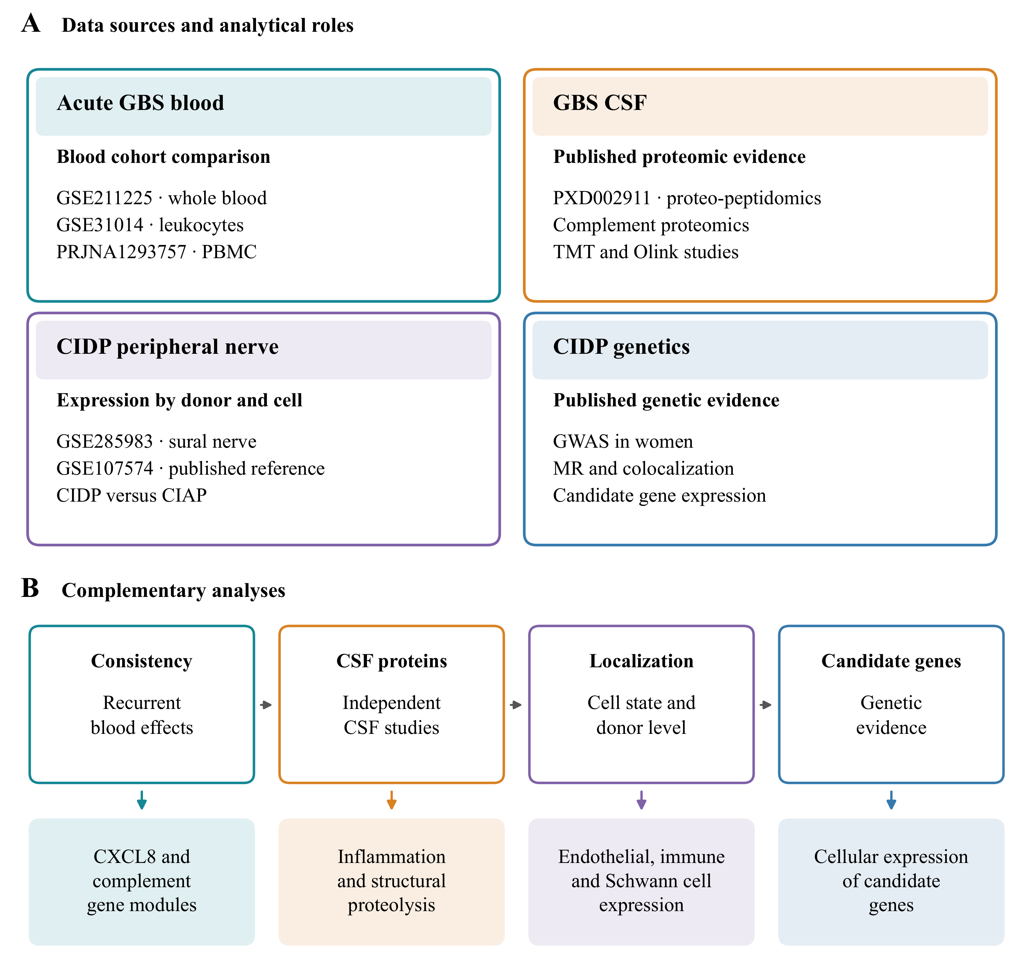
Public blood, CSF, peripheral nerve and genetic resources contributed complementary measurements. Blood cohorts provided gene module effects, CSF reports provided protein and peptide findings, and the nerve atlas provided expression by donor and cell group. Published genetic associations guided candidate selection for nerve expression analysis. Arrows summarise analytical connections and biological questions.

Figure 2. Acute GBS blood modules across cohorts
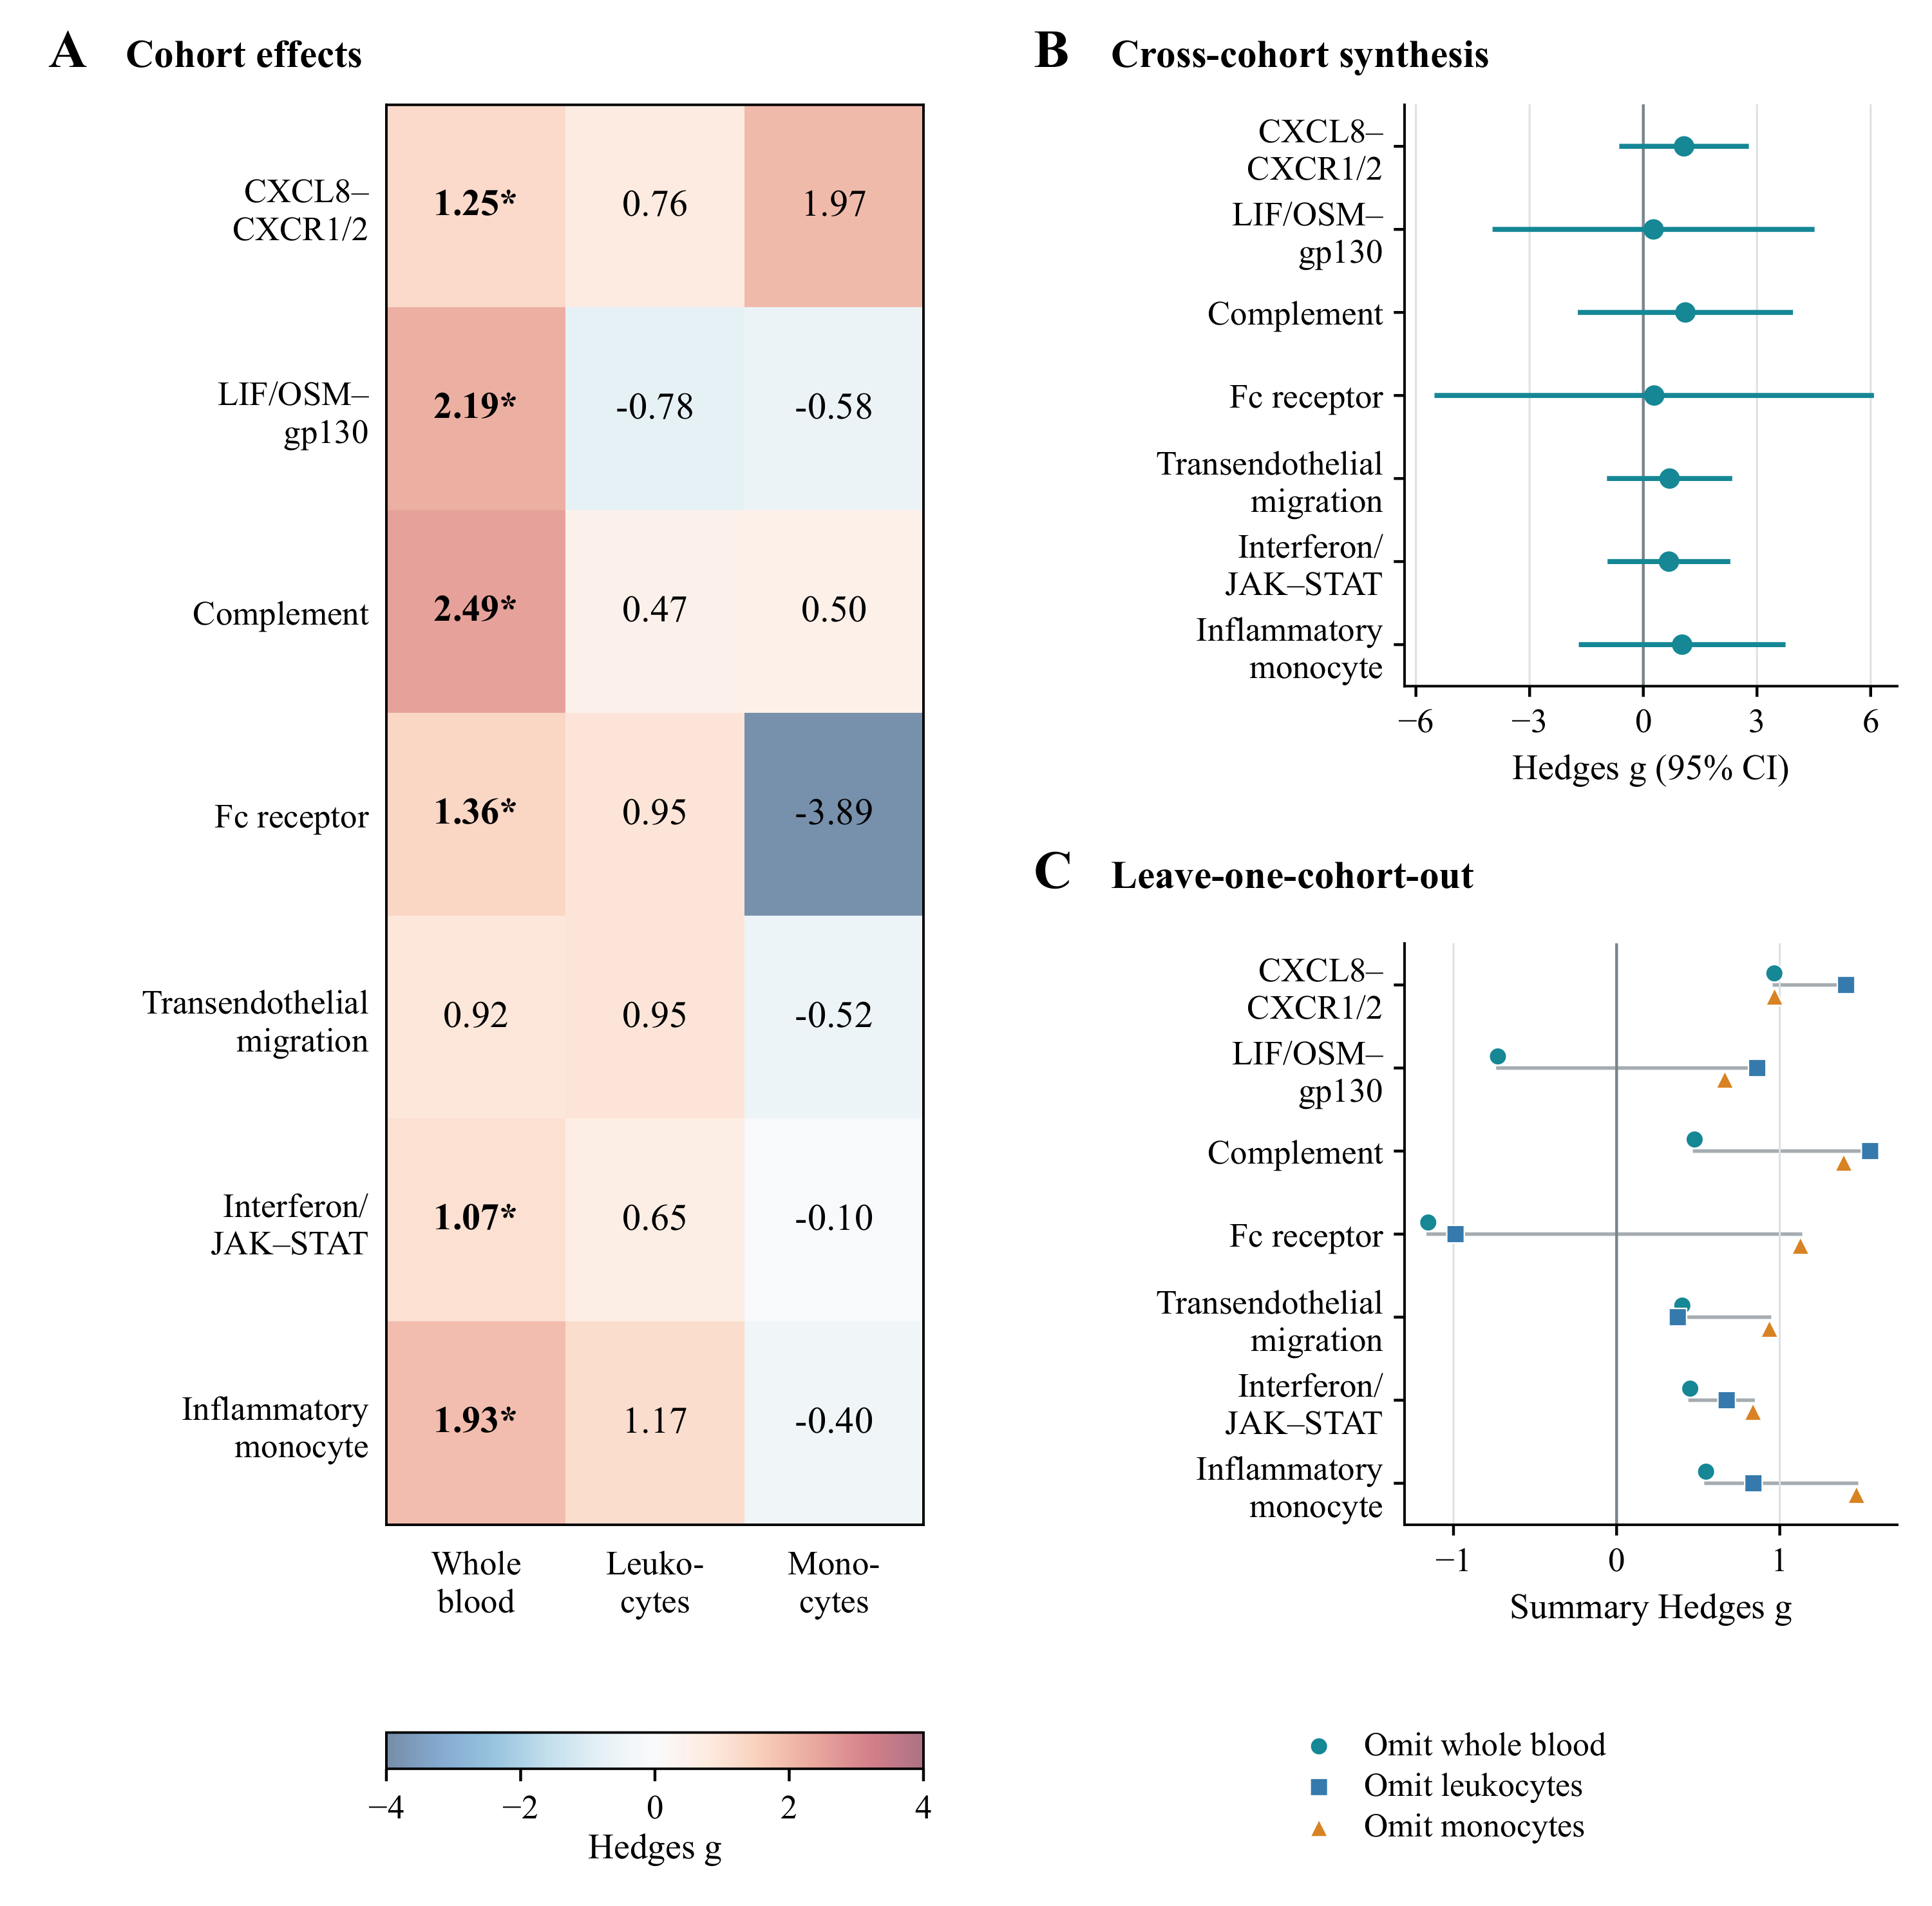
(A) Hedges g for seven gene modules in whole blood, leukocytes and monocyte pseudobulk. Asterisks indicate q < 0.05 after correction within each cohort. (B) Pooled estimates from models with random effects and 95% confidence intervals calculated using the modified Hartung and Knapp method. (C) Pooled estimates after each cohort was omitted in turn. CXCL8 recruitment and complement retained positive estimates in all subsets, and both effects in each retained pair were positive. All pooled intervals in B include zero.

Figure 3. Synthesis of published CSF protein coefficients
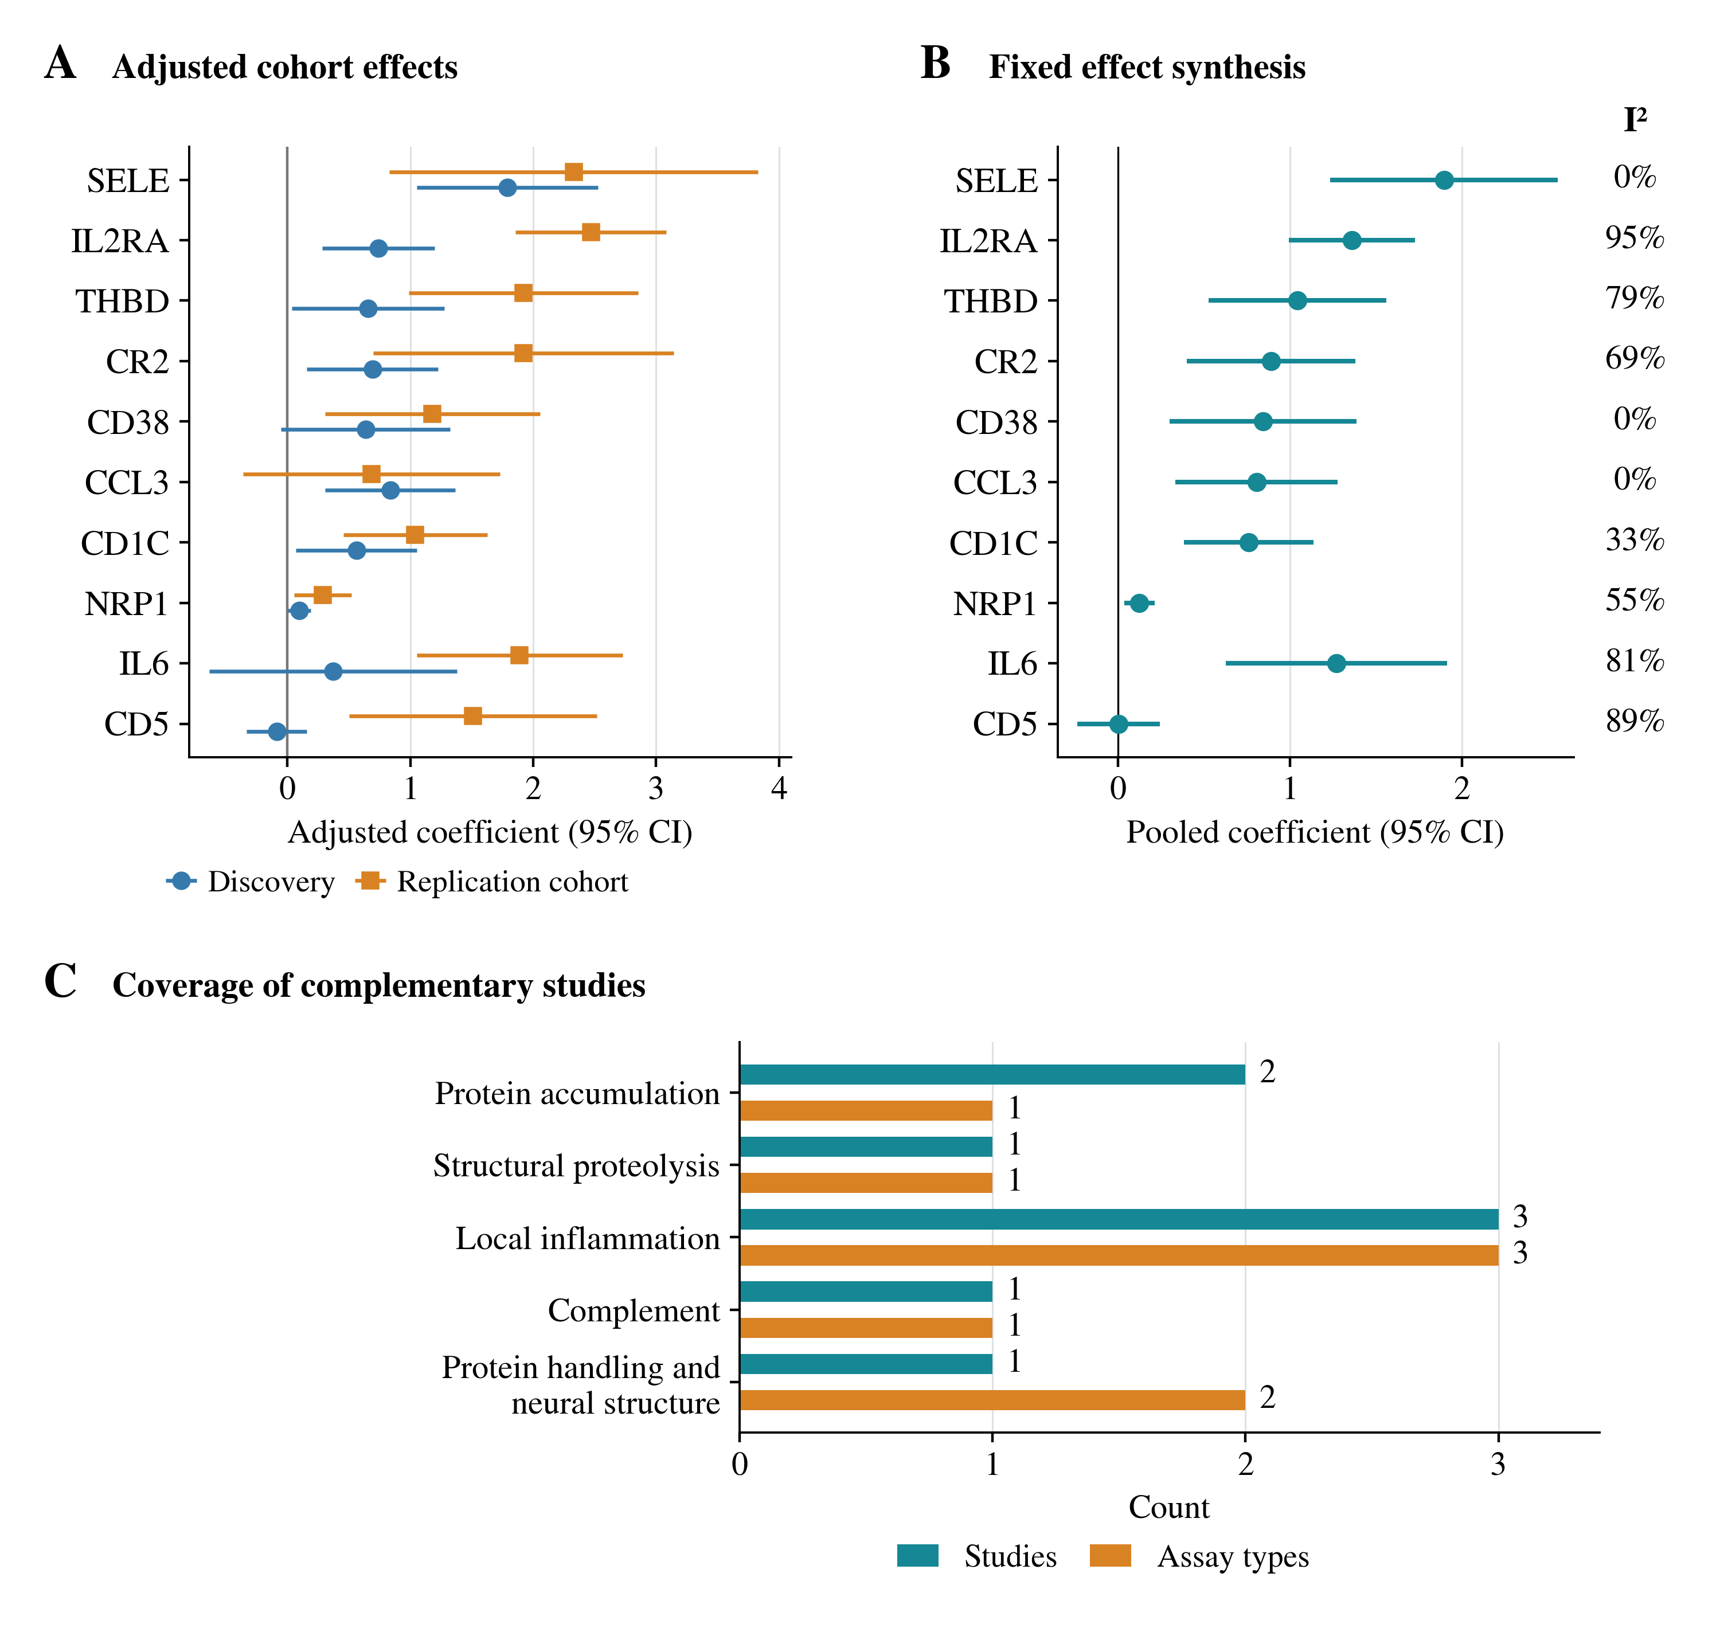
(A) Coefficients for GBS versus healthy controls from the discovery and replication cohorts of Kmezic et al., expressed on the log2 NPX scale and adjusted for age, sex and the CSF sample handling marker CCL19 [36]. Error bars show 95% confidence intervals calculated from the reported standard errors using a normal approximation. (B) Estimates pooled with inverse variance weights in a model with a fixed effect. The analysis includes the ten proteins with paired coefficients in source Table 4B, with IL8 considered separately. Nine pooled tests have q < 0.05, while CD5 has q = 0.984. I² describes heterogeneity. The source study found adjusted significance in both cohorts for SELE and IL2RA. (C) Coverage by study and assay type across four descriptive reports [26,33,34,35]. Concentration measurements are grouped as one broad assay type.

Figure 4. Immune and repair modules in CIDP nerve
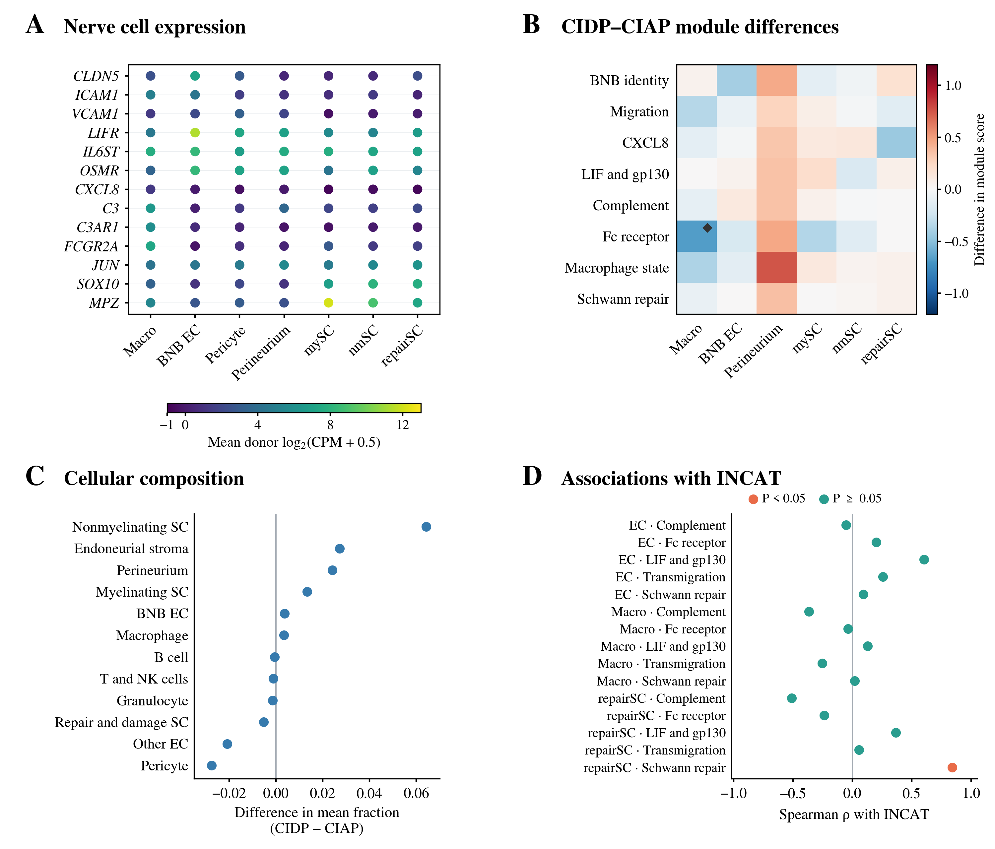
(A) Mean donor gene expression across seven CIDP nerve cell groups. Colour shows the arithmetic mean of donor log2(CPM + 0.5) values on a common scale across genes and cell groups. All dots have the same area. Each cell group includes nine donors. Granulocytes are omitted because matching expression summaries were unavailable. (B) Differences in donor module scores between CIDP and CIAP for six selected cell groups. Diamonds indicate q < 0.05 after correction within a cell group. The macrophage Fc receptor result has q = 0.087 after correction across all 80 eligible comparisons. (C) Differences in mean cell fractions, calculated as CIDP minus CIAP. The comparisons in B and C use the Mann and Whitney U test with donors as independent samples. (D) Spearman correlations between donor module scores and INCAT disability. Orange indicates P < 0.05 and teal indicates P ≥ 0.05. All disability correlations have q > 0.05 after correction. BNB EC denotes endoneurial microvascular endothelial cells. Supplementary Figures 3 and 4 present the macrophage sensitivity analyses. Macro denotes macrophages. mySC denotes myelinating Schwann cells, nmSC denotes nonmyelinating Schwann cells, and repairSC denotes Schwann cells annotated as repair and damage states.

Figure 5. Evidence across compartments and expression of genetic candidates
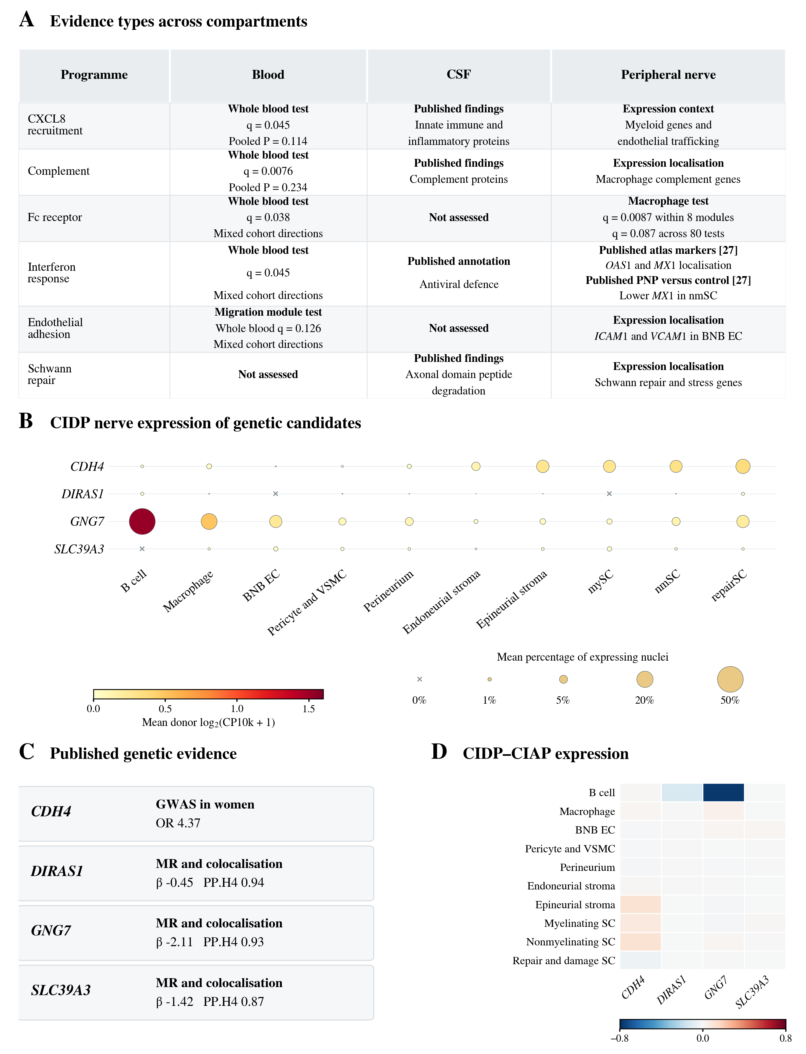
(A) Descriptive evidence map with the evidence type stated in each cell. The categories are not ranked. Blood q values refer to seven module tests within the whole blood cohort. The nerve macrophage Fc receptor q values refer separately to eight modules within macrophages and all 80 eligible nerve module comparisons. All pooled blood module effects have P > 0.05. Published nerve interferon evidence comes from Supplementary Data 3 and 9 of Heming et al. [27]. The marker results identify OAS1 enrichment in macrophages and MX1 enrichment in arterial endothelial cells relative to other atlas nuclei. The published disease comparison shows lower MX1 in nonmyelinating Schwann cells in polyneuropathy than in source controls. (B) Expression of CDH4, DIRAS1, GNG7 and SLC39A3 across CIDP nerve cell groups. Dot area is proportional to the arithmetic mean of donor percentages of expressing nuclei. Colour shows the arithmetic mean of donor mean log2(CP10k + 1) values. Both summaries give equal weight to each of the nine CIDP donors. Crosses indicate zero detected expression. (C) Published genetic estimates from Du et al. that guided candidate selection [32]. The CDH4 estimate is for rs80339443 in women. MR, Mendelian randomisation. PP.H4, posterior probability of a shared causal variant. (D) Differences in donor mean expression between CIDP and CIAP. Red indicates higher expression in CIDP and blue indicates lower expression. All displayed comparisons have q > 0.05. PNP denotes polyneuropathy. BNB EC denotes endoneurial microvascular endothelial cells. VSMC denotes vascular smooth muscle cells. mySC denotes myelinating Schwann cells, nmSC denotes nonmyelinating Schwann cells, and repairSC denotes Schwann cells annotated as repair and damage states.

