Immune compartmentalization across blood, cerebrospinal fluid and peripheral nerve in Guillain-Barré syndrome and CIDP
Yuan Feng¹, Fang Feng², Shuxiao Ma¹, Shuman Feng¹, Chao Jiang¹*, Yibin Hao¹*
¹ Department of Neurology, Henan Provincial People’s Hospital, People’s Hospital of Zhengzhou University, Zhengzhou 450003, China
² Department of Neurology, The First Affiliated Hospital of Zhengzhou University, Zhengzhou 450002, China
* Correspondence: Yibin Hao, haoyibin999@163.com, and Chao Jiang, chaoj@zzu.edu.cn. Postal address: No. 7 Weiwu Road, Jinshui District, Zhengzhou, Henan, China.
Running title: Immune compartmentalization across blood, CSF and peripheral nerve

Abstract
Background: Inflammatory neuropathies are commonly examined in one biospecimen, leaving the relationship between circulating immunity, cerebrospinal-fluid (CSF) injury signals, nerve-resident responses and inherited susceptibility incompletely resolved. We mapped these layers across Guillain-Barré syndrome (GBS) and chronic inflammatory demyelinating polyradiculoneuropathy (CIDP) and anchored the tissue findings to the human blood-nerve barrier (BNB).
Methods: A staged framework integrated three acute-GBS blood transcriptomic cohorts, four peer-reviewed GBS CSF proteomic studies, a CIDP sural-nerve single-nucleus atlas, a normal human BNB reference and published CIDP GWAS, Mendelian-randomization and colocalization results. Cohort-specific effects, random-effects synthesis, donor-level pseudobulk, cross-study CSF evidence mapping, donor-resolved candidate-gene localization and Open Targets tractability were evaluated.
Results: Acute GBS blood showed coordinated recruitment and humoral-effector activity, with CXCL8-CXCR1/2 and complement positive in all three cohorts. Across GBS CSF studies, the disease was characterized by increased protein and peptide-fragment burden, inflammatory chemokines, complement C3 and independently validated protein-handling markers. In CIDP nerve, macrophage Fc-receptor activity was lower than in chronic idiopathic axonal polyneuropathy, while cell-type composition remained comparatively stable. Published CIDP genetic signals localized CDH4 predominantly to repair and nonmyelinating Schwann cells, GNG7 to B cells, macrophages and BNB endothelium, and SLC39A3 at low abundance to BNB endothelium. None of the four primary genes was differentially expressed after FDR correction, and no direct clinical drug candidate was identified.
Conclusions: The analysis defines a compartmentalized architecture linking systemic recruitment, CSF inflammation and proteolysis, and nerve-resident BNB, macrophage and Schwann-cell states. Genetic anchoring identifies the cell states in which susceptibility signals may operate and prioritizes gene-cell combinations for functional validation.
Keywords: Guillain-Barré syndrome, chronic inflammatory demyelinating polyradiculoneuropathy, cerebrospinal fluid, blood-nerve barrier, macrophage, Schwann cell, genetic anchoring, functional validation

Background
Guillain-Barré syndrome (GBS) and chronic inflammatory demyelinating polyradiculoneuropathy (CIDP) occupy different clinical time scales but share core pathological processes, including leukocyte recruitment, antibody and complement activity, macrophage-mediated myelin injury and Schwann-cell reprogramming [1-15]. The biological relationship between these processes is difficult to infer from a single tissue because blood, CSF and peripheral nerve capture different stages of the immune response.
The blood-nerve barrier (BNB) is the vascular interface that regulates immune entry into the endoneurium. Tight-junction-bearing endothelial cells and pericytes maintain this specialized barrier, while ICAM1, VCAM1, CCL2 and leukocyte integrins provide a route for inflammatory adhesion and transendothelial migration [16-22]. The BNB is therefore positioned between circulating recruitment signals and the macrophage and Schwann-cell states that develop within injured nerve.
Recent single-cell and multi-omic studies show that disease biology is most informative when resolved across cohorts, cell states and anatomical locations [10,23-32]. Blood transcriptomics measures systemic immune activation, CSF proteomics records inflammatory proteins, protein entry and tissue-derived degradation products, and nerve single-nucleus data identify the cellular sites in which immune and repair programs are expressed. Published human genetics can further distinguish susceptibility-linked localization from disease-state expression.
We constructed a staged analysis with six linked objectives: define the acute blood program, assess consistency across cohorts, synthesize GBS CSF proteomic evidence, localize immune and repair programs in CIDP nerve, identify programs shared across compartments and those specific to each compartment, and map published CIDP genetic candidates to peripheral-nerve cell states for functional prioritization.

Methods

Study design and datasets
The analysis integrated human resources across blood, CSF, peripheral nerve and genetics. GSE211225 contained whole-blood profiles from 6 patients with acute GBS, 10 post-acute patients and 6 controls [23]. GSE31014 provided leukocyte microarrays from 7 patients with GBS and 7 controls [24]. PRJNA1293757 provided PBMC single-cell RNA sequencing from 3 treatment-naive patients with AIDP and 2 controls [25]. These datasets formed the cross-cohort blood analysis tier.
PXD002911 provided group-level CSF proteomic and endogenous peptidomic measurements [26]. GSE285983 contributed 365,708 nuclei from 37 sural nerves, including 9 CIDP and 11 chronic idiopathic axonal polyneuropathy donors [27]. GSE107574 supplied a normal human BNB reference [17]. Published CIDP GWAS, Mendelian-randomization and colocalization results were taken from Du et al. [33]. Three independent peer-reviewed CSF studies contributed complementary complement, quantitative proteomic and inflammatory-panel evidence [34-36].

Definition and scoring of biological programs
Seven biological programs were specified before group comparison: CXCL8-CXCR1/2 recruitment, LIF/OSM-gp130 signaling, complement, Fc-receptor activity, interferon-JAK-STAT signaling, inflammatory monocytes and transendothelial migration. Nerve analyses additionally quantified BNB identity, macrophage state and Schwann-cell myelin-repair programs. Transcriptomic scores were calculated within participants or donors. CSF proteins and peptides were assigned to the same biological axes using the published PXD002911 functional annotations.

Acute GBS cohort analysis and meta-analysis
Within each blood cohort, gene expression was standardized and averaged into participant-level program scores. Acute GBS was compared with controls using Hedges g. Cohort-specific effects were displayed together to assess direction concordance, and comparable estimates from whole blood, leukocytes and monocyte pseudobulk were synthesized with random-effects models. Hartung-Knapp confidence intervals, Tau² and I² quantified uncertainty and heterogeneity across the three small cohorts [37,38]. Acute-to-post-acute contrasts in GSE211225 were analyzed separately to identify phase-responsive programs.

Published GBS CSF proteomic evidence synthesis
PXD002911 protein and peptide identifications were summarized across AIDP, multiple sclerosis and control groups [26]. To test whether its interpretation persisted across formally published data, we constructed a structured evidence map using D’Aguanno et al. [34], Ding et al. [35] and Sun et al. [36]. We retained each study’s assay, comparator and inferential level. Reported counts, medians and validated markers were not converted into participant-level effect estimates or pooled statistically.

CIDP donor-by-cell-state pseudobulk
Nuclei from GSE285983 were grouped by donor and annotated cell state. The focused analysis included macrophages, T/NK cells, B cells, granulocytes, endoneurial endothelial cells, other endothelial cells, pericytes, perineurium, endoneurial stroma and myelinating, nonmyelinating and repair-damage Schwann cells. Donor-state combinations were retained when at least 20 nuclei were available. Counts were aggregated to donor-level pseudobulk, converted to log2 counts per million and analyzed with age and collection center included in the models. CIDP was compared with CIAP, and false-discovery rates were calculated within each cell-type comparison [39-42].

Pathway, regulon and cellular composition analysis
Signed gene-level statistics were used to score the prespecified immune, barrier and repair programs within each cell group [43]. Cell-state abundance was evaluated at donor level. A pseudocount of 0.5 was added to cell counts, proportions were transformed by the centered log ratio, and diagnosis effects were estimated with age and center included in the model [44]. These analyses separated transcriptional remodeling within a cell state from changes in the abundance of that state.

Donor-level tissue coordination and clinical association
Five donor-resolved scores captured BNB endothelial LIF-LIFR signaling, BNB endothelial leukocyte transmigration, macrophage complement, macrophage Fc-receptor activity and repair-damage Schwann-cell myelin-repair activity. Spearman correlations were calculated across the nine CIDP donors to identify coordinated tissue configurations. Selected macrophage, endothelial and Schwann-cell program scores were also correlated with INCAT disability. Benjamini-Hochberg correction was applied separately to the donor-correlation and clinical-correlation families. Ligand-receptor biology was interpreted in relation to established communication frameworks [45,46], but the statistical unit remained the tissue donor.

Cross-compartment triangulation and robustness criteria
Cross-compartment integration was organized around recurrent biological programs rather than individual genes. A program entered the integrated map when it showed a reproducible blood direction, a corresponding CSF protein or peptide annotation, or localization to a biologically relevant nerve cell state. The map retained three evidence classes: cross-cohort blood effects, published CSF molecular features and donor-resolved nerve localization. This structure enabled biological comparison across modalities without converting qualitatively different measurements into a common numerical scale.

CIDP genetic anchoring, nerve cell-type localization and functional prioritization
CIDP genetic estimates were not recomputed. We extracted the female-specific CDH4 locus and the DIRAS1, GNG7 and SLC39A3 Mendelian-randomization and colocalization results from the peer-reviewed study of 516 CIDP cases and 403,545 controls [33]. Raw CellBender counts from GSE285983 were normalized as log2(CP10k+1) per nucleus and summarized by donor and grouped nerve cell type. Detection fraction and donor-level mean expression were reported. CIDP and CIAP donors were compared using two-sided Mann-Whitney tests with Benjamini-Hochberg correction within cell group. Open Targets was queried on 31 August 2026 for direct clinical candidates and modality tractability [47].

Statistical analysis
Analyses were performed at the participant or donor level, rather than treating individual cells or measurements as independent samples. Benjamini-Hochberg correction was applied within each declared family of program, abundance, donor-correlation or clinical-correlation tests. Effect sizes and confidence intervals accompany P values. Two-sided P values were used throughout, and analyses were implemented in Python using versioned scripts supplied with the article.

Results

A staged design combines cross-cohort comparison and anatomical localization
The study was organized as a progression from systemic discovery to target-organ localization. GSE211225 defined the acute whole-blood response, GSE31014 and PRJNA1293757 tested cross-platform direction and monocyte localization, PXD002911 added a CSF proteo-peptidomic layer, and GSE285983 resolved the corresponding programs across peripheral-nerve cell states. GSE107574 anchored the endothelial findings to the normal human BNB (Fig. 1 and Table 1).
Table 1. Datasets and analytical roles
Resource | Material | Participants or samples | Analytical role
GSE211225 | Whole-blood transcriptomics | 6 acute GBS, 10 post-acute, 6 controls | Primary participant-level blood effects
GSE31014 | Leukocyte microarray | 7 GBS, 7 controls | Independent blood direction check
PRJNA1293757 | PBMC single-cell RNA sequencing | 3 AIDP, 2 controls | Monocyte localization and direction check
PXD002911 | CSF proteo-peptidomics | AIDP/GBS, MS and controls, with pooled discovery material | Group-level CSF identification and pathway evidence
GSE285983 | Sural-nerve single-nucleus RNA sequencing | 9 CIDP, 11 CIAP in focused comparison | Donor-resolved nerve cell-state localization
GSE107574 | Human endoneurial endothelial transcriptomics | Cultured cells and microvessels | Normal BNB reference
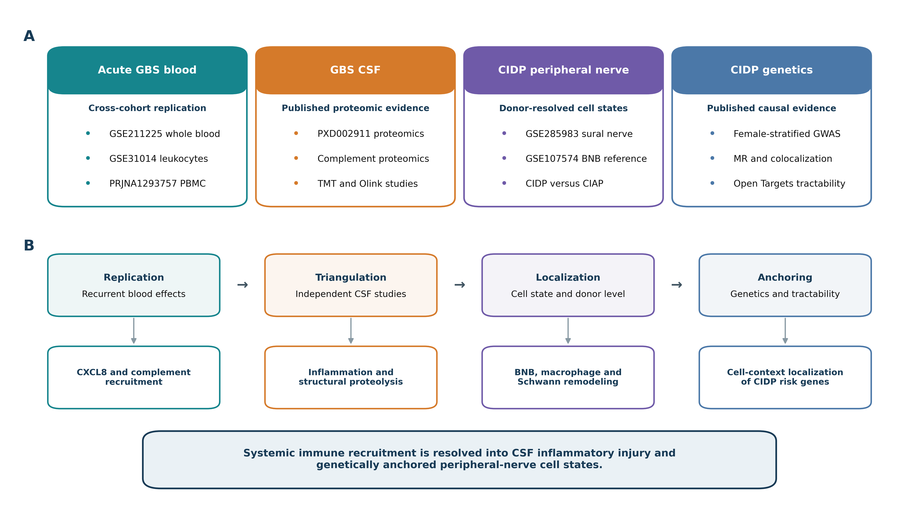
Figure 1: Published-data study design and integrated compartment model. Blood, CSF, peripheral-nerve and genetic resources progress through cross-cohort comparison, CSF evidence triangulation, donor-resolved nerve analysis and genetic anchoring. The resulting model connects systemic CXCL8-complement recruitment with CSF inflammation and proteolysis, BNB-macrophage-Schwann remodeling and cell-context localization of CIDP susceptibility genes.

Acute GBS blood couples chemotactic recruitment with humoral effector activity
GSE211225 revealed a coordinated acute whole-blood response. Relative to healthy controls, acute GBS showed higher CXCL8-CXCR1/2 activity (Hedges g=1.25, FDR=0.045), LIF/OSM-gp130 signaling (g=2.19, FDR=0.0076), complement (g=2.49, FDR=0.0076), Fc-receptor activity (g=1.36, FDR=0.038), interferon-JAK-STAT signaling (g=1.07, FDR=0.045) and inflammatory-monocyte activity (g=1.93, FDR=0.015). Transendothelial migration also increased (g=0.92), although its FDR was 0.126. The effect profile jointly links chemotaxis with complement- and Fc-dependent effector activity.
The acute-to-post-acute contrast identified the phase-responsive component of this program. Complement (g=1.35, FDR=0.041), Fc-receptor activity (g=1.23, FDR=0.046), transendothelial migration (g=1.59, FDR=0.024) and inflammatory-monocyte activity (g=1.68, FDR=0.024) were higher during the acute phase. CXCL8-CXCR1/2 and LIF/OSM-gp130 remained elevated but changed less between acute and post-acute samples. Thus, the acute profile combines a broad inflammatory state with a more phase-restricted trafficking and humoral-effector component.
Independent cohorts refined this signal. GSE31014 reproduced positive effects for six of seven programs, with CXCL8-CXCR1/2, complement, Fc-receptor activity, transendothelial migration, interferon and inflammatory-monocyte scores all shifting in the same direction as whole blood. In PRJNA1293757 monocytes, CXCL8-CXCR1/2 was the largest positive effect (g=1.97), and complement was also positive. The remaining monocyte effects varied in direction, indicating that the single-cell cohort localized the recruitment axis more clearly than the complete whole-blood program.
CXCL8-CXCR1/2 signaling and complement activity showed positive effects in all three datasets. CXCL8-CXCR1/2 showed a pooled Hedges g of 1.08 (95% CI -0.63 to 2.78, Hartung-Knapp P=0.114, I²=0%), while complement showed a pooled g of 1.11 (95% CI -1.73 to 3.95, P=0.234, I²=57.2%). Five additional programs were positive in two of three cohorts. The combined estimates were imprecise, but their direction structure consistently prioritized chemotactic recruitment and complement activation (Fig. 2 and Table 2).
Table 2. Cross-cohort acute GBS program synthesis
Program | Summary Hedges g | 95% CI lower | 95% CI upper | Hartung-Knapp P | I², % | Cohorts, n
CXCL8–CXCR1/2 | 1.075 | -0.634 | 2.785 | 0.114 | 0.0 | 3
LIF/OSM–gp130 | 0.271 | -3.978 | 4.519 | 0.810 | 81.2 | 3
Complement | 1.111 | -1.728 | 3.950 | 0.234 | 57.2 | 3
Fc receptor | 0.288 | -5.510 | 6.086 | 0.851 | 72.7 | 3
Transendothelial migration | 0.694 | -0.958 | 2.347 | 0.212 | 1.1 | 3
Interferon/JAK–STAT | 0.677 | -0.943 | 2.297 | 0.214 | 0.0 | 3
Inflammatory monocyte | 1.026 | -1.702 | 3.754 | 0.247 | 49.5 | 3
Taken together, the blood analysis resolves two levels of evidence. GSE211225 captured a broad acute immune state with six FDR-controlled programs, whereas comparison with additional cohorts narrowed the recurrent component to a CXCL8-complement axis. This distinction between a broad within-cohort response and a smaller recurrent core guided the subsequent cross-compartment analysis.
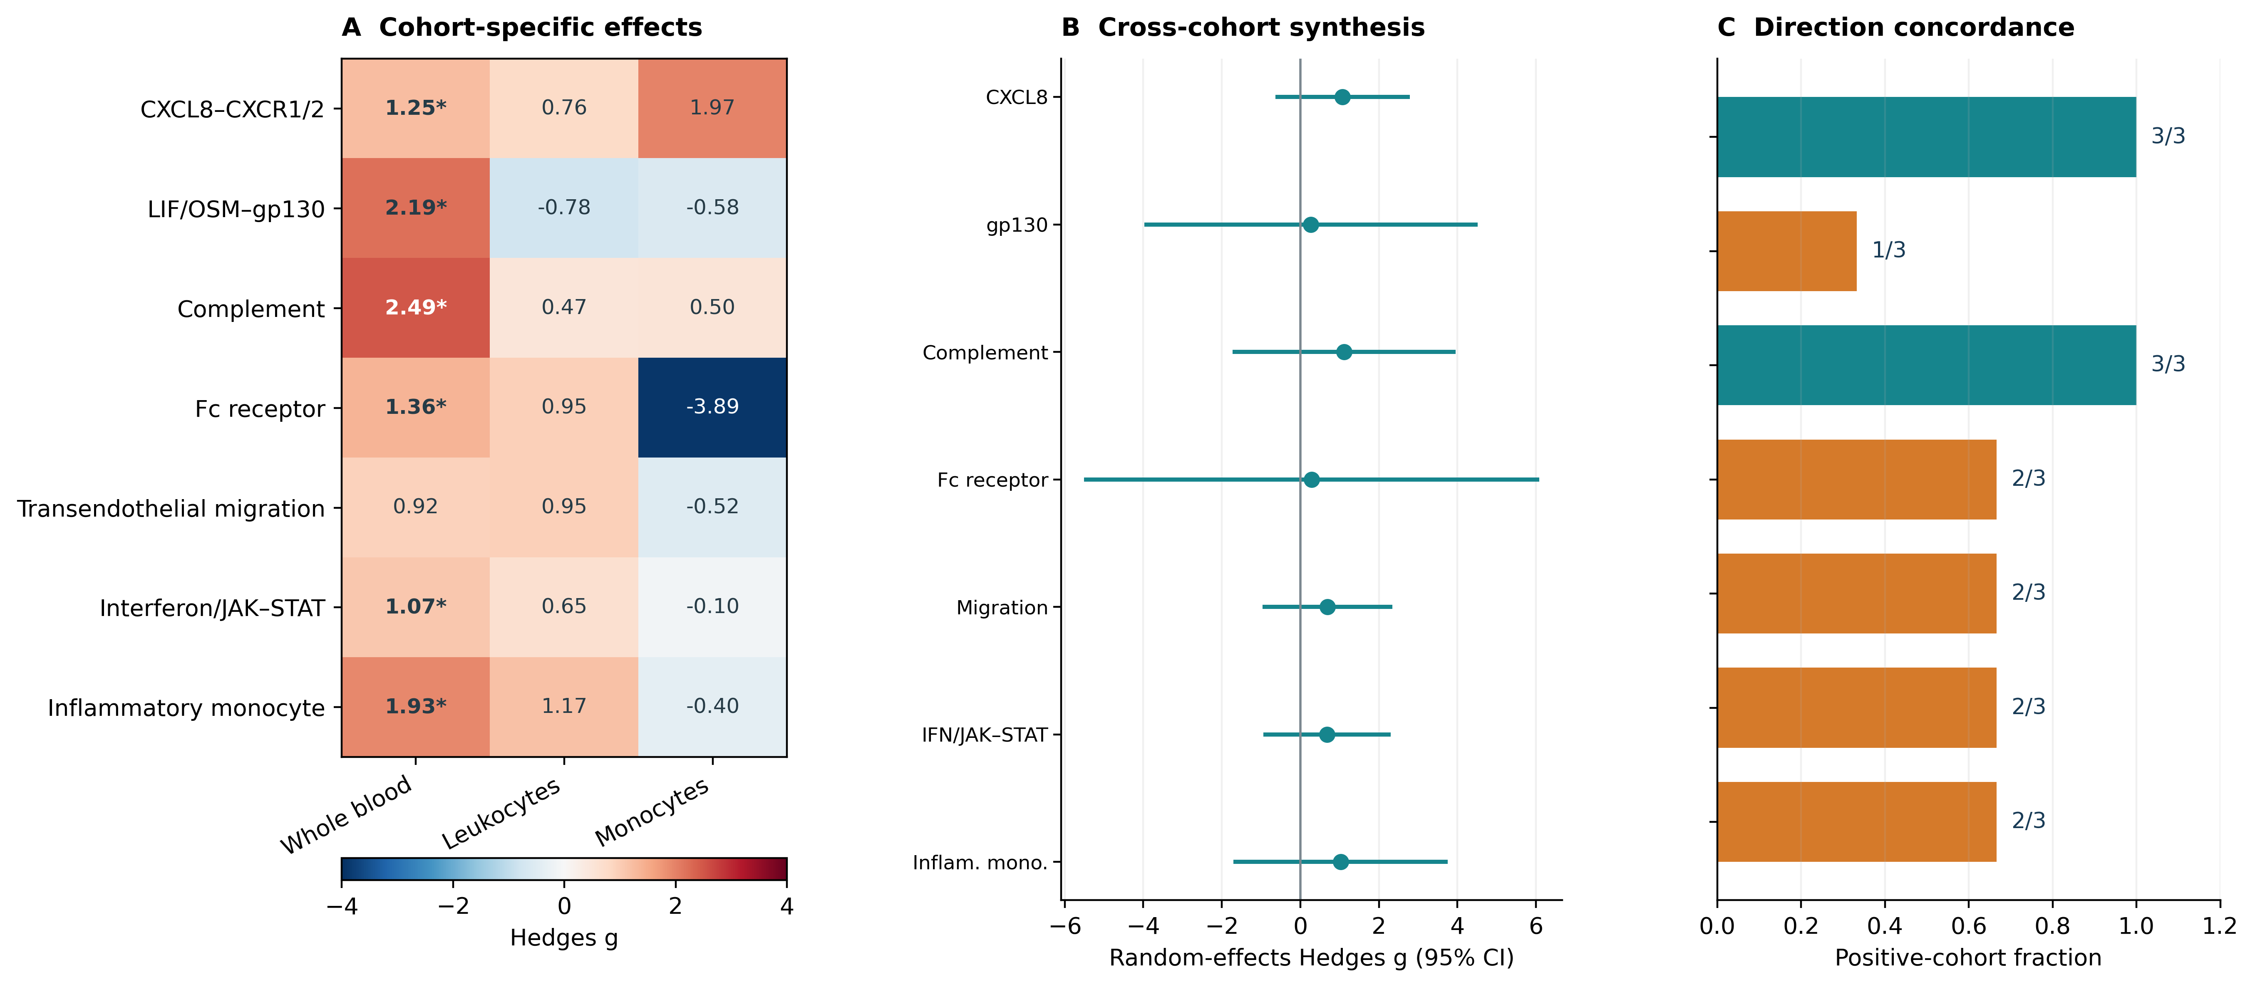
Figure 2: Acute-GBS blood programs across cohorts. (A) Cohort-specific Hedges g values for seven prespecified programs in whole blood, leukocytes and monocyte pseudobulk. Asterisks denote FDR<0.05 within cohort. (B) Random-effects estimates with 95% confidence intervals. (C) Fraction of cohorts showing a positive effect. CXCL8-CXCR1/2 and complement were positive in all three cohorts.

Cross-cohort heterogeneity reveals platform-dependent immune modules
Heterogeneity differed markedly by program. CXCL8-CXCR1/2 and interferon-JAK-STAT showed I²=0%, and transendothelial migration showed I²=1.1%. In contrast, LIF/OSM-gp130 (I²=81.2%), Fc-receptor activity (I²=72.7%), complement (I²=57.2%) and the inflammatory-monocyte program (I²=49.5%) varied across whole blood, leukocyte microarray and monocyte pseudobulk. The stable CXCL8 effect therefore contrasts with modules that depend more strongly on cellular composition and assay platform.
This heterogeneity also clarifies the biological scale of the blood result. Recruitment is detectable across mixed and purified blood compartments, whereas LIF/OSM, Fc-receptor and monocyte-state signals are amplified or attenuated by the sampled cell population. The meta-analysis was therefore used to identify recurrent direction, while cohort-specific estimates retained the richer immune context of each platform.

Formally published GBS CSF studies converge on local inflammation, complement and structural injury
PXD002911 showed 1,402 proteins in AIDP CSF versus 1,103 in controls and 2,355 endogenous peptide fragments versus 774 in controls. Proteome overlap was 67%, whereas peptidome overlap was 21.5%, supporting a distinct layer of structural proteolysis [26].
Independent studies extended this finding. D’Aguanno et al. identified increased complement C3 isoform together with vitamin D-binding protein, apolipoprotein H and altered albumin fragments [34]. Ding et al. detected 97 differential proteins among 298 quantified proteins and validated increased APOC3 with decreased TGOLN2 and NCAM1 in an independent 40-GBS and 40-control series [35]. Sun et al. identified 20 inflammatory proteins, 19 higher and IL5 lower, including IL8, CCL20, MCP-1, CXCL1, CXCL9, CXCL10, TNF, IL17C and IL18 [36]. Median CSF total protein, IgG and IgM were 2.17-fold, 2.41-fold and 4.33-fold higher than in non-inflammatory neurological controls. Across assays, the reproducible architecture comprised local chemokine inflammation, complement, protein accumulation or handling and structural proteolysis (Fig. 3).
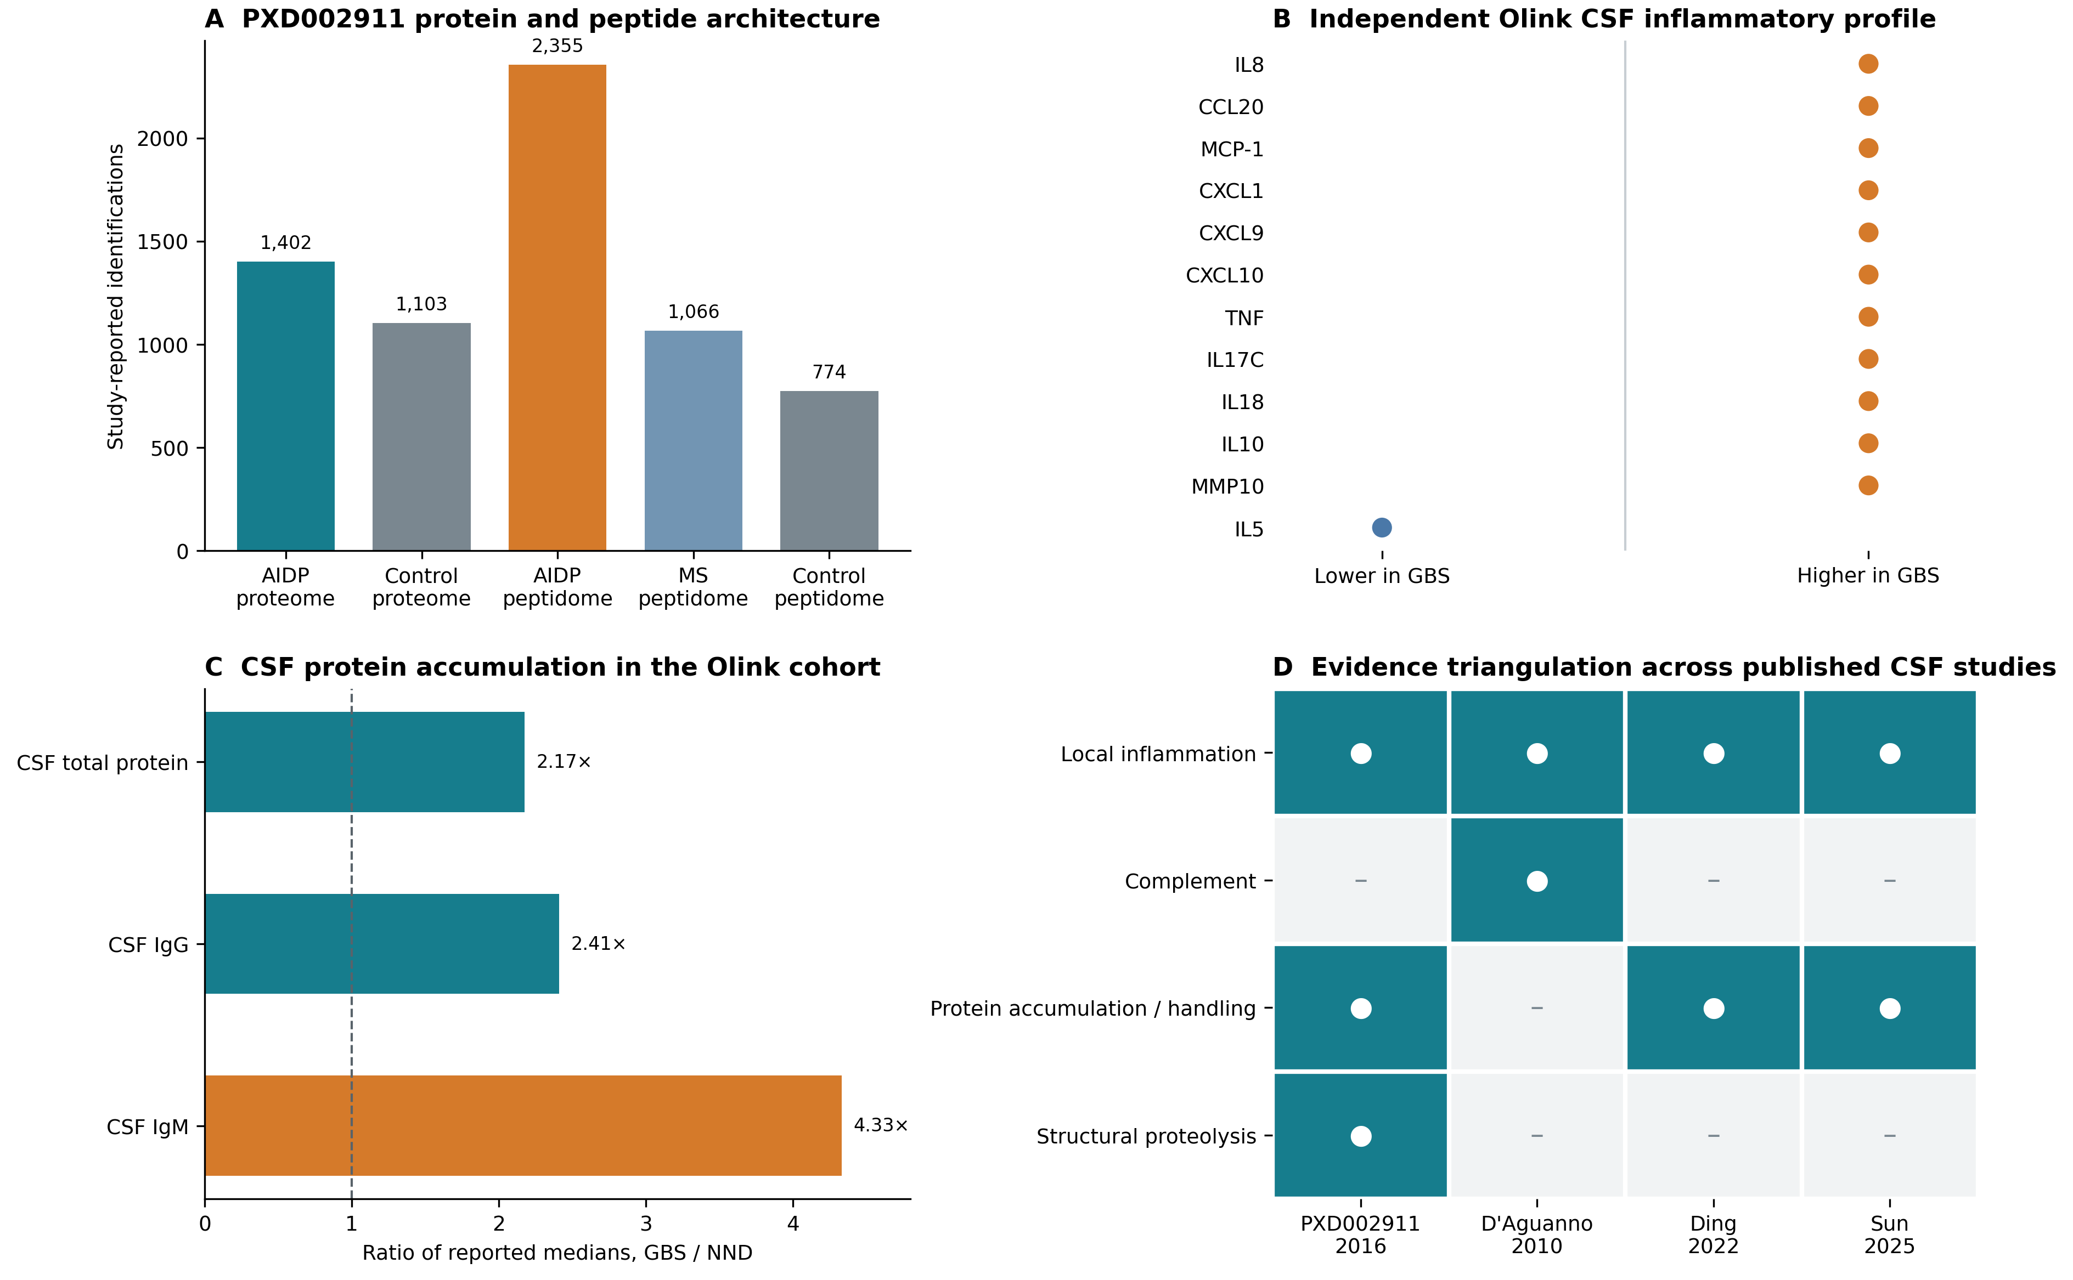
Figure 3: Formally published GBS CSF evidence. (A) PXD002911 protein and endogenous peptide-fragment counts. (B) Representative higher inflammatory proteins from the Olink study of 23 patients with GBS and 14 non-inflammatory neurological controls. (C) Ratios of reported median CSF total protein, IgG and IgM in GBS versus non-inflammatory neurological controls. (D) Cross-study evidence map. The synthesis preserves study-level estimates and is not a pooled participant-level meta-analysis.

CIDP nerve remodeling is concentrated in cell state rather than cellular abundance
The sural-nerve atlas localized the integrated programs within the target organ. Macrophages expressed C3, C3AR1 and FCGR2A, endoneurial endothelial cells expressed CLDN5, ICAM1, VCAM1, LIFR, IL6ST and OSMR, and Schwann-cell states expressed the gp130 receptor machinery together with myelin, stress and repair genes. Granulocytes showed the strongest CXCR1/2 signal. This cellular distribution places macrophages downstream of humoral injury, endothelial cells at the trafficking interface and Schwann cells at the transition from damage to repair (Fig. 4A).
The independent BNB reference reproduced the vascular architecture of the nerve atlas. Laser-captured endoneurial microvessels and cultured endoneurial endothelial cells expressed CLDN5, OCLN, TJP1, CDH5 and VWF together with LIFR, IL6ST, ICAM1 and C3. The co-expression of junctional, cytokine-receptor, complement and adhesion genes identifies the human BNB as an immune-responsive endothelial compartment rather than a passive structural boundary.
The strongest CIDP-CIAP difference occurred in macrophage Fc-receptor activity, which was lower in CIDP (delta mean z=-0.673, P=0.0011, FDR=0.0087). Macrophage leukocyte-transmigration (delta z=-0.345, P=0.0185, FDR=0.074) and macrophage-state scores (delta z=-0.368, P=0.0334, FDR=0.089) shifted in the same direction. In the perineurium, macrophage-state (delta z=0.758, P=0.0227) and complement (delta z=0.348, P=0.0334) scores increased, although their within-cell-type FDR values were 0.109. BNB endothelial identity also decreased nominally (delta z=-0.404, P=0.0276, FDR=0.221).
This pattern distinguishes CIDP from CIAP through the organization of tissue programs rather than a uniform rise in inflammation. CIAP is itself an axonal-injury comparator with active phagocyte recruitment. The lower macrophage Fc-receptor state in CIDP, together with higher perineurial immune scores, points to redistribution of humoral-effector activity across nerve compartments.
Cellular composition was comparatively stable. No cell group passed FDR correction for abundance. The largest numerical differences were increases in nonmyelinating Schwann cells (+0.064), endoneurial stroma (+0.027) and myelinating Schwann cells (+0.013), with FDR=0.515 for each. The dominant CIDP signal was transcriptional remodeling within macrophage, endothelial, perineurial and Schwann-cell states, with little change in the overall cellular composition.
Clinical association added a phenotypic layer to the tissue map. The repair-damage Schwann-cell myelin-repair score showed the strongest relationship with INCAT disability (rho=0.840, P=0.0046, FDR=0.069). BNB endothelial LIF-LIFR activity showed a second, weaker positive relationship (rho=0.602, P=0.086). These findings connect donor-resolved repair and cytokine-response programs to variation in neurological impairment.
Together, the localization, differential-state, compositional and clinical analyses define a target-organ response in which macrophage Fc-receptor remodeling is the strongest controlled disease contrast and Schwann-cell repair is the tissue program most closely related to disability.
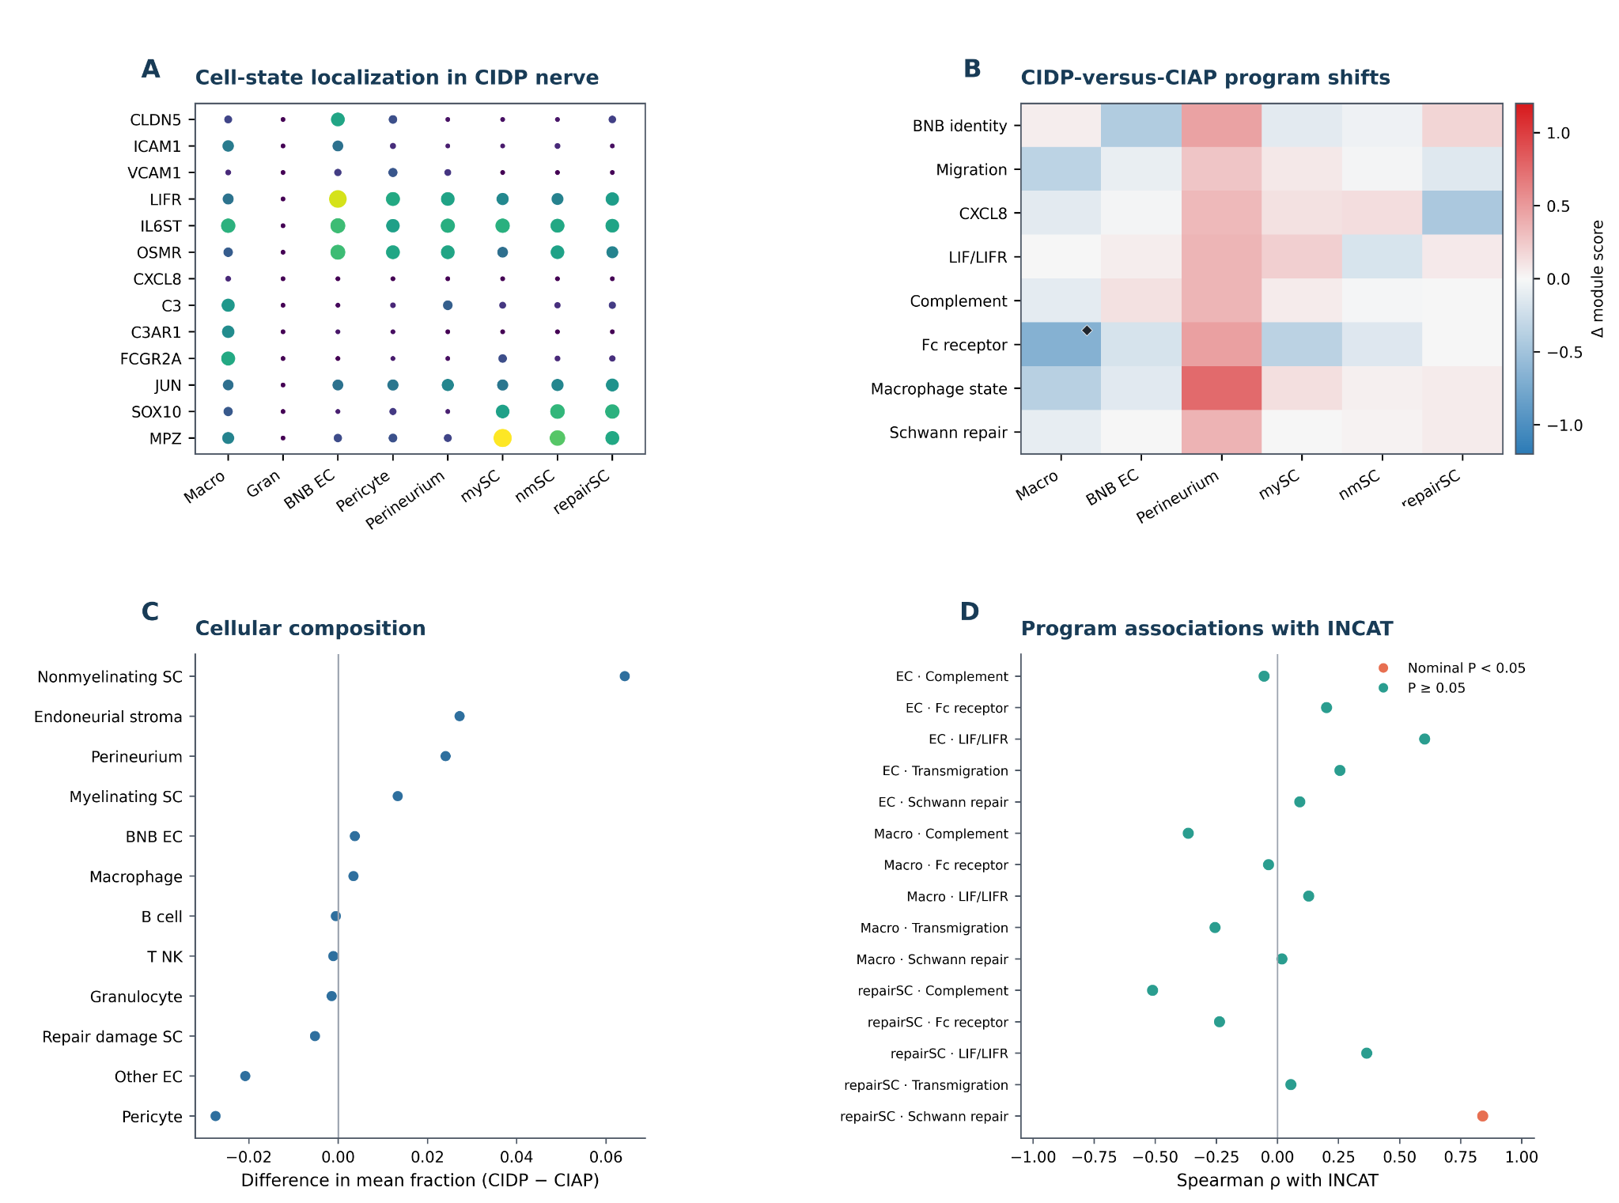
Figure 4: CIDP nerve resolves barrier, immune and repair programs. (A) Expression localization across nerve cell states. Dot size represents detection and color represents scaled mean expression. (B) CIDP-versus-CIAP program shifts. Diamonds denote FDR<0.05. (C) Donor-level differences in centered-log-ratio cell fractions. (D) Spearman associations with INCAT disability. Orange denotes nominal P<0.05 and teal denotes P>=0.05. BNB EC denotes endoneurial microvascular endothelial cells.

Donor-level coordination links BNB endothelial, macrophage and Schwann-cell programs
The nine CIDP donors displayed distinct tissue-program configurations. BNB endothelial LIF-LIFR activity covaried with endothelial leukocyte-transmigration activity (rho=0.667, P=0.0499) and with repair-damage Schwann-cell myelin-repair activity (rho=0.783, P=0.0125). Endothelial leukocyte transmigration also covaried with macrophage complement activity (rho=0.683, P=0.0424). Although these pairwise relationships did not remain significant after correction across the donor-correlation family, their direction identifies a coordinated endothelial-myeloid-glial axis that varies among patients.
The cross-compartment map placed this tissue axis beside the blood and CSF findings. CXCL8 recruitment and complement were recurrent in blood, represented in the CSF innate-defense context and localized to myeloid or endothelial programs in nerve. Fc-receptor activity linked acute whole-blood activation to the strongest controlled nerve result. Endothelial adhesion and Schwann-cell repair were concentrated in the target organ, while CSF contributed the intervening signature of protein accumulation and axonal-domain proteolysis (Fig. 5 and Table 3).
Table 3. Cross-compartment evidence map
Program | Blood evidence | CSF evidence | Peripheral-nerve evidence | Interpretation
CXCL8 recruitment | Positive in 3/3 cohorts. Whole-blood FDR<0.05 | Innate immune/cytokine context reported | Myeloid localization and endothelial trafficking context | Shared recruitment hypothesis
Complement | Positive in 3/3 cohorts. Whole-blood FDR<0.01 | Broad protein accumulation and innate-defense representation | Macrophage localization | Humoral amplification across compartments
Fc receptor | Whole-blood FDR<0.05. Mixed pooled direction | Not directly evaluated | Macrophage module FDR=0.0087 | Strongest controlled nerve result
Interferon response | Whole-blood FDR<0.05. Mixed pooled direction | Antiviral-defense representation reported | Macrophage, endothelial and Schwann states | Compartment-dependent response
Endothelial adhesion | Positive blood direction | Not directly evaluated | BNB endothelial ICAM1/VCAM1 localization | BNB receiver/localization hypothesis
Schwann repair | Not evaluated | Axonal-domain peptide degradation reported | Repair/stress programs localized to Schwann cells | Structural injury-to-repair hypothesis
The evidence map summarizes biological continuity at the program level while preserving the anatomical specificity of each measurement.
Blood, CSF and peripheral nerve therefore contribute complementary views of recruitment, molecular injury and tissue repair.

CIDP genetic risk maps to Schwann, immune and BNB-associated cell states
The published female-specific CIDP locus at 20q13.33 implicated rs80339443 within CDH4 (OR=4.37, 95% CI 2.61-7.33, P=1.49×10^-8). Published causal-prioritization evidence also supported DIRAS1 (MR beta=-0.45, colocalization PP.H4=0.94), GNG7 (beta=-2.11, PP.H4=0.93) and SLC39A3 (beta=-1.42, PP.H4=0.87) [33]. These estimates were treated as external genetic anchors rather than recomputed GWAS or TWAS results.
Donor-resolved localization in GSE285983 separated these candidates across nerve cell states. CDH4 was highest in repair-damage Schwann cells (mean log2[CP10k+1]=0.365, 15.5% detected), nonmyelinating Schwann cells (0.313, 11.3%) and epineurial stroma (0.286, 11.8%). GNG7 was strongest in B cells (1.519, 50.5%), followed by macrophages (0.503, 19.2%), BNB endothelial cells (0.245, 11.4%) and repair-damage Schwann cells (0.212, 11.6%). SLC39A3 was low and highest in BNB endothelium (0.032, 1.5%), while DIRAS1 was sparse. None of the four genes differed between CIDP and CIAP after FDR correction. Thus, the analysis localizes genetic susceptibility without treating candidate-gene expression as a disease-state biomarker (Fig. 5).
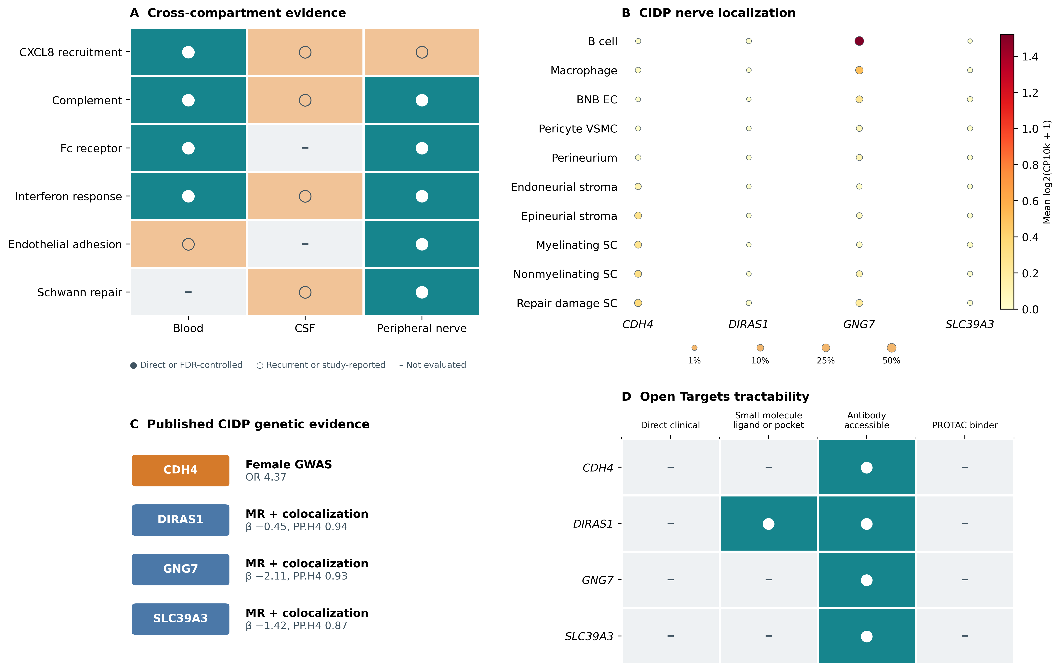
Figure 5: Cross-compartment immune programs and genetic anchoring in inflammatory peripheral neuropathy. (A) Evidence map across blood, CSF and peripheral nerve. Filled circles denote direct localization or FDR-controlled evidence, open circles denote recurrent direction or study-reported representation, and dashes denote programs not evaluated. (B) Donor-resolved localization of CDH4, DIRAS1, GNG7 and SLC39A3 across CIDP nerve cell groups. Dot size denotes the percentage of expressing nuclei and color denotes mean log2(CP10k+1). (C) Published CIDP genetic evidence for CDH4, DIRAS1, GNG7 and SLC39A3. (D) Therapeutic tractability assessment. No direct approved drug or clinical candidate was identified.

Compartmental integration connects recruitment, proteolysis and repair
The integrated model links three dominant features of inflammatory peripheral neuropathy. Acute GBS blood defines a systemic recruitment-humoral axis centered on CXCL8, complement and inflammatory monocytes. GBS CSF records chemokine inflammation, complement, protein accumulation and structural proteolysis. CIDP nerve localizes the corresponding effector and repair programs to macrophages, BNB endothelial cells, perineurium and Schwann cells. Published genetic signals further map susceptibility to Schwann, immune and endothelial states. The BNB sits at the anatomical interface where circulating recruitment can be translated into nerve-resident immune remodeling (Fig. 1).

Discussion
A principal contribution of this study is the construction of a compartment-resolved immune framework spanning acute GBS blood, GBS cerebrospinal fluid and CIDP peripheral nerve. Rather than extending a conventional disease-versus-control comparison, the analysis connects circulating immune recruitment, CSF inflammation and structural injury, and nerve-resident macrophage, BNB-endothelial and Schwann-cell states. Integration of three biospecimen compartments with human sural-nerve single-nucleus data provides the tissue context needed to distinguish shared immune processes from compartment-specific responses across inflammatory peripheral neuropathies.
The blood analysis illustrates the value of assessing consistency across cohorts. GSE211225 contained a broad acute signature involving chemotaxis, gp130 signaling, complement, Fc receptors, interferon and inflammatory monocytes. Cross-cohort synthesis retained CXCL8-CXCR1/2 and complement as the most recurrent signals, while LIF/OSM and Fc-receptor effects varied across mixed blood, leukocyte and monocyte platforms. This pattern is biologically coherent with elevated IL-8 in GBS biofluids and chemokine-dependent leukocyte trafficking across human endoneurial endothelium [19,48-51].
The CSF synthesis adds information that cannot be captured by blood transcription alone. PXD002911 identified broad protein accumulation and a disease-distinct peptidome. Independent complement, quantitative proteomic and inflammatory-panel studies reproduced adjacent features rather than an identical marker list [26,34-36]. This convergence across assay types strengthens the compartment-level conclusion while avoiding a pooled effect estimate that the public data cannot support.
CSF and the BNB represent adjacent but distinct anatomical layers. CSF samples the environment surrounding roots and the neuraxis, while the BNB is formed by endoneurial microvascular endothelial cells within peripheral nerve. Their complementary signals suggest a sequence in which systemic recruitment meets an immune-responsive vascular interface, followed by protein leakage, proteolysis and target-organ remodeling. This sequence is directly testable using matched blood-CSF sampling, endothelial permeability assays and spatial nerve profiling.
The nerve analysis further shows that disease-associated biology is not equivalent to cell expansion. No cell fraction passed FDR correction, yet macrophage Fc-receptor activity differed strongly between CIDP and CIAP and nominal shifts were distributed across macrophage, BNB endothelial and perineurial programs. A recent multi-modal blood study identified B-cell dysregulation and CD8 effector activation in CIDP [30]. The present tissue analysis complements that peripheral immune profile by locating humoral-effector and repair programs within the diseased nerve.
At the donor level, BNB LIF-LIFR activity tracked endothelial migration and Schwann-cell repair, while endothelial migration tracked macrophage complement. In parallel, the Schwann-cell repair score showed the strongest association with INCAT disability. These relationships support a tissue configuration in which endothelial activation, myeloid effector activity and Schwann-cell repair vary together across patients. They also nominate the BNB-endothelial to Schwann-cell axis for validation by multiplex imaging and ex vivo functional assays.
The genetic analysis was designed to anchor susceptibility signals within this cross-compartment framework, not to nominate immediate drug targets. Published CIDP genetic candidates localized to defined peripheral-nerve cell populations, prioritizing CDH4 in repair-associated and nonmyelinating Schwann cells, GNG7 in B cells, macrophages and BNB endothelium, and SLC39A3 at lower abundance in BNB endothelium. These results identify gene-cell combinations for targeted functional studies of barrier integrity, immune recruitment, myelin injury and Schwann-cell repair. The tractability assessment identified no direct clinical candidate for the four primary genes, so the appropriate next step is cell-specific functional validation rather than drug repurposing [47].

Limitations
Several limitations define the next steps for this work. The blood cohorts were small and yielded wide meta-analytic confidence intervals. CSF evidence was synthesized across studies with different assays and comparators and was not a participant-level meta-analysis. The nerve comparison used CIAP instead of unaffected nerve and included nine CIDP donors. Blood, CSF and nerve came from independent cohorts, and the study did not include validation in newly collected peripheral-nerve tissue, patient-derived cells or experimental models. CIDP genetic estimates were extracted from a published study because complete public summary statistics were unavailable. Cell-type expression localizes candidate genes but does not establish causality. None of the four primary genes showed FDR-significant disease-state differential expression, and no gene had sufficient evidence for immediate therapeutic nomination. The present study therefore provides a systems-level prioritization framework for subsequent spatial profiling, barrier models and cell-specific perturbation experiments.

Conclusions
Inflammatory peripheral neuropathy is organized into systemic recruitment and humoral activity in acute GBS blood, local inflammation, complement and structural injury in GBS CSF, and a nerve-resident BNB-macrophage-Schwann response in CIDP. By anchoring published CIDP susceptibility signals to Schwann-cell, B-cell, macrophage and BNB-endothelial states, the study provides a prioritized set of gene-cell contexts for mechanistic testing. This framework is intended to guide functional validation rather than define immediate drug targets.

List of abbreviations
AIDP, acute inflammatory demyelinating polyradiculoneuropathy, BNB, blood-nerve barrier, CIAP, chronic idiopathic axonal polyneuropathy, CIDP, chronic inflammatory demyelinating polyradiculoneuropathy, CSF, cerebrospinal fluid, FDR, false-discovery rate, GBS, Guillain-Barré syndrome, MS, multiple sclerosis, PBMC, peripheral-blood mononuclear cell.

Declarations

Ethics approval and consent to participate
This study reanalyzed publicly available, de-identified human datasets and did not recruit participants or obtain new specimens. The original studies reported ethics approval and informed consent. No additional institutional review-board approval was required for this secondary analysis.

Consent for publication
Not applicable.

Availability of data and materials
All primary datasets are publicly available through GEO, NCBI BioProject, PRIDE/ProteomeXchange or the cited peer-reviewed articles. GSE211225, GSE31014, PRJNA1293757, PXD002911, GSE285983 and GSE107574 are listed in Methods. Published CIDP genetic estimates are from Du et al. Aggregate source data underlying all revised figures and tables are supplied with the article.

Code availability
The public repository at https://github.com/applepie567/gbs-cidp-blood-nerve-barrier and its archived v1.0.0 release at https://doi.org/10.5281/zenodo.22067879 document the earlier analysis. The revised published-data-only scripts and source-data package will be released as version 2.0.0 with a new Zenodo version DOI before resubmission.

Competing interests
The authors declare that they have no competing interests.

Funding
This work was supported by the Henan Medical Science and Technology Talent Overseas Training Program (HNMOT2024022) and the Henan Provincial Medical Science and Technology Research Program (LHGJ20250063 and SBGJ202401001).

Authors’ contributions
YF conceived the study, developed the analytical framework, performed the analyses and drafted the manuscript. FF curated data, validated results and revised the manuscript. SXM contributed to validation, interpretation and manuscript revision. SMF contributed to data curation, literature evaluation and manuscript revision. CJ supervised the methodology and critically revised the manuscript. YH supervised the study, coordinated the project and critically revised the manuscript. All authors read and approved the final manuscript.

Acknowledgements
We thank the participants and investigators who generated and shared the public datasets used in this study.

Authors’ information
Not applicable.

Additional files
Additional file 1 (.xlsx): Machine-readable figure, table and panel-level source data.
Additional file 2 (.docx): Reproducibility appendix, dataset provenance, software environment and extended methods.

References
1. Willison HJ, Jacobs BC, van Doorn PA. Guillain-Barré syndrome. Lancet. 2016,388:717-727. doi:10.1016/S0140-6736(16)00339-1.
2. van Doorn PA, Van den Bergh PYK, Hadden RDM, et al. European Academy of Neurology/Peripheral Nerve Society guideline on diagnosis and treatment of Guillain-Barré syndrome. Eur J Neurol. 2023,30:3646-3674. doi:10.1111/ene.16073.
3. Van den Bergh PYK, van Doorn PA, Hadden RDM, et al. European Academy of Neurology/Peripheral Nerve Society guideline on CIDP: second revision. Eur J Neurol. 2021,28:3556-3583. doi:10.1111/ene.14959.
4. Quast I, Cueni F, Nimmerjahn F, Tackenberg B, Lünemann JD. Deregulated Fcγ receptor expression in patients with CIDP. Neurol Neuroimmunol Neuroinflamm. 2015,2:e148. doi:10.1212/NXI.0000000000000148.
5. Hafer-Macko CE, Sheikh KA, Li CY, et al. Immune attack on the Schwann cell surface in acute inflammatory demyelinating polyneuropathy. Ann Neurol. 1996,39:625-635. doi: 10.1002/ana.410390512.
6. Koike H, Nishi R, Ikeda S, et al. Ultrastructural mechanisms of macrophage-induced demyelination in CIDP. Neurology. 2018,91:1051-1060. doi: 10.1212/WNL.0000000000006625.
7. Susuki K, Rasband MN, Tohyama K, et al. Anti-GM1 antibodies cause complement-mediated disruption of sodium channel clusters. J Neurosci. 2007,27:3956-3967. doi: 10.1523/JNEUROSCI.4401-06.2007.
8. Kiefer R, Kieseier BC, Stoll G, Hartung HP. The role of macrophages in immune-mediated damage to the peripheral nervous system. Prog Neurobiol. 2001,64:109-127. doi: 10.1016/s0301-0082(00)00060-5.
9. Shen D, Chu F, Lang Y, et al. Beneficial or harmful role of macrophages in Guillain-Barré syndrome and experimental autoimmune neuritis. Mediators Inflamm. 2018,2018:4286364.doi: 10.1155/2018/4286364.
10. Wolbert J, Li X, Heming M, et al. Redefining the heterogeneity of peripheral nerve cells in health and autoimmunity. Proc Natl Acad Sci USA. 2020,117:9466-9476. doi: 10.1073/pnas.1912139117.
11. Arthur-Farraj PJ, Latouche M, Wilton DK, et al. c-Jun reprograms Schwann cells of injured nerves to generate a repair cell essential for regeneration. Neuron. 2012,75:633-647. doi: 10.1016/j.neuron.2012.06.021.
12. Jessen KR, Mirsky R. The repair Schwann cell and its function in regenerating nerves. J Physiol. 2016,594:3521-3531. doi: 10.1113/JP270874.
13. Napoli I, Noon LA, Ribeiro S, et al. A central role for ERK signaling in controlling Schwann cell plasticity and peripheral nerve regeneration. Neuron. 2012,73:729-742. doi: 10.1016/j.neuron.2011.11.031.
14. Dowsing BJ, Morrison WA, Nicola NA, et al. Leukemia inhibitory factor is an autocrine survival factor for Schwann cells. J Neurochem. 1999,73:96-104. doi: 10.1046/j.1471-4159.1999.0730096.x.
15. Chen Q, et al. Leukemia inhibitory factor regulates Schwann-cell proliferation and migration. Cell Death Dis. 2021,12:417. doi: 10.1038/s41419-021-03706-8.
16. Ubogu EE. Biology of the human blood-nerve barrier in health and disease. Exp Neurol. 2020,328:113272. doi:10.1016/j.expneurol.2020.113272.
17. Palladino SP, Helton ES, Jain P, et al. The human blood-nerve barrier transcriptome. Sci Rep. 2017,7:17477. doi:10.1038/s41598-017-17475-y.
18. Yosef N, Ubogu EE. Development and characterization of a novel human in vitro blood-nerve barrier model. J Neuropathol Exp Neurol. 2010,69:82-97. doi:10.1097/NEN.0b013e3181c84a9a.
19. Yosef N, Ubogu EE. αMβ2-integrin-ICAM1 interactions drive flow-dependent trafficking of GBS leukocytes at the BNB. J Cell Physiol. 2012,227:3857-3875. doi:10.1002/jcp.24100.
20. Dong C, Greathouse KM, Beacham RL, et al. Fibronectin connecting segment-1 peptide inhibits pathogenic leukocyte trafficking in experimental CIDP. Exp Neurol. 2017,292:35-45. doi:10.1016/j.expneurol.2017.02.012.
21. Langert KA, Von Zee CL, Stubbs EB Jr. TNF-α enhances CCL2 and ICAM1 expression in peripheral nerve endoneurial endothelial cells. ASN Neuro. 2013,5:e00104. doi:10.1042/AN20120048.
22. Kanda T, Numata Y, Mizusawa H. Chronic inflammatory demyelinating polyneuropathy: decreased claudin-5 and relocated ZO-1. J Neurol Neurosurg Psychiatry. 2004,75:765-769. doi:10.1136/jnnp.2003.025692.
23. Lima MFO, Nogueira VB, Maury W, et al. Altered cellular pathways in the blood of patients with Guillain-Barré syndrome. J Peripher Nerv Syst. 2025,30:e70012. doi:10.1111/jns.70012.
24. Chang KH, Chuang TJ, Lyu RK, et al. Identification of gene networks and pathways associated with Guillain-Barré syndrome. PLoS One. 2012,7:e29506. doi:10.1371/journal.pone.0029506.
25. Shi P, Diao Y, Yang H, Li R, Ye M, Liu D, Nian D. Single cell transcriptome profiling of peripheral blood mononuclear cells in Guillain-Barré syndrome patients. Sci Data. 2026,13:843. doi:10.1038/s41597-026-07489-5.
26. Ziganshin RH, Ivanova OM, Lomakin YA, et al. The pathogenesis of the demyelinating form of Guillain-Barré syndrome: proteo-peptidomic and immunological profiling of physiological fluids. Mol Cell Proteomics. 2016,15:2366-2378. doi:10.1074/mcp.M115.056036.
27. Heming M, Börsch AL, Wolbert J, et al. Multi-omic identification of perineurial hyperplasia and lipid-associated nerve macrophages in human polyneuropathies. Nat Commun. 2025,16:7872. doi:10.1038/s41467-025-62964-8.
28. Li M, et al. Single-cell analysis reveals novel clonally expanded monocytes associated with the IL1β-IL1R2 pair in AIDP. Sci Rep. 2023,13:5862. doi:10.1038/s41598-023-32427-5.
29. Xue Y, Yin P, Li G, Zhong D. Transcriptomes in rat sciatic nerves at different stages of experimental autoimmune neuritis. Clin Exp Immunol. 2019,198:184-197. doi:10.1111/cei.13354.
30. Kim H, Chun J, Cha DH, et al. Integrated peripheral immune profiling reveals B-cell dysregulation and CD8 effector signatures in CIDP. Front Immunol. 2026,17:1888882. doi:10.3389/fimmu.2026.1888882.
31. Richard A, Corvol JC, Debs R, et al. Transcriptome analysis of peripheral blood in CIDP identifies TNFR1 and TLR pathways in the IVIg response. Medicine. 2016,95:e3370. doi:10.1097/MD.0000000000003370.
32. Shimizu F, Sato R, Mizukami Y, et al. Blood-nerve barrier breakdown induced by immunoglobulin G in CIDP and multifocal motor neuropathy. Int J Mol Sci. 2026,27:1088. doi:10.3390/ijms27021088.
33. Du Z, et al. Genome-wide association study, Mendelian randomization, and colocalization analyses identify susceptibility genes for chronic inflammatory demyelinating polyneuropathy. HGG Adv. 2024,5:100317. doi:10.1016/j.xhgg.2024.100317.
34. D’Aguanno S, Franciotta D, Lupisella S, et al. Protein profiling of Guillain-Barré syndrome cerebrospinal fluid by two-dimensional electrophoresis and mass spectrometry. Neurosci Lett. 2010,485:49-54. PMID:20801190.
35. Ding J, Ren K, Wu J, et al. Proteomic analysis of cerebrospinal fluid identifies biomarkers for Guillain-Barré syndrome. Eur J Neurol. 2022,29:1155-1164. doi:10.1111/ene.15213.
36. Sun S, Li M, Song J, Zhong D. Using Olink proteomics to identify inflammatory biomarkers in the cerebrospinal fluid in Guillain-Barré syndrome. J Inflamm Res. 2025,18:6703-6717. doi:10.2147/JIR.S507515.
37. Higgins JPT, Thompson SG, Deeks JJ, Altman DG. Measuring inconsistency in meta-analyses. BMJ. 2003,327:557-560.
38. IntHout J, Ioannidis JPA, Borm GF. Hartung-Knapp-Sidik-Jonkman method for random effects meta-analysis. BMC Med Res Methodol. 2014,14:25. doi:10.1186/1471-2288-14-25.
39. Squair JW, Gautier M, Kathe C, et al. Confronting false discoveries in single-cell differential expression. Nat Commun. 2021,12:5692. doi:10.1038/s41467-021-25960-2.
40. Crowell HL, Soneson C, Germain PL, et al. muscat detects subpopulation-specific state transitions from multi-sample single-cell data. Nat Commun. 2020,11:6077. doi:10.1038/s41467-020-19894-4.
41. Benjamini Y, Hochberg Y. Controlling the false discovery rate. J R Stat Soc Series B. 1995,57:289-300.
42. Zimmerman KD, Espeland MA, Langefeld CD. A practical solution to pseudoreplication bias in single-cell studies. Nat Commun. 2021,12:738. doi:10.1038/s41467-021-21038-1.
43. Subramanian A, Tamayo P, Mootha VK, et al. Gene set enrichment analysis. Proc Natl Acad Sci USA. 2005,102:15545-15550.
44. Aitchison J. The statistical analysis of compositional data. J R Stat Soc Series B. 1982,44:139-177.
45. Jin S, Guerrero-Juarez CF, Zhang L, et al. Inference and analysis of cell-cell communication using CellChat. Nat Commun. 2021,12:1088. doi:10.1038/s41467-021-21246-9.
46. Browaeys R, Saelens W, Saeys Y. NicheNet: modeling intercellular communication by linking ligands to target genes. Nat Methods. 2020,17:159-162. doi:10.1038/s41592-019-0667-5.
47. Ochoa D, Hercules A, Carmona M, et al. The next-generation Open Targets Platform: reimagined, redesigned, rebuilt. Nucleic Acids Res. 2023,51:D1353-D1359. doi:10.1093/nar/gkac1046.
48. Kmezic I, Gustafsson R, Fink K, et al. Validation of elevated interleukin-8 in CSF and discovery of biomarkers in GBS and CIDP. Front Immunol. 2023,14:1241199. doi:10.3389/fimmu.2023.1241199.
49. Bréville G, Lascano AM, Roux-Lombard P, et al. Interleukin 8, a Biomarker to Differentiate Guillain-Barré Syndrome From CIDP. Neurol Neuroimmunol Neuroinflamm. 2021,8:e1031.doi: 10.1212/NXI.0000000000001031.
50. Heming M, Lohmann L, Schulte-Mecklenbeck A, et al. Immune cell profiling of CSF provides pathogenetic insights into inflammatory neuropathies. Front Immunol. 2019,10:515. doi:10.3389/fimmu.2019.00515.
51. Xia RH, Yosef N, Ubogu EE. Chemokine ligand-receptor expression in severe experimental autoimmune neuritis. Neuropathol Appl Neurobiol. 2010,36:388-398. doi:10.1111/j.1365-2990.2010.01092.x.

