Supplementary Information
Immune recruitment across blood cohorts and macrophage composition in inflammatory neuropathies
Yuan Feng, Fang Feng, Shuxiao Ma, Shuman Feng, Chao Jiang and Yibin Hao

Supplementary Methods

Purpose and evidence attribution
This supplement gives the full results and analytical procedures. The blood analysis first examines recurrence across three cohorts, then tests two fixed programmes in an independent monocyte cohort and a separate PBMC reanalysis. Published CSF estimates provide a related protein comparison. The nerve analysis examines macrophage Fc expression, its relation to cellular composition, an independent whole nerve comparison and an internal check of the disease comparator. Genetic localisation and public nerve protein assessments provide additional context.
Supplementary Data 1 contains aggregate results, source documentation, gene coverage, donor design summaries and sensitivity analyses. Supplementary Data 2 preserves the earlier analysis release, including the exploratory extension scripts and their inputs. That archive does not redistribute donor expression matrices or full donor metadata. It includes the anonymous score and disability coordinates needed for Supplementary Figure S8, without sample identifiers, age, sex or centre. Procedures for reconstruction from the source matrices are described below. Supplementary Data 3 contains the external nerve sample mapping and results. Supplementary Data 4 supplies their inputs and scripts, including recovered atlas macrophage counts for the comparator check. Supplementary Data 5 contains external blood inputs, donor counts, gene mappings, full results, a dated plan and figure code. Supplementary Data 6 contains the macrophage marker analysis, donor and lineage counts, calibration results and conditional external models.

Blood cohorts and cross-cohort synthesis
GSE211225 contains six acute, ten postacute and six control whole blood profiles. GSE31014 contributes seven GBS and seven control leukocyte profiles. PRJNA1293757 contributes PBMC data from three untreated patients with AIDP and two controls. Cells were retained if they had 200 to 6000 detected genes, at least 500 counts and a mitochondrial count fraction below 20%. Each retained cell was assigned to the lineage with the highest mean log1p(CP10k) expression across available marker genes. Competing lineage marker panels are specified in the analysis scripts. Monocyte counts were summed by donor and transformed as log2(CPM + 0.5) for module analysis.
Seven script-defined gene modules were evaluated within each blood cohort. Cohort effects used Hedges g and exact label permutation tests of mean score differences. Benjamini–Hochberg correction covered seven modules within each comparison. Acute versus postacute inferential results were omitted from the current manuscript because cross-phase donor independence could not be verified from the archived design.
Blood effects were pooled using inverse variance weights and the DerSimonian and Laird estimate of variance between studies. Modified Hartung–Knapp intervals used a residual variance scale of at least one and a t distribution with k minus one degrees of freedom. Omitting each cohort left two cohorts for checking the pooled direction. All seven intervals from the full synthesis included zero.

External monocyte cohort
GSE304872 provides an independent early untreated AIDP cohort of four GBS and three healthy control donors. The source investigators excluded one additional control because of inadequate cell viability. The same study supplies sorted cell bulk profiles under GSE304871 and is reported as a preprint [1]. We recovered the 107,656 retained cells and their sample, condition, broad.cluster and seurat_clusters fields. We used the raw RNA counts layer containing 16,164 deposited genes. Integrated and scaled expression were not used. Counts were nonnegative integers, and cell order matched the assay barcode map. Deposited counts per cell did not exceed the earlier nCount_RNA metadata values, with a median retained fraction of 0.995. CPM denominators were calculated from the complete deposited counts layer.
The primary group, broad.cluster = Monocyte, contained 22,592 cells from all seven donors. We kept the author’s PMA group separate. Monocytes comprised original clusters 3, 6, 9 and 13, with each donor contributing at least 20 cells to every cluster. We summed counts by donor and applied log2(CPM + 0.5). Within each population, each gene was centred and divided by its sample standard deviation across the seven donors. The module score was the mean of the available variable genes. The CXCL8 set retained CXCL8, CXCR1 and CXCR2. The complement set retained 15 genes, with C4A, C4B and CFI absent. Supplementary Data 5 records coverage for every population.
Both modules were fixed before external effect estimation. Primary tests compared four GBS with three control donor scores using all 35 label assignments, a two sided mean difference statistic and correction across two tests. HC3 confidence intervals used five residual degrees of freedom. Hedges g used the pooled variance and small sample correction from the original blood pipeline. Whole PBMCs and the four monocyte clusters generated ten secondary module tests, which were corrected together. The twelve broad cell fraction comparisons formed a separate family. Fractions describe the cells retained by the source investigators. All of these comparisons use the same seven donors.

Sorted cell measurements from overlapping donors
GSE304871 includes five CD11b profiles (two GBS, three controls), six CD4 profiles (three per group) and five CD8 profiles (two GBS, three controls). GEO library names link these columns to source donor codes. The deposited gene_name fields did not consistently match the Ensembl row identifiers. Before scoring, we remapped the versioned Ensembl identifiers using GENCODE release 38, the reference reported by the source investigators. Original files, the exact annotation subset and a row by row audit for the target genes are retained. Scores used log2(deposited normalised counts + 0.5) and gene standardisation within each preparation. The CXCL8 set contained all three genes. The number of variable complement genes is listed by preparation. All six tests used exact label permutations and one six test correction. These small overlapping subsets provide complementary measurements within the external cohort [1].

Additional PBMC reanalysis and paired follow up
PRJNA1174992 includes 12 acute GBS samples, eight follow up samples from those patients and five controls. The publisher’s public count table contains 35,061 gene entries and 87 technical sequencing columns. The public clinical table, sequencing identifiers and SRA records link every column to one of 25 biological samples from 17 participants. We summed technical columns within sample, checked that no column was reused or omitted, and preserved total counts. Duplicate gene symbols were summed without reference to disease effects [2].
The acute analysis normalised and scaled only the 12 acute and five control samples. Median ratio size factors were calculated from genes with positive counts in every sample and rescaled to a geometric mean of one. We transformed expression as log2(normalised counts + 0.5). Both fixed modules had complete gene coverage. Two sided exact mean difference tests used all 6,188 group assignments, with correction across two tests. Prespecified sensitivity analyses used CPM normalisation and adjustment for age and sex, with HC3 covariance and 13 residual degrees of freedom. The eight paired comparisons were normalised and standardised separately across their 16 samples. We defined change as follow up minus acute and tested all 256 sign assignments, with correction across two modules. Paired confidence intervals used the standard error of the eight within patient differences and seven t degrees of freedom.
The source article and SRA records give inconsistent collection periods. The article describes sampling in 1994–2007, while some acute SRA entries give 2013 and follow up entries give 2016–2017. The dataset shares a centre and investigators with GSE211225. Public records for that dataset lack sufficient dates and cross-study donor identifiers to exclude participant reuse, so we did not include PRJNA1174992 as an independent cohort in the synthesis. Sequencing column layouts also differ between acute and follow up samples. Column names alone cannot establish batch assignment, and complete preparation and batch metadata were unavailable. Technical effects therefore remain unresolved in the longitudinal comparison.

Targeted four cohort sensitivity synthesis
After confirming a separate participant source and recovering donor counts, we added GSE304872 monocytes to the original three cohort synthesis for the two fixed modules. We used the same DerSimonian and Laird and modified Hartung and Knapp calculations. New effect variances followed the archived formula, (n1 + n0)/(n1 × n0) + g²/[2(n1 + n0 − 2)]. The two pooled tests were corrected together. Because the programmes were selected from the initial cohort comparison, this extension is reported as a sensitivity synthesis. The original seven module, three cohort results are unchanged. Whole PBMCs and sorted preparations from GSE304871/2 were not counted as independent studies.

Peripheral nerve analyses
GSE285983 provides sural nerve single nucleus data. The principal comparison includes nine CIDP and eleven CIAP donors, with the number of eligible donors varying by cell group. We summed counts within each donor and annotated cell group. A donor contributed to a targeted pseudobulk comparison when the group contained at least 20 nuclei. Expression was transformed as log2(CPM + 0.5).
Within each cell group, we standardised genes across eligible donors from all diagnoses. Module scores were the means of available standardised genes. Two-sided Mann–Whitney U tests compared CIDP with CIAP, with correction across eight modules within each cell group. We also report correction across all 80 eligible nerve module comparisons.
The macrophage Fc receptor module contained 11 measured genes because FCGR2C was absent from the expression matrix. Sensitivity analyses included demographic adjustment, sex restriction, centre-preserving permutation, donor omission, gene omission and alternative macrophage annotations.

Independent whole nerve cohort
GSE213455 contains 16 diagnostic sural nerve biopsies measured with the Illumina whole genome DASL HT assay on GPL13369. GSM6586615–GSM6586618 have the deposited label “inflammatory neuropathy” and are the four CIDP cases described in the source article. GSM6586606–GSM6586614 are nine vasculitic neuropathy cases. GSM6586619–GSM6586621 are three neurolymphomatosis cases, excluded from score scaling and disease testing. This is an independent Italian tissue cohort, separate from the German single nucleus atlas [3].
The external plan was recorded on 26 September 2026 before inspecting target gene values or disease effects. It followed the original exploratory Fc finding and was not preregistered. The fixed gene set comprised FCGR1A, FCGR2A, FCGR2B, FCGR3A, FCGR3B, FCGRT, FCER1G, TYROBP, SYK, LYN and HCK. FCGR2C was excluded to match the genes measured in the original score. The deposited series matrix contains 47,303 probes and 16 samples with no missing values. Its quantile normalised expression is already on a log scale and was not logged again. GPL13369 supplied probe annotations. We retained exact single symbol matches, without selecting probes by disease association, and took the median across probes for each gene. This uses deposited normalised values without adding a detection P value filter.
Each gene was centred and divided by its sample standard deviation across the 13 eligible biopsies. The module score was the mean of the available variable gene z scores, with at least eight of 11 genes required for testing. All 11 were available, represented by 18 probes. The disease effect is the mean CIDP score minus the mean vasculitic neuropathy score. The two sided exact rank test enumerated all 715 assignments of four CIDP labels among 13 biopsies. Hedges g used the pooled within group standard deviation and the exact small sample correction. Unadjusted mean difference intervals used HC3 covariance estimates and 11 residual degrees of freedom. The rank P value and model interval are distinct summaries.
Sensitivity analyses adjusted for age and sex, combined probes by their mean instead of their median, and omitted each donor in turn. For each donor omission, genes were standardised again across the remaining samples. The adjusted model had nine residual degrees of freedom. Gene level tests used the same exact rank procedure, with Benjamini and Hochberg correction across all 11 genes. We report the targeted module’s unadjusted P value as an exploratory result because its selection followed the original analysis. The existing correction across 91 atlas tests is unchanged. The external cohort addresses a separate question and is reported separately.

Atlas check using the same disease comparator
After calculating the external result, we retrieved all 37 public CellBender matrices and the original atlas metadata. A dated addendum specified the internal comparator check before its Fc expression values were examined. Counts for Macro1 and Macro2 nuclei were summed for each donor. All donors had at least 20 macrophage nuclei. Whole library counts supplied the CPM denominator, followed by log2(CPM + 0.5). The same 11 genes were standardised across all 37 atlas donors using the sample standard deviation. Reconstruction reproduced the original CIDP versus CIAP difference of −0.672867173 and its original asymptotic rank P value of 0.001087437.
The internal comparison included nine CIDP and five vasculitic neuropathy donors, all male. We used an exact rank test and a separate HC3 interval for the mean difference. Because all five vasculitic neuropathy donors came from Würzburg, sensitivity analyses adjusted for age and centre and restricted the comparison to Würzburg. Sex did not vary and was not fitted. The comparison within Würzburg included three CIDP and five vasculitic neuropathy donors. These analyses reuse the discovery atlas. We retained the score scale of each cohort and did not pool the atlas and external tissue effects.

Macrophage marker index in whole nerve tissue
We added this exploratory analysis after the external Fc result was known. The dated plan fixed the marker rules and feasibility criteria before constructing the reference or examining marker associations in GSE213455. We recovered all 37 GSE285983 CellBender matrices and retained the 365,708 nuclei listed in the authors’ metadata. Counts were summed by donor into 13 broad lineages. Macro1 and Macro2 formed the macrophage group. Related Schwann, perineurial, blood endothelial and mural clusters were pooled within their respective lineages. The remaining groups were endoneurial and epineurial stroma, lymphatic endothelium, T and NK cells, B cells, mast cells, granulocytes and adipocytes. Reference profiles required at least 20 nuclei for a donor and lineage. Whole donor mixtures retained every annotated nucleus. Reconstructed macrophage counts and Fc gene totals exactly matched the preceding analysis.
Gene symbols were matched to unambiguous probes present on GPL13369. After excluding the 11 Fc genes, 16,633 common genes defined the ranking background. Mitochondrial and ribosomal genes, XIST and the Y linked markers listed in the script were ineligible as marker genes. Each eligible donor and lineage profile was normalised to counts per million. Lineage means gave equal weight to donors. Candidate markers required a macrophage mean of at least 10 CPM, expression above 1 CPM in at least half the macrophage donors, and at least fourfold enrichment over the largest other lineage mean after adding 1 CPM. The 20 most enriched genes were selected, with a minimum of ten required. The index was the mean within sample percentile rank of these genes among the common ranking background.
We rebuilt the marker set after leaving out each entire donor and then calculated the index in that donor’s mixture. We compared the index with the observed macrophage nucleus fraction and the macrophage share of captured counts. The plan required Spearman correlations of at least 0.60 with nucleus fraction and 0.70 with captured count share, plus positive correlations within every centre containing at least five donors. We also left out each whole centre and required positive correlations with both targets in all three centres. These thresholds determined whether this exploratory adjustment was feasible. They were not established performance standards. If any criterion failed, we would omit the external adjustment.
After the criteria were met, we fixed the 20 markers selected from all atlas donors. Using median probe expression, we calculated their percentile ranks separately in each of the 13 external biopsies. The Fc outcome and its standardisation were unchanged. The conditional model contained an intercept, diagnosis and one standardised marker index. HC3 covariance and ten residual t degrees of freedom provided the interval and model P value. Sensitivity analyses used mean probe aggregation and omitted each donor while retaining the original score scale. No additional clinical covariates were added to this small model. We report all specifications together. The atlas calibration does not establish accuracy across assay platforms, and marker expression may reflect both cell abundance and cell state.

Refined annotation and composition
The original and refined macrophage annotations describe different levels of classification. We linked them by nucleus barcode while retaining the original macrophage nuclei. Fractions were calculated for each donor, with correction across the tested categories.
Composition models used centred log-ratio transformation after adding a pseudocount of 0.5 to category counts. Principal components were calculated without disease labels and incorporated into sensitivity models together with age and centre.

Focused Fc reference comparisons
The original 11 gene macrophage score was reconstructed using the same standardisation across all 37 atlas donors. CIDP and CIAP were compared separately with four donors providing residual sural nerve autograft tissue from surgery for traumatic nerve injury. These reference donors belonged to the same atlas. Two sided exact Mann and Whitney tests were corrected across the two reference comparisons. Mean difference intervals used 20,000 donor bootstrap replicates with independent resampling within groups, fixed score standardisation and seed 20260921. The CIDP versus reference contrast was present in the original pipeline and was reexamined in this follow up.
Adding the two reference comparisons to the original 80 module tests and nine functional programme tests produced a sensitivity family of 91 tests. Results from the earlier 80 and 89 test corrections remain available. Comparing the full disease cohort at common macrophage subtype proportions required at least 20 nuclei from each subtype in every donor. None of the 18 refined subtypes met this requirement. We did not estimate the missing subtype expression values.

Exploratory separation of nerve programmes
The extension was motivated by inspection of the original BNB and combined Schwann cell scores. Its gene sets were fixed before calculating extension results and were not selected from differential expression rankings. The dated analysis plan records this sequence. The endothelial junction set contains CLDN5, OCLN, TJP1 and CDH5. The transport set contains ABCB1, SLC1A1 and MFSD2A. The inflammatory adhesion set contains ICAM1, VCAM1, SELE and SELP. The Schwann cell myelin maintenance set contains MPZ, MBP, PRX, EGR2, PMP22 and MAG. The injury response set contains NGFR, ATF3, JUN, FOS, GDNF and RUNX2. SOX10 and S100B were retained as lineage references and were excluded from these functional summaries. These selected sets summarise transcripts and are not validated measurements of permeability, transport flux or repair activity. The biological rationale includes Schwann cell injury and repair programmes and normal BNB expression [4,5,6]. LIF affects Schwann cell survival, proliferation and migration in experimental systems [7,8].
Twenty original CellBender count matrices were reaggregated by barcode using the source metadata. The endothelial analysis used the second venular and capillary endothelial subtype (ven_capEC2). Schwann cell analyses used mySC, nmSC and the union of repairSC and damageSC. A donor group required at least 20 nuclei. There were nine CIDP donors in every new contrast, with 11 CIAP donors in endothelium and nonmyelinating Schwann cells and ten CIAP donors in myelinating and pooled repair and damage Schwann cells. The two excluded CIAP groups contained zero and four nuclei, respectively. Whole library counts across all 36,387 genes formed the CPM denominator. Each available variable gene was transformed as log2(CPM + 0.5), standardised across eligible CIDP and CIAP donors using the sample standard deviation, and averaged within its gene set. All specified genes were measured and variable. Gene coverage and detection counts are reported completely.
The three endothelial and six Schwann cell contrasts formed a family of nine tests. Unadjusted P values came from two sided Mann and Whitney tests. Separate ordinary least squares models supplied mean score differences and HC3 confidence intervals using residual degrees of freedom. These intervals and the rank tests used for q values describe different statistical summaries. Models adjusted for age and centre formed a separate nine test sensitivity family. In the pooled repair and damage Schwann cell group, we also added the fraction of nuclei annotated as repairSC, with correction across the two programme tests. Every model treated donors as independent observations. Treatment and other unmeasured clinical differences remained potential sources of confounding.
An expanded sensitivity family combines the original 80 rank test P values with the nine new rank test P values. Both the original family q values and the expanded 89 test q values are retained. The subsequent 91 test family adds the two focused Fc reference comparisons described above. The new functional scores standardise genes only across eligible CIDP and CIAP donors, whereas the original broad modules standardised across eligible donors from all diagnoses. They therefore have distinct scales and do not replace one another. As a processing check, the reconstruction reproduced the archived macrophage Fc result under the corresponding 20 donor standardisation and matched all 11 Fc component gene differences to an absolute tolerance below 1.1 × 10⁻¹⁵.
We correlated the two separated Schwann cell scores with INCAT in nine CIDP donors from the pooled repair and damage group. Exact two sided P values used all 9! assignments of INCAT ranks, preserving tied values and their multiplicities. Each permuted absolute correlation was compared with the observed absolute correlation, including the observed assignment. We corrected across the two new exact tests and also across an expanded family of 17 tests that combined them with the 15 archived asymptotic Spearman tests. This broader calculation checks sensitivity to the number of comparisons while retaining the original P values. Exact testing and donor omission checks were added after the initial extension correlations had been inspected. Removing each donor in turn assessed how much individual donors influenced the result within this cohort.
We re-extracted the normal BNB reference from GSE107574_fpkm_gene_expression_values.xlsx.gz. All 11 selected endothelial genes were retained in both cultured endothelial preparations and all four laser captured normal nerve preparations. We reported FPKM values without case control testing, and Supplementary Fig. S7 shows log2(FPKM + 1). The culture passages and tissue preparations were not treated as six independent patients. These samples establish the anatomical expression context for the selected genes but contain no CIDP comparison.

Original nerve correlations and exact clinical tests
We examined relationships among five scores in the nine CIDP donors. These comprised endothelial LIF and leukocyte transmigration, macrophage complement and Fc receptors, and the combined myelin and repair score in repair and damage Schwann cells. Spearman correlations assessed the ten pairs of scores. We also tested 15 cell group and module combinations for associations with Inflammatory Neuropathy Cause and Treatment (INCAT) disability scores. The ten intermodule tests and 15 disability tests were corrected as separate families.

CSF protein synthesis
All age, sex and CCL19 adjusted CSF coefficients printed in source Tables 3 and 4B of Kmezic et al. were extracted for GBS versus healthy controls. Fifteen distinct proteins were represented. Eleven had coefficients and standard errors in both cohorts and entered synthesis, including IL8 from Table 3. CD4, MMP7 and IL3RA lacked a replication estimate, while ITGAM lacked a discovery estimate. Their absence was attributed to the source study’s call rate requirement of at least 60%. Missing values were recorded without imputation. All eligible paired proteins were included irrespective of direction or significance. The coefficients are on the log2 NPX scale. The discovery comparison comprised six GBS and 20 healthy participants, and the replication comparison comprised six GBS and six healthy participants [9].
Fixed effect estimates use inverse squared standard errors as weights. Their standard errors equal the square root of the inverse weight sum. Normal approximation intervals use the 0.975 standard normal quantile. DerSimonian and Laird variance estimates are bounded below by zero. Random effects weights equal the inverse of within cohort variance plus estimated variance between cohorts. Q and I² describe heterogeneity. Modified Hartung–Knapp intervals use the random effects estimate, its residual variance scale bounded below by one, and a t distribution with one degree of freedom. Benjamini and Hochberg correction is reported separately across the 11 fixed effect, 11 normal approximation random effects and 11 modified Hartung–Knapp tests. These are sensitivity analyses of the same selected protein set. Native source regression P and q values are retained separately and need not agree with intervals reconstructed using a normal approximation.
Direct disease comparisons comprise all ten adjusted GBS versus CIDP and all six adjusted CIDP versus healthy control coefficients printed in Tables 3, 5 and 6. IL8 was in Table 3, nine other GBS versus CIDP proteins were in Table 5, and five other CIDP versus control proteins were in Table 6. Each contrast involved six participants per group in the same replication cohort. The original source P and q values are displayed rather than recalculated. Normal approximation intervals in Figure 4C and D serve only to visualise the printed coefficients and standard errors. Shared participants prevent treating these comparisons as additional independent studies. The complete extraction also retains the other printed Table 3 CSF contrasts for documentation.
Protein and peptide identifications from PXD002911 and additional reports were summarised descriptively. Identification counts were not interpreted as evidence of increased protein concentration.

Genetic candidate localisation
The selection of CDH4, DIRAS1, GNG7 and SLC39A3 was based on published GWAS, Mendelian randomisation and colocalisation results from Du et al. No independent GWAS, MAGMA analysis, TWAS or new colocalisation analysis was performed [10].
We normalised CellBender counts to 10,000 per nucleus and applied log2(CP10k + 1). For each donor and cell group, we calculated mean expression and the percentage of nuclei with detectable expression. CIDP display summaries weighted each of the nine donors equally. This localisation used individual nucleus expression without the minimum of 20 nuclei per donor required for targeted pseudobulk analysis. Eight of the nine CIDP B cell groups were below that threshold, with counts ranging from one to 54 nuclei. Estimates for this rare population are therefore imprecise. Percentile intervals used 5,000 donor bootstrap resamples with seed 20260904. CIDP versus CIAP comparisons used Mann and Whitney tests, with correction across the original 11 gene candidate screen within each cell group, including the four displayed CIDP candidates. These tests compare expression and do not test genetic association or colocalisation. Supplementary Figures S1 and S5 give the full localisation results.

Published external nerve observations
We extracted published complement deposition and proteomic findings from the publication associated with PXD056286. The proportion and Wilson interval were calculated from 52 positive biopsies among 55 CIDP or variant cases. Individual biopsy records were not reanalysed. These findings concern complement, while the macrophage score concerns Fc receptor expression. The source atlas spatial panel contained none of the 11 measured Fc module genes, and the normal BNB transcriptome supplied an anatomical reference. These sources therefore provide related observations but cannot independently test the disease matched programme contrasts or Fc score [11].

Public protein data usability
The stored PXD056286 protein database was read using verified byte ranges. Raw and normalised abundances were extracted with missing value flags preserved, and run columns were checked against native study and workflow tables. Every available raw and normalised pair was checked against the stored run multiplier. The saved protein filter required master status, no exclusion, high identification confidence and at least two group unique peptides. It retained 1,470 protein records, including 1,460 with quantitative values. This differs from the published final count of 1,411 proteins. Further selection or aggregation could not be reconstructed from the inspected records.
The inspected public sources did not provide verified links between instrument runs, biological specimens and diagnoses. We therefore did not treat the 19 runs as 19 participants or infer technical replicates from repeated filename codes. Only FCGRT among the original 11 module genes passed the saved filter, so we could not compare this module between diagnoses. The exports document which data and proteins are available. They do not provide a positive or negative independent validation result.

Additional blood cohort availability
Li et al. deposited AIDP single cell data under NODE accessions OEP002315 and OEP002701. Their public clinical supplement identifies three peak stage patients, two late stage patients and three healthy controls. We planned a donor level comparison of peak AIDP with healthy controls for the original CXCL8 recruitment and complement modules [12]. The NODE project pages returned HTTP 403 during the analysis on 26 September 2026. Publisher supplements retrieved through Europe PMC contained clinical, sequencing and enrichment summaries, but no cell level expression matrix. Their sample tag summaries also left the donor name column blank. We could not reconstruct donor pseudobulk profiles from these materials and calculated no NODE result. The separate GEO and PRJNA1174992 analyses described above were completed. The NODE assessment records an access limitation and does not test the blood findings.

Reproduction and figure provenance
The Zenodo v2.5.0 archive contains the current manuscript, figures, source data and analysis code. Supplementary Data 2 preserves the earlier analysis package. In that package, Figures 3 and 4 correspond to Figures 4 and 5 in this manuscript, while Figure 5 corresponds to Supplementary Figure S8. The current Figure 3 displays external blood donor scores. Supplementary Data 4 contains the external nerve analysis and Figure S9. Supplementary Data 5 contains the external blood analyses, Figures 1 and 3, Figures S10 and S11, and a source index. Supplementary Data 6 contains the macrophage composition analysis and Figure S12. Final display scripts and an updated figure source index are included in the archive.
https://doi.org/10.5281/zenodo.22996923
The GitHub repository provides the versioned analysis code and aggregate results.
https://github.com/applepie567/gbs-cidp-blood-nerve-barrier
Supplementary Data 2 includes the dated plan, analysis scripts, dependency information, extraction tables, public input manifest with checksums, complete aggregate results and archived figure files. The reconstruction commands in its README generate nerve intermediate files locally from the original source matrices, then repeat the functional contrasts, exact correlation checks and figure generation. The original 80 nerve and 15 clinical result tables are retained as fixed reference inputs for expanded multiplicity calculations. The subsequent focused Fc analyses include the 91 test family and its complete results. The protein component supplies stored intensity exports, run metadata, identification quality, cached source ranges and extraction scripts. Unmodified earlier blood analyses and original broad nerve analyses remain attributable to their source code and archived aggregate inputs.
The external analysis can be reproduced from the deposited GSE213455 series matrix and extracted GPL13369 annotation included in Supplementary Data 4. The package also contains complete target gene values, donor scores, sample mapping, probe annotations, all sensitivity results and an input manifest with checksums. The atlas comparator can be recomputed from the recovered donor counts supplied in that package. Repeating aggregation from the full matrices requires downloading the GSE285983 raw archive and metadata from GEO. All raw matrix filenames and their checksums are recorded.
The external blood package includes the full public bulk input tables, verified gene annotations, biological sample mappings, donor pseudobulk counts, score tables and source data for every added panel. The large original Seurat object is retrieved separately from its public GEO URL. Its byte count and checksum are recorded, and the extraction scripts retain the author cell and donor assignments. A separate implementation in base R reproduced the primary Python module scores and exact P values. All statistical tables can be regenerated from the included donor counts without downloading the large object.
The composition analysis can be rerun from the donor and lineage count array, metadata, external probe matrix and annotations in Supplementary Data 6. The download script retrieves the 37 original matrices and full nucleus metadata if aggregation is repeated. Complete gene counts, all held out marker selections and panel source tables are retained. A separate base R implementation reproduced the conditional coefficient, HC3 interval and model P value.

Supplementary Results

Cohort specific blood estimates
We first examined whether the broad immune differences in whole blood recurred in other blood preparations. In GSE211225, six of seven module scores were higher in acute GBS after multiple testing correction. These were CXCL8 recruitment through CXCR1 and CXCR2 (Hedges g = 1.25, q = 0.045), LIF and OSM signalling through gp130 (g = 2.19, q = 0.0076), complement (g = 2.49, q = 0.0076), Fc receptors (g = 1.36, q = 0.038), interferon signalling through JAK and STAT (g = 1.07, q = 0.045), and inflammatory monocytes (g = 1.93, q = 0.015). Transendothelial migration also had a positive estimate (g = 0.92, q = 0.126).
The independent leukocyte cohort, GSE31014, had positive estimates for six of the seven modules. All except LIF and OSM signalling agreed in direction with whole blood. In PRJNA1293757 monocytes, CXCL8 recruitment had the largest positive estimate (g = 1.97), and complement was also positive. The remaining monocyte effects varied in direction.
Variation between cohorts was greatest for Fc receptors and LIF and OSM signalling. I² was 0% for CXCL8 recruitment and interferon signalling, 1.1% for transendothelial migration, 49.5% for inflammatory monocytes, 57.2% for complement, 72.7% for Fc receptors and 81.2% for LIF and OSM signalling. Thus, the strongest whole blood effects were not always the most consistent across preparations. Platform, cell composition and clinical differences could each contribute to this variation in the three cohorts.

External monocyte and preparation comparisons
In GSE304872, the primary monocyte CXCL8 difference was 0.439 (HC3 95% confidence interval −0.714 to 1.592, g = 0.709, exact P = 0.343). The complement difference was 0.292 (−0.275 to 0.858, g = 0.882, exact P = 0.229). Both q values were 0.343. Monocyte counts ranged from 935 to 8,310 per donor. In all PBMCs from these donors, the CXCL8 estimate was negative (g = −0.597) and the complement estimate was positive (g = 0.604). Both q values were 0.657 within the ten test family. Figure 3 shows the primary monocyte and whole PBMC results.
All four monocyte cluster complement estimates were positive. CXCL8 estimates were positive in classical, intermediate and activated intermediate monocytes, and negative in nonclassical monocytes. The smallest secondary q value was 0.429, for complement in clusters 9 and 13. No broad cell fraction comparison passed correction across 12 categories. In the overlapping sorted CD11b data, CXCL8 had g = −0.545 and complement g = 1.551, with q = 0.840 and 0.600. CD4 and CD8 effects also varied in direction, and all six sorted cell tests had q ≥ 0.600 (Supplementary Fig. S10 and Supplementary Table S4).

Additional PBMC and longitudinal results
In PRJNA1174992, the acute CXCL8 mean difference was −0.290 (95% confidence interval −1.031 to 0.451, g = −0.398), and the complement difference was 0.172 (−0.287 to 0.631, g = 0.407). Both q values were 0.439. CPM normalisation and adjustment for age and sex retained these directions, with intervals including zero. Among eight patients with paired samples, the CXCL8 score increased by 1.408 from acute to follow up sampling (paired 95% confidence interval 1.047 to 1.768, exact P = 0.0078, q = 0.0156). The complement change was −0.036 (−0.320 to 0.248, q = 0.773). The increase at follow up argues against treating the CXCL8 score as a simple marker of acute disease burden. Its relation to recovery or treatment remains unresolved because the available records cannot separate sampling time from technical effects (Supplementary Fig. S11).

Four cohort sensitivity estimates
Adding the independent monocyte cohort gave a CXCL8 summary g of 1.002 (95% confidence interval −0.129 to 2.134, P = 0.0668, I² = 0%) and a complement summary g of 1.032 (−0.464 to 2.529, P = 0.1156, I² = 36.1%). Both targeted pooled q values were 0.1156. The pooled directions remained positive, but the intervals still spanned zero (Supplementary Table S5).

Additional nerve comparisons
Among the CIDP versus CIAP comparisons, the macrophage Fc receptor score showed the strongest statistical evidence of a difference. Its mean difference was −0.673 (CIDP minus CIAP, P = 0.0011), with q = 0.0087 across eight macrophage modules and q = 0.099 across all 91 nerve tests. Results for the earlier 80 and 89 test corrections are retained in the source tables. Macrophage leukocyte transmigration and macrophage state scores were also lower, with differences of −0.345 (P = 0.0185, q = 0.074) and −0.368 (P = 0.0334, q = 0.089). The original endothelial BNB identity score was lower by 0.404 (P = 0.0276, q = 0.221). These latter q values refer to eight modules within the relevant cell group (Fig. 5B).
We then examined whether the sampled cell populations differed between diagnoses. No broad cell fraction comparison had q < 0.05. The largest numerical increases in CIDP were in nonmyelinating Schwann cells (0.064, q = 0.515), endoneurial stroma (0.027, q = 0.515) and perineurial cells (0.024, q = 0.892) (Fig. 5C).
The four graft reference donors allowed a further comparison within the atlas. The Fc receptor difference was −0.401 for CIDP versus reference (bootstrap 95% confidence interval −0.901 to 0.050, exact P = 0.330) and 0.271 for CIAP versus reference (−0.171 to 0.652, exact P = 0.343). Both had q = 0.343 across the two reference tests. All four reference donors came from one centre, and only one was male. These wide intervals leave the position of each disease group relative to the graft samples uncertain.

External Fc score comparison and internal comparator check
All 11 Fc genes were represented in GSE213455. The score was lower in CIDP than in vasculitic neuropathy, with a mean difference of −0.837 (HC3 95% confidence interval −1.764 to 0.090), Hedges g = −1.197 and exact rank P = 0.0755. Adjustment for age and sex gave −0.846 (−1.891 to 0.198, model P = 0.100). Combining probes by their mean gave −0.879 (−1.738 to −0.020), with exact rank P = 0.0503 and model P = 0.0458. Whether the model interval included zero therefore depended on probe aggregation. The median probe analysis specified in the plan remains the primary result. Donor omission estimates ranged from −1.107 to −0.650. None of the 11 gene level rank tests met q < 0.05, with the smallest q of 0.0615 for FCGR1A (Supplementary Fig. S9A and B).
In the original atlas, the CIDP versus vasculitic neuropathy macrophage difference was −0.533 (HC3 95% confidence interval −0.976 to −0.090), with Hedges g = −1.276 and exact rank P = 0.0290. Adjustment for age and centre gave −0.703 (−1.641 to 0.236, model P = 0.124). Restriction to Würzburg gave −0.510 (−1.382 to 0.363, exact rank P = 0.143). These estimates agree in direction with the independent tissue comparison, although centre imbalance limits the internal check. The external comparison adds an independent whole nerve estimate against vasculitic neuropathy. It does not directly replicate the original macrophage specific CIDP versus CIAP association (Supplementary Fig. S9C and D and Supplementary Table S3).

Macrophage marker calibration and external conditional analysis
The index met the specified feasibility criteria, retaining 20 marker genes after every donor and centre exclusion. Across the 37 held out donors, Spearman correlations were 0.933 with macrophage nucleus fraction and 0.950 with captured count share. Within centre correlations with nucleus fraction ranged from 0.855 to 0.937. Excluding entire centres gave overall correlations of 0.911 with nucleus fraction and 0.927 with captured count share. Every within centre correlation remained positive. Supplementary Data 6 supplies the full marker lists, which include CD163, MS4A7, CSF1R, F13A1, C1QA and C1QB. The lists exclude all 11 genes in the Fc outcome.
In the 13 external biopsies, the fixed marker index correlated with the Fc score at ρ = 0.907. Including the index changed the CIDP minus vasculitic neuropathy difference from −0.837 to 0.208 (HC3 95% confidence interval −0.916 to 1.332, model P = 0.689). Mean probe aggregation gave 0.151 (−0.752 to 1.053, P = 0.718). Donor omission coefficients ranged from 0.016 to 0.636 on the fixed score scale. Marker index values ranged from 0.557 to 0.615 in CIDP and from 0.574 to 0.682 in vasculitic neuropathy, with partial overlap. Maximum model leverage was 0.567. The small sample and correlation between the expression summaries leave the conditional estimate imprecise. Accounting for the broader macrophage profile changes the tissue Fc difference, although the index cannot distinguish cell abundance from changes in expression within a state (Supplementary Fig. S12 and Supplementary Table S6).

Endothelial and Schwann cell extensions
The separate endothelial gene sets were expressed in the normal BNB reference. All 11 genes were detected in at least two of the four laser captured nerve preparations in GSE107574. Expression in these samples and in cultured endothelium placed the selected genes in the relevant anatomical setting (Supplementary Fig. S7).
We compared the separate endothelial and Schwann cell scores to determine which functions might contribute to the original broad modules. The endothelial transport score was lower in CIDP by 0.593 (P = 0.0276), with q = 0.248 across the nine new tests and q = 0.434 across all 91 nerve tests. Its age and centre adjusted difference was −0.615 (95% confidence interval −1.448 to 0.217, P = 0.136). Junction and adhesion scores each had q = 0.939 in the comparisons without covariate adjustment. Neither myelin maintenance nor injury response differed after correction in any of the three Schwann cell groups. All nine comparisons were nonsignificant under both correction scopes. Adjustment for age, centre and the repair cell fraction in the pooled repair and damage group also gave no significant disease difference (Supplementary Fig. S8A and B).
The disability analysis examined whether Schwann cell expression varied with severity within CIDP. In the nine donors, myelin maintenance and injury response scores in the pooled repair and damage group correlated positively with INCAT (ρ = 0.803 and ρ = 0.858). Exact P values were 0.0152 and 0.0066. Correction across these two tests gave q = 0.0152 and q = 0.0132. Including the 15 original clinical tests increased these to q = 0.086 and q = 0.056, so neither association met the broader threshold (Supplementary Fig. S8C and D). The original combined myelin and repair score likewise had q > 0.05 across its 15 test family (ρ = 0.840, q = 0.069) (Supplementary Fig. S6).
We also examined whether the original nerve modules varied together within CIDP. None of the ten pairwise correlations met the multiple testing threshold. The strongest nominal relationship linked endothelial LIF to the combined Schwann cell myelin and repair score (ρ = 0.783, q = 0.125). Supplementary Data 1 contains the full correlation results.

Interpretation of the exploratory nerve programmes
The endothelial analysis relates local tissue responses to the recruitment question. Separate gene sets distinguish junction structure, transport and inflammatory adhesion, functions that are combined in a broad BNB score. Their expression in normal human BNB preparations supports the anatomical choice of genes [6]. The transport estimate was lower in CIDP, but none of the endothelial comparisons passed correction. Measurements of permeability, transport or leukocyte adhesion would be needed to determine the functional implications of these expression patterns.
The Schwann cell analysis asks how expression relates to the response to injury. Both myelin maintenance and injury response scores rose with disability in the pooled repair and damage group, although neither passed correction across all 17 clinical tests. One possible explanation is that residual myelin expression and an injury response coexist in damaged tissue. A higher combined score would then not necessarily indicate more effective repair. Testing this explanation requires expression measurements in specific Schwann cell states alongside subsequent tissue or functional recovery.

Published nerve protein findings and independent validation feasibility
Published nerve protein findings addressed complement deposition and immune cell presence. Stascheit et al. reported terminal complement complex deposits on endoneurial capillaries in 52 of 55 biopsies from patients with CIDP or its variants [11]. This corresponds to 94.5% (calculated Wilson 95% confidence interval 85.1% to 98.1%). The study also described CD68 expressing macrophages and CD8 expressing T cells. In its proteomic subset of nine CIDP cases and two controls, C3, C5 and C9 abundance was higher, while C6 was elevated in only two cases (Supplementary Fig. S2).
We exported quantitative values from the public PXD056286 files and assessed whether they could independently test the nerve findings. The export contained 2,356 protein records across 19 instrument runs. The inspected public records lacked reliable links between runs, biological samples, diagnoses and replicates. Only FCGRT among the 11 Fc module genes passed the saved protein filter. We therefore could not perform the disease comparison. The exports establish data availability and gene coverage, while leaving independent validation unresolved. They should not be interpreted as a negative validation result (Supplementary Data 1 and 2).

Genetic candidate expression and interpretation
We examined the nerve cells expressing candidates from published genetic association and colocalisation analyses [10]. CDH4 expression was highest in Schwann cells. GNG7 had its highest mean in B cells, but eight of the nine CIDP donors contributed fewer than 20 B cell nuclei. DIRAS1 and SLC39A3 were detected in only a small proportion of nuclei. None of the displayed CIDP versus CIAP comparisons passed multiple testing correction. Supplementary Figures S1 and S5 show the published genetic estimates and donor expression results.
These expression patterns suggest cell populations in which the published genetic associations could be studied. Schwann cells are a candidate for CDH4, although the association was reported in women and all CIDP nerve donors were men [10]. Few sampled B cells make the GNG7 estimate imprecise, while infrequent detection limits localisation of DIRAS1 and SLC39A3. Establishing a link between these cellular patterns and genetic risk will require genotype and expression data from suitably sampled cells.

Abbreviations
AIDP, acute inflammatory demyelinating polyradiculoneuropathy. BNB, blood–nerve barrier. CIAP, chronic idiopathic axonal polyneuropathy. CIDP, chronic inflammatory demyelinating polyradiculoneuropathy. CPM, counts per million. CP10k, counts per 10,000. CSF, cerebrospinal fluid. FDR, false discovery rate. GBS, Guillain–Barré syndrome. GWAS, genome-wide association study. INCAT, Inflammatory Neuropathy Cause and Treatment. LIF, leukaemia inhibitory factor. NPX, normalised protein expression. OSM, oncostatin M. PBMC, peripheral blood mononuclear cell. VN, vasculitic neuropathy.

Supplementary references
1. O’Brien, J. A. et al. Peripheral nerve-targeting and pain-promoting transcriptomic signatures in early Guillain-Barré syndrome. bioRxiv (2025). https://doi.org/10.1101/2025.09.24.678413 (preprint).
2. Negreiros Neto, T. da S. et al. Peripheral immune gene expression partially converges toward control profiles after clinical recovery from Guillain-Barré syndrome. Sci. Rep. (2026). https://doi.org/10.1038/s41598-026-71564-5.
3. Cerri, F. et al. Clinical and pathological findings in neurolymphomatosis: Preliminary association with gene expression profiles in sural nerves. Front. Oncol. 12, 974751 (2022). https://doi.org/10.3389/fonc.2022.974751.
4. Arthur-Farraj, P. J. et al. c-Jun reprograms Schwann cells of injured nerves to generate a repair cell essential for regeneration. Neuron 75, 633-647 (2012). https://doi.org/10.1016/j.neuron.2012.06.021.
5. Jessen, K. R. & Mirsky, R. The repair Schwann cell and its function in regenerating nerves. J. Physiol. 594, 3521-3531 (2016). https://doi.org/10.1113/JP270874.
6. Palladino, S. P. et al. The Human Blood-Nerve Barrier Transcriptome. Sci. Rep. 7, 17477 (2017). https://doi.org/10.1038/s41598-017-17475-y.
7. Dowsing, B. J. et al. Leukemia inhibitory factor is an autocrine survival factor for Schwann cells. J. Neurochem. 73, 96-104 (1999). https://doi.org/10.1046/j.1471-4159.1999.0730096.x.
8. Chen, Q., Liu, Q., Zhang, Y., Li, S. & Yi, S. Leukemia inhibitory factor regulates Schwann cell proliferation and migration and affects peripheral nerve regeneration. Cell Death Dis. 12, 417 (2021). https://doi.org/10.1038/s41419-021-03706-8.
9. Kmezic, I. et al. Validation of elevated levels of interleukin-8 in the cerebrospinal fluid, and discovery of new biomarkers in patients with GBS and CIDP using a proximity extension assay. Front. Immunol. 14, 1241199 (2023). https://doi.org/10.3389/fimmu.2023.1241199.
10. Du, Z. et al. Genetic analyses of inflammatory polyneuropathy and chronic inflammatory demyelinating polyradiculoneuropathy identified candidate genes. HGG Adv. 5, 100317 (2024). https://doi.org/10.1016/j.xhgg.2024.100317.
11. Stascheit, F. et al. Complement profiling of sural nerves in chronic-inflammatory demyelinating polyneuropathy. Acta Neuropathol. 150, 32 (2025). https://doi.org/10.1007/s00401-025-02936-w.
12. Li, M. et al. Single-cell analysis reveals novel clonally expanded monocytes associated with IL1β-IL1R2 pair in acute inflammatory demyelinating polyneuropathy. Sci. Rep. 13, 5862 (2023). https://doi.org/10.1038/s41598-023-32427-5.
13. Heming, M. et al. Multi-omic identification of perineurial hyperplasia and lipid-associated nerve macrophages in human polyneuropathies. Nat. Commun. 16, 7872 (2025). https://doi.org/10.1038/s41467-025-62964-8.

Supplementary Table S1. Evidence across blood, CSF and peripheral nerve
Programme | Blood evidence | CSF evidence | Peripheral nerve evidence | Interpretation
CXCL8 recruitment | Positive in 3 original cohorts and external monocytes (g = 0.71, q = 0.343). Negative in external mixed PBMCs. | IL8 meets source q < 0.05 in both GBS cohorts and in direct GBS versus CIDP and CIDP versus control comparisons | Expression in myeloid cells and related endothelial trafficking genes | Direction depends on the cell population measured; external precision remains limited.
Complement | Positive in 3 original cohorts, external monocytes (g = 0.88, q = 0.343) and both added whole PBMC comparisons. | Published complement protein findings | Complement gene expression in macrophages | Related complement findings at gene and protein levels
Fc receptor | Whole blood q < 0.05, with mixed directions across cohorts | Not directly evaluated | Macrophage q = 0.0087 across eight modules and 0.099 across all 91 nerve tests. External whole nerve score is lower in CIDP than in VN, exact P = 0.0755. | The atlas Fc difference decreases after composition adjustment. The external tissue difference also decreases after adjustment for the macrophage marker index, with an imprecise conditional estimate.
Interferon response | Whole blood q < 0.05, with mixed directions across cohorts | Published evidence of antiviral defence | Published enrichment of OAS1 in macrophages and MX1 in arterial endothelium. Lower MX1 in nonmyelinating Schwann cells in PNP versus controls [13]. | Published expression patterns identify relevant nerve cell types
Endothelial programmes | Migration module q = 0.126 in whole blood. Positive in whole blood and leukocytes, negative in monocytes | SELE is higher in GBS in both source cohorts. Its tissue source is unresolved | Junction, transport and adhesion comparisons all have q > 0.05. Selected genes are expressed in normal BNB preparations | Separate expression scores address distinct endothelial functions
Schwann cell responses | Not evaluated | Published evidence of axonal domain peptide degradation | No significant disease difference in myelin or injury scores. Disability correlations have q > 0.05 across the expanded family | Myelin maintenance and injury responses need separate interpretation
Blood results compare acute GBS with healthy controls. The original nerve results compare CIDP with CIAP. The added Fc analyses compare CIDP with vasculitic neuropathy. Whole blood q values cover seven module tests, and nerve q values use the stated families. The interferon entry reports published cell markers and a polyneuropathy (PNP) versus control comparison from the source atlas [13]. It is separate from the CIDP versus CIAP module analysis, which did not test a dedicated interferon module. Each column retains the evidence type and scale of its source.

Supplementary Table S2. Complete source catalogue and analytical roles
Resource | Material | Participants or samples | Analytical role
GSE211225 | Whole blood transcriptomics | 6 acute GBS, 10 postacute, 6 controls | Whole blood module differences between GBS and controls
GSE31014 | Leukocyte microarray | 7 GBS, 7 controls | Recurrence of blood effects in an independent leukocyte cohort
PRJNA1293757 | PBMC transcriptomics | 3 AIDP, 2 controls | Monocyte expression and recurrence of blood effects
GSE304872 / GSE304871 | PBMC single cell and sorted bulk | 4 GBS and 3 controls; sorted subsets overlap | Independent monocyte test and within cohort preparation checks
PRJNA1174992 | PBMC bulk RNA sequencing | 12 acute GBS, 5 controls; 8 paired follow up samples | Separate reanalysis; independence from GSE211225 unresolved
PXD002911 | CSF proteomics and peptidomics | GBS (AIDP), MS and controls, with pooled discovery material | Published CSF identifications and functional annotations
GSE285983 | Sural nerve nuclear transcriptomics | 9 CIDP, 11 CIAP, 5 VN and 4 graft reference donors, within a 37 donor atlas | Donor expression, specific functional gene sets, and the contribution of cell composition
GSE107574 | Human endoneurial endothelial transcriptomics | 2 culture conditions and 4 normal nerve preparations | Expression of 11 endothelial genes in normal BNB preparations
Kmezic et al. 2023 | CSF Olink proteomics | Discovery with 6 GBS and 20 controls. Replication with 6 GBS, 6 CIDP, 6 controls and 4 noninflammatory neuropathy cases. | 11 paired GBS coefficients and 16 direct disease comparison coefficients from source Tables 3 to 6 [9].
PXD056286 | Sural nerve histology and proteomics | 55 CIDP biopsies for histology. Proteomics in 9 CIDP cases and 2 controls. | Published tissue findings, calculated Wilson interval, and assessment of public protein data for independent validation
GSE213455 | Whole sural nerve microarray | 4 CIDP and 9 VN. Three neurolymphomatosis biopsies excluded. | Independent Fc score comparison and macrophage marker sensitivity [3].
OEP002315 and OEP002701 | PBMC single cell transcriptomics | 3 peak AIDP, 2 late AIDP and 3 controls in the published clinical supplement | Candidate blood cohort. Public attachments checked, but count matrix and cell to donor links not retrieved. No disease test performed [12].
GBS, Guillain–Barré syndrome. AIDP, acute inflammatory demyelinating polyradiculoneuropathy. CIDP, chronic inflammatory demyelinating polyradiculoneuropathy. CIAP, chronic idiopathic axonal polyneuropathy. CSF, cerebrospinal fluid. MS, multiple sclerosis. PBMC, peripheral blood mononuclear cell. BNB, blood–nerve barrier. Eligible nerve donor numbers vary by cell group. VN, vasculitic neuropathy.

Supplementary Table S3. Added Fc score comparisons
Cohort and model | n (CIDP, VN) | Difference | HC3 95% CI | Exact rank P | Model P
External: median probes | 4, 9 | -0.837 | -1.764 to 0.090 | 0.0755 | 0.0725
External: age and sex | 4, 9 | -0.846 | -1.891 to 0.198 | n.a. | 0.1001
External: mean probes | 4, 9 | -0.879 | -1.738 to -0.020 | 0.0503 | 0.0458
Atlas: unadjusted | 9, 5 | -0.533 | -0.976 to -0.090 | 0.0290 | 0.0222
Atlas: age and centre | 9, 5 | -0.703 | -1.641 to 0.236 | n.a. | 0.1245
Atlas: Würzburg only | 3, 5 | -0.510 | -1.382 to 0.363 | 0.1429 | 0.2031
Differences are CIDP minus vasculitic neuropathy. The external score uses gene standardisation across 13 eligible biopsies. Atlas scores use the original standardisation across 37 donors. Confidence intervals and model P values use HC3 covariance and residual t degrees of freedom. Exact rank P values come from separate donor rank tests. The external analysis is a targeted exploratory comparison. Atlas analyses reuse discovery donors. n.a., not applicable.

Supplementary Table S4. External blood module comparisons
Dataset and cells | Module | n  GBS, HC | Hedges g | Difference  (HC3 95% CI) | Exact P | q
GSE304872  Monocyte | CXCL8 | 4, 3 | 0.709 | 0.439  (−0.714 to 1.592) | 0.343 | 0.343
GSE304872  Monocyte | Complement | 4, 3 | 0.882 | 0.292  (−0.275 to 0.858) | 0.229 | 0.343
GSE304872  All PBMCs | CXCL8 | 4, 3 | −0.597 | −0.438  (−2.060 to 1.183) | 0.457 | 0.657
GSE304872  All PBMCs | Complement | 4, 3 | 0.604 | 0.425  (−0.817 to 1.666) | 0.343 | 0.657
GSE304871  CD11b | CXCL8 | 2, 3 | −0.545 | −0.325  (−1.526 to 0.877) | 0.700 | 0.840
GSE304871  CD11b | Complement | 2, 3 | 1.551 | 0.808  (−0.433 to 2.049) | 0.200 | 0.600
GSE304871  CD4 | CXCL8 | 3, 3 | 0.802 | 0.666  (−1.179 to 2.511) | 0.300 | 0.600
GSE304871  CD4 | Complement | 3, 3 | 0.068 | 0.021  (−0.670 to 0.713) | 1.000 | 1.000
GSE304871  CD8 | CXCL8 | 2, 3 | −0.553 | −0.500  (−2.773 to 1.772) | 0.600 | 0.840
GSE304871  CD8 | Complement | 2, 3 | −1.840 | −0.372  (−0.861 to 0.117) | 0.200 | 0.600
PRJNA1174992  Acute PBMCs | CXCL8 | 12, 5 | −0.398 | −0.290  (−1.031 to 0.451) | 0.439 | 0.439
PRJNA1174992  Acute PBMCs | Complement | 12, 5 | 0.407 | 0.172  (−0.287 to 0.631) | 0.439 | 0.439
HC, healthy control. Differences are GBS minus control. Monocyte q values cover two primary tests. Whole PBMC q values cover ten secondary tests, including the monocyte clusters. Sorted cell q values cover six tests. The Brazilian acute comparison has a separate two test family. Intervals come from unadjusted models and do not correspond directly to the exact P values. Preparations in GSE304871/2 use overlapping donors. PRJNA1174992 was not included as an independent pooled cohort.

Supplementary Table S5. Targeted extension of the blood synthesis
Module | Cohorts | Hedges g | 95% CI | P | I² (%) | Targeted q
CXCL8 | Original 3 | 1.075 | −0.634 to 2.785 | 0.1137 | 0.0 | —
CXCL8 | Targeted 4 | 1.002 | −0.129 to 2.134 | 0.0668 | 0.0 | 0.1156
Complement | Original 3 | 1.111 | −1.728 to 3.950 | 0.2342 | 57.2 | —
Complement | Targeted 4 | 1.032 | −0.464 to 2.529 | 0.1156 | 36.1 | 0.1156
All intervals and P values use the modified Hartung and Knapp method. The targeted four cohort analysis adds only GSE304872 monocytes to the original synthesis and corrects its two selected modules together. The original three cohort rows reproduce the existing results. Selection of these modules followed the original exploratory analysis.

Supplementary Table S6. External Fc models including a macrophage marker index
Model | Difference | 95% confidence interval | Model P
Unadjusted | −0.837 | −1.764 to 0.090 | 0.073
Macrophage index adjusted | 0.208 | −0.916 to 1.332 | 0.689
Mean probe sensitivity | 0.151 | −0.752 to 1.053 | 0.718
All models use the same four CIDP and nine vasculitic neuropathy biopsies. Differences are CIDP minus vasculitic neuropathy. Intervals and P values use HC3 covariance with 11 residual degrees of freedom for the unadjusted model and ten for the conditional models. The original exact rank P value is 0.0755 and is reported separately in Table S3. The mean probe sensitivity uses the marker index and Fc score obtained by averaging probes. The index is a gene expression summary, not an absolute cell fraction.

Supplementary Figure S1. Donor bootstrap intervals for genetic candidate expression
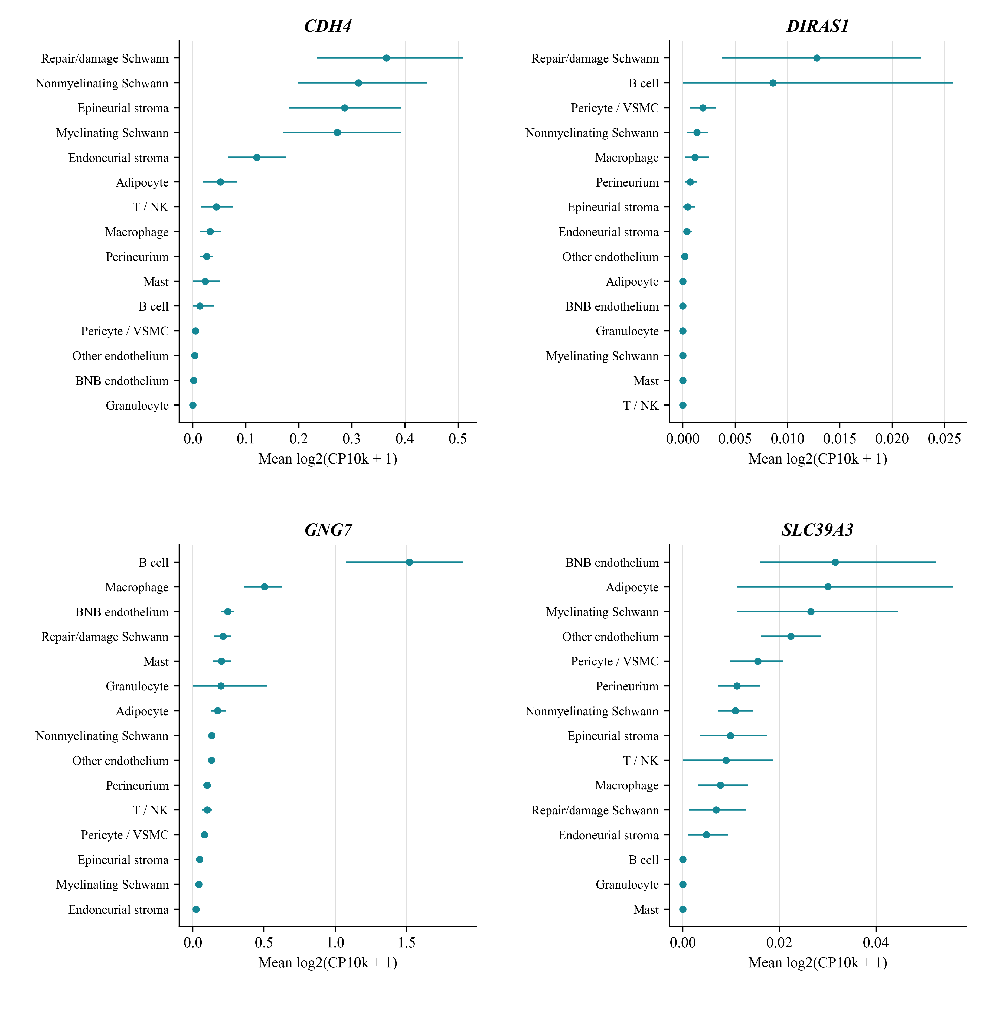
Points show mean log2(CP10k + 1) across eligible CIDP donors. Bars show percentile 95% intervals from 5000 resamples within each gene and cell group. Resampling was performed at donor level with random seed 20260904. The intervals quantify uncertainty in the donor mean for each gene and cell group. The source values and eligible donor counts are provided in the Genetic_bootstrap worksheet of Supplementary Data 1. This localisation workflow did not impose the 20 nucleus cutoff used for pseudobulk modules. Eight of the nine CIDP B cell samples contained fewer than 20 nuclei, limiting precision for that population.

Supplementary Figure S2. Published nerve observations and complement deposition
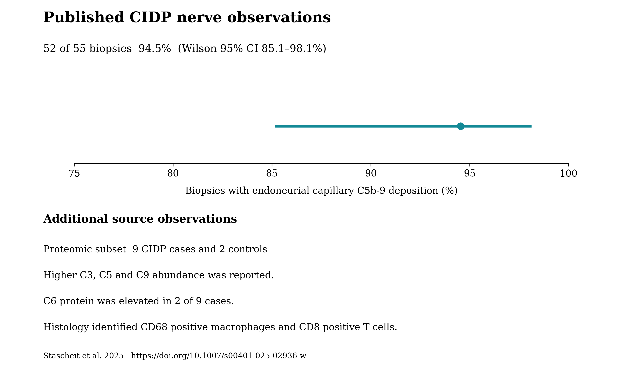
Stascheit et al. reported deposition of the terminal complement complex on endoneurial capillaries in 52 of 55 biopsies from patients with CIDP or its variants, together with histological and proteomic findings [11]. The proportion of 94.5% and Wilson 95% interval of 85.1% to 98.1% were calculated from the published count. The other observations summarise qualitative findings from the source study associated with PXD056286. The proteomic subset comprised nine CIDP cases and two controls. Higher C3, C5 and C9 abundance was reported, while C6 protein was elevated in only two cases.

Supplementary Figure S3. Fc module components and donor sensitivity analyses
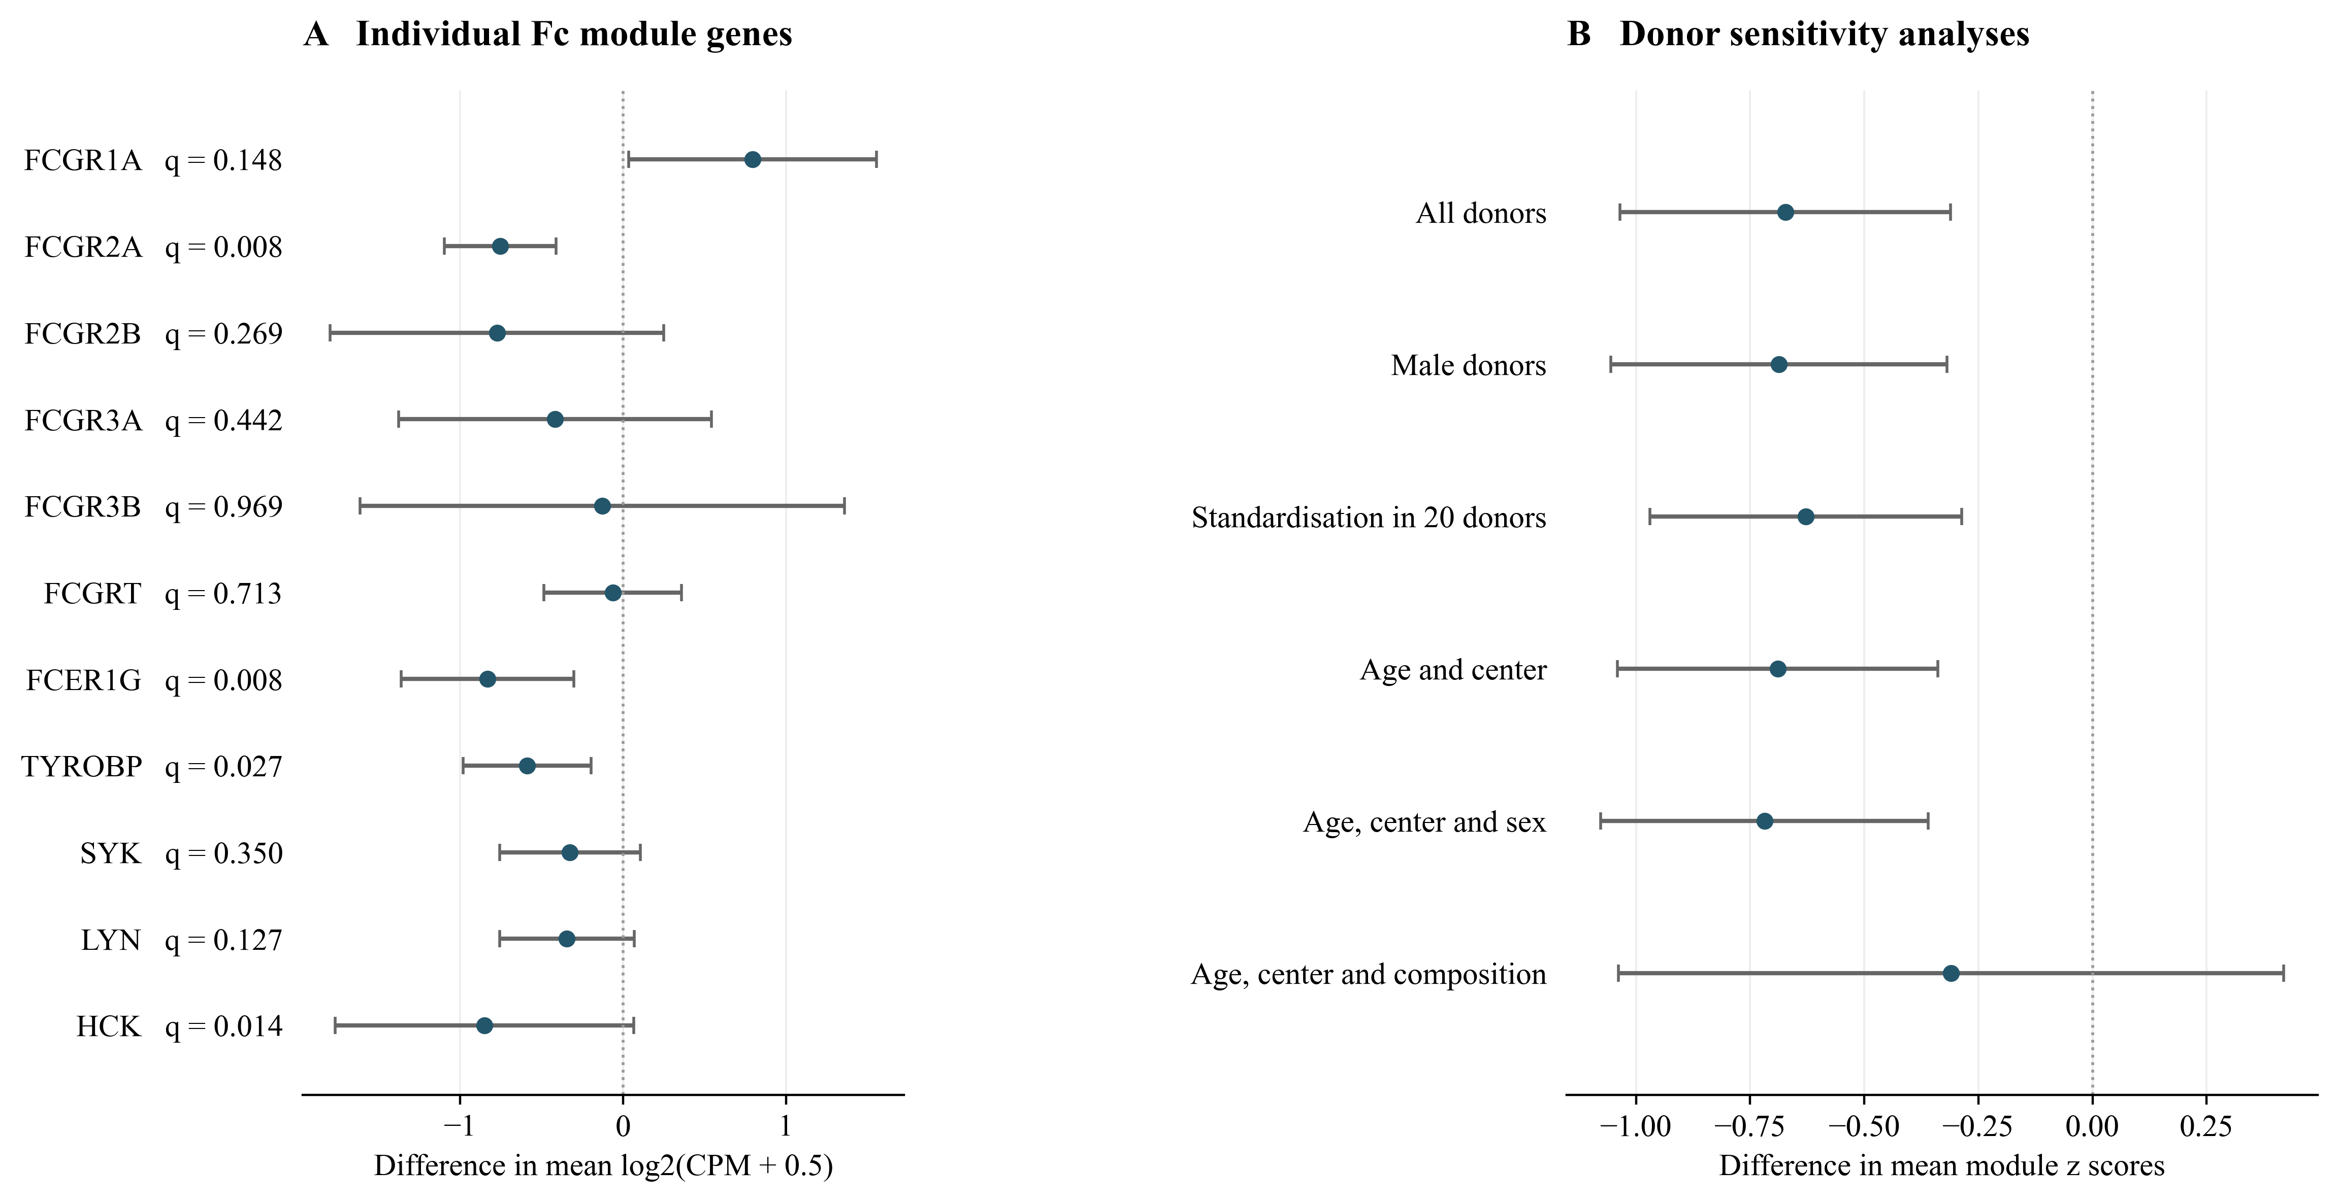
(A) Differences in mean log2(CPM + 0.5) for the 11 measured genes, calculated as CIDP minus CIAP. FCGR2C was absent from the matrix. Displayed q values were derived from two sided Mann and Whitney tests with Benjamini and Hochberg correction across the 11 genes. Points and bars show mean differences and unadjusted 95% confidence intervals from separate ordinary least squares models with HC3 covariance and residual degrees of freedom. These intervals do not correspond to the rank tests used to calculate q values. (B) Module score differences under demographic and composition sensitivity analyses, with HC3 95% confidence intervals. Standardisation within the 20 CIDP and CIAP donors changes the score scale. The exact permutation test within centres gave P = 0.0048 and is reported separately from the model intervals. The original module q value was 0.0087 within eight macrophage modules and 0.087 across all 80 eligible module tests. These exploratory analyses followed the initial Fc module observation. When the nine new programme tests are included, the original Fc module result has q = 0.097 across 89 tests. The subsequent 91 test family, which adds the two Fc reference comparisons, gives q = 0.099.

Supplementary Figure S4. Fc scores under alternative macrophage annotations
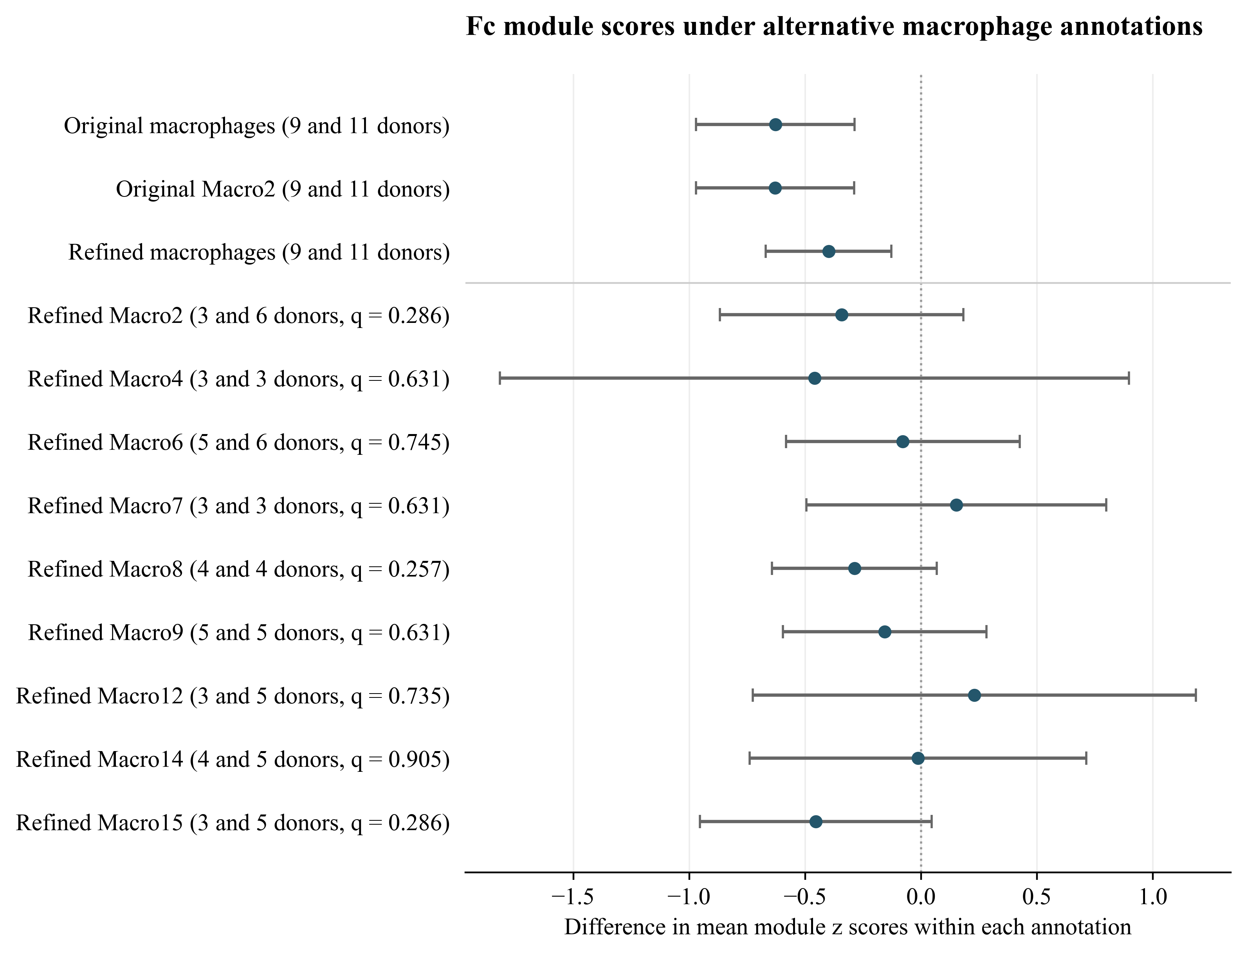
The original and refined annotations represent distinct classification levels. The refined union contains Macro1 through Macro18. Eligibility requires at least 20 nuclei per donor and three donors per diagnosis. Original Macro1 was ineligible. Points and bars show mean score differences calculated as CIDP minus CIAP, with unadjusted HC3 95% confidence intervals. Genes are standardised across eligible CIDP and CIAP donors within each annotation. Parentheses give CIDP and CIAP donor counts. Subtype q values were derived from two sided Mann and Whitney tests with Benjamini and Hochberg correction across nine subtypes, and all exceed 0.05. The three broader definition checks form a separate testing family. The HC3 intervals describe mean differences and do not correspond to the rank tests used for q values.

Supplementary Figure S5. Cellular expression of published genetic candidates
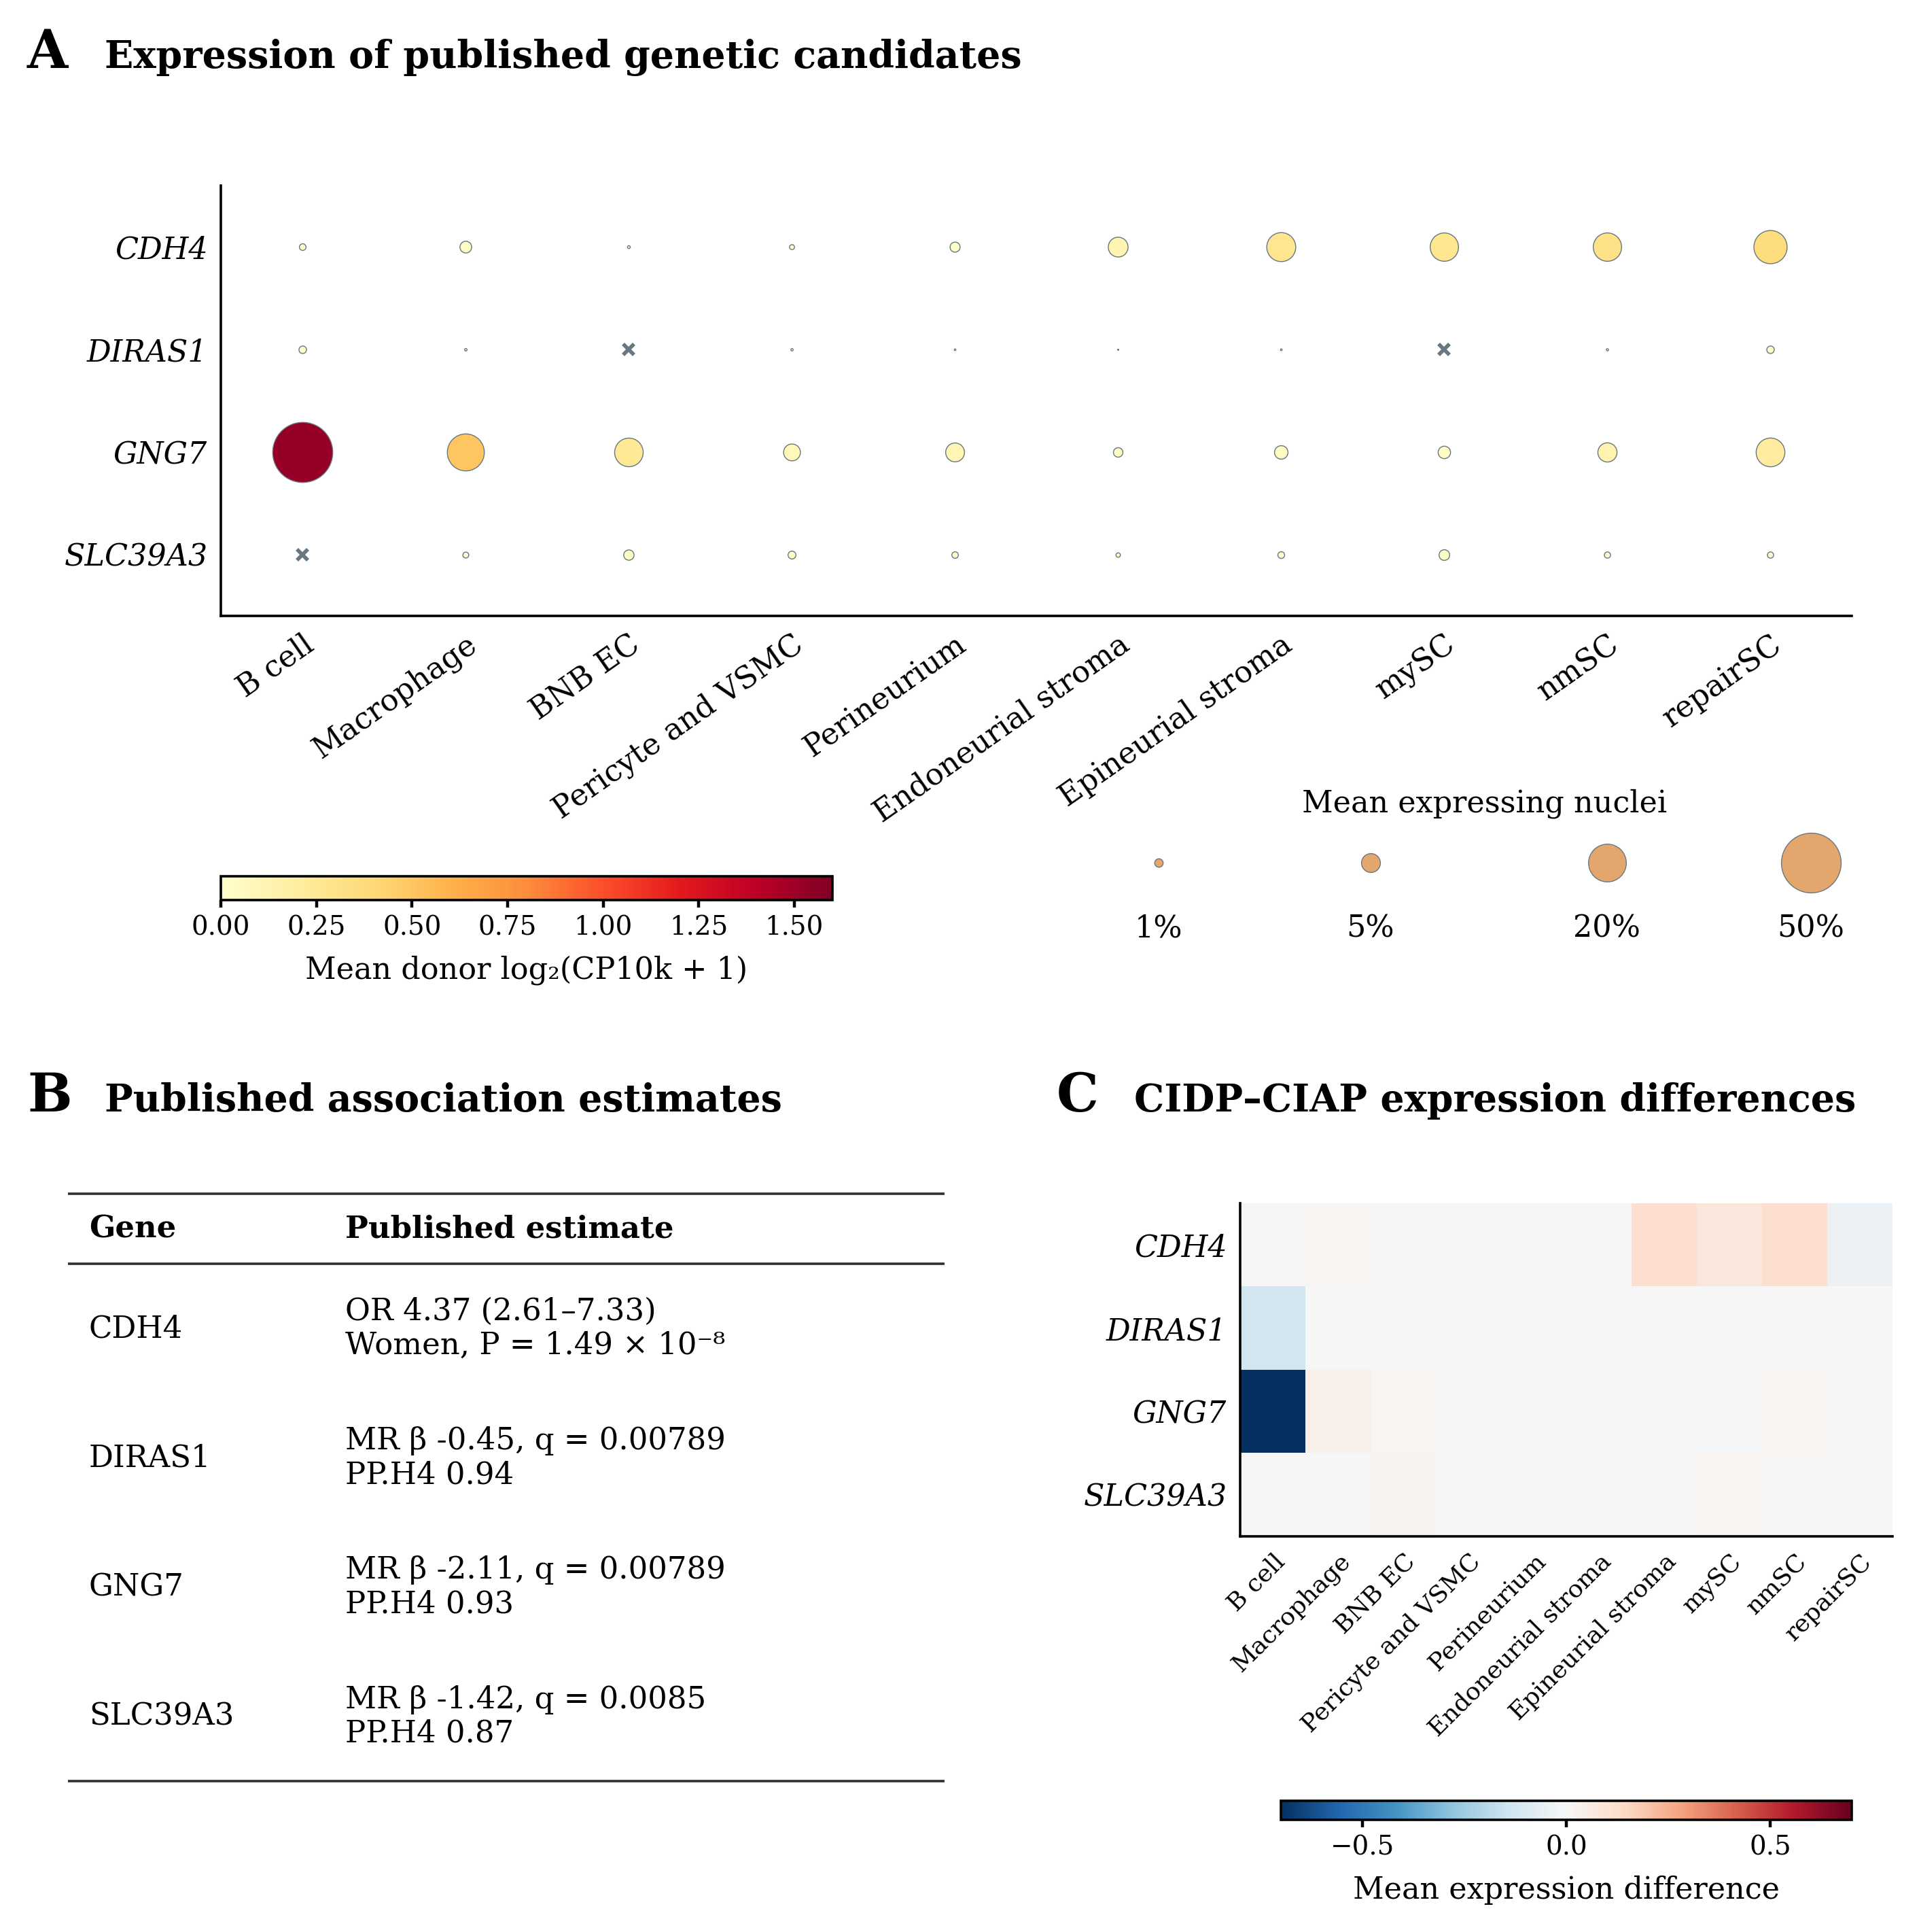
(A) Donor mean expression and detection for CDH4, DIRAS1, GNG7 and SLC39A3. Colour shows the mean of donor mean log2(CP10k + 1) values. Dot area is proportional to the mean donor percentage of expressing nuclei, with crosses for zero detection. Each summary gives equal weight to nine CIDP donors. This workflow did not apply the 20 nucleus pseudobulk cutoff. Eight of nine CIDP B cell groups contained fewer than 20 nuclei. (B) Published estimates from Du et al. used for candidate selection [10]. The CDH4 odds ratio concerns rs80339443 in women. MR denotes Mendelian randomisation and PP.H4 the posterior probability of a shared causal variant. (C) CIDP minus CIAP donor mean expression. All displayed q values exceed 0.05 after correction within the original candidate screening family. These expression summaries do not establish genetic mediation. Abbreviations follow Figure 5.

Supplementary Figure S6. Original nerve module correlations with disability
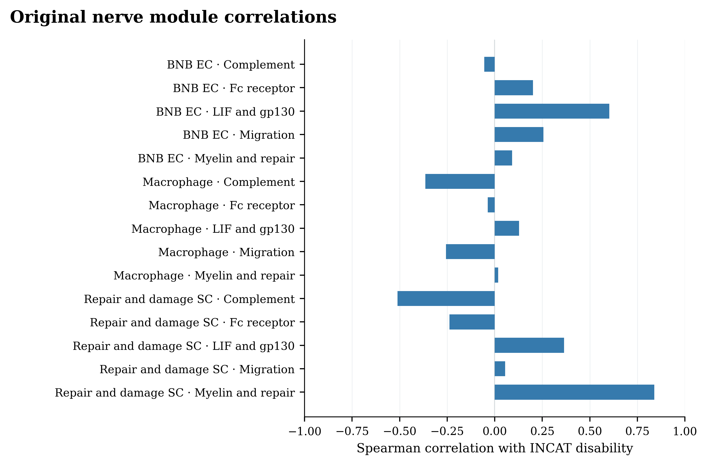
Spearman correlations between the 15 original combinations of cell group and gene module and INCAT disability in nine CIDP donors. All original q values exceed 0.05 after correction across 15 tests. The combined myelin and repair score in repair and damage Schwann cells has ρ = 0.840, P = 0.0046 and q = 0.069. These archived tests use asymptotic P values. The two separated programme correlations are reported in Supplementary Figure S8 using exact P values and an expanded 17 test correction. The original correlations are preserved without changing their P values.

Supplementary Figure S7. Selected endothelial genes in normal human BNB preparations
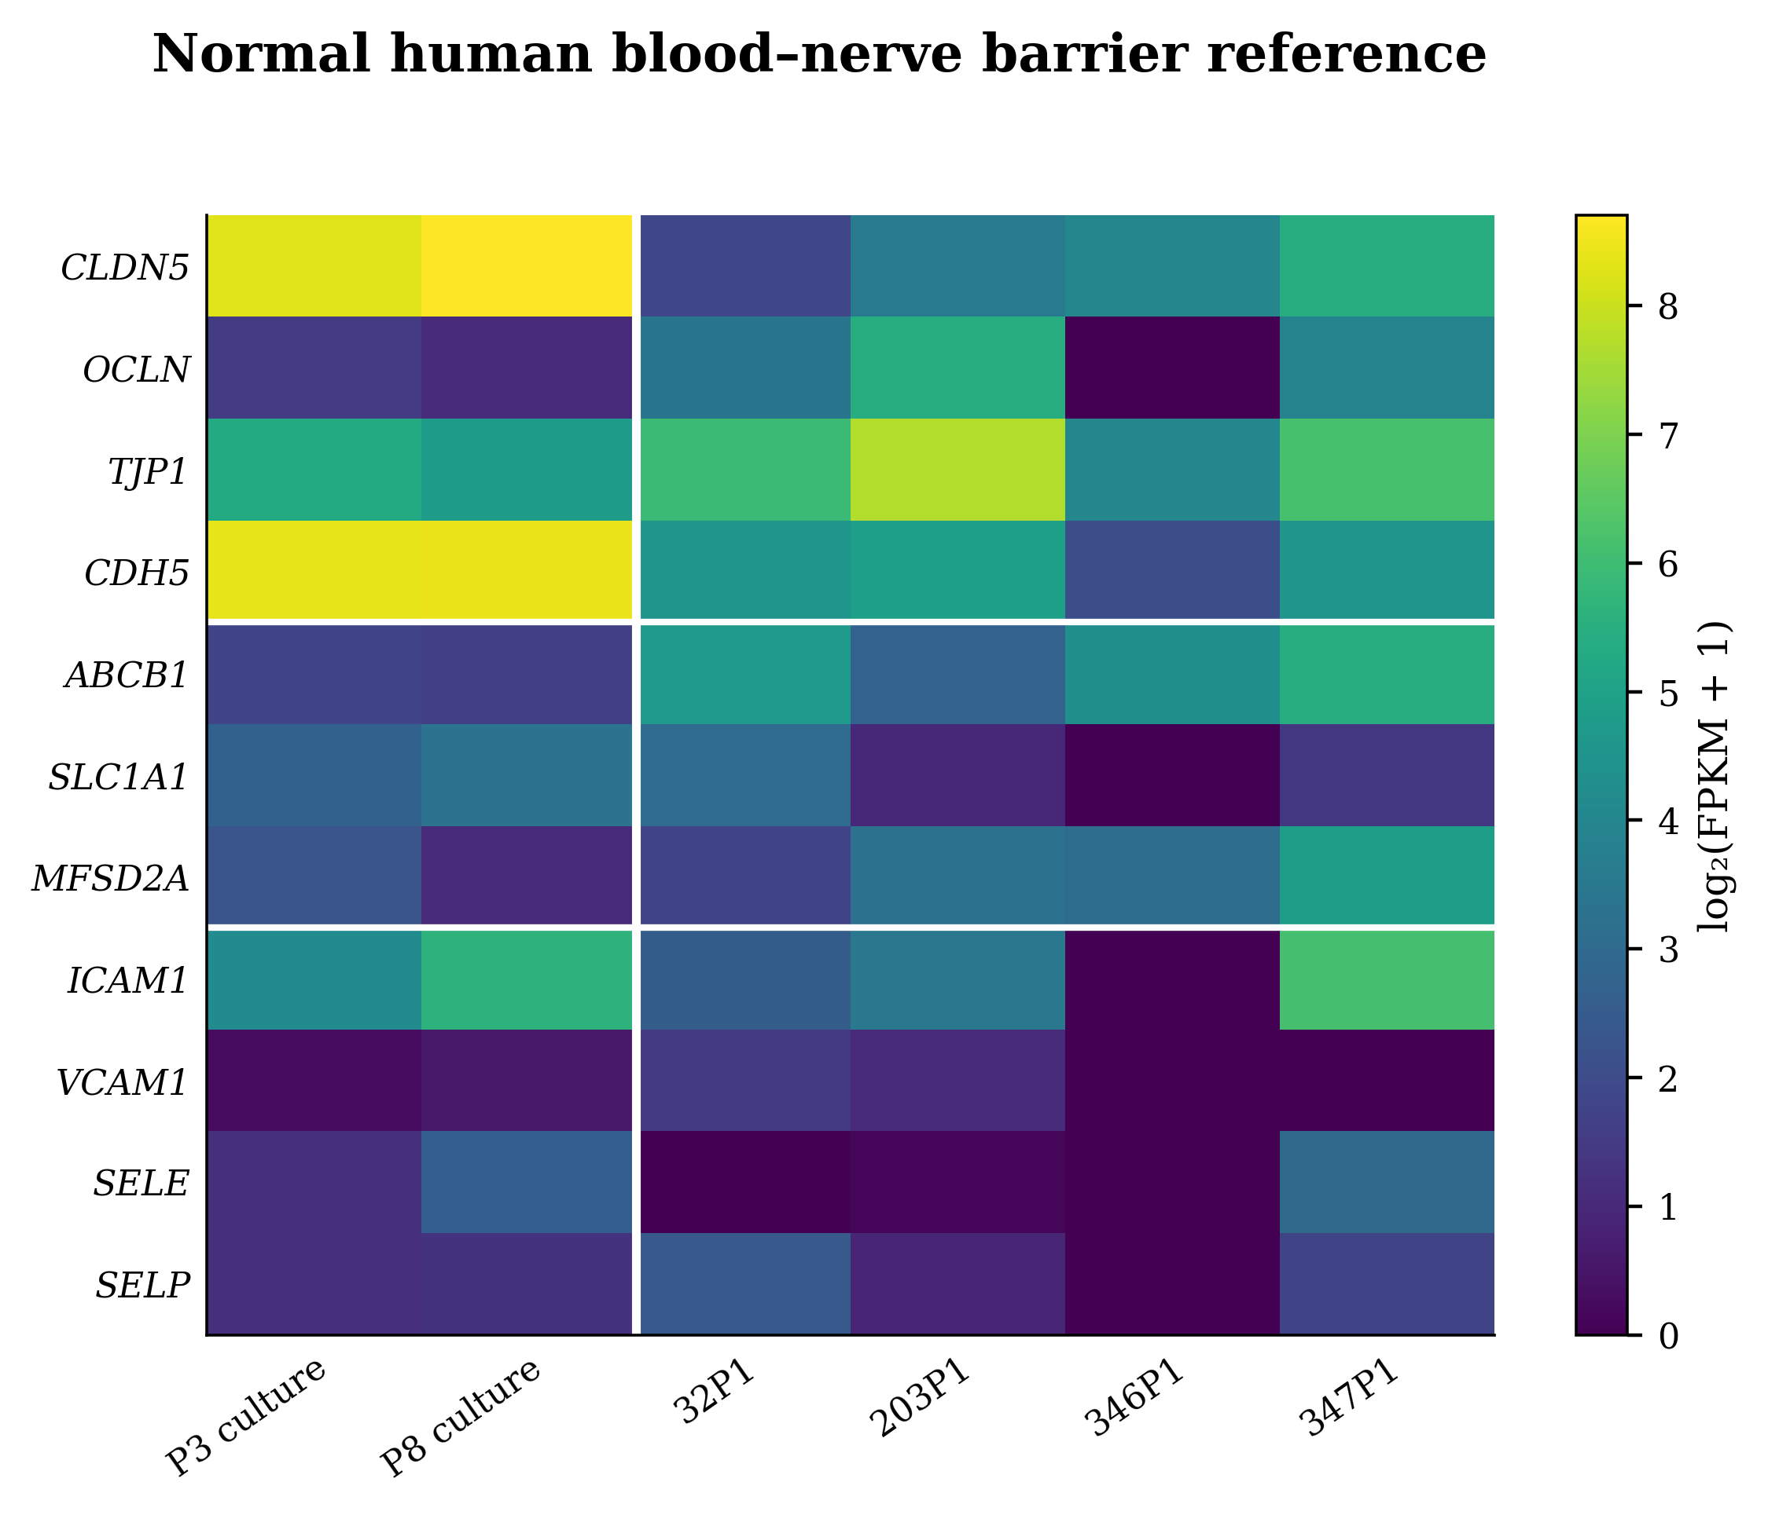
Expression of all 11 genes in the endothelial junction, transport and inflammatory adhesion sets in GSE107574. Colour shows log2(FPKM + 1). The first two columns are cultured endothelial preparations at different passages. The next four are laser captured normal nerve preparations. White lines separate preparations and gene sets. All 11 genes were detected in at least two of the four nerve preparations. These samples provide anatomical expression context without a CIDP comparison. They were not treated as six independent patients.

Supplementary Figure S8. Separate endothelial and Schwann cell programmes
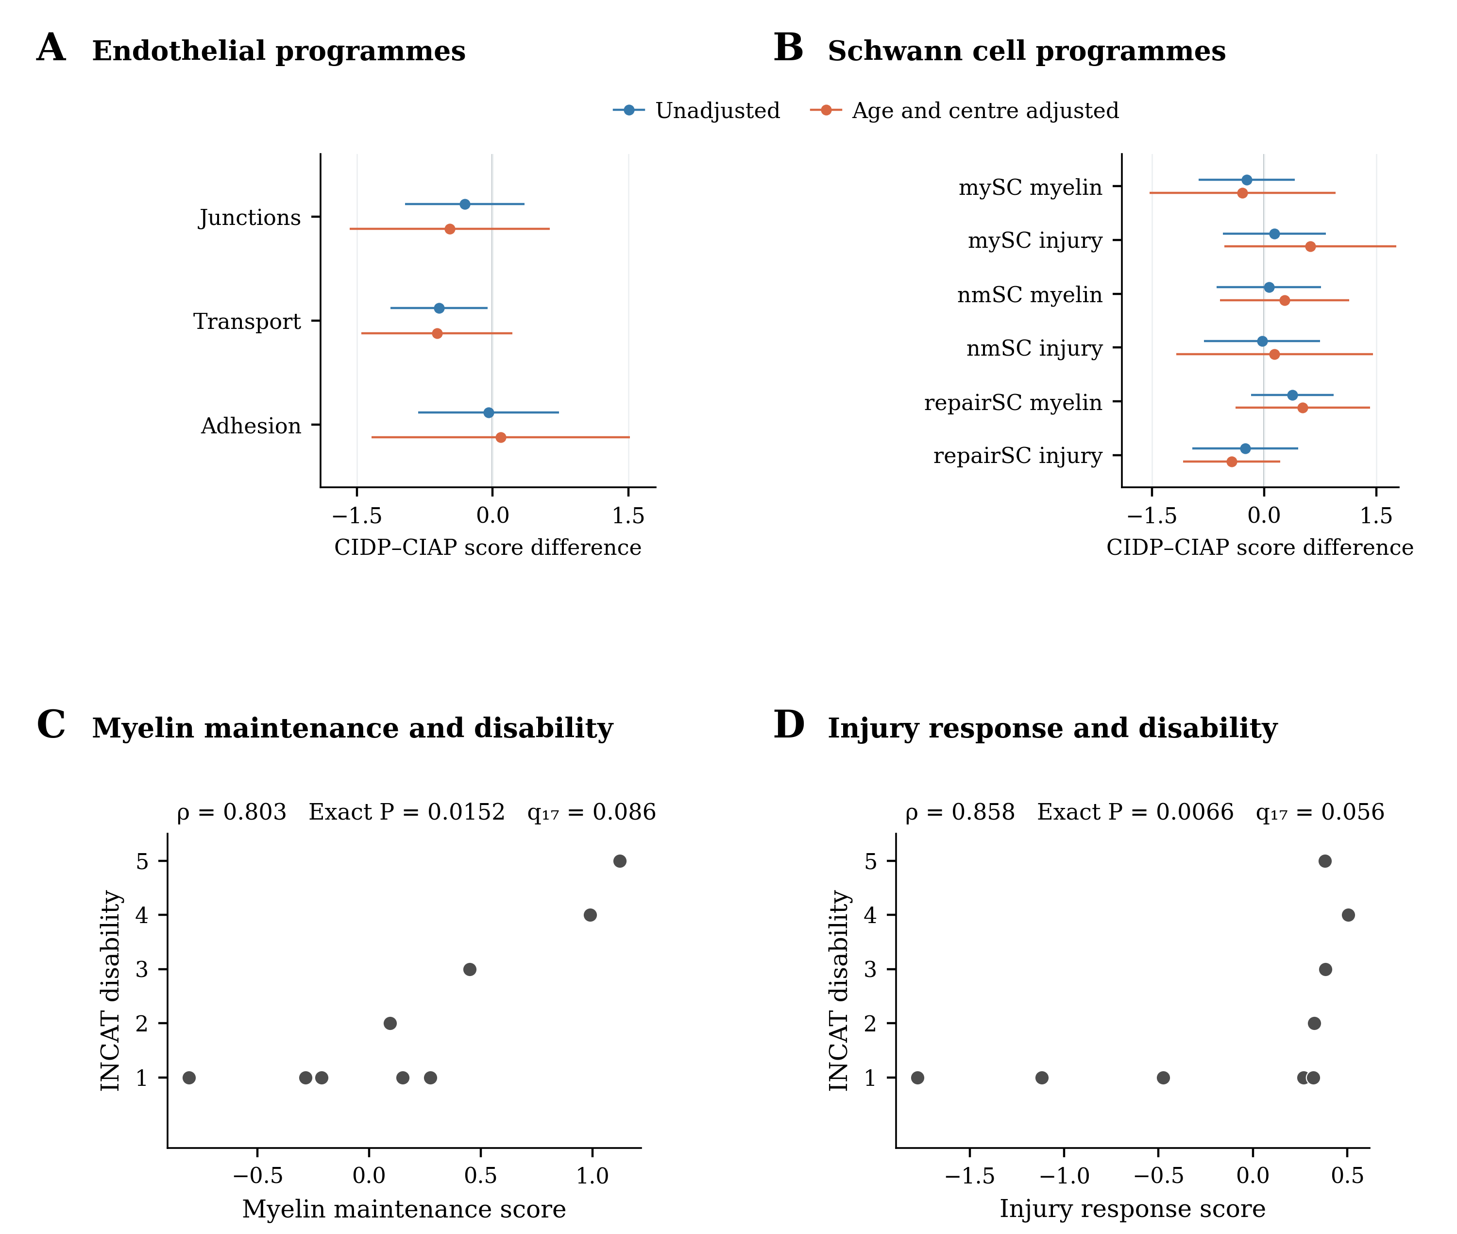
(A) Junction, transport and inflammatory adhesion gene sets in endoneurial endothelium. (B) Myelin maintenance and injury response gene sets in three Schwann cell groups. Points show mean CIDP minus CIAP differences with HC3 95% intervals. Blue denotes unadjusted estimates and orange denotes estimates adjusted for age and centre. The new scores standardise genes across eligible CIDP and CIAP donors. All nine comparisons have q > 0.05 across both the nine new tests and the expanded 91 test family. Unadjusted q values come from rank tests and are separate from the displayed model intervals. (C, D) The two scores in relation to INCAT disability in the pooled repair and damage group. Grey points represent the same nine CIDP donors in both panels. Exact P values use all 362,880 permutations and preserve tied ranks. Displayed q values combine these two exact tests with the 15 archived clinical tests. Neither association meets q < 0.05. Abbreviations are defined in Figure 5.

Supplementary Figure S9. External nerve Fc scores and atlas comparator checks
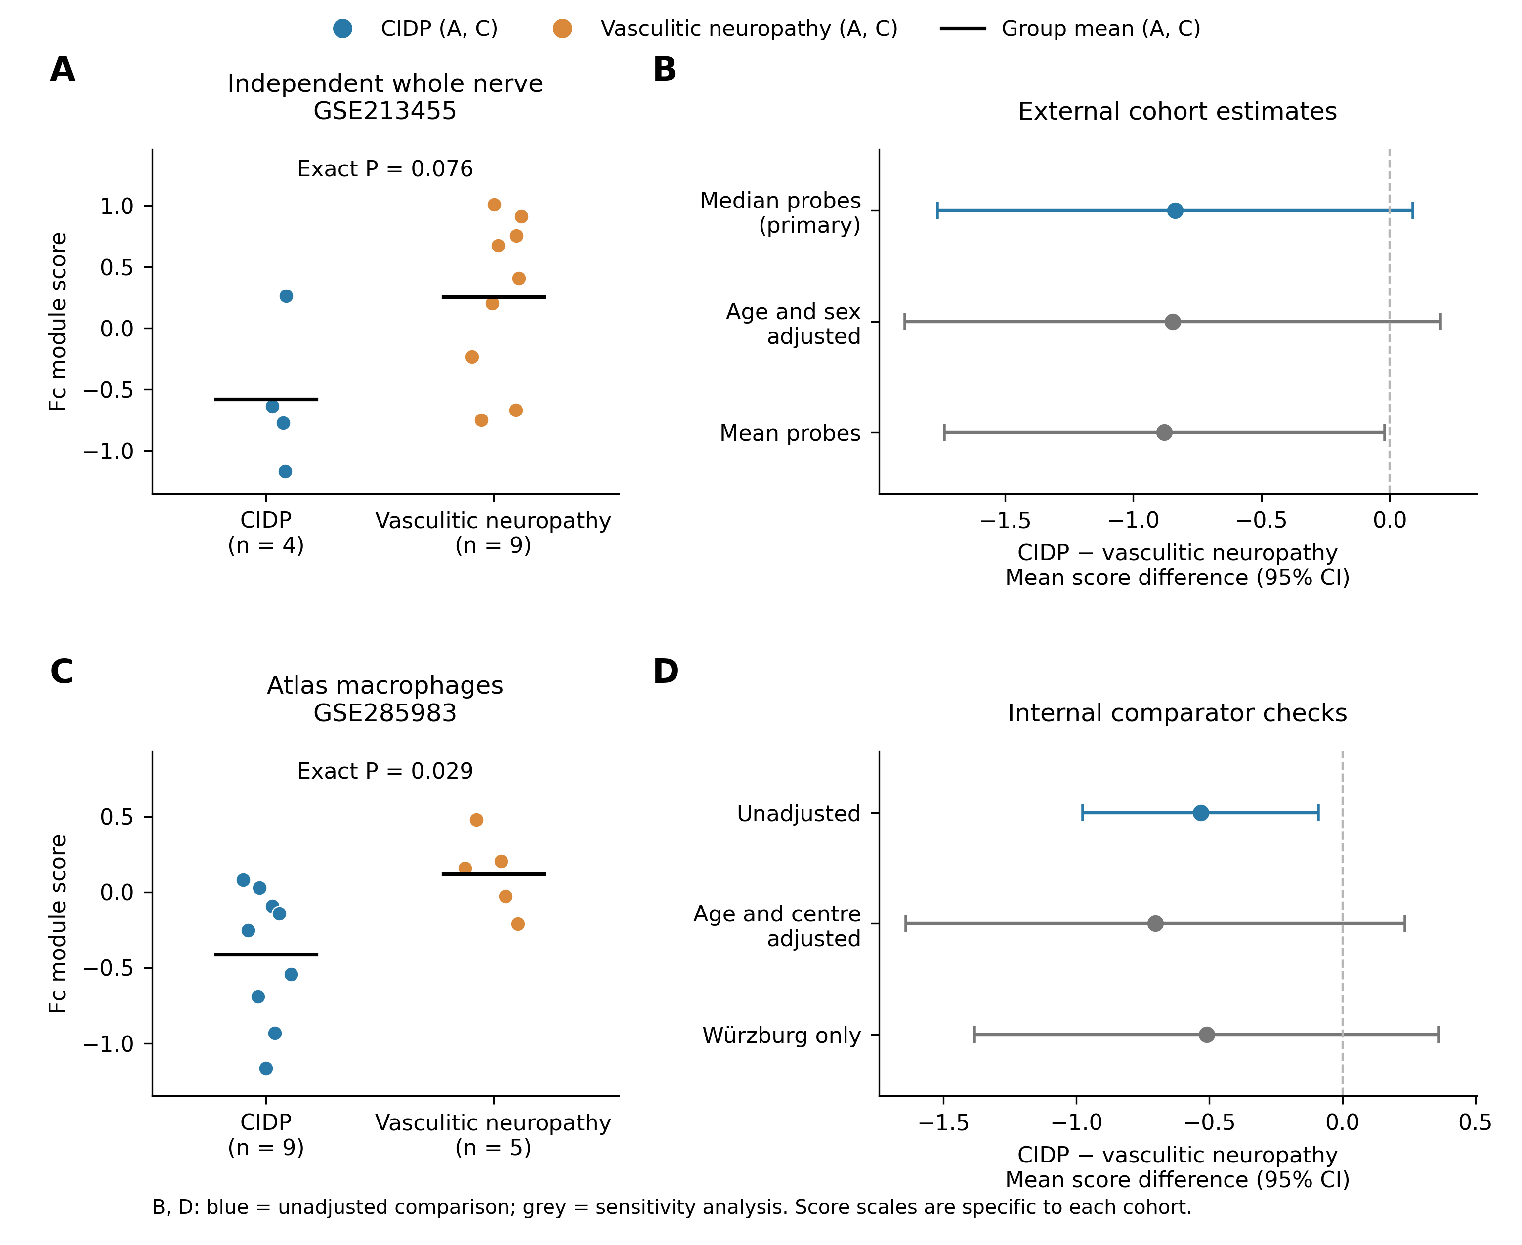
The same 11 Fc genes are evaluated in an independent whole nerve cohort and in the original atlas. (A) Individual scores for four CIDP and nine vasculitic neuropathy biopsies in GSE213455. (B) External mean differences with HC3 95% intervals under median probe aggregation, adjustment for age and sex, and mean probe aggregation. (C) Macrophage scores for nine CIDP and five vasculitic neuropathy donors in GSE285983. (D) Atlas mean differences before and after age and centre adjustment and after restriction to Würzburg, which includes three CIDP and five vasculitic neuropathy donors. In A and C, blue denotes CIDP, orange denotes vasculitic neuropathy, and black bars mark group means. In B and D, blue denotes the unadjusted comparison and grey denotes sensitivity analyses. Displayed P values in A and C are exact two sided rank tests. They are separate from the model intervals in B and D. External scores are scaled across 13 eligible biopsies, whereas atlas scores retain the original 37 donor scale. The two cohorts are not pooled. Complete gene and donor values are supplied in Supplementary Data 3 and 4.

Supplementary Figure S10. External monocyte clusters and sorted cells
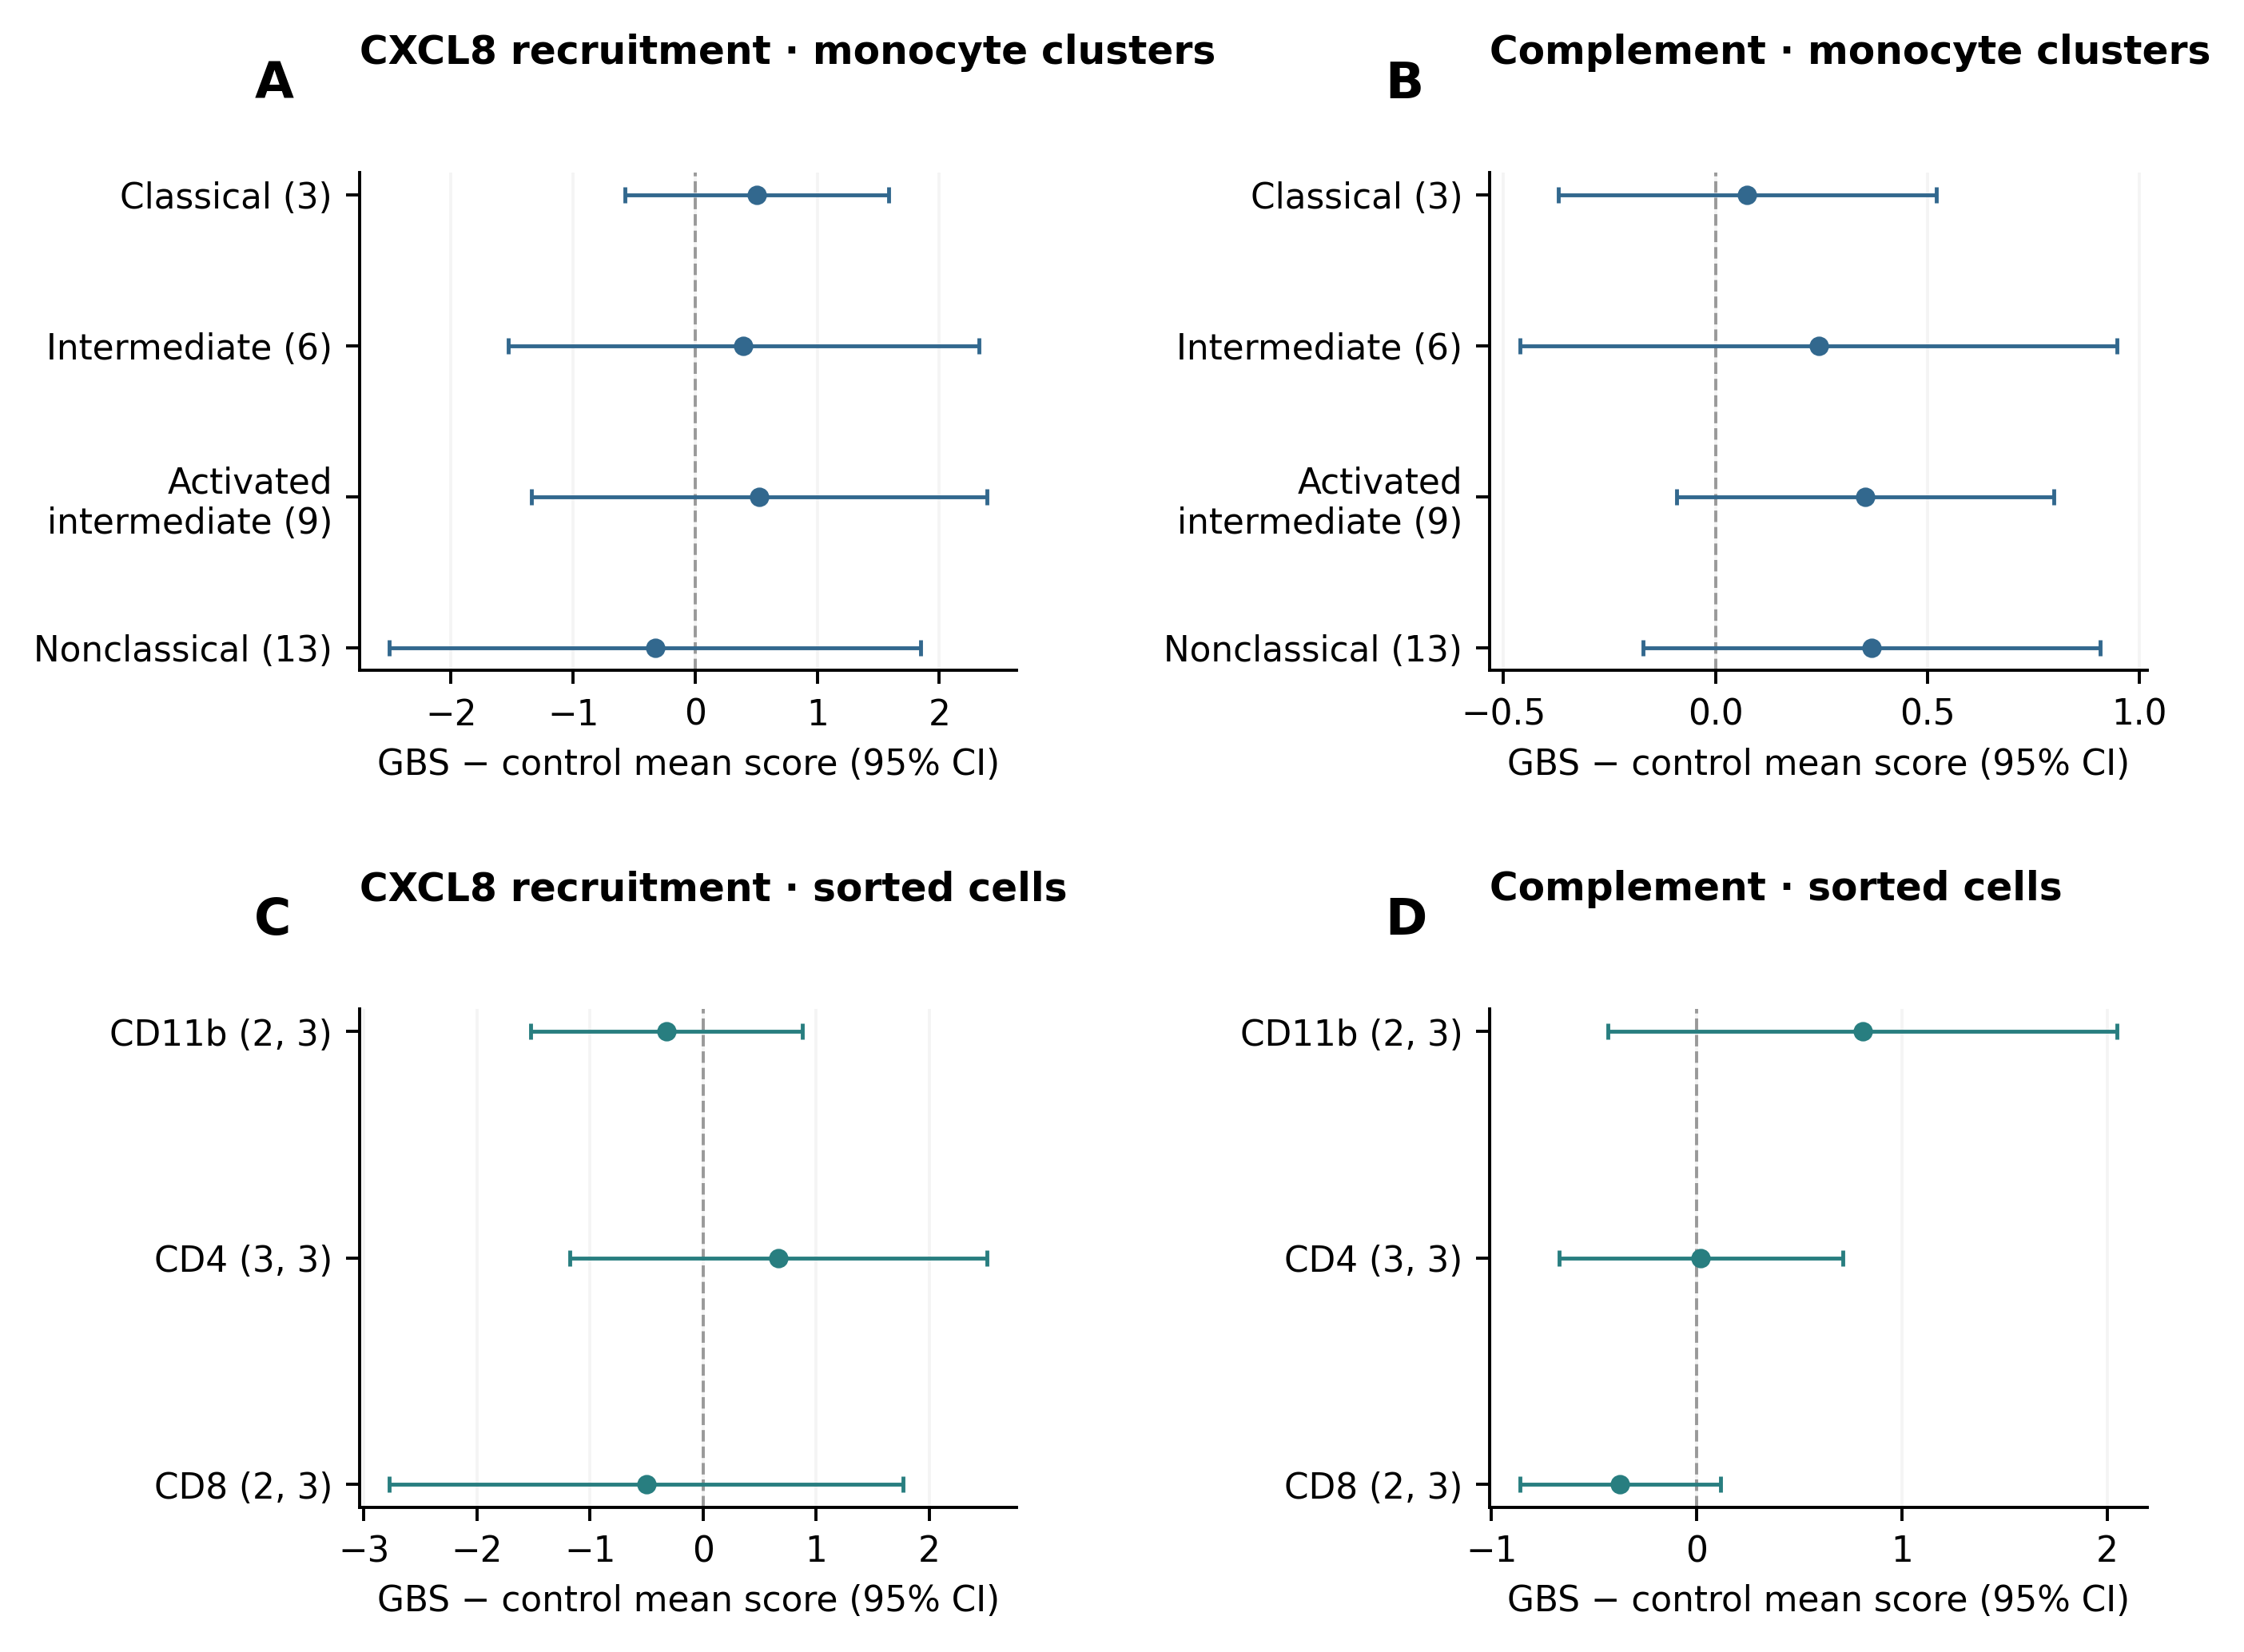
(A, B) GBS minus control differences in the four author annotated monocyte clusters in GSE304872. Each cluster includes four GBS and three control donors with at least 20 cells. Numbers in parentheses identify the original clusters. (C, D) Differences in CD11b, CD4 and CD8 sorted cell profiles in GSE304871. Parentheses give GBS and control donor counts. These preparations overlap the single cell cohort. Blue indicates single cell pseudobulk estimates and teal indicates sorted bulk estimates. Points and bars show mean differences and HC3 95% confidence intervals. Scores are standardised within each population or preparation. The eight cluster tests and two whole PBMC tests form a secondary family of ten tests, with all q values above 0.05. The six sorted cell tests form a separate family, also with all q values above 0.05. The model intervals are distinct from the exact tests used for q values. Sorted matrix gene identifiers were mapped using GENCODE release 38. Supplementary Data 5 supplies the annotation audit and all plotted values.

Supplementary Figure S11. Additional PBMC and paired follow up results
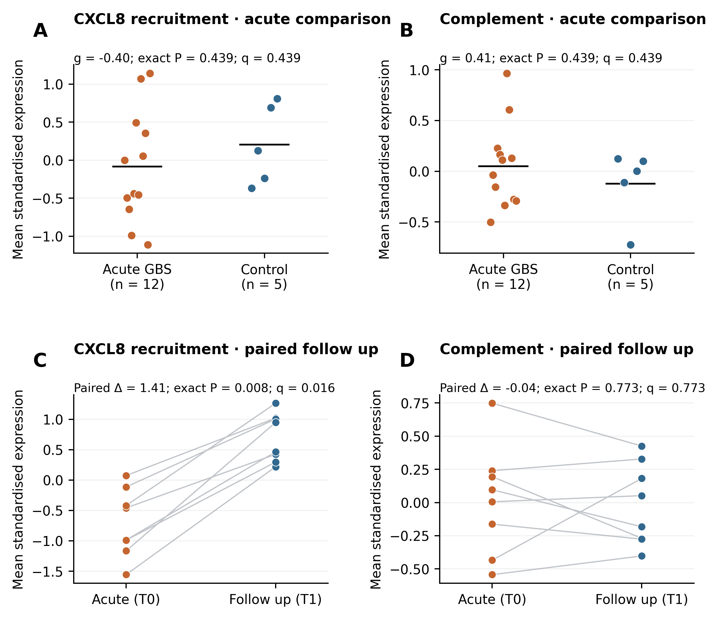
(A, B) Acute GBS versus control scores in PRJNA1174992 after technical sequencing columns were summed into biological samples and median ratio normalisation was applied. Orange indicates 12 acute GBS samples, blue indicates five controls, and black bars show group means. (C, D) Eight patients with paired acute and follow up samples. Orange indicates acute samples, blue indicates follow up samples, and grey lines link samples from the same patient. The paired comparison is normalised and standardised separately across the 16 paired samples. Absolute scores therefore cannot be compared between the upper and lower panels. P values use 6,188 exact label assignments for A and B and 256 sign assignments for C and D. Each pair of module tests has its own two test correction. Paired differences are follow up minus acute. We kept this dataset outside the pooled synthesis because overlap with GSE211225 could not be excluded. Incomplete batch information also limits interpretation of the follow up comparison.

Supplementary Figure S12. Macrophage marker calibration and external Fc sensitivity
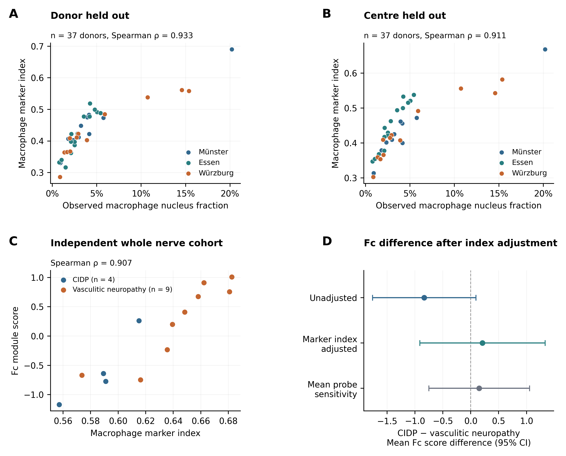
(A) Association between the macrophage marker index and observed macrophage nucleus fraction when each atlas donor is excluded from marker selection. (B) The same comparison after excluding each donor’s entire centre. Both panels show 37 donors from GSE285983. Blue indicates Münster, teal Essen and orange Würzburg. Markers were selected from donor balanced lineage profiles. The index uses within sample gene ranks and excludes the 11 Fc outcome genes. It measures relative marker expression, not a cell percentage. (C) The fixed 20 gene index and Fc score in the independent GSE213455 biopsies. Blue indicates four CIDP cases and orange indicates nine vasculitic neuropathy cases. Each point represents one donor. (D) CIDP minus vasculitic neuropathy Fc score differences with HC3 95% confidence intervals. Blue indicates the original unadjusted comparison, teal the model including the marker index, and grey the corresponding model using mean probe aggregation. The conditional model has ten residual degrees of freedom. All intervals include zero. Supplementary Data 6 supplies marker selections, held out index values, donor scores and the plotted model estimates.

