Immune compartmentalization across blood, cerebrospinal fluid and peripheral nerve in Guillain-Barré syndrome and CIDP
Yuan Feng¹, Fang Feng², Shuxiao Ma¹, Shuman Feng¹, Chao Jiang¹*, Yibin Hao¹*
¹ Department of Neurology, Henan Provincial People’s Hospital, People’s Hospital of Zhengzhou University, Zhengzhou 450003, China
² Department of Neurology, The First Affiliated Hospital of Zhengzhou University, Zhengzhou 450002, China
* Correspondence: Yibin Hao, haoyibin999@163.com, and Chao Jiang, chaoj@zzu.edu.cn. Postal address: No. 7 Weiwu Road, Jinshui District, Zhengzhou, Henan, China.
Running title: Immune compartmentalization across blood, CSF and peripheral nerve
Abstract
Background: Studies of inflammatory neuropathies usually examine a single biospecimen, leaving the relationships among circulating immunity, cerebrospinal fluid (CSF) injury signals, nerve responses and inherited susceptibility unresolved. We examined these relationships in Guillain-Barré syndrome (GBS) and chronic inflammatory demyelinating polyradiculoneuropathy (CIDP), focusing on the human blood-nerve barrier (BNB).
Methods: We integrated three acute GBS blood transcriptomic cohorts, published CSF proteomic estimates, a CIDP sural nerve single nucleus atlas, a human BNB reference and published genetic candidates. Analyses included random effects blood synthesis with successive omission of each cohort, inverse variance synthesis of reported CSF coefficients, donor pseudobulk analysis and 5,000 bootstrap resamples for genetic localization.
Results: CXCL8 recruitment and complement gene modules showed positive effects across all three blood cohorts and after successive omission of each cohort. Eight CSF proteins had concordant adjusted coefficients in two independent cohorts, and their pooled effects met the FDR criterion. Macrophage Fc receptor module scores were lower in CIDP than in CIAP. Correlations among endothelial, macrophage and Schwann cell modules remained exploratory after multiple testing correction. Bootstrap analysis supported CDH4 localization to Schwann cell states and GNG7 localization to B cells, macrophages and BNB endothelium. Estimates for DIRAS1 and SLC39A3 remained uncertain because expression was sparse.
Conclusions: These findings describe immune organization across compartments, relating systemic recruitment, CSF inflammation and proteolysis to BNB endothelial, macrophage and Schwann cell responses in nerve. Genetic localization identifies combinations of genes and cell types to prioritize for functional validation.
Keywords: Guillain-Barré syndrome, chronic inflammatory demyelinating polyradiculoneuropathy, cerebrospinal fluid, blood-nerve barrier, macrophage, Schwann cell, genetic anchoring, functional validation
Background
Guillain-Barré syndrome (GBS) and chronic inflammatory demyelinating polyradiculoneuropathy (CIDP) differ in their clinical time course but share several pathological processes. These include leukocyte recruitment, antibody and complement activity, myelin injury mediated by macrophages and Schwann cell reprogramming [1-15]. Their relationships are difficult to resolve from a single tissue because blood, CSF and peripheral nerve capture different aspects of the immune response.
The blood-nerve barrier (BNB) regulates the entry of immune cells into the endoneurium. Endothelial tight junctions and pericytes maintain this specialized barrier, whereas ICAM1, VCAM1, CCL2 and leukocyte integrins support inflammatory adhesion and migration across the endothelium [16-22]. The BNB thus forms an interface between circulating recruitment signals and the responses of macrophages and Schwann cells within injured nerve.
Recent studies using single cell data and multiple omics approaches illustrate the value of examining disease processes across cohorts, cell states and anatomical locations [10,23-32]. Blood transcriptomics measures systemic immune activation. CSF proteomics captures inflammatory proteins, protein entry into CSF and degradation products released from tissue, while single nucleus data from nerve identify the cells expressing immune and repair programs. Human genetic evidence provides an additional perspective by relating cellular localization to inherited susceptibility rather than solely to expression changes during disease.
We organized the analysis around six related objectives. These were to characterize the acute blood response, assess its consistency across cohorts, synthesize GBS CSF proteomic evidence, localize immune and repair programs in CIDP nerve, compare processes shared among compartments with those concentrated in individual compartments, and map published CIDP genetic candidates to peripheral nerve cell states to guide functional validation.
Methods
Study design and datasets
The study integrated human data from blood, CSF, peripheral nerve and genetic studies. GSE211225 contained whole blood expression profiles from 6 patients with acute GBS, 10 patients in the postacute phase and 6 controls [23]. GSE31014 provided leukocyte microarrays from 7 patients with GBS and 7 controls [24]. PRJNA1293757 provided PBMC single cell RNA sequencing data from 3 untreated patients with AIDP and 2 controls [25]. These three datasets were used to assess the consistency of blood findings across cohorts.
Published results linked to PXD002911 provided CSF protein and endogenous peptide identifications by diagnostic group [26]. GSE285983 contributed 365,708 nuclei from 37 sural nerves, including 9 donors with CIDP and 11 with chronic idiopathic axonal polyneuropathy [27]. GSE107574 supplied a reference for the normal human BNB [17]. The CIDP GWAS, Mendelian randomization and colocalization results reported by Du et al. were used to select genetic candidates for localization [33]. Three additional CSF studies provided published findings on complement, quantitative proteomics and inflammatory proteins [34-36]. From the Olink study by Kmezic et al., we extracted coefficients and standard errors for GBS compared with controls in independent discovery and replication cohorts. These coefficients had been adjusted by the original authors for age, sex and sample handling [37]. Published histological and proteomic findings associated with PXD056286 provided complementary tissue evidence from 55 sural nerve biopsies representing CIDP or its variants.
Definition and scoring of biological programs
Seven biological programs were specified before comparing blood groups. They comprised recruitment through CXCL8 and its receptors CXCR1 and CXCR2, LIF and OSM signaling through gp130, complement, Fc receptors, interferon signaling through JAK and STAT, inflammatory monocytes and transendothelial migration. Nerve analyses used eight gene modules covering BNB identity, leukocyte transmigration, CXCL8 recruitment, LIF signaling, complement, Fc receptors, macrophage state and Schwann cell myelin repair. Scores summarized expression of the genes in each module for individual participants or donors. They were interpreted as transcriptional measures of the corresponding processes, without assuming equivalent changes in protein activity or cellular function. Published CSF proteins and peptides were assigned to biological processes using the annotations recorded in the source studies.
Analysis and synthesis of acute GBS blood cohorts
Within each blood cohort, gene expression values were standardized and averaged to obtain program scores for each participant. Hedges g was used to compare acute GBS with controls. Within each cohort, P values were obtained from two-sided exact label permutation tests of mean score differences, with Benjamini-Hochberg correction across the seven modules for each comparison. Effects from individual cohorts were plotted together to assess agreement in direction, and comparable estimates from whole blood, leukocytes and monocyte pseudobulk were combined using random effects models. Hartung-Knapp confidence intervals, Tau² and I² were used to characterize uncertainty and heterogeneity across the three small cohorts [38,39]. Robustness was assessed by repeating each synthesis after omitting one cohort at a time. Each sensitivity analysis therefore included only two studies and was interpreted in terms of the stability and direction of the summary effect, rather than as an additional confirmatory significance test. Acute and postacute samples in GSE211225 were compared as independent groups to identify modules that differed by disease phase.
Synthesis of published GBS CSF proteomic evidence
Protein and peptide counts and functional annotations were extracted from the published report associated with PXD002911 for the AIDP, multiple sclerosis and control groups [26]. From Kmezic et al., we extracted the coefficients and standard errors adjusted for age, sex and sample handling that were available for the same eight proteins in both Olink cohorts [37]. We calculated inverse variance fixed effect estimates, confidence intervals and Benjamini-Hochberg adjusted P values across these eight proteins. DerSimonian-Laird estimates, Q and I² were calculated to assess heterogeneity. Interpretation was restricted to the reported subset because complete estimates for all assayed proteins were unavailable. Findings from PXD002911, D’Aguanno et al. [34], Ding et al. [35] and Sun et al. [36] were recorded with their source, platform, feature and biological category in a descriptive evidence map. Coverage was summarized as the number of distinct studies and assay platforms represented in each category. These counts describe the four selected studies and do not measure effect magnitude or statistical strength. Clinical IL8 associations from the literature were used only to provide context in the Discussion. CSF matrices for individual samples were unavailable, so no new analyses of individual CSF samples were performed.
Pseudobulk analysis by donor and cell state in CIDP nerve
Nuclei from GSE285983 were grouped by donor and annotated cell state. The focused analysis included macrophages, T and NK cells, B cells, granulocytes, endoneurial endothelial cells, other endothelial cells, pericytes, perineurium, endoneurial stroma and Schwann cells in myelinating, nonmyelinating or repair and damage states. A cell state was retained for a donor when at least 20 nuclei were available. Counts were summed within each donor and cell group and normalized as log2(CPM+0.5), using the total counts across all genes as the library size. The donor was the biological replicate throughout the comparison of CIDP with CIAP [40-43].
Gene module scores and cellular composition
To summarize expression within predefined gene sets [44], each gene was standardized across eligible donors from all diagnostic groups within a cell group, and the resulting z scores were averaged across the available genes in each module. CIDP and CIAP module scores were compared using two-sided Mann-Whitney U tests. Differences were reported as the mean score in CIDP minus the mean score in CIAP, with Benjamini-Hochberg correction across the eight modules within each cell group. Cell fractions were calculated separately for each donor and compared using the same test, with correction across cell groups. These comparisons were unadjusted for age, sex and collection center. Because cell fractions are compositional [45], their interpretation concerned relative cellular representation. Module scores and cell fractions were examined separately to distinguish transcriptional variation within a cell group from variation in its abundance.
Coordination of tissue programs and associations with disability
Five gene module scores were paired by donor: the BNB endothelial LIF module, endothelial leukocyte transmigration, macrophage complement, macrophage Fc receptors and myelin repair in Schwann cells in the repair and damage state. Spearman correlations were calculated for the ten pairs of these five scores across the nine CIDP donors. Fifteen combinations of cell group and module were also examined for correlation with INCAT disability. Benjamini-Hochberg correction was applied separately to the ten correlations among modules and the fifteen correlations with disability. Established frameworks for cellular communication informed biological interpretation [46,47]. The calculated correlations describe how donor scores vary together and do not constitute ligand and receptor interaction tests.
Integration across compartments and assessment of robustness
Integration across compartments focused on recurrent biological programs rather than individual genes. A program was included in the integrated map if it showed a consistent direction across blood cohorts, had a corresponding published protein or peptide annotation in CSF, or was localized to a relevant cell state in nerve. The map distinguished effects calculated from blood cohorts, new synthesis of published CSF coefficients, descriptive CSF evidence from the literature and nerve localization assessed for individual donors. These forms of evidence were displayed separately without combining them into a single numerical score. Because blood, CSF and nerve samples came from independent cohorts, correspondence across compartments was not interpreted as evidence of temporal progression, cell migration or causal signaling.
Localization of CIDP genetic candidates to nerve cell types for functional prioritization
We selected CDH4, DIRAS1, GNG7 and SLC39A3 from the published CIDP study of 516 cases and 403,545 controls [33]. The CDH4 locus reported in women and the Mendelian randomization and colocalization estimates for the other three genes were treated as prior genetic evidence. The new analyses examined the cellular expression of these candidates, differences between CIDP and CIAP, and the stability of localization across donors. Raw CellBender counts from GSE285983 were normalized as log2(CP10k+1) for each nucleus and summarized by donor and grouped nerve cell type. We reported the fraction of nuclei with detectable expression and mean expression for each donor. Uncertainty in localization was assessed using 5,000 bootstrap resamples of CIDP donors for each combination of gene and cell type. CIDP and CIAP donors were compared using two-sided Mann-Whitney tests, with Benjamini-Hochberg correction within each cell group. Complete summary statistics from the custom FinnGen GWAS were available only on request, so independent GWAS, MAGMA, Mendelian randomization, colocalization and TWAS analyses were not performed.
Statistical analysis
Participants and tissue donors were analyzed as independent biological samples. Individual cells or repeated measurements from the same person were not treated as independent observations. Benjamini-Hochberg correction was applied within each specified family of tests for gene modules, cell abundance, correlations among modules or clinical associations. Effect sizes and confidence intervals were reported alongside P values, and all P values were two-sided. Published coefficients and clinical findings retained their original study attribution. Analyses used Python 3.12 or later, h5py 3.16, NumPy 2.3 to below 2.7, SciPy 1.17, pandas 2.2 to below 3.1 and statsmodels 0.14. Figures were generated using matplotlib 3.9 or later within major version 3 and seaborn 0.13. Versioned scripts and dependency specifications are supplied with the article.
Results
The study design combines comparison across cohorts with anatomical localization
The analysis linked characterization of the systemic response to localization within nerve. GSE211225 defined the acute response in whole blood, while GSE31014 and PRJNA1293757 assessed agreement in direction across platforms and localization to monocytes. PXD002911 contributed CSF proteomic and peptidomic evidence, and GSE285983 mapped the corresponding programs to cell states in peripheral nerve. GSE107574 related the endothelial findings to the normal human BNB (Fig. 1 and Table 1).

Table 1. Datasets and analytical roles
Resource | Material | Participants or samples | Analytical role
GSE211225 | Whole blood transcriptomics | 6 acute GBS, 10 postacute, 6 controls | Primary blood effects for individual participants
GSE31014 | Leukocyte microarray | 7 GBS, 7 controls | Independent assessment of blood effect direction
PRJNA1293757 | PBMC single cell RNA sequencing | 3 AIDP, 2 controls | Monocyte localization and assessment of effect direction
PXD002911 | CSF proteomics and peptidomics | GBS (AIDP), MS and controls, with pooled discovery material | Published CSF identifications and functional annotations
GSE285983 | Sural nerve single nucleus RNA sequencing | 9 CIDP, 11 CIAP in focused comparison | Donor gene module scores, cell fractions and expression localization
GSE107574 | Human endoneurial endothelial transcriptomics | Cultured cells and microvessels | Normal BNB reference
Kmezic et al. 2023 | CSF Olink proteomics | Discovery: 6 GBS and 20 controls. Replication: 6 GBS and 6 controls | New synthesis of published adjusted coefficients and standard errors
PXD056286 | Sural nerve histology and proteomics | 55 biopsies from CIDP or its variants | Published tissue observations and calculated Wilson interval
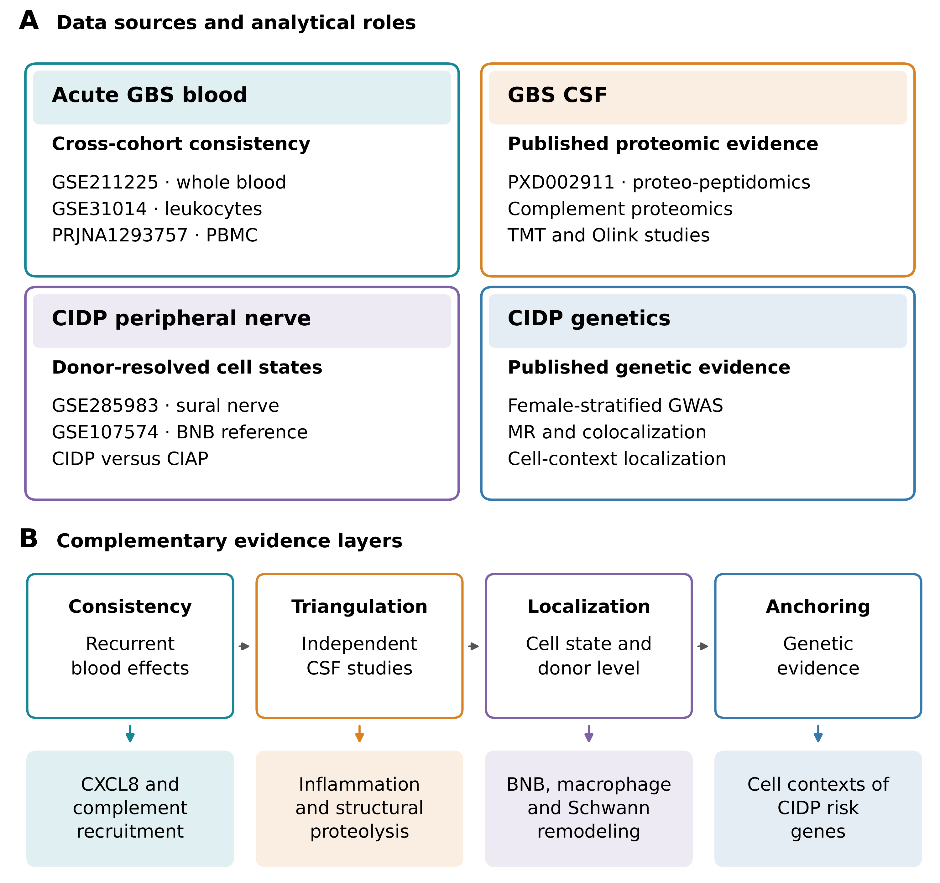
Figure 1. Study design and integrated model of immune compartments. Published blood, CSF, peripheral nerve and genetic resources were used to compare blood cohorts, integrate CSF findings, analyze nerve responses for individual donors and localize genetic susceptibility signals. The model relates systemic recruitment involving CXCL8 and complement to CSF inflammation and proteolysis, responses of BNB endothelial cells, macrophages and Schwann cells, and the cellular distribution of CIDP susceptibility genes.
Acute GBS blood shows higher expression of recruitment and humoral effector gene modules
GSE211225 showed a coordinated transcriptional response in whole blood during acute GBS. Compared with healthy controls, patients had higher scores for CXCL8 recruitment through CXCR1 and CXCR2 (Hedges g=1.25, FDR=0.045), LIF and OSM signaling through gp130 (g=2.19, FDR=0.0076), complement (g=2.49, FDR=0.0076), Fc receptors (g=1.36, FDR=0.038), interferon signaling through JAK and STAT (g=1.07, FDR=0.045) and inflammatory monocytes (g=1.93, FDR=0.015). The transendothelial migration module score was also higher (g=0.92), although the FDR was 0.126. These results identify increased expression of genes involved in chemotaxis and humoral effector responses.
Comparison of acute and postacute samples identified modules that differed by disease phase. Scores for complement (g=1.35, FDR=0.041), Fc receptors (g=1.23, FDR=0.046), transendothelial migration (g=1.59, FDR=0.024) and inflammatory monocytes (g=1.68, FDR=0.024) were higher in the acute phase. The CXCL8 recruitment and LIF and OSM modules remained elevated but differed less between the two phases. The acute profile therefore combined a broad inflammatory expression pattern with recruitment and humoral effector modules that varied more clearly by disease phase.
The independent cohorts helped identify which responses were consistent across datasets. GSE31014 showed positive effects for six of the seven programs. Scores for CXCL8 signaling through CXCR1 and CXCR2, complement, Fc receptors, transendothelial migration, interferon and inflammatory monocytes all changed in the same direction as in whole blood. In PRJNA1293757 monocytes, CXCL8 signaling through CXCR1 and CXCR2 had the largest positive effect (g=1.97), and the complement effect was also positive. The remaining monocyte effects varied in direction, providing clearer support for localization of the recruitment response than for reproduction of the full whole blood profile.
The CXCL8 recruitment and complement modules showed positive effects in all three datasets. The pooled Hedges g for CXCL8 recruitment was 1.08 (95% CI -0.63 to 2.78, Hartung-Knapp P=0.114, I²=0%), and that for complement was 1.11 (95% CI -1.73 to 3.95, P=0.234, I²=57.2%). Four other modules showed positive effects in two of the three cohorts, whereas the LIF and OSM module was positive only in whole blood. Although the pooled estimates were imprecise, agreement in direction identified recruitment and complement gene expression as the most consistent findings (Fig. 2 and Table 2).
Sensitivity analyses supported the stability of these directions. The summary effect for CXCL8 signaling through CXCR1 and CXCR2 remained positive after each cohort was omitted in turn, ranging from g=0.97 to 1.41. Complement effects also remained positive in all three analyses, ranging from g=0.48 to 1.55. For both programs, the individual effects in every retained pair of cohorts were positive. Other programs had positive summary estimates in some or all subsets, but at least one retained cohort showed an effect in the opposite direction. Hartung-Knapp intervals based on two studies were wide, so these analyses were not interpreted as confirmatory significance tests.
Table 2. Synthesis of acute GBS blood programs across cohorts
Gene module | Summary Hedges g | 95% CI lower | 95% CI upper | Hartung-Knapp P | I², % | Cohorts, n
CXCL8 signaling via CXCR1 and CXCR2 | 1.075 | -0.634 | 2.785 | 0.114 | 0.0 | 3
LIF and OSM signaling via gp130 | 0.271 | -3.978 | 4.519 | 0.810 | 81.2 | 3
Complement | 1.111 | -1.728 | 3.950 | 0.234 | 57.2 | 3
Fc receptor | 0.288 | -5.510 | 6.086 | 0.851 | 72.7 | 3
Transendothelial migration | 0.694 | -0.958 | 2.347 | 0.212 | 1.1 | 3
Interferon signaling via JAK and STAT | 0.677 | -0.943 | 2.297 | 0.214 | 0.0 | 3
Inflammatory monocyte | 1.026 | -1.702 | 3.754 | 0.247 | 49.5 | 3
The blood analyses thus identified a broad acute transcriptional response in GSE211225, with six modules meeting the FDR criterion, and a smaller set of consistent findings across cohorts. Comparison with the additional cohorts and successive omission of each cohort supported stable directions for the CXCL8 recruitment and complement modules. This distinction between the broader response within one cohort and the findings that recurred across cohorts guided integration with CSF and nerve evidence.
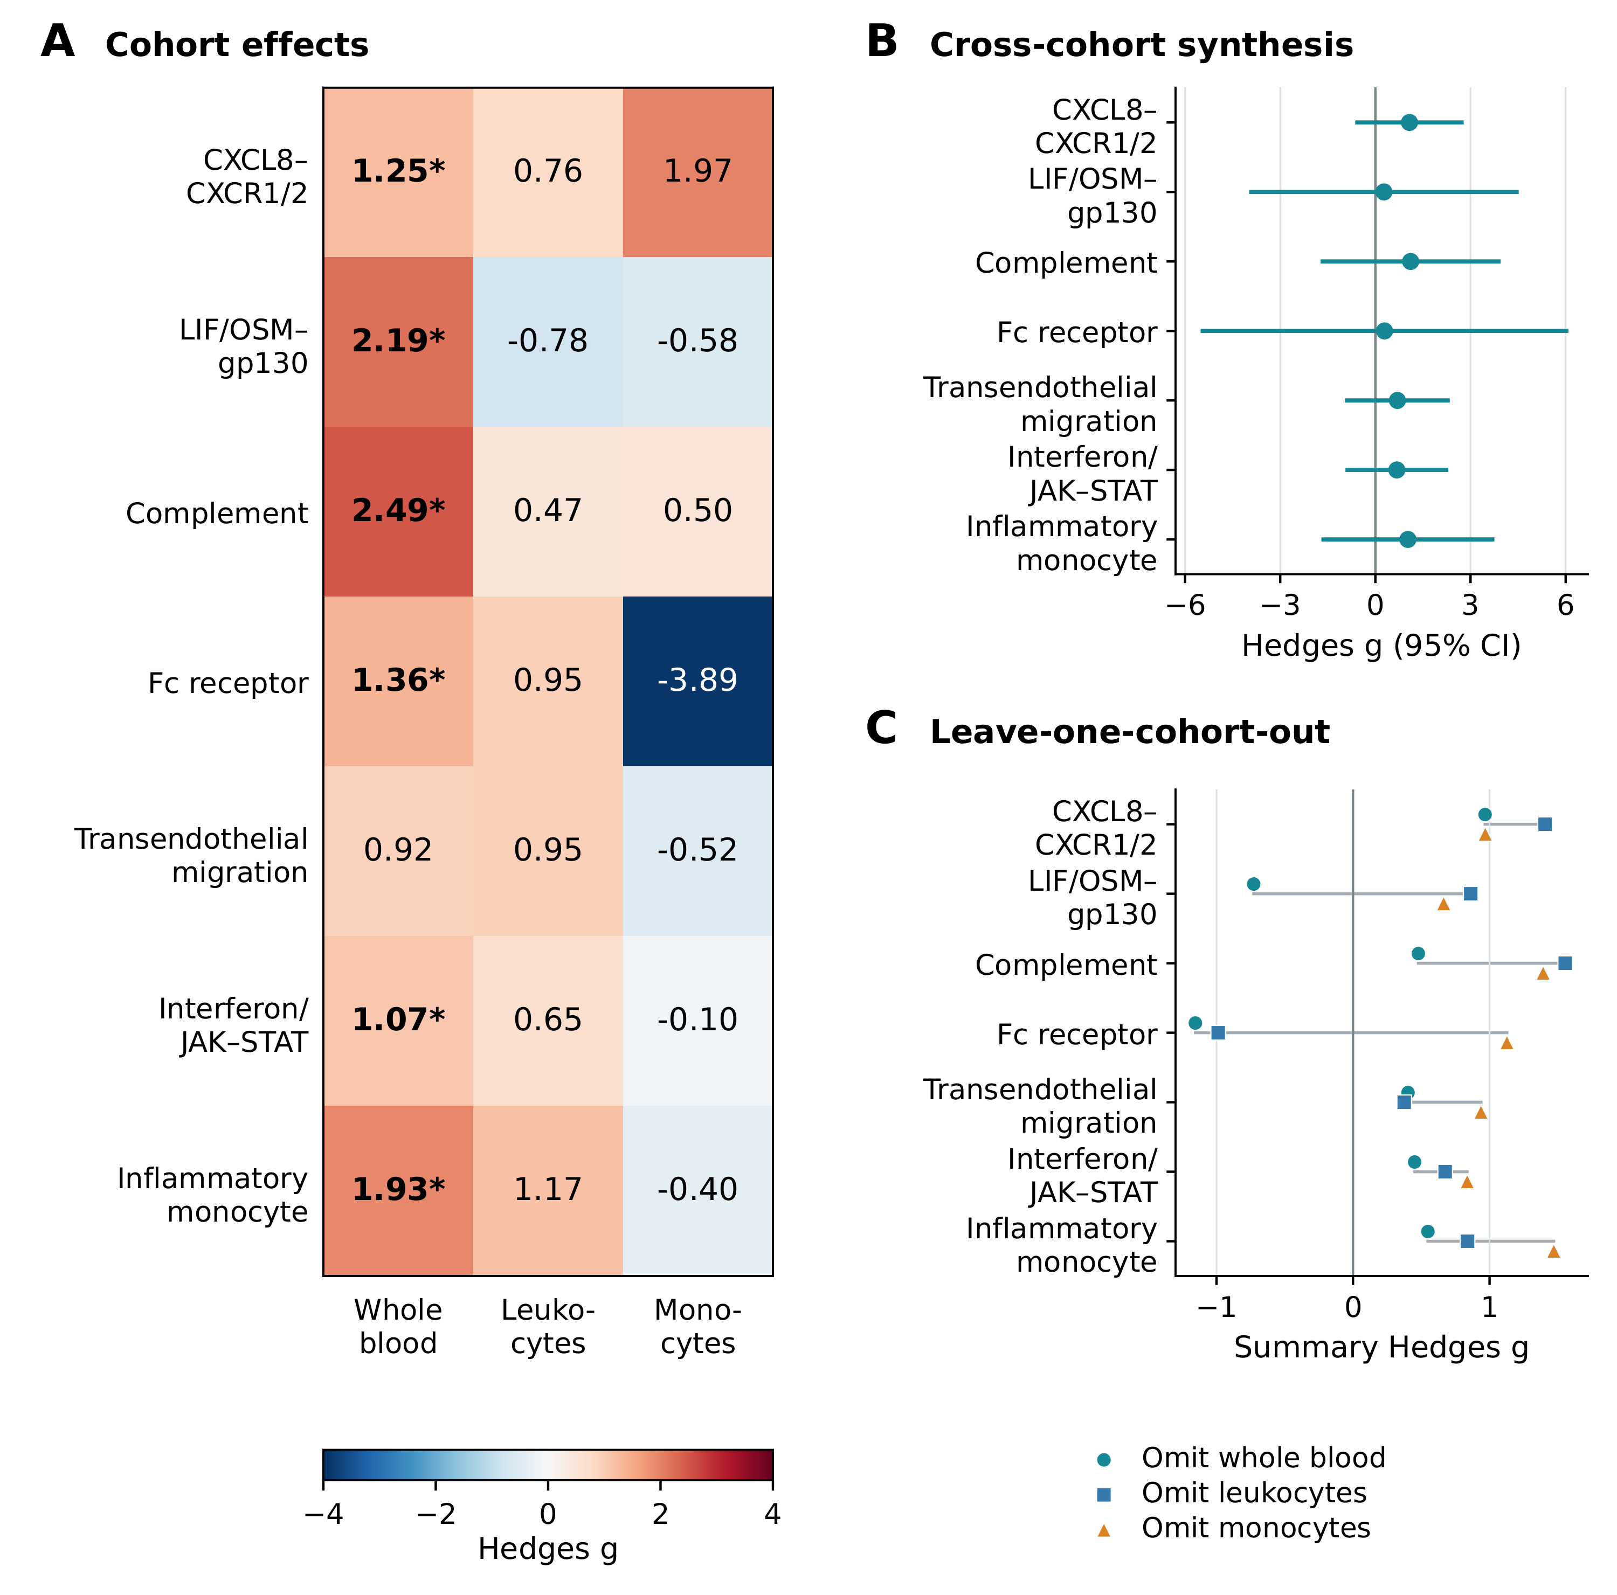
Figure 2. Acute GBS blood programs across cohorts and sensitivity analyses. (A) Hedges g values for seven prespecified programs in whole blood, leukocytes and monocyte pseudobulk. Asterisks indicate FDR<0.05 within each cohort. (B) Random effects estimates and 95% confidence intervals. (C) Summary effects after each cohort was omitted in turn. CXCL8 signaling through CXCR1 and CXCR2 and complement activity retained positive summary effects in all three subsets, with positive individual effects in both retained cohorts. These sensitivity analyses assess stability of direction and do not constitute confirmatory significance tests.
Immune programs differ in their consistency across blood cohorts and platforms
Heterogeneity varied substantially among gene modules. CXCL8 recruitment through CXCR1 and CXCR2 and interferon signaling through JAK and STAT both had I²=0%, while transendothelial migration had I²=1.1%. In contrast, LIF and OSM signaling through gp130 (I²=81.2%), Fc receptors (I²=72.7%), complement (I²=57.2%) and inflammatory monocytes (I²=49.5%) varied across whole blood, leukocyte microarrays and monocyte pseudobulk. The consistency of the CXCL8 recruitment effect contrasted with modules that appeared more sensitive to cellular composition and assay platform.
These differences also help interpret the blood findings. Recruitment signals were detectable in both mixed blood populations and monocytes, whereas the magnitude of LIF and OSM, Fc receptor and monocyte state signals varied with the cell population sampled. We therefore used synthesis across cohorts to identify recurrent directions while retaining estimates from individual cohorts to describe the broader immune response measured by each platform.
Synthesis of published CSF coefficients identifies concordant protein effects across cohorts
Our synthesis of the published Olink coefficients identified positive effects in both cohorts for all eight proteins with adjusted estimates available [37]. Inverse variance fixed effect estimates met the Benjamini-Hochberg criterion for SELE, IL2RA, CCL3, CR2, CD1C, THBD, NRP1 and CD38. Heterogeneity was substantial for IL2RA, THBD and CR2, indicating that agreement in direction did not imply similar effect magnitude across cohorts (Fig. 3A and B).
The descriptive evidence map provided context from four complementary CSF studies. The report linked to PXD002911 contributed protein and peptide identifications and functional annotations [26]. D’Aguanno et al. contributed complement and inflammatory protein findings [34], Ding et al. contributed protein handling and neural structure findings [35], and Sun et al. contributed inflammatory protein and routine CSF measurements [36]. Across these selected reports, local inflammation was represented in three studies and protein accumulation in two. Structural proteolysis, complement, and protein handling and neural structure were each represented in one study (Fig. 3C). These counts summarize the coverage of published evidence alongside the new synthesis of Olink coefficients.
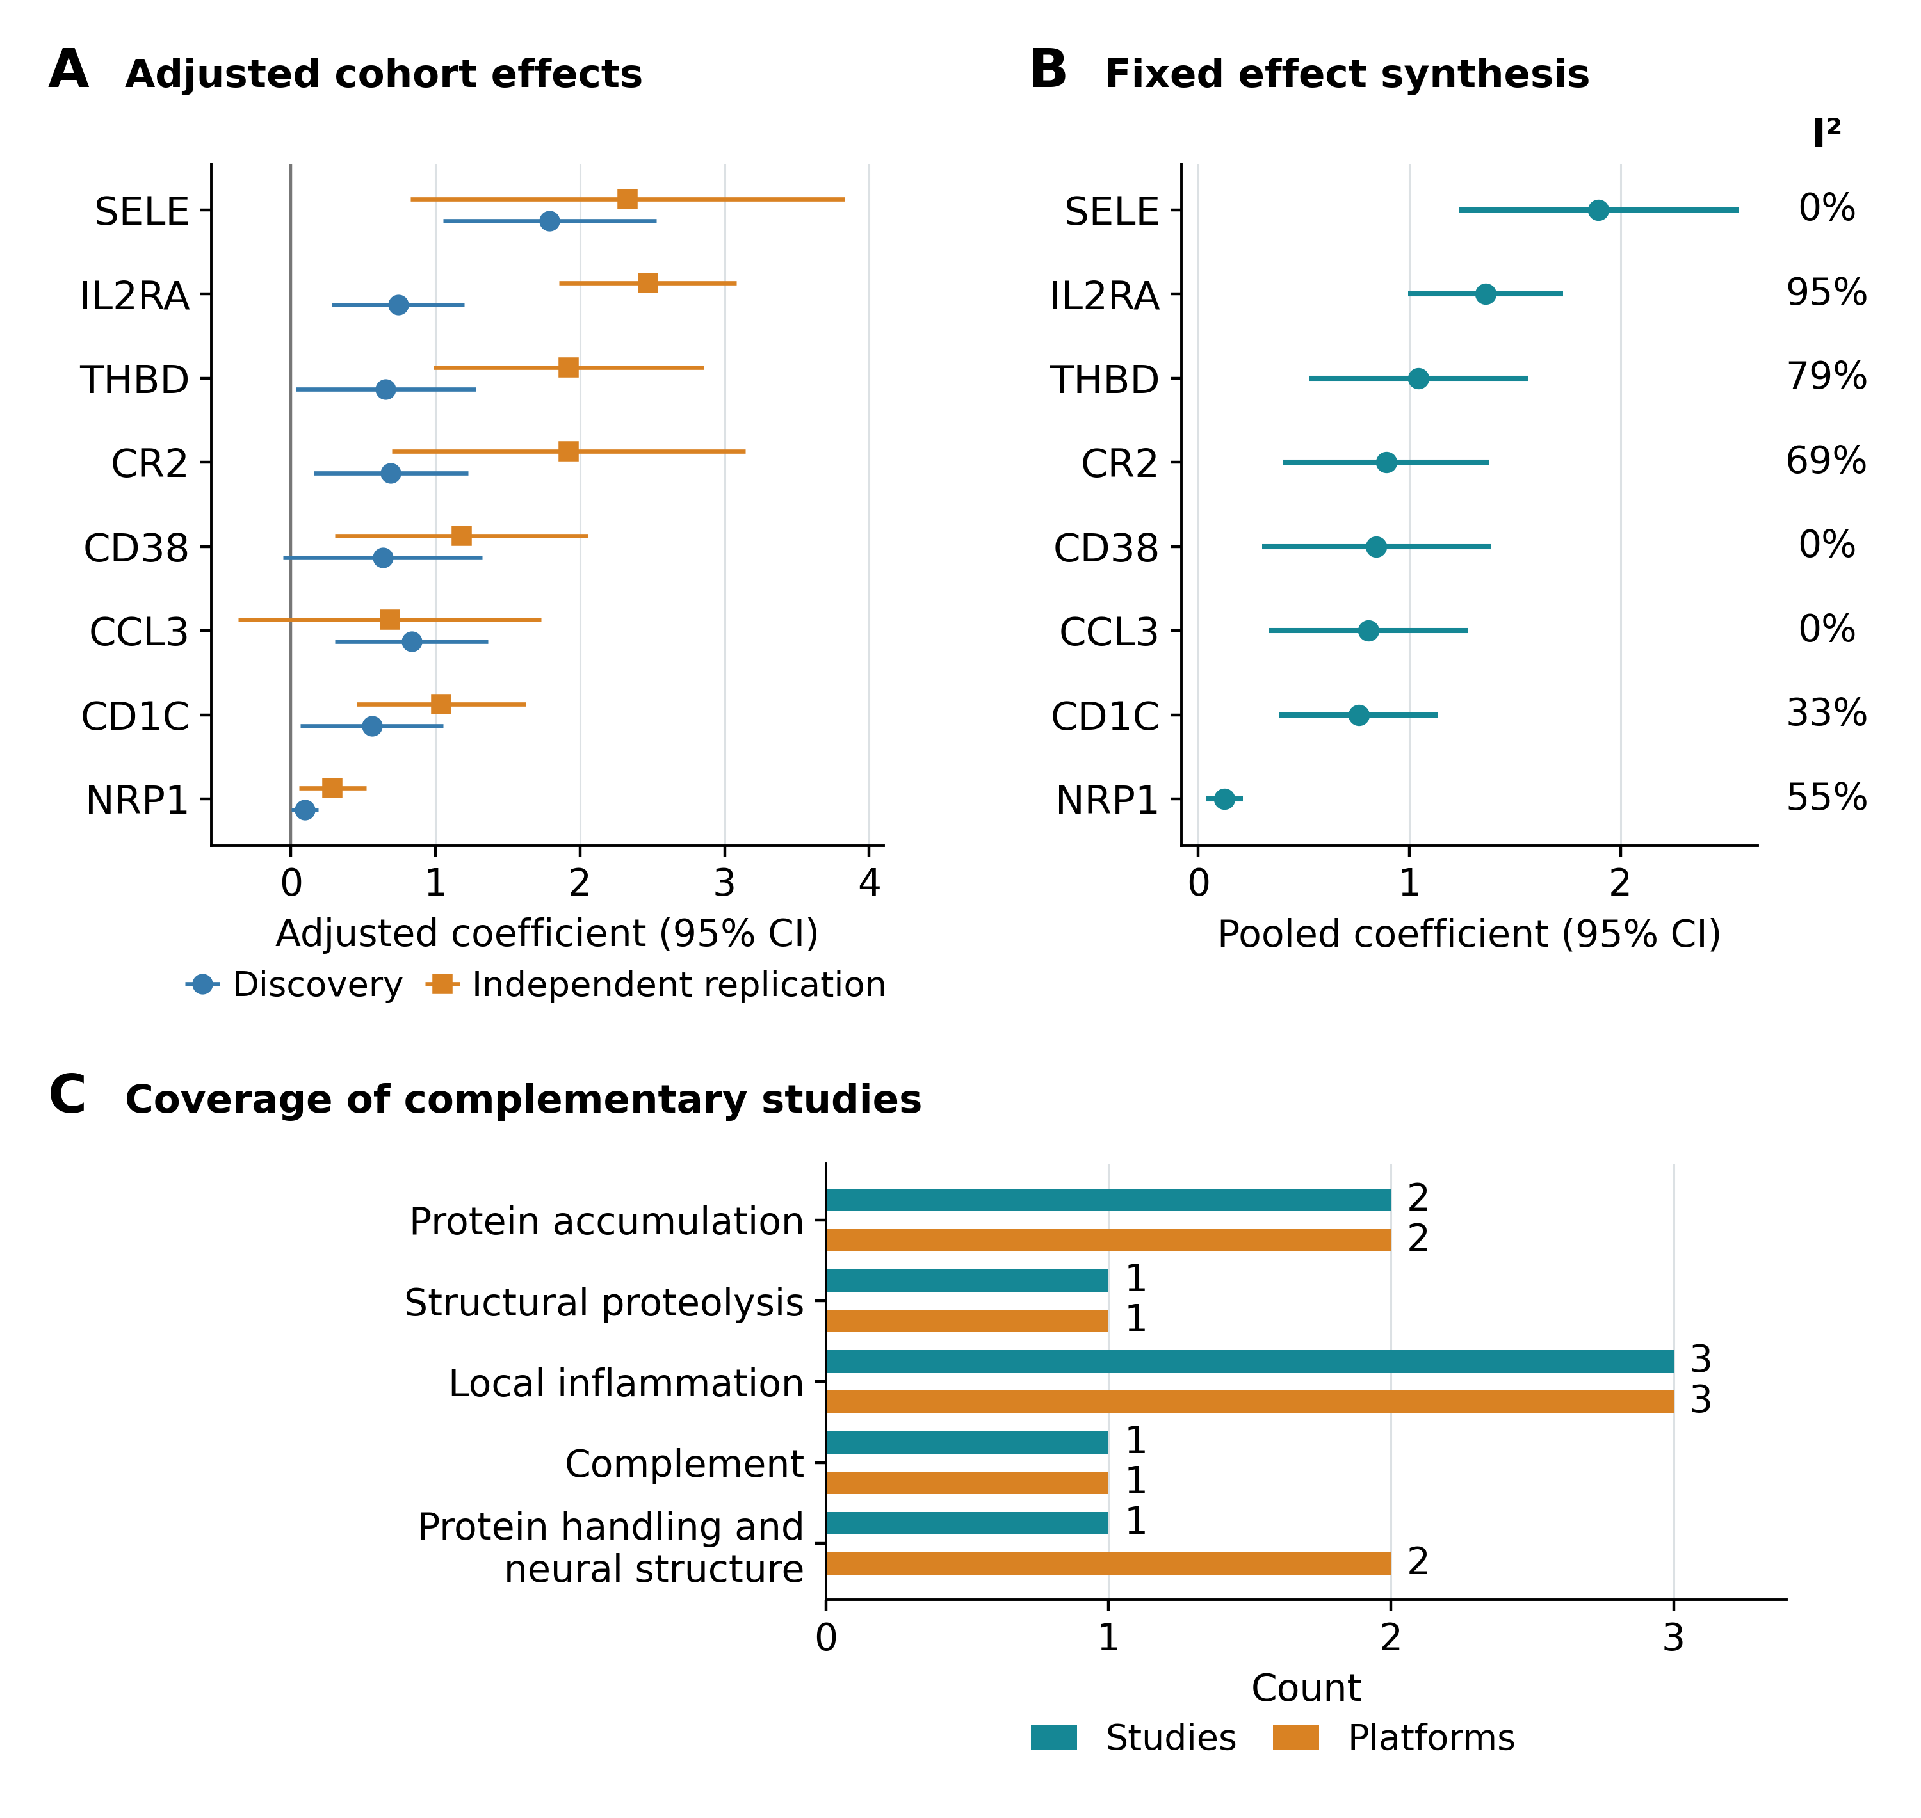
Figure 3. Synthesis of published CSF protein estimates and coverage of complementary studies. (A) Adjusted coefficients and 95% confidence intervals extracted from the independent Olink discovery and replication cohorts of Kmezic et al. [37]. Age, sex and sample handling were adjusted in the source study. (B) Inverse variance fixed effect estimates calculated in the present study for the eight proteins with coefficients and standard errors available in both cohorts. I² describes heterogeneity between cohorts. (C) Counts of distinct studies and assay platforms in each biological category among four complementary CSF reports [26,34-36]. Panel C summarizes descriptive coverage and does not represent pooled effects or statistical validation.
CIDP nerve shows more pronounced changes in cell state than in cellular abundance
The sural nerve atlas identified the cells expressing the integrated programs within peripheral nerve. Macrophages expressed C3, C3AR1 and FCGR2A, while endoneurial endothelial cells expressed CLDN5, ICAM1, VCAM1, LIFR, IL6ST and OSMR. Schwann cell states expressed gp130 receptor components together with genes involved in myelin, stress and repair. Granulocytes showed the strongest CXCR1 and CXCR2 signal. This distribution places macrophages among the potential effectors of humoral injury, endothelial cells at the interface for immune trafficking and Schwann cells in the response to damage and repair (Fig. 4A).
The independent BNB reference supported the vascular expression pattern observed in the nerve atlas. Endoneurial microvessels obtained by laser capture and cultured endoneurial endothelial cells expressed CLDN5, OCLN, TJP1, CDH5 and VWF, together with LIFR, IL6ST, ICAM1 and C3. The expression of junctional genes alongside cytokine receptors, complement and adhesion genes is consistent with a role for the human BNB in responding to immune signals as well as maintaining a structural barrier.
The clearest difference between CIDP and CIAP was a lower macrophage Fc receptor gene module score in CIDP (delta mean z=-0.673, P=0.0011, FDR=0.0087). Macrophage module scores for leukocyte transmigration (delta z=-0.345, P=0.0185, FDR=0.074) and macrophage state (delta z=-0.368, P=0.0334, FDR=0.089) were also lower, but neither met the FDR criterion. In the perineurial cell group, scores for the macrophage state gene module (delta z=0.758, P=0.0227) and complement module (delta z=0.348, P=0.0334) were higher, with an FDR of 0.109 for both. The BNB endothelial identity module score was nominally lower in CIDP (delta z=-0.404, P=0.0276, FDR=0.221). These estimates describe gene module expression within the annotated cell groups.
The lower macrophage Fc receptor module score distinguishes the CIDP transcriptional profile from that of CIAP, a comparator characterized by axonal injury and phagocyte recruitment. The accompanying nominal differences in perineurial and endothelial scores suggest possible variation in the organization of immune responses within nerve, but require confirmation because they did not meet the FDR criterion.
Differences in cellular composition were less pronounced. No cell group showed an abundance difference that met the FDR criterion. The largest numerical increases were observed in nonmyelinating Schwann cells (+0.064), endoneurial stroma (+0.027) and myelinating Schwann cells (+0.013), with FDR=0.515 for each. The predominant CIDP findings therefore concerned transcriptional changes within macrophage, endothelial, perineurial and Schwann cell states, with limited evidence of altered overall cellular composition.
Correlations calculated across the nine CIDP donors provided clinical context for the tissue findings. The myelin repair module score in Schwann cells in the repair and damage state showed the strongest association with INCAT disability (rho=0.840, P=0.0046, FDR=0.069). The BNB endothelial LIF module score showed a weaker positive association (rho=0.602, P=0.086). Neither association met the FDR criterion. They therefore describe exploratory relationships between gene expression and neurological impairment.
Across the analyses of localization, gene modules, cellular composition and disability, the macrophage Fc receptor module showed the clearest difference between diagnoses after correction for multiple testing. The Schwann cell myelin repair module showed the closest association with disability, although this association did not meet the FDR criterion.
Published tissue observations provided complementary evidence on the BNB. Stascheit et al. reported C5b-9 deposition on endoneurial capillaries in 52 of 55 biopsies from patients with CIDP or its variants [48]. From that published count, we calculated a proportion of 94.5% and a Wilson 95% CI of 85.1% to 98.1%. The accompanying observations of CD68-positive macrophages, CD8-positive T cells and increased C3 and C6 abundance were taken from the source report. This evidence provides histological and proteomic context for the nerve findings, without constituting a new analysis of biopsy specimens or replication in a second single nucleus dataset (Supplementary Fig. S2).
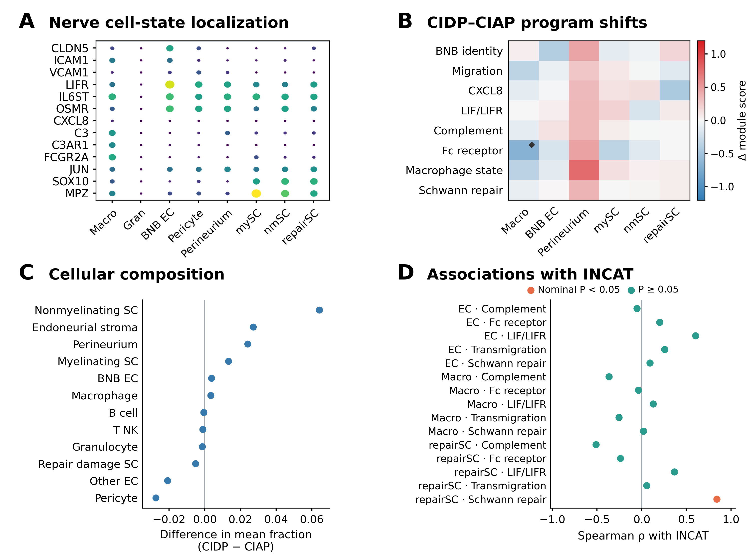
Figure 4. Barrier, immune and repair gene modules in CIDP nerve. (A) Expression across nerve cell states. Dot size indicates detection and color indicates scaled mean expression. (B) Differences in donor gene module scores between CIDP and CIAP. Diamonds indicate FDR<0.05 within a cell group. (C) Differences in mean cell fractions, calculated as CIDP minus CIAP, with donors analyzed as independent samples. Group comparisons in B and C used unadjusted Mann-Whitney U tests. (D) Spearman associations between donor module scores and INCAT disability. Orange indicates nominal P<0.05 and teal indicates P>=0.05. None of the associations in D met the FDR criterion. BNB EC refers to endoneurial microvascular endothelial cells.
Endothelial, macrophage and Schwann cell programs vary together among CIDP donors
Across the nine CIDP donors, the BNB endothelial LIF module score correlated positively with the endothelial leukocyte transmigration score (rho=0.667, P=0.0499, FDR=0.166) and the myelin repair score in Schwann cells in the repair and damage state (rho=0.783, P=0.0125, FDR=0.125). The endothelial leukocyte transmigration score also correlated with the macrophage complement score (rho=0.683, P=0.0424, FDR=0.166). These correlations were calculated from scores paired by donor. None remained significant after correction across the ten module pairs, so the observed directions provide exploratory evidence that endothelial, myeloid and glial transcriptional responses may vary together among patients.
The integrated map related these tissue findings to the blood and CSF results. CXCL8 recruitment and complement gene modules showed recurrent effects in blood, corresponding processes were represented in published CSF findings, and related genes localized to myeloid or endothelial cells in nerve. The Fc receptor module score was higher in acute whole blood than in healthy controls but lower in CIDP macrophages than in CIAP macrophages. Endothelial adhesion and Schwann cell repair genes were concentrated in nerve, while published CSF evidence contributed information on protein accumulation and proteolysis of axonal domains. The map thus relates findings across independently sampled compartments without demonstrating a temporal sequence (Fig. 5 and Table 3).
Table 3. Evidence map across blood, CSF and peripheral nerve
Program | Blood evidence | CSF evidence | Peripheral nerve evidence | Interpretation
CXCL8 recruitment | Positive in all 3 cohorts, with whole blood FDR<0.05 | Published innate immune and inflammatory protein findings | Myeloid localization and endothelial trafficking context | Shared recruitment hypothesis
Complement | Positive in all 3 cohorts, with whole blood FDR<0.01 | Published complement protein findings | Macrophage localization | Humoral amplification across compartments
Fc receptor | Whole blood FDR<0.05, with mixed directions across cohorts | Not directly evaluated | Macrophage module FDR=0.0087 | Clearest corrected difference in nerve
Interferon response | Whole blood FDR<0.05, with mixed directions across cohorts | Published evidence of antiviral defense | Macrophage, endothelial and Schwann cell states | Response varies by compartment
Endothelial adhesion | Positive blood direction | Not directly evaluated | ICAM1 and VCAM1 localization to BNB endothelial cells | BNB as a potential site of signal reception
Schwann repair | Not evaluated | Published evidence of axonal domain peptide degradation | Repair and stress programs localized to Schwann cells | Proposed link between structural injury and repair
The evidence map preserves the anatomical context and level of inference for each measurement. It brings together complementary observations on immune recruitment in blood, molecular injury in CSF and repair responses in peripheral nerve.
CIDP genetic candidates localize to Schwann cells, immune cells and BNB endothelium
Four candidates from the published study of Du et al. were selected for nerve cell localization [33]. CDH4 was supported by the locus reported in women at 20q13.33, while DIRAS1, GNG7 and SLC39A3 were selected from the reported Mendelian randomization and colocalization findings. Figure 5C summarizes these published estimates as the basis for candidate selection.
Analysis of individual donors in GSE285983 localized these candidates to different nerve cell states. CDH4 expression was highest in nonmyelinating Schwann cells and Schwann cells in the repair and damage state. GNG7 expression was strongest in B cells and was also detected in macrophages and BNB endothelial cells. SLC39A3 expression was low, with its highest level in BNB endothelium, while DIRAS1 expression was sparse. Five thousand bootstrap resamples of donors supported the predominant localization of CDH4 to Schwann cells and GNG7 to B cells. Wide intervals for the sparsely expressed DIRAS1 and SLC39A3 genes indicated greater uncertainty (Supplementary Fig. S1). None of the four genes differed between CIDP and CIAP after FDR correction. The findings therefore identify cellular contexts for genetic susceptibility without establishing candidate gene expression as a biomarker of disease state (Fig. 5).
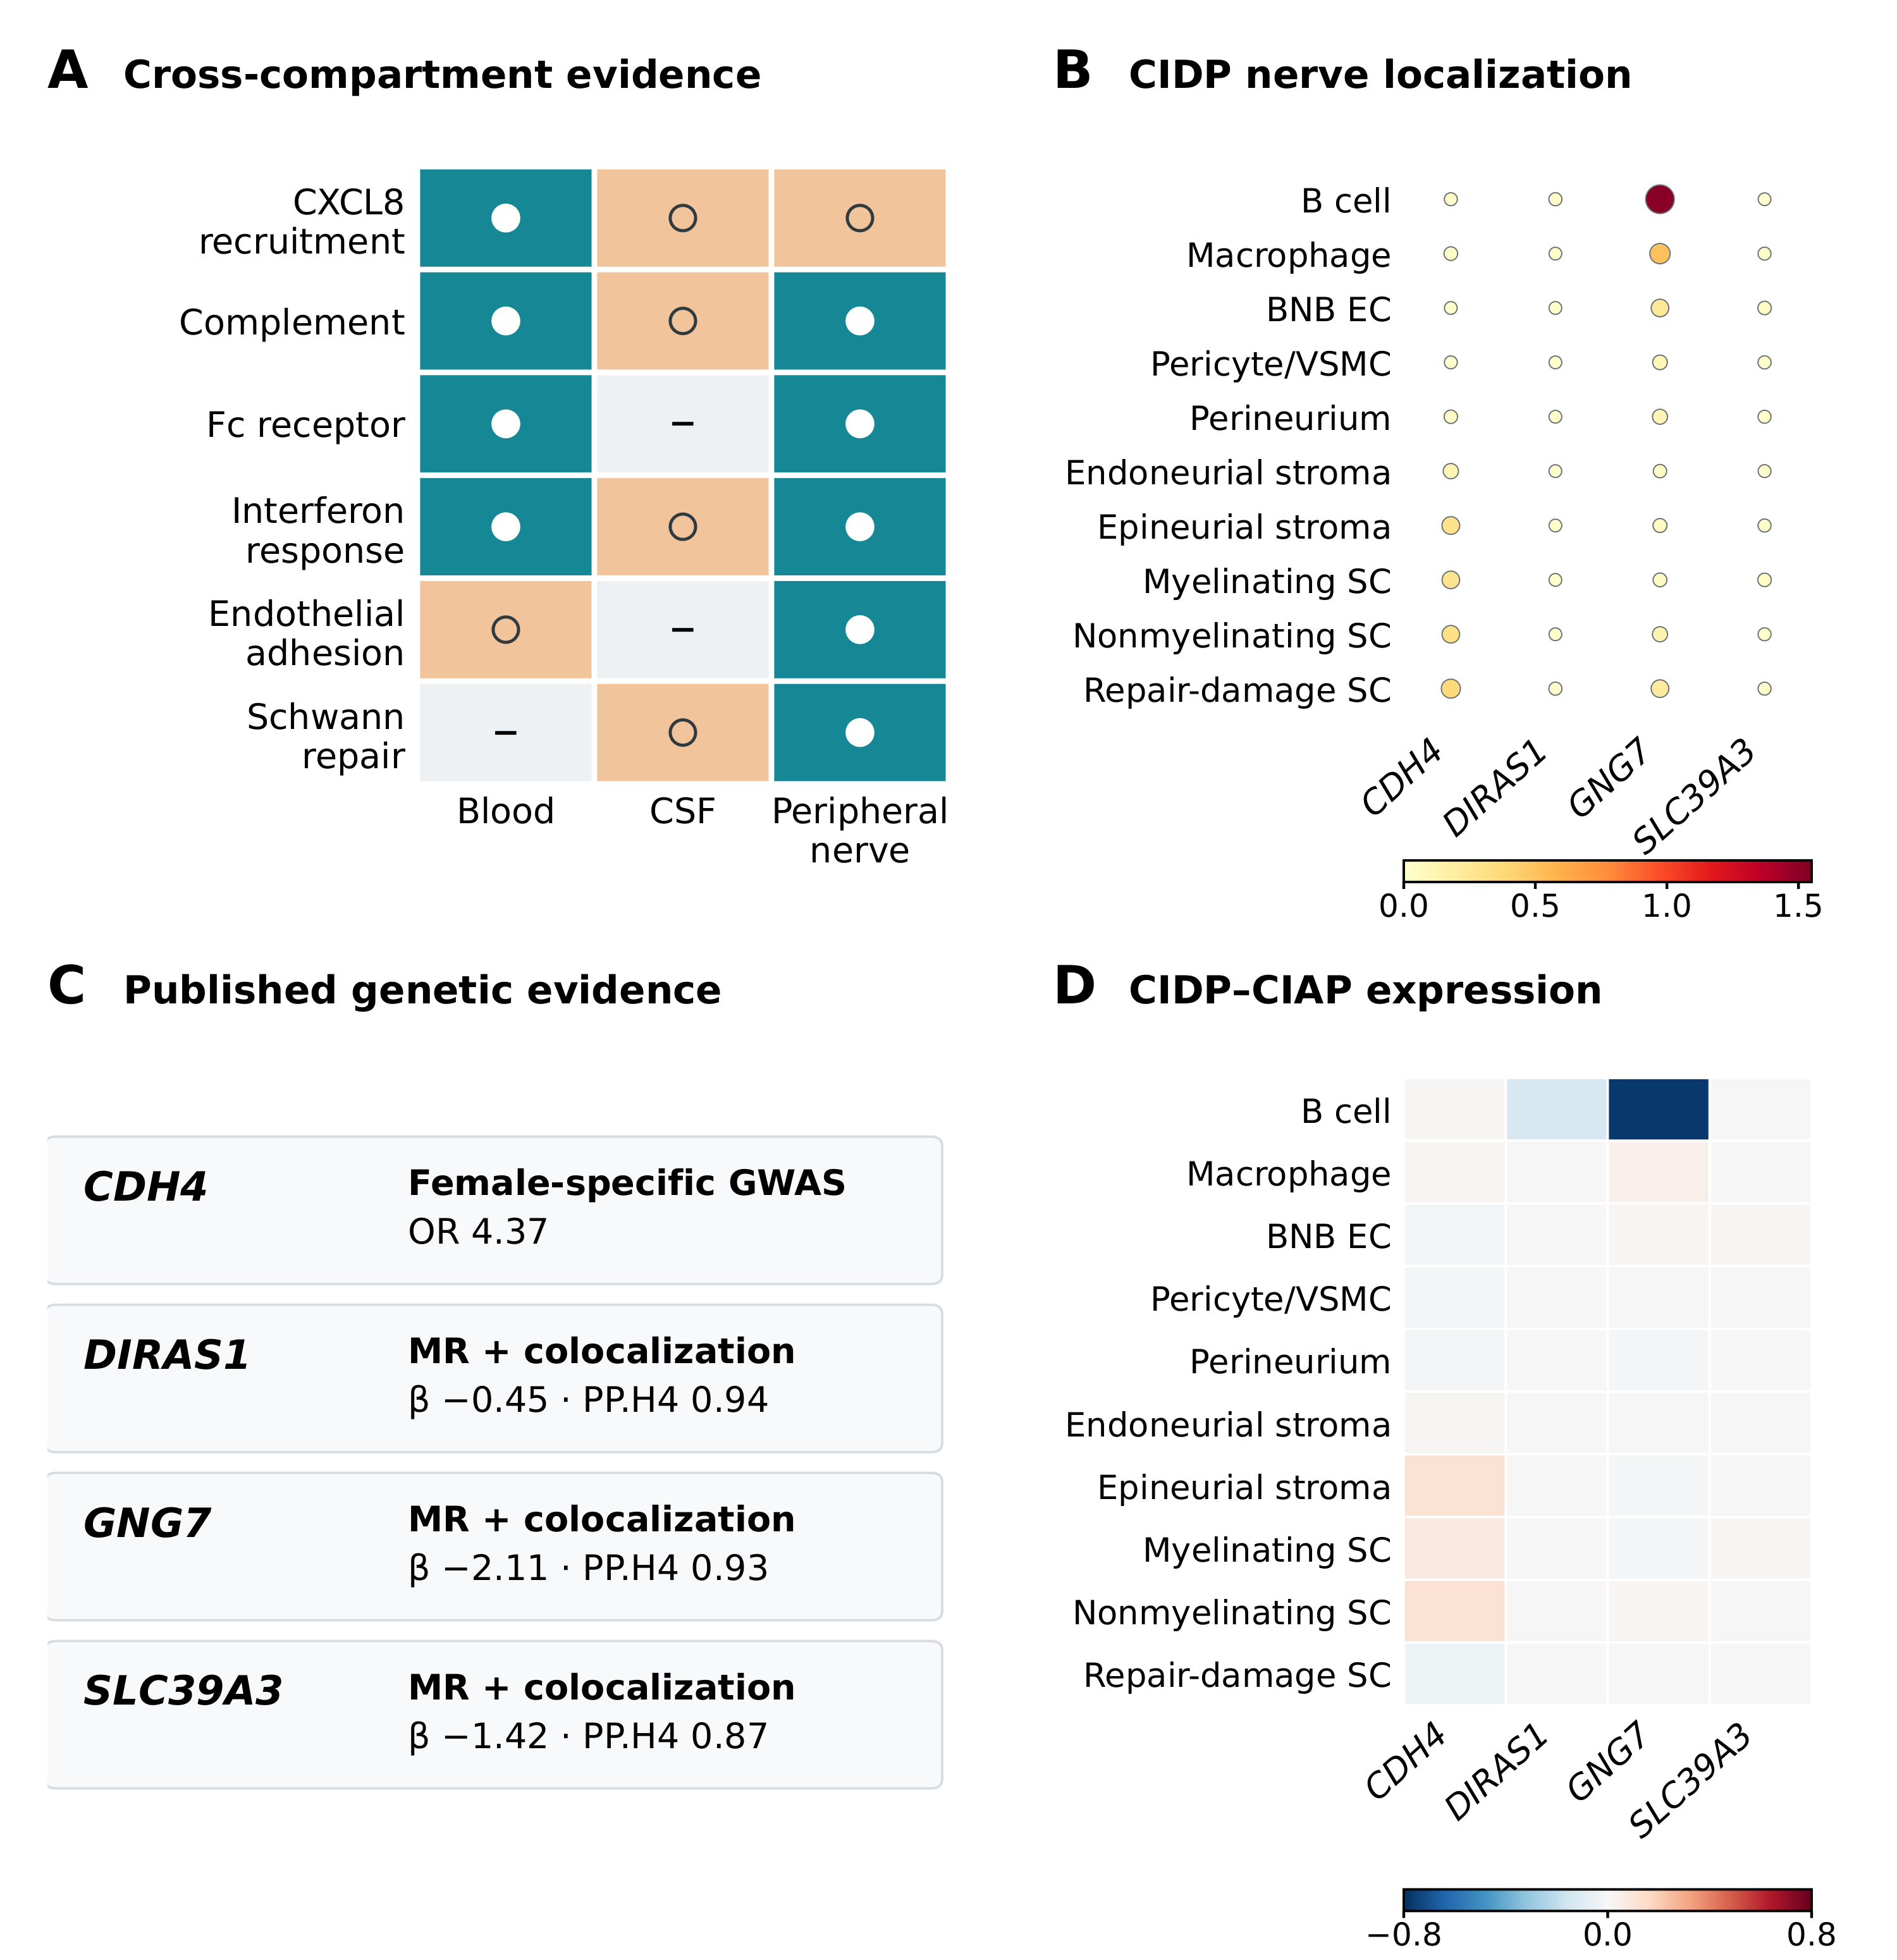
Figure 5. Immune programs across compartments and cellular localization of genetic candidates in inflammatory peripheral neuropathy. (A) Evidence map across blood, CSF and peripheral nerve. Filled circles indicate direct localization or evidence meeting the FDR criterion, open circles indicate recurrent directions or representation in published findings, and dashes indicate programs that were not evaluated. (B) Localization of CDH4, DIRAS1, GNG7 and SLC39A3 across CIDP nerve cell groups, calculated from donor expression summaries in this study. Dot size indicates the percentage of nuclei expressing each gene and color indicates mean log2(CP10k+1). (C) Genetic estimates reported by Du et al. [33], shown to explain candidate selection. These GWAS, Mendelian randomization and colocalization estimates were not recalculated. (D) Differences between CIDP and CIAP for the same genes and cell groups, calculated in this study from donor means of log2(CP10k+1) as CIDP minus CIAP. Red indicates higher expression in CIDP and blue indicates lower expression. None of the displayed comparisons met FDR<0.05. The color scales represent mean expression in B and differences between diagnoses in D.
Integration across compartments relates immune recruitment to proteolysis and repair
The integrated model places three features of inflammatory peripheral neuropathy in a common anatomical framework. Acute GBS blood shows higher expression of genes involved in recruitment and humoral responses. Published GBS CSF findings provide evidence of inflammation, protein accumulation and structural proteolysis, complemented by our synthesis of adjusted protein coefficients. CIDP nerve analyses localize immune and repair gene modules to macrophages, BNB endothelial cells, perineurium and Schwann cells. Published tissue observations provide additional context on C5b-9 deposition at endoneurial capillaries. Mapping previously reported genetic candidates to nerve cells identifies cellular contexts in which susceptibility can be investigated. These independently sampled compartments provide complementary evidence on related biological processes without establishing temporal progression from GBS to CIDP (Fig. 1).
Discussion
This study brings together acute GBS blood, GBS CSF and CIDP peripheral nerve data to describe how immune responses are organized across anatomical compartments. The analysis relates circulating immune recruitment to CSF inflammation and structural injury, and to the states of macrophages, BNB endothelial cells and Schwann cells within nerve. Integrating these three types of biospecimen, including single nucleus data from human sural nerve, helps distinguish recurrent inflammatory processes from responses concentrated in a particular disease or compartment. The resulting framework describes differences in the organization of related immune processes across blood, CSF and peripheral nerve. It does not imply biological progression from GBS to CIDP.
The blood findings illustrate why consistency across cohorts matters. GSE211225 showed a broad acute expression pattern involving chemotaxis, gp130 signaling, complement, Fc receptors, interferon and inflammatory monocytes. Synthesis across cohorts identified the CXCL8 recruitment and complement modules as the most recurrent findings, whereas LIF and OSM and Fc receptor module effects varied across whole blood, leukocyte and monocyte datasets. This pattern is consistent with published evidence of elevated IL-8 in GBS biofluids and the role of chemokines in leukocyte trafficking across human endoneurial endothelium [19,37,49-51].
CSF evidence provides information beyond blood transcription. Our synthesis identified concordant adjusted effects for eight proteins in two independent Olink cohorts, although heterogeneity distinguished relatively consistent signals from those that varied more between cohorts [37]. Kmezic et al. also reported associations between pretreatment CSF IL8 and GBS severity and follow-up disability, providing clinical context for the inflammatory findings [37]. The report linked to PXD002911 described 1,402 proteins and 2,355 endogenous peptide fragments in AIDP CSF, compared with 1,103 proteins and 774 fragments in controls. The reported overlap of 67% for the proteome and 21.5% for the peptidome suggests that peptide profiles capture information beyond protein identification [26]. Published findings of a complement C3 isoform, inflammatory proteins, and validated changes in APOC3, TGOLN2 and NCAM1 provide further context [34-36]. These observations support the biological interpretation of the new coefficient synthesis while retaining their status as findings from the original studies.
CSF and the BNB represent anatomically related but distinct environments. CSF reflects the milieu surrounding nerve roots and the neuraxis, whereas the BNB is formed by endoneurial microvascular endothelial cells within peripheral nerve. The findings support a working model in which endothelial activation at the BNB may influence the entry and local organization of circulating immune effectors. Their temporal relationship to systemic recruitment, CSF inflammation and tissue remodeling remains unresolved because the compartments were sampled in independent cohorts. Paired blood and CSF samples, endothelial permeability assays and spatial profiling of nerve tissue will be needed to determine whether these processes are linked within individual patients.
The nerve findings distinguish transcriptional differences from changes in cell abundance. No cell fraction differed after FDR correction, yet the macrophage Fc receptor gene module score differed between CIDP and CIAP, with additional nominal differences in macrophage, BNB endothelial and perineurial modules. CIAP involves axonal injury and phagocyte recruitment, so the lower score in CIDP indicates a different macrophage expression profile rather than demonstrating generalized suppression or immune tolerance. Stascheit et al. reported C5b-9 deposition on endoneurial capillaries in 52 of 55 biopsies and additional evidence of C3, C6 and macrophage involvement [48]. This independent report supports complement involvement at the BNB through a different type of measurement, although it does not replicate the transcriptomic comparison or establish that the two observations occur together in the same patients. A separate study integrating several types of blood data identified B cell dysregulation and activation of CD8 effector cells in CIDP [30].
Among CIDP donors, the BNB endothelial LIF module score varied with endothelial leukocyte transmigration and Schwann cell myelin repair scores, while the transmigration score varied with the macrophage complement score. The Schwann cell myelin repair score also showed the closest association with INCAT disability. This positive association could reflect greater demand for repair in more severely injured nerves, an insufficient compensatory response or variation within the repair and damage state. It does not establish repair exhaustion or functional signaling between cell types. The correlations did not meet the FDR criterion. Their directions identify coordination between endothelial and Schwann cell transcriptional responses as a question for validation using multiplex imaging and ex vivo functional assays.
The genetic analysis adds cellular context to previously reported susceptibility findings. The GWAS, Mendelian randomization and colocalization estimates were supplied by Du et al. [33]. Our contribution was to examine expression of the selected genes across nerve cell populations and assess the stability of localization by resampling donors. CDH4 expression was consistently highest in nonmyelinating Schwann cells and states associated with repair, identifying cellular contexts in which the locus reported in women could be investigated. GNG7 expression was strongest in B cells, with additional expression in macrophages and BNB endothelial cells. These patterns can guide the choice of cells for perturbation studies, but do not demonstrate that GNG7 controls immune cell residence or that CDH4 regulates barrier integrity. Estimates for DIRAS1 and SLC39A3 remained less certain because expression was sparse. Complete summary statistics from the custom FinnGen CIDP study are available only on request. Functional studies in the relevant cell types are therefore the appropriate next step, rather than treating these candidates as established drug targets.
Limitations
Several limitations affect interpretation. The blood cohorts were small, resulting in wide confidence intervals for pooled effects. CXCL8 recruitment and complement modules retained positive directions when each cohort was omitted in turn, but each sensitivity analysis included only two studies. CSF synthesis was restricted to published adjusted coefficients for eight proteins, which limits generalization to the full proteome and may be influenced by selective reporting. Individual CSF matrices were unavailable for new differential, enrichment, stability or clinical analyses. Several pooled protein estimates also showed substantial heterogeneity. The descriptive CSF evidence map covers four selected reports and is not an exhaustive systematic review. Nerve analyses compared nine CIDP donors with CIAP donors rather than unaffected nerve. The reported module and cell fraction tests were unadjusted, so age, sex and collection center may confound the comparisons. Correlations among modules and with disability were exploratory and did not meet the FDR criterion. PXD056286 contributed published tissue observations and a newly calculated interval for the reported deposition proportion, rather than a second single cell dataset. Blood, CSF and nerve data came from independent cohorts, preventing inference about within-patient sequences, progression from GBS to CIDP or causal mediation by the BNB. Genetic estimates were taken from the source study, and independent GWAS, MAGMA, Mendelian randomization, colocalization and TWAS analyses were not performed. Donor bootstrap analysis characterizes uncertainty in expression localization but does not establish gene function. No new tissue or experimental validation was performed. Prospective studies with paired biofluid and nerve samples, followed by perturbation of candidates in relevant cell types and functional BNB assays, are needed to test the proposed framework.
Conclusions
The findings describe complementary features of inflammatory peripheral neuropathy across anatomical compartments. Acute GBS blood shows systemic recruitment and humoral activity, GBS CSF reflects inflammation, complement activity and structural injury, and CIDP nerve shows responses involving BNB endothelial cells, macrophages and Schwann cells. Mapping published CIDP susceptibility signals to Schwann cells, B cells, macrophages and BNB endothelial cells identifies combinations of genes and cell types to prioritize for mechanistic studies. This framework is intended to guide functional validation rather than establish immediate drug targets.
List of abbreviations
AIDP, acute inflammatory demyelinating polyradiculoneuropathy, BNB, blood-nerve barrier, CIAP, chronic idiopathic axonal polyneuropathy, CIDP, chronic inflammatory demyelinating polyradiculoneuropathy, CSF, cerebrospinal fluid, FDR, false discovery rate, GBS, Guillain-Barré syndrome, MS, multiple sclerosis, PBMC, peripheral blood mononuclear cell.
Declarations
Ethics approval and consent to participate
This study reanalyzed publicly available human datasets from which identifying information had been removed. No participants were recruited and no new specimens were collected. The original studies reported ethics approval and informed consent. No additional institutional review board approval was required for this secondary analysis.
Consent for publication
Not applicable.
Availability of data and materials
This study used public transcriptomic data and published proteomic and genetic results. Dataset identifiers, original input filenames and access links are listed in Additional file 1, together with aggregate results underlying the figures and tables. Processing details and requirements for reconstructing donor-level intermediate tables are provided in Additional file 2.
Code availability
Analysis scripts are available in the study repository at https://github.com/applepie567/gbs-cidp-blood-nerve-barrier. Archive information and the scope of the reproducibility materials are described in Additional file 2.
Competing interests
The authors declare that they have no competing interests.
Funding
This work was supported by the Henan Medical Science and Technology Talent Overseas Training Program (HNMOT2024022) and the Henan Provincial Medical Science and Technology Research Program (LHGJ20250063 and SBGJ202401001).
Authors’ contributions
YF conceived the study, developed the analytical framework, performed the analyses and drafted the manuscript. FF curated data, validated results and revised the manuscript. SXM contributed to validation, interpretation and manuscript revision. SMF contributed to data curation, literature evaluation and manuscript revision. CJ supervised the methodology and critically revised the manuscript. YH supervised the study, coordinated the project and critically revised the manuscript. All authors read and approved the final manuscript.
Acknowledgements
We thank the participants and investigators who generated and shared the public datasets used in this study.
Authors’ information
Not applicable.
Additional files
Additional file 1 (.xlsx): Aggregate source data, dataset and original-input access information, and a figure and table index.
Additional file 2 (.docx): Reproducibility appendix describing processing methods, source attribution, the software environment and requirements for donor-level reconstruction.

Supplementary figures
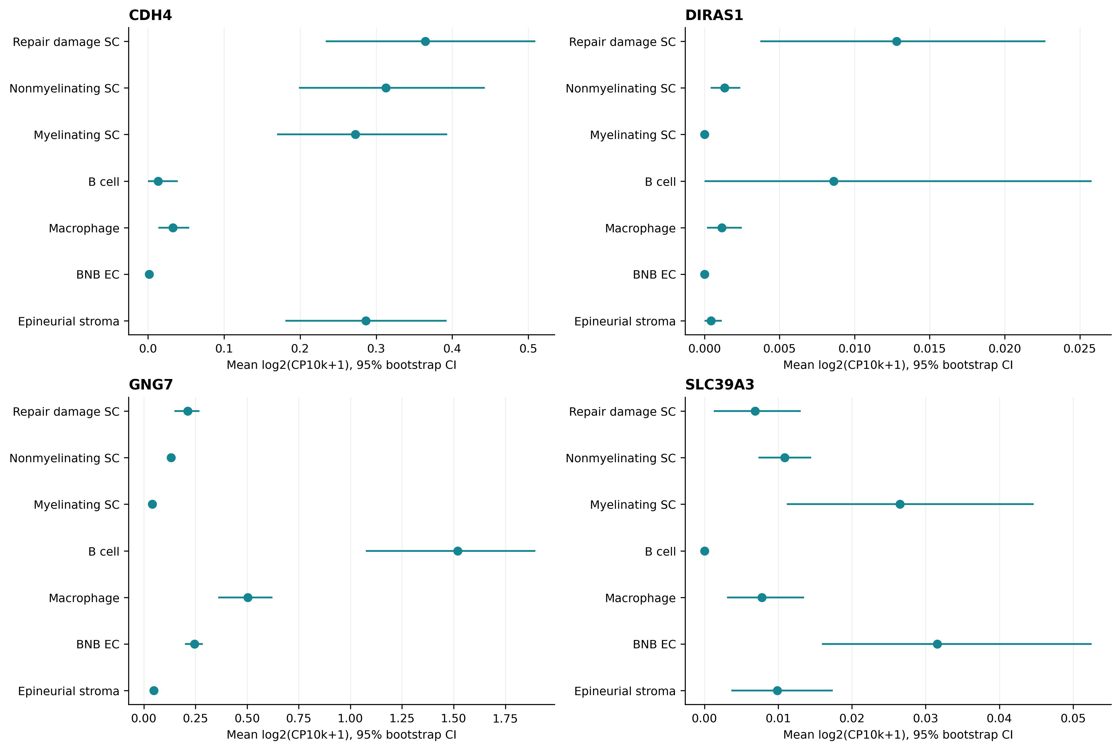
Supplementary Figure S1. Stability of CIDP genetic candidate localization assessed by bootstrap resampling of donors. Candidate genes were selected from published genetic evidence. Points show mean log2(CP10k+1) calculated across CIDP donors, and bars show 95% intervals calculated from 5,000 resamples in this study. The localization analysis is descriptive and does not establish mediation.
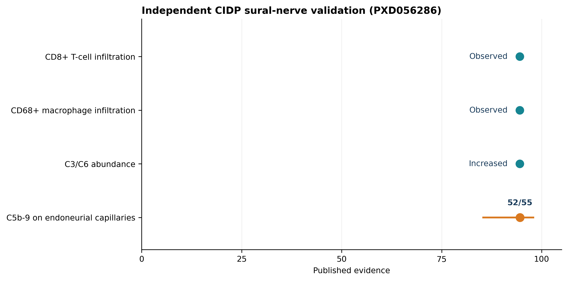
Supplementary Figure S2. Published CIDP tissue evidence and a calculated interval for complement deposition. Stascheit et al. reported C5b-9 deposition on endoneurial capillaries in 52 of 55 biopsies, increased C3 and C6 abundance, and infiltration of CD68-positive macrophages and CD8-positive T cells [48]. The proportion and 95% Wilson binomial interval were calculated in the present study from the published count. The remaining observations summarize qualitative findings from the source study associated with PXD056286.
References
1. Willison HJ, Jacobs BC, van Doorn PA. Guillain-Barré syndrome. Lancet. 2016,388:717-727. doi:10.1016/S0140-6736(16)00339-1.
2. van Doorn PA, Van den Bergh PYK, Hadden RDM, et al. European Academy of Neurology/Peripheral Nerve Society guideline on diagnosis and treatment of Guillain-Barré syndrome. Eur J Neurol. 2023,30:3646-3674. doi:10.1111/ene.16073.
3. Van den Bergh PYK, van Doorn PA, Hadden RDM, et al. European Academy of Neurology/Peripheral Nerve Society guideline on CIDP: second revision. Eur J Neurol. 2021,28:3556-3583. doi:10.1111/ene.14959.
4. Quast I, Cueni F, Nimmerjahn F, Tackenberg B, Lünemann JD. Deregulated Fcγ receptor expression in patients with CIDP. Neurol Neuroimmunol Neuroinflamm. 2015,2:e148. doi:10.1212/NXI.0000000000000148.
5. Hafer-Macko CE, Sheikh KA, Li CY, et al. Immune attack on the Schwann cell surface in acute inflammatory demyelinating polyneuropathy. Ann Neurol. 1996,39:625-635. doi: 10.1002/ana.410390512.
6. Koike H, Nishi R, Ikeda S, et al. Ultrastructural mechanisms of macrophage-induced demyelination in CIDP. Neurology. 2018,91:1051-1060. doi: 10.1212/WNL.0000000000006625.
7. Susuki K, Rasband MN, Tohyama K, et al. Anti-GM1 antibodies cause complement-mediated disruption of sodium channel clusters. J Neurosci. 2007,27:3956-3967. doi: 10.1523/JNEUROSCI.4401-06.2007.
8. Kiefer R, Kieseier BC, Stoll G, Hartung HP. The role of macrophages in immune-mediated damage to the peripheral nervous system. Prog Neurobiol. 2001,64:109-127. doi: 10.1016/s0301-0082(00)00060-5.
9. Shen D, Chu F, Lang Y, et al. Beneficial or harmful role of macrophages in Guillain-Barré syndrome and experimental autoimmune neuritis. Mediators Inflamm. 2018,2018:4286364.doi: 10.1155/2018/4286364.
10. Wolbert J, Li X, Heming M, et al. Redefining the heterogeneity of peripheral nerve cells in health and autoimmunity. Proc Natl Acad Sci USA. 2020,117:9466-9476. doi: 10.1073/pnas.1912139117.
11. Arthur-Farraj PJ, Latouche M, Wilton DK, et al. c-Jun reprograms Schwann cells of injured nerves to generate a repair cell essential for regeneration. Neuron. 2012,75:633-647. doi: 10.1016/j.neuron.2012.06.021.
12. Jessen KR, Mirsky R. The repair Schwann cell and its function in regenerating nerves. J Physiol. 2016,594:3521-3531. doi: 10.1113/JP270874.
13. Napoli I, Noon LA, Ribeiro S, et al. A central role for ERK signaling in controlling Schwann cell plasticity and peripheral nerve regeneration. Neuron. 2012,73:729-742. doi: 10.1016/j.neuron.2011.11.031.
14. Dowsing BJ, Morrison WA, Nicola NA, et al. Leukemia inhibitory factor is an autocrine survival factor for Schwann cells. J Neurochem. 1999,73:96-104. doi: 10.1046/j.1471-4159.1999.0730096.x.
15. Chen Q, et al. Leukemia inhibitory factor regulates Schwann-cell proliferation and migration. Cell Death Dis. 2021,12:417. doi: 10.1038/s41419-021-03706-8.
16. Ubogu EE. Biology of the human blood-nerve barrier in health and disease. Exp Neurol. 2020,328:113272. doi:10.1016/j.expneurol.2020.113272.
17. Palladino SP, Helton ES, Jain P, et al. The human blood-nerve barrier transcriptome. Sci Rep. 2017,7:17477. doi:10.1038/s41598-017-17475-y.
18. Yosef N, Ubogu EE. Development and characterization of a novel human in vitro blood-nerve barrier model. J Neuropathol Exp Neurol. 2010,69:82-97. doi:10.1097/NEN.0b013e3181c84a9a.
19. Yosef N, Ubogu EE. αMβ2-integrin-ICAM1 interactions drive flow-dependent trafficking of GBS leukocytes at the BNB. J Cell Physiol. 2012,227:3857-3875. doi:10.1002/jcp.24100.
20. Dong C, Greathouse KM, Beacham RL, et al. Fibronectin connecting segment-1 peptide inhibits pathogenic leukocyte trafficking in experimental CIDP. Exp Neurol. 2017,292:35-45. doi:10.1016/j.expneurol.2017.02.012.
21. Langert KA, Von Zee CL, Stubbs EB Jr. TNF-α enhances CCL2 and ICAM1 expression in peripheral nerve endoneurial endothelial cells. ASN Neuro. 2013,5:e00104. doi:10.1042/AN20120048.
22. Kanda T, Numata Y, Mizusawa H. Chronic inflammatory demyelinating polyneuropathy: decreased claudin-5 and relocated ZO-1. J Neurol Neurosurg Psychiatry. 2004,75:765-769. doi:10.1136/jnnp.2003.025692.
23. Lima MFO, Nogueira VB, Maury W, et al. Altered cellular pathways in the blood of patients with Guillain-Barré syndrome. J Peripher Nerv Syst. 2025,30:e70012. doi:10.1111/jns.70012.
24. Chang KH, Chuang TJ, Lyu RK, et al. Identification of gene networks and pathways associated with Guillain-Barré syndrome. PLoS One. 2012,7:e29506. doi:10.1371/journal.pone.0029506.
25. Shi P, Diao Y, Yang H, Li R, Ye M, Liu D, Nian D. Single cell transcriptome profiling of peripheral blood mononuclear cells in Guillain-Barré syndrome patients. Sci Data. 2026,13:843. doi:10.1038/s41597-026-07489-5.
26. Ziganshin RH, Ivanova OM, Lomakin YA, et al. The pathogenesis of the demyelinating form of Guillain-Barré syndrome: proteo-peptidomic and immunological profiling of physiological fluids. Mol Cell Proteomics. 2016,15:2366-2378. doi:10.1074/mcp.M115.056036.
27. Heming M, Börsch AL, Wolbert J, et al. Multi-omic identification of perineurial hyperplasia and lipid-associated nerve macrophages in human polyneuropathies. Nat Commun. 2025,16:7872. doi:10.1038/s41467-025-62964-8.
28. Li M, et al. Single-cell analysis reveals novel clonally expanded monocytes associated with the IL1β-IL1R2 pair in AIDP. Sci Rep. 2023,13:5862. doi:10.1038/s41598-023-32427-5.
29. Xue Y, Yin P, Li G, Zhong D. Transcriptomes in rat sciatic nerves at different stages of experimental autoimmune neuritis. Clin Exp Immunol. 2019,198:184-197. doi:10.1111/cei.13354.
30. Kim H, Chun J, Cha DH, et al. Integrated peripheral immune profiling reveals B-cell dysregulation and CD8 effector signatures in CIDP. Front Immunol. 2026,17:1888882. doi:10.3389/fimmu.2026.1888882.
31. Richard A, Corvol JC, Debs R, et al. Transcriptome analysis of peripheral blood in CIDP identifies TNFR1 and TLR pathways in the IVIg response. Medicine. 2016,95:e3370. doi:10.1097/MD.0000000000003370.
32. Shimizu F, Sato R, Mizukami Y, et al. Blood-nerve barrier breakdown induced by immunoglobulin G in CIDP and multifocal motor neuropathy. Int J Mol Sci. 2026,27:1088. doi:10.3390/ijms27021088.
33. Du Z, et al. Genome-wide association study, Mendelian randomization, and colocalization analyses identify susceptibility genes for chronic inflammatory demyelinating polyneuropathy. HGG Adv. 2024,5:100317. doi:10.1016/j.xhgg.2024.100317.
34. D’Aguanno S, Franciotta D, Lupisella S, et al. Protein profiling of Guillain-Barré syndrome cerebrospinal fluid by two-dimensional electrophoresis and mass spectrometry. Neurosci Lett. 2010,485:49-54. PMID:20801190.
35. Ding J, Ren K, Wu J, et al. Proteomic analysis of cerebrospinal fluid identifies biomarkers for Guillain-Barré syndrome. Eur J Neurol. 2022,29:1155-1164. doi:10.1111/ene.15213.
36. Sun S, Li M, Song J, Zhong D. Using Olink proteomics to identify inflammatory biomarkers in the cerebrospinal fluid in Guillain-Barré syndrome. J Inflamm Res. 2025,18:6703-6717. doi:10.2147/JIR.S507515.
37. Kmezic I, Gustafsson R, Fink K, et al. Validation of elevated levels of interleukin-8 in the cerebrospinal fluid, and discovery of new biomarkers in patients with GBS and CIDP using a proximity extension assay. Front Immunol. 2023,14:1241199. doi:10.3389/fimmu.2023.1241199.
38. Higgins JPT, Thompson SG, Deeks JJ, Altman DG. Measuring inconsistency in meta-analyses. BMJ. 2003,327:557-560.
39. IntHout J, Ioannidis JPA, Borm GF. Hartung-Knapp-Sidik-Jonkman method for random effects meta-analysis. BMC Med Res Methodol. 2014,14:25. doi:10.1186/1471-2288-14-25.
40. Squair JW, Gautier M, Kathe C, et al. Confronting false discoveries in single-cell differential expression. Nat Commun. 2021,12:5692. doi:10.1038/s41467-021-25960-2.
41. Crowell HL, Soneson C, Germain PL, et al. muscat detects subpopulation-specific state transitions from multi-sample single-cell data. Nat Commun. 2020,11:6077. doi:10.1038/s41467-020-19894-4.
42. Benjamini Y, Hochberg Y. Controlling the false discovery rate. J R Stat Soc Series B. 1995,57:289-300.
43. Zimmerman KD, Espeland MA, Langefeld CD. A practical solution to pseudoreplication bias in single-cell studies. Nat Commun. 2021,12:738. doi:10.1038/s41467-021-21038-1.
44. Subramanian A, Tamayo P, Mootha VK, et al. Gene set enrichment analysis. Proc Natl Acad Sci USA. 2005,102:15545-15550.
45. Aitchison J. The statistical analysis of compositional data. J R Stat Soc Series B. 1982,44:139-177.
46. Jin S, Guerrero-Juarez CF, Zhang L, et al. Inference and analysis of cell-cell communication using CellChat. Nat Commun. 2021,12:1088. doi:10.1038/s41467-021-21246-9.
47. Browaeys R, Saelens W, Saeys Y. NicheNet: modeling intercellular communication by linking ligands to target genes. Nat Methods. 2020,17:159-162. doi:10.1038/s41592-019-0667-5.
48. Stascheit F, Roos A, Schroeter CB, et al. Complement profiling of sural nerves in chronic-inflammatory demyelinating polyneuropathy. Acta Neuropathol. 2025,150:32. doi:10.1007/s00401-025-02936-w.
49. Bréville G, Lascano AM, Roux-Lombard P, et al. Interleukin 8, a Biomarker to Differentiate Guillain-Barré Syndrome From CIDP. Neurol Neuroimmunol Neuroinflamm. 2021,8:e1031.doi: 10.1212/NXI.0000000000001031.
50. Heming M, Lohmann L, Schulte-Mecklenbeck A, et al. Immune cell profiling of CSF provides pathogenetic insights into inflammatory neuropathies. Front Immunol. 2019,10:515. doi:10.3389/fimmu.2019.00515.
51. Xia RH, Yosef N, Ubogu EE. Chemokine ligand-receptor expression in severe experimental autoimmune neuritis. Neuropathol Appl Neurobiol. 2010,36:388-398. doi:10.1111/j.1365-2990.2010.01092.x.

