Immune gene expression across blood, cerebrospinal fluid and nerve in inflammatory neuropathies
Yuan Feng¹, Fang Feng², Shuxiao Ma¹, Shuman Feng¹, Chao Jiang¹*, Yibin Hao¹*
¹ Department of Neurology, Henan Provincial People’s Hospital, People’s Hospital of Zhengzhou University, Zhengzhou 450003, China
² Department of Neurology, The First Affiliated Hospital of Zhengzhou University, Zhengzhou 450002, China
* Correspondence: Yibin Hao, haoyibin999@163.com, and Chao Jiang, chaoj@zzu.edu.cn. Postal address: No. 7 Weiwu Road, Jinshui District, Zhengzhou, Henan, China.
Running title: Immune expression in neuropathy
Article type: Original Article. Main text: 5292 words. Abstract: 296 words.
Display items: 5 main figures, 3 tables and 4 supplementary figures

Abstract
Inflammatory neuropathies are commonly studied in a single biospecimen, limiting understanding of systemic and tissue immune responses. We examined complementary evidence from blood, cerebrospinal fluid and peripheral nerve in Guillain–Barré syndrome and chronic inflammatory demyelinating polyradiculoneuropathy. Three acute blood transcriptomic cohorts were analysed using gene module scores and models with random effects. Published cerebrospinal fluid protein coefficients were combined using a model with a fixed effect. A sural nerve atlas was analysed at donor level, focusing on nine donors with chronic inflammatory demyelinating polyradiculoneuropathy and 11 with chronic idiopathic axonal polyneuropathy. Macrophage findings underwent exploratory demographic, composition and annotation sensitivity analyses. Published genetic candidates were mapped to nerve cell states. CXCL8 recruitment and complement modules had positive effects in all three blood cohorts, but pooled confidence intervals included zero: Hedges g 1.08 (95% confidence interval −0.63 to 2.78) and 1.11 (−1.73 to 3.95), respectively. Nine of ten selected cerebrospinal fluid proteins had positive coefficients in both cohorts and positive pooled effects after correction across ten tests. CD5 was discordant and its pooled effect was not significant. In nerve, the macrophage Fc receptor score was lower in the inflammatory neuropathy group after correction across eight modules within macrophages (q = 0.0087), but not across all 80 eligible module comparisons (q = 0.087). The association persisted after age and centre adjustment, but weakened when macrophage composition was included. No eligible refined macrophage subtype met its correction threshold. Intermodule and disability correlations also did not survive correction. Expression localization placed CDH4 predominantly in Schwann cell states and GNG7 in B cells, with expression in additional cell groups. These independently sampled datasets describe complementary expression patterns and an exploratory macrophage association that remains sensitive to analytical scope and composition. Independent cohorts and functional experiments are needed to establish biological mechanisms.
Keywords: neuroimmunology, endoneurial endothelium, pseudobulk analysis, proteomics, genetic susceptibility

Abbreviated summary
Feng et al. examine blood, cerebrospinal fluid and nerve expression in inflammatory neuropathies. A macrophage Fc receptor association persists after demographic adjustment but weakens after composition adjustment and broader multiple testing correction. These findings refine hypotheses for independent validation without establishing communication between compartments.

Abbreviations
AIDP, acute inflammatory demyelinating polyradiculoneuropathy. BNB, blood nerve barrier. CIAP, chronic idiopathic axonal polyneuropathy. CIDP, chronic inflammatory demyelinating polyradiculoneuropathy. CPM, counts per million. FDR, false discovery rate. GBS, Guillain–Barré syndrome. INCAT, Inflammatory Neuropathy Cause and Treatment. PBMC, peripheral blood mononuclear cell.

Introduction
Guillain–Barré syndrome (GBS) and chronic inflammatory demyelinating polyradiculoneuropathy (CIDP) differ in their clinical course and diagnostic criteria.^{1,2,3} Injury associated with antibodies, complement deposition and demyelination mediated by macrophages contribute to inflammatory neuropathy, with their relative importance varying by disease and subtype.^{4,5,6,7,8,9} Peripheral nerve cell atlases and experimental injury studies also identify distinct immune and Schwann cell responses.^{10,11,12,13} Leukemia inhibitory factor (LIF) can influence Schwann cell survival, proliferation and migration in experimental systems.^{14,15} These observations motivate examination of gene expression related to immune responses and repair across tissues, although a shared expression pattern does not establish a shared mechanism.
The blood nerve barrier (BNB) regulates exchange between the circulation and the endoneurium. Endoneurial endothelial junctions and associated mural cells contribute to its specialized properties.^{16,17,18} Experimental studies implicate leukocyte integrins, endothelial adhesion molecules and chemokines in trafficking across this interface.^{19,20,21} Altered junctional protein expression has also been described in CIDP nerve.²² The BNB is therefore a plausible site at which circulating immune responses interact with tissue injury and repair.
Blood transcriptomic studies characterize systemic immune expression in GBS across whole blood, leukocytes and peripheral blood mononuclear cells (PBMCs).^{23,24,25} CSF proteomics and peptidomics provide complementary measurements of inflammation and molecular injury, while nuclear transcriptomic data from nerve localize expression to annotated cell states.^{26,27} Other studies report monocyte changes in acute inflammatory demyelinating polyradiculoneuropathy (AIDP), peripheral immune alterations in CIDP and transcriptomic associations with treatment response.^{28,29,30} Experimental evidence that patient immunoglobulin can disrupt barrier properties further motivates investigation of the BNB.³¹ Human genetics supplies an additional route to candidate selection.³² However, findings from different diseases, sample types and cohorts cannot by themselves establish communication between compartments.
We aimed to assess the consistency of acute GBS blood gene modules across cohorts, synthesize selected published CSF evidence, and localize related immune and repair programs in CIDP nerve. We also mapped published CIDP genetic candidates to nerve cell states. Integration was descriptive and retained the distinct sampling units and evidence levels of each dataset.

Materials and methods

Study design and datasets
The study integrated human data from blood, CSF, peripheral nerve and genetic studies. GSE211225 contained six whole blood expression profiles from acute GBS, ten from the postacute phase and six from controls.²³ GSE31014 provided leukocyte microarrays from 7 patients with GBS and 7 controls.²⁴ PRJNA1293757 provided RNA sequencing data for individual PBMCs collected from 3 untreated patients with AIDP and 2 controls.²⁵ These three datasets were used to assess the consistency of blood findings across cohorts.
Published findings associated with PXD002911 provided CSF protein and endogenous peptide identifications by diagnostic group.²⁶ GSE285983 contained 365,708 nuclei from 37 sural nerves, including nine donors with CIDP and 11 with chronic idiopathic axonal polyneuropathy (CIAP).²⁷ The published GSE107574 BNB transcriptome supplied biological context. Its raw expression data were not independently reanalysed here.¹⁷ Genetic candidates were selected from the analyses of CIDP reported by Du et al., which included association testing across the genome, Mendelian randomization and colocalization.³² Additional CSF reports contributed descriptive evidence on complement, quantitative proteomics and inflammatory proteins.^{33,34,35} We extracted adjusted CSF coefficients from the independent Olink discovery and replication cohorts reported by Kmezic et al.³⁶ Published histological and proteomic findings associated with PXD056286 provided tissue context from 55 CIDP nerve biopsies.³⁷ Original resource names, accession identifiers, filenames and access links are consolidated in Supplementary Data 1.

Definition and scoring of biological programs
Seven blood gene modules covered CXCL8 recruitment through CXCR1 and CXCR2, LIF and oncostatin M (OSM) signalling through gp130, complement, Fc receptors, interferon signalling through JAK and STAT, inflammatory monocytes and transendothelial migration. Eight nerve modules covered BNB identity, leukocyte transmigration, CXCL8 recruitment, LIF signalling, complement, Fc receptors, macrophage state and Schwann cell myelin repair. Gene sets were specified in the analysis scripts. The study was not prospectively registered. Module scores summarize transcription of selected genes and were not interpreted as direct measurements of protein activity or cellular function. CSF features were assigned to biological categories using annotations from the source studies.

Analysis and synthesis of acute GBS blood cohorts
Within each blood cohort, gene expression was standardized across participants and averaged over available genes to obtain module scores. Differences between acute GBS and control groups were quantified using Hedges g. Exact label permutation tests assessed differences in mean scores, with P values calculated from both tails. Correction using the Benjamini and Hochberg procedure was applied across seven modules within each cohort comparison.³⁸ Effects from whole blood, leukocytes and monocyte pseudobulk were combined using exploratory models with random effects. Variance between studies was estimated using the method of DerSimonian and Laird. Intervals calculated using the modified Hartung and Knapp method used a residual variance scale bounded below by one and a t distribution with degrees of freedom equal to the number of cohorts minus one. Heterogeneity was summarized using τ² and I².^{39,40} We repeated each synthesis after omitting one cohort to assess direction and uncertainty using the two remaining cohorts. Differences in assay platform, cellular composition and available module genes limit interpretation of a common pooled effect. Postacute profiles were retained in the original preprocessing, but no inference about differences between disease phases is presented here because independence of donors across phases could not be verified from the archived design.

Synthesis of published GBS CSF proteomic evidence
CSF evidence was assembled from selected reports rather than a systematic literature review. For the quantitative synthesis, all ten CSF proteins other than IL8 with coefficients and standard errors in both cohorts of Table 4B in Kmezic et al. were eligible, irrespective of effect direction or statistical significance.³⁶ This corrected an earlier extraction that omitted IL6 and CD5. The source regressions adjusted for age, sex and sample handling. Pooled estimates were calculated using a model with a fixed effect and weighting by inverse variance. The 95% confidence intervals used a normal approximation, and correction using the Benjamini and Hochberg procedure covered ten pooled tests. Estimates calculated using the method of DerSimonian and Laird, Q and I² were reported as heterogeneity assessments. The normal approximation does not reproduce the tests used in the source regressions for small samples, and pooled significance does not establish significance in both cohorts. IL8, the source study’s separately reported primary biomarker in Table 3, was retained as contextual evidence. The selected table does not contain the full assayed proteome. Published identifications and annotations from PXD002911 and three other reports were recorded in a descriptive evidence map.^{26,33,34,35} Counts of reports and platforms describe coverage of these four studies, not effect magnitude or statistical strength. No CSF matrix containing data for individual participants was reconstructed or reanalysed.

Pseudobulk analysis by donor and cell state in CIDP nerve
Nuclei from GSE285983 were grouped by donor and annotated cell state. Focused groups included macrophages, T and natural killer cells, B cells, granulocytes, endoneurial endothelial cells, other endothelial cells, pericytes, perineurium, endoneurial stroma and Schwann cells in myelinating, nonmyelinating and repair and damage states. A cell group was eligible for a given donor if it contained at least 20 nuclei. Counts were summed within each group and transformed as log2(CPM + 0.5), using counts across all genes for the library size. Donors were the biological replicates for comparisons between CIDP and CIAP.^{41,42,43}

Gene module scores and cellular composition
Within each cell group, each gene was standardized across eligible donors from all diagnostic categories. Module scores were means of the available gene z scores. CIDP and CIAP were compared using the U test of Mann and Whitney with two tails. Effect estimates were calculated as mean CIDP scores minus mean CIAP scores. The original correction using the Benjamini and Hochberg procedure covered eight modules within each cell group. We additionally evaluated correction across all 80 eligible module comparisons for the CIDP versus CIAP contrast. Donor cell fractions were compared separately, with correction across cell groups. Because fractions are compositional, these comparisons describe relative representation.⁴⁴
The macrophage Fc module contained 11 measured genes from 12 specified genes because FCGR2C was absent. We examined individual genes with correction across 11 tests and four functional summaries with a separate correction. Sensitivity analyses restricted the comparison to male donors, standardized expression within the 20 case and comparator donors, adjusted for age and centre, and additionally included sex. Linear model intervals used HC3 covariance and residual degrees of freedom. An exact permutation test preserved the observed number of CIDP donors within each centre. Details are provided in Supplementary Methods.
Original macrophage annotations were joined to the refined immune annotations by nucleus barcode. We retained unmatched and reassigned categories when describing composition. A sensitivity model added the first two principal components of donor composition, represented as centred log ratios, to age and centre. Raw count matrices for all 20 CIDP and CIAP donors were reaggregated under alternative macrophage definitions. Refined subtype tests required at least 20 nuclei per donor and at least three donors per diagnosis. Correction covered all nine eligible subtype tests. These analyses assess sensitivity to annotation and composition without formally separating biological mediation from confounding.

Coordination of tissue programs and associations with disability
Five module scores were paired by donor: BNB endothelial LIF, endothelial leukocyte transmigration, macrophage complement, macrophage Fc receptors and myelin repair in Schwann cells in the repair and damage state. Spearman correlations were calculated for their ten pairwise combinations across nine CIDP donors. Fifteen combinations of cell group and module were examined for associations with Inflammatory Neuropathy Cause and Treatment (INCAT) disability scores. Correction using the Benjamini and Hochberg procedure was applied separately to the ten intermodule and 15 clinical correlations. These analyses describe covariation. Interactions between ligands and receptors were not inferred.

Integration across compartments and assessment of robustness
Integration across compartments focused on recurrent biological programs rather than individual genes. A program was included in the integrated map if it showed a consistent direction across blood cohorts, had a corresponding published protein or peptide annotation in CSF, or was localized to a relevant cell state in nerve. The map distinguished effects calculated from blood cohorts, new synthesis of published CSF coefficients, descriptive CSF evidence from the literature and nerve localization assessed for individual donors. These forms of evidence were displayed separately without combining them into a single numerical score. Because blood, CSF and nerve samples came from independent cohorts, correspondence across compartments was not interpreted as evidence of temporal progression, cell migration or causal signaling.

Cellular localization of published CIDP genetic candidates
We selected CDH4, DIRAS1, GNG7 and SLC39A3 from the published CIDP study of 516 cases and 403,545 controls.³² The CDH4 locus reported in women and the Mendelian randomization and colocalization estimates for the other three genes were treated as prior genetic evidence. The new analyses examined the cellular expression of these candidates, differences between CIDP and CIAP, and the stability of localization across donors. Raw CellBender counts from GSE285983 were normalized as log2(CP10k+1) for each nucleus and summarized by donor and grouped nerve cell type. We reported the fraction of nuclei with detectable expression and mean expression for each donor. Uncertainty in localization was assessed using 5,000 bootstrap resamples of CIDP donors for each combination of gene and cell type. CIDP and CIAP donors were compared using the U test of Mann and Whitney with two tails, followed by correction using the Benjamini and Hochberg procedure within each cell group. Complete summary statistics from the custom FinnGen GWAS were available only on request, so independent GWAS, MAGMA, Mendelian randomization, colocalization and TWAS analyses were not performed.

Statistical analysis
Participants and nerve donors were the independent biological samples. Cells from the same donor were not treated as independent observations. All P values were calculated from tests with two tails. P values adjusted using the Benjamini and Hochberg procedure are denoted q. A threshold of q < 0.05 was used within each specified testing family. New Fc sensitivity analyses were exploratory and were specified after the original association was known. Their testing families do not provide independent confirmation of that association. Scripts accompanying this revision document the corrected CSF extraction, reproduce the Fc summaries and reaggregate the 20 nerve count matrices for annotation checks. Other original matrix processing and genetic bootstrapping were retained from the preceding analysis.

Ethical considerations
This study used secondary data from public resources and published reports. No participants were recruited and no new specimens were collected. The source studies reported their own ethics approvals and consent procedures.

Results

Study resources and analytical roles
GSE211225 characterized acute expression in whole blood, while GSE31014 and PRJNA1293757 assessed directional agreement in leukocytes and monocytes. Published CSF studies supplied evidence from protein measurements, and GSE285983 localized selected genes and modules in nerve. The published BNB reference informed interpretation of the endothelial context (Fig. 1 and Table 1).

Acute blood expression and consistency across cohorts
GSE211225 showed a coordinated transcriptional response in whole blood during acute GBS. Compared with healthy controls, patients had higher scores for CXCL8 recruitment through CXCR1 and CXCR2 (Hedges g = 1.25, q = 0.045), LIF and OSM signaling through gp130 (g = 2.19, q = 0.0076), complement (g = 2.49, q = 0.0076), Fc receptors (g = 1.36, q = 0.038), interferon signaling through JAK and STAT (g = 1.07, q = 0.045) and inflammatory monocytes (g = 1.93, q = 0.015). The transendothelial migration module score was also higher (g = 0.92), although q was 0.126. These results identify increased expression of genes involved in chemotaxis and humoral effector responses.
The independent cohorts helped identify which responses were consistent across datasets. GSE31014 showed positive effects for six of the seven programs. Scores for CXCL8 signaling through CXCR1 and CXCR2, complement, Fc receptors, transendothelial migration, interferon and inflammatory monocytes all changed in the same direction as in whole blood. In PRJNA1293757 monocytes, CXCL8 signaling through CXCR1 and CXCR2 had the largest positive effect (g = 1.97), and the complement effect was also positive. The remaining monocyte effects varied in direction, providing clearer support for localization of the recruitment response than for reproduction of the full whole blood profile.
CXCL8 recruitment and complement effects were positive in all three datasets. The pooled Hedges g was 1.08 for CXCL8 recruitment (95% CI −0.63 to 2.78, P = 0.114 using the modified Hartung and Knapp method, I² = 0%) and 1.11 for complement (95% CI −1.73 to 3.95, P = 0.234, I² = 57.2%). None of the seven pooled module effects reached P < 0.05. Four other modules were positive in two cohorts, whereas the module for LIF and OSM signalling was positive only in whole blood. Directional agreement therefore identified exploratory signals, with substantial uncertainty in their pooled magnitude (Fig. 2 and Table 2).
After successive omission of each cohort, CXCL8 recruitment summary estimates remained positive (g = 0.97 to 1.41), as did complement estimates (g = 0.48 to 1.55). Both individual effects in each retained pair were also positive. Other modules showed at least one discordant cohort. Intervals based on two studies were wide. Persistence of direction did not provide additional evidence of statistical significance.
Thus, six blood modules met the criterion for correction within the cohort in GSE211225, while only CXCL8 recruitment and complement had positive effects across all three cohorts. This distinction between a result from one cohort and consistency in direction across cohorts guided the subsequent descriptive integration.

Heterogeneity across blood sample types
I² estimates were 0% for CXCL8 recruitment and interferon signalling through JAK and STAT, 1.1% for transendothelial migration, 81.2% for LIF and OSM, 72.7% for Fc receptors, 57.2% for complement and 49.5% for inflammatory monocytes. With only three cohorts, these estimates are themselves uncertain. Variation may reflect assay platform, cell composition, gene coverage or clinical differences. The present design cannot separate these explanations.
These differences also help interpret the blood findings. Recruitment signals were detectable in both mixed blood populations and monocytes, whereas the magnitude of LIF and OSM, Fc receptor and monocyte state signals varied with the cell population sampled. We therefore used synthesis across cohorts to identify recurrent directions while retaining estimates from individual cohorts to describe the broader immune response measured by each platform.

Corrected synthesis of published CSF protein coefficients
Ten CSF proteins other than IL8 had paired adjusted coefficients in the selected source table.³⁶ Nine proteins, namely SELE, IL2RA, CCL3, CR2, CD1C, THBD, NRP1, CD38 and IL6, had positive effects in both cohorts. Their pooled estimates from the model with a fixed effect had q < 0.05 after correction across ten tests. CD5 was discordant: its discovery coefficient was −0.0882 and its replication coefficient was 1.51. Its pooled coefficient was 0.0024 (95% CI −0.237 to 0.242, q = 0.984). Heterogeneity was high for IL2RA (I² = 94.9%), CD5 (89.0%), IL6 (80.7%) and THBD (79.5%). These pooled results must be distinguished from the source study’s finding that only SELE and IL2RA remained significant in both cohorts after its own adjustment for sample handling and correction for multiple testing among the proteins other than IL8 (Fig. 3A and B).
The descriptive evidence map provided context from four complementary CSF studies. The report linked to PXD002911 contributed protein and peptide identifications and functional annotations.²⁶ D’Aguanno et al. contributed complement and inflammatory protein findings,³³ Ding et al. contributed protein handling and neural structure findings,³⁴ and Sun et al. contributed inflammatory protein and routine CSF measurements.³⁵ Across these selected reports, local inflammation was represented in three studies and protein accumulation in two. Structural proteolysis, complement, and protein handling and neural structure were each represented in one study (Fig. 3C). These counts summarize the coverage of published evidence alongside the new synthesis of Olink coefficients.

Gene expression related to immune responses and repair in CIDP nerve
The sural nerve atlas identified the cells expressing the integrated programs within peripheral nerve. Macrophages expressed C3, C3AR1 and FCGR2A, while endoneurial endothelial cells expressed CLDN5, ICAM1, VCAM1, LIFR, IL6ST and OSMR. Schwann cell states expressed gp130 receptor components together with genes involved in myelin, stress and repair. These expression patterns provide cellular context for programs involving humoral responses, endothelium and Schwann cells (Fig. 4A).
CLDN5 and genes associated with adhesion in the nerve atlas were interpreted in the context of the published human BNB transcriptome.¹⁷ That reference supports the biological relevance of endoneurial endothelium, but it was not used as an independently reanalysed validation cohort.
The clearest difference between CIDP and CIAP was a lower macrophage Fc receptor gene module score in CIDP (difference in mean z scores = −0.673, P = 0.0011, q = 0.0087). Macrophage module scores for leukocyte transmigration (difference in mean z scores = −0.345, P = 0.0185, q = 0.074) and macrophage state (difference in mean z scores = −0.368, P = 0.0334, q = 0.089) were also lower, but neither met the threshold after correction for multiple testing. In the perineurial cell group, scores for the macrophage state gene module (difference in mean z scores = 0.758, P = 0.0227) and complement module (difference in mean z scores = 0.348, P = 0.0334) were higher, with a q value of 0.109 for both. The BNB endothelial identity module score was nominally lower in CIDP (difference in mean z scores = −0.404, P = 0.0276, q = 0.221). These estimates describe gene module expression within the annotated cell groups.
The Fc module association met the original correction threshold within macrophages, but its q value increased to 0.087 when correction covered all 80 eligible module comparisons. All nine CIDP donors were male, compared with seven of 11 CIAP donors. The direction persisted among male donors (difference in mean z scores = −0.687, P = 0.0007). Adjustment for age and centre gave an estimated difference of −0.690 (95% CI −1.040 to −0.339, P = 0.0008). The exact test with permutation within centres gave P = 0.0048. Estimates remained negative after separate omission of individual donors, centres and genes. These sensitivity analyses support consistency of the observed direction within this dataset (Supplementary Fig. 3).
Four measured genes, FCGR2A, FCER1G, TYROBP and HCK, had lower expression with q < 0.05 within the 11 gene component analysis. FCGRT showed no significant difference (q = 0.713), and FCGR1A had a positive estimate that did not meet the correction threshold (q = 0.148). The signalling component summary was lower (q = 0.039), while the activating receptor, inhibitory receptor and neonatal Fc receptor summaries did not meet their correction threshold. The composite score therefore does not indicate uniform suppression of Fc receptors.
After adding two macrophage composition components to age and centre, the estimated difference was −0.310 (95% CI −1.038 to 0.419, P = 0.375). The refined union of macrophage states retained a lower score (P = 0.0062), but none of the nine eligible individual refined subtypes met q < 0.05. None of the 32 refined annotation fractions met its correction threshold. These findings leave uncertainty about the relative contributions of state composition and expression within individual states (Supplementary Fig. 4).
No cell fraction differed between CIDP and CIAP after correction across cell groups. The largest numerical increases were in nonmyelinating Schwann cells (+0.064), endoneurial stroma (+0.027) and myelinating Schwann cells (+0.013), each with q = 0.515. These results provide limited evidence for a compositional difference and should not be interpreted as equivalence between diagnoses.
Correlations calculated across the nine CIDP donors provided clinical context for the tissue findings. The myelin repair module score in Schwann cells in the repair and damage state showed the strongest association with INCAT disability (ρ = 0.840, P = 0.0046, q = 0.069). The BNB endothelial LIF module score showed a weaker positive association (ρ = 0.602, P = 0.086). Neither association met the threshold after correction for multiple testing. They therefore describe exploratory relationships between gene expression and neurological impairment.
Thus, the macrophage Fc score identifies an exploratory association whose interpretation depends on the testing family and macrophage composition. The strongest observed disability correlation involved the Schwann cell state associated with repair and damage, but remained exploratory after correction.
Published tissue observations provided complementary evidence on the BNB. Stascheit et al. reported C5b-9 deposition on endoneurial capillaries in 52 of 55 biopsies from patients with CIDP or its variants.³⁷ From that published count, we calculated a proportion of 94.5% and a Wilson 95% CI of 85.1% to 98.1%. The accompanying observations of macrophages expressing CD68, T cells expressing CD8 and increased C3 and C6 abundance were taken from the source report. This evidence provides histological and proteomic context for the nerve findings, without constituting a new analysis of biopsy specimens or replication in a second dataset of nuclear transcriptomes (Supplementary Fig. 2).

Exploratory correlations among nerve modules
Across nine CIDP donors, BNB endothelial LIF scores correlated with endothelial leukocyte transmigration (ρ = 0.667, P = 0.0499, q = 0.166) and myelin repair scores in Schwann cells in the repair and damage state (ρ = 0.783, P = 0.0125, q = 0.125). Endothelial transmigration also correlated with macrophage complement (ρ = 0.683, P = 0.0424, q = 0.166). None of the ten intermodule correlations survived correction. These estimates generate hypotheses about covariation across donors without demonstrating signalling between cell types.
The evidence map placed these tissue observations alongside blood and CSF findings. CXCL8 recruitment and complement had directionally consistent blood effects and corresponding published CSF annotations. The Fc receptor score was higher in acute GBS whole blood than in healthy controls, but lower in CIDP nerve macrophages than in CIAP macrophages. Because diseases, cell populations and comparators differ, this contrast cannot establish a reversal between compartments within the same disease. Endothelial adhesion and Schwann cell repair genes supplied tissue context, while CSF reports contributed evidence of protein accumulation and proteolysis (Fig. 5 and Table 3).

Cellular expression of published CIDP genetic candidates
Four candidates from the published study of Du et al. were selected for nerve cell localization.³² CDH4 was supported by the locus reported in women at 20q13.33, while DIRAS1, GNG7 and SLC39A3 were selected from the reported Mendelian randomization and colocalization findings. Figure 5C summarizes these published estimates as the basis for candidate selection.
In GSE285983 donor summaries, CDH4 expression was highest in nonmyelinating Schwann cells and Schwann cells in the repair and damage state. GNG7 expression was strongest in B cells, with additional expression in macrophages and BNB endothelial cells. SLC39A3 was expressed at low levels, with its highest mean in BNB endothelium, and DIRAS1 was sparsely expressed. Donor bootstrap intervals described uncertainty around these means for each cell group (Supplementary Fig. 1). They were not tests of specificity for one cell type. None of the displayed comparisons of candidate expression between CIDP and CIAP survived correction. These findings describe cellular expression contexts without identifying a biomarker of disease state or a causal effector cell (Fig. 5).

Discussion
This study assembled complementary blood, CSF and peripheral nerve evidence in GBS and CIDP. The principal observations were directionally consistent but statistically uncertain blood effects, a synthesis of selected published CSF proteins, and cellular localization of expression related to inflammation and repair. A lower macrophage Fc score in CIDP than in CIAP persisted across demographic sensitivity analyses, but did not meet the correction threshold across all nerve module comparisons and weakened after composition adjustment. Genetic candidate expression identified cellular contexts for further study. Because disease and tissue source were partly confounded, the design cannot determine whether apparent differences reflect anatomical compartment, diagnosis or cohort characteristics.
The blood analysis separates a broad response in one cohort from directional consistency across cohorts. Six modules met the correction criterion in GSE211225, but no pooled effect was statistically significant. CXCL8 recruitment and complement remained positive across datasets and omission analyses. These directions are compatible with published observations concerning CSF IL8 and leukocyte trafficking, but transcription of a blood module related to CXCL8 is not equivalent to elevated circulating IL8 protein.^{19,36,45,46,47} Small cohorts and differences between mixed blood populations and monocyte pseudobulk limit the strength of conclusions across platforms.
The CSF synthesis illustrates the importance of retaining the full eligible reported subset. Including the previously omitted IL6 and CD5 estimates changed the description from eight uniformly concordant proteins to nine concordant proteins among ten. The pooled findings from the model with a fixed effect do not establish independent replication under the source study’s regression tests, and high heterogeneity limits interpretation in terms of a common effect.³⁶ Published proteomic and peptidomic findings from PXD002911, together with the three complementary reports, provide descriptive context for inflammation, complement and molecular injury.^{26,33,34,35} Variation in assays and selected reporting prevents treating this evidence map as a comprehensive quantitative synthesis of proteomic findings.
CSF and the BNB represent anatomically related but distinct environments. CSF reflects the milieu surrounding nerve roots and the neuraxis, whereas the BNB is formed by endoneurial microvascular endothelial cells within peripheral nerve. The findings support a working model in which endothelial activation at the BNB may influence the entry and local organization of circulating immune effectors. Their temporal relationship to systemic recruitment, CSF inflammation and tissue remodeling remains unresolved because the compartments were sampled in independent cohorts. Paired blood and CSF samples, endothelial permeability assays and spatial profiling of nerve tissue will be needed to determine whether these processes are linked within individual patients.
The nerve results distinguish two types of measurement: relative cell representation and transcription within annotated cell groups. Absence of a difference in cell fractions after correction does not exclude altered composition, while a lower macrophage Fc receptor score relative to CIAP does not establish generalized immune suppression. The published C5b-9 deposition finding in 52 of 55 CIDP biopsies provides independent histological context for complement at endoneurial capillaries.³⁷ It does not replicate the current transcriptomic contrast or demonstrate that the same abnormalities occur together in individual patients. Peripheral immune profiling in CIDP also reports B cell and CD8 effector changes, emphasizing the relevance of measurements for individual cell types.²⁹
None of the intermodule or disability correlations survived correction. The observed positive association between scores in Schwann cells in the repair and damage state and INCAT disability could reflect repair demand, variation in cell state related to injury or other clinical factors. It does not establish repair failure, exhaustion or signalling between endothelial and glial cells. Paired measurements, spatial profiling and perturbation experiments would be needed to test these alternatives.
The genetic component adds expression context to published candidate selection.³² CDH4 and GNG7 localization can inform the choice of cells for experiments, but expression alone does not identify the effector gene at a locus or the direction of a causal mechanism. The locus finding from the source study’s analysis of women should also not be generalized to all CIDP without qualification. Sparse DIRAS1 and SLC39A3 expression adds uncertainty, and donor bootstrapping cannot establish function. Independent genetic analyses were not performed because the complete custom CIDP summary statistics were available only on request in the source study. These candidates therefore remain priorities for validation, rather than established therapeutic targets.

Limitations
Several limitations constrain inference. The small blood cohorts produced wide pooled intervals, and effects from whole blood, leukocytes and monocytes are not directly interchangeable. CSF synthesis used selected published coefficients, rather than the full assayed proteome or individual samples. Pooled tests based on a normal approximation differ from the source regressions, and correction across ten reported proteins cannot remove selection bias in the source report. The CSF evidence map based on four studies was not systematic.
The nerve comparison used nine CIDP donors and a disease comparator, with eligible numbers varying by cell group. All CIDP donors were male and recruitment centres were imbalanced. Demographic sensitivity analyses reduce concern about those measured factors but cannot establish generalizability to women or remove residual confounding by treatment and clinical differences. Macrophage subtype analyses had few eligible donors. Composition adjustment attenuated the Fc association and increased uncertainty. Composition may reflect disease biology as well as confounding, so this adjustment does not prove that composition explains the original association. The original Fc result did not meet the threshold after correction across all 80 nerve module comparisons. New component and sensitivity analyses were selected after that result was known.
An audit of the companion spatial dataset GSE285984 found 99 measured biological genes, with no coverage of the specified Fc module. Only two CIDP and two CIAP spatial donors were included, from the same atlas. These data cannot directly validate the Fc association. The inspected PRIDE deposit and article supplement did not supply a plain donor protein abundance table suitable for immediate reanalysis. Additional CIDP blood datasets were recorded as candidates, but no new analysable external blood matrix was obtained. Consequently, the present revision adds sensitivity analyses and measurement audits without independent external replication.
Most importantly, blood, CSF and nerve were sampled independently, and diagnosis was partly linked to sample type. The analysis cannot establish communication within individual patients, temporal progression from GBS to CIDP or causal mediation by the BNB. Genetic estimates were taken from the source publication. Bootstrap intervals quantify sampling variation in expression summaries, not gene function. The public reproducibility materials contain aggregate results and scripts. Complete recalculation requires original inputs and, for genetic localization, a precomputed intermediate containing summaries for individual donors. No new tissue or functional experiments were performed.

Conclusions
Independent public datasets provide complementary views of gene expression related to inflammation and repair in GBS and CIDP. A macrophage Fc module association is consistent across several demographic sensitivity analyses but remains exploratory because of broader multiplicity, composition sensitivity and limited subtype sampling. Pooled blood effects and nerve correlations remain uncertain. Matched independent cohorts, paired biospecimens and functional assays are required before mechanistic or therapeutic conclusions can be drawn.

Data availability
The public databases, accession identifiers, original input filenames and access URLs are listed in Supplementary Data 1. That workbook contains aggregate data underlying the figures and tables, new sensitivity results and an external data feasibility audit. Supplementary Methods describes processing and requirements for reconstructing intermediates for individual donors. Original acquisition dates absent from the preceding archive have not been retrospectively assigned. Files newly acquired for the present nerve reaggregation and spatial coverage audit have actual download dates and checksums in the new input manifest.
The public analysis release accompanying this revision (v2.2.0) is archived at https://doi.org/10.5281/zenodo.22636223 and maintained at https://github.com/applepie567/gbs-cidp-blood-nerve-barrier. It includes the corrected ten protein CSF synthesis, new Fc sensitivity analyses, annotation reaggregation and external data audit. Public files contain aggregate results and reconstruction scripts. Complete recalculation of genetic localization additionally requires the intermediate described in Supplementary Methods.

Acknowledgements
We thank the participants and investigators who generated and shared the datasets. ChatGPT (OpenAI) assisted with manuscript editing, reference checking, formatting and preparation of analysis and plotting code. The authors retain responsibility for the submitted work.

Funding
This work was supported by the Henan Medical Science and Technology Talent Overseas Training Program (HNMOT2024022) and the Henan Provincial Medical Science and Technology Research Program (LHGJ20250063 and SBGJ202401001).

Competing interests
The authors declare that they have no competing interests.

Author contributions
YF conceived the study, developed the analytical framework, performed the analyses and drafted the manuscript. FF curated data, validated results and revised the manuscript. SXM contributed to validation, interpretation and manuscript revision. SMF contributed to data curation, literature evaluation and manuscript revision. CJ supervised the methodology and critically revised the manuscript. YH supervised the study, coordinated the project and critically revised the manuscript.

Supplementary material
Supplementary Data 1 contains aggregate source data, new sensitivity results and access documentation. Supplementary Methods describes reproducibility and evidence attribution. Supplementary Figures 1 to 4 accompany the article.

References
1. Willison HJ, Jacobs BC, van Doorn PA. Guillain-Barré syndrome. Lancet. 2016;388(10045):717-727. doi:10.1016/S0140-6736(16)00339-1
2. van Doorn PA, Van den Bergh PYK, Hadden RDM, et al. European Academy of Neurology/Peripheral Nerve Society Guideline on diagnosis and treatment of Guillain-Barré syndrome. Eur J Neurol. 2023;30(12):3646-3674. doi:10.1111/ene.16073
3. Van den Bergh PYK, van Doorn PA, Hadden RDM, et al. European Academy of Neurology/Peripheral Nerve Society guideline on diagnosis and treatment of chronic inflammatory demyelinating polyradiculoneuropathy: Report of a joint Task Force-Second revision. Eur J Neurol. 2021;28(11):3556-3583. doi:10.1111/ene.14959
4. Quast I, Cueni F, Nimmerjahn F, Tackenberg B, Lünemann JD. Deregulated Fcγ receptor expression in patients with CIDP. Neurol Neuroimmunol Neuroinflamm. 2015;2(5):e148. doi:10.1212/NXI.0000000000000148
5. Hafer-Macko CE, Sheikh KA, Li CY, et al. Immune attack on the Schwann cell surface in acute inflammatory demyelinating polyneuropathy. Ann Neurol. 1996;39(5):625-635. doi:10.1002/ana.410390512
6. Koike H, Nishi R, Ikeda S, et al. Ultrastructural mechanisms of macrophage-induced demyelination in CIDP. Neurology. 2018;91(23):1051-1060. doi:10.1212/WNL.0000000000006625
7. Susuki K, Rasband MN, Tohyama K, et al. Anti-GM1 antibodies cause complement-mediated disruption of sodium channel clusters in peripheral motor nerve fibers. J Neurosci. 2007;27(15):3956-3967. doi:10.1523/JNEUROSCI.4401-06.2007
8. Kiefer R, Kieseier BC, Stoll G, Hartung HP. The role of macrophages in immune-mediated damage to the peripheral nervous system. Prog Neurobiol. 2001;64(2):109-127. doi:10.1016/s0301-0082(00)00060-5
9. Shen D, Chu F, Lang Y, et al. Beneficial or Harmful Role of Macrophages in Guillain-Barré Syndrome and Experimental Autoimmune Neuritis. Mediators Inflamm. 2018;2018:4286364. doi:10.1155/2018/4286364
10. Wolbert J, Li X, Heming M, et al. Redefining the heterogeneity of peripheral nerve cells in health and autoimmunity. Proc Natl Acad Sci U S A. 2020;117(17):9466-9476. doi:10.1073/pnas.1912139117
11. Arthur-Farraj PJ, Latouche M, Wilton DK, et al. c-Jun reprograms Schwann cells of injured nerves to generate a repair cell essential for regeneration. Neuron. 2012;75(4):633-647. doi:10.1016/j.neuron.2012.06.021
12. Jessen KR, Mirsky R. The repair Schwann cell and its function in regenerating nerves. J Physiol. 2016;594(13):3521-3531. doi:10.1113/JP270874
13. Napoli I, Noon LA, Ribeiro S, et al. A central role for the ERK-signaling pathway in controlling Schwann cell plasticity and peripheral nerve regeneration in vivo. Neuron. 2012;73(4):729-742. doi:10.1016/j.neuron.2011.11.031
14. Dowsing BJ, Morrison WA, Nicola NA, Starkey GP, Bucci T, Kilpatrick TJ. Leukemia inhibitory factor is an autocrine survival factor for Schwann cells. J Neurochem. 1999;73(1):96-104. doi:10.1046/j.1471-4159.1999.0730096.x
15. Chen Q, Liu Q, Zhang Y, Li S, Yi S. Leukemia inhibitory factor regulates Schwann cell proliferation and migration and affects peripheral nerve regeneration. Cell Death Dis. 2021;12(5):417. doi:10.1038/s41419-021-03706-8
16. Ubogu EE. Biology of the human blood-nerve barrier in health and disease. Exp Neurol. 2020;328:113272. doi:10.1016/j.expneurol.2020.113272
17. Palladino SP, Helton ES, Jain P, et al. The Human Blood-Nerve Barrier Transcriptome. Sci Rep. 2017;7(1):17477. doi:10.1038/s41598-017-17475-y
18. Yosef N, Xia RH, Ubogu EE. Development and characterization of a novel human in vitro blood-nerve barrier model using primary endoneurial endothelial cells. J Neuropathol Exp Neurol. 2010;69(1):82-97. doi:10.1097/NEN.0b013e3181c84a9a
19. Yosef N, Ubogu EE. α(M)β(2)-integrin-intercellular adhesion molecule-1 interactions drive the flow-dependent trafficking of Guillain-Barré syndrome patient derived mononuclear leukocytes at the blood-nerve barrier in vitro. J Cell Physiol. 2012;227(12):3857-3875. doi:10.1002/jcp.24100
20. Dong C, Greathouse KM, Beacham RL, Palladino SP, Helton ES, Ubogu EE. Fibronectin connecting segment-1 peptide inhibits pathogenic leukocyte trafficking and inflammatory demyelination in experimental models of chronic inflammatory demyelinating polyradiculoneuropathy. Exp Neurol. 2017;292:35-45. doi:10.1016/j.expneurol.2017.02.012
21. Langert KA, Von Zee CL, Stubbs EB Jr. Tumour necrosis factor α enhances CCL2 and ICAM-1 expression in peripheral nerve microvascular endoneurial endothelial cells. ASN Neuro. 2013;5(1):e00104. doi:10.1042/AN20120048
22. Kanda T, Numata Y, Mizusawa H. Chronic inflammatory demyelinating polyneuropathy: decreased claudin-5 and relocated ZO-1. J Neurol Neurosurg Psychiatry. 2004;75(5):765-769. doi:10.1136/jnnp.2003.025692
23. Lima MFO, Nogueira VB, Maury W, et al. Altered Cellular Pathways in the Blood of Patients With Guillain-Barre Syndrome. J Peripher Nerv Syst. 2025;30(1):e70012. doi:10.1111/jns.70012
24. Chang KH, Chuang TJ, Lyu RK, et al. Identification of gene networks and pathways associated with Guillain-Barré syndrome. PLoS One. 2012;7(1):e29506. doi:10.1371/journal.pone.0029506
25. Shi P, Diao Y, Yang H, et al. Single cell transcriptome profiling of peripheral blood mononuclear cells in Guillain-Barré syndrome patients. Sci Data. 2026;13(1):843. doi:10.1038/s41597-026-07489-5
26. Ziganshin RH, Ivanova OM, Lomakin YA, et al. The Pathogenesis of the Demyelinating Form of Guillain-Barre Syndrome (GBS): Proteo-peptidomic and Immunological Profiling of Physiological Fluids. Mol Cell Proteomics. 2016;15(7):2366-2378. doi:10.1074/mcp.M115.056036
27. Heming M, Börsch AL, Wolbert J, et al. Multi-omic identification of perineurial hyperplasia and lipid-associated nerve macrophages in human polyneuropathies. Nat Commun. 2025;16(1):7872. doi:10.1038/s41467-025-62964-8
28. Li M, Song J, Yin P, et al. Single-cell analysis reveals novel clonally expanded monocytes associated with IL1β-IL1R2 pair in acute inflammatory demyelinating polyneuropathy. Sci Rep. 2023;13(1):5862. doi:10.1038/s41598-023-32427-5
29. Kim H, Chun J, Cha DH, et al. Integrated peripheral immune profiling reveals B-cell dysregulation and CD8 effector signatures in chronic inflammatory demyelinating polyneuropathy. Front Immunol. 2026;17:1888882. doi:10.3389/fimmu.2026.1888882
30. Richard A, Corvol JC, Debs R, et al. Transcriptome Analysis of Peripheral Blood in Chronic Inflammatory Demyelinating Polyradiculoneuropathy Patients Identifies TNFR1 and TLR Pathways in the IVIg Response. Medicine (Baltimore). 2016;95(19):e3370. doi:10.1097/MD.0000000000003370
31. Shimizu F, Sato R, Mizukami Y, et al. Blood-Nerve Barrier Breakdown Induced by Immunoglobulin G in Typical and Multifocal Chronic Inflammatory Demyelinating Polyneuropathy and Multifocal Motor Neuropathy. Int J Mol Sci. 2026;27(2):1088. doi:10.3390/ijms27021088
32. Du Z, Lessard S, Iyyanki T, et al. Genetic analyses of inflammatory polyneuropathy and chronic inflammatory demyelinating polyradiculoneuropathy identified candidate genes. HGG Adv. 2024;5(3):100317. doi:10.1016/j.xhgg.2024.100317
33. D'Aguanno S, Franciotta D, Lupisella S, et al. Protein profiling of Guillain-Barrè syndrome cerebrospinal fluid by two-dimensional electrophoresis and mass spectrometry. Neurosci Lett. 2010;485(1):49-54. doi:10.1016/j.neulet.2010.08.060
34. Ding Y, Shi Y, Wang L, et al. Potential biomarkers identified by tandem mass tags based quantitative proteomics for diagnosis and classification of Guillain-Barré syndrome. Eur J Neurol. 2022;29(4):1155-1164. doi:10.1111/ene.15213
35. Sun S, Li M, Song J, Zhong D. Using Olink Proteomics to Identify Inflammatory Biomarkers in the Cerebrospinal Fluid in Guillain-Barré Syndrome. J Inflamm Res. 2025;18:6703-6717. doi:10.2147/JIR.S507515
36. Kmezic I, Gustafsson R, Fink K, et al. Validation of elevated levels of interleukin-8 in the cerebrospinal fluid, and discovery of new biomarkers in patients with GBS and CIDP using a proximity extension assay. Front Immunol. 2023;14:1241199. doi:10.3389/fimmu.2023.1241199
37. Stascheit F, Roos A, Schroeter CB, et al. Complement profiling of sural nerves in chronic-inflammatory demyelinating polyneuropathy. Acta Neuropathol. 2025;150(1):32. doi:10.1007/s00401-025-02936-w
38. Benjamini Y, Hochberg Y. Controlling the False Discovery Rate: A Practical and Powerful Approach to Multiple Testing. J R Stat Soc Series B Methodol. 1995;57(1):289-300. doi:10.1111/j.2517-6161.1995.tb02031.x
39. Higgins JP, Thompson SG, Deeks JJ, Altman DG. Measuring inconsistency in meta-analyses. BMJ. 2003;327(7414):557-560. doi:10.1136/bmj.327.7414.557
40. IntHout J, Ioannidis JP, Borm GF. The Hartung-Knapp-Sidik-Jonkman method for random effects meta-analysis is straightforward and considerably outperforms the standard DerSimonian-Laird method. BMC Med Res Methodol. 2014;14(1):25. doi:10.1186/1471-2288-14-25
41. Squair JW, Gautier M, Kathe C, et al. Confronting false discoveries in single-cell differential expression. Nat Commun. 2021;12(1):5692. doi:10.1038/s41467-021-25960-2
42. Crowell HL, Soneson C, Germain PL, et al. muscat detects subpopulation-specific state transitions from multi-sample multi-condition single-cell transcriptomics data. Nat Commun. 2020;11(1):6077. doi:10.1038/s41467-020-19894-4
43. Zimmerman KD, Espeland MA, Langefeld CD. A practical solution to pseudoreplication bias in single-cell studies. Nat Commun. 2021;12(1):738. doi:10.1038/s41467-021-21038-1
44. Aitchison J. The Statistical Analysis of Compositional Data. J R Stat Soc Series B Methodol. 1982;44(2):139-160. doi:10.1111/j.2517-6161.1982.tb01195.x
45. Breville G, Lascano AM, Roux-Lombard P, Vuilleumier N, Lalive PH. Interleukin 8, a Biomarker to Differentiate Guillain-Barré Syndrome From CIDP. Neurol Neuroimmunol Neuroinflamm. 2021;8(5):e1031. doi:10.1212/NXI.0000000000001031
46. Heming M, Schulte-Mecklenbeck A, Brix T, et al. Immune Cell Profiling of the Cerebrospinal Fluid Provides Pathogenetic Insights Into Inflammatory Neuropathies. Front Immunol. 2019;10:515. doi:10.3389/fimmu.2019.00515
47. Xia RH, Yosef N, Ubogu EE. Selective expression and cellular localization of pro-inflammatory chemokine ligand/receptor pairs in the sciatic nerves of a severe murine experimental autoimmune neuritis model of Guillain-Barré syndrome. Neuropathol Appl Neurobiol. 2010;36(5):388-398. doi:10.1111/j.1365-2990.2010.01092.x

Figures and legends
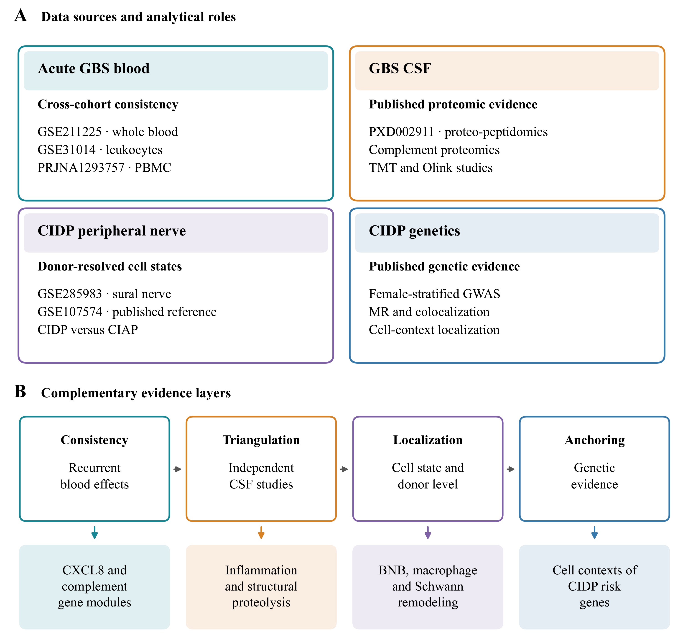
Figure 1. Study design and integrated model of immune compartments. Published blood, CSF, peripheral nerve and genetic resources were used to compare blood cohorts, integrate CSF findings, analyze nerve responses for individual donors and localize expression of published genetic candidates. The model relates systemic recruitment involving CXCL8 and complement to CSF inflammation and proteolysis, responses of BNB endothelial cells, macrophages and Schwann cells, and the cellular distribution of CIDP susceptibility genes.
Alt text: Diagram of independent blood, CSF, peripheral nerve and genetic resources, linked to their analytical roles and proposed biological questions.
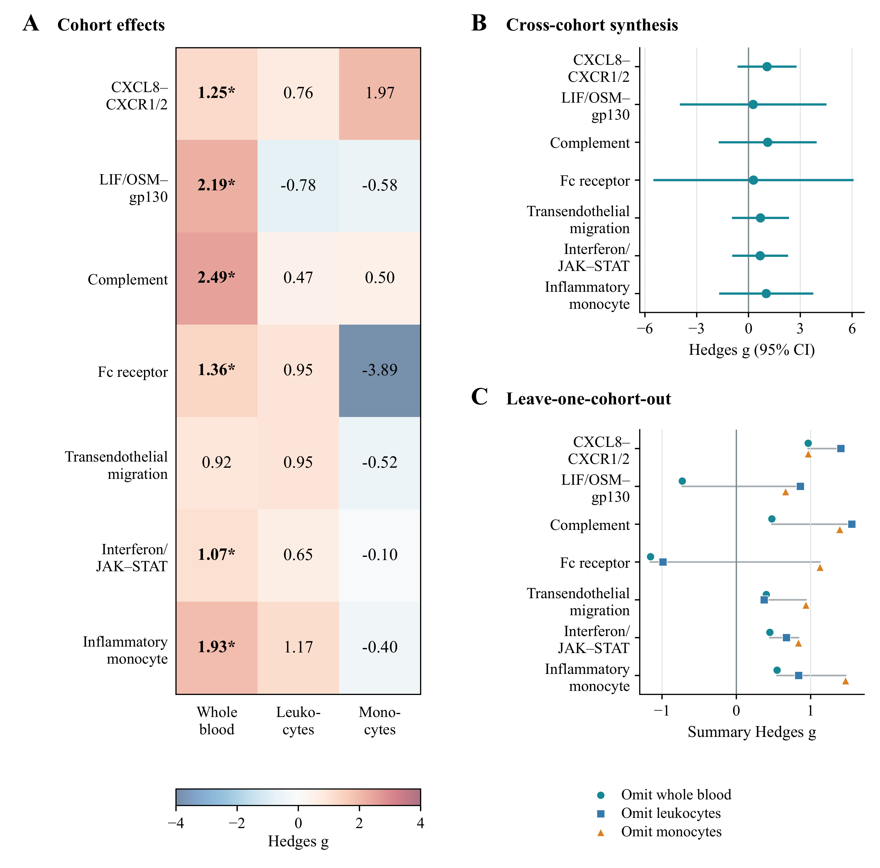
Figure 2. Acute GBS blood programs across cohorts and sensitivity analyses. (A) Hedges g values for seven gene programs in whole blood, leukocytes and monocyte pseudobulk. The programs were defined in the analysis scripts. Asterisks indicate q < 0.05 within each cohort. (B) Estimates from models with random effects and 95% confidence intervals calculated using the modified Hartung and Knapp method. (C) Summary effects after each cohort was omitted in turn. CXCL8 signaling through CXCR1 and CXCR2 and the complement gene module retained positive summary effects in all three subsets, with positive individual effects in both retained cohorts. These sensitivity analyses assess stability of direction and do not constitute confirmatory significance tests.
Alt text: Heatmap and forest plots of seven blood gene modules. CXCL8 recruitment and complement effects are positive in all cohorts, while all pooled confidence intervals include zero.
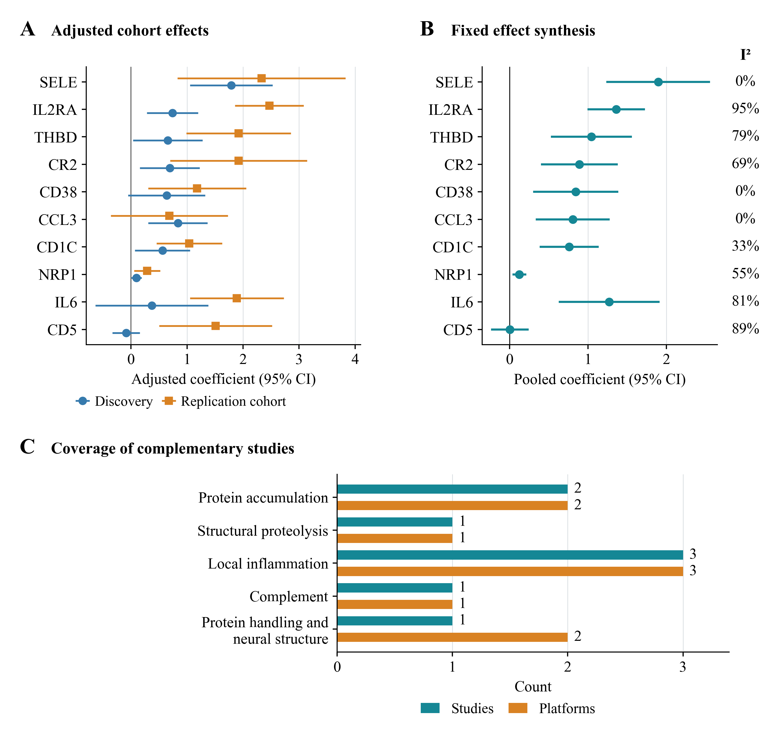
Figure 3. Synthesis of published CSF estimates. (A) Coefficients from the independent discovery and replication cohorts of Kmezic et al., adjusted for age, sex and sample handling. Error bars are 95% confidence intervals calculated from the reported standard errors using a normal approximation.³⁶ (B) Synthesis using a model with a fixed effect and weighting by inverse variance for all ten CSF proteins other than IL8 with paired estimates in source Table 4B. Nine pooled effects have q < 0.05 after correction across ten tests. The pooled effect for CD5 does not meet this threshold. I² summarizes heterogeneity. Pooled significance is distinct from significance in each source cohort. (C) Numbers of selected studies and platforms covering each biological category, from four complementary reports.^{26,33,34,35} These counts describe coverage, not statistical validation.
Alt text: Cohort and pooled coefficient plots for ten CSF proteins. Nine proteins have positive coefficients in both cohorts. CD5 changes direction. The lower panel counts study and platform coverage.
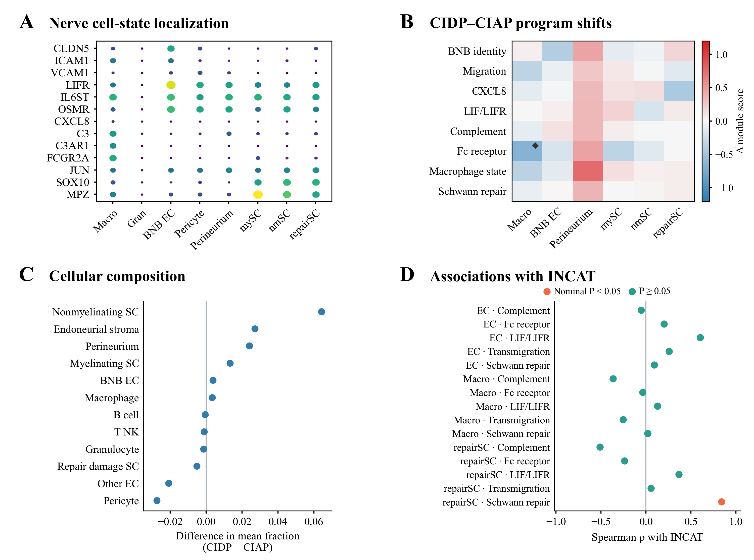
Figure 4. Barrier, immune and repair gene modules in CIDP nerve. (A) Expression across nerve cell states. Dot size indicates detection and color indicates scaled mean expression. (B) Differences in donor gene module scores between CIDP and CIAP. Diamonds indicate q < 0.05 within a cell group. No module meets q < 0.05 across all 80 eligible comparisons. Supplementary Figures 3 and 4 show the new Fc sensitivity analyses. (C) Differences in mean cell fractions, calculated as CIDP minus CIAP, with donors analyzed as independent samples. Group comparisons in B and C used the U test of Mann and Whitney without covariate adjustment. (D) Spearman associations between donor module scores and INCAT disability. Orange indicates nominal P<0.05 and teal indicates P ≥ 0.05. None of the associations in D met the threshold after correction for multiple testing. BNB EC refers to endoneurial microvascular endothelial cells.
Alt text: Four panels show nerve gene localization, module score and cell fraction differences, and disability correlations. The macrophage Fc module meets the original correction threshold within macrophages, but not the threshold across all 80 eligible module comparisons. Clinical correlations do not survive correction.
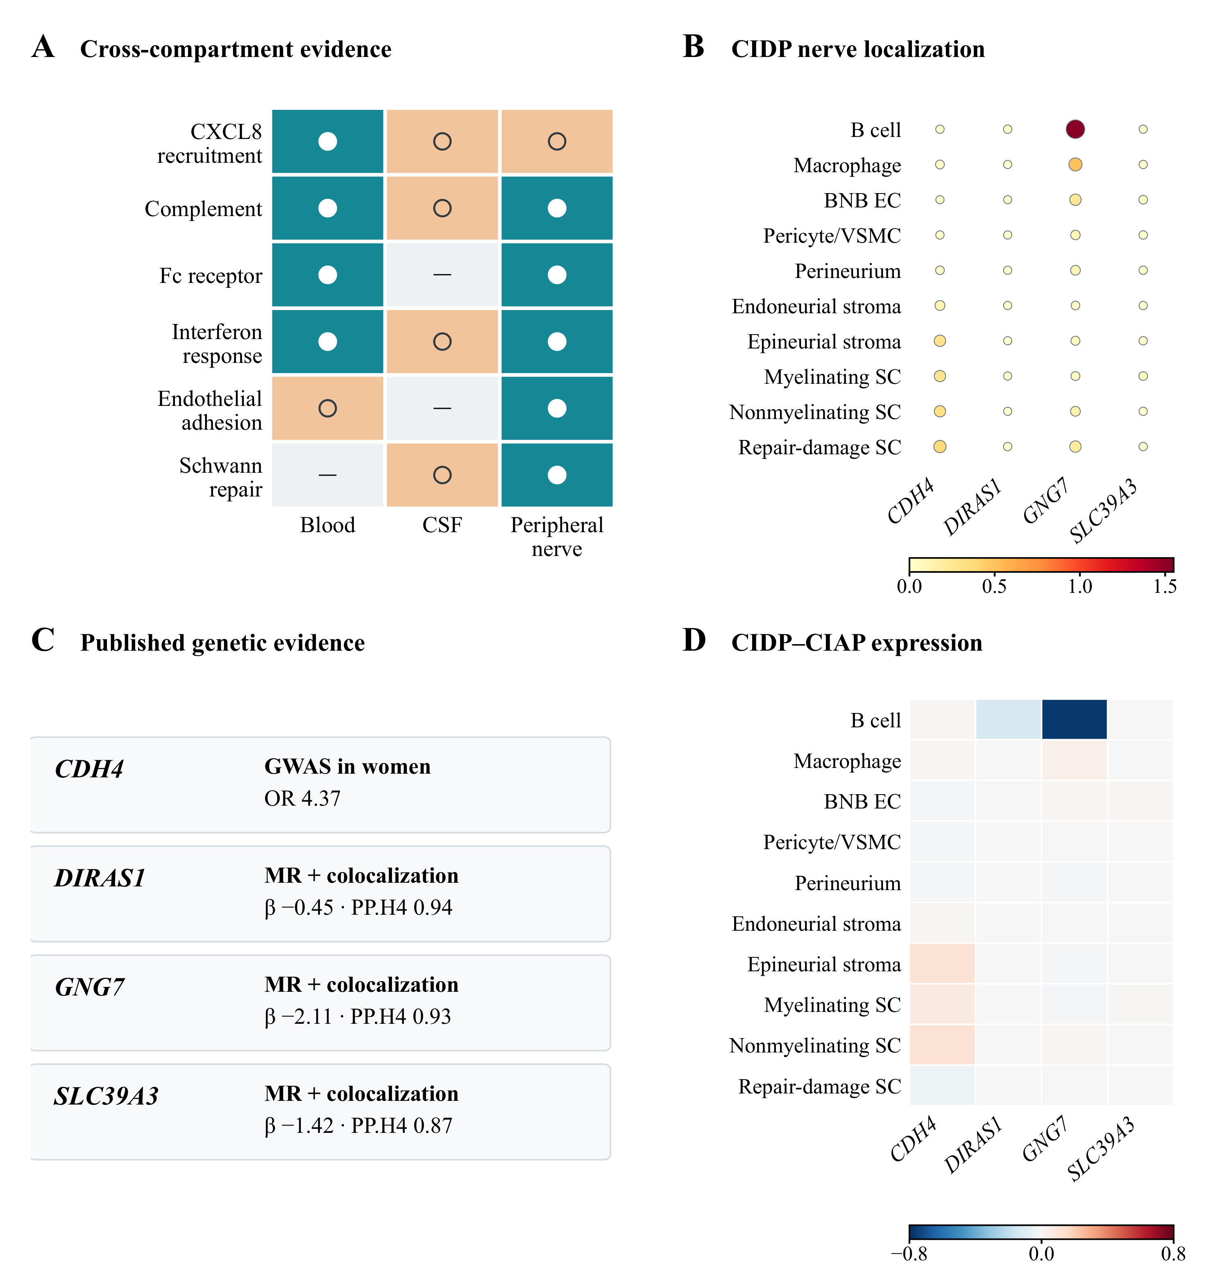
Figure 5. Immune programs across compartments and cellular localization of genetic candidates in inflammatory peripheral neuropathy. (A) Evidence map across blood, CSF and peripheral nerve. White filled circles indicate direct localization or evidence meeting the threshold after correction for multiple testing, The macrophage Fc classification uses the original correction within a cell group and remains exploratory under broader correction. Open circles indicate recurrent directions or representation in published findings, and dashes indicate programs that were not evaluated. (B) Localization of CDH4, DIRAS1, GNG7 and SLC39A3 across CIDP nerve cell groups, calculated from donor expression summaries in this study. Dot size indicates the percentage of nuclei expressing each gene and color indicates mean log2(CP10k + 1). (C) Genetic estimates reported by Du et al.,³² shown to explain candidate selection. These GWAS, Mendelian randomization and colocalization estimates were not recalculated. (D) Differences between CIDP and CIAP for the same genes and cell groups, calculated in this study from donor means of log2(CP10k + 1) as CIDP minus CIAP. Red indicates higher expression in CIDP and blue indicates lower expression. None of the displayed comparisons met q < 0.05. The color scales represent mean expression in B and differences between diagnoses in D.
Alt text: An evidence map is followed by candidate gene expression, published genetic estimates and contrasts between CIDP and CIAP. CDH4 and GNG7 have distinct expression patterns. Displayed diagnostic contrasts do not survive correction.

Table 1. Datasets and analytical roles
Resource | Material | Participants or samples | Analytical role
GSE211225 | Whole blood transcriptomics | 6 acute GBS, 10 postacute, 6 controls | Primary blood effects for individual participants
GSE31014 | Leukocyte microarray | 7 GBS, 7 controls | Independent assessment of blood effect direction
PRJNA1293757 | PBMC single-cell RNA sequencing | 3 AIDP, 2 controls | Monocyte localization and assessment of effect direction
PXD002911 | CSF proteomics and peptidomics | GBS (AIDP), MS and controls, with pooled discovery material | Published CSF identifications and functional annotations
GSE285983 | Sural nerve single-nucleus RNA sequencing | 9 CIDP, 11 CIAP in focused comparison | Donor gene module scores, cell fractions and expression localization
GSE107574 | Human endoneurial endothelial transcriptomics | Cultured cells and microvessels | Published BNB context; no independent raw-data reanalysis
Kmezic et al. 2023 | CSF Olink proteomics | Discovery: 6 GBS and 20 controls. Replication: 6 GBS and 6 controls | Synthesis of ten paired non-IL8 CSF coefficients from source Table 4B
PXD056286 | Sural nerve histology and proteomics | 55 biopsies from CIDP or its variants | Published tissue observations and calculated Wilson interval
GBS, Guillain–Barré syndrome; AIDP, acute inflammatory demyelinating polyradiculoneuropathy; CIDP, chronic inflammatory demyelinating polyradiculoneuropathy; CIAP, chronic idiopathic axonal polyneuropathy; CSF, cerebrospinal fluid; MS, multiple sclerosis; PBMC, peripheral blood mononuclear cell; BNB, blood–nerve barrier. Cohorts were independently sampled. Focused nerve sample sizes vary with cell-group eligibility.

Table 2. Exploratory synthesis of acute GBS blood gene modules
Gene module | Summary Hedges g | 95% CI lower | 95% CI upper | Modified Hartung–Knapp P | I², % | Cohorts, n
CXCL8 signaling via CXCR1 and CXCR2 | 1.075 | -0.634 | 2.785 | 0.114 | 0.0 | 3
LIF and OSM signaling via gp130 | 0.271 | -3.978 | 4.519 | 0.810 | 81.2 | 3
Complement | 1.111 | -1.728 | 3.950 | 0.234 | 57.2 | 3
Fc receptor | 0.288 | -5.510 | 6.086 | 0.851 | 72.7 | 3
Transendothelial migration | 0.694 | -0.958 | 2.347 | 0.212 | 1.1 | 3
Interferon signaling via JAK and STAT | 0.677 | -0.943 | 2.297 | 0.214 | 0.0 | 3
Inflammatory monocyte | 1.026 | -1.702 | 3.754 | 0.247 | 49.5 | 3
Positive Hedges g indicates a higher acute GBS score. Between-study variance used DerSimonian–Laird estimation; intervals and P values used the modified Hartung–Knapp procedure with residual scale bounded below by one. Each synthesis includes three cohorts. No pooled effect reaches P < 0.05. CI, confidence interval.

Table 3. Descriptive evidence map across blood, CSF and peripheral nerve
Program | Blood evidence | CSF evidence | Peripheral nerve evidence | Interpretation
CXCL8 recruitment | Positive in 3 cohorts; pooled P = 0.114; whole-blood q < 0.05 | Published innate immune and inflammatory protein findings | Myeloid localization and endothelial trafficking context | Shared recruitment hypothesis
Complement | Positive in 3 cohorts; pooled P = 0.234; whole-blood q < 0.01 | Published complement protein findings | Macrophage localization | Complement-related evidence; amplification remains a hypothesis
Fc receptor | Whole blood q < 0.05, with mixed directions across cohorts | Not directly evaluated | Macrophage q = 0.0087 within eight modules and q = 0.087 across 80 nerve comparisons | Exploratory association. Attenuated after composition adjustment.
Interferon response | Whole blood q < 0.05, with mixed directions across cohorts | Published evidence of antiviral defense | Macrophage, endothelial and Schwann cell states | Response varies by compartment
Endothelial adhesion | Positive blood direction | Not directly evaluated | ICAM1 and VCAM1 localization to BNB endothelial cells | Endothelial context for functional study
Schwann repair | Not evaluated | Published evidence of axonal domain peptide degradation | Repair and stress programs localized to Schwann cells | Proposed link between structural injury and repair
q denotes the Benjamini–Hochberg-adjusted P value within the specified testing family. Blood comparisons concern acute GBS versus controls; the nerve comparison concerns CIDP versus CIAP. This map does not constitute a direct paired comparison between compartments or a test of causal mediation.

