Supplementary Figure 1
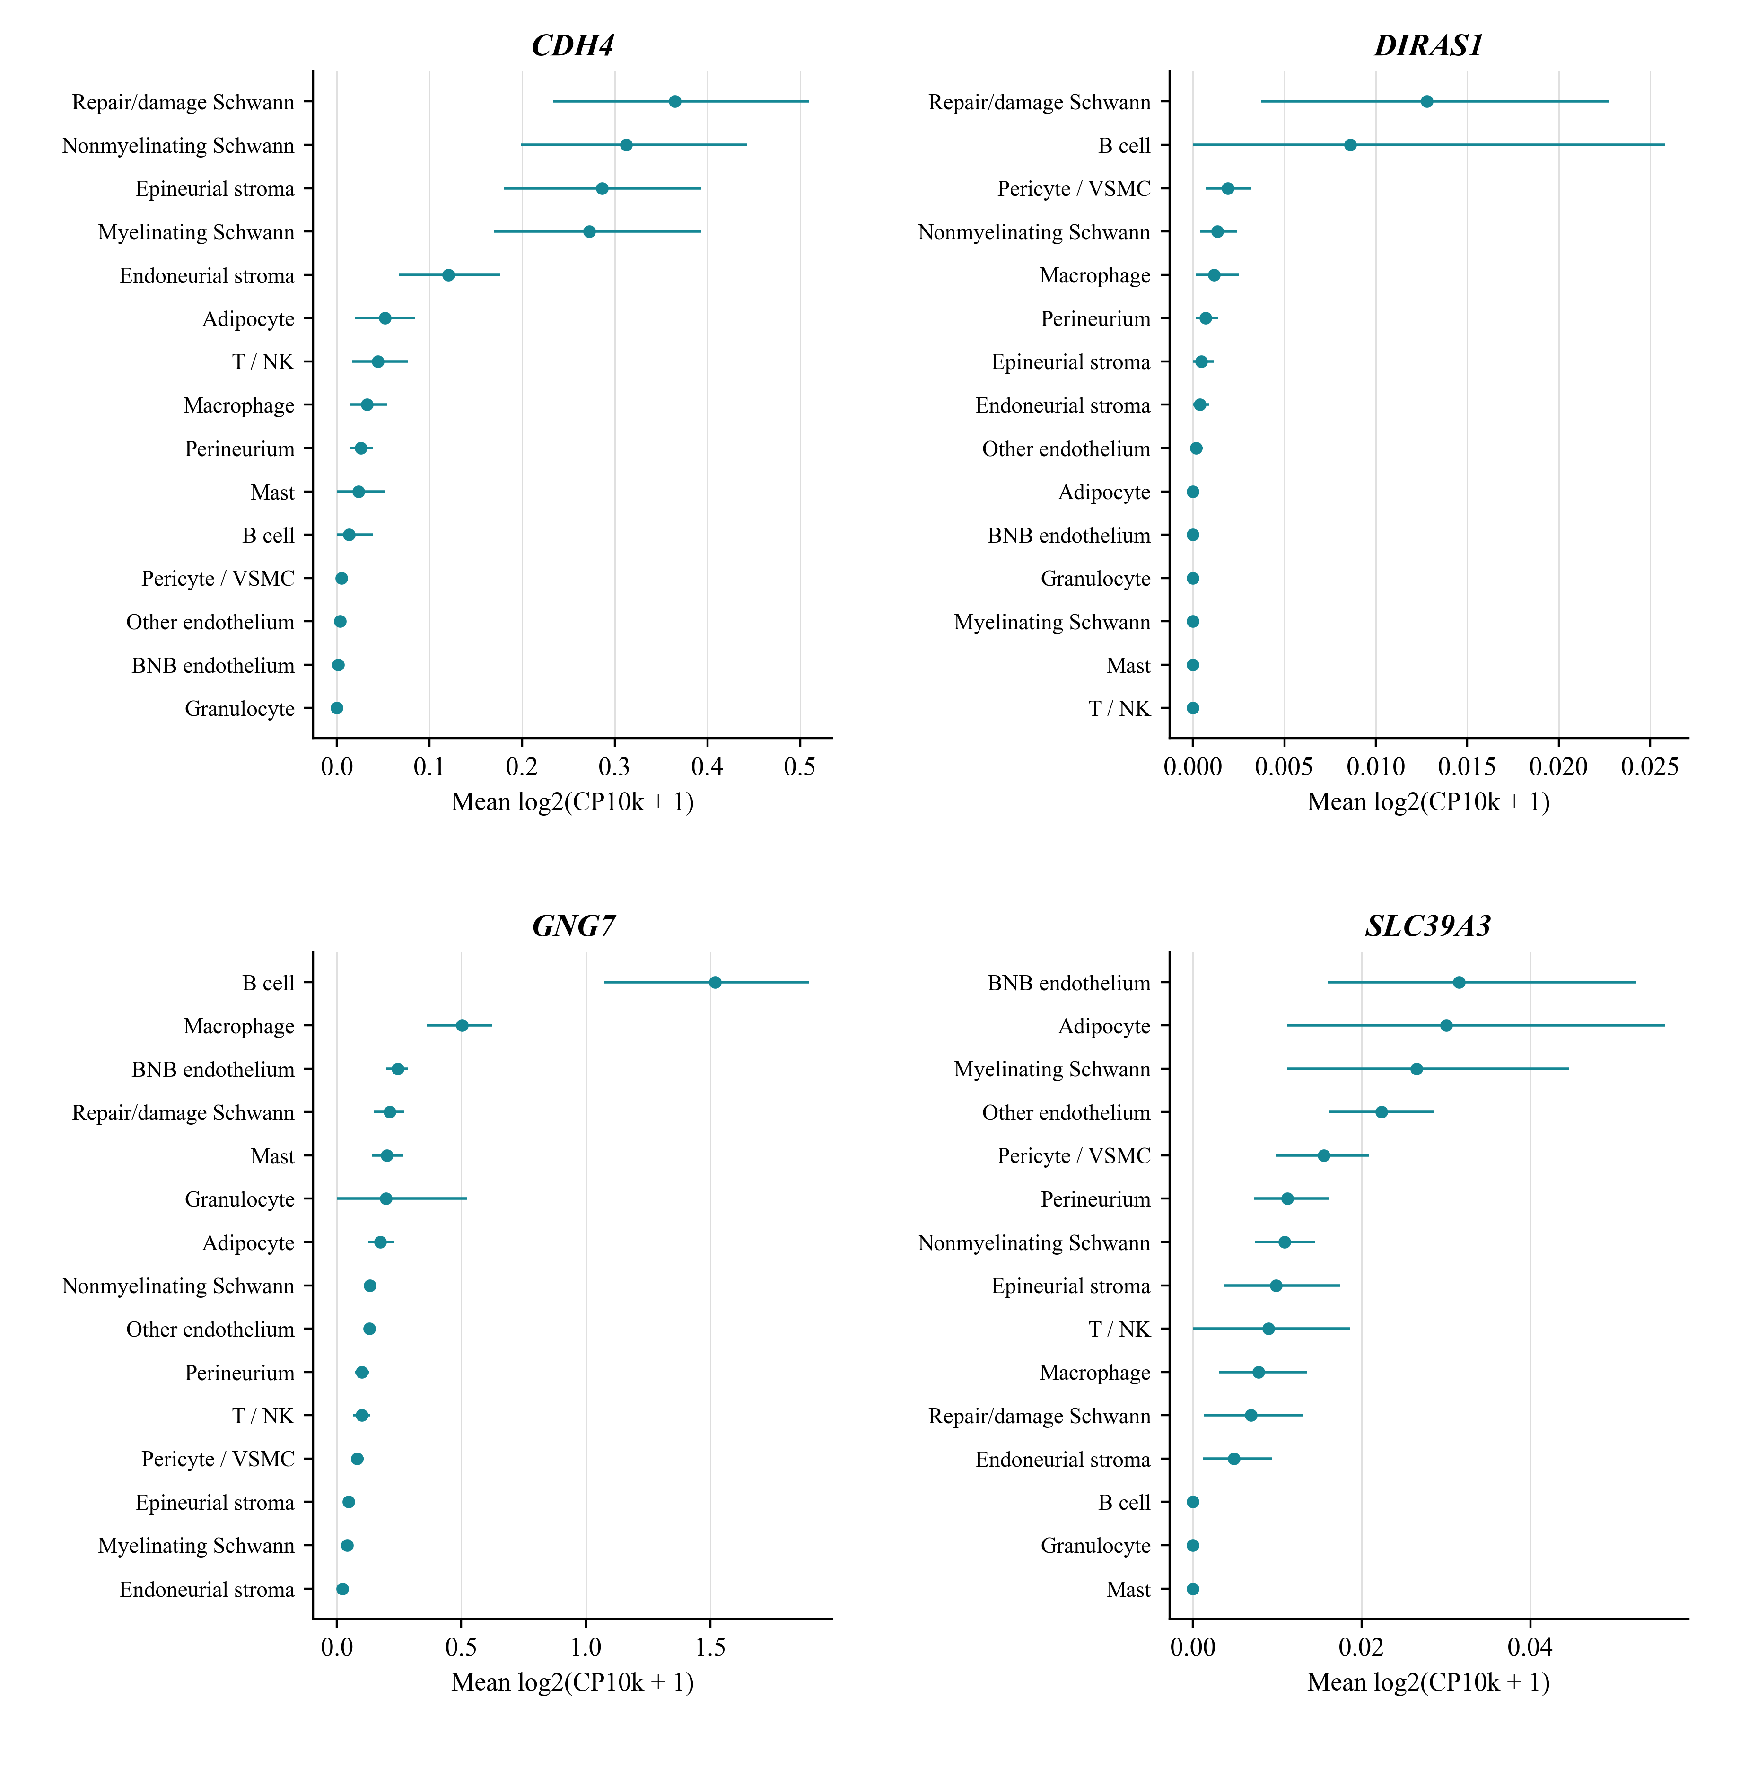
Supplementary Figure 1. Donor bootstrap uncertainty in genetic candidate expression. Points show mean log2(CP10k + 1) across eligible CIDP donors and bars show percentile 95% intervals from 5000 resamples within each gene–cell group. These are descriptive intervals for expression means, not tests of cell-type specificity or genetic mediation.
Alt text: Four expression plots show gene-specific mean expression and donor-bootstrap intervals across nerve cell groups.

Supplementary Figure 2
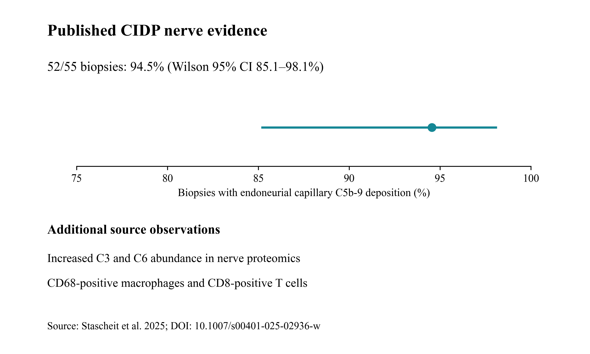
Supplementary Figure 2. Published nerve observations and a calculated complement-deposition interval. Stascheit et al. reported C5b-9 deposition on endoneurial capillaries in 52 of 55 CIDP biopsies and additional histological and proteomic observations.³⁷ The proportion (94.5%) and Wilson 95% interval (85.1–98.1%) were calculated from that published count. The other observations are qualitative source findings associated with PXD056286; no biopsy or proteome was reanalysed.
Alt text: A point and interval summarize published C5b-9 deposition in 52 of 55 biopsies; text lists additional source observations.

Supplementary Figure 3
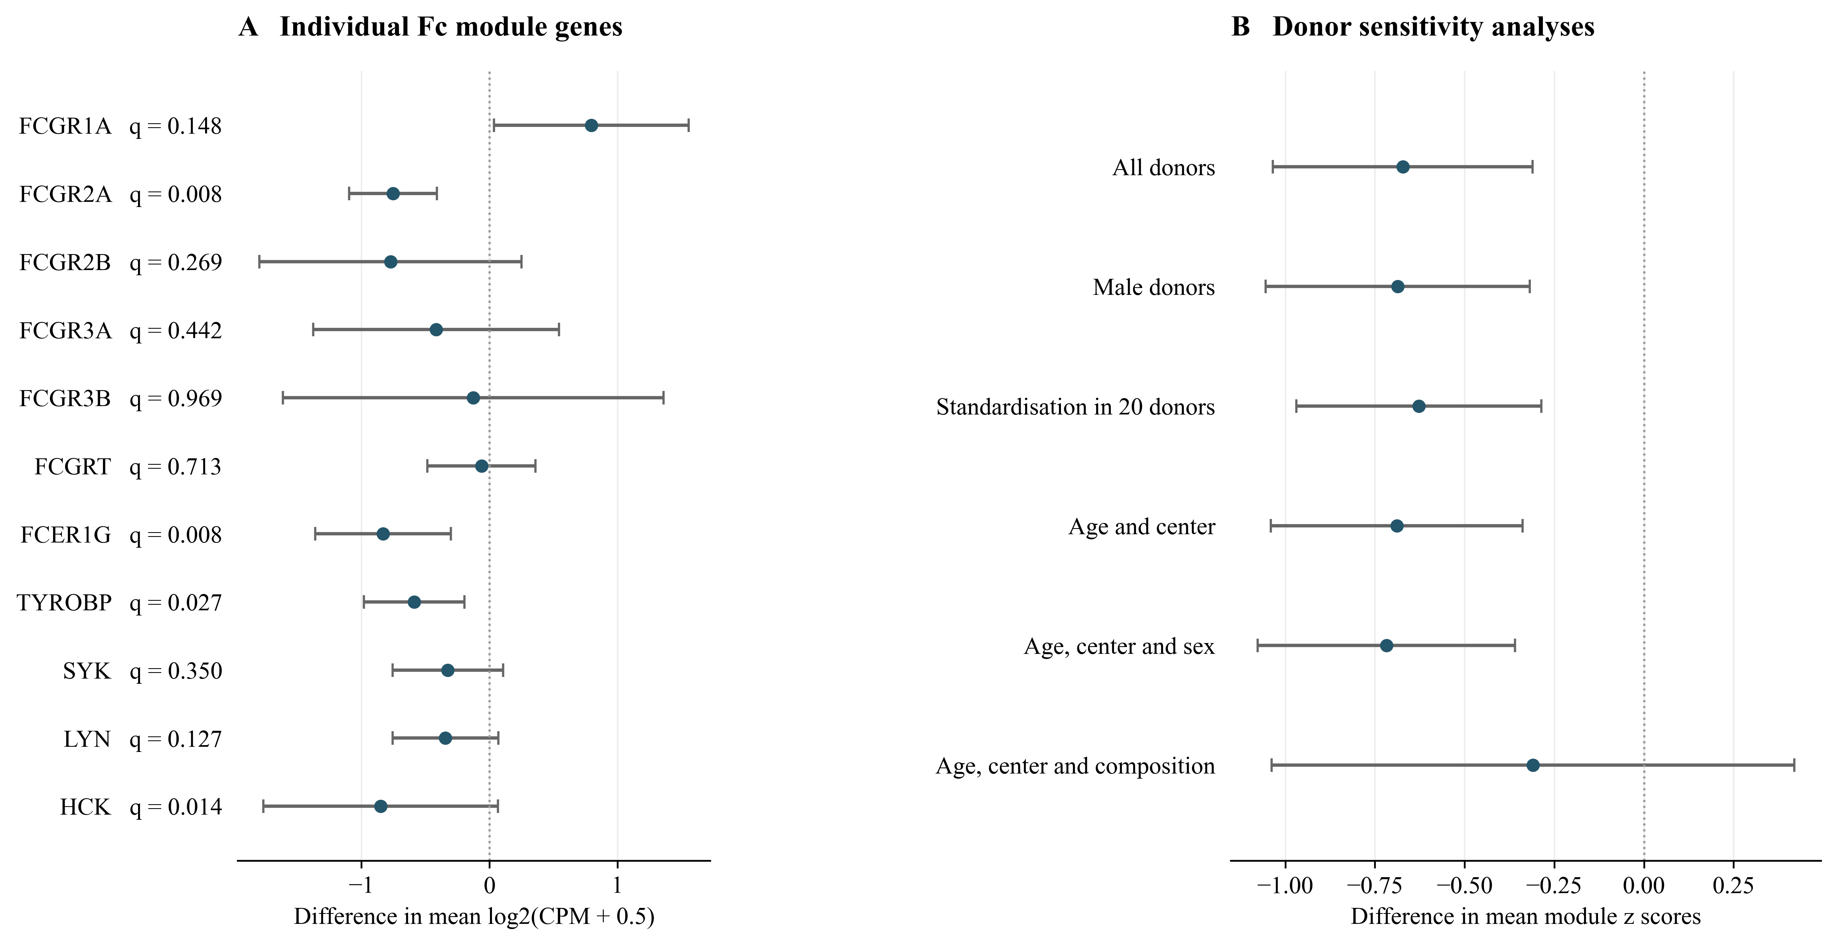
Supplementary Figure 3. Fc module components and donor sensitivity analyses. Panel A shows differences in mean log2(CPM + 0.5) for the 11 measured genes. FCGR2C is unavailable. Displayed q values use the 11 gene family. Panel B shows module score differences under demographic and composition sensitivity analyses. Points and bars are mean differences and 95% intervals from ordinary least squares with HC3 covariance and residual degrees of freedom. Standardisation in 20 donors changes the score scale. The exact permutation test within centres has P = 0.0048 and is reported separately because it does not supply a model interval. The original module q value is 0.0087 within eight macrophage modules and 0.087 across all 80 eligible module tests. These post hoc analyses are not independent validation.
Alt text: Gene effects vary in direction. Demographic model intervals exclude zero. The composition adjusted interval includes zero.

Supplementary Figure 4
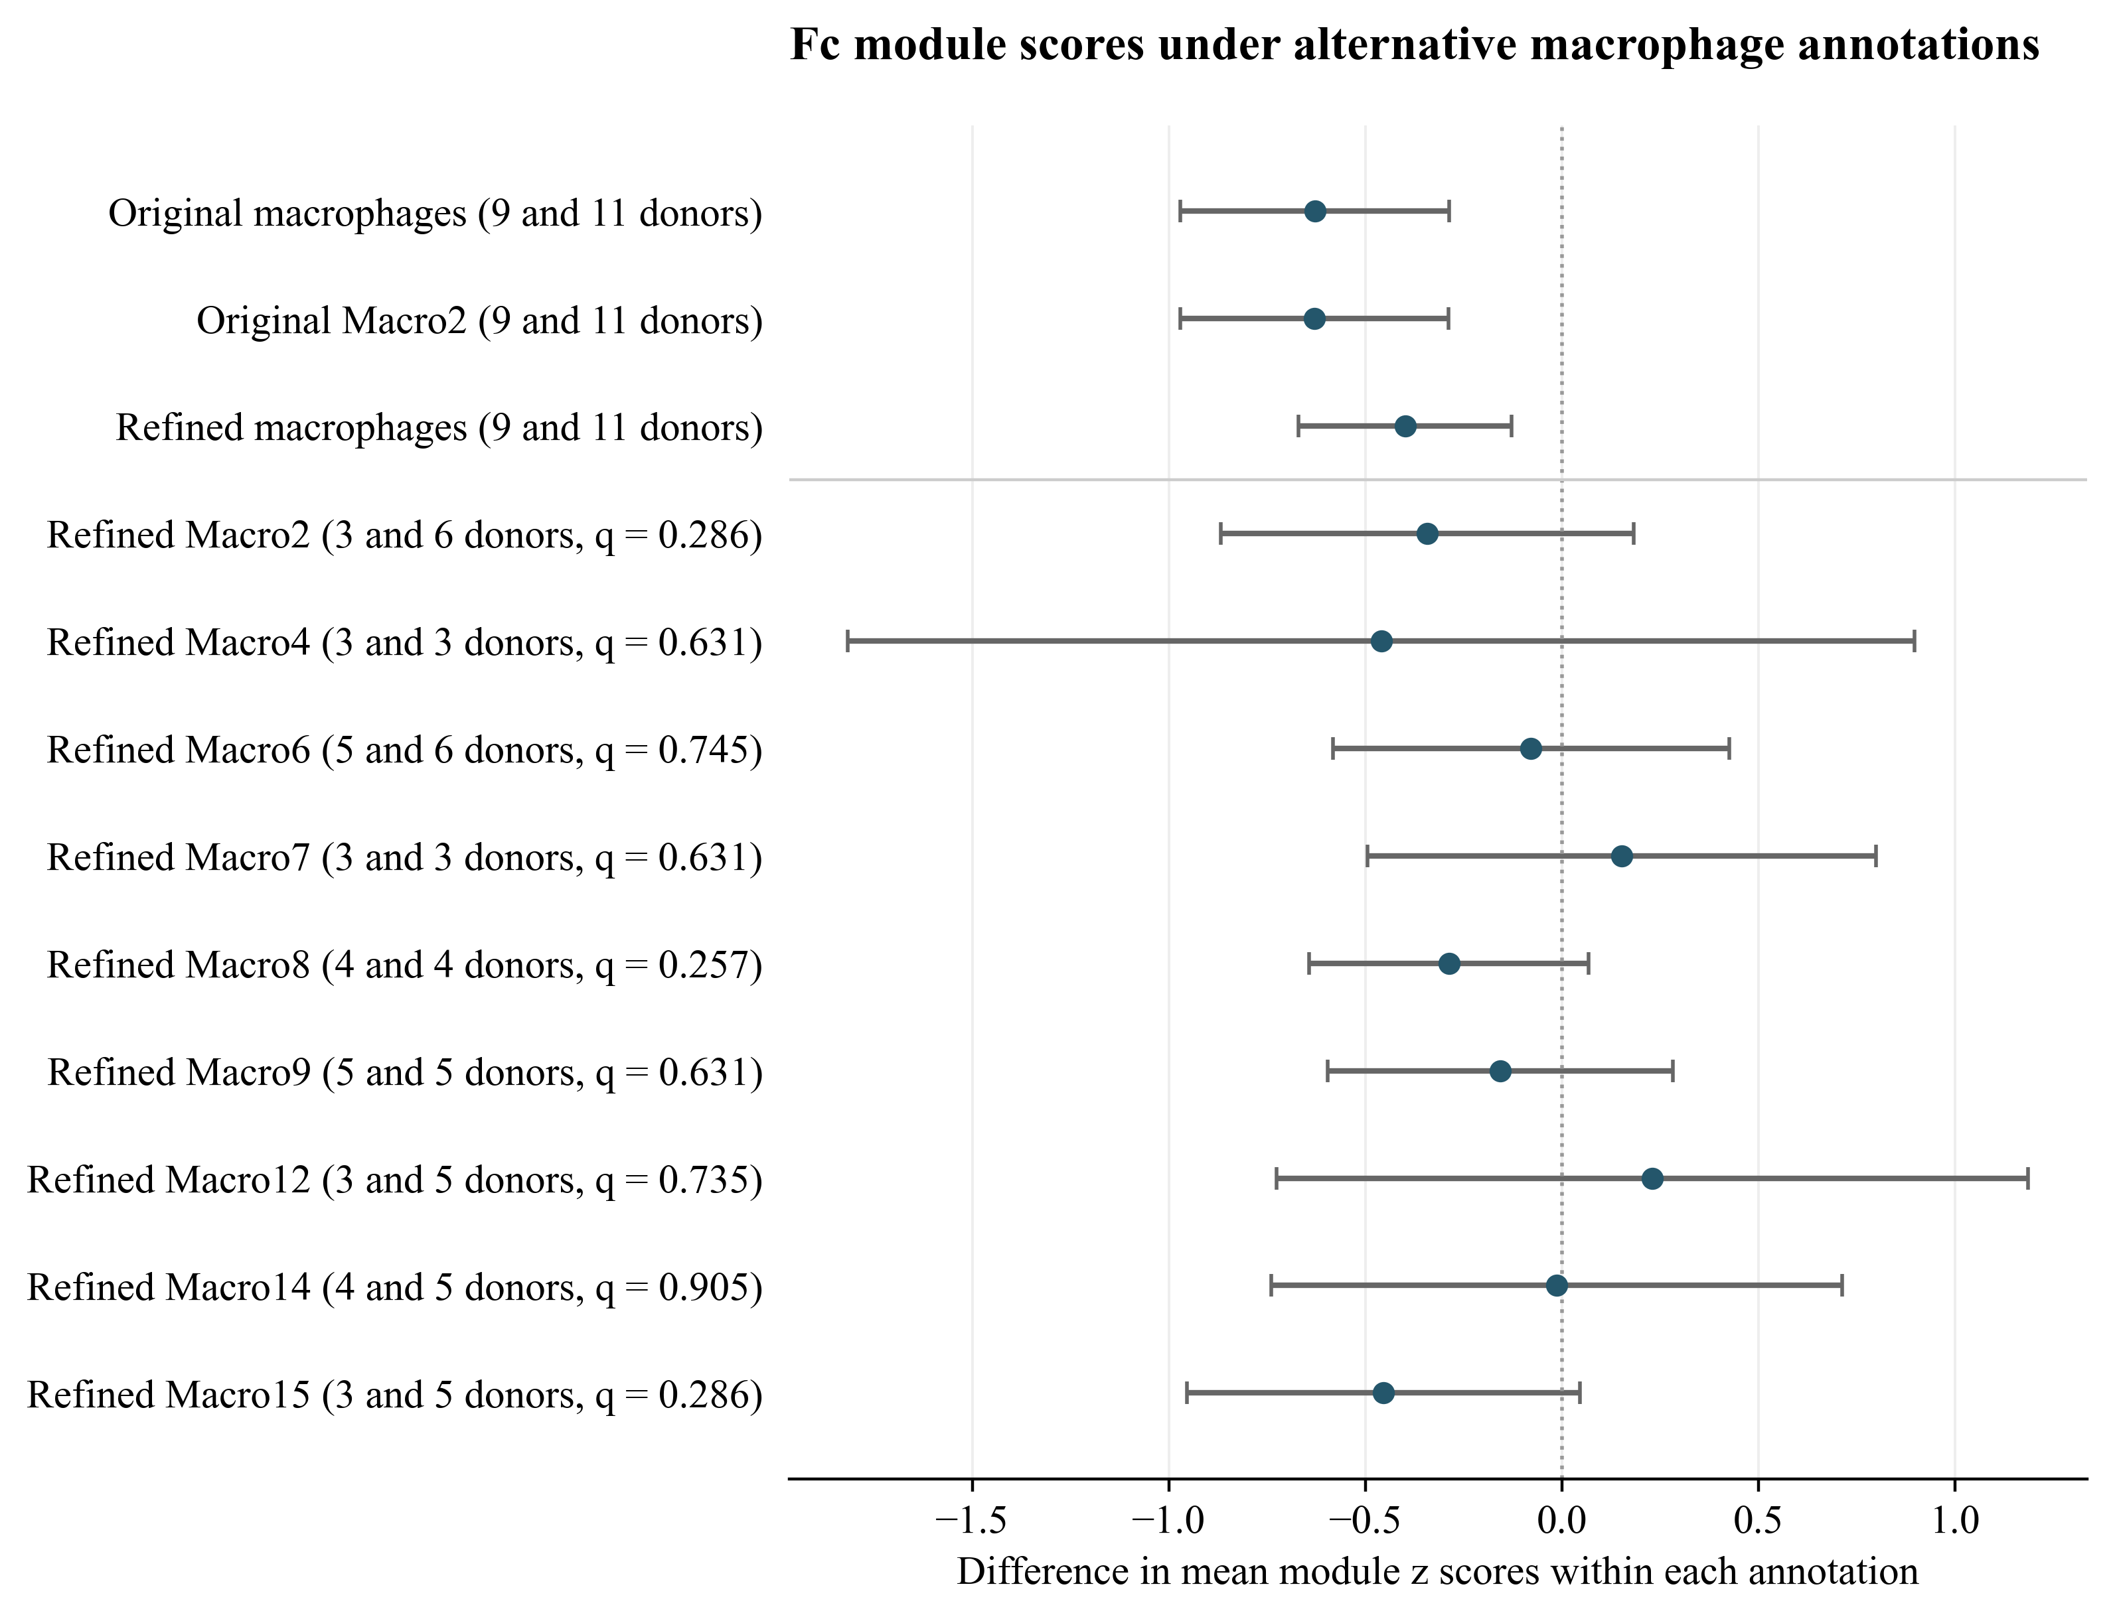
Supplementary Figure 4. Fc scores under alternative annotations. The original and refined annotations are distinct classification levels. The refined union contains Macro1 through Macro18. Eligibility requires 20 nuclei per donor and three donors per diagnosis. Original Macro1 is ineligible. Points and bars show mean score differences and HC3 95% intervals. Genes are standardized within each eligible annotation. Parentheses give CIDP and CIAP donor counts. Subtype q values use nine tests. None meets q < 0.05. The three broader definition checks form a separate family.
Alt text: Broader macrophage definitions retain negative differences. Individual refined subtype estimates have limited donor counts, and none survives correction across nine subtypes.

