Immune recruitment signatures and cellular context in inflammatory neuropathies
Yuan Feng¹†, Fang Feng²†, Shuxiao Ma¹†, Shuman Feng¹, Chao Jiang¹*, Yibin Hao¹*
¹ Department of Neurology, Henan Provincial People’s Hospital, People’s Hospital of Zhengzhou University, Zhengzhou 450003, China
² Department of Neurology, The First Affiliated Hospital of Zhengzhou University, Zhengzhou 450002, China
† Yuan Feng, Fang Feng and Shuxiao Ma contributed equally to this work.
* Correspondence: Yibin Hao, haoyibin999@163.com, and Chao Jiang, chaoj@zzu.edu.cn. Postal address: No. 7 Weiwu Road, Jinshui District, Zhengzhou, Henan, China.

Abstract
Background
Inflammatory neuropathies involve circulating immune responses and local nerve injury. We asked which immune signals recur across blood cohorts and how cerebrospinal fluid (CSF) proteins and nerve cell expression inform their interpretation.
Methods
We analysed three acute Guillain–Barré syndrome (GBS) blood cohorts, published CSF estimates from two cohorts, and nerve transcriptomes from nine donors with chronic inflammatory demyelinating polyradiculoneuropathy (CIDP) and 11 with axonal neuropathy. Donor level nerve analyses examined macrophage composition and separate endothelial and Schwann cell programmes.
Results
CXCL8 recruitment and complement scores were higher in GBS across all three blood cohorts, with pooled Hedges g estimates of 1.08 and 1.11. Both CSF cohorts showed elevated IL8, SELE and IL2RA. CIDP nerve macrophages had a lower Fc receptor score than those in axonal neuropathy, but the difference decreased after composition adjustment. Confidence intervals for pooled blood effects and conservative CSF estimates included zero. Fc receptor, endothelial and Schwann cell differences were not significant after correction across all nerve comparisons.
Conclusions
Immune recruitment was the clearest recurring theme in GBS blood and CSF. Lower Fc receptor expression in CIDP nerve needs to be interpreted in the context of macrophage composition.

Keywords
Inflammatory neuropathy, transcriptomics, proteomics, blood–nerve barrier, macrophages, Schwann cells

Background
Guillain–Barré syndrome (GBS) and chronic inflammatory demyelinating polyradiculoneuropathy (CIDP) cause inflammatory peripheral nerve injury but differ in their clinical course and diagnostic criteria [1,2,3]. Antibodies, complement and macrophages contribute to this injury, with different roles across diseases and subtypes [4,5,6,7,8,9]. The affected nerve also contains immune and Schwann cell states involved in the response to injury and repair [10,11,12,13]. For example, leukaemia inhibitory factor (LIF) affects Schwann cell survival, proliferation and migration in experimental systems [14,15]. Interpreting inflammatory gene expression therefore requires attention to both immune activity and the responses of the cells within nerve.
Immune cell recruitment provides a biological link between circulating inflammation and local nerve responses. At the blood–nerve barrier (BNB), endothelial junctions and associated mural cells regulate exchange between blood and the endoneurium [16,17,18]. Leukocyte integrins, endothelial adhesion molecules and chemokines contribute to immune cell trafficking across this interface [19,20,21]. Altered junctional protein expression has also been reported in CIDP nerve [22]. These observations motivate examining recruitment signals alongside endothelial and Schwann cell expression, while distinguishing the different processes represented by each gene set.
Public molecular datasets allow different parts of this problem to be examined. Whole blood, leukocyte and peripheral blood mononuclear cell (PBMC) transcriptomes can identify immune signals that recur in GBS across sample preparations [23,24,25]. Cerebrospinal fluid (CSF) proteomics adds measurements of inflammation and molecular injury, and nerve transcriptomics identifies the cells expressing related genes [26,27]. Studies of monocytes in acute inflammatory demyelinating polyradiculoneuropathy (AIDP), peripheral immune profiles in CIDP and treatment associated blood expression illustrate the variation in systemic responses [28,29,30]. Experiments using patient immunoglobulin address effects on the BNB, whereas genetic studies identify candidate genes whose cellular expression can be examined [31,32]. The question is how these sources of evidence clarify one another when they measure different aspects of disease.
We first asked which immune gene programmes showed the same direction of change across acute GBS blood cohorts. We then examined corresponding CSF protein findings, including direct comparisons of GBS and CIDP. Nerve analyses addressed a related question in CIDP and axonal neuropathy by locating relevant gene expression and comparing scores between donors. Follow up analyses examined whether the macrophage Fc receptor difference depended on cell composition. They also distinguished junction, transport and adhesion programmes in endothelium and myelin maintenance and injury responses in Schwann cells. Normal BNB expression and genetic candidate localisation helped interpret these cellular findings. This approach links the questions addressed by each dataset while retaining the disease comparison appropriate to that dataset.

Methods

Study design and datasets
We analysed human blood and nerve transcriptomes alongside published CSF protein and genetic findings. The blood datasets covered three preparations. GSE211225 contained six acute GBS, ten postacute and six healthy control whole blood profiles [23]. GSE31014 contained leukocyte microarrays from seven patients with GBS and seven healthy controls [24]. PRJNA1293757 contained PBMC transcriptomes from three untreated patients with acute inflammatory demyelinating polyradiculoneuropathy (AIDP) and two healthy controls [25]. The blood comparisons used acute disease and healthy control samples from each dataset.
For CSF, we used published protein and endogenous peptide identifications by diagnostic group from the study associated with PXD002911 and reports on complement, quantitative proteomics and inflammatory proteins [26,33,34,35]. Quantitative synthesis used adjusted protein coefficients from the independent discovery and replication cohorts of Kmezic et al. [36].
The nerve dataset, GSE285983, contained 365,708 nuclei from 37 sural nerves, including nine donors with CIDP and 11 with chronic idiopathic axonal polyneuropathy (CIAP) [27]. GSE107574 supplied expression data for selected endothelial genes in normal human BNB preparations [17]. Four donors in the nerve atlas had contributed residual sural nerve autograft tissue during surgery for traumatic nerve injury [27]. The publication associated with PXD056286 added histological observations from 55 biopsies in CIDP and its variants and proteomic findings from a smaller subset [37]. Candidate genes for cellular localisation came from published genetic association, Mendelian randomisation and colocalisation findings [32].
We also assessed whether the public PXD056286 data could support an independent nerve comparison. We exported the stored raw and normalised protein intensities, checked instrument run columns and normalisation coefficients, and reproduced the saved protein filter. We then examined whether runs could be linked to biological specimens and diagnoses and whether the data covered the original 11 gene Fc receptor module. Additional files 1 and 4 contain the quantitative exports, identification quality checks and sample mapping assessment.
Figure 1 outlines the study design. Table 1 summarises the datasets and the questions they address. Database names, accession identifiers, original filenames and source links are provided in Additional file 1.

Gene modules
We used seven blood gene modules for CXCL8 recruitment through CXCR1 and CXCR2, LIF and oncostatin M (OSM) signalling through gp130, complement, Fc receptors, interferon signalling through JAK and STAT, inflammatory monocytes, and transendothelial migration. The eight nerve modules covered BNB identity, leukocyte transmigration, CXCL8 recruitment, LIF and related gp130 signalling, complement, Fc receptors, macrophage state, and Schwann cell myelin and repair. Gene lists are provided in the analysis scripts. The original BNB and Schwann cell modules each combined genes with several functions. We therefore examined more specific gene sets in subsequent analyses. All scores summarise expression of the selected genes. Barrier function and nerve repair were not measured directly.

Blood cohort analysis
In PRJNA1293757, marker gene scores assigned quality controlled PBMCs to broad cell lineages. We summed monocyte counts for each donor to produce pseudobulk profiles, normalised them to counts per million (CPM), and transformed them as log₂(CPM + 0.5). Within each blood cohort, we standardised each gene across participants and averaged the available gene values within each module. We expressed the difference between acute GBS and healthy controls as Hedges g and compared mean module scores using exact label permutation tests. Benjamini and Hochberg correction covered the seven modules in each cohort [38].
We pooled effects from whole blood, leukocytes and monocytes using a random effects model. Between cohort variance was estimated by the DerSimonian and Laird method, with heterogeneity described by τ² and I² [39]. Modified Hartung and Knapp confidence intervals used a residual variance scale of at least one and a t distribution with degrees of freedom equal to the number of cohorts minus one [40]. We repeated the synthesis after omitting each cohort to assess its influence. Postacute profiles contributed to the original preprocessing but were excluded from the reported comparisons. The archived study design did not establish whether the acute and postacute samples came from independent donors.

CSF protein synthesis
We extracted all GBS versus healthy control coefficients adjusted for age, sex and CCL19 in Tables 3 and 4B of Kmezic et al. [36]. Eleven of the 15 reported proteins had coefficients and standard errors in both independent cohorts, including IL8 in Table 3. Four proteins lacked an estimate in one cohort and were recorded but not imputed. We pooled the 11 pairs on the log₂ normalised protein expression (NPX) scale using inverse variance fixed effect models, with Benjamini and Hochberg correction across 11 tests. Sensitivity analyses used DerSimonian and Laird random effects models with normal approximation intervals. We also calculated modified Hartung–Knapp intervals with a variance scale of at least one and one degree of freedom. The original study P and q values were retained separately from the pooled tests.
We extracted all adjusted coefficients for GBS versus CIDP and CIDP versus healthy controls in source Tables 3, 5 and 6 [36]. These comparisons use participants from the same replication cohort. We presented them with the original P and q values and did not count them as additional independent cohorts. Four other reports contributed descriptive findings on CSF proteins, peptides and functional annotations [26,33,34,35]. Protein identification counts were kept separate from concentration measurements.

Nerve pseudobulk analysis
We grouped nerve nuclei by donor and annotated cell state. The groups comprised macrophages, T and natural killer cells, B cells, granulocytes, endoneurial and other endothelial cells, pericytes, perineurial cells, endoneurial stroma, and myelinating, nonmyelinating, and repair and damage Schwann cells. A donor contributed to a cell group analysis if that group contained at least 20 nuclei. We summed counts within each donor and cell group, normalised to CPM using counts across all genes, and applied log₂(CPM + 0.5). Donors were the independent observations in CIDP versus CIAP comparisons [41,42,43].

Nerve module comparisons and macrophage composition
Within each cell group, we standardised gene expression across eligible donors from all diagnostic categories and averaged the available gene z scores for each module. We compared CIDP with CIAP using the Mann and Whitney U test and reported the mean CIDP score minus the mean CIAP score. Multiple testing correction covered the eight modules within each cell group. A separate correction covered all 80 nerve module comparisons. To examine cell composition, we calculated each group’s share of a donor’s sampled nuclei and compared these proportions between diagnoses, with correction across cell groups.
The macrophage Fc receptor module contained 11 measured genes. FCGR2C, the twelfth specified gene, was absent from the matrix. To identify the genes contributing to the score difference, we tested each gene using the Mann and Whitney U test, with correction across 11 tests. Four functional summaries formed a separate testing family. For comparisons without covariate adjustment, q values came from rank tests. Separate HC3 models supplied confidence intervals for mean differences. Sensitivity analyses restricted the comparison to men, standardised genes within the 20 CIDP and CIAP donors, adjusted for age and centre, and added sex to the adjusted model. Linear model intervals used HC3 covariance estimates and residual degrees of freedom. An exact permutation test kept the number of CIDP donors within each centre unchanged. Model specifications are given in Additional file 2.
We next examined variation within the macrophage population. Nucleus barcodes linked the original labels to refined immune annotations. Composition summaries included unmatched nuclei and nuclei reassigned to other categories. We calculated centred log ratios of donor composition and added their first two principal components to the age and centre model [44]. We also reaggregated raw counts for all 20 CIDP and CIAP donors using alternative macrophage definitions. A refined subtype was tested if at least three donors in each diagnosis had at least 20 nuclei, with correction across the nine eligible subtypes. Finally, we checked whether any subtype had at least 20 nuclei in every one of the 20 disease donors. This coverage was required to compare all donors at a common set of subtype proportions without estimating missing expression values.
To place the CIDP versus CIAP difference alongside the graft reference samples, we reconstructed the original 11 gene Fc receptor score using the same standardisation across all 37 atlas donors. We compared each diagnosis with the four graft donors. The CIDP versus reference comparison had been included in the original pipeline and was reexamined here. Two sided exact Mann and Whitney tests were corrected across the two reference comparisons. Adding them to the 89 module and programme tests gave an expanded family of 91 tests. Confidence intervals for mean differences used 20,000 bootstrap replicates, resampling donors independently within each group with fixed score standardisation and seed 20260921.

Separate endothelial and Schwann cell gene programmes
To distinguish the functions combined in the original modules, we defined endothelial gene sets for junction structure, transport and inflammatory adhesion, and Schwann cell gene sets for myelin maintenance and injury response [11,12,17]. Gene membership was fixed before calculating these extension results and is listed in Additional file 2. We reaggregated raw counts for all 20 CIDP and CIAP donors, retained cell groups with at least 20 nuclei, and standardised genes across eligible donors from these two diagnoses. All specified genes were measured and variable. The three endothelial and six Schwann cell comparisons formed a nine test family. We also combined these with the original 80 nerve comparisons to examine correction across 89 tests.
Mann and Whitney tests assessed unadjusted differences. We also reported mean score differences with separate HC3 confidence intervals and models adjusted for age and centre. For the pooled repair and damage Schwann cell group, an additional model included the fraction of repair cells. The original broad module scores retained their original standardisation. To assess the anatomical expression of the endothelial gene sets, we extracted values for 11 genes from GSE107574, which included cultured endothelium and four normal nerve preparations collected by laser capture.

Nerve module and disability correlations
We examined relationships among five scores in the nine CIDP donors. These comprised endothelial LIF and leukocyte transmigration, macrophage complement and Fc receptors, and the combined myelin and repair score in repair and damage Schwann cells. Spearman correlations assessed the ten pairs of scores. We also tested 15 cell group and module combinations for associations with Inflammatory Neuropathy Cause and Treatment (INCAT) disability scores. The ten intermodule tests and 15 disability tests were corrected as separate families.
We then correlated the separate myelin maintenance and injury response scores with INCAT in the nine CIDP donors, using the pooled repair and damage Schwann cell group. Exact two sided P values were calculated from all 362,880 assignments of INCAT ranks, preserving ties. We corrected these two tests together and also examined a broader family of 17 tests by adding the 15 archived asymptotic P values. We repeated the analysis after excluding each donor to assess individual influence. The exact tests were added after inspection of the initial correlations.

Comparison across compartments
We organised the findings into a map of biological programmes across compartments. Entries were included for programmes with a consistent direction across blood cohorts, a corresponding published CSF protein or peptide annotation, or expression in a relevant nerve cell population. Each entry states the type of evidence and retains its original testing family. For interferon related nerve genes, we used cell cluster markers from Supplementary Data 3 and polyneuropathy versus control results from Supplementary Data 9 of Heming et al. [27]. Those controls were residual sural nerve autografts from patients with traumatic nerve injury. The map relates findings from separately sampled cohorts without combining them into a single score.

Genetic candidate localisation
We located expression of the genetic candidates CDH4, DIRAS1, GNG7 and SLC39A3 across nerve cell groups [32]. Expression and detection summaries gave equal weight to donors. Bootstrap intervals and CIDP versus CIAP comparisons are reported in the supplementary material. This analysis calculated expression in individual nuclei before summarising it by donor and cell group. It included groups with fewer than 20 nuclei, which reduces precision for rare populations. Additional file 2 describes normalisation, the original 11 gene screening family and the donor bootstrap procedure.

Statistical analysis
Participants and nerve donors were the units of inference. All disease and correlation tests were two sided. We use q for Benjamini and Hochberg adjusted P values, with q < 0.05 within each stated family. The Fc sensitivity and reference analyses, CSF extensions and separate functional gene sets were examined after the original findings and are exploratory. Complete results include nonsignificant comparisons, and the analysis record documents when each extension was added. Additional file 2 describes the methods, Additional file 3 contains Supplementary Figures 1 to 7, and Additional file 4 provides extension scripts, source tables and figure files.

Results

CXCL8 recruitment and complement recur across GBS blood cohorts
We began by asking whether the broad immune differences in whole blood recurred in other blood preparations. In GSE211225, six of seven module scores were higher in acute GBS after multiple testing correction. These were CXCL8 recruitment through CXCR1 and CXCR2 (Hedges g = 1.25, q = 0.045), LIF and OSM signalling through gp130 (g = 2.19, q = 0.0076), complement (g = 2.49, q = 0.0076), Fc receptors (g = 1.36, q = 0.038), interferon signalling through JAK and STAT (g = 1.07, q = 0.045), and inflammatory monocytes (g = 1.93, q = 0.015). Transendothelial migration also had a positive estimate (g = 0.92, q = 0.126).
The independent leukocyte cohort, GSE31014, had positive estimates for six of the seven modules. All except LIF and OSM signalling agreed in direction with whole blood. In PRJNA1293757 monocytes, CXCL8 recruitment had the largest positive estimate (g = 1.97), and complement was also positive. The remaining monocyte effects varied in direction.
CXCL8 recruitment and complement were the only modules with positive estimates in all three cohorts. Their pooled Hedges g values were 1.08 (95% confidence interval −0.63 to 2.78, P = 0.114, I² = 0%) and 1.11 (95% confidence interval −1.73 to 3.95, P = 0.234, I² = 57.2%), respectively. Four other modules were positive in two cohorts, whereas LIF and OSM signalling was positive only in whole blood. All seven pooled confidence intervals included zero (Fig. 2 and Table 2).
The recurring direction for CXCL8 recruitment and complement did not depend on retaining any one cohort. After each cohort was omitted, pooled estimates ranged from g = 0.97 to 1.41 for CXCL8 recruitment and from g = 0.48 to 1.55 for complement. Both effects in each retained pair were positive, although the intervals based on two cohorts were wide. Every other module had at least one cohort with an effect in the opposite direction.
Variation between cohorts was greatest for Fc receptors and LIF and OSM signalling. I² was 0% for CXCL8 recruitment and interferon signalling, 1.1% for transendothelial migration, 49.5% for inflammatory monocytes, 57.2% for complement, 72.7% for Fc receptors and 81.2% for LIF and OSM signalling. Thus, the strongest whole blood effects were not always the most consistent across preparations. Platform, cell composition and clinical differences could each contribute to this variation in the three cohorts.

CSF proteins add evidence related to immune recruitment
We next examined whether published CSF protein measurements contained related immune signals. Ten of the 11 proteins with paired estimates had positive GBS coefficients in both cohorts and fixed effect pooled q values below 0.05. IL8, SELE and IL2RA met the source study’s adjusted significance threshold in each cohort independently [36]. The fixed effect estimate for IL8 was 2.089 log₂ NPX units (95% confidence interval 1.484 to 2.694, I² = 58.2%). CD5 differed in direction between cohorts and had a pooled q value of 0.984. Pooled uncertainty depended on the model. Normal approximation random effects intervals included zero for IL2RA, NRP1, IL6 and CD5. Modified Hartung–Knapp intervals included zero for all 11 proteins, with an IL8 interval of −3.974 to 8.211 and P = 0.142 (Fig. 3A and B).
Direct comparisons within the replication cohort helped distinguish the diagnostic groups. The source reported ten adjusted GBS versus CIDP coefficients and six CIDP versus healthy control coefficients. IL8, ITGAM, IL2RA, IL6 and NRP1 were higher in GBS than in CIDP at source q < 0.05. Only IL8 met that threshold for CIDP versus healthy controls, with a coefficient of 1.13, standard error of 0.181 and q = 0.0081 (Fig. 3C and D). The four descriptive reports added findings on inflammation, complement, protein handling and molecular injury [26,33,34,35].

The nerve macrophage Fc receptor difference depends on cellular context
The nerve analysis first identified the cells expressing genes relevant to the blood and CSF findings. Macrophages expressed C3, C3AR1 and FCGR2A. Endoneurial endothelial cells expressed CLDN5, ICAM1, VCAM1, LIFR, IL6ST and OSMR, while Schwann cell states expressed gp130 receptor components alongside genes involved in myelination, stress and repair (Fig. 4A). Endothelial expression of CLDN5 and adhesion genes agreed with the published human BNB transcriptome [17].
Among the CIDP versus CIAP comparisons, the macrophage Fc receptor score showed the strongest statistical evidence of a difference. Its mean difference was −0.673 (CIDP minus CIAP, P = 0.0011), with q = 0.0087 across eight macrophage modules and q = 0.099 across all 91 nerve tests. Results for the earlier 80 and 89 test corrections are retained in the source tables. Macrophage leukocyte transmigration and macrophage state scores were also lower, with differences of −0.345 (P = 0.0185, q = 0.074) and −0.368 (P = 0.0334, q = 0.089). The original endothelial BNB identity score was lower by 0.404 (P = 0.0276, q = 0.221). These latter q values refer to eight modules within the relevant cell group (Fig. 4B).
We examined donor characteristics before interpreting the lower Fc receptor score. All nine CIDP donors were male, compared with seven of the 11 CIAP donors. The male only comparison gave a difference of −0.687 (P = 0.0007). Adjustment for age and centre gave a similar estimate of −0.690 (95% confidence interval −1.040 to −0.339, P = 0.0008), and the exact within centre permutation test gave P = 0.0048. The score remained lower in CIDP after each donor, centre or module gene was excluded in turn (Supplementary Fig. 3).
Gene level analysis showed which parts of the Fc receptor module contributed to the difference. Four of the 11 measured genes, FCGR2A, FCER1G, TYROBP and HCK, had lower expression in CIDP with q < 0.05 in rank tests. FCGRT had q = 0.713, and FCGR1A had a positive estimate with q = 0.148. The signalling component summary was lower (q = 0.039), whereas the activating receptor, inhibitory receptor and neonatal Fc receptor summaries all had q > 0.05. The aggregate difference therefore reflected selected receptor and signalling genes.
We then examined whether the sampled cell populations differed between diagnoses. No broad cell fraction comparison had q < 0.05. The largest numerical increases in CIDP were in nonmyelinating Schwann cells (0.064, q = 0.515), endoneurial stroma (0.027, q = 0.515) and perineurial cells (0.024, q = 0.892) (Fig. 4C).
Composition within the macrophage group affected the estimated Fc receptor difference. Adding two composition components to the age and centre model reduced it to −0.310 (95% confidence interval −1.038 to 0.419, P = 0.375) (Fig. 4D). The combined group of refined macrophage subtypes also had a lower score (P = 0.0062). However, all nine individual subtype tests and all 32 annotation fraction tests had q > 0.05 (Supplementary Fig. 4). None of the 18 subtypes had at least 20 nuclei in every disease donor, so comparison at a common set of subtype proportions would have required estimating missing expression values.
The four graft reference donors allowed a further comparison within the atlas. The Fc receptor difference was −0.401 for CIDP versus reference (bootstrap 95% confidence interval −0.901 to 0.050, exact P = 0.330) and 0.271 for CIAP versus reference (−0.171 to 0.652, exact P = 0.343). Both had q = 0.343 across the two reference tests. All four reference donors came from one centre, and only one was male. These wide intervals leave the position of each disease group relative to the graft samples uncertain.

Distinct endothelial and Schwann cell responses
The separate endothelial gene sets were expressed in the normal BNB reference. All 11 genes were detected in at least two of the four laser captured nerve preparations in GSE107574. Expression in these samples and in cultured endothelium placed the selected genes in the relevant anatomical setting (Supplementary Fig. 7).
We compared the separate endothelial and Schwann cell scores to determine which functions might contribute to the original broad modules. The endothelial transport score was lower in CIDP by 0.593 (P = 0.0276), with q = 0.248 across the nine new tests and q = 0.434 across all 91 nerve tests. Its age and centre adjusted difference was −0.615 (95% confidence interval −1.448 to 0.217, P = 0.136). Junction and adhesion scores each had q = 0.939 in the comparisons without covariate adjustment. Neither myelin maintenance nor injury response differed after correction in any of the three Schwann cell groups. All nine comparisons were nonsignificant under both correction scopes. Adjustment for age, centre and the repair cell fraction in the pooled repair and damage group also gave no significant disease difference (Fig. 5A and B).
The disability analysis asked whether Schwann cell expression varied with severity within CIDP. In the nine donors, myelin maintenance and injury response scores in the pooled repair and damage group correlated positively with INCAT (ρ = 0.803 and ρ = 0.858). Exact P values were 0.0152 and 0.0066. Correction across these two tests gave q = 0.0152 and q = 0.0132. Including the 15 original clinical tests increased these to q = 0.086 and q = 0.056, so neither association met the broader threshold (Fig. 5C and D). The original combined myelin and repair score likewise had q > 0.05 across its 15 test family (ρ = 0.840, q = 0.069) (Supplementary Fig. 6).
We also examined whether the original nerve modules varied together within CIDP. None of the ten pairwise correlations met the multiple testing threshold. The strongest nominal relationship linked endothelial LIF to the combined Schwann cell myelin and repair score (ρ = 0.783, q = 0.125). Additional file 1 contains the full correlation results.

Published nerve proteins and feasibility of independent validation
Published nerve protein findings addressed complement deposition and immune cell presence. Stascheit et al. reported terminal complement complex deposits on endoneurial capillaries in 52 of 55 biopsies from patients with CIDP or its variants [37]. This corresponds to 94.5% (calculated Wilson 95% confidence interval 85.1% to 98.1%). The study also described CD68 expressing macrophages and CD8 expressing T cells. In its proteomic subset of nine CIDP cases and two controls, C3, C5 and C9 abundance was higher, while C6 was elevated in only two cases (Supplementary Fig. 2).
We completed a quantitative export and usability assessment of the public PXD056286 files to determine whether they could independently test the nerve expression findings. The export contained 2,356 protein records across 19 instrument runs. Reliable links between runs, biological samples, diagnoses and replicates were unavailable in the inspected public records. Only FCGRT among the 11 Fc module genes passed the saved protein filter. Disease comparisons therefore could not be completed from these intensities. The resulting exports document data availability and coverage, rather than a positive or negative validation result (Additional files 1 and 4).

Cellular expression of genetic candidates
Genetic candidate localisation asked which nerve cells expressed genes implicated by published association and colocalisation findings [32]. CDH4 expression was highest in Schwann cells. GNG7 had its highest mean expression in B cells, although eight of the nine CIDP donors contributed fewer than 20 B cell nuclei. DIRAS1 and SLC39A3 were detected in only a small proportion of nuclei. None of the displayed CIDP versus CIAP comparisons was significant after multiple testing correction. Supplementary Figures 1 and 5 show the published genetic estimates and the donor expression results.

Discussion
Immune recruitment was the clearest recurring theme in GBS blood and CSF. CXCL8 recruitment scores were higher across all blood preparations, alongside complement, and IL8, SELE and IL2RA were elevated in both CSF cohorts. The nerve results add a question about the cellular basis of an immune expression difference. The macrophage Fc receptor difference between CIDP and CIAP became smaller after composition adjustment, making the distribution of macrophage states relevant to its interpretation.
Recurrence across whole blood, leukocytes and monocytes helps identify which blood findings merit closer study. LIF and OSM signalling had a strong whole blood effect but differed in direction in the other preparations. CXCL8 recruitment and complement were positive in all three. This agreement makes them more consistent candidates within the available datasets, although all pooled intervals included zero and the effect sizes remain uncertain. The recruitment theme also fits experimental work on leukocyte trafficking and chemokine expression and clinical studies of CSF inflammation [19,36,45,46,47].
CSF IL8 provides the most direct connection to the blood CXCL8 recruitment programme. Its repeated elevation, together with SELE and IL2RA, adds protein evidence to the expression findings. The direct CSF comparisons refine this observation. IL8 was higher in the sampled GBS group than in CIDP and was also higher in CIDP than in healthy controls [36]. A useful next question is whether blood recruitment scores and CSF IL8 vary together within the same patients. Paired measurements, followed over time, could distinguish a shared immune response from signals that vary independently across compartments.
The evidence map separates recurrence of a programme from agreement between disease comparisons (Table 3). For Fc receptors, acute GBS whole blood was compared with healthy controls, whereas CIDP nerve macrophages were compared with CIAP macrophages. The opposite directions therefore require interpretation within each disease and cell population. Published interferon related atlas findings also vary by nerve cell type [27]. Their contribution here is to identify the cellular setting in which a signal should be examined.
Macrophage composition mattered to the estimated Fc receptor difference. The difference between CIDP and CIAP remained after demographic adjustment and removal of individual donors, centres or genes. It became smaller after composition adjustment, which points to the mix of macrophage states as one possible explanation. Lower expression within a state, different state proportions, or both could contribute. The gene results further narrow the interpretation because selected receptor and signalling genes accounted for the aggregate difference. The score thus describes a specific expression pattern whose relation to overall macrophage immune activity remains to be determined. Published peripheral immune profiles and nerve complement deposits describe related aspects of CIDP, but measure different processes from this Fc receptor score [29,37].
Endothelial expression addresses how local tissue responses relate to the recruitment theme. The separate gene sets distinguish junction structure, transport and inflammatory adhesion, which a broad BNB score does not resolve. This distinction gives each expression difference a more specific biological meaning. Their expression in normal human BNB preparations supports the anatomical choice of genes [17]. In the disease comparison, the estimated transport score was lower in CIDP, but none of the endothelial differences was significant after correction. Functional measurements would be needed to connect these expression patterns to permeability, transport or leukocyte adhesion.
The Schwann cell analysis raises a different question about the response to injury. Both myelin maintenance and injury response scores increased with disability in the pooled repair and damage group. Although neither association met the threshold across all 17 clinical tests, their shared direction is useful for framing a hypothesis. Residual myelin expression and an injury response may coexist in the same damaged tissue, so a higher combined score need not represent more effective repair. Resolving this relationship would require expression measured in specific Schwann cell states alongside subsequent tissue or functional recovery.
Genetic candidate localisation provides a starting point for choosing cells in which to study the published associations. CDH4 expression was highest in Schwann cells, making them a candidate for further investigation. However, the reported association was identified in women, whereas the CIDP nerve donors were all men [32]. Sparse B cell sampling makes the GNG7 estimate less secure, and infrequent detection limits localisation of DIRAS1 and SLC39A3. Establishing a link to genetic risk would require genotype and expression data in suitably sampled cells. The present localisation identifies possible cellular settings for that work.

Limitations
Precision is limited by the small blood and CSF cohorts and by differences in blood preparation and assay platform. The CSF synthesis used every available paired estimate in the specified source tables, but those tables covered only part of the original protein screen. Four proteins lacked an estimate in one cohort. The pooled results therefore describe the reported subset and remain subject to selection in the source report. Original study tests and pooled tests answer related questions using different statistical methods, which explains why their significance may differ.
The main nerve comparison comprised nine CIDP and 11 CIAP donors, with all CIDP donors male. The four graft reference donors came from one centre and had a different sex distribution. This sampling, together with unmeasured treatment and clinical differences, limits how specifically the expression differences can be attributed to diagnosis. Sparse macrophage subtypes prevented a comparison at common subtype proportions across all donors, and the graft samples did not define a normal Fc receptor level. The functional, clinical and reference extensions followed inspection of the original results. Their interpretation therefore depends on the full testing scope, under which the Fc, endothelial, Schwann cell and new disability findings were not significant.
The datasets also differ in what they can connect. Blood, CSF and nerve came from separate participants, and diagnosis partly coincided with specimen type. These cross sectional comparisons do not establish a sequence across tissues or progression from GBS to CIDP. The Fc receptor and separate endothelial and Schwann cell findings still require independent disease matched nerve testing. PXD056286 quantification was feasible, but reliable sample to diagnosis mapping and adequate Fc module coverage were missing. An independent test will require documented diagnoses and sufficient sampling of the relevant nerve cell states.

Conclusions
Immune recruitment is the most consistent theme across GBS blood and CSF, with CXCL8 related expression recurring alongside complement. In CIDP nerve, the sensitivity of the Fc receptor difference to macrophage composition makes cell state a necessary part of its interpretation. The next step is to determine whether recruitment signals vary together in paired blood and CSF and whether lower Fc receptor expression persists within comparable nerve macrophage states.

List of abbreviations
AIDP, acute inflammatory demyelinating polyradiculoneuropathy. BNB, blood–nerve barrier. CIAP, chronic idiopathic axonal polyneuropathy. CIDP, chronic inflammatory demyelinating polyradiculoneuropathy. CPM, counts per million. CP10k, counts per 10,000. CSF, cerebrospinal fluid. FDR, false discovery rate. GBS, Guillain–Barré syndrome. GWAS, genome-wide association study. INCAT, Inflammatory Neuropathy Cause and Treatment. LIF, leukaemia inhibitory factor. NPX, normalised protein expression. OSM, oncostatin M. PBMC, peripheral blood mononuclear cell.

Declarations

Ethics approval and consent to participate
This study analysed publicly available, deidentified transcriptomes and published proteomic and genetic results. Ethics approvals and consent procedures were reported by the source studies where applicable. No participants were recruited, no specimens were collected, and no identifiable information was accessed for this secondary analysis. Additional ethical approval was therefore not required.

Consent for publication
Not applicable. The manuscript contains no identifiable personal information.

Availability of data and materials
Additional file 1 lists database names, accession identifiers, original filenames and source links, together with the aggregate data underlying the figures and tables. Additional file 2 describes the analysis procedures and reconstruction of intermediate tables. Analysis code and aggregate results are available in the GitHub repository at version 2.3.0 and in the corresponding Zenodo archive [48,49]. That release contains the CSF coefficient synthesis, macrophage sensitivity analyses, annotation comparisons and source documentation. The genetic localisation scripts require the intermediate donor expression data described in Additional file 2.
The later exploratory analyses are supplied in Additional file 4. They include the expanded CSF extraction, separate nerve programmes, exact clinical correlations, normal BNB reference analysis, updated figure scripts, Fc reference comparisons, subtype coverage checks, and the completed PXD056286 usability assessment and quantitative exports. These files accompany the manuscript and have not been incorporated into the cited version 2.3.0 archive. Reconstructing nerve scores requires the original matrices and metadata from the source repositories.

Competing interests
The authors declare that they have no competing interests.

Funding
This work was supported by the Henan Medical Science and Technology Talent Overseas Training Program (HNMOT2024022) and the Henan Provincial Medical Science and Technology Research Program (LHGJ20250063 and SBGJ202401001).

Authors' contributions
YF conceived the study, developed the analytical framework, performed the analyses and drafted the manuscript. FF curated data, validated results and revised the manuscript. SXM contributed to validation, interpretation and manuscript revision. SMF contributed to data curation, literature evaluation and manuscript revision. CJ supervised the methodology and critically revised the manuscript. YH supervised the study, coordinated the project and critically revised the manuscript. All authors read and approved the final manuscript.

Acknowledgements
We thank the participants and investigators who generated and shared the datasets.

Supplementary information
Additional file 1. Source data. The workbook contains the data underlying the figures and tables, complete exploratory results, gene coverage, sensitivity analyses and source access records.
Additional file 2. Supplementary methods. The document describes the analysis procedures, multiple testing families, sources of evidence and requirements for reconstructing the analyses.
Additional file 3. Supplementary figures. Supplementary Figures 1 to 7 cover candidate gene expression, published nerve observations, macrophage sensitivity analyses, original clinical correlations and normal BNB expression.
Additional file 4. Exploratory extension code and results. The archive contains the dated analysis plan, extracted source data, complete result tables, analysis and figure scripts, a revision record and the focused Fc follow up. Its PXD056286 component includes quantitative exports and the completed assessment of protein coverage and public sample metadata.

References
1. Willison HJ, Jacobs BC, van Doorn PA. Guillain-Barré syndrome. Lancet. 2016;388(10045):717-727. https://doi.org/10.1016/S0140-6736(16)00339-1.
2. van Doorn PA, Van den Bergh PYK, Hadden RDM, Avau B, Vankrunkelsven P, Attarian S, et al. European Academy of Neurology/Peripheral Nerve Society Guideline on diagnosis and treatment of Guillain-Barré syndrome. Eur J Neurol. 2023;30(12):3646-3674. https://doi.org/10.1111/ene.16073.
3. Van den Bergh PYK, van Doorn PA, Hadden RDM, Avau B, Vankrunkelsven P, Allen JA, et al. European Academy of Neurology/Peripheral Nerve Society guideline on diagnosis and treatment of chronic inflammatory demyelinating polyradiculoneuropathy: Report of a joint Task Force-Second revision. Eur J Neurol. 2021;28(11):3556-3583. https://doi.org/10.1111/ene.14959.
4. Quast I, Cueni F, Nimmerjahn F, Tackenberg B, Lünemann JD. Deregulated Fcγ receptor expression in patients with CIDP. Neurol Neuroimmunol Neuroinflamm. 2015;2(5):e148. https://doi.org/10.1212/NXI.0000000000000148.
5. Hafer-Macko CE, Sheikh KA, Li CY, Ho TW, Cornblath DR, McKhann GM, et al. Immune attack on the Schwann cell surface in acute inflammatory demyelinating polyneuropathy. Ann Neurol. 1996;39(5):625-635. https://doi.org/10.1002/ana.410390512.
6. Koike H, Nishi R, Ikeda S, Kawagashira Y, Iijima M, Katsuno M, et al. Ultrastructural mechanisms of macrophage-induced demyelination in CIDP. Neurology. 2018;91(23):1051-1060. https://doi.org/10.1212/WNL.0000000000006625.
7. Susuki K, Rasband MN, Tohyama K, Koibuchi K, Okamoto S, Funakoshi K, et al. Anti-GM1 antibodies cause complement-mediated disruption of sodium channel clusters in peripheral motor nerve fibers. J Neurosci. 2007;27(15):3956-3967. https://doi.org/10.1523/JNEUROSCI.4401-06.2007.
8. Kiefer R, Kieseier BC, Stoll G, Hartung HP. The role of macrophages in immune-mediated damage to the peripheral nervous system. Prog Neurobiol. 2001;64(2):109-127. https://doi.org/10.1016/s0301-0082(00)00060-5.
9. Shen D, Chu F, Lang Y, Geng Y, Zheng X, Zhu J, et al. Beneficial or Harmful Role of Macrophages in Guillain-Barré Syndrome and Experimental Autoimmune Neuritis. Mediators Inflamm. 2018;2018:4286364. https://doi.org/10.1155/2018/4286364.
10. Wolbert J, Li X, Heming M, Mausberg AK, Akkermann D, Frydrychowicz C, et al. Redefining the heterogeneity of peripheral nerve cells in health and autoimmunity. Proc Natl Acad Sci U S A. 2020;117(17):9466-9476. https://doi.org/10.1073/pnas.1912139117.
11. Arthur-Farraj PJ, Latouche M, Wilton DK, Quintes S, Chabrol E, Banerjee A, et al. c-Jun reprograms Schwann cells of injured nerves to generate a repair cell essential for regeneration. Neuron. 2012;75(4):633-647. https://doi.org/10.1016/j.neuron.2012.06.021.
12. Jessen KR, Mirsky R. The repair Schwann cell and its function in regenerating nerves. J Physiol. 2016;594(13):3521-3531. https://doi.org/10.1113/JP270874.
13. Napoli I, Noon LA, Ribeiro S, Kerai AP, Parrinello S, Rosenberg LH, et al. A central role for the ERK-signaling pathway in controlling Schwann cell plasticity and peripheral nerve regeneration in vivo. Neuron. 2012;73(4):729-742. https://doi.org/10.1016/j.neuron.2011.11.031.
14. Dowsing BJ, Morrison WA, Nicola NA, Starkey GP, Bucci T, Kilpatrick TJ. Leukemia inhibitory factor is an autocrine survival factor for Schwann cells. J Neurochem. 1999;73(1):96-104. https://doi.org/10.1046/j.1471-4159.1999.0730096.x.
15. Chen Q, Liu Q, Zhang Y, Li S, Yi S. Leukemia inhibitory factor regulates Schwann cell proliferation and migration and affects peripheral nerve regeneration. Cell Death Dis. 2021;12(5):417. https://doi.org/10.1038/s41419-021-03706-8.
16. Ubogu EE. Biology of the human blood-nerve barrier in health and disease. Exp Neurol. 2020;328:113272. https://doi.org/10.1016/j.expneurol.2020.113272.
17. Palladino SP, Helton ES, Jain P, Dong C, Crowley MR, Crossman DK, et al. The Human Blood-Nerve Barrier Transcriptome. Sci Rep. 2017;7(1):17477. https://doi.org/10.1038/s41598-017-17475-y.
18. Yosef N, Xia RH, Ubogu EE. Development and characterization of a novel human in vitro blood-nerve barrier model using primary endoneurial endothelial cells. J Neuropathol Exp Neurol. 2010;69(1):82-97. https://doi.org/10.1097/NEN.0b013e3181c84a9a.
19. Yosef N, Ubogu EE. α(M)β(2)-integrin-intercellular adhesion molecule-1 interactions drive the flow-dependent trafficking of Guillain-Barré syndrome patient derived mononuclear leukocytes at the blood-nerve barrier in vitro. J Cell Physiol. 2012;227(12):3857-3875. https://doi.org/10.1002/jcp.24100.
20. Dong C, Greathouse KM, Beacham RL, Palladino SP, Helton ES, Ubogu EE. Fibronectin connecting segment-1 peptide inhibits pathogenic leukocyte trafficking and inflammatory demyelination in experimental models of chronic inflammatory demyelinating polyradiculoneuropathy. Exp Neurol. 2017;292:35-45. https://doi.org/10.1016/j.expneurol.2017.02.012.
21. Langert KA, Von Zee CL, Stubbs EB Jr. Tumour necrosis factor α enhances CCL2 and ICAM-1 expression in peripheral nerve microvascular endoneurial endothelial cells. ASN Neuro. 2013;5(1):e00104. https://doi.org/10.1042/AN20120048.
22. Kanda T, Numata Y, Mizusawa H. Chronic inflammatory demyelinating polyneuropathy: decreased claudin-5 and relocated ZO-1. J Neurol Neurosurg Psychiatry. 2004;75(5):765-769. https://doi.org/10.1136/jnnp.2003.025692.
23. Lima MFO, Nogueira VB, Maury W, Wilson ME, Júnior METD, Teixeira DG, et al. Altered Cellular Pathways in the Blood of Patients With Guillain-Barre Syndrome. J Peripher Nerv Syst. 2025;30(1):e70012. https://doi.org/10.1111/jns.70012.
24. Chang KH, Chuang TJ, Lyu RK, Ro LS, Wu YR, Chang HS, et al. Identification of gene networks and pathways associated with Guillain-Barré syndrome. PLoS One. 2012;7(1):e29506. https://doi.org/10.1371/journal.pone.0029506.
25. Shi P, Diao Y, Yang H, Li R, Ye M, Liu D, et al. Single cell transcriptome profiling of peripheral blood mononuclear cells in Guillain-Barré syndrome patients. Sci Data. 2026;13(1):843. https://doi.org/10.1038/s41597-026-07489-5.
26. Ziganshin RH, Ivanova OM, Lomakin YA, Belogurov AA Jr, Kovalchuk SI, Azarkin IV, et al. The Pathogenesis of the Demyelinating Form of Guillain-Barre Syndrome (GBS): Proteo-peptidomic and Immunological Profiling of Physiological Fluids. Mol Cell Proteomics. 2016;15(7):2366-2378. https://doi.org/10.1074/mcp.M115.056036.
27. Heming M, Börsch AL, Wolbert J, Thomas C, Mausberg AK, Szepanowski F, et al. Multi-omic identification of perineurial hyperplasia and lipid-associated nerve macrophages in human polyneuropathies. Nat Commun. 2025;16(1):7872. https://doi.org/10.1038/s41467-025-62964-8.
28. Li M, Song J, Yin P, Chen H, Wang Y, Xu C, et al. Single-cell analysis reveals novel clonally expanded monocytes associated with IL1β-IL1R2 pair in acute inflammatory demyelinating polyneuropathy. Sci Rep. 2023;13(1):5862. https://doi.org/10.1038/s41598-023-32427-5.
29. Kim H, Chun J, Cha DH, Lee JS, Seo D, Shin W, et al. Integrated peripheral immune profiling reveals B-cell dysregulation and CD8 effector signatures in chronic inflammatory demyelinating polyneuropathy. Front Immunol. 2026;17:1888882. https://doi.org/10.3389/fimmu.2026.1888882.
30. Richard A, Corvol JC, Debs R, Reach P, Tahiri K, Carpentier W, et al. Transcriptome Analysis of Peripheral Blood in Chronic Inflammatory Demyelinating Polyradiculoneuropathy Patients Identifies TNFR1 and TLR Pathways in the IVIg Response. Medicine (Baltimore). 2016;95(19):e3370. https://doi.org/10.1097/MD.0000000000003370.
31. Shimizu F, Sato R, Mizukami Y, Watanabe K, Maeda T, Kanda T, et al. Blood-Nerve Barrier Breakdown Induced by Immunoglobulin G in Typical and Multifocal Chronic Inflammatory Demyelinating Polyneuropathy and Multifocal Motor Neuropathy. Int J Mol Sci. 2026;27(2):1088. https://doi.org/10.3390/ijms27021088.
32. Du Z, Lessard S, Iyyanki T, Chao M, Hammond T, Ofengeim D, et al. Genetic analyses of inflammatory polyneuropathy and chronic inflammatory demyelinating polyradiculoneuropathy identified candidate genes. HGG Adv. 2024;5(3):100317. https://doi.org/10.1016/j.xhgg.2024.100317.
33. D’Aguanno S, Franciotta D, Lupisella S, Barassi A, Pieragostino D, Lugaresi A, et al. Protein profiling of Guillain-Barrè syndrome cerebrospinal fluid by two-dimensional electrophoresis and mass spectrometry. Neurosci Lett. 2010;485(1):49-54. https://doi.org/10.1016/j.neulet.2010.08.060.
34. Ding Y, Shi Y, Wang L, Li G, Osman RA, Sun J, et al. Potential biomarkers identified by tandem mass tags based quantitative proteomics for diagnosis and classification of Guillain-Barré syndrome. Eur J Neurol. 2022;29(4):1155-1164. https://doi.org/10.1111/ene.15213.
35. Sun S, Li M, Song J, Zhong D. Using Olink Proteomics to Identify Inflammatory Biomarkers in the Cerebrospinal Fluid in Guillain-Barré Syndrome. J Inflamm Res. 2025;18:6703-6717. https://doi.org/10.2147/JIR.S507515.
36. Kmezic I, Gustafsson R, Fink K, Svenningsson A, Samuelsson K, Ingre C, et al. Validation of elevated levels of interleukin-8 in the cerebrospinal fluid, and discovery of new biomarkers in patients with GBS and CIDP using a proximity extension assay. Front Immunol. 2023;14:1241199. https://doi.org/10.3389/fimmu.2023.1241199.
37. Stascheit F, Roos A, Schroeter CB, Thomas JK, Hahn K, Preßler H, et al. Complement profiling of sural nerves in chronic-inflammatory demyelinating polyneuropathy. Acta Neuropathol. 2025;150(1):32. https://doi.org/10.1007/s00401-025-02936-w.
38. Benjamini Y, Hochberg Y. Controlling the False Discovery Rate: A Practical and Powerful Approach to Multiple Testing. J R Stat Soc Series B Methodol. 1995;57(1):289-300. https://doi.org/10.1111/j.2517-6161.1995.tb02031.x.
39. Higgins JPT, Thompson SG, Deeks JJ, Altman DG. Measuring inconsistency in meta-analyses. BMJ. 2003;327(7414):557-560. https://doi.org/10.1136/bmj.327.7414.557.
40. Röver C, Knapp G, Friede T. Hartung-Knapp-Sidik-Jonkman approach and its modification for random-effects meta-analysis with few studies. BMC Med Res Methodol. 2015;15:99. https://doi.org/10.1186/s12874-015-0091-1.
41. Squair JW, Gautier M, Kathe C, Anderson MA, James ND, Hutson TH, et al. Confronting false discoveries in single-cell differential expression. Nat Commun. 2021;12(1):5692. https://doi.org/10.1038/s41467-021-25960-2.
42. Crowell HL, Soneson C, Germain PL, Calini D, Collin L, Raposo C, et al. muscat detects subpopulation-specific state transitions from multi-sample multi-condition single-cell transcriptomics data. Nat Commun. 2020;11(1):6077. https://doi.org/10.1038/s41467-020-19894-4.
43. Zimmerman KD, Espeland MA, Langefeld CD. A practical solution to pseudoreplication bias in single-cell studies. Nat Commun. 2021;12(1):738. https://doi.org/10.1038/s41467-021-21038-1.
44. Aitchison J. The Statistical Analysis of Compositional Data. J R Stat Soc Series B Methodol. 1982;44(2):139-160. https://doi.org/10.1111/j.2517-6161.1982.tb01195.x.
45. Breville G, Lascano AM, Roux-Lombard P, Vuilleumier N, Lalive PH. Interleukin 8, a Biomarker to Differentiate Guillain-Barré Syndrome From CIDP. Neurol Neuroimmunol Neuroinflamm. 2021;8(5):e1031. https://doi.org/10.1212/NXI.0000000000001031.
46. Heming M, Schulte-Mecklenbeck A, Brix T, Wolbert J, Ruland T, Klotz L, et al. Immune Cell Profiling of the Cerebrospinal Fluid Provides Pathogenetic Insights Into Inflammatory Neuropathies. Front Immunol. 2019;10:515. https://doi.org/10.3389/fimmu.2019.00515.
47. Xia RH, Yosef N, Ubogu EE. Selective expression and cellular localization of pro-inflammatory chemokine ligand/receptor pairs in the sciatic nerves of a severe murine experimental autoimmune neuritis model of Guillain-Barré syndrome. Neuropathol Appl Neurobiol. 2010;36(5):388-398. https://doi.org/10.1111/j.1365-2990.2010.01092.x.
48. Feng Y. gbs-cidp-blood-nerve-barrier. Version 2.3.0. GitHub. https://github.com/applepie567/gbs-cidp-blood-nerve-barrier. Accessed 21 September 2026.
49. Feng Y, Feng F, Ma S, Feng S, Jiang C, Hao Y. Immune gene and protein profiles across blood, cerebrospinal fluid and peripheral nerve in inflammatory neuropathies. Version 2.3.0. Zenodo. 2026. https://doi.org/10.5281/zenodo.22641099.

Tables

Table 1. Datasets and analytical roles
Resource | Material | Participants or samples | Analytical role
GSE211225 | Whole blood transcriptomics | 6 acute GBS, 10 postacute, 6 controls | Whole blood module differences between GBS and controls
GSE31014 | Leukocyte microarray | 7 GBS, 7 controls | Recurrence of blood effects in an independent leukocyte cohort
PRJNA1293757 | PBMC transcriptomics | 3 AIDP, 2 controls | Monocyte expression and recurrence of blood effects
PXD002911 | CSF proteomics and peptidomics | GBS (AIDP), MS and controls, with pooled discovery material | Published CSF identifications and functional annotations
GSE285983 | Sural nerve nuclear transcriptomics | 9 CIDP, 11 CIAP in the primary comparison and 4 graft reference donors | Donor expression, specific functional gene sets, and the contribution of cell composition
GSE107574 | Human endoneurial endothelial transcriptomics | 2 culture conditions and 4 normal nerve preparations | Expression of 11 endothelial genes in normal BNB preparations
Kmezic et al. 2023 | CSF Olink proteomics | Discovery with 6 GBS and 20 controls. Replication with 6 GBS, 6 CIDP, 6 controls and 4 noninflammatory neuropathy cases. | 11 paired GBS coefficients and 16 direct disease comparison coefficients from source Tables 3 to 6 [36].
PXD056286 | Sural nerve histology and proteomics | 55 CIDP biopsies for histology. Proteomics in 9 CIDP cases and 2 controls. | Published tissue findings, calculated Wilson interval, and assessment of public protein data for independent validation
GBS, Guillain–Barré syndrome. AIDP, acute inflammatory demyelinating polyradiculoneuropathy. CIDP, chronic inflammatory demyelinating polyradiculoneuropathy. CIAP, chronic idiopathic axonal polyneuropathy. CSF, cerebrospinal fluid. MS, multiple sclerosis. PBMC, peripheral blood mononuclear cell. BNB, blood–nerve barrier. Eligible nerve donor numbers vary by cell group.

Table 2. Pooled effects of acute GBS blood modules
Gene module | Hedges g | 95% CI | P value | I² (%) | Cohorts
CXCL8 signalling via CXCR1 and CXCR2 | 1.075 | −0.634 to 2.785 | 0.114 | 0.0 | 3
LIF and OSM signalling via gp130 | 0.271 | −3.978 to 4.519 | 0.810 | 81.2 | 3
Complement | 1.111 | −1.728 to 3.950 | 0.234 | 57.2 | 3
Fc receptor | 0.288 | −5.510 to 6.086 | 0.851 | 72.7 | 3
Transendothelial migration | 0.694 | −0.958 to 2.347 | 0.212 | 1.1 | 3
Interferon signalling via JAK and STAT | 0.677 | −0.943 to 2.297 | 0.214 | 0.0 | 3
Inflammatory monocyte | 1.026 | −1.702 to 3.754 | 0.247 | 49.5 | 3
Positive Hedges g values indicate higher scores in acute GBS than in healthy controls. Each estimate combines three cohorts. Between cohort variance was estimated by the DerSimonian and Laird method. Confidence intervals and P values use the modified Hartung and Knapp procedure, with a residual scale of at least one. CI, confidence interval.

Table 3. Evidence across blood, CSF and peripheral nerve
Programme | Blood evidence | CSF evidence | Peripheral nerve evidence | Interpretation
CXCL8 recruitment | Positive in 3 cohorts. Pooled P = 0.114. Whole blood q < 0.05 | IL8 meets source q < 0.05 in both GBS cohorts and in direct GBS versus CIDP and CIDP versus control comparisons | Expression in myeloid cells and related endothelial trafficking genes | Recruitment related signals recur, with uncertain pooled effect sizes
Complement | Positive in 3 cohorts. Pooled P = 0.234. Whole blood q < 0.01 | Published complement protein findings | Complement gene expression in macrophages | Related complement findings at gene and protein levels
Fc receptor | Whole blood q < 0.05, with mixed directions across cohorts | Not directly evaluated | Macrophage q = 0.0087 across eight modules and 0.099 across all 91 nerve tests | The Fc score difference decreases after composition adjustment
Interferon response | Whole blood q < 0.05, with mixed directions across cohorts | Published evidence of antiviral defence | Published enrichment of OAS1 in macrophages and MX1 in arterial endothelium. Lower MX1 in nonmyelinating Schwann cells in PNP versus controls [27]. | Published expression patterns identify relevant nerve cell types
Endothelial programmes | Migration module q = 0.126 in whole blood. Positive in whole blood and leukocytes, negative in monocytes | SELE is higher in GBS in both source cohorts. Its tissue source is unresolved | Junction, transport and adhesion comparisons all have q > 0.05. Selected genes are expressed in normal BNB preparations | Separate expression scores address distinct endothelial functions
Schwann cell responses | Not evaluated | Published evidence of axonal domain peptide degradation | No significant disease difference in myelin or injury scores. Disability correlations have q > 0.05 across the expanded family | Myelin maintenance and injury responses need separate interpretation
Blood results compare acute GBS with healthy controls. Nerve results from this study compare CIDP with CIAP. Whole blood q values cover seven module tests, and nerve q values use the stated families. The interferon entry reports published cell markers and a polyneuropathy (PNP) versus control comparison from the source atlas [27]. It is separate from the CIDP versus CIAP module analysis, which did not test a dedicated interferon module. Each column retains the evidence type and scale of its source.

Figures and legends

Figure 1. Study questions and data sources
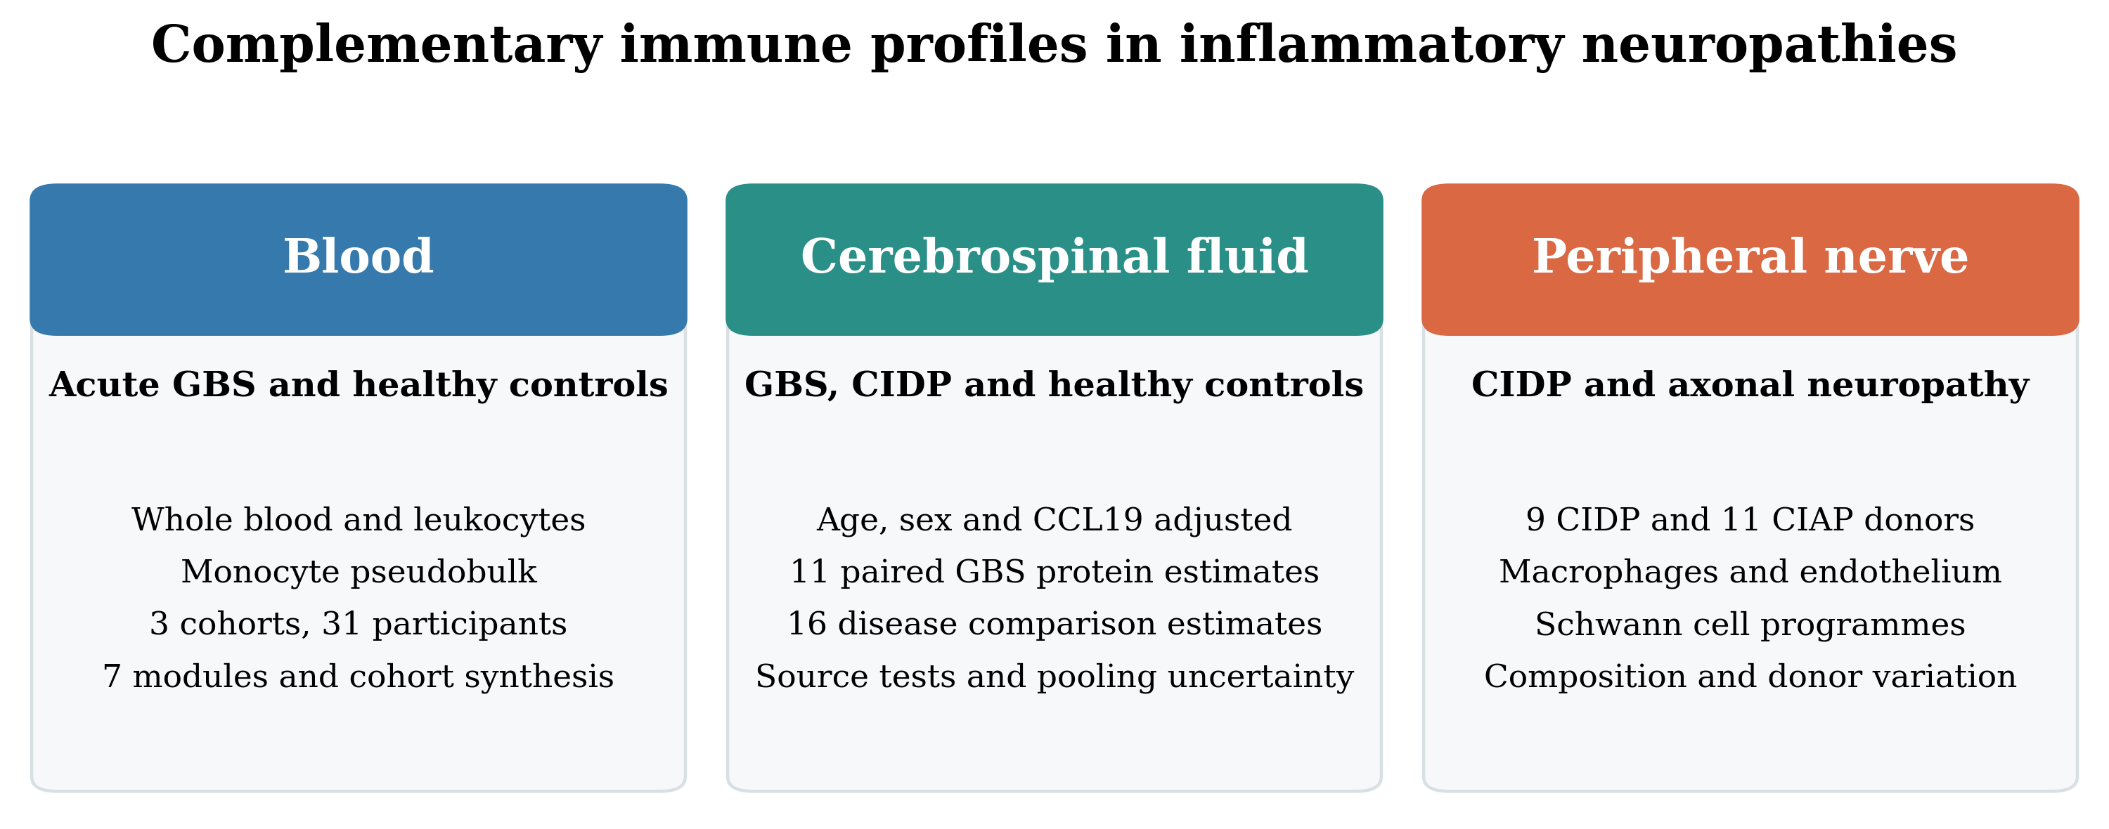
Blood gene modules identify recurring immune signals, published CSF protein coefficients provide related protein measurements, and nerve expression identifies the cells and programmes involved. The three analyses use separate participant cohorts. Direct GBS versus CIDP comparisons come from the CSF replication cohort. Normal BNB expression, published tissue observations and genetic candidate localisation support interpretation of the nerve findings. The diagram shows the analytical sequence, not a temporal sequence within disease.

Figure 2. Acute GBS blood modules across cohorts
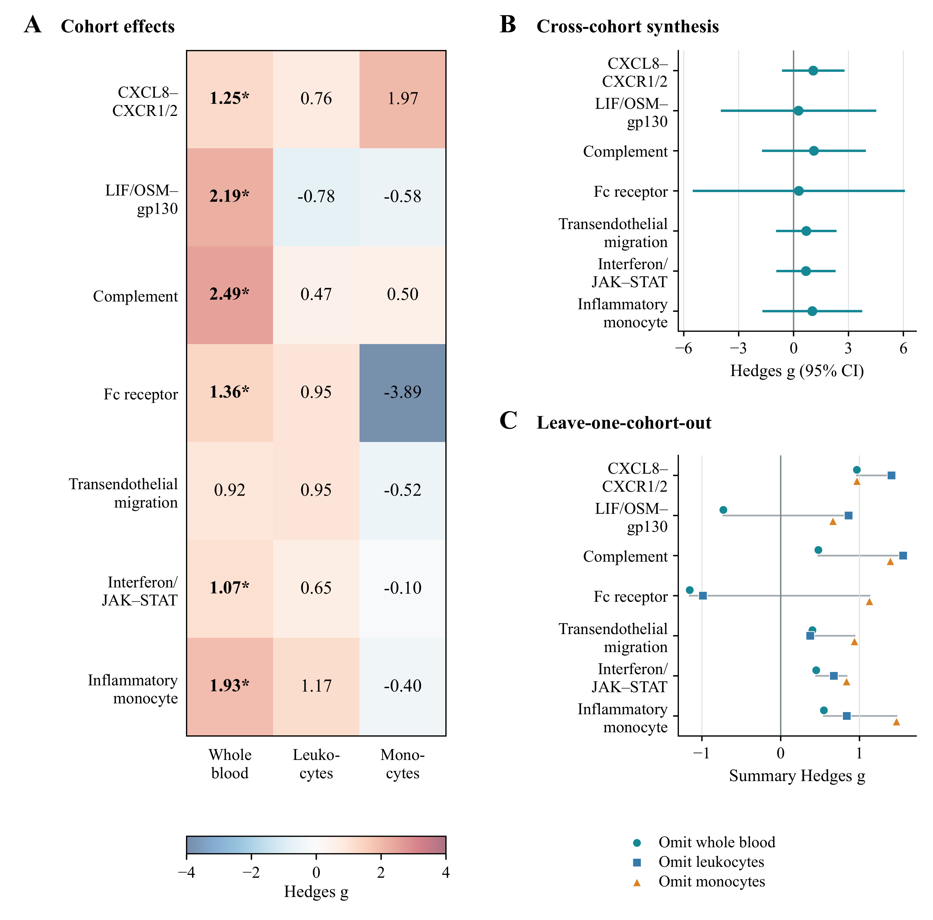
(A) Hedges g for seven gene modules in whole blood, leukocytes and monocyte pseudobulk. Asterisks mark q < 0.05 after correction within each cohort. (B) Random effects pooled estimates with 95% confidence intervals from the modified Hartung and Knapp method. All intervals include zero. (C) Pooled estimates after each cohort was omitted. CXCL8 recruitment and complement remained positive in every subset, with both individual effects positive in each retained pair.

Figure 3. Synthesis of published CSF protein coefficients
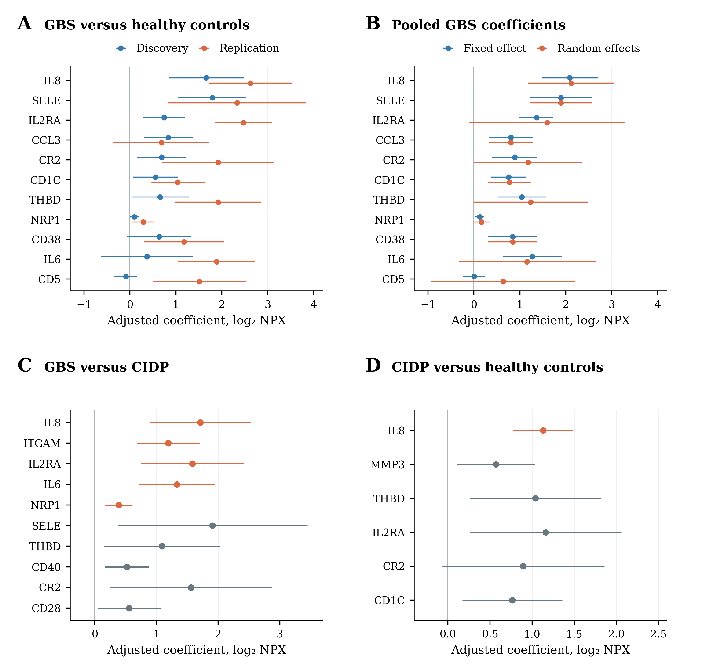
(A) All 11 proteins with paired GBS versus healthy control coefficients in source Tables 3 and 4B, adjusted for age, sex and CCL19 [36]. (B) Fixed effect and DerSimonian and Laird random effects pooled estimates. Panels A and B display normal approximation 95% intervals. All 11 modified Hartung–Knapp intervals include zero and are listed in Additional file 1. (C) All ten reported GBS versus CIDP coefficients. (D) All six reported CIDP versus healthy control coefficients. Panels C and D use participants from the same replication cohort. In panels C and D, orange marks the original source q < 0.05. Their intervals were reconstructed from the published standard errors using a normal approximation and may differ from the original small sample tests. NPX, normalised protein expression.

Figure 4. Immune and repair modules in CIDP nerve
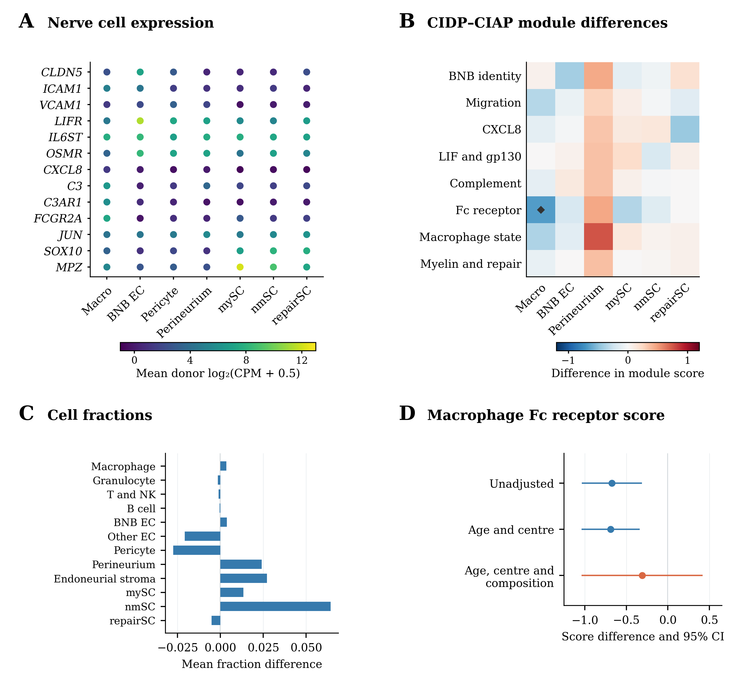
(A) Mean donor log₂(CPM + 0.5) expression in seven CIDP cell groups. Dots have equal area and share one colour scale. (B) Mean CIDP minus CIAP differences for the original modules. Diamonds mark q < 0.05 across eight modules within a cell group. The macrophage Fc receptor result has q = 0.099 across the expanded 91 test family. Earlier corrections are retained in the source tables. (C) Mean differences in cell fractions. The rank tests in B and C treat donors as independent samples. (D) Macrophage Fc receptor differences with HC3 95% intervals before and after adjustment for age, centre and two composition components. These model intervals are separate from the rank tests used to calculate module q values. BNB EC, endoneurial microvascular endothelium. mySC, nmSC and repairSC, myelinating, nonmyelinating and pooled repair and damage Schwann cells. Supplementary Figures 3 and 4 contain the full sensitivity analyses.

Figure 5. Separate endothelial and Schwann cell programmes
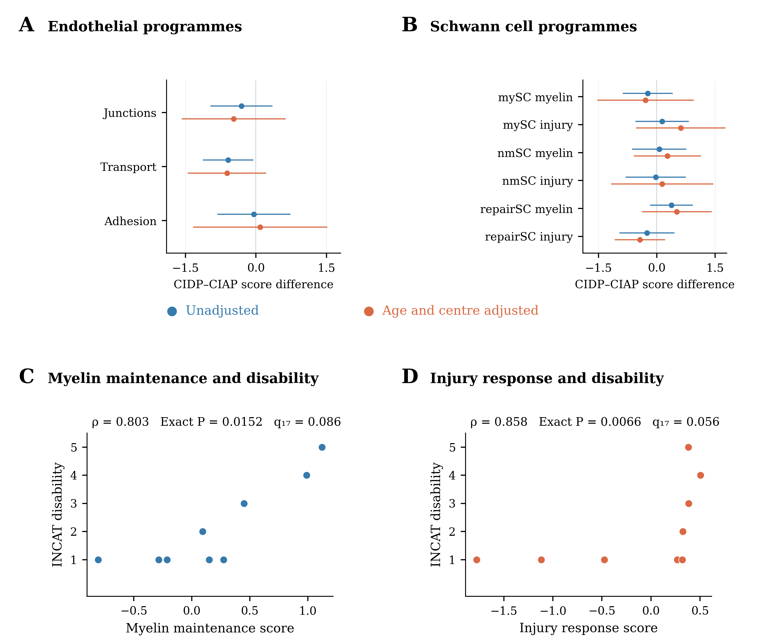
(A) Junction, transport and inflammatory adhesion gene sets in endoneurial endothelium. (B) Myelin maintenance and injury response gene sets in three Schwann cell groups. Points show mean CIDP minus CIAP differences before and after adjustment for age and centre, with HC3 95% intervals. The new scores standardise genes across eligible CIDP and CIAP donors. All nine comparisons have q > 0.05 across both the nine new tests and the expanded 91 test family. Unadjusted q values come from rank tests and are separate from the displayed model intervals. (C, D) The two scores in relation to INCAT disability in nine CIDP donors from the pooled repair and damage group. Exact P values use all 362,880 permutations and preserve tied ranks. Displayed q values combine these two exact tests with the 15 archived clinical tests. Neither association meets q < 0.05. Abbreviations are defined in Figure 4.

