Additional file 3. Supplementary figures
Immune gene and protein profiles across blood, cerebrospinal fluid and peripheral nerve in inflammatory neuropathies

Supplementary Figure 1. Donor bootstrap intervals for genetic candidate expression
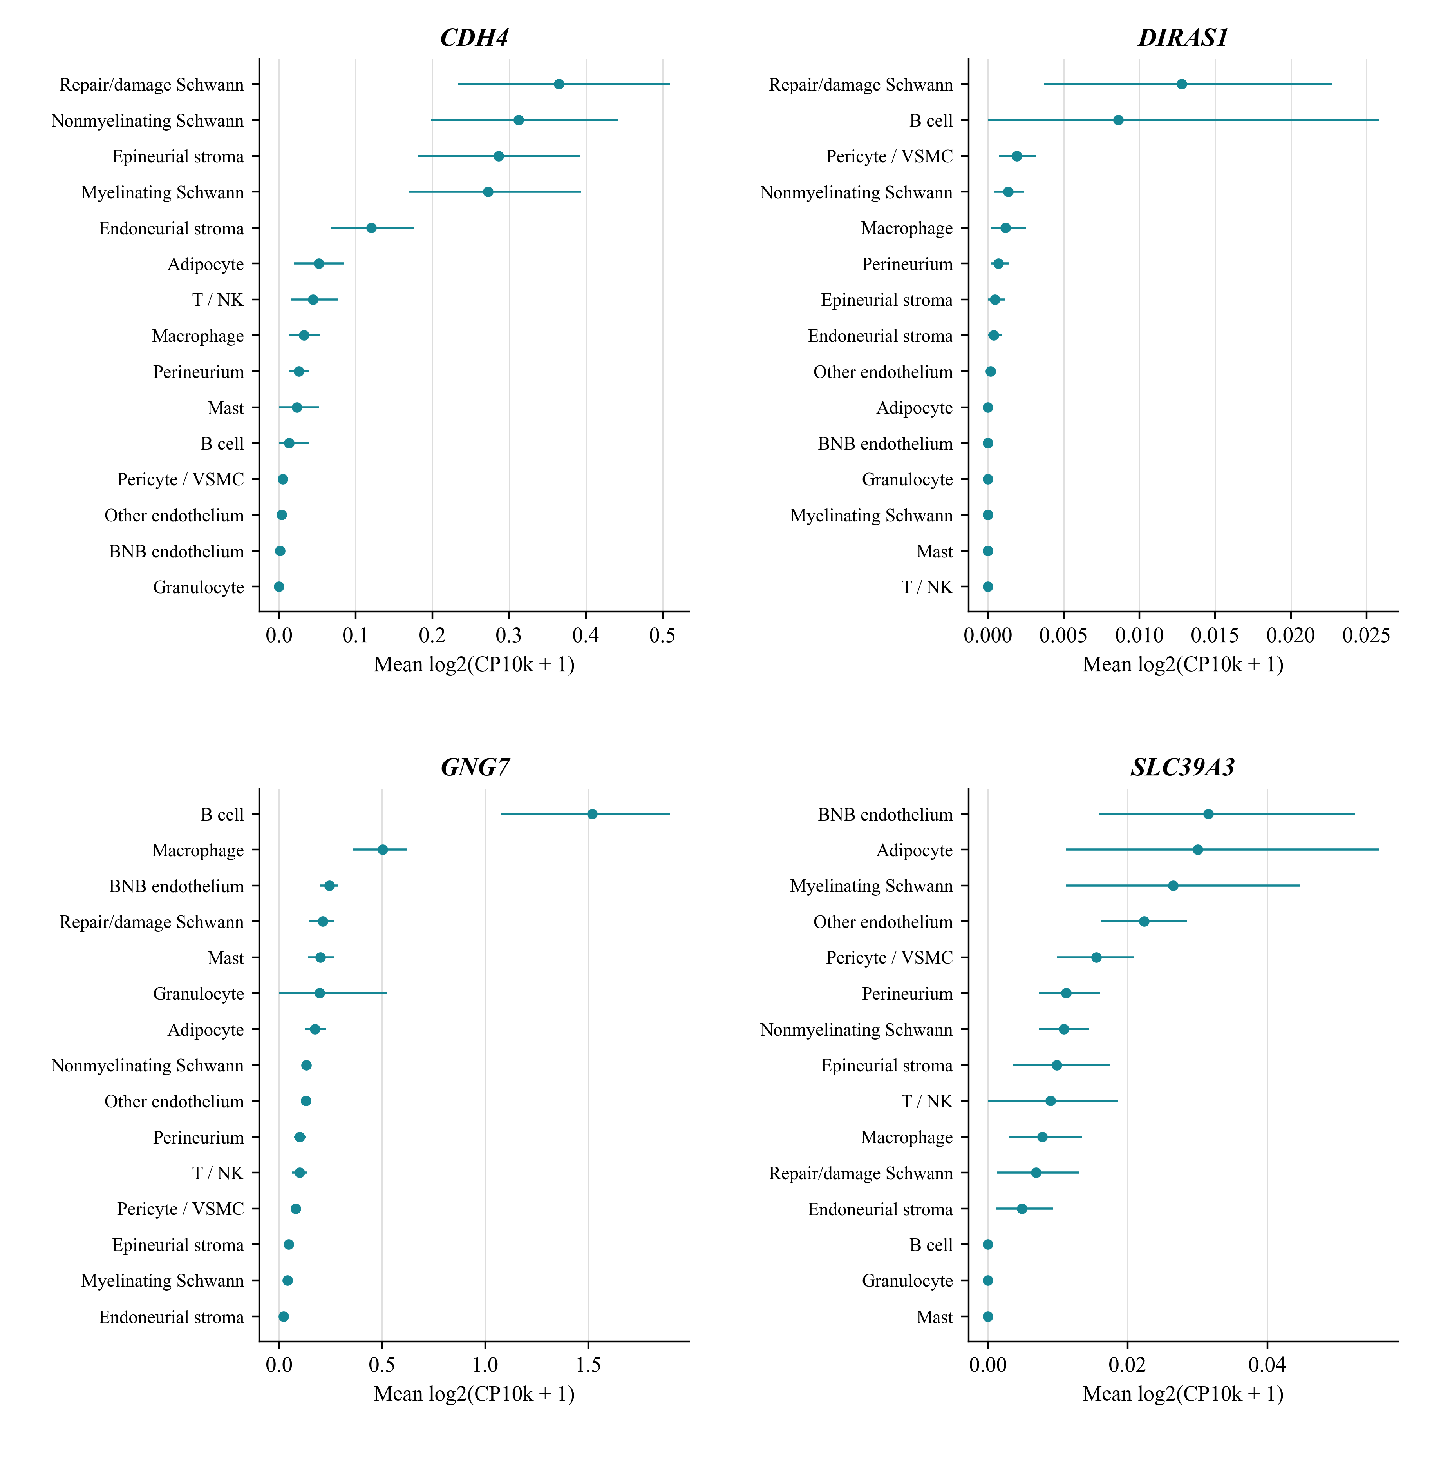
Points show mean log2(CP10k + 1) across eligible CIDP donors. Bars show percentile 95% intervals from 5000 resamples within each gene and cell group. Resampling was performed at donor level with random seed 20260904. The intervals quantify uncertainty in the donor mean for each gene and cell group. The source values and eligible donor counts are provided in the Genetic_bootstrap worksheet of Additional file 1. This localisation workflow did not impose the 20 nucleus cutoff used for pseudobulk modules. Eight of the nine CIDP B cell samples contained fewer than 20 nuclei, limiting precision for that population.

Supplementary Figure 2. Published nerve observations and complement deposition
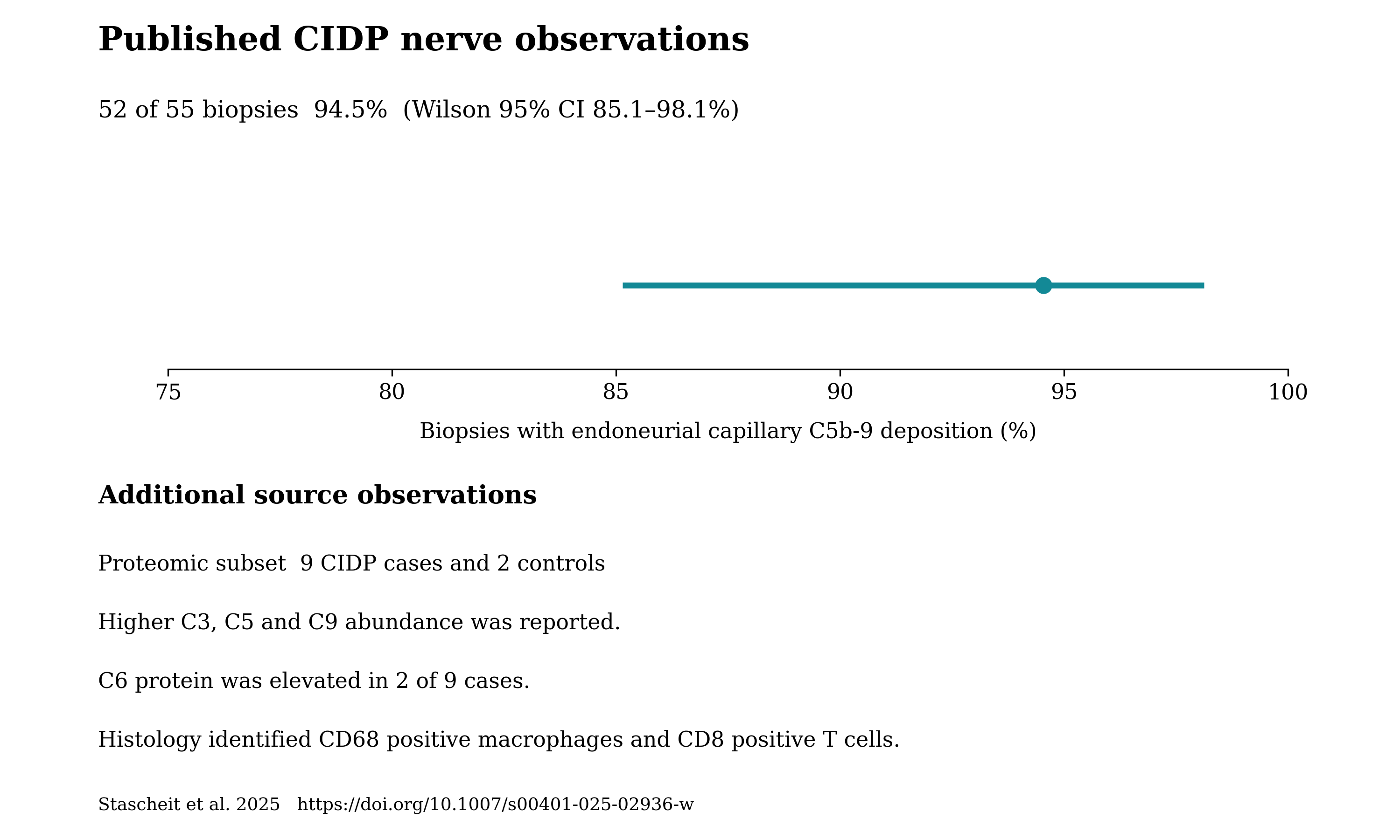
Stascheit et al. reported deposition of the terminal complement complex on endoneurial capillaries in 52 of 55 biopsies from patients with CIDP or its variants, together with histological and proteomic findings [37]. The proportion of 94.5% and Wilson 95% interval of 85.1% to 98.1% were calculated from the published count. The other observations summarise qualitative findings from the source study associated with PXD056286. The proteomic subset comprised nine CIDP cases and two controls. Higher C3, C5 and C9 abundance was reported, while C6 protein was elevated in only two cases.

Supplementary Figure 3. Fc module components and donor sensitivity analyses
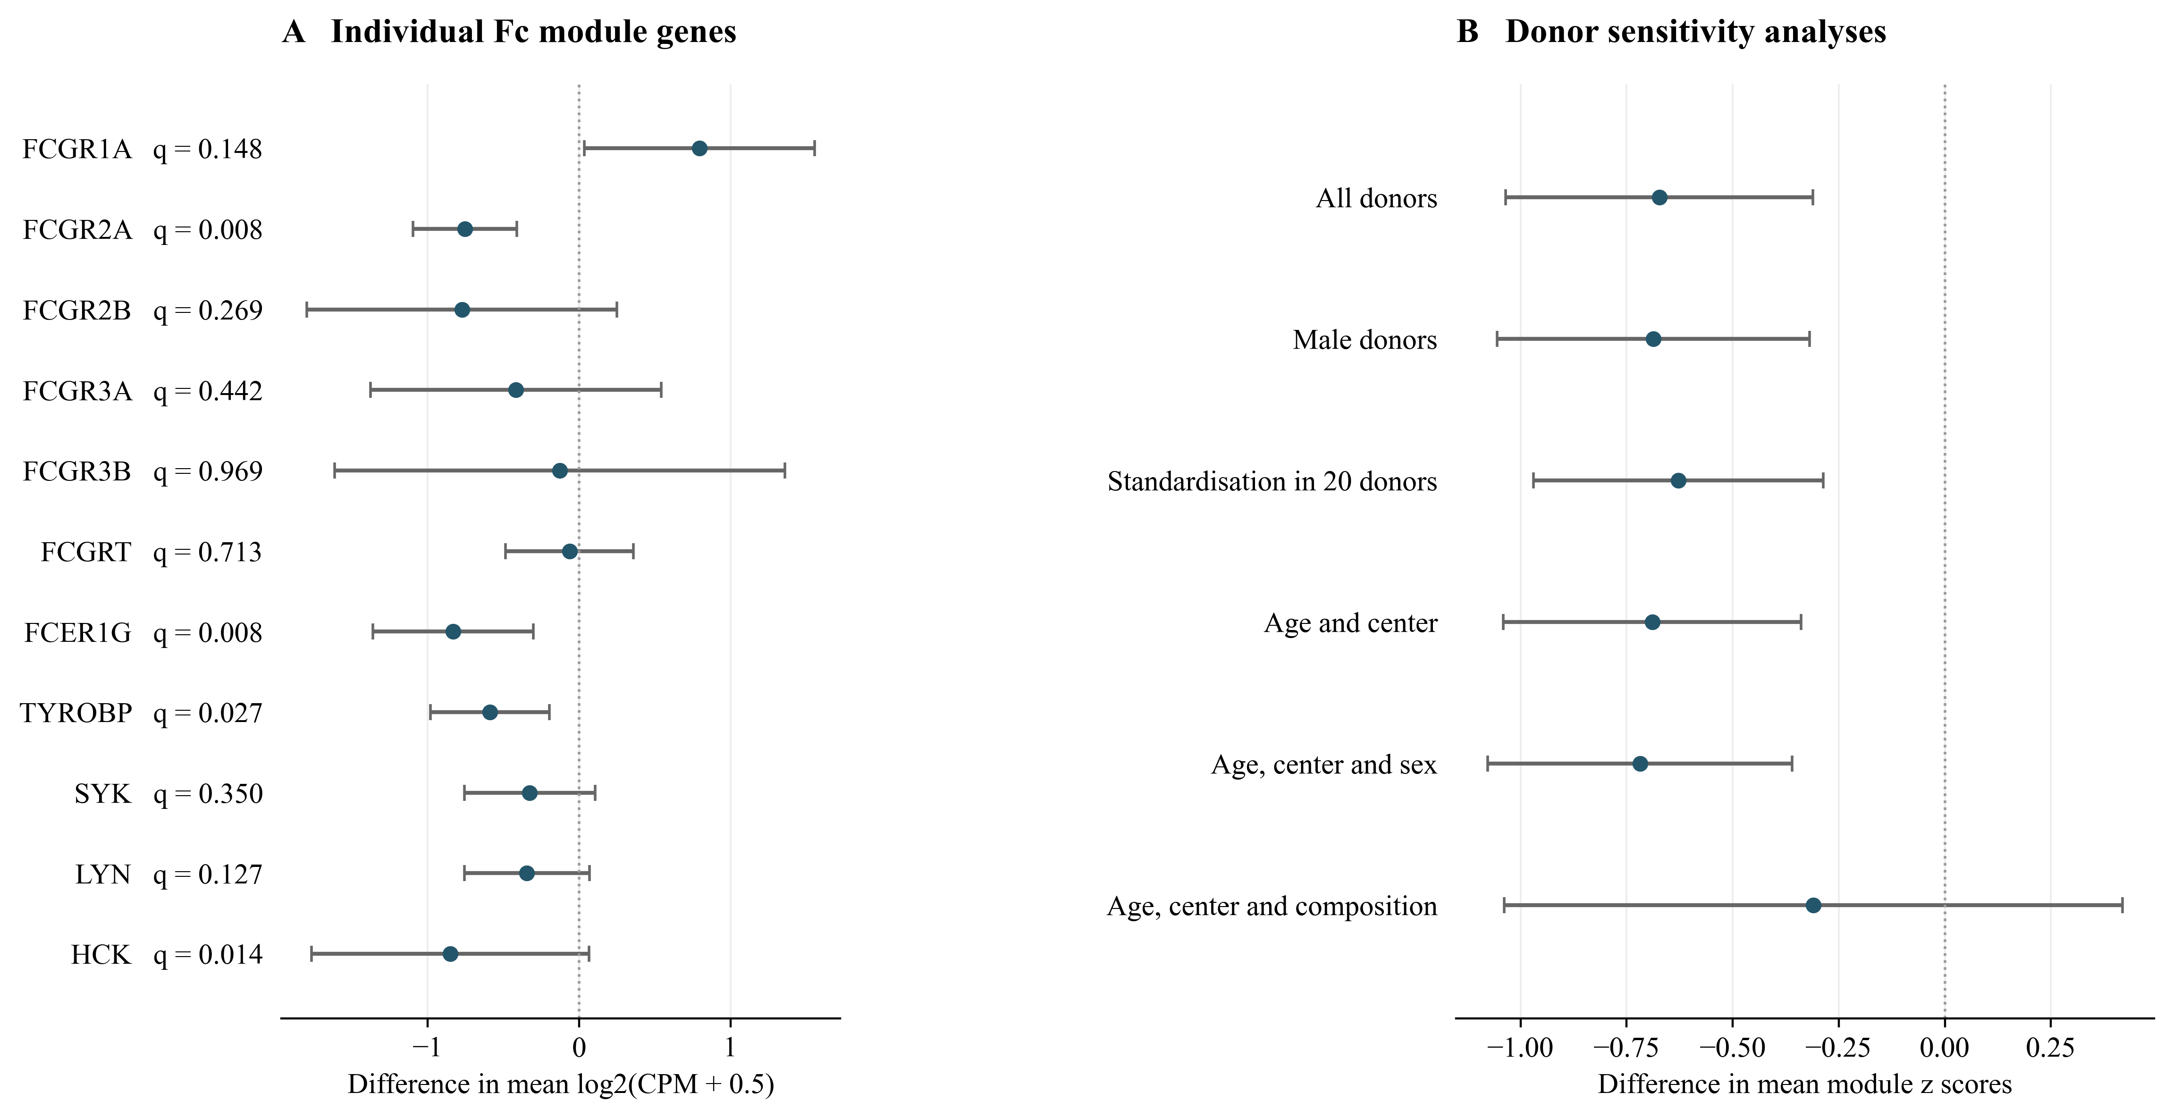
(A) Differences in mean log2(CPM + 0.5) for the 11 measured genes, calculated as CIDP minus CIAP. FCGR2C was absent from the matrix. Displayed q values were derived from two sided Mann and Whitney tests with Benjamini and Hochberg correction across the 11 genes. Points and bars show mean differences and unadjusted 95% confidence intervals from separate ordinary least squares models with HC3 covariance and residual degrees of freedom. These intervals do not correspond to the rank tests used to calculate q values. (B) Module score differences under demographic and composition sensitivity analyses, with HC3 95% confidence intervals. Standardisation within the 20 CIDP and CIAP donors changes the score scale. The exact permutation test within centres gave P = 0.0048 and is reported separately from the model intervals. The original module q value was 0.0087 within eight macrophage modules and 0.087 across all 80 eligible module tests. These exploratory analyses followed the initial Fc module observation. When the nine new programme tests are included, the original Fc module result has q = 0.097 across 89 tests.

Supplementary Figure 4. Fc scores under alternative macrophage annotations
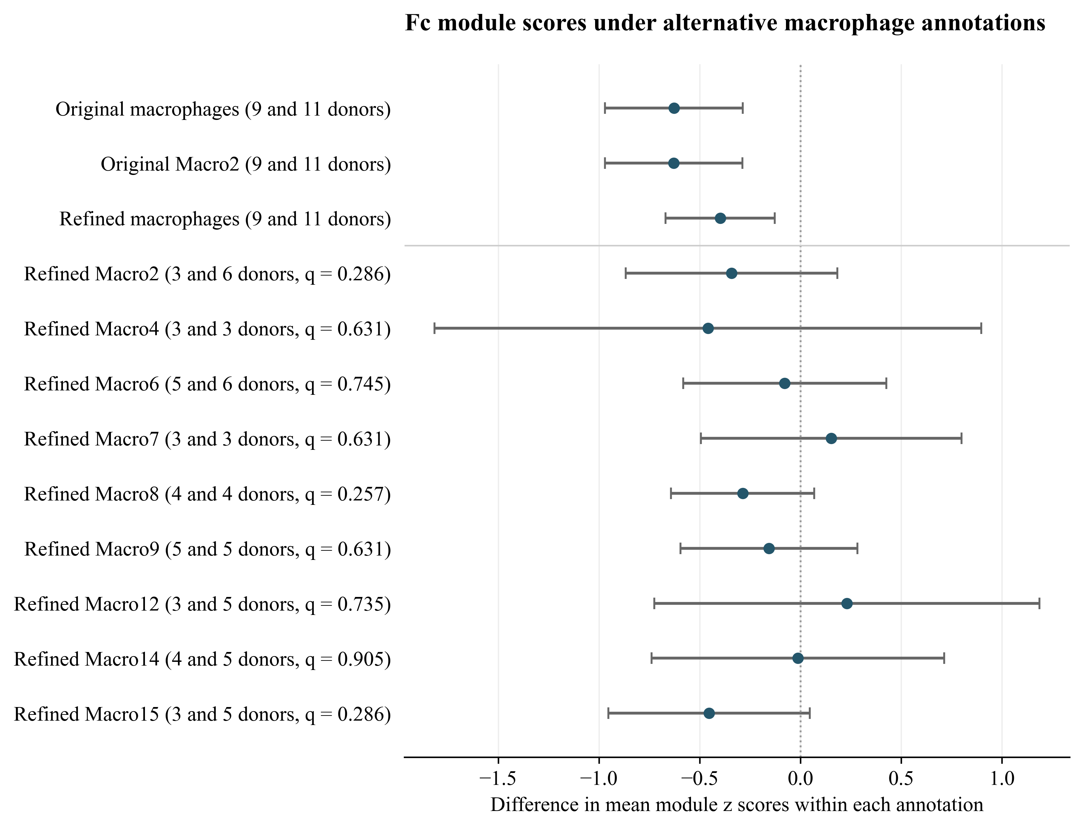
The original and refined annotations represent distinct classification levels. The refined union contains Macro1 through Macro18. Eligibility requires at least 20 nuclei per donor and three donors per diagnosis. Original Macro1 was ineligible. Points and bars show mean score differences calculated as CIDP minus CIAP, with unadjusted HC3 95% confidence intervals. Genes are standardised across eligible CIDP and CIAP donors within each annotation. Parentheses give CIDP and CIAP donor counts. Subtype q values were derived from two sided Mann and Whitney tests with Benjamini and Hochberg correction across nine subtypes, and all exceed 0.05. The three broader definition checks form a separate testing family. The HC3 intervals describe mean differences and do not correspond to the rank tests used for q values.

Supplementary Figure 5. Cellular expression of published genetic candidates
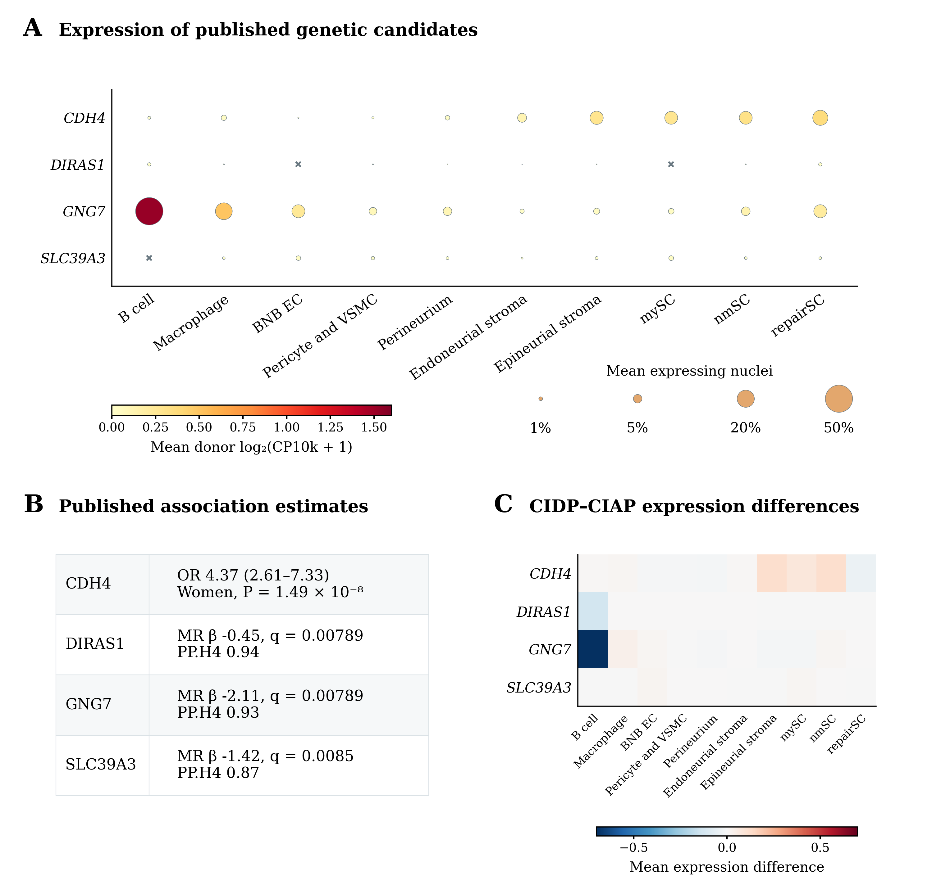
(A) Donor mean expression and detection for CDH4, DIRAS1, GNG7 and SLC39A3. Colour shows the mean of donor mean log2(CP10k + 1) values. Dot area is proportional to the mean donor percentage of expressing nuclei, with crosses for zero detection. Each summary gives equal weight to nine CIDP donors. This workflow did not apply the 20 nucleus pseudobulk cutoff. Eight of nine CIDP B cell groups contained fewer than 20 nuclei. (B) Published estimates from Du et al. used for candidate selection [32]. The CDH4 odds ratio concerns rs80339443 in women. MR denotes Mendelian randomisation and PP.H4 the posterior probability of a shared causal variant. (C) CIDP minus CIAP donor mean expression. All displayed q values exceed 0.05 after correction within the original candidate screening family. These expression summaries do not establish genetic mediation. Abbreviations follow Figure 4.

Supplementary Figure 6. Original nerve module correlations with disability
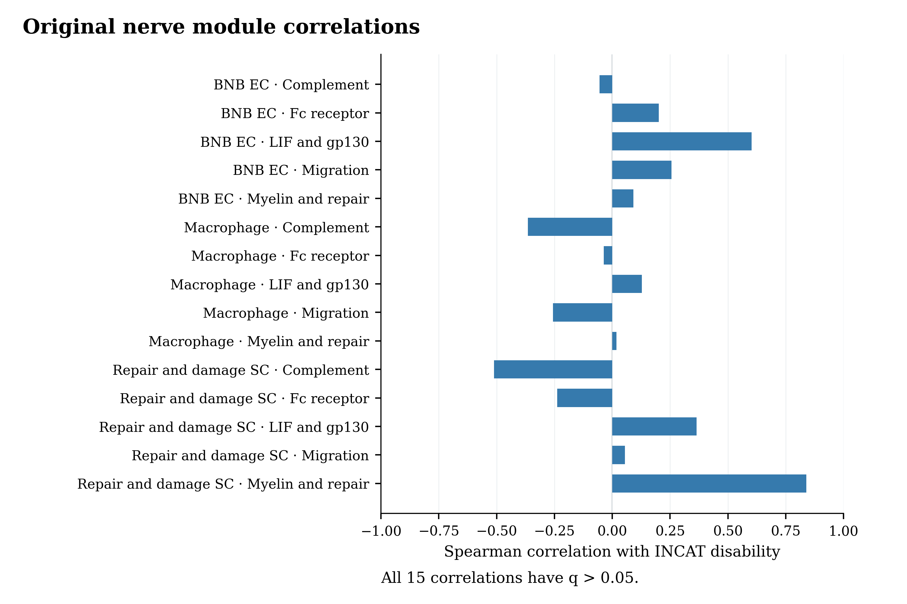
Spearman correlations between the 15 original combinations of cell group and gene module and INCAT disability in nine CIDP donors. All original q values exceed 0.05 after correction across 15 tests. The combined myelin and repair score in repair and damage Schwann cells has ρ = 0.840, P = 0.0046 and q = 0.069. These archived tests use asymptotic P values. The two separated programme correlations are reported in main Figure 5 using exact P values and an expanded 17 test correction. The original correlations are preserved without changing their P values.

Supplementary Figure 7. Selected endothelial genes in normal human BNB preparations
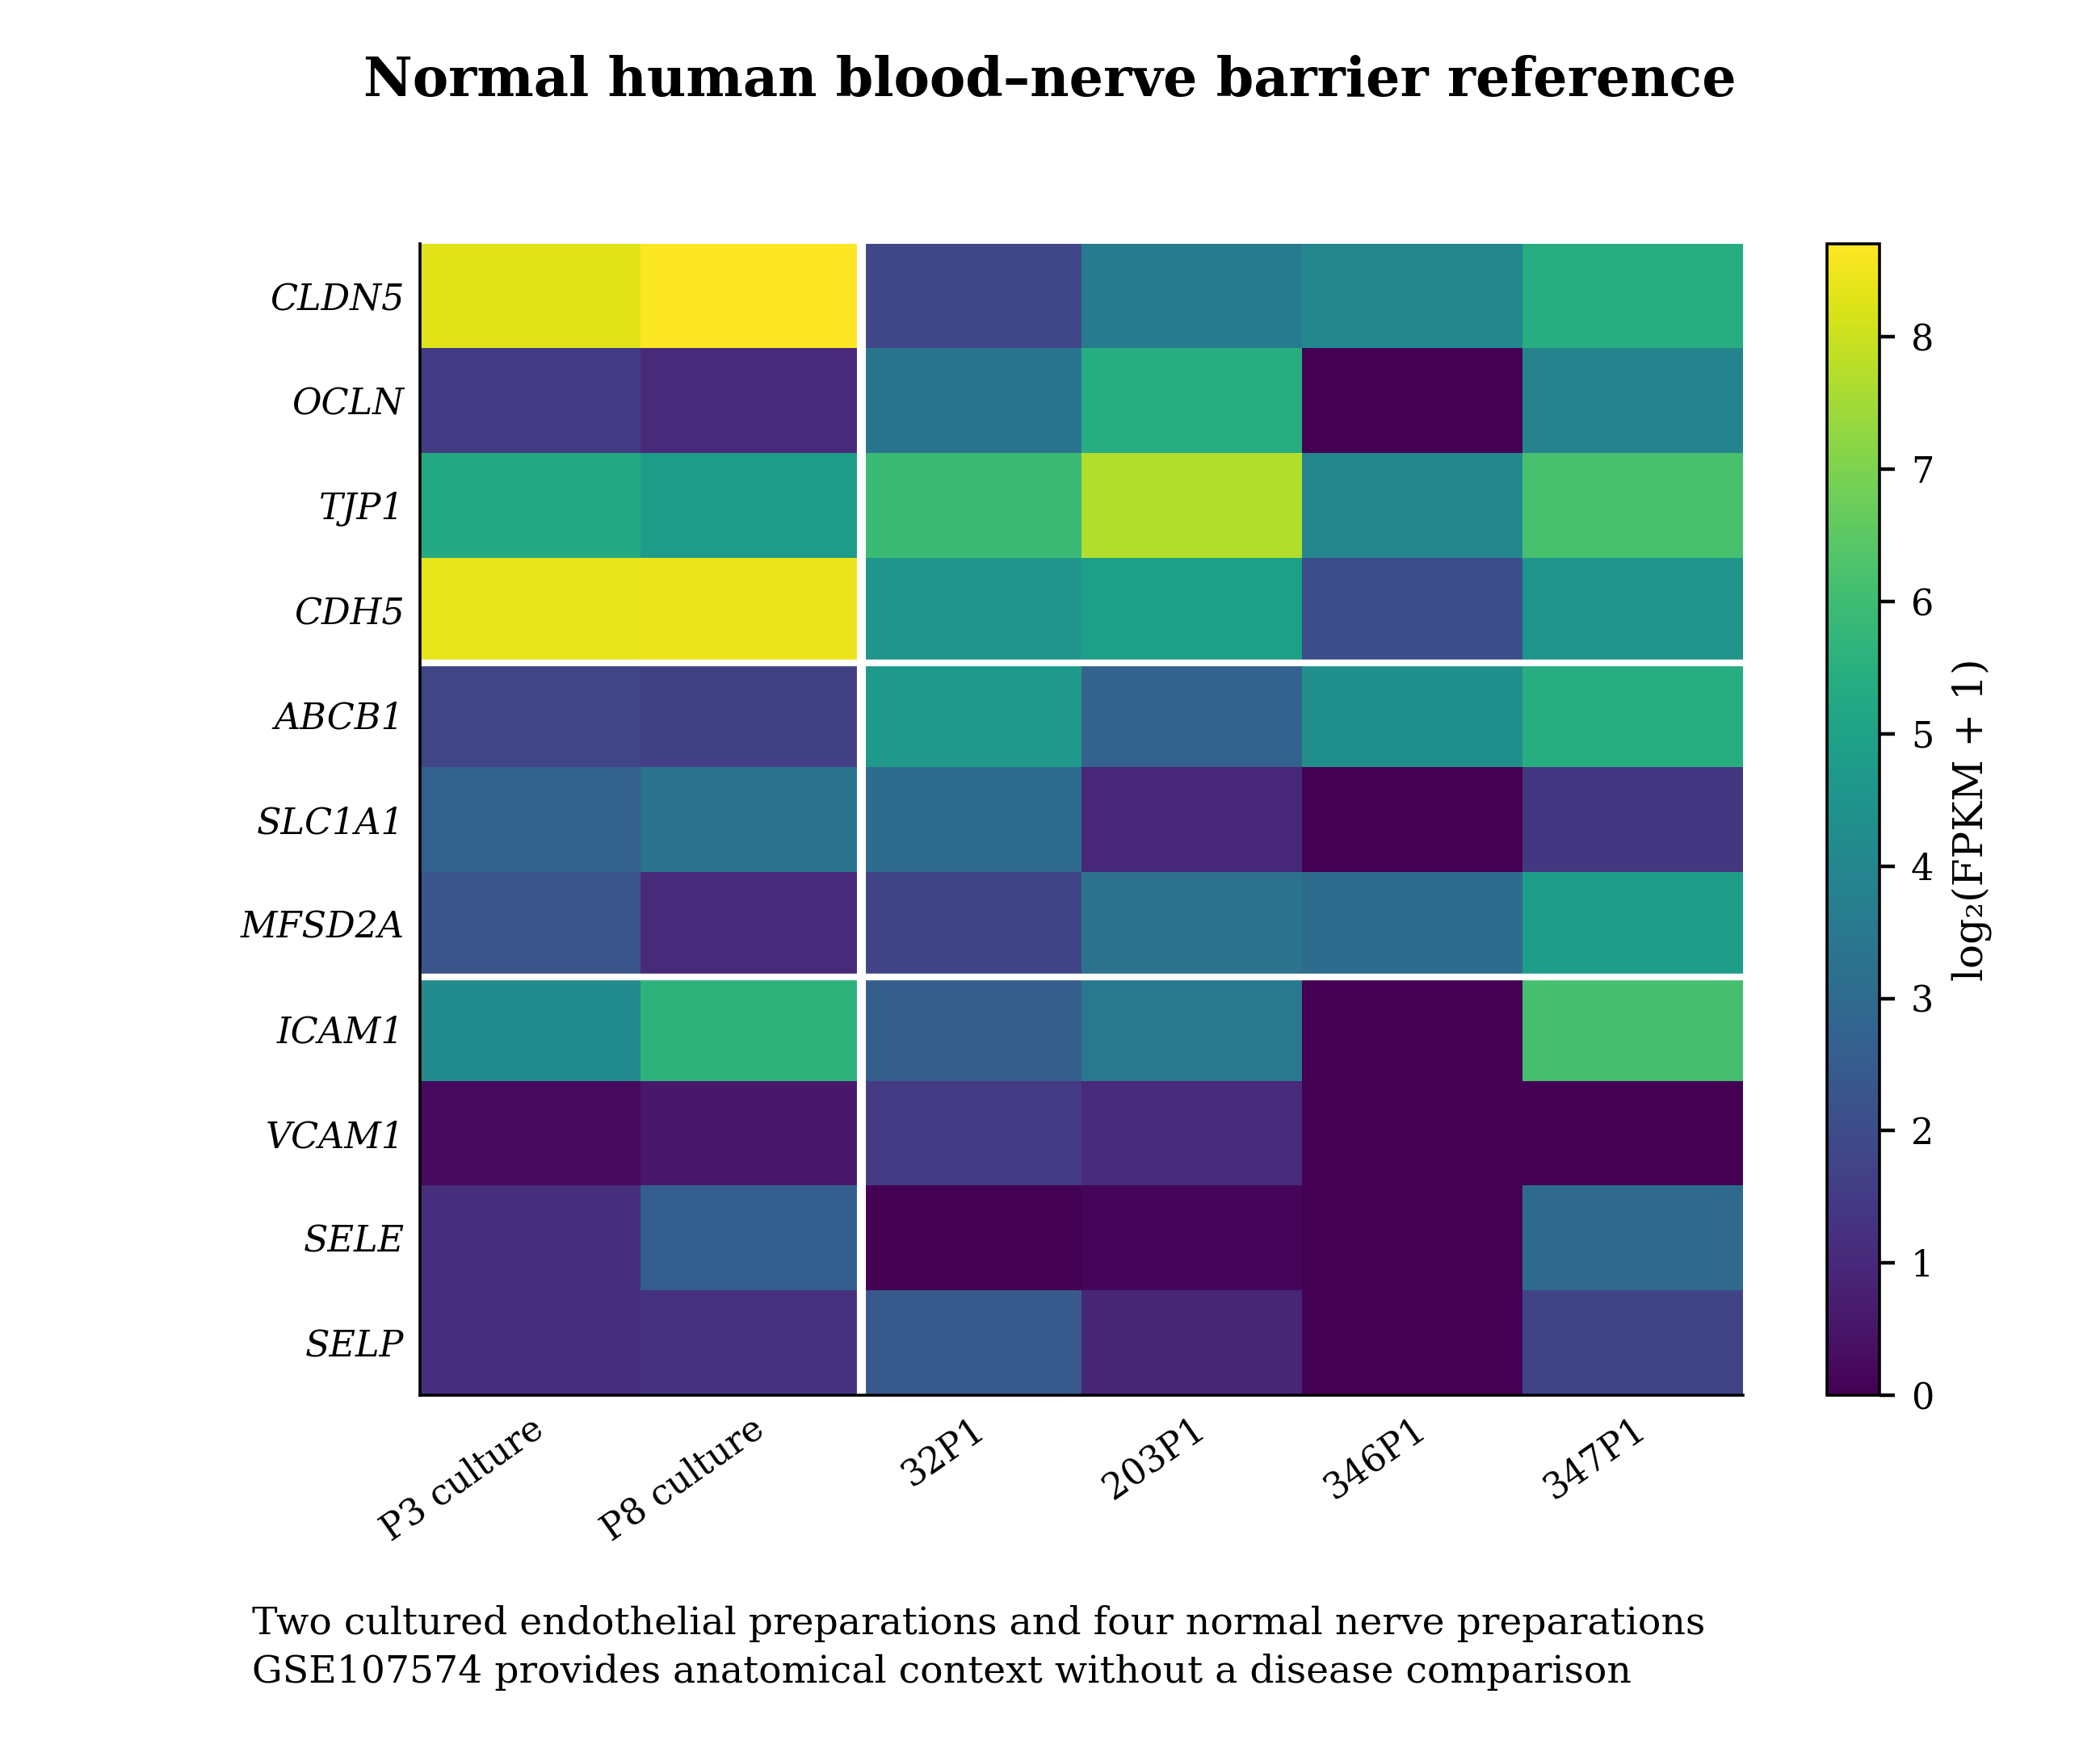
Expression of all 11 genes in the endothelial junction, transport and inflammatory adhesion sets in GSE107574. Colour shows log2(FPKM + 1). The first two columns are cultured endothelial preparations at different passages, followed by four laser captured normal nerve preparations. White lines separate preparations and gene sets. All 11 genes were detected in at least two of the four nerve preparations. These samples provide anatomical expression context and contain no CIDP comparison. They are not independent disease validation and were not treated as six independent patients.

