

|  |
| --- |
| Manual for  Assignment 3 |
|  |
|  |

# Catalogue

|  |
| --- |
| 1. Main form overview 2. Read a file 3. Save a file 4. Chart 5. Search 6. Add Player or Add teams 7. List |

# Main form overview

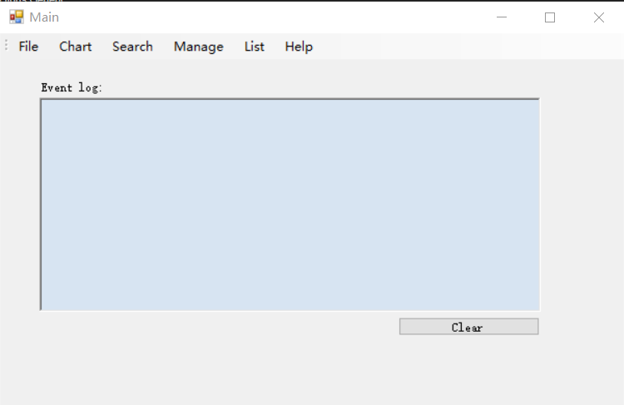

This is main form, it has 6 functionalities and a event log, the event log will record some manipulations that user did such as if the file is read or saved, or how many players or teams were added after reading a file etc. It has a clear button and click it will clear the event log box.

# Read a File

Directory: File -> Open

After click the “Open”, the user will see the open file dialog, after reading the file, the message “File was read at xxxx” would apear to tell the user that program finished to read the file. For reading the file, only txt file is allowed.

If the file only contains players or only contains teams, user can easily find there were 0 teams or 0 players were added, same as if the file is empty, the teams and players that added will both be 0, such as line two on the diagram below.

This program has considered several situations.

There are 3 situations when adding the player by reading from the file

First one is the ID is duplicated, in this case, the code will be devided to handled two sub-situations.

One is this players has already have team, the other one is do not have team.

The program will tell the user to change the ID first(A message box will appear), after the user click “Yes”(the only button of the message box, the text on it will depends on the users’s system language, but always means “yes”), a new form called “AddPlayerFrom” will just appear, and a suggested ID will also be filled into ID NumericUpDown initially.

If the team is exist when you are adding this player, this from will add this team and close it self, if the team is not exits, a tip form will apper to ask if the user want to add this player, if the user click “yes”, then another new form called “AddTeamForm” will appear, in this case, the team name will not allowed to change and becom gray.

If the user click “No” on the tip form, it will back to the AddPlayerFrom, and if the user click “cancel” on the AddTeamForm, the Tip form will appear again to ask if the user want to add the team, and if the user click “cancel” on the AddPlayerFrom, this player will not be added.

The other situation is if the player has a team already, and ID is not duplicated, this player will be added automatically.

The third situation is when player has no teams and ID is not duplicated, the program will save all those players into a arrays, and after finishing read the file, the Tip Form will appear and ask user if the user want to add this player one by one, which means if there are 10 players who has no team, the program will ask if want to add the user for 10 times. If the user click “ Cancle” this player will not be added.

When the user is adding the player who has no team but ID is not duplicated, the this will cause 2 sub-situations.

First situation will have same effect that is introduced before(The case that ID is duplicated and has no team), the only different is there will only AddTeamFrom appear but will tell you which player the user is adding for, and the ID suggestion will not appear.手机截图图社交软件的信息

If the user “click” cancle, this player will not be added.

The second case is if there are two players who have the same teams, after the user added the team for the first player, the second player will be added automatically, this is checked by those code, every time when the user added one team for a player who has no team, this code will check if there is any player who has no team can be added to the new team that user just added.

After finishing adding the players who has no team, a line on the event log will appear to tell user how many players who has no team are added(e.g: Second line of event log on the first picture).

There are two situations when adding the team by reading from the file, one is the team has already exist, in this case, this duplicated team will be ignored automatically,This program will not ask user to change team, change the name dose not make sense, because the real team’s name is not going to change even the user change the name in the program. The other case is not exist, it will directly read this team into the program.

# Save the file

Directory: File -> Save

This functionality can save the teams and players into one file, depends on which button you clicked, there are three buttons, it allows user save all teams and players into one file or just save all the teams into a file or just save all the players into a file.

If there is no teams or players on record but the user still click save file button, a empty txt file will be generated.

# Chart

Directory: Chart

This program can plots all the players' height and weight, also the age group, for the age group, it can devide all players into 7 diffenent groups, as the above digram shows. If there is no players on record, the chart can not be open and a message will tell the user by showing on the even log.

# Search

Directory: Search->Player

The program can search for players by age and place of born. If the user searches for a specific age or place of born, the list of players will be displayed. If there is no players on record, the chart can not be open and a message will tell the user by showing on the even log. If no players are found or the entering is empty, a messege box will just appear to tell user what happened. The program can also determin if the user’s input is an age or a bornplace. When searching the born place, the program support fuzzy search and user does not have to worried about the upper case or lower case.

# Add Player or Add teams

Directory: Manage->AddTeams, Manage ->AddPlayers

The program can store the following information about each player – ID number (unique), name, birth date, height, weight, place of Birth and the team they are signed in. The system should also store the following information about each team – name (unique), ground, coach, founded year, region and a list of players enrolled in the team.

The program should store a collection of players and the team the player signed in, it should also have the functionality to add a new player and a new team to the system, and sign a player to a team. For the situation that can happened during the adding time, I have talked them in the part of reading the file. For the limit of the birth day of a player, maxium is the current date of today, and the minimum is 1/1/1753 which is the earliest date of that is limited by the system, for the limit of founeded year of team, the minimum is 1 and maxium is the current date of year. The suggestion of ID will not be shown unless the program find the ID that user input is duplicated, but the user can still set the ID as -1 to let the program generate an avaliable ID automatically.

The other thing is the maxium weight and maxium heigh that can be set are 255, the program used the short type to store each value, as normally a player will not havier than 255 kg or higher than 255 cm, use a short type can use less the storge space.

# List

Directory: List -> Player, List -> Teams

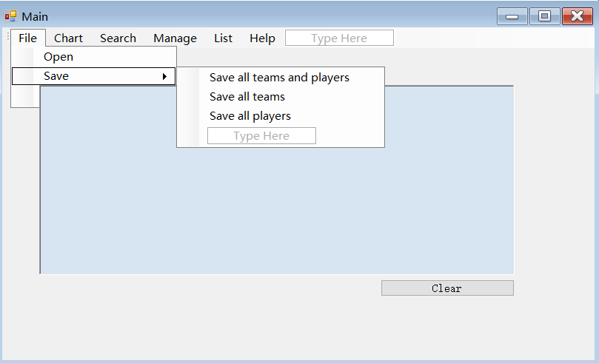

The program is able to display a list of all the players, a list of all the teams, allow the user to select a player and display the team that player is signed in and allow the user to select a team and display all of the players signed with it. If there is no players or teams on record yet, a message will shows on the event log, if the user click a team without any players, the “List of all players in this team” will not be shown and nothing will happens.