STaR-Body: Joint-Indexed Feedback
for Spatiotemporal Human Mesh Refinement
Anonymous submission

Abstract
Video human mesh refinement must combine evidence across frames while directing each correction to the appropriate body part. However, pooling landmark feedback erases which landmark produced a residual, even when the image features remain spatially structured. To preserve this correspondence, we introduce STaR-Body, a geometry-guided framework for camera-space pose and shape refinement. A dual-order decoder integrates image and video tokens, while a track-conditioned residual shares shape information across a person track. Anatomically biased attention then routes 17 identity-bearing landmark tokens to 24 pose joints. A part-aware iterative refiner combines these features with local image evidence and composes bounded rotation updates; zero-initialized feedback preserves the inherited prediction at initialization. On 10,413 person-frames of the 3DPW validation split under a shared crop protocol, joint-indexed feedback reduces vertex error by 0.31% against a mean-feedback control at the same refinement budget. The complete refinement stage also lowers vertex error on 11 of 12 sequences relative to its common starting model.

1. Introduction
Monocular human mesh recovery estimates an articulated body from images. Parametric models such as SMPL [13] provide a common representation of pose and shape, while image-based regressors [6, 8, 11] recover useful estimates from a single observation. Video offers repeated views of the same person, creating an opportunity to combine local appearance, body geometry, and temporal context. An effective refiner must decide which evidence should change each body joint and which information should remain shared across the track.
Geometry-aligned methods revisit image features around the current mesh [26, 27], and temporal models relate predictions across frames [2, 9, 15]. These mechanisms address where to sample visual evidence and when to exchange it. A complementary question concerns the feedback interface itself: does the correction stage retain the anatomical identity of the evidence it receives? When landmark residuals are averaged into one vector and broadcast to every joint, their assignment to body parts disappears. A wrist residual and an ankle residual can therefore produce the same pooled feedback after their values are exchanged, although the corresponding pose corrections act on different branches of the kinematic tree.
This observation concerns the feedback representation. The image grid, pose queries, and projected geometry remain spatially structured, yet a pooled feedback channel cannot distinguish two assignments with the same average. Preserving landmark identity at this interface gives the subsequent refiner access to a distinction that pooling removes. Figure 2 illustrates this mechanism with a schematic exchange of landmark evidence.
We address this issue with STaR-Body, or Spatial-Temporal Attentive Refinement. The framework combines a dual-order spatiotemporal decoder, a track-conditioned shape residual, and a joint-indexed refinement stage. Its central module retains 17 landmark identities and routes their residual evidence to 24 pose joints through anatomically biased attention. The receiving joints then exchange information within anatomical parts and across time before a recurrent refiner updates their rotations. Thus, evidence is assigned to joints before it is shared among them.
The refinement preserves a controlled starting point through a zero-initialized feedback branch and bounded rotation increments. Moreover, complete-sequence motion accounting includes transitions across inference-window boundaries. Together, these choices support an equal-budget comparison of mean and joint-indexed feedback.
We evaluate this comparison on the 3DPW validation split using the same parent checkpoint, cached visual inputs, crop protocol, and training schedule. After 1,000 additional steps, joint-indexed feedback reduces vertex error from 73.05 to 72.82 mm and yields lower values for all four reported metrics. Sequence-level analysis shows that the complete refinement stage reduces vertex error on 11 of 12 sequences relative to the parent. We contribute:
• We identify how mean landmark feedback discards anatomical assignment and formulate an identity-preserving interface for body-joint refinement.
• We introduce anatomically biased landmark-to-joint attention within a spatiotemporal refiner, with inherited-output-preserving initialization and bounded iterative rotation updates.
• We evaluate the feedback design through an equal-budget validation comparison and complete-sequence analysis, connecting aggregate geometry improvements to changes across individual sequences.

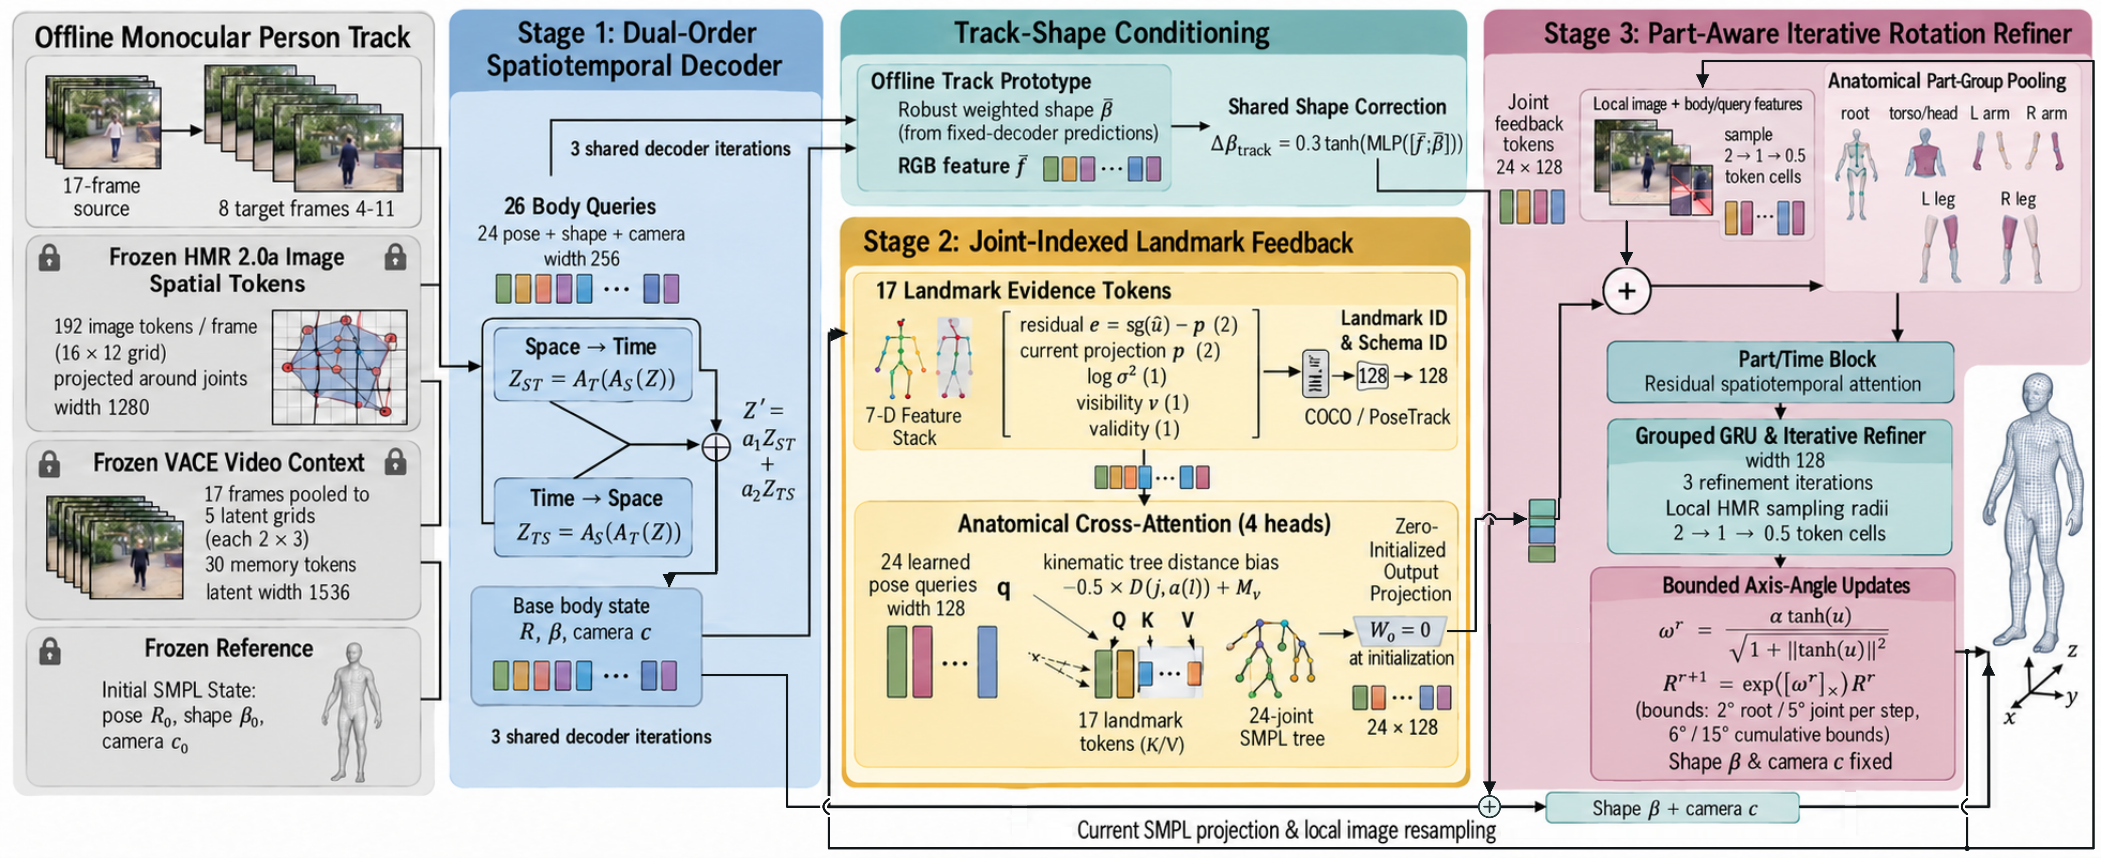
Figure 1. STaR-Body overview. Frozen image and video features support contextual body decoding. A track-conditioned residual shares shape information across a person, while projected landmark evidence is routed to individual pose joints. Part/time attention and grouped recurrent updates refine rotations, recomputing geometric evidence at each iteration. Shape and camera remain fixed during the final rotation-refinement stage.

2. Related Work
Image-based estimation and geometric feedback. HMR [8], SPIN [11], and HMR 2.0 [6] establish regression-based pose and shape estimation from images, with SPIN incorporating model fitting during training. PARE [10] uses part-guided attention to associate image features with body regions. PyMAF [26] and PyMAF-X [27] revisit features aligned with the projected mesh and iteratively update its parameters. These approaches motivate geometry-aware refinement. ReFit [21] recurrently updates body estimates using locally sampled marker features. STaR-Body focuses on a complementary interface: the assignment of predicted landmark evidence to pose joints before anatomical pooling. Its controlled comparison changes this feedback representation while retaining the visual inputs and body representation.
Temporal and world-grounded reconstruction. VIBE [9] models temporal context with a motion prior, TCMR [2] emphasizes temporal information beyond static features, and GLoT [15] combines global and local temporal modeling with spatial correlation. STaR-Body likewise exchanges information across frames, but separates temporal interaction from the routing of local feedback to joints. Its dual-order decoder supports spatial-first and temporal-first processing, while the final recurrent state advances over refinement iterations. GLAMR [25], WHAM [17], TRAM [22], GVHMR [16], HumanMM [28], and OnlineHMR [29] additionally address global motion, camera trajectories, multi-shot input, or streaming reconstruction. Several also report camera-space body accuracy and are relevant external comparators. Their global-motion and streaming capabilities remain distinct from the offline, joint-indexed refinement interface studied here.
Pose representations and observation conditioning. TokenHMR [4] introduces a tokenized pose representation, MEGA [5] uses a masked generative autoencoder, and ScoreHMR [18] refines estimates through score-guided diffusion. PromptHMR [23] incorporates spatial and semantic prompts, while HSMR [24] reconstructs a biomechanically accurate skeleton. STaR-Body instead applies deterministic residual updates to SMPL rotations. Its inherited landmark heads supply conditioning features, and three-dimensional geometry and motion objectives train the final refinement stage.
Visual representations. Attention [19] and vision transformers [3] provide token interfaces for combining heterogeneous features. We use spatial HMR 2.0 [6] features and cached Wan/VACE video features [1, 7]. Although Wan and VACE originate from video generation and editing, their role here is frozen feature extraction; body reconstruction remains a discriminative geometric computation. Together, these representations supply appearance and temporal context. The method below explains how STaR-Body turns that context into joint-specific feedback and bounded body updates.

3. Method

3.1. Body state and spatiotemporal context
Given an offline monocular person track, STaR-Body predicts a camera-space SMPL state xₜ = (Rₜ, βₜ, cₜ) for each target frame: 24 rotations Rₜ, ten shape coefficients βₜ, and crop camera cₜ = (sₜ, tₓ,ₜ, tᵧ,ₜ). SMPL [13] produces vertices and joints, and the crop camera projects the joints into normalized image coordinates. Figure 1 shows the three coupled computations: contextual body decoding, joint-indexed feedback, and part-aware rotation refinement. Source frames index observations, target windows organize computation, and refinement iterations index repeated updates; these roles remain distinct throughout.
Each eight-frame target window reads HMR 2.0a image tokens and a 17-frame VACE context, compressed to 30 memory tokens. A frozen reference supplies the initial body state. Geometry-aligned image samples, projected coordinates, and body parameters form 24 pose queries; shape and camera queries complete the 26-token state. Joint identities and relative source-time embeddings preserve the query structure, while masks prevent invalid or duplicate frames from becoming independent temporal evidence.
The decoder attends to image, video, and learned landmark features, then mixes two independently parameterized attention orders. Spatial attention Aₛ exchanges information among body queries within a frame, and temporal attention Aₜ links corresponding queries across frames:
$$Z_{ST}=A_{T}^{ST}(A_{S}^{ST}(Z)),Z_{TS}=A_{S}^{TS}(A_{T}^{TS}(Z))$$
$$Z^{'}=a_{1}Z_{ST}+a_{2}Z_{TS},a=softmax(g([Z_{ST};Z_{TS}]))$$
Four dual-order blocks operate in each of three weight-shared decoding iterations. Each iteration recomputes local sampling locations and predicts a full residual relative to the fixed reference. Rotations use the continuous six-dimensional representation [30], shape combines bounded shared and frame-specific corrections, and the camera updates scale in log space and translation additively. Track-level shape conditioning follows in Section 3.2; interface dimensions and prototype construction appear in Supplementary Section S1.

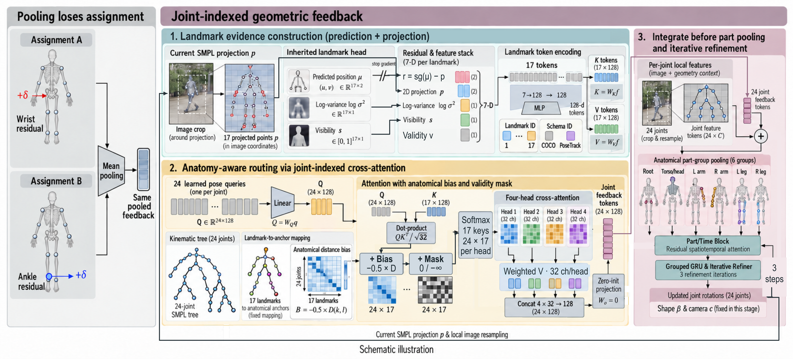
Figure 2. Preserving anatomical assignment in the feedback channel. Mean pooling maps exchanged landmark residuals to the same feedback vector. STaR-Body retains the landmark and schema identities, then uses 24 pose queries to read 17 evidence tokens through a soft kinematic-distance bias. Joint-specific feedback enters before part pooling. The exchanged residuals are a schematic illustration of the representation.

3.2. Track-conditioned shape
Shape is shared over longer time scales than pose. We therefore form a fixed track prototype from the decoder's predictions and image descriptors. Predicted shapes are averaged with weights inversely related to their distance from the track median, while the image prototype uses deterministic frames from the closer half of the track. An MLP maps their concatenation to a correction bounded componentwise by 0.3. Adding this residual to every valid frame shares track information while retaining the base model's frame-specific shape variation. The prototype remains fixed during refinement training, and the subsequent rotation updates pass shape and camera through unchanged.

3.3. Joint-indexed landmark feedback
Mean feedback averages landmark residuals and head features before broadcasting the result to all joints. This channel is invariant to exchanging landmark values: two assignments with the same average are indistinguishable. STaR-Body instead retains one token per landmark, including its identity, and lets each pose joint read the resulting set. Figure 2 contrasts these interfaces. The distinction concerns information available to the refiner; Section 4 evaluates the complete joint-indexed interface at a matched optimization budget.
At iteration r, the inherited observation head gives coordinates ûₜₗ, log-variance feature ℓₜₗ, and visibility-logit feature zₜₗ for landmark l. The current body projects to pₜₗʳ in the same declared schema. With stop-gradient sg, sigmoid σ, and finite-validity indicator vₜₗ, the seven-dimensional evidence is
$$e_{tl}^{r}=sg({\hat{u}}_{tl})-p_{tl}^{r},x_{tl}^{r}=[e_{tl}^{r};p_{tl}^{r};sg(l_{tl});σ(sg(z_{tl}));v_{tl}]$$
A two-layer encoder maps this vector to width 128 and adds learned landmark and schema embeddings. The declared PoseTrack and COCO conventions give each observation slot a semantic identity. Residuals, projections, and variance features are clipped to finite ranges before encoding. These head outputs are conditioning features; the module does not require their calibration as probabilities.
Twenty-four learned pose queries attend to the evidence. For each of four heads, attention combines content similarity and distance on the SMPL kinematic tree:
$$A_{jl}={softmax}_{l}\left(\frac{q_{j}^{T}k_{l}}{\sqrt{d_{h}}}-\frac{D(j,a(l))}{2}+M_{l}\right)$$
Here a(l) is the anatomical anchor of landmark l, D is shortest-path tree distance, and M masks invalid evidence. The distance term favors nearby anatomical relations without preventing a query from reading distant valid landmarks. A final projection Wₒ yields 24 feedback vectors of width 128. This computation is independent for each person-frame; temporal exchange occurs in the downstream refiner.
We initialize Wₒ to zero, making the new feedback contribution exactly zero at initialization. Together with zero-initialized added part/time residuals, this preserves the inherited prediction. Wₒ can receive gradients immediately; after it changes, gradients reach the internal encoder and attention. For an all-invalid frame, a temporary valid slot keeps softmax finite and the resulting frame feedback is explicitly zeroed. Thus, both initialization and missing evidence have defined behavior without an additional learned fallback. The complete feedback module has 105,472 parameters.

3.4. Part-aware iterative rotation refinement
Each joint combines its contextual pose query, current body state, and geometry-aligned local image samples. Joint-indexed feedback is added before pooling into six groups: root, torso/head, left arm, right arm, left leg, and right leg. Two residual part/time blocks exchange context across groups within a frame and across time within a group. Their outputs are broadcast back to the joint features. Source-frame identities determine temporal segments, preventing duplicate observations or padding gaps from creating spurious transitions.
Local image evidence is refreshed along with the body projection. Over the three iterations, the sampling radius decreases from two to one to half a token cell. Valid neighborhood samples are projected and averaged before entering the joint feature. The refiner therefore combines the persistent contextual query with evidence sampled around its current geometric estimate.
A group-specific GRU retains a separate state for every person-frame-joint across the three refinement iterations. The recurrence therefore describes the correction process; it does not scan video frames. A group-specific output head predicts a three-vector uₜⱼʳ, converted to a bounded axis-angle increment and composed with the current rotation:
$$ω_{tj}^{r}=α_{j}\frac{tanhu_{tj}^{r}}{\sqrt{1+‖tanhu_{tj}^{r}‖_{2}^{2}}},R_{tj}^{r+1}=exp([ω_{tj}^{r}]_{×})R_{tj}^{r}$$
The scale αⱼ is 2° for the root and 5° for other joints. Because the denominator exceeds the numerator norm, each increment has magnitude below its scale. The triangle inequality on rotations then bounds the three-step geodesic displacement by 6° for the root and 15° for any other joint relative to the refiner input. Shape and camera stay fixed while projected landmarks and local image samples are recomputed. The bound controls update size; the geometry and motion objectives determine which updates are useful.

3.5. Geometry and complete-sequence motion
Training combines joint and vertex errors, rotation and shape supervision, motion terms, and regularization. Geometry is computed in metres. Motion uses first and second differences of hip-centered prediction-minus-target joint errors; it does not simply penalize movement in the prediction. Each person-frame has one owning window, allowing complete sequences to be assembled without counting overlapping predictions more than once.
For acceleration, the valid annotation-adjacent triplets partition into within-window and cross-window sets. If their counts are Nw and Nb and their mean losses are ℓ̄w and ℓ̄b, respectively, the complete final-output objective is
$$L_{acc}=\frac{N_{w}}{N_{w}+N_{b}}{\overline{l}}_{w}+\frac{N_{b}}{N_{w}+N_{b}}{\overline{l}}_{b}$$
Boundary triplets are retained by forwarding their owner contexts separately. Consequently, changing the computational window does not discard a physical transition. Intermediate decoder states receive additional geometry and within-window motion supervision. Supplementary Section S2 gives the precise loss coefficients, sampling normalization, and ownership diagram. The matched comparison uses this same objective for both feedback interfaces, so the experiment compares the two complete feedback interfaces within a common refinement procedure.

Table 1. 3DPW reconstruction results (mm, lower is better). Published baselines follow the cited papers. Train indicates use of 3DPW training data; bold marks the best reported test value.
Method | Setting | Train | Split | MPJPE ↓ | PA-MPJPE ↓
PyMAF [26] | Image; ResNet-50 | No | Test | 92.80 | 58.90
PARE [10] | Image; HRNet-W32 | No | Test | 82.00 | 50.90
PARE [10] | Image; HRNet-W32 | Yes | Test | 74.50 | 46.50
CLIFF [12] | Image; HRNet-W48 | Yes | Test | 69.00 | 43.00
PyMAF-X [27] | Image; body-only HR48 | No | Test | 78.00 | 47.10
PyMAF-X [27] | Image; body-only HR48 | Yes | Test | 74.20 | 45.30
HMR 2.0a [6] | Image; ViT | No | Test | 70.00 | 44.50
HMR 2.0b [6] | Image; ViT | No | Test | 81.30 | 54.30
ReFit [21] | Image; HRNet | Yes | Test | 65.80 | 41.00
ReFit [21] | Image; BEDLAM + real | Yes | Test | 57.60 | 38.20
CameraHMR [14] | Image; All + 3DPW | Yes | Test | 56.00 | 35.10
PromptHMR [23] | Image; GT focal length | Yes | Test | 58.70 | 36.60
VIBE [9] | Video; SPIN features | Yes | Test | 82.90 | 51.90
TCMR [2] | Video; temporal context | Yes | Test | 86.50 | 52.70
GLoT [15] | Video; 16 frames | Yes | Test | 80.70 | 50.60
WHAM [17] | Video; ViT; real data | Yes | Test | 57.80 | 35.90
WHAM [17] | Video; ViT; + BEDLAM | Yes | Test | 56.90 | 35.70
GVHMR [16] | Video; flip evaluation | Yes | Test | 55.60 | 36.20
PromptHMR [23] | Video; no flip averaging | Yes | Test | 56.90 | 35.50
OnlineHMR [29] | Causal online video | Yes | Test | 69.90 | 43.70
STaR-Body (ours) | Full model; EMA | Yes | Val. | 61.19 | 37.61

4. Experiments

4.1. Evaluation protocol
We evaluate camera-space human reconstruction on 3DPW [20]. Table 1 summarizes published methods alongside our full-model result, with each data split and setting identified. Table 2 compares feedback designs under a shared local protocol.
For the controlled study, the training cache contains 2,909 windows and 22,735 unique person-frames; validation contains 1,357 windows, 10,413 person-frames, and 12 sequences. All local comparisons use the same targets, feature caches, body-model assets, and frame-ownership manifest. Person crops use annotated two-dimensional person extent with a 25% margin.
Local MPJPE uses pelvis-aligned LSP 14 joints regressed through the H36M convention; PA-MPJPE additionally applies a proper per-frame similarity alignment. PVE measures vertex error under the common SMPL target convention, without additional pelvis alignment. Acceleration error uses the second difference of hip-centered joint error over all 10,226 annotation-adjacent triplets, including window boundaries, in mm/annotation-frame². Inference and SMPL computation use FP32 with double-precision aggregate sums, without flip averaging or temporal smoothing.

4.2. Comparison with published methods
Table 1 brings together image-based and video-based methods using the authors’ reported 3DPW test results. HMR 2.0 [6] anchors image-based estimation, while VIBE [9], TCMR [2], and GLoT [15] characterize temporal reconstruction. PyMAF [26], PARE [10], CLIFF [12], and the body branch of PyMAF-X [27] provide established image-based comparisons. ReFit [21] studies recurrent image fitting, and CameraHMR [14] incorporates perspective-aware training. WHAM [17], GVHMR [16], PromptHMR [23], and OnlineHMR [29] provide recent camera-space comparisons alongside their broader reconstruction capabilities. The table retains stronger additional-data variants and records each reported input setting.
STaR-Body’s full model obtains 61.19 mm MPJPE and 37.61 mm PA-MPJPE on validation. The following controlled experiments examine the feedback interface and its geometric and temporal behavior.

4.3. Controlled feedback comparison
The recorded matched-budget comparison starts mean and joint-indexed feedback from the same selected parent. Both receive 1,000 additional optimizer steps with identical sample exposure, losses, and staged unfreezing. We use AdamW, an effective batch of 16 windows, gradient clipping, and exponential moving average (EMA) weights. Feature encoders, the reference, camera head, and observation heads remain frozen. Both final rows use the 1,000-step EMA checkpoint; Supplementary Section S3 specifies the schedule and the validation-only selection rule, whose normalization constants were fixed before the comparison.

Table 2. Controlled validation comparison under the shared 3DPW crop and target protocol. All four rows cover 10,413 person-frames and 10,226 motion triplets. Errors are in mm, except acceleration in mm/annotation-frame²; lower is better. The final two rows start from the same parent and use 1,000 additional steps with EMA. Bold marks the lowest observed value within this comparison. Relative improvement uses the mean-feedback control and unrounded metrics.
Model / refinement stage | MPJPE ↓ | PA-MPJPE ↓ | PVE ↓ | Accel. ↓
Spatiotemporal reference  Selected base | 61.42 | 37.78 | 73.29 | 21.51
Track-shape + iterative parent  2,000-step EMA | 61.26 | 37.64 | 73.02 | 21.48
Mean-feedback control  +1,000-step EMA | 61.26 | 37.64 | 73.05 | 21.45
STaR-Body joint feedback  +1,000-step EMA | 61.19 | 37.61 | 72.82 | 21.44
Relative improvement | 0.12% | 0.06% | 0.31% | 0.02%

Table 2 shows lower errors for joint-indexed feedback on all four measured validation metrics at the matched budget. PVE falls from 73.05 to 72.82 mm, a 0.31% relative reduction, while MPJPE falls from 61.26 to 61.19 mm and PA-MPJPE from 37.64 to 37.61 mm. Acceleration changes from 21.45 to 21.44 mm/annotation-frame². The largest absolute change is in vertex geometry, following refinement of the same inherited parent.
Both feedback designs share visual evidence, body representation, initialization, and optimization exposure. The joint-indexed interface combines landmark identities, projected coordinates, validity features, and anatomically biased attention to change how evidence enters the refiner. The joint-indexed interface yields lower observed validation errors under this matched-budget setting. The shared decoder, track-shape conditioning, and part/time update mechanism define the common refinement procedure.
The progression rows clarify the starting point. Adding the track-shape and iterative parent stage changes PVE from 73.29 to 73.02 mm; the mean-feedback continuation reaches 73.05 mm, and joint-indexed feedback reaches 72.82 mm at the same continuation budget. Thus, the final two rows compare feedback interfaces, whereas parent-to-final changes describe the complete additional refinement stage.

4.4. Sequence and temporal analysis
Figure 3 shows how the complete refinement stage changes geometry across sequences. Relative to the parent, PVE decreases on 11 sequences, MPJPE on nine, and PA-MPJPE on ten. Vertex improvements extend across golf, range of motions, freestyle, and cross-country motion, indicating that the aggregate reduction is distributed across actions. Supplementary Table S3 gives all sequence counts and absolute errors.
Aggregate geometry metrics weight person-frames equally: sequence error sums are added and divided by 10,413. An unweighted average of the twelve sequence means would give short and long sequences equal influence and would not reproduce the geometry columns of Table 2. Figure 3 uses identical person-frames for the parent and STaR-Body, so its changes reflect predictions rather than coverage. Joint and vertex errors observe different functions of the body state; basketball, for example, has lower vertex error but higher 14-joint error after refinement.

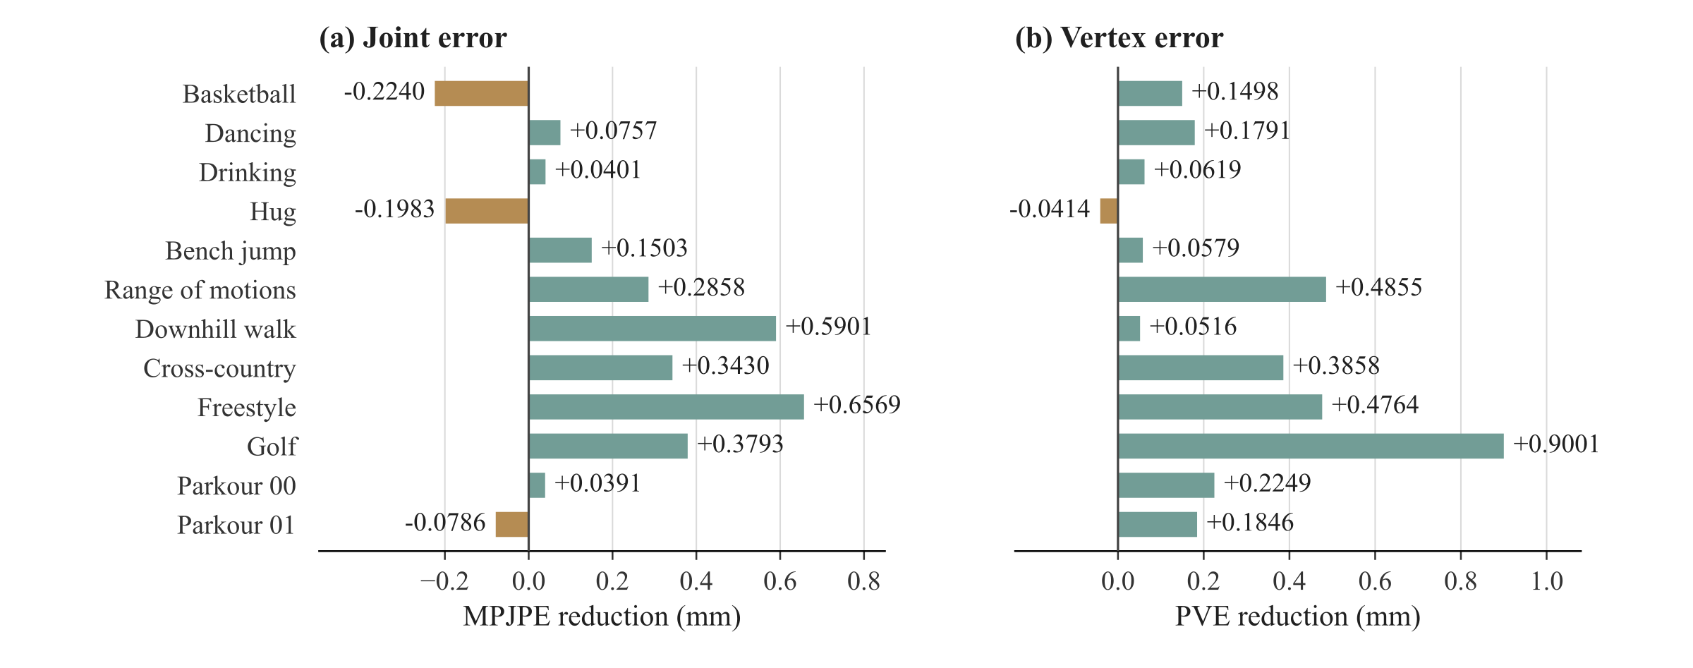
Figure 3. Changes from the common parent to STaR-Body across all 12 validation sequences. Positive values denote lower error after refinement. PVE decreases on 11 sequences and MPJPE on nine; signed bars retain both increases and decreases. This comparison measures the complete additional refinement stage, while Table 2 compares feedback interfaces at equal budget.

Temporal error is measured on the assembled sequences, retaining all 10,226 annotation-adjacent triplets rather than resetting at inference-window boundaries. This common accounting makes the motion column in Table 2 consistent across model variants. Supplementary Figure S2 places the matched result alongside recorded continuation checkpoints, and Table S4 separates the student and EMA weights. Together, these diagnostics show how geometry and temporal error evolve within the same optimization schedule.

5. Conclusion
STaR-Body routes predicted landmark evidence to individual pose joints before sharing information across anatomical parts and time. Its identity-preserving feedback interface complements a dual-order decoder, track-conditioned shape correction, and bounded recurrent rotation updates. Under a shared 3DPW validation protocol, the equal-budget comparison reduces vertex error by 0.31% relative to mean feedback, and the complete additional stage lowers vertex error on 11 of 12 sequences relative to the parent. These results support joint-indexed evidence routing as a practical interface for incremental human mesh refinement.

LLM Usage Statement
OpenAI Codex assisted with manuscript editing, source and result cross-checking, reference metadata verification, and document preparation. Google Gemini supplied the overview reference; OpenAI image generation revised the overview and produced the landmark-feedback and frame-ownership drafts. The figures were subsequently edited and checked against the implemented computation. Human, mesh, and attention illustrations are schematic. Quantitative plots and tables use archived measurements and cited original-paper results; generative tools did not produce experimental outcomes.

References
[1] Team Wan et al. Wan: Open and Advanced Large-Scale Video Generative Models. arXiv:2503.20314, 2025.
[2] Hongsuk Choi, Gyeongsik Moon, Ju Yong Chang, and Kyoung Mu Lee. Beyond Static Features for Temporally Consistent 3D Human Pose and Shape From a Video. Proceedings of the IEEE/CVF Conference on Computer Vision and Pattern Recognition (CVPR), pages 1964–1973, 2021.
[3] Alexey Dosovitskiy, Lucas Beyer, Alexander Kolesnikov, Dirk Weissenborn, Xiaohua Zhai, Thomas Unterthiner, Mostafa Dehghani, Matthias Minderer, Georg Heigold, Sylvain Gelly, Jakob Uszkoreit, and Neil Houlsby. An Image is Worth 16x16 Words: Transformers for Image Recognition at Scale. International Conference on Learning Representations, 2021.
[4] Sai Kumar Dwivedi, Yu Sun, Priyanka Patel, Yao Feng, and Michael J. Black. TokenHMR: Advancing Human Mesh Recovery with a Tokenized Pose Representation. Proceedings of the IEEE/CVF Conference on Computer Vision and Pattern Recognition (CVPR), pages 1323–1333, 2024.
[5] Guénolé Fiche, Simon Leglaive, Xavier Alameda-Pineda, and Francesc Moreno-Noguer. MEGA: Masked Generative Autoencoder for Human Mesh Recovery. Proceedings of the IEEE/CVF Conference on Computer Vision and Pattern Recognition (CVPR), pages 5366–5378, 2025.
[6] Shubham Goel, Georgios Pavlakos, Jathushan Rajasegaran, Angjoo Kanazawa, and Jitendra Malik. Humans in 4D: Reconstructing and Tracking Humans with Transformers. Proceedings of the IEEE/CVF International Conference on Computer Vision (ICCV), pages 14783–14794, 2023.
[7] Zeyinzi Jiang, Zhen Han, Chaojie Mao, Jingfeng Zhang, Yulin Pan, and Yu Liu. VACE: All-in-One Video Creation and Editing. Proceedings of the IEEE/CVF International Conference on Computer Vision (ICCV), pages 17191–17202, 2025.
[8] Angjoo Kanazawa, Michael J. Black, David W. Jacobs, and Jitendra Malik. End-to-End Recovery of Human Shape and Pose. Proceedings of the IEEE Conference on Computer Vision and Pattern Recognition (CVPR), pages 7122–7131, 2018.
[9] Muhammed Kocabas, Nikos Athanasiou, and Michael J. Black. VIBE: Video Inference for Human Body Pose and Shape Estimation. Proceedings of the IEEE/CVF Conference on Computer Vision and Pattern Recognition (CVPR), pages 5253–5263, 2020.
[10] Muhammed Kocabas, Chun-Hao P. Huang, Otmar Hilliges, and Michael J. Black. PARE: Part Attention Regressor for 3D Human Body Estimation. Proceedings of the IEEE/CVF International Conference on Computer Vision (ICCV), pages 11127–11137, 2021.
[11] Nikos Kolotouros, Georgios Pavlakos, Michael J. Black, and Kostas Daniilidis. Learning to Reconstruct 3D Human Pose and Shape via Model-Fitting in the Loop. Proceedings of the IEEE/CVF International Conference on Computer Vision (ICCV), pages 2252–2261, 2019.
[12] Zhihao Li, Jianzhuang Liu, Zhensong Zhang, Songcen Xu, and Youliang Yan. CLIFF: Carrying Location Information in Full Frames into Human Pose and Shape Estimation. Computer Vision – ECCV 2022, pages 590–606, 2022.
[13] Matthew Loper, Naureen Mahmood, Javier Romero, Gerard Pons-Moll, and Michael J. Black. SMPL: a skinned multi-person linear model. ACM Transactions on Graphics 34(6), pages 248:1–248:16, 2015.
[14] Priyanka Patel, and Michael J. Black. CameraHMR: Aligning People with Perspective. International Conference on 3D Vision (3DV), 2025.
[15] Xiaolong Shen, Zongxin Yang, Xiaohan Wang, Jianxin Ma, Chang Zhou, and Yi Yang. Global-to-Local Modeling for Video-Based 3D Human Pose and Shape Estimation. Proceedings of the IEEE/CVF Conference on Computer Vision and Pattern Recognition (CVPR), pages 8887–8896, 2023.
[16] Zehong Shen, Huaijin Pi, Yan Xia, Zhi Cen, Sida Peng, Zechen Hu, Hujun Bao, Ruizhen Hu, and Xiaowei Zhou. World-Grounded Human Motion Recovery via Gravity-View Coordinates. SIGGRAPH Asia Conference Papers, pages 144:1–144:11, 2024.
[17] Soyong Shin, Juyong Kim, Eni Halilaj, and Michael J. Black. WHAM: Reconstructing World-grounded Humans with Accurate 3D Motion. Proceedings of the IEEE/CVF Conference on Computer Vision and Pattern Recognition (CVPR), pages 2070–2080, 2024.
[18] Anastasis Stathopoulos, Ligong Han, and Dimitris Metaxas. Score-Guided Diffusion for 3D Human Recovery. Proceedings of the IEEE/CVF Conference on Computer Vision and Pattern Recognition (CVPR), pages 906–915, 2024.
[19] Ashish Vaswani, Noam Shazeer, Niki Parmar, Jakob Uszkoreit, Llion Jones, Aidan N. Gomez, Łukasz Kaiser, and Illia Polosukhin. Attention Is All You Need. Advances in Neural Information Processing Systems 30, pages 5998–6008, 2017.
[20] Timo von Marcard, Roberto Henschel, Michael J. Black, Bodo Rosenhahn, and Gerard Pons-Moll. Recovering Accurate 3D Human Pose in The Wild Using IMUs and a Moving Camera. Proceedings of the European Conference on Computer Vision (ECCV), pages 601–617, 2018.
[21] Yufu Wang, and Kostas Daniilidis. ReFit: Recurrent Fitting Network for 3D Human Recovery. Proceedings of the IEEE/CVF International Conference on Computer Vision (ICCV), pages 14644–14654, 2023.
[22] Yufu Wang, Ziyun Wang, Lingjie Liu, and Kostas Daniilidis. TRAM: Global Trajectory and Motion of 3D Humans from in-the-wild Videos. European Conference on Computer Vision, pages 467–487, 2024.
[23] Yufu Wang, Yu Sun, Priyanka Patel, Kostas Daniilidis, Michael J. Black, and Muhammed Kocabas. PromptHMR: Promptable Human Mesh Recovery. Proceedings of the IEEE/CVF Conference on Computer Vision and Pattern Recognition (CVPR), pages 1148–1159, 2025.
[24] Yan Xia, Xiaowei Zhou, Etienne Vouga, Qixing Huang, and Georgios Pavlakos. Reconstructing Humans with a Biomechanically Accurate Skeleton. Proceedings of the IEEE/CVF Conference on Computer Vision and Pattern Recognition (CVPR), pages 5355–5365, 2025.
[25] Ye Yuan, Umar Iqbal, Pavlo Molchanov, Kris Kitani, and Jan Kautz. GLAMR: Global Occlusion-Aware Human Mesh Recovery With Dynamic Cameras. Proceedings of the IEEE/CVF Conference on Computer Vision and Pattern Recognition (CVPR), pages 11038–11049, 2022.
[26] Hongwen Zhang, Yating Tian, Xinchi Zhou, Wanli Ouyang, Yebin Liu, Limin Wang, and Zhenan Sun. PyMAF: 3D Human Pose and Shape Regression With Pyramidal Mesh Alignment Feedback Loop. Proceedings of the IEEE/CVF International Conference on Computer Vision (ICCV), pages 11446–11456, 2021.
[27] Hongwen Zhang, Yating Tian, Yuxiang Zhang, Mengcheng Li, Liang An, Zhenan Sun, and Yebin Liu. PyMAF-X: Towards Well-Aligned Full-Body Model Regression From Monocular Images. IEEE Transactions on Pattern Analysis and Machine Intelligence 45(10), pages 12287–12303, 2023.
[28] Yuhong Zhang, Guanlin Wu, Ling-Hao Chen, Zhuokai Zhao, Jing Lin, Xiaoke Jiang, Jiamin Wu, Zhuoheng Li, Hao Frank Yang, Haoqian Wang, and Lei Zhang. HumanMM: Global Human Motion Recovery from Multi-shot Videos. Proceedings of the IEEE/CVF Conference on Computer Vision and Pattern Recognition (CVPR), pages 1973–1983, 2025.
[29] Yiwen Zhao, Ce Zheng, Yufu Wang, Hsueh-Han Daniel Yang, Liting Wen, and László A. Jeni. OnlineHMR: Video-based Online World-Grounded Human Mesh Recovery. Proceedings of the IEEE/CVF Conference on Computer Vision and Pattern Recognition (CVPR), pages 13951–13961, 2026.
[30] Yi Zhou, Connelly Barnes, Jingwan Lu, Jimei Yang, and Hao Li. On the Continuity of Rotation Representations in Neural Networks. Proceedings of the IEEE/CVF Conference on Computer Vision and Pattern Recognition (CVPR), pages 5745–5753, 2019.

