**Assignment for Intents & Serialization**

*Question:*

*Create a HarmonyOS app, which will generate a Student ID card based on the details you enter in the Regsitration form.*

*Explanation :*

Your application must have 2 screens.

Screen 1 – Collect the student information using a registration form.

Screen 2 – Generate a student ID card which renders the details entered by the student in the registration form.

Find the sample screens for both Screen 1 & Screen 2 below :

Screen 1

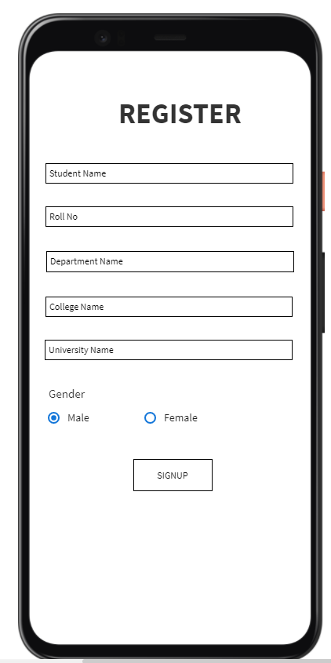

Say if user enters the following details i.e

Student name as “**Jarvo Singh**”

Roll No as “**UR12CS171**”

Department Name as “**Computer Science Engineering**”

University Name as “**Stanford University**”

After student clicks the SIGNUP button, he must be taken to the Screen 2.

Screen 2 must look like this with the generated ID card.

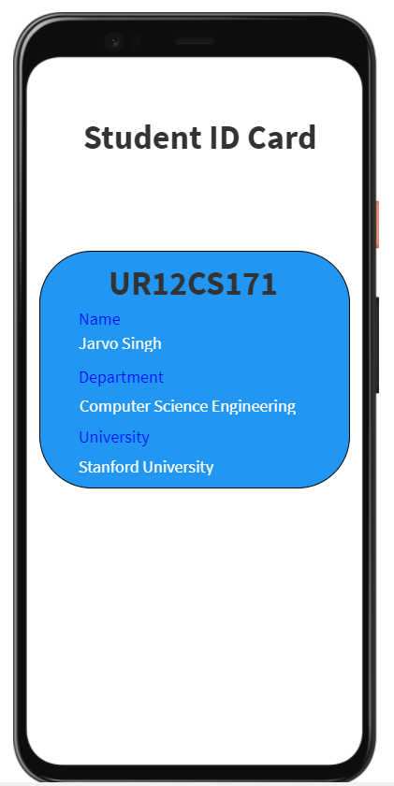

PS : The screens shown in the above sample screenshots are with basic customization. You can try to modify/enhance the layouts as per your liking. But do make sure the mentioned functionality is present in your application.