Please create attached Input forms using xml and load into Ability Slice by making use of usecase specific UI components and Layouts.

**Note:** Please make use of Previewer available with DevEco to view your UI changes, those who have their ID approved can use Simulator to test your UI.

All the best.

**Assignment Number – 1:**

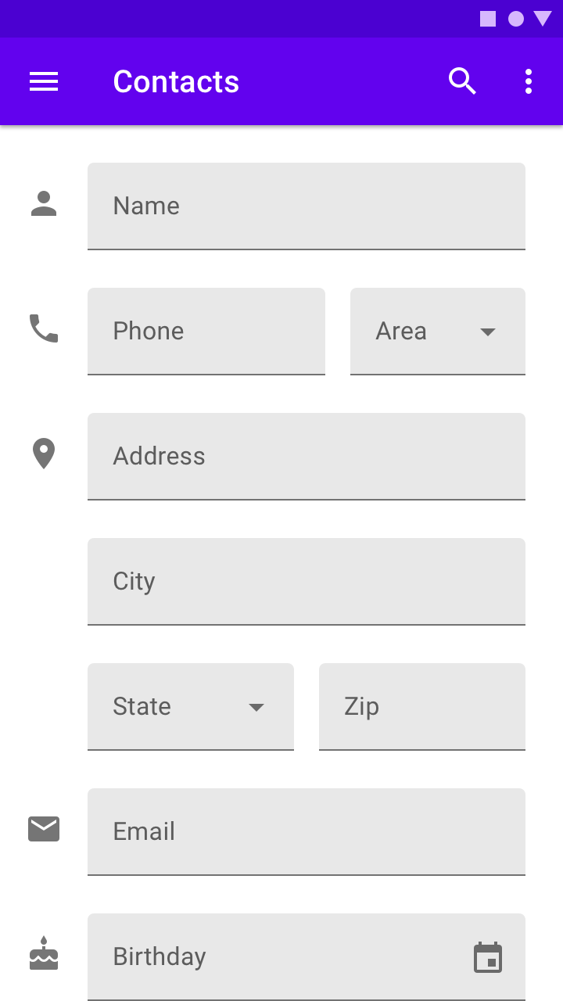

**Assignment Number – 2:**

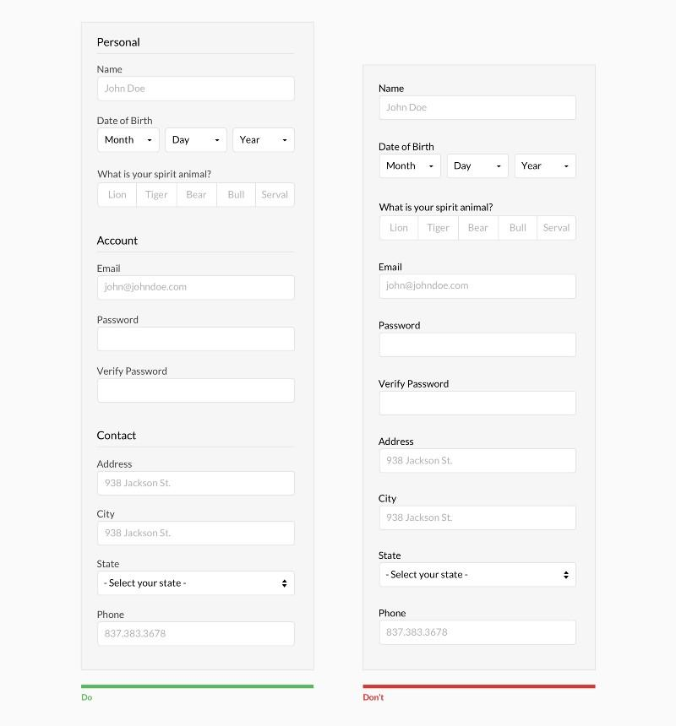

**Assignment Number – 3:**

