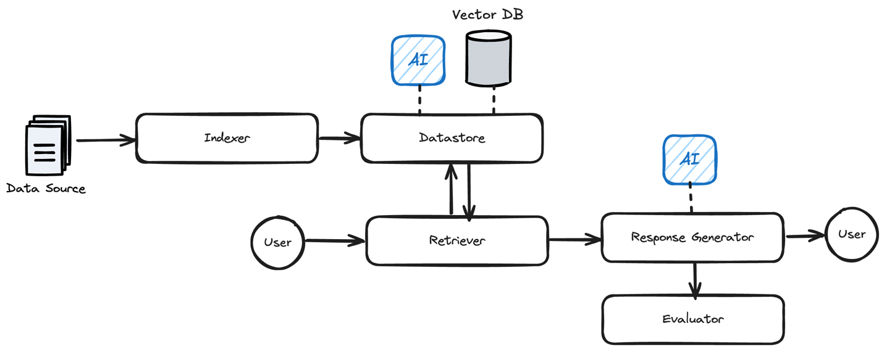
Requirements.txt

# Default Dependencies
pydantic>=2.0.0 # For data validation
openai>=1.0.0 # For AI service integration
lancedb==0.22.0
docling==2.31.0
cohere==5.15.0

Main
import glob
import json
import os
from typing import List
from rag_pipeline import RAGPipeline
from create_parser import create_parser

from impl import Datastore, Indexer, Retriever, ResponseGenerator, Evaluator

DEFAULT_SOURCE_PATH = "sample_data/source/"
DEFAULT_EVAL_PATH = "sample_data/eval/sample_questions.json"

def create_pipeline() -> RAGPipeline:
"""Create and return a new RAG Pipeline instance with all components."""
datastore = Datastore()
indexer = Indexer()
retriever = Retriever(datastore=datastore)
response_generator = ResponseGenerator()
evaluator = Evaluator()
return RAGPipeline(datastore, indexer, retriever, response_generator, evaluator)

def main():
parser = create_parser() # Create the CLI parser
args = parser.parse_args()
pipeline = create_pipeline()

# Process source paths and eval path
source_path = args.path if args.path else DEFAULT_SOURCE_PATH
eval_path = args.eval_file if args.eval_file else DEFAULT_EVAL_PATH
document_paths = get_files_in_directory(source_path)

# Execute commands
if args.command in ["reset", "run"]:
print("🗑️ Resetting the database...")
pipeline.reset()

if args.command in ["add", "run"]:
print(f"🔍 Adding documents: {', '.join(document_paths)}")
pipeline.add_documents(document_paths)

if args.command in ["evaluate", "run"]:
print(f"📊 Evaluating using questions from: {eval_path}")
with open(eval_path, "r") as file:
sample_questions = json.load(file)
pipeline.evaluate(sample_questions)

if args.command == "query":
print(f"✨ Response: {pipeline.process_query(args.prompt)}")

def get_files_in_directory(source_path: str) -> List[str]:
if os.path.isfile(source_path):
return [source_path]
return glob.glob(os.path.join(source_path, "*"))

if __name__ == "__main__":
main()

Parser_py
import argparse
def create_parser():
"""Initialize and return the argument parser with all commands."""
parser = argparse.ArgumentParser(description="RAG Pipeline CLI")

# Define parent parsers for shared arguments
# These will be used by both the main parser (by direct addition)
# and relevant subparsers (via the `parents` attribute).

path_arg_parent = argparse.ArgumentParser(add_help=False)
path_arg_parent.add_argument(
"-p",
"--path",
type=str,
required=False,
help="Path to a directory containing documents to index.",
)

eval_file_arg_parent = argparse.ArgumentParser(add_help=False)
eval_file_arg_parent.add_argument(
"-f",
"--eval_file",
type=str,
required=False,
help="Path to a .json file with question/expected_answer pairs.",
)

# Add global arguments to the main parser.
# These definitions must match those in the parent parsers for consistent behavior.
parser.add_argument(
"-p",
"--path",
type=str,
required=False,
help="Path to a directory containing documents to index.",
)

parser.add_argument(
"-f",
"--eval_file",
type=str,
required=False,
help="Path to a .json file with question/expected_answer pairs.",
)

# Then create subparsers
subparsers = parser.add_subparsers(dest="command", help="Commands", required=True)

subparsers.add_parser(
"run",
help="Run the full pipeline: reset, add, evaluate.",
parents=[path_arg_parent, eval_file_arg_parent],
)
subparsers.add_parser("reset", help="Reset the database")
subparsers.add_parser(
"add", help="Add (index) documents to the database.", parents=[path_arg_parent]
)
subparsers.add_parser(
"evaluate", help="Evaluate the model", parents=[eval_file_arg_parent]
)

# "Query" command
query_parser = subparsers.add_parser("query", help="Query the documents")
query_parser.add_argument("prompt", type=str, help="What to search for.")

return parser

