DNS Private Resolver in a Hub-Spoke Hybrid Network
Pixar-style story + practical flows. Last updated: 2026-01-26

You built a hub-spoke city in Azure. On-premises is another city. The big question is always the same: when someone asks for a name, who answers it, and where does the question travel?
Azure DNS Private Resolver is the managed bridge that lets DNS questions travel both ways:
• On-premises to Azure private names (Private Endpoints)
• Azure workloads to on-premises names
No VM-based DNS forwarder is needed.
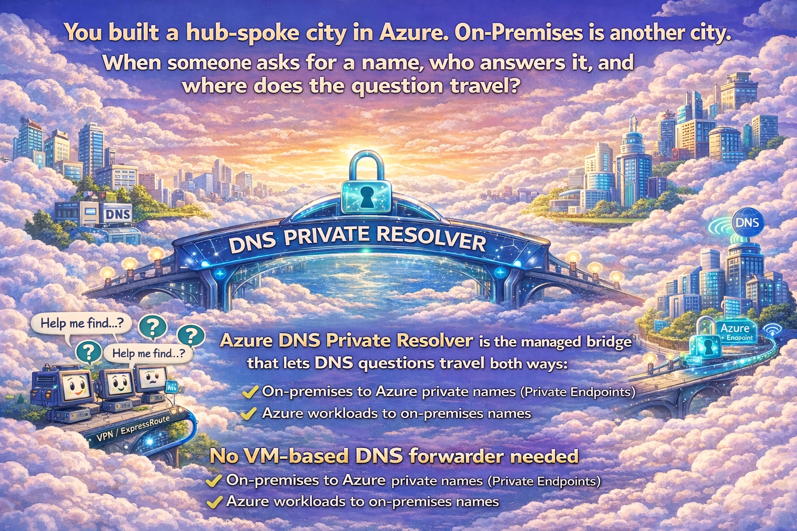

Architecture overview
Hub-spoke topology with DNS Private Resolver deployed in the hub and Private DNS zones linked to the hub/spokes.
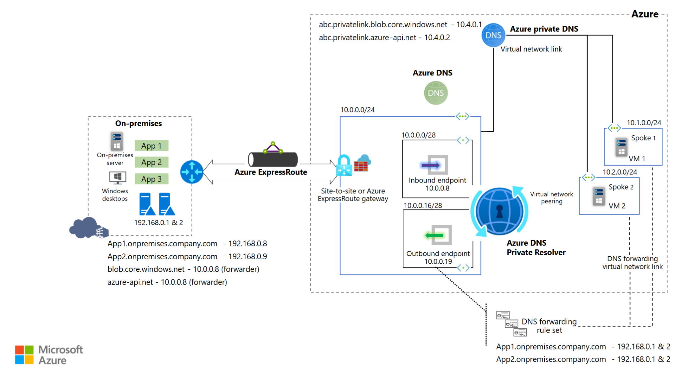
Figure 1. DNS Private Resolver in the hub (no VM-based DNS forwarder).

Cast of characters

On-premises side
- Apps and desktops: the callers asking “Where is App1 / blob / api?”
- Local DNS servers: 192.168.0.1 and 192.168.0.2 (your home reception desks).

Azure hub
- Inbound endpoint (10.0.0.8): the arrival gate. Receives DNS queries coming into Azure.
- Outbound endpoint (10.0.0.19): the departure gate. Sends DNS queries out of Azure (to on-premises DNS).
- DNS forwarding rule set: the routing board. Example: if domain is onprem.company.com, forward to 192.168.0.1/2.

Azure DNS and Private DNS
- Azure-provided DNS (168.63.129.16): Azure’s built-in DNS brain for VNets.
- Private DNS zones: Azure’s private phonebook for Private Endpoints, for example:
- privatelink.blob.core.windows.net -> 10.4.0.1
- privatelink.azure-api.net -> 10.4.0.2

One-line difference vs the old “DNS forwarder VM” pattern
Old model: a VM forwarder acted as the bridge. New model: DNS Private Resolver is the bridge. It is managed, highly available, and you do not patch or scale VMs.
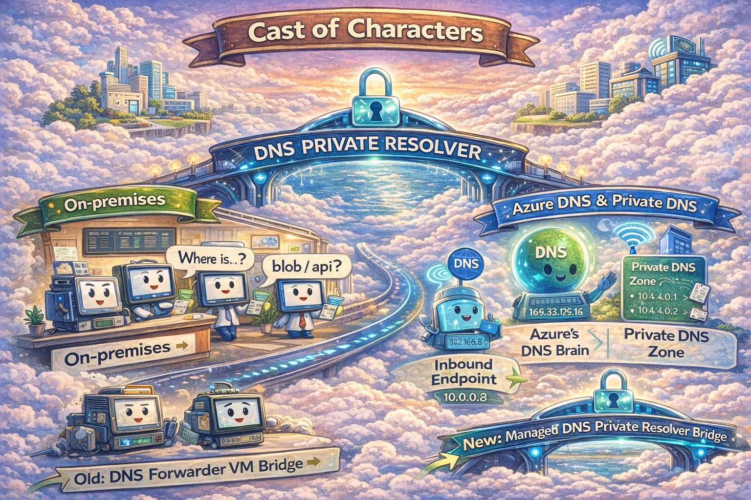

Key configuration inputs

Local DNS records and forwarders on-premises
Domain name | IP address | Record type
App1.onprem.company.com | 192.168.0.8 | Address mapping (A)
App2.onprem.company.com | 192.168.0.9 | Address mapping (A)
blob.core.windows.net | 10.0.0.8 | Conditional forwarder target
azure-api.net | 10.0.0.8 | Conditional forwarder target

DNS Private Resolver parameters in the hub
Parameter | Value
Virtual network (hub) | 10.0.0.0/24
Inbound endpoint subnet | 10.0.0.0/28
Inbound endpoint IP | 10.0.0.8
Outbound endpoint subnet | 10.0.0.16/28
Outbound endpoint IP | 10.0.0.19

The 3 DNS flows (separate stories)

Flow 1. On-premises asks for an Azure Private Endpoint name
Example: an on-premises app asks for blob.core.windows.net (which should resolve to a private endpoint IP).
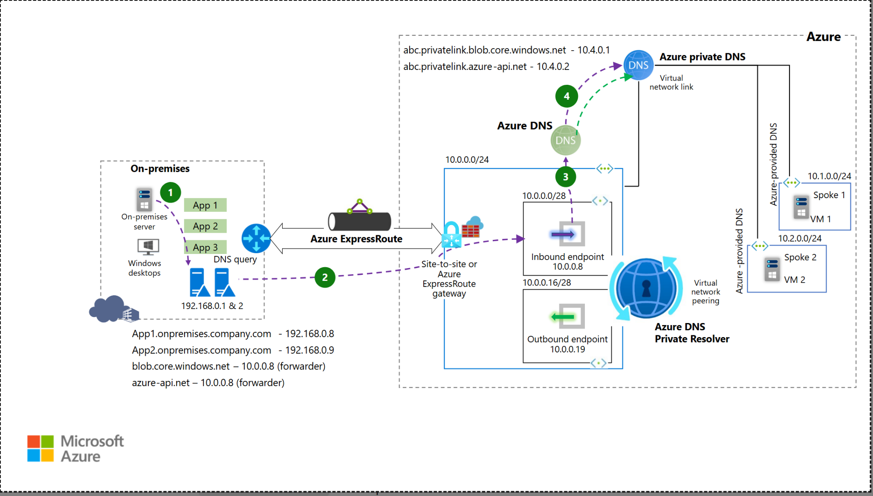
Figure 2. Flow 1: On-premises -> Azure private name (via inbound endpoint).
1. An on-premises client asks local DNS (192.168.0.1/2) to resolve blob.core.windows.net.
2. Local DNS uses a conditional forwarder for blob.core.windows.net and forwards the query to the hub inbound endpoint 10.0.0.8.
3. DNS Private Resolver receives the query and consults Azure DNS (which can see VNet links).
4. Azure Private DNS zone resolves the privatelink record and returns the private IP (for example 10.4.0.1).
5. The answer returns back through the same path to the on-premises client.
Result: on-premises resolves Azure private endpoints without running any DNS forwarder VM in Azure.

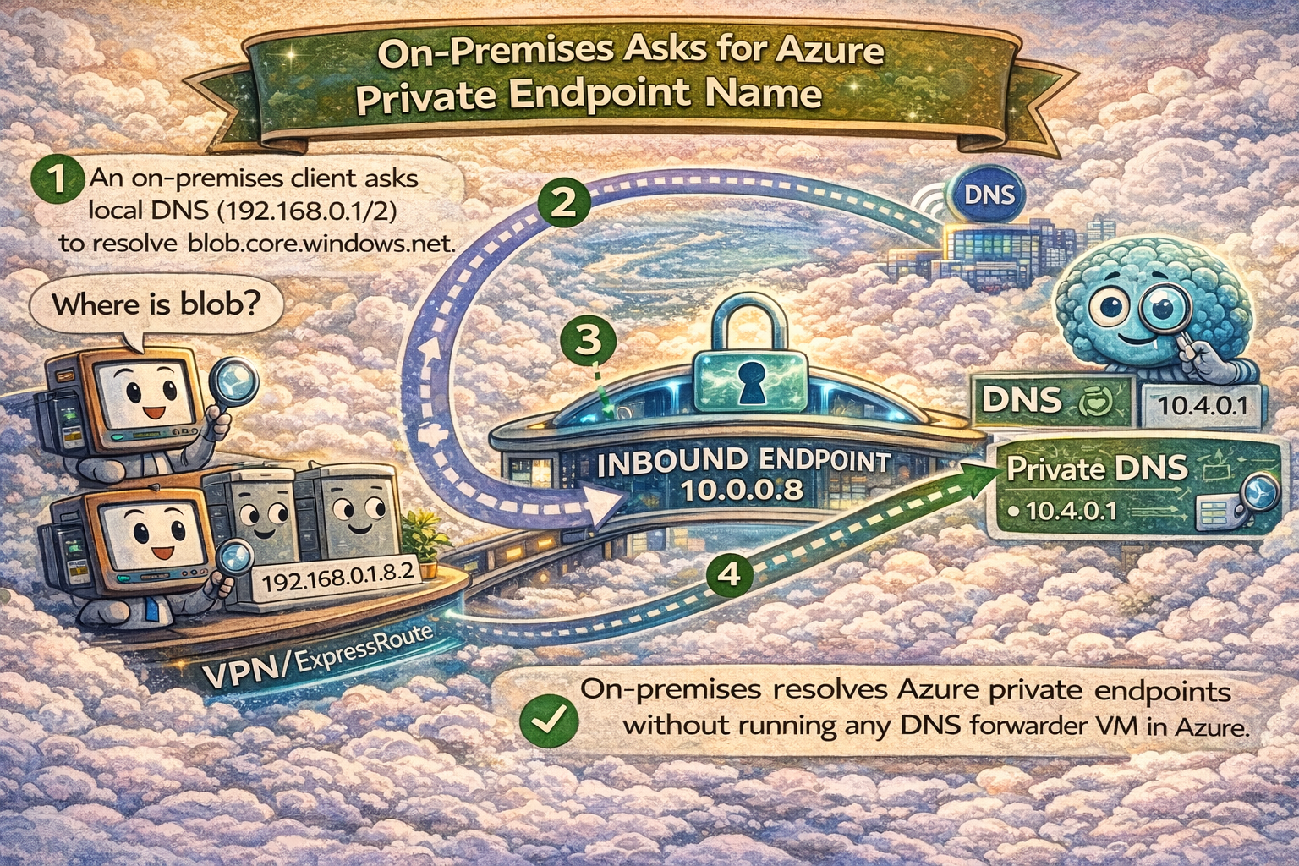

Flow 2. Azure VM asks for an Azure private name (default Azure DNS)
Example: a VM in Spoke 1 asks for abc.privatelink.blob.core.windows.net or blob.core.windows.net.
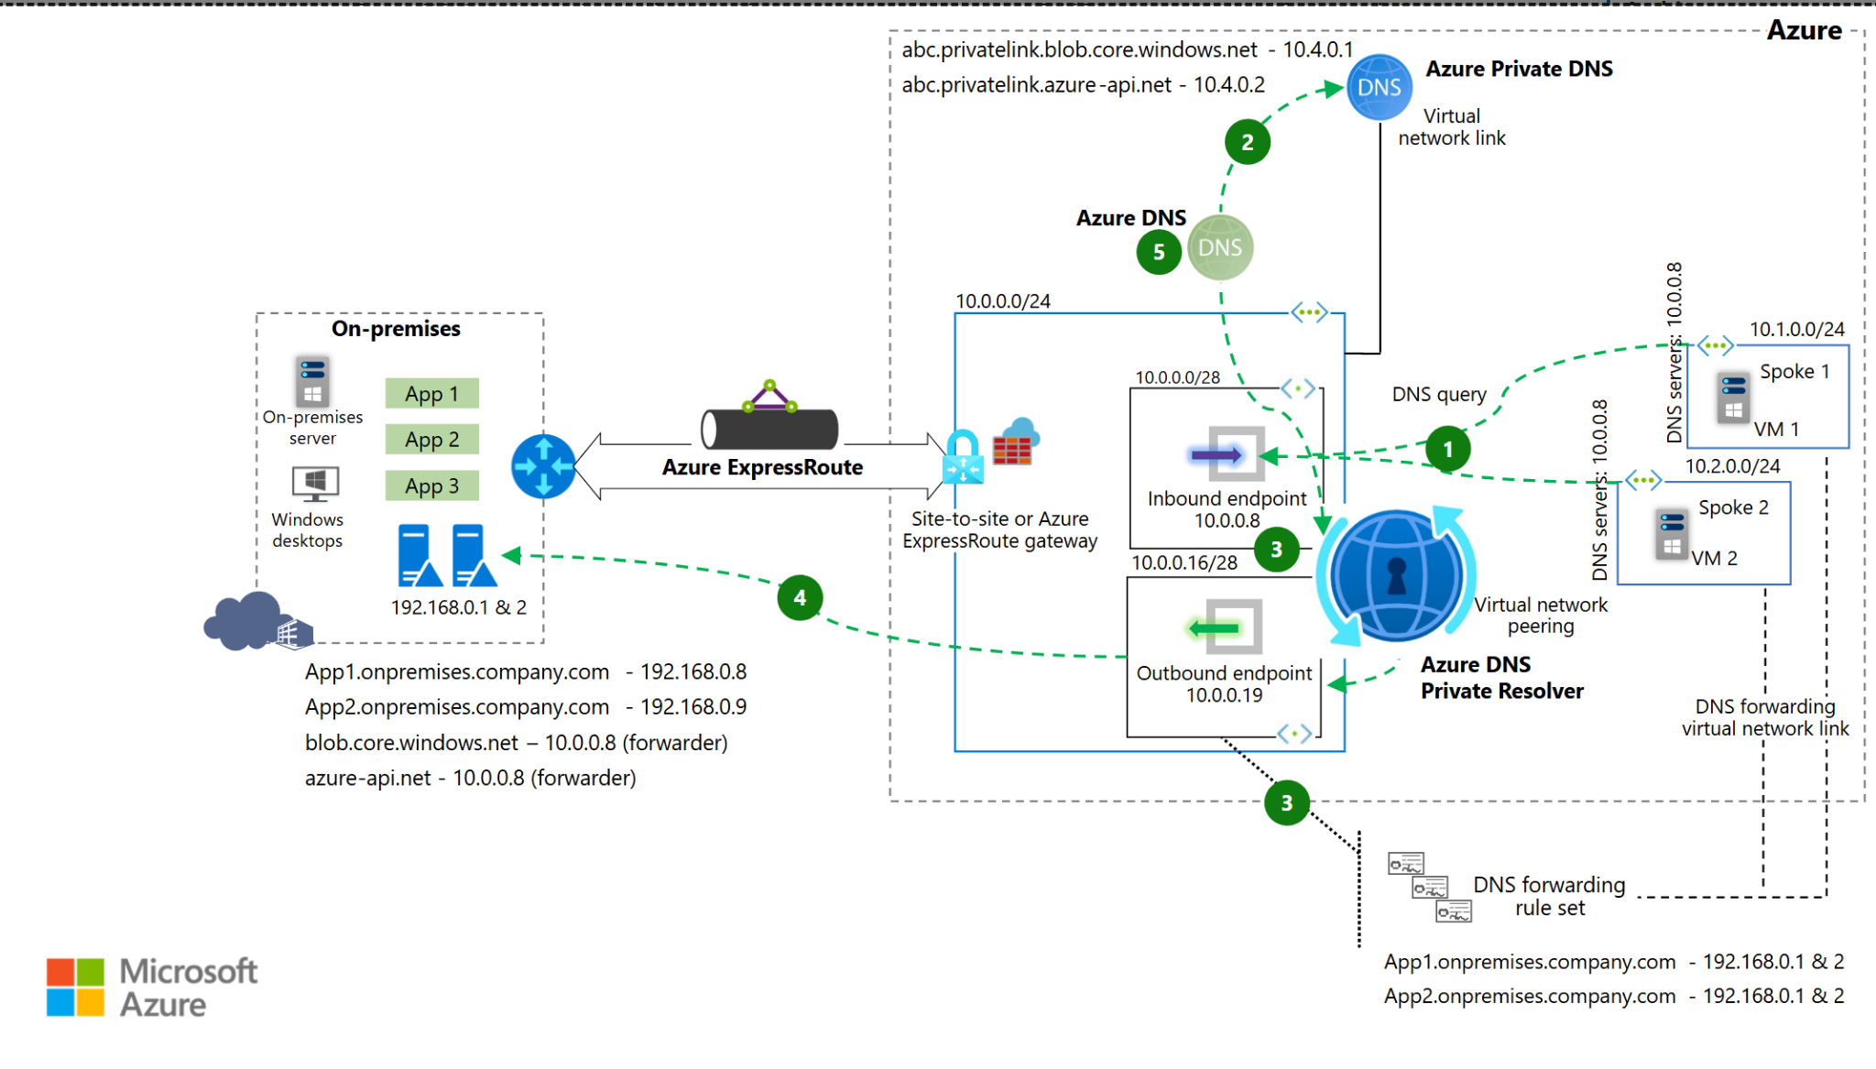
Figure 3. Flow 2: Spoke VM -> Azure private name (Azure DNS + Private DNS zone).
1. VM1 uses Azure-provided DNS (168.63.129.16) to resolve the name.
2. Azure DNS detects that a linked Private DNS zone owns the name (for example privatelink.blob.core.windows.net).
3. Azure Private DNS zone returns the private endpoint IP (for example 10.4.0.1).
4. VM1 connects to the service privately using that IP (data plane is separate from DNS).
Result: Azure workloads resolve private endpoint names natively as long as the right Private DNS zones are linked to the hub/spokes.

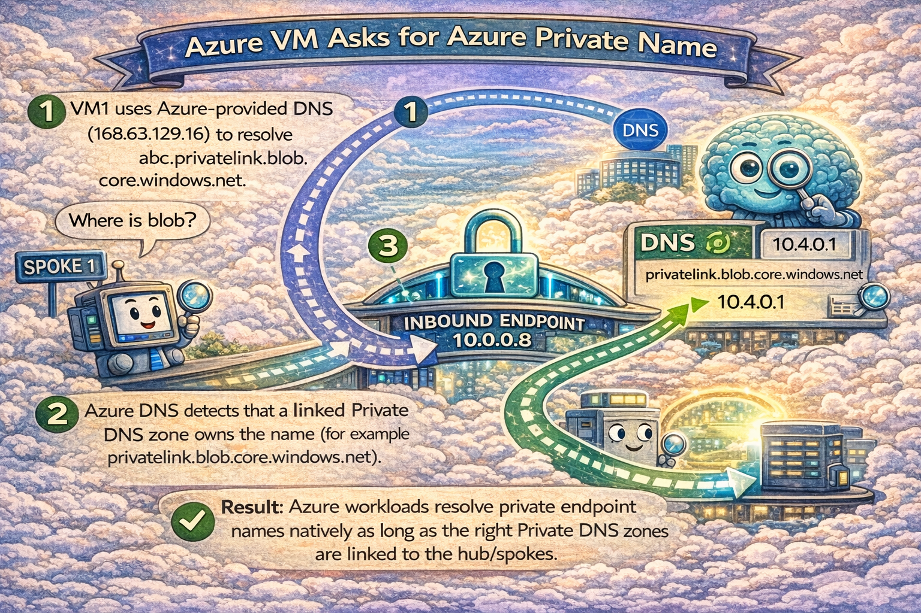

Flow 3. Azure VM asks for an on-premises name (the outbound path)
Example: VM1 asks for app1.onprem.company.com. Azure DNS does not know this record unless you add forwarding.
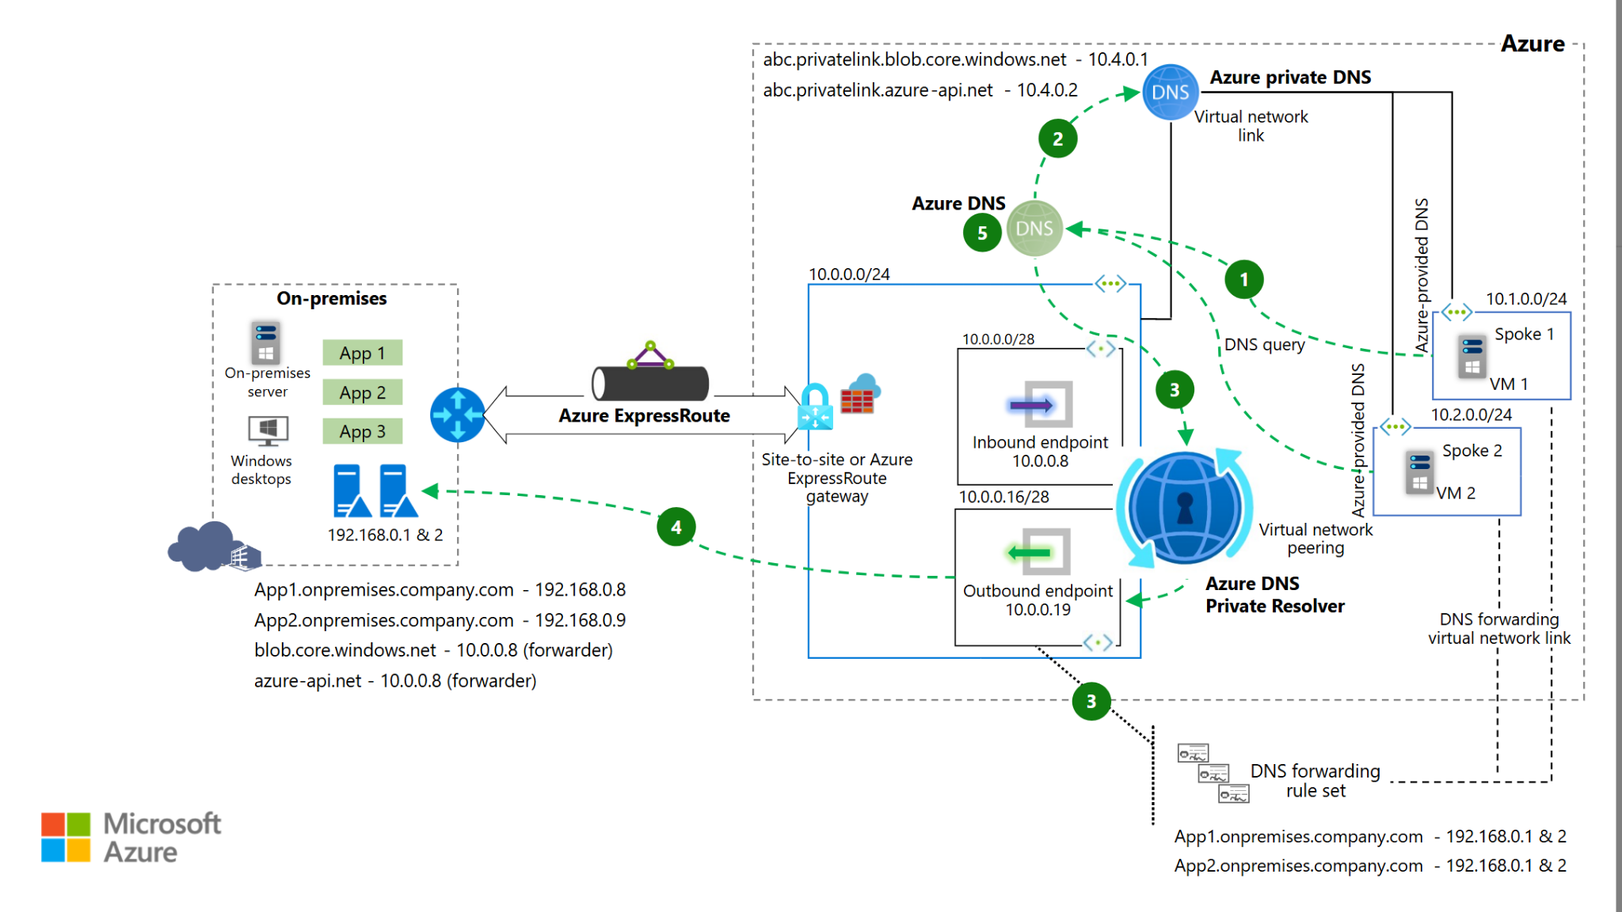
Figure 4. Flow 3: Spoke VM -> on-premises name (via outbound endpoint and forwarding rules).
1. VM1 asks Azure DNS (168.63.129.16) to resolve app1.onprem.company.com.
2. Azure DNS sees no matching Private DNS zone for that name. It checks whether the VNet is linked to a DNS forwarding rule set.
3. A forwarding rule matches onprem.company.com and sends the query to DNS Private Resolver.
4. DNS Private Resolver forwards the query out via the outbound endpoint (10.0.0.19) to on-premises DNS (192.168.0.1/2).
5. On-premises DNS returns the A record (for example 192.168.0.8). The answer returns back to VM1.
Result: Azure workloads can resolve on-premises names without pointing every VM directly to on-premises DNS servers.
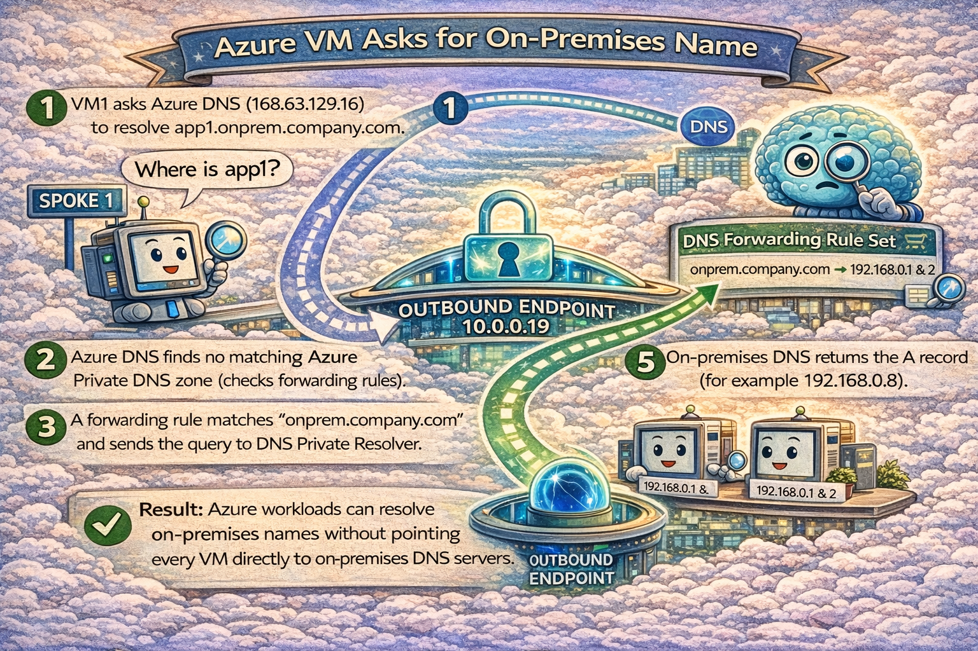

Why the diagrams show different VM DNS settings

Option A (recommended for most): use default Azure DNS
Spoke VMs use Azure-provided DNS (168.63.129.16). Private DNS zones handle Azure private names. Forwarding rule sets handle on-premises names via DNS Private Resolver.

Option B: point spoke VNets to the inbound endpoint (10.0.0.8)
Spoke VMs send every query to DNS Private Resolver first. This gives one DNS IP for everything, but increases dependency on the hub path.
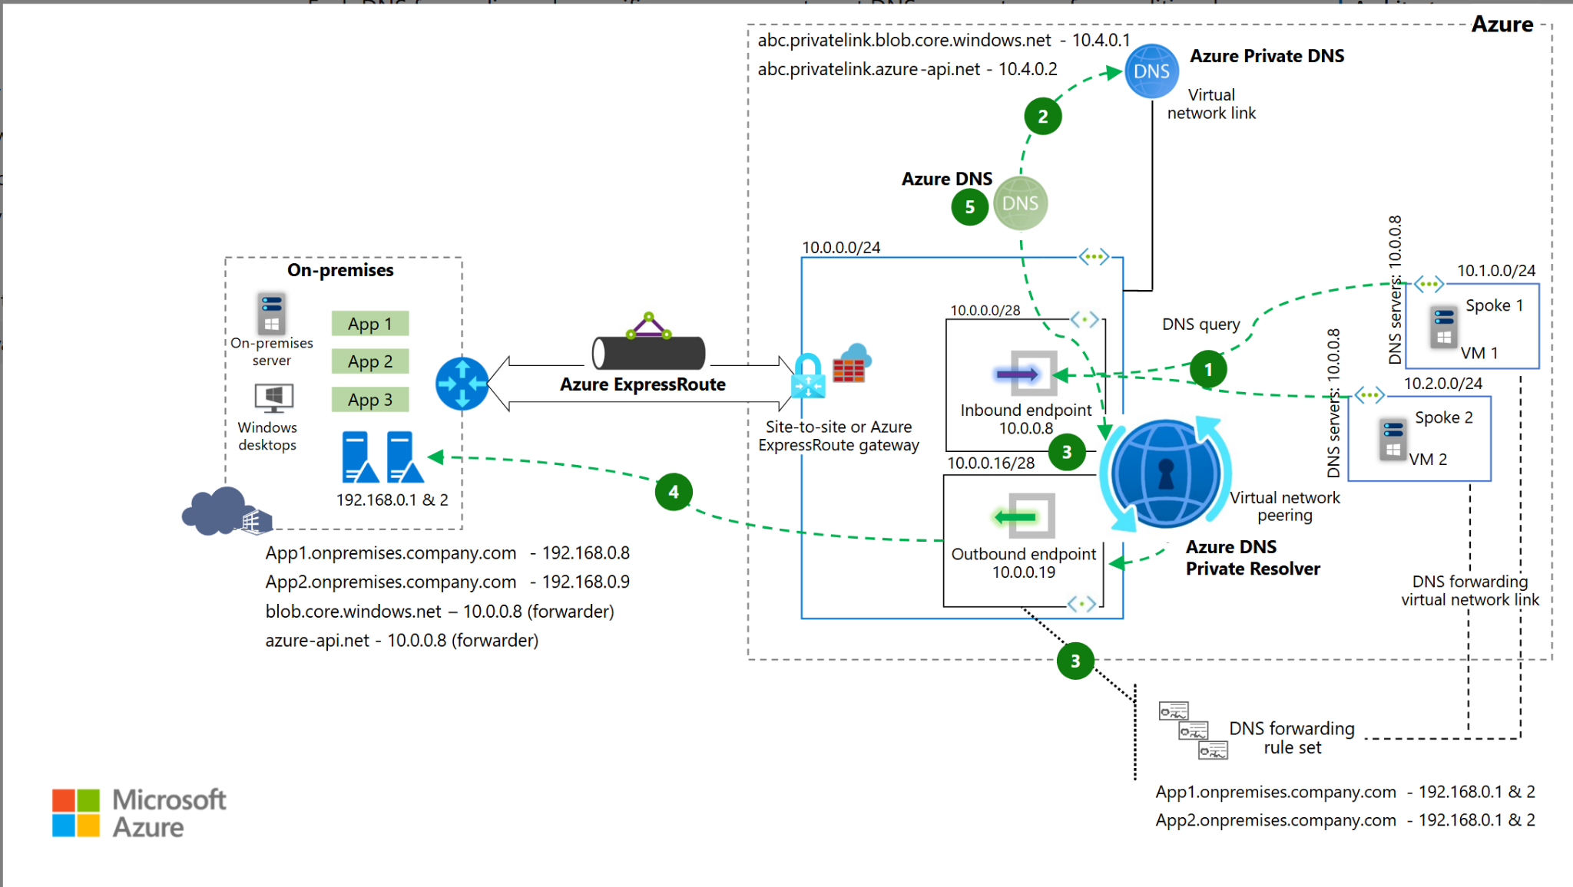
Figure 5. Option B: Spoke workloads use 10.0.0.8 as their DNS server (inbound endpoint).

Option C: point spoke VNets to on-premises DNS (192.168.0.1/2)
Classic approach. Works, but Azure workloads now depend on on-premises DNS latency and availability for most lookups.
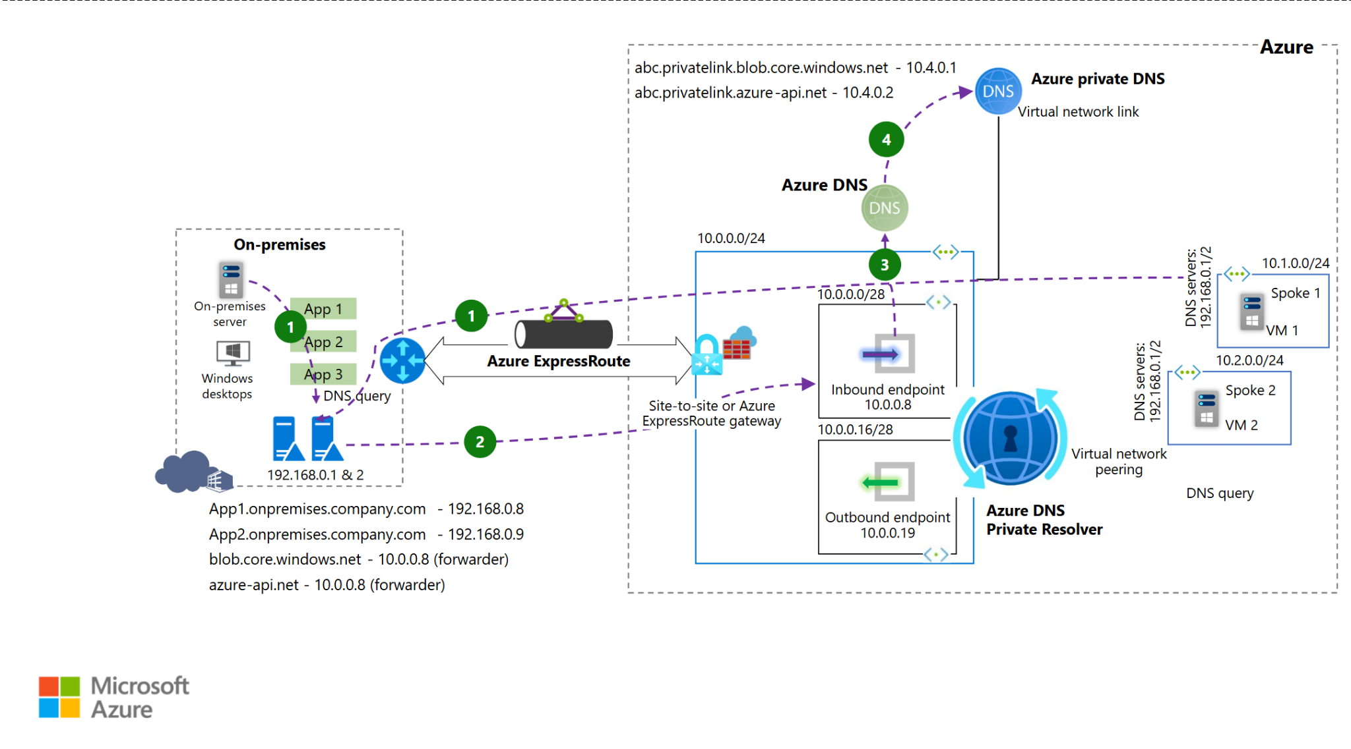
Figure 6. Option C: Spoke workloads use on-premises DNS servers directly.

Minimal checklist to make this work

On-premises DNS (192.168.0.1/2)
- Create local A records, for example app1.onprem.company.com -> 192.168.0.8.
- Create conditional forwarders for Azure services that you want to resolve privately, for example:
- blob.core.windows.net -> 10.0.0.8
- azure-api.net -> 10.0.0.8

Azure hub
- Deploy DNS Private Resolver with dedicated subnets for inbound and outbound endpoints (/28 or larger).
- Link the hub VNet to required Private DNS zones, for example privatelink.blob.core.windows.net and privatelink.azure-api.net.
- Create a DNS forwarding rule set for onprem.company.com -> 192.168.0.1, 192.168.0.2.
- Link the rule set to spoke VNets that must resolve on-premises names.
- Ensure routes and firewall rules allow DNS (UDP/TCP 53) between on-premises <-> inbound endpoint and outbound endpoint <-> on-premises DNS.

Mental model you can remember in 10 seconds
- Private DNS zone = Azure’s private phonebook.
- Inbound endpoint = on-premises asking Azure.
- Outbound endpoint = Azure asking on-premises.
- Rule set = which domains must be forwarded out to on-premises.

Common mistakes that break this design
- Private DNS zone is created but not linked to the right VNet(s).
- DNS forwarding rule set is created but not linked to the correct spoke VNet.
- NSG/Azure Firewall blocks UDP/TCP 53 on the path (on-premises <-> inbound endpoint, outbound endpoint <-> on-premises DNS).
- Pointing name resolution of an ExpressRoute gateway VNet to a wildcard custom DNS server can break management connectivity. Avoid wildcard patterns in gateway VNets.

