Emory Covid-19 Case Study Script

EpiRHandbook Team

13 August 2021

# Descriptive analysis

This section will be analysing data by time, place, and person to produce descriptive tables.

## Summary

* As of giugno 23 2021, Fulton County has recorded 81757 confirmed cases of COVID-19.
* As of giugno 23 2021, Fulton County has recorded 1701 (2.1%) deaths.
* Among all confirmed cases of COVID-19 in Fulton County, 5277 (6.5%) required hospitalization.

## Time

**Figure** **:** COVID-19 cases by week and hospitalisation status in Fulton County

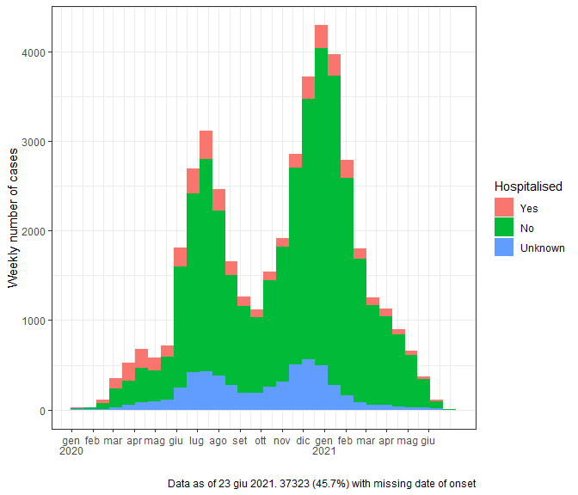

As you can see from above in Table we can see clear trends in reporting patterns - cases increase in waves and peak in dicembre 2020.

## Place

**Table** **:** COVID-19 new case counts by ZIP-code

|  | **Recent 14-day reporting period 06/10-06/23** | | **Previous 14-day reporting period 05/27-06/09** | | **Change between reporting periodsb** |
| --- | --- | --- | --- | --- | --- |
| **Zip Code** | **n** | **Incidence** | **n** | **Incidencea** | **%b** |
| 30000 | 0 | 0.0 | 0 | 0.0 | 0.0 |
| 30002 | 0 | 0.0 | 0 | 0.0 | 0.0 |
| 30004 | 7 | 1.5 | 12 | 2.6 | -41.7 |
| 30005 | 6 | 1.9 | 8 | 2.5 | -25.0 |
| 30009 | 8 | 4.3 | 6 | 3.3 | 33.3 |
| 30013 | 0 | 0.0 | 0 | 0.0 | 0.0 |
| 30022 | 11 | 1.6 | 29 | 4.1 | -62.1 |
| 30023 | 0 | 0.0 | 0 | 0.0 | 0.0 |
| 30024 | 0 | 0.0 | 0 | 0.0 | 0.0 |
| 30031 | 0 | 0.0 | 0 | 0.0 | 0.0 |
| 30032 | 0 | 0.0 | 0 | 0.0 | 0.0 |
| 30037 | 0 | 0.0 | 0 | 0.0 | 0.0 |
| 30039 | 0 | 0.0 | 0 | 0.0 | 0.0 |
| 30042 | 0 | 0.0 | 0 | 0.0 | 0.0 |
| 30044 | 0 | 0.0 | 0 | 0.0 | 0.0 |
| 30045 | 0 | 0.0 | 0 | 0.0 | 0.0 |
| 30046 | 0 | 0.0 | 0 | 0.0 | 0.0 |
| 30054 | 0 | 0.0 | 0 | 0.0 | 0.0 |
| 30062 | 0 | 0.0 | 0 | 0.0 | 0.0 |
| 30065 | 0 | 0.0 | 0 | 0.0 | 0.0 |
| 30075 | 9 | 2.0 | 15 | 3.3 | -40.0 |
| 30076 | 6 | 1.3 | 13 | 2.8 | -53.8 |
| 30077 | 0 | 0.0 | 0 | 0.0 | 0.0 |
| 30078 | 0 | 0.0 | 0 | 0.0 | 0.0 |
| 30080 | 0 | 0.0 | 0 | 0.0 | 0.0 |
| 30082 | 0 | 0.0 | 1 | 0.0 | -100.0 |
| 30083 | 0 | 0.0 | 0 | 0.0 | 0.0 |
| 30084 | 0 | 0.0 | 0 | 0.0 | 0.0 |
| 30085 | 0 | 0.0 | 0 | 0.0 | 0.0 |
| 30087 | 0 | 0.0 | 0 | 0.0 | 0.0 |
| 30092 | 1 | Inf | 0 | 0.0 | 100.0 |
| 30096 | 0 | 0.0 | 0 | 0.0 | 0.0 |
| 30097 | 1 | 0.4 | 5 | 1.9 | -80.0 |
| 30114 | 0 | 0.0 | 0 | 0.0 | 0.0 |
| 30115 | 0 | 0.0 | 0 | 0.0 | 0.0 |
| 30122 | 0 | 0.0 | 0 | 0.0 | 0.0 |
| 30123 | 0 | 0.0 | 0 | 0.0 | 0.0 |
| 30134 | 0 | 0.0 | 0 | 0.0 | 0.0 |
| 30135 | 0 | 0.0 | 0 | 0.0 | 0.0 |
| 30144 | 0 | 0.0 | 0 | 0.0 | 0.0 |
| 30168 | 0 | 0.0 | 0 | 0.0 | 0.0 |
| 30189 | 0 | 0.0 | 0 | 0.0 | 0.0 |
| 30202 | 1 | 0.0 | 0 | 0.0 | 100.0 |
| 30211 | 0 | 0.0 | 0 | 0.0 | 0.0 |
| 30212 | 0 | 0.0 | 0 | 0.0 | 0.0 |
| 30213 | 9 | 2.3 | 29 | 7.3 | -69.0 |
| 30214 | 0 | 0.0 | 0 | 0.0 | 0.0 |
| 30219 | 0 | 0.0 | 0 | 0.0 | 0.0 |
| 30222 | 0 | 0.0 | 0 | 0.0 | 0.0 |
| 30236 | 0 | 0.0 | 0 | 0.0 | 0.0 |
| 30237 | 0 | 0.0 | 0 | 0.0 | 0.0 |
| 30238 | 0 | 0.0 | 0 | 0.0 | 0.0 |
| 30268 | 1 | 1.3 | 3 | 3.9 | -66.7 |
| 30272 | 0 | 0.0 | 0 | 0.0 | 0.0 |
| 30274 | 0 | 0.0 | 0 | 0.0 | 0.0 |
| 30291 | 10 | 4.8 | 17 | 8.2 | -41.2 |
| 30294 | 0 | 0.0 | 0 | 0.0 | 0.0 |
| 30296 | 2 | 4.1 | 4 | 8.2 | -50.0 |
| 30297 | 0 | 0.0 | 0 | 0.0 | 0.0 |
| 30301 | 0 | 0.0 | 0 | 0.0 | 0.0 |
| 30302 | 0 | 0.0 | 0 | 0.0 | 0.0 |
| 30303 | 2 | 2.9 | 0 | 0.0 | 100.0 |
| 30304 | 0 | 0.0 | 0 | 0.0 | 0.0 |
| 30305 | 8 | 2.7 | 12 | 4.1 | -33.3 |
| 30306 | 1 | 0.7 | 4 | 2.6 | -75.0 |
| 30307 | 0 | 0.0 | 2 | 3.2 | -100.0 |
| 30308 | 3 | 1.5 | 9 | 4.5 | -66.7 |
| 30309 | 5 | 1.8 | 8 | 2.9 | -37.5 |
| 30310 | 7 | 2.5 | 10 | 3.6 | -30.0 |
| 30311 | 10 | 3.0 | 28 | 8.3 | -64.3 |
| 30312 | 6 | 2.6 | 12 | 5.1 | -50.0 |
| 30313 | 2 | 2.1 | 7 | 7.2 | -71.4 |
| 30314 | 9 | 3.8 | 17 | 7.2 | -47.1 |
| 30315 | 13 | 3.7 | 15 | 4.3 | -13.3 |
| 30316 | 3 | 3.1 | 7 | 7.3 | -57.1 |
| 30317 | 0 | 0.0 | 0 | 0.0 | 0.0 |
| 30318 | 15 | 2.4 | 33 | 5.4 | -54.5 |
| 30319 | 1 | 1.5 | 1 | 1.5 | 0.0 |
| 30320 | 0 | 0.0 | 0 | 0.0 | 0.0 |
| 30321 | 0 | 0.0 | 0 | 0.0 | 0.0 |
| 30322 | 0 | 0.0 | 0 | 0.0 | 0.0 |
| 30324 | 3 | 1.2 | 10 | 4.0 | -70.0 |
| 30325 | 0 | 0.0 | 0 | 0.0 | 0.0 |
| 30326 | 3 | 6.5 | 5 | 10.8 | -40.0 |
| 30327 | 4 | 1.6 | 9 | 3.7 | -55.6 |
| 30328 | 5 | 1.4 | 17 | 4.9 | -70.6 |
| 30329 | 0 | 0.0 | 1 | 0.0 | -100.0 |
| 30330 | 0 | 0.0 | 0 | 0.0 | 0.0 |
| 30331 | 28 | 4.8 | 35 | 6.0 | -20.0 |
| 30331 | 28 | 4.8 | 35 | 6.0 | -20.0 |
| 30332 | 1 | 0.0 | 0 | 0.0 | 100.0 |
| 30333 | 0 | 0.0 | 0 | 0.0 | 0.0 |
| 30334 | 0 | 0.0 | 0 | 0.0 | 0.0 |
| 30336 | 1 | 6.8 | 0 | 0.0 | 100.0 |
| 30337 | 3 | 2.5 | 8 | 6.6 | -62.5 |
| 30338 | 0 | 0.0 | 2 | 47.6 | -100.0 |
| 30339 | 3 | 82.6 | 4 | 110.2 | -25.0 |
| 30340 | 0 | 0.0 | 0 | 0.0 | 0.0 |
| 30341 | 0 | 0.0 | 0 | 0.0 | 0.0 |
| 30342 | 7 | 2.1 | 11 | 3.2 | -36.4 |
| 30343 | 0 | 0.0 | 0 | 0.0 | 0.0 |
| 30344 | 11 | 3.3 | 25 | 7.4 | -56.0 |
| 30345 | 0 | 0.0 | 0 | 0.0 | 0.0 |
| 30346 | 0 | 0.0 | 0 | 0.0 | 0.0 |
| 30348 | 0 | 0.0 | 0 | 0.0 | 0.0 |
| 30349 | 31 | 5.6 | 40 | 7.2 | -22.5 |
| 30350 | 3 | 0.8 | 6 | 1.6 | -50.0 |
| 30353 | 0 | 0.0 | 0 | 0.0 | 0.0 |
| 30354 | 4 | 2.4 | 7 | 4.3 | -42.9 |
| 30355 | 0 | 0.0 | 0 | 0.0 | 0.0 |
| 30357 | 0 | 0.0 | 0 | 0.0 | 0.0 |
| 30358 | 0 | 0.0 | 0 | 0.0 | 0.0 |
| 30360 | 0 | 0.0 | 0 | 0.0 | 0.0 |
| 30363 | 3 | 6.5 | 2 | 4.3 | 50.0 |
| 30364 | 0 | 0.0 | 0 | 0.0 | 0.0 |
| 30366 | 0 | 0.0 | 0 | 0.0 | 0.0 |
| 30374 | 1 | 0.0 | 0 | 0.0 | 100.0 |
| 30375 | 0 | 0.0 | 0 | 0.0 | 0.0 |
| 30377 | 0 | 0.0 | 0 | 0.0 | 0.0 |
| 30381 | 0 | 0.0 | 0 | 0.0 | 0.0 |
| 30388 | 0 | 0.0 | 0 | 0.0 | 0.0 |
| 30458 | 0 | 0.0 | 0 | 0.0 | 0.0 |
| 30506 | 0 | 0.0 | 0 | 0.0 | 0.0 |
| 30776 | 0 | 0.0 | 0 | 0.0 | 0.0 |
| 30909 | 0 | 0.0 | 0 | 0.0 | 0.0 |
| 31107 | 0 | 0.0 | 1 | 0.0 | -100.0 |
| 31126 | 0 | 0.0 | 0 | 0.0 | 0.0 |
| 31139 | 0 | 0.0 | 0 | 0.0 | 0.0 |
| 31156 | 0 | 0.0 | 0 | 0.0 | 0.0 |
| 31707 | 0 | 0.0 | 0 | 0.0 | 0.0 |
| Unknown | 0 | 0.0 | 1 | 0.0 | -100.0 |
| **Total** | **268** | **2.4** | **491** | **4.5** | **-45.4** |
| aIncidence calculated as cases per 10,000 population by zip code | | | | | |
| bThese reflect the percentage increase or decrease of new diagnoses   between the 14 days preceding the past 7 days and the 14 days  preceding that. | | | | | |

## Person

**Table** **:** Cumulative and recent confirmed COVID-19 case and death counts by gender, age, and race/ethnicity in Fulton County, Georgia. Past 28 day period refers to maggio 27-giugno 23, 2021

| **Characteristic** | **Total Confirmed Cases** | **% of Total Cases** | **Confirmed Cases past 28 days** | **% of Confirmed Cases past 28 days** | **Total Confirmed Deathsb** | **% of Total Deaths** | **Confirmed Deaths past 28 daysb** | **% of Confirmed Deaths past 28 days** |
| --- | --- | --- | --- | --- | --- | --- | --- | --- |
| **Total** | **81,757** |  | **816** |  | **1,334** |  |  |  |
| Female | 43,112 | 52.7 | 453 | 55.5 | 632 | 47.4 | 6 | 50.0 |
| Male | 38,240 | 46.8 | 361 | 44.2 | 702 | 52.6 | 6 | 50.0 |
| Unknowna | 405 | 0.5 | 2 | 0.2 | 0 | 0.0 | 0 | 0.0 |
| 0-9 | 2,814 | 3.4 | 41 | 5.0 | 0 | 0.0 | 0 | 0.0 |
| 10-19 | 7,680 | 9.4 | 92 | 11.3 | 1 | 0.1 | 0 | 0.0 |
| 20-29 | 18,042 | 22.1 | 169 | 20.7 | 4 | 0.3 | 0 | 0.0 |
| 30-39 | 16,166 | 19.8 | 175 | 21.4 | 24 | 1.8 | 0 | 0.0 |
| 40-49 | 12,522 | 15.3 | 132 | 16.2 | 40 | 3.0 | 0 | 0.0 |
| 50-59 | 11,344 | 13.9 | 106 | 13.0 | 109 | 8.2 | 3 | 25.0 |
| 60-69 | 6,846 | 8.4 | 52 | 6.4 | 242 | 18.1 | 3 | 25.0 |
| 70+ | 6,296 | 7.7 | 48 | 5.9 | 914 | 68.5 | 6 | 50.0 |
| Unknowna | 47 | 0.1 | 1 | 0.1 | 0 | 0.0 | 0 | 0.0 |
| Asian, NH | 3,022 | 3.7 | 14 | 1.7 | 23 | 1.7 | 0 | 0.0 |
| Black, NH | 34,395 | 42.1 | 493 | 60.4 | 833 | 62.4 | 10 | 83.3 |
| White, NH | 27,303 | 33.4 | 170 | 20.8 | 417 | 31.3 | 1 | 8.3 |
| Hispanic, all races | 8,600 | 10.5 | 49 | 6.0 | 55 | 4.1 | 0 | 0.0 |
| Other, NH | 2,912 | 3.6 | 17 | 2.1 | 6 | 0.4 | 1 | 8.3 |
| Unknowna | 5,525 | 6.8 | 73 | 8.9 | 0 | 0.0 | 0 | 0.0 |
| aUnknown includes cases not yet interviewed | | | | | | | | |
| bDeaths refer to all persons who had a positive PCR test result  for Covid-19 and there is evidence that COVID-19 was the cause of  death or a significant contributor to their death. | | | | | | | | |

### Risk factors for mortality

**Table** **:** Demographic characteristics and association with mortality among COVID-19 cases

| **Characteristic** | **Dead (N=801)1** | **Alive (N=88)1** | **p-value2** |
| --- | --- | --- | --- |
| Gender |  |  | 0.003 |
| Female | 453 (57%) | 35 (40%) |  |
| Male | 348 (43%) | 53 (60%) |  |
| Ethnicity |  |  | 0.8 |
| Black, NH | 547 (68%) | 58 (66%) |  |
| White, NH | 147 (18%) | 27 (31%) |  |
| Hispanic, all races | 76 (9.5%) | 2 (2.3%) |  |
| Asian, NH | 20 (2.5%) | 1 (1.1%) |  |
| Other, NH | 11 (1.4%) | 0 (0%) |  |
| Age (years) | 55 (41, 66) | 73 (64, 80) | <0.001 |
| Days in hospital | 3 (2, 6) | 15 (11, 25) | <0.001 |
| 1n (%) for categorical; median (IQR) for continuous | | | |
| 2Pearson's Chi-squared test for dichotomous; Kruskal-Wallis rank sum test for continuous and categorical | | | |

**Table** **:** Univariate regression investigating associations with mortality among COVID-19 cases

|  | **Died** | | **Univariate regression** | | |
| --- | --- | --- | --- | --- | --- |
| **Characteristic** | **No, N = 8011** | **Yes, N = 881** | **OR2** | **95% CI2** | **p-value** |
| Age (years) | 55 (41, 66) | 73 (64, 80) | 1.07 | 1.05, 1.09 | <0.001 |
| Gender |  |  |  |  |  |
| Female | 453 (57%) | 35 (40%) | — | — |  |
| Male | 348 (43%) | 53 (60%) | 1.97 | 1.26, 3.11 | 0.003 |
| Ethnicity |  |  |  |  |  |
| Black, NH | 547 (68%) | 58 (66%) | — | — |  |
| White, NH | 147 (18%) | 27 (31%) | 1.73 | 1.05, 2.81 | 0.028 |
| Hispanic, all races | 76 (9.5%) | 2 (2.3%) | 0.25 | 0.04, 0.82 | 0.056 |
| Asian, NH | 20 (2.5%) | 1 (1.1%) | 0.47 | 0.03, 2.33 | 0.5 |
| Other, NH | 11 (1.4%) | 0 (0%) | 0.00 |  | >0.9 |
| Fever |  |  |  |  |  |
| No | 434 (54%) | 53 (60%) | — | — |  |
| Yes | 367 (46%) | 35 (40%) | 0.78 | 0.49, 1.22 | 0.3 |
| Subjective fever |  |  |  |  |  |
| No | 531 (66%) | 63 (72%) | — | — |  |
| Yes | 270 (34%) | 25 (28%) | 0.78 | 0.47, 1.25 | 0.3 |
| Myalgia |  |  |  |  |  |
| No | 409 (51%) | 56 (64%) | — | — |  |
| Yes | 392 (49%) | 32 (36%) | 0.60 | 0.37, 0.93 | 0.026 |
| Loss taste/smell |  |  |  |  |  |
| No | 502 (63%) | 80 (91%) | — | — |  |
| Yes | 299 (37%) | 8 (9.1%) | 0.17 | 0.07, 0.33 | <0.001 |
| Sore throat |  |  |  |  |  |
| No | 604 (75%) | 81 (92%) | — | — |  |
| Yes | 197 (25%) | 7 (8.0%) | 0.26 | 0.11, 0.54 | <0.001 |
| Cough |  |  |  |  |  |
| No | 308 (38%) | 37 (42%) | — | — |  |
| Yes | 493 (62%) | 51 (58%) | 0.86 | 0.55, 1.35 | 0.5 |
| Headache |  |  |  |  |  |
| No | 463 (58%) | 77 (88%) | — | — |  |
| Yes | 338 (42%) | 11 (13%) | 0.20 | 0.10, 0.36 | <0.001 |
| Hospitalized |  |  |  |  |  |
| No | 23 (2.9%) | 3 (3.4%) | — | — |  |
| Yes | 778 (97%) | 85 (97%) | 0.84 | 0.28, 3.58 | 0.8 |
| Days in hospital | 3 (2, 6) | 15 (11, 25) | 1.14 | 1.11, 1.17 | <0.001 |
| 1n (%) for categorical; median (IQR) for continuous | | | | | |
| 2OR = Odds Ratio, CI = Confidence Interval | | | | | |

As seen in Table , mortality was associated with being male (OR 1.97; 95% CI 1.26, 3.11), being white (OR 1.73; 95% CI 1.05, 2.81)and longer hospital stays (OR 1.14; 95% CI 1.11, 1.17).

# Visualisation

## Person

As we see below in Figure there appears to be an association between older age, length of hospital stay and mortality. We saw this in Table as well for the individual associations, although we did not check for interaction and confounding.

**Figure** **:** COVID-19 cases by ethnicity

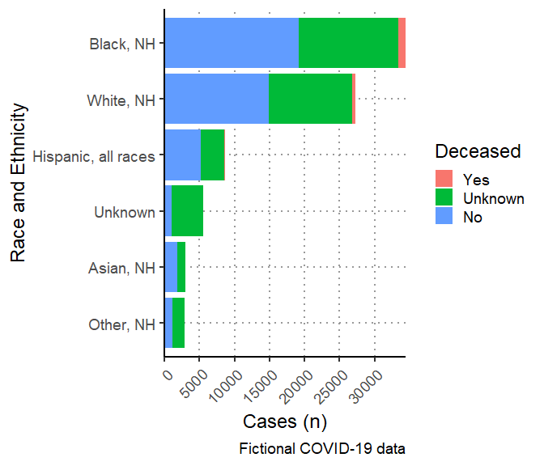

**Figure** **:** Age and Gender of COVID-19 cases, Fulton County

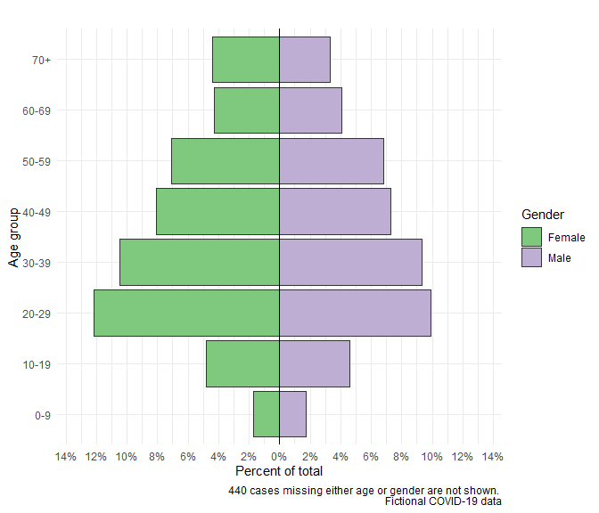

## Time