Fulton Covid-19 Case Study Script

AppliedEpi Team

30 June 2021

# **Descriptive analysis**

This document will be analysing COVID-19 data in Fulton County by time, place, and person to produce descriptive tables and graphs.

## **Summary**

* As of June 23 2021, Fulton County has recorded 81757 confirmed cases of COVID-19.
* Among all confirmed cases of COVID-19 in Fulton County, 5277 (6.5%) required hospitalization.
* As of June 23 2021, Fulton County has recorded 1701 (2.1%) deaths.

## **Time**

**Figure** **:** COVID-19 cases by reporting week and hospitalisation status in Fulton County

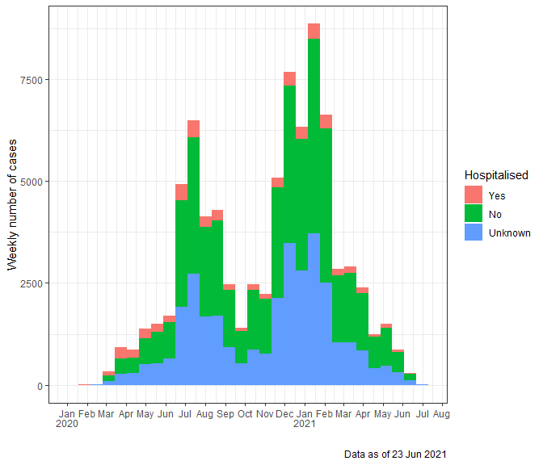

As it can be observed from above in Figure there are clear trends in reporting patterns: cases increase in waves and peak in the week starting on the 30 December 2020.

## **Person**

Table shows the demographic characteristics of the cumulative and recent COVID-19 cases and COVID-19 deaths in Fulton County.

**Table** **:** Cumulative and recent confirmed COVID-19 case and death counts by gender, age, and race/ethnicity in Fulton County, Georgia. Past 28 day period refers to May 27-June 23, 2021

| **Characteristic** | **Total Confirmed Cases** | **% of Total Cases** | **Confirmed Cases past 28 days** | **% of Confirmed Cases past 28 days** | **Total Confirmed Deathsb** | **% of Total Deaths** | **Confirmed Deaths past 28 daysb** | **% of Confirmed Deaths past 28 days** |
| --- | --- | --- | --- | --- | --- | --- | --- | --- |
| **Total** | **81,757** |  | **816** |  | **1,334** |  |  |  |
| Female | 43,112 | 52.7 | 453 | 55.5 | 632 | 47.4 | 6 | 50.0 |
| Male | 38,240 | 46.8 | 361 | 44.2 | 702 | 52.6 | 6 | 50.0 |
| Unknowna | 405 | 0.5 | 2 | 0.2 | 0 | 0.0 | 0 | 0.0 |
| 0-9 | 2,814 | 3.4 | 41 | 5.0 | 0 | 0.0 | 0 | 0.0 |
| 10-19 | 7,680 | 9.4 | 92 | 11.3 | 1 | 0.1 | 0 | 0.0 |
| 20-29 | 18,042 | 22.1 | 169 | 20.7 | 4 | 0.3 | 0 | 0.0 |
| 30-39 | 16,166 | 19.8 | 175 | 21.4 | 24 | 1.8 | 0 | 0.0 |
| 40-49 | 12,522 | 15.3 | 132 | 16.2 | 40 | 3.0 | 0 | 0.0 |
| 50-59 | 11,344 | 13.9 | 106 | 13.0 | 109 | 8.2 | 3 | 25.0 |
| 60-69 | 6,846 | 8.4 | 52 | 6.4 | 242 | 18.1 | 3 | 25.0 |
| 70+ | 6,296 | 7.7 | 48 | 5.9 | 914 | 68.5 | 6 | 50.0 |
| Unknowna | 47 | 0.1 | 1 | 0.1 | 0 | 0.0 | 0 | 0.0 |
| Asian, NH | 3,022 | 3.7 | 14 | 1.7 | 23 | 1.7 | 0 | 0.0 |
| Black, NH | 34,395 | 42.1 | 493 | 60.4 | 833 | 62.4 | 10 | 83.3 |
| White, NH | 27,303 | 33.4 | 170 | 20.8 | 417 | 31.3 | 1 | 8.3 |
| Hispanic, all races | 8,600 | 10.5 | 49 | 6.0 | 55 | 4.1 | 0 | 0.0 |
| Other, NH | 2,912 | 3.6 | 17 | 2.1 | 6 | 0.4 | 1 | 8.3 |
| Unknowna | 5,525 | 6.8 | 73 | 8.9 | 0 | 0.0 | 0 | 0.0 |
| aUnknown includes cases not yet interviewed | | | | | | | | |
| bDeaths refer to all persons who had a positive PCR test result  for Covid-19 and there is evidence that COVID-19 was the cause of  death or a significant contributor to their death. | | | | | | | | |

Above, in Table it could be observed that, even though a larger proportion of cases occur in females, more deaths occur in males. The age pyramid below in shows that the larger proportion of cases observed in females is consistent across most age groups, with the exception of those aged 0-9 and those aged 60-69, where a similar proportion of females and males can be observed.

**Figure** **:** Age and Gender of COVID-19 cases, Fulton County

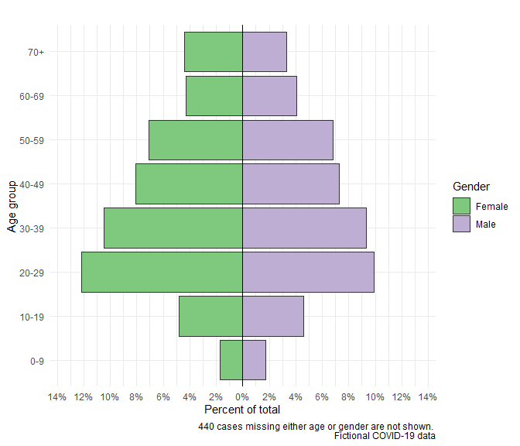

Table also showed that, although most cases occur in under 40 years old, the vast majority of deaths occur in people aged 70+. This is confirmed by Figure below, which suggests an association between older age, length of hospital stay and mortality. We see similar individual associations in Table , though these do not take into consideration interaction or confounding, so they should be interpreted with caution.

**Figure** **:** Duration of admission among hospitalized COVID-19 patients

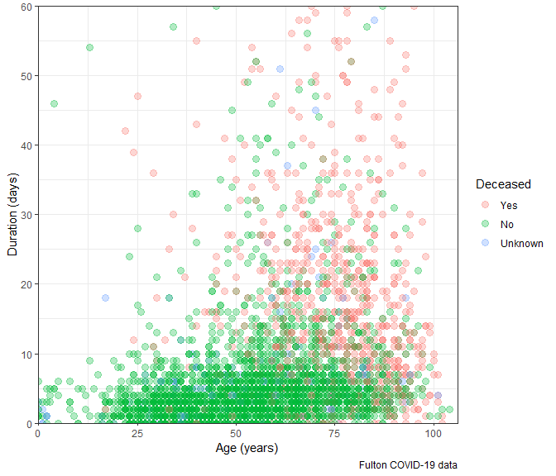

Finally, in , looking at the distribution of cases according to race, we observe that the percentage of deaths in the Black population is larger than one would expect. In fact, below confirms that in Fulton County the black population is disproportionally affected by COVID-19.

**Figure** **:** COVID-19 cases by ethnicity

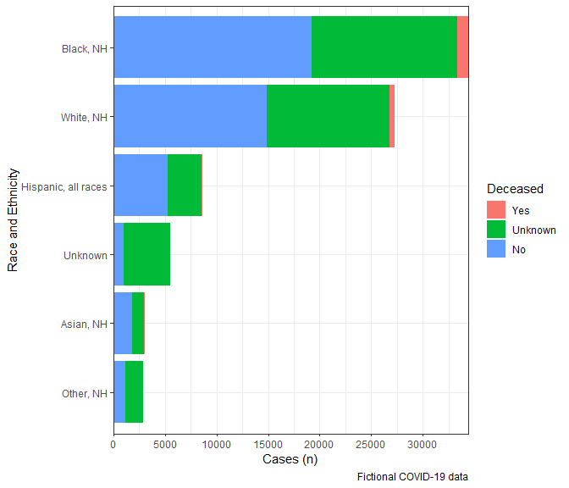

## **Place**

The below can be used to identify areas where the incidence of SARS-CoV-2 infection is rapidly increasing in Fulton County, so that public health authorities can consider the implementation of measures aimed at controlling the epidemic.

**Table** **:** COVID-19 new case counts by ZIP-code

|  | **Recent 14-day reporting period 06/10-06/23** | | **Previous 14-day reporting period 05/27-06/09** | | **Change between reporting periodsb** |
| --- | --- | --- | --- | --- | --- |
| **Zip Code** | **n** | **Incidence** | **n** | **Incidencea** | **%b** |
| 30000 | 0 | 0.0 | 0 | 0.0 | 0.0 |
| 30002 | 0 | 0.0 | 0 | 0.0 | 0.0 |
| 30004 | 7 | 1.5 | 12 | 2.6 | -41.7 |
| 30005 | 6 | 1.9 | 8 | 2.5 | -25.0 |
| 30009 | 8 | 4.3 | 6 | 3.3 | 33.3 |
| 30013 | 0 | 0.0 | 0 | 0.0 | 0.0 |
| 30022 | 11 | 1.6 | 29 | 4.1 | -62.1 |
| 30023 | 0 | 0.0 | 0 | 0.0 | 0.0 |
| 30024 | 0 | 0.0 | 0 | 0.0 | 0.0 |
| 30031 | 0 | 0.0 | 0 | 0.0 | 0.0 |
| 30032 | 0 | 0.0 | 0 | 0.0 | 0.0 |
| 30037 | 0 | 0.0 | 0 | 0.0 | 0.0 |
| 30039 | 0 | 0.0 | 0 | 0.0 | 0.0 |
| 30042 | 0 | 0.0 | 0 | 0.0 | 0.0 |
| 30044 | 0 | 0.0 | 0 | 0.0 | 0.0 |
| 30045 | 0 | 0.0 | 0 | 0.0 | 0.0 |
| 30046 | 0 | 0.0 | 0 | 0.0 | 0.0 |
| 30054 | 0 | 0.0 | 0 | 0.0 | 0.0 |
| 30062 | 0 | 0.0 | 0 | 0.0 | 0.0 |
| 30065 | 0 | 0.0 | 0 | 0.0 | 0.0 |
| 30075 | 9 | 2.0 | 15 | 3.3 | -40.0 |
| 30076 | 6 | 1.3 | 13 | 2.8 | -53.8 |
| 30077 | 0 | 0.0 | 0 | 0.0 | 0.0 |
| 30078 | 0 | 0.0 | 0 | 0.0 | 0.0 |
| 30080 | 0 | 0.0 | 0 | 0.0 | 0.0 |
| 30082 | 0 | 0.0 | 1 | 0.0 | -100.0 |
| 30083 | 0 | 0.0 | 0 | 0.0 | 0.0 |
| 30084 | 0 | 0.0 | 0 | 0.0 | 0.0 |
| 30085 | 0 | 0.0 | 0 | 0.0 | 0.0 |
| 30087 | 0 | 0.0 | 0 | 0.0 | 0.0 |
| 30092 | 1 | Inf | 0 | 0.0 | 100.0 |
| 30096 | 0 | 0.0 | 0 | 0.0 | 0.0 |
| 30097 | 1 | 0.4 | 5 | 1.9 | -80.0 |
| 30114 | 0 | 0.0 | 0 | 0.0 | 0.0 |
| 30115 | 0 | 0.0 | 0 | 0.0 | 0.0 |
| 30122 | 0 | 0.0 | 0 | 0.0 | 0.0 |
| 30123 | 0 | 0.0 | 0 | 0.0 | 0.0 |
| 30134 | 0 | 0.0 | 0 | 0.0 | 0.0 |
| 30135 | 0 | 0.0 | 0 | 0.0 | 0.0 |
| 30144 | 0 | 0.0 | 0 | 0.0 | 0.0 |
| 30168 | 0 | 0.0 | 0 | 0.0 | 0.0 |
| 30189 | 0 | 0.0 | 0 | 0.0 | 0.0 |
| 30202 | 1 | 0.0 | 0 | 0.0 | 100.0 |
| 30211 | 0 | 0.0 | 0 | 0.0 | 0.0 |
| 30212 | 0 | 0.0 | 0 | 0.0 | 0.0 |
| 30213 | 9 | 2.3 | 29 | 7.3 | -69.0 |
| 30214 | 0 | 0.0 | 0 | 0.0 | 0.0 |
| 30219 | 0 | 0.0 | 0 | 0.0 | 0.0 |
| 30222 | 0 | 0.0 | 0 | 0.0 | 0.0 |
| 30236 | 0 | 0.0 | 0 | 0.0 | 0.0 |
| 30237 | 0 | 0.0 | 0 | 0.0 | 0.0 |
| 30238 | 0 | 0.0 | 0 | 0.0 | 0.0 |
| 30268 | 1 | 1.3 | 3 | 3.9 | -66.7 |
| 30272 | 0 | 0.0 | 0 | 0.0 | 0.0 |
| 30274 | 0 | 0.0 | 0 | 0.0 | 0.0 |
| 30291 | 10 | 4.8 | 17 | 8.2 | -41.2 |
| 30294 | 0 | 0.0 | 0 | 0.0 | 0.0 |
| 30296 | 2 | 4.1 | 4 | 8.2 | -50.0 |
| 30297 | 0 | 0.0 | 0 | 0.0 | 0.0 |
| 30301 | 0 | 0.0 | 0 | 0.0 | 0.0 |
| 30302 | 0 | 0.0 | 0 | 0.0 | 0.0 |
| 30303 | 2 | 2.9 | 0 | 0.0 | 100.0 |
| 30304 | 0 | 0.0 | 0 | 0.0 | 0.0 |
| 30305 | 8 | 2.7 | 12 | 4.1 | -33.3 |
| 30306 | 1 | 0.7 | 4 | 2.6 | -75.0 |
| 30307 | 0 | 0.0 | 2 | 3.2 | -100.0 |
| 30308 | 3 | 1.5 | 9 | 4.5 | -66.7 |
| 30309 | 5 | 1.8 | 8 | 2.9 | -37.5 |
| 30310 | 7 | 2.5 | 10 | 3.6 | -30.0 |
| 30311 | 10 | 3.0 | 28 | 8.3 | -64.3 |
| 30312 | 6 | 2.6 | 12 | 5.1 | -50.0 |
| 30313 | 2 | 2.1 | 7 | 7.2 | -71.4 |
| 30314 | 9 | 3.8 | 17 | 7.2 | -47.1 |
| 30315 | 13 | 3.7 | 15 | 4.3 | -13.3 |
| 30316 | 3 | 3.1 | 7 | 7.3 | -57.1 |
| 30317 | 0 | 0.0 | 0 | 0.0 | 0.0 |
| 30318 | 15 | 2.4 | 33 | 5.4 | -54.5 |
| 30319 | 1 | 1.5 | 1 | 1.5 | 0.0 |
| 30320 | 0 | 0.0 | 0 | 0.0 | 0.0 |
| 30321 | 0 | 0.0 | 0 | 0.0 | 0.0 |
| 30322 | 0 | 0.0 | 0 | 0.0 | 0.0 |
| 30324 | 3 | 1.2 | 10 | 4.0 | -70.0 |
| 30325 | 0 | 0.0 | 0 | 0.0 | 0.0 |
| 30326 | 3 | 6.5 | 5 | 10.8 | -40.0 |
| 30327 | 4 | 1.6 | 9 | 3.7 | -55.6 |
| 30328 | 5 | 1.4 | 17 | 4.9 | -70.6 |
| 30329 | 0 | 0.0 | 1 | 0.0 | -100.0 |
| 30330 | 0 | 0.0 | 0 | 0.0 | 0.0 |
| 30331 | 28 | 4.8 | 35 | 6.0 | -20.0 |
| 30331 | 28 | 4.8 | 35 | 6.0 | -20.0 |
| 30332 | 1 | 0.0 | 0 | 0.0 | 100.0 |
| 30333 | 0 | 0.0 | 0 | 0.0 | 0.0 |
| 30334 | 0 | 0.0 | 0 | 0.0 | 0.0 |
| 30336 | 1 | 6.8 | 0 | 0.0 | 100.0 |
| 30337 | 3 | 2.5 | 8 | 6.6 | -62.5 |
| 30338 | 0 | 0.0 | 2 | 47.6 | -100.0 |
| 30339 | 3 | 82.6 | 4 | 110.2 | -25.0 |
| 30340 | 0 | 0.0 | 0 | 0.0 | 0.0 |
| 30341 | 0 | 0.0 | 0 | 0.0 | 0.0 |
| 30342 | 7 | 2.1 | 11 | 3.2 | -36.4 |
| 30343 | 0 | 0.0 | 0 | 0.0 | 0.0 |
| 30344 | 11 | 3.3 | 25 | 7.4 | -56.0 |
| 30345 | 0 | 0.0 | 0 | 0.0 | 0.0 |
| 30346 | 0 | 0.0 | 0 | 0.0 | 0.0 |
| 30348 | 0 | 0.0 | 0 | 0.0 | 0.0 |
| 30349 | 31 | 5.6 | 40 | 7.2 | -22.5 |
| 30350 | 3 | 0.8 | 6 | 1.6 | -50.0 |
| 30353 | 0 | 0.0 | 0 | 0.0 | 0.0 |
| 30354 | 4 | 2.4 | 7 | 4.3 | -42.9 |
| 30355 | 0 | 0.0 | 0 | 0.0 | 0.0 |
| 30357 | 0 | 0.0 | 0 | 0.0 | 0.0 |
| 30358 | 0 | 0.0 | 0 | 0.0 | 0.0 |
| 30360 | 0 | 0.0 | 0 | 0.0 | 0.0 |
| 30363 | 3 | 6.5 | 2 | 4.3 | 50.0 |
| 30364 | 0 | 0.0 | 0 | 0.0 | 0.0 |
| 30366 | 0 | 0.0 | 0 | 0.0 | 0.0 |
| 30374 | 1 | 0.0 | 0 | 0.0 | 100.0 |
| 30375 | 0 | 0.0 | 0 | 0.0 | 0.0 |
| 30377 | 0 | 0.0 | 0 | 0.0 | 0.0 |
| 30381 | 0 | 0.0 | 0 | 0.0 | 0.0 |
| 30388 | 0 | 0.0 | 0 | 0.0 | 0.0 |
| 30458 | 0 | 0.0 | 0 | 0.0 | 0.0 |
| 30506 | 0 | 0.0 | 0 | 0.0 | 0.0 |
| 30776 | 0 | 0.0 | 0 | 0.0 | 0.0 |
| 30909 | 0 | 0.0 | 0 | 0.0 | 0.0 |
| 31107 | 0 | 0.0 | 1 | 0.0 | -100.0 |
| 31126 | 0 | 0.0 | 0 | 0.0 | 0.0 |
| 31139 | 0 | 0.0 | 0 | 0.0 | 0.0 |
| 31156 | 0 | 0.0 | 0 | 0.0 | 0.0 |
| 31707 | 0 | 0.0 | 0 | 0.0 | 0.0 |
| Unknown | 0 | 0.0 | 1 | 0.0 | -100.0 |
| **Total** | **268** | **2.4** | **491** | **4.5** | **-45.4** |
| aIncidence calculated as cases per 10,000 population by zip code | | | | | |
| bThese reflect the percentage increase or decrease of new diagnoses   between the 14 days preceding the past 7 days and the 14 days  preceding that. | | | | | |

## **Analysis of risk factors for mortality**

**Table** **:** Demographic characteristics and association with mortality among COVID-19 cases

| **Characteristic** | **Dead (N=801)1** | **Alive (N=88)1** | **p-value2** |
| --- | --- | --- | --- |
| Gender |  |  | 0.003 |
| Female | 453 (57%) | 35 (40%) |  |
| Male | 348 (43%) | 53 (60%) |  |
| Ethnicity |  |  | 0.8 |
| Black, NH | 547 (68%) | 58 (66%) |  |
| White, NH | 147 (18%) | 27 (31%) |  |
| Hispanic, all races | 76 (9.5%) | 2 (2.3%) |  |
| Asian, NH | 20 (2.5%) | 1 (1.1%) |  |
| Other, NH | 11 (1.4%) | 0 (0%) |  |
| Age (years) | 55 (41, 66) | 73 (64, 80) | <0.001 |
| Days in hospital | 3 (2, 6) | 15 (11, 25) | <0.001 |
| 1n (%) for categorical; median (IQR) for continuous | | | |
| 2Pearson's Chi-squared test for dichotomous; Kruskal-Wallis rank sum test for continuous and categorical | | | |

**Table** **:** Univariate regression investigating associations with mortality among COVID-19 cases

|  | **Died** | | **Univariate regression** | | |
| --- | --- | --- | --- | --- | --- |
| **Characteristic** | **No, N = 8011** | **Yes, N = 881** | **OR2** | **95% CI2** | **p-value** |
| Age (years) | 55 (41, 66) | 73 (64, 80) | 1.07 | 1.05, 1.09 | <0.001 |
| Gender |  |  |  |  |  |
| Female | 453 (57%) | 35 (40%) | — | — |  |
| Male | 348 (43%) | 53 (60%) | 1.97 | 1.26, 3.11 | 0.003 |
| Ethnicity |  |  |  |  |  |
| Black, NH | 547 (68%) | 58 (66%) | — | — |  |
| White, NH | 147 (18%) | 27 (31%) | 1.73 | 1.05, 2.81 | 0.028 |
| Hispanic, all races | 76 (9.5%) | 2 (2.3%) | 0.25 | 0.04, 0.82 | 0.056 |
| Asian, NH | 20 (2.5%) | 1 (1.1%) | 0.47 | 0.03, 2.33 | 0.5 |
| Other, NH | 11 (1.4%) | 0 (0%) | 0.00 |  | >0.9 |
| Fever |  |  |  |  |  |
| No | 434 (54%) | 53 (60%) | — | — |  |
| Yes | 367 (46%) | 35 (40%) | 0.78 | 0.49, 1.22 | 0.3 |
| Subjective fever |  |  |  |  |  |
| No | 531 (66%) | 63 (72%) | — | — |  |
| Yes | 270 (34%) | 25 (28%) | 0.78 | 0.47, 1.25 | 0.3 |
| Myalgia |  |  |  |  |  |
| No | 409 (51%) | 56 (64%) | — | — |  |
| Yes | 392 (49%) | 32 (36%) | 0.60 | 0.37, 0.93 | 0.026 |
| Loss taste/smell |  |  |  |  |  |
| No | 502 (63%) | 80 (91%) | — | — |  |
| Yes | 299 (37%) | 8 (9.1%) | 0.17 | 0.07, 0.33 | <0.001 |
| Sore throat |  |  |  |  |  |
| No | 604 (75%) | 81 (92%) | — | — |  |
| Yes | 197 (25%) | 7 (8.0%) | 0.26 | 0.11, 0.54 | <0.001 |
| Cough |  |  |  |  |  |
| No | 308 (38%) | 37 (42%) | — | — |  |
| Yes | 493 (62%) | 51 (58%) | 0.86 | 0.55, 1.35 | 0.5 |
| Headache |  |  |  |  |  |
| No | 463 (58%) | 77 (88%) | — | — |  |
| Yes | 338 (42%) | 11 (13%) | 0.20 | 0.10, 0.36 | <0.001 |
| Hospitalized |  |  |  |  |  |
| No | 23 (2.9%) | 3 (3.4%) | — | — |  |
| Yes | 778 (97%) | 85 (97%) | 0.84 | 0.28, 3.58 | 0.8 |
| Days in hospital | 3 (2, 6) | 15 (11, 25) | 1.14 | 1.11, 1.17 | <0.001 |
| 1n (%) for categorical; median (IQR) for continuous | | | | | |
| 2OR = Odds Ratio, CI = Confidence Interval | | | | | |

As seen in Table , mortality was associated with being male (OR 1.97; 95% CI 1.26, 3.11), being white (OR 1.73; 95% CI 1.05, 2.81)and longer hospital stays (OR 1.14; 95% CI 1.11, 1.17).