## A starter’s guide to dagitty:

For easy use click on **launch**:

**To rename the existing variables**

1. Select the one variable, by clicking on it (for example A):

Then select rename on the left:

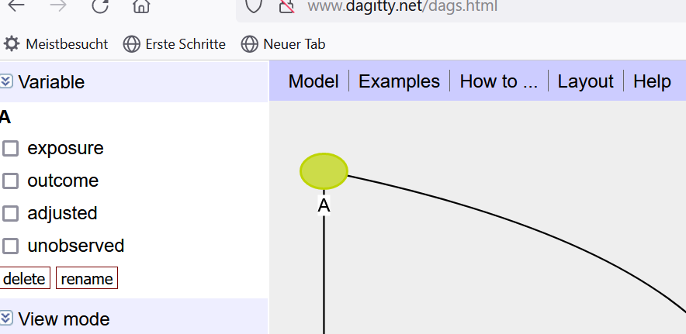 A new window will open to rename the variable.

To **change the type of variable** just check the boxes on the left:

To **add a variable** just click anywhere on the grey panel beneath your DAG.

To **add arrows**, sequentially click on

1. The variable where the new arrow should start, 2. the variable to which it should point

To **delete any arrow,** repeat the previous steps.

Don’t forget to save your final DAG. An easy way of doing this is to copy the syntax on the right to a text file on your computer. Just manually mark the code and copy:

For additional questions you may want to consult the manual: <http://www.dagitty.net/manual-2.x.pdf>

Good luck!