Emory Covid-19 Case Study Script

EpiRHandbook Team

13 August 2021

# Introduction to this case study script

This is a an example R-markdown script which demonstrates how to create an automated outbreak situation report for COVID-19 in Fulton county, USA.

* We demonstrate how to import, clean and analyse your data.
* Analysis is organised by time, place and person.
  + For the purpose of the case study we separate this by descriptive analysis and visualisation (normally this would be mixed together of course)
    - The visualisation section is organised in to place, time and person. This is to simplify flow for didactic delivery.
  + Analysis is loosely based off the monthly [epidemiology reports](https://www.fultoncountyga.gov/covid-19/epidemiology-reports) for Fulton county
* Text within <! > will not show in your final document.
  + The other parts such as slashes (///), dashes (-) and tildes (~) are just aesthetic
  + These comments are used to explain the code chunks.
  + We refer to functions in curly brackets, e.g. {dplyr} and functions end in brackets, e.g. count()
  + This comment will not show up when you knit the document.
  + You can delete them if you want.
* Feedback & suggestions are welcome at the [GitHub issues page](https://github.com/appliedepi/emory_training/issues)
  + Alternatively email us at: [epirhandbook@gmail.com](mailto:epiRhandbook@gmail.com)

# Descriptive analysis

This section will be analysing data by time place and person to produce descriptive tables.

## Summary

* As of June 23 2021, Fulton County has recorded 81757 confirmed cases of COVID-19.
* As of June 23 2021, Fulton County has recorded 1701 (2.1%) deaths.
* Among all confirmed cases of COVID-19 in Fulton County, 5277 (6.5%) required hospitalization.

## Time

Table : COVID-19 case counts by calendar week in Fulton County

| Calendar Week | Cases (n) | Percent (%) |
| --- | --- | --- |
| 2020-01-01 | 1 | 0.0 |
| 2020-01-29 | 1 | 0.0 |
| 2020-02-05 | 2 | 0.0 |
| 2020-02-12 | 3 | 0.0 |
| 2020-02-19 | 17 | 0.0 |
| 2020-02-26 | 54 | 0.1 |
| 2020-03-04 | 118 | 0.1 |
| 2020-03-11 | 164 | 0.2 |
| 2020-03-18 | 267 | 0.3 |
| 2020-03-25 | 285 | 0.3 |
| 2020-04-01 | 368 | 0.5 |
| 2020-04-08 | 424 | 0.5 |
| 2020-04-15 | 437 | 0.5 |
| 2020-04-22 | 469 | 0.6 |
| 2020-04-29 | 450 | 0.6 |
| 2020-05-06 | 464 | 0.6 |
| 2020-05-13 | 433 | 0.5 |
| 2020-05-20 | 477 | 0.6 |
| 2020-05-27 | 583 | 0.7 |
| 2020-06-03 | 708 | 0.9 |
| 2020-06-10 | 983 | 1.2 |
| 2020-06-17 | 1,365 | 1.7 |
| 2020-06-24 | 1,636 | 2.0 |
| 2020-07-01 | 1,918 | 2.3 |
| 2020-07-08 | 2,010 | 2.5 |
| 2020-07-15 | 2,207 | 2.7 |
| 2020-07-22 | 2,279 | 2.8 |
| 2020-07-29 | 2,190 | 2.7 |
| 2020-08-05 | 1,943 | 2.4 |
| 2020-08-12 | 1,705 | 2.1 |
| 2020-08-19 | 1,353 | 1.7 |
| 2020-08-26 | 1,226 | 1.5 |
| 2020-09-02 | 952 | 1.2 |
| 2020-09-09 | 782 | 1.0 |
| 2020-09-16 | 735 | 0.9 |
| 2020-09-23 | 700 | 0.9 |
| 2020-09-30 | 697 | 0.9 |
| 2020-10-07 | 779 | 1.0 |
| 2020-10-14 | 814 | 1.0 |
| 2020-10-21 | 874 | 1.1 |
| 2020-10-28 | 1,046 | 1.3 |
| 2020-11-04 | 1,187 | 1.5 |
| 2020-11-11 | 1,401 | 1.7 |
| 2020-11-18 | 1,758 | 2.2 |
| 2020-11-25 | 1,920 | 2.3 |
| 2020-12-02 | 2,266 | 2.8 |
| 2020-12-09 | 2,578 | 3.2 |
| 2020-12-16 | 2,836 | 3.5 |
| 2020-12-23 | 3,021 | 3.7 |
| 2020-12-30 | 3,317 | 4.1 |
| 2021-01-06 | 3,180 | 3.9 |
| 2021-01-13 | 2,989 | 3.7 |
| 2021-01-20 | 2,698 | 3.3 |
| 2021-01-27 | 2,549 | 3.1 |
| 2021-02-03 | 2,176 | 2.7 |
| 2021-02-10 | 1,909 | 2.3 |
| 2021-02-17 | 1,557 | 1.9 |
| 2021-02-24 | 1,285 | 1.6 |
| 2021-03-03 | 1,104 | 1.4 |
| 2021-03-10 | 899 | 1.1 |
| 2021-03-17 | 903 | 1.1 |
| 2021-03-24 | 831 | 1.0 |
| 2021-03-31 | 812 | 1.0 |
| 2021-04-07 | 754 | 0.9 |
| 2021-04-14 | 667 | 0.8 |
| 2021-04-21 | 579 | 0.7 |
| 2021-04-28 | 542 | 0.7 |
| 2021-05-05 | 538 | 0.7 |
| 2021-05-12 | 427 | 0.5 |
| 2021-05-19 | 339 | 0.4 |
| 2021-05-26 | 276 | 0.3 |
| 2021-06-02 | 241 | 0.3 |
| 2021-06-09 | 144 | 0.2 |
| 2021-06-16 | 141 | 0.2 |
| 2021-06-23 | 14 | 0.0 |
| Total | 81,757 | 100.0 |

As you can see from above in Table we can see clear trends in reporting patterns - cases increase in waves and peak in December 2020.

## Place

Table : COVID-19 new case counts by ZIP-code

|  | **Recent 14-day reporting period 06/10-06/23** | | **Previous 14-day reporting period 05/27-06/09** | | **Change between reporting periodsb** |
| --- | --- | --- | --- | --- | --- |
| **Zip Code** | **n** | **Incidencea** | **n** | **Incidencea** | **%b** |
| 30000 | 0 | 0.0 | 0 | 0.0 | 0.0 |
| 30002 | 0 | 0.0 | 0 | 0.0 | 0.0 |
| 30004 | 7 | 1.5 | 12 | 2.6 | -41.7 |
| 30005 | 6 | 1.9 | 8 | 2.5 | -25.0 |
| 30009 | 8 | 4.3 | 6 | 3.3 | 33.3 |
| 30013 | 0 | 0.0 | 0 | 0.0 | 0.0 |
| 30022 | 11 | 1.6 | 29 | 4.1 | -62.1 |
| 30023 | 0 | 0.0 | 0 | 0.0 | 0.0 |
| 30024 | 0 | 0.0 | 0 | 0.0 | 0.0 |
| 30031 | 0 | 0.0 | 0 | 0.0 | 0.0 |
| 30032 | 0 | 0.0 | 0 | 0.0 | 0.0 |
| 30037 | 0 | 0.0 | 0 | 0.0 | 0.0 |
| 30039 | 0 | 0.0 | 0 | 0.0 | 0.0 |
| 30042 | 0 | 0.0 | 0 | 0.0 | 0.0 |
| 30044 | 0 | 0.0 | 0 | 0.0 | 0.0 |
| 30045 | 0 | 0.0 | 0 | 0.0 | 0.0 |
| 30046 | 0 | 0.0 | 0 | 0.0 | 0.0 |
| 30054 | 0 | 0.0 | 0 | 0.0 | 0.0 |
| 30062 | 0 | 0.0 | 0 | 0.0 | 0.0 |
| 30065 | 0 | 0.0 | 0 | 0.0 | 0.0 |
| 30075 | 9 | 2.0 | 15 | 3.3 | -40.0 |
| 30076 | 6 | 1.3 | 13 | 2.8 | -53.8 |
| 30077 | 0 | 0.0 | 0 | 0.0 | 0.0 |
| 30078 | 0 | 0.0 | 0 | 0.0 | 0.0 |
| 30080 | 0 | 0.0 | 0 | 0.0 | 0.0 |
| 30082 | 0 | 0.0 | 1 | 0.0 | -100.0 |
| 30083 | 0 | 0.0 | 0 | 0.0 | 0.0 |
| 30084 | 0 | 0.0 | 0 | 0.0 | 0.0 |
| 30085 | 0 | 0.0 | 0 | 0.0 | 0.0 |
| 30087 | 0 | 0.0 | 0 | 0.0 | 0.0 |
| 30092 | 1 | Inf | 0 | 0.0 | 100.0 |
| 30096 | 0 | 0.0 | 0 | 0.0 | 0.0 |
| 30097 | 1 | 0.4 | 5 | 1.9 | -80.0 |
| 30114 | 0 | 0.0 | 0 | 0.0 | 0.0 |
| 30115 | 0 | 0.0 | 0 | 0.0 | 0.0 |
| 30122 | 0 | 0.0 | 0 | 0.0 | 0.0 |
| 30123 | 0 | 0.0 | 0 | 0.0 | 0.0 |
| 30134 | 0 | 0.0 | 0 | 0.0 | 0.0 |
| 30135 | 0 | 0.0 | 0 | 0.0 | 0.0 |
| 30144 | 0 | 0.0 | 0 | 0.0 | 0.0 |
| 30168 | 0 | 0.0 | 0 | 0.0 | 0.0 |
| 30189 | 0 | 0.0 | 0 | 0.0 | 0.0 |
| 30202 | 1 | 0.0 | 0 | 0.0 | 100.0 |
| 30211 | 0 | 0.0 | 0 | 0.0 | 0.0 |
| 30212 | 0 | 0.0 | 0 | 0.0 | 0.0 |
| 30213 | 9 | 2.3 | 29 | 7.3 | -69.0 |
| 30214 | 0 | 0.0 | 0 | 0.0 | 0.0 |
| 30219 | 0 | 0.0 | 0 | 0.0 | 0.0 |
| 30222 | 0 | 0.0 | 0 | 0.0 | 0.0 |
| 30236 | 0 | 0.0 | 0 | 0.0 | 0.0 |
| 30237 | 0 | 0.0 | 0 | 0.0 | 0.0 |
| 30238 | 0 | 0.0 | 0 | 0.0 | 0.0 |
| 30268 | 1 | 1.3 | 3 | 3.9 | -66.7 |
| 30272 | 0 | 0.0 | 0 | 0.0 | 0.0 |
| 30274 | 0 | 0.0 | 0 | 0.0 | 0.0 |
| 30291 | 10 | 4.8 | 17 | 8.2 | -41.2 |
| 30294 | 0 | 0.0 | 0 | 0.0 | 0.0 |
| 30296 | 2 | 4.1 | 4 | 8.2 | -50.0 |
| 30297 | 0 | 0.0 | 0 | 0.0 | 0.0 |
| 30301 | 0 | 0.0 | 0 | 0.0 | 0.0 |
| 30302 | 0 | 0.0 | 0 | 0.0 | 0.0 |
| 30303 | 2 | 2.9 | 0 | 0.0 | 100.0 |
| 30304 | 0 | 0.0 | 0 | 0.0 | 0.0 |
| 30305 | 8 | 2.7 | 12 | 4.1 | -33.3 |
| 30306 | 1 | 0.7 | 4 | 2.6 | -75.0 |
| 30307 | 0 | 0.0 | 2 | 3.2 | -100.0 |
| 30308 | 3 | 1.5 | 9 | 4.5 | -66.7 |
| 30309 | 5 | 1.8 | 8 | 2.9 | -37.5 |
| 30310 | 7 | 2.5 | 10 | 3.6 | -30.0 |
| 30311 | 10 | 3.0 | 28 | 8.3 | -64.3 |
| 30312 | 6 | 2.6 | 12 | 5.1 | -50.0 |
| 30313 | 2 | 2.1 | 7 | 7.2 | -71.4 |
| 30314 | 9 | 3.8 | 17 | 7.2 | -47.1 |
| 30315 | 13 | 3.7 | 15 | 4.3 | -13.3 |
| 30316 | 3 | 3.1 | 7 | 7.3 | -57.1 |
| 30317 | 0 | 0.0 | 0 | 0.0 | 0.0 |
| 30318 | 15 | 2.4 | 33 | 5.4 | -54.5 |
| 30319 | 1 | 1.5 | 1 | 1.5 | 0.0 |
| 30320 | 0 | 0.0 | 0 | 0.0 | 0.0 |
| 30321 | 0 | 0.0 | 0 | 0.0 | 0.0 |
| 30322 | 0 | 0.0 | 0 | 0.0 | 0.0 |
| 30324 | 3 | 1.2 | 10 | 4.0 | -70.0 |
| 30325 | 0 | 0.0 | 0 | 0.0 | 0.0 |
| 30326 | 3 | 6.5 | 5 | 10.8 | -40.0 |
| 30327 | 4 | 1.6 | 9 | 3.7 | -55.6 |
| 30328 | 5 | 1.4 | 17 | 4.9 | -70.6 |
| 30329 | 0 | 0.0 | 1 | 0.0 | -100.0 |
| 30330 | 0 | 0.0 | 0 | 0.0 | 0.0 |
| 30331 | 28 | 4.8 | 35 | 6.0 | -20.0 |
| 30331 | 28 | 4.8 | 35 | 6.0 | -20.0 |
| 30332 | 1 | 0.0 | 0 | 0.0 | 100.0 |
| 30333 | 0 | 0.0 | 0 | 0.0 | 0.0 |
| 30334 | 0 | 0.0 | 0 | 0.0 | 0.0 |
| 30336 | 1 | 6.8 | 0 | 0.0 | 100.0 |
| 30337 | 3 | 2.5 | 8 | 6.6 | -62.5 |
| 30338 | 0 | 0.0 | 2 | 47.6 | -100.0 |
| 30339 | 3 | 82.6 | 4 | 110.2 | -25.0 |
| 30340 | 0 | 0.0 | 0 | 0.0 | 0.0 |
| 30341 | 0 | 0.0 | 0 | 0.0 | 0.0 |
| 30342 | 7 | 2.1 | 11 | 3.2 | -36.4 |
| 30343 | 0 | 0.0 | 0 | 0.0 | 0.0 |
| 30344 | 11 | 3.3 | 25 | 7.4 | -56.0 |
| 30345 | 0 | 0.0 | 0 | 0.0 | 0.0 |
| 30346 | 0 | 0.0 | 0 | 0.0 | 0.0 |
| 30348 | 0 | 0.0 | 0 | 0.0 | 0.0 |
| 30349 | 31 | 5.6 | 40 | 7.2 | -22.5 |
| 30350 | 3 | 0.8 | 6 | 1.6 | -50.0 |
| 30353 | 0 | 0.0 | 0 | 0.0 | 0.0 |
| 30354 | 4 | 2.4 | 7 | 4.3 | -42.9 |
| 30355 | 0 | 0.0 | 0 | 0.0 | 0.0 |
| 30357 | 0 | 0.0 | 0 | 0.0 | 0.0 |
| 30358 | 0 | 0.0 | 0 | 0.0 | 0.0 |
| 30360 | 0 | 0.0 | 0 | 0.0 | 0.0 |
| 30363 | 3 | 6.5 | 2 | 4.3 | 50.0 |
| 30364 | 0 | 0.0 | 0 | 0.0 | 0.0 |
| 30366 | 0 | 0.0 | 0 | 0.0 | 0.0 |
| 30374 | 1 | 0.0 | 0 | 0.0 | 100.0 |
| 30375 | 0 | 0.0 | 0 | 0.0 | 0.0 |
| 30377 | 0 | 0.0 | 0 | 0.0 | 0.0 |
| 30381 | 0 | 0.0 | 0 | 0.0 | 0.0 |
| 30388 | 0 | 0.0 | 0 | 0.0 | 0.0 |
| 30458 | 0 | 0.0 | 0 | 0.0 | 0.0 |
| 30506 | 0 | 0.0 | 0 | 0.0 | 0.0 |
| 30776 | 0 | 0.0 | 0 | 0.0 | 0.0 |
| 30909 | 0 | 0.0 | 0 | 0.0 | 0.0 |
| 31107 | 0 | 0.0 | 1 | 0.0 | -100.0 |
| 31126 | 0 | 0.0 | 0 | 0.0 | 0.0 |
| 31139 | 0 | 0.0 | 0 | 0.0 | 0.0 |
| 31156 | 0 | 0.0 | 0 | 0.0 | 0.0 |
| 31707 | 0 | 0.0 | 0 | 0.0 | 0.0 |
| Unknown | 0 | 0.0 | 1 | 0.0 | -100.0 |
| **Total** | **268** | **2.4** | **491** | **4.5** | **-45.4** |
| aIncidence calculated as cases per 10,000 population by zip code | | | | | |
| bThese reflect the percentage increase or decrease of new diagnoses   between the 14 days preceding the past 7 days and the 14 days  preceding that. | | | | | |

## Person

Table : Cumulative and recent confirmed COVID-19 case and death counts by gender, age, and race/ethnicity in Fulton County, Georgia. Past 28 day period refers to May 27-June 23, 2021

| **Characteristic** | **Total Confirmed Cases** | **% of Total Cases** | **Confirmed Cases past 28 days** | **% of Confirmed Cases past 28 days** | **Total Confirmed Deathsb** | **% of Total Deaths** | **Confirmed Deaths past 28 daysb** | **% of Confirmed Deaths past 28 days** |
| --- | --- | --- | --- | --- | --- | --- | --- | --- |
| **Total** | **81,757** |  | **816** |  | **1,334** |  |  |  |
| Female | 43,112 | 52.7 | 453 | 55.5 | 632 | 47.4 | 6 | 50.0 |
| Male | 38,240 | 46.8 | 361 | 44.2 | 702 | 52.6 | 6 | 50.0 |
| Unknowna | 405 | 0.5 | 2 | 0.2 | 0 | 0.0 | 0 | 0.0 |
| 0-9 | 2,814 | 3.4 | 41 | 5.0 | 0 | 0.0 | 0 | 0.0 |
| 10-19 | 7,680 | 9.4 | 92 | 11.3 | 1 | 0.1 | 0 | 0.0 |
| 20-29 | 18,042 | 22.1 | 169 | 20.7 | 4 | 0.3 | 0 | 0.0 |
| 30-39 | 16,166 | 19.8 | 175 | 21.4 | 24 | 1.8 | 0 | 0.0 |
| 40-49 | 12,522 | 15.3 | 132 | 16.2 | 40 | 3.0 | 0 | 0.0 |
| 50-59 | 11,344 | 13.9 | 106 | 13.0 | 109 | 8.2 | 3 | 25.0 |
| 60-69 | 6,846 | 8.4 | 52 | 6.4 | 242 | 18.1 | 3 | 25.0 |
| 70+ | 6,296 | 7.7 | 48 | 5.9 | 914 | 68.5 | 6 | 50.0 |
| Unknowna | 47 | 0.1 | 1 | 0.1 | 0 | 0.0 | 0 | 0.0 |
| Asian, NH | 3,022 | 3.7 | 14 | 1.7 | 23 | 1.7 | 0 | 0.0 |
| Black, NH | 34,395 | 42.1 | 493 | 60.4 | 833 | 62.4 | 10 | 83.3 |
| White, NH | 27,303 | 33.4 | 170 | 20.8 | 417 | 31.3 | 1 | 8.3 |
| Hispanic, all races | 8,600 | 10.5 | 49 | 6.0 | 55 | 4.1 | 0 | 0.0 |
| Other, NH | 2,912 | 3.6 | 17 | 2.1 | 6 | 0.4 | 1 | 8.3 |
| Unknowna | 5,525 | 6.8 | 73 | 8.9 | 0 | 0.0 | 0 | 0.0 |
| aUnknown includes cases not yet interviewed | | | | | | | | |
| bDeaths refer to all persons who had a positive PCR test result  for Covid-19 and there is evidence that COVID-19 was the cause of  death or a significant contributor to their death. | | | | | | | | |

### Risk factors for mortality

Table : Demographic characteristics and association with mortality among COVID-19 cases

| **Characteristic** | **Dead (N=801)1** | **Alive (N=88)1** | **p-value2** |
| --- | --- | --- | --- |
| Gender |  |  | 0.003 |
| Female | 453 (57%) | 35 (40%) |  |
| Male | 348 (43%) | 53 (60%) |  |
| Ethnicity |  |  | 0.8 |
| Black, NH | 547 (68%) | 58 (66%) |  |
| White, NH | 147 (18%) | 27 (31%) |  |
| Hispanic, all races | 76 (9.5%) | 2 (2.3%) |  |
| Asian, NH | 20 (2.5%) | 1 (1.1%) |  |
| Other, NH | 11 (1.4%) | 0 (0%) |  |
| Age (years) | 55 (41, 66) | 73 (64, 80) | <0.001 |
| Days in hospital | 3 (2, 6) | 15 (11, 25) | <0.001 |
| 1n (%) for categorical; median (IQR) for continuous | | | |
| 2Pearson's Chi-squared test for dichotomous; Kruskal-Wallis rank sum test for continuous and categorical | | | |

Table : Univariate regression investigating associations with mortality among COVID-19 cases

|  | **Died** | | **Univariate regression** | | |
| --- | --- | --- | --- | --- | --- |
| **Characteristic** | **No, N = 8011** | **Yes, N = 881** | **OR2** | **95% CI2** | **p-value** |
| Age (years) | 55 (41, 66) | 73 (64, 80) | 1.07 | 1.05, 1.09 | <0.001 |
| Gender |  |  |  |  |  |
| Female | 453 (57%) | 35 (40%) | — | — |  |
| Male | 348 (43%) | 53 (60%) | 1.97 | 1.26, 3.11 | 0.003 |
| Ethnicity |  |  |  |  |  |
| Black, NH | 547 (68%) | 58 (66%) | — | — |  |
| White, NH | 147 (18%) | 27 (31%) | 1.73 | 1.05, 2.81 | 0.028 |
| Hispanic, all races | 76 (9.5%) | 2 (2.3%) | 0.25 | 0.04, 0.82 | 0.056 |
| Asian, NH | 20 (2.5%) | 1 (1.1%) | 0.47 | 0.03, 2.33 | 0.5 |
| Other, NH | 11 (1.4%) | 0 (0%) | 0.00 |  | >0.9 |
| Fever |  |  |  |  |  |
| No | 434 (54%) | 53 (60%) | — | — |  |
| Yes | 367 (46%) | 35 (40%) | 0.78 | 0.49, 1.22 | 0.3 |
| Subjective fever |  |  |  |  |  |
| No | 531 (66%) | 63 (72%) | — | — |  |
| Yes | 270 (34%) | 25 (28%) | 0.78 | 0.47, 1.25 | 0.3 |
| Myalgia |  |  |  |  |  |
| No | 409 (51%) | 56 (64%) | — | — |  |
| Yes | 392 (49%) | 32 (36%) | 0.60 | 0.37, 0.93 | 0.026 |
| Loss taste/smell |  |  |  |  |  |
| No | 502 (63%) | 80 (91%) | — | — |  |
| Yes | 299 (37%) | 8 (9.1%) | 0.17 | 0.07, 0.33 | <0.001 |
| Sore throat |  |  |  |  |  |
| No | 604 (75%) | 81 (92%) | — | — |  |
| Yes | 197 (25%) | 7 (8.0%) | 0.26 | 0.11, 0.54 | <0.001 |
| Cough |  |  |  |  |  |
| No | 308 (38%) | 37 (42%) | — | — |  |
| Yes | 493 (62%) | 51 (58%) | 0.86 | 0.55, 1.35 | 0.5 |
| Headache |  |  |  |  |  |
| No | 463 (58%) | 77 (88%) | — | — |  |
| Yes | 338 (42%) | 11 (12%) | 0.20 | 0.10, 0.36 | <0.001 |
| Hospitalized |  |  |  |  |  |
| No | 23 (2.9%) | 3 (3.4%) | — | — |  |
| Yes | 778 (97%) | 85 (97%) | 0.84 | 0.28, 3.58 | 0.8 |
| Days in hospital | 3 (2, 6) | 15 (11, 25) | 1.14 | 1.11, 1.17 | <0.001 |
| 1n (%) for categorical; median (IQR) for continuous | | | | | |
| 2OR = Odds Ratio, CI = Confidence Interval | | | | | |

As seen in Table , mortality was associated with being male (OR 1.97; 95% CI 1.26, 3.11), being white (OR 1.73; 95% CI 1.05, 2.81)and longer hospital stays (OR 1.14; 95% CI 1.11, 1.17).

# Visualisation

## Person

As we see below in Figure there appears to be an association between older age, length of hospital stay and mortality. We saw this in Table as well for the individual associations, although we did not check for interaction and confounding.

Figure : Duration of admission among hospitalized COVID-19 patients

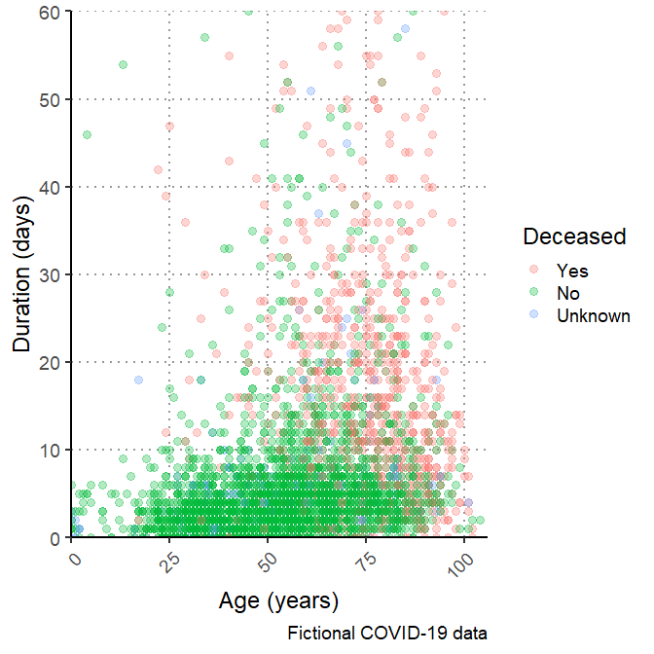

Figure : COVID-19 cases by ethnicity

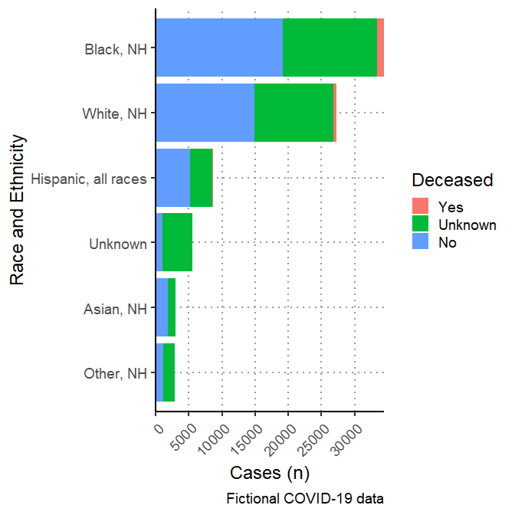

Figure : Age and Gender of COVID-19 cases, Fulton County

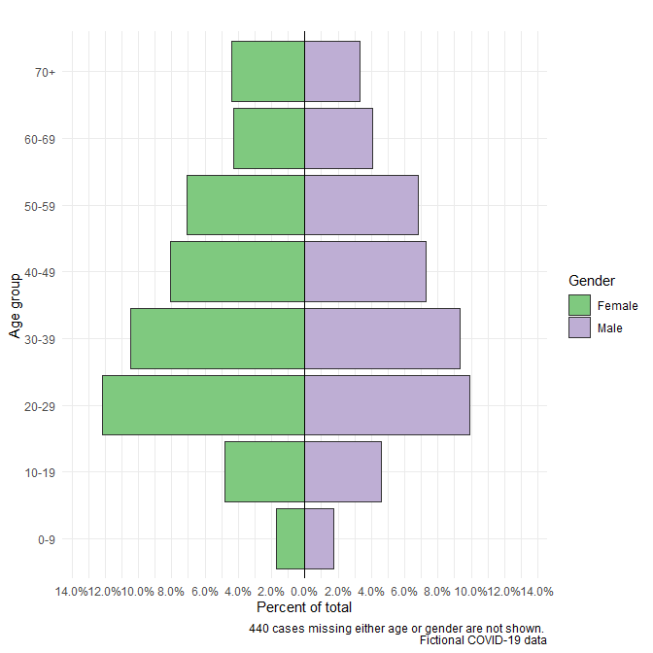

## Time

Figure : COVID-19 cases by week and race/ethnicity in Fulton County

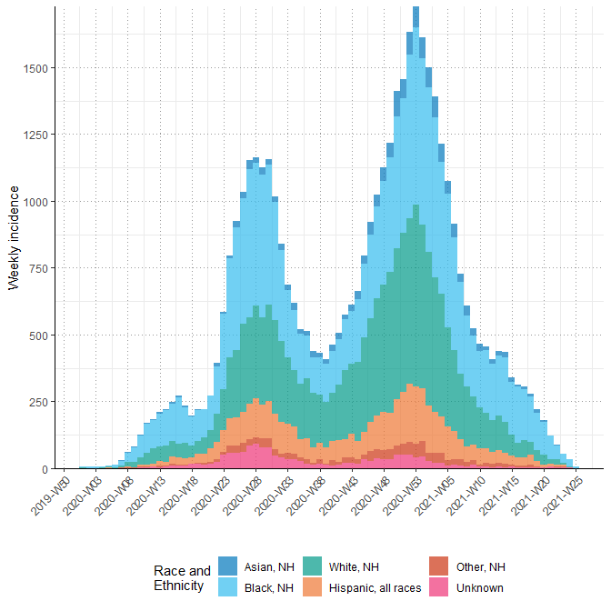

## Place

Figure : New COVID-19 cases (06/10-06/23) by ethnicity in Fulton County

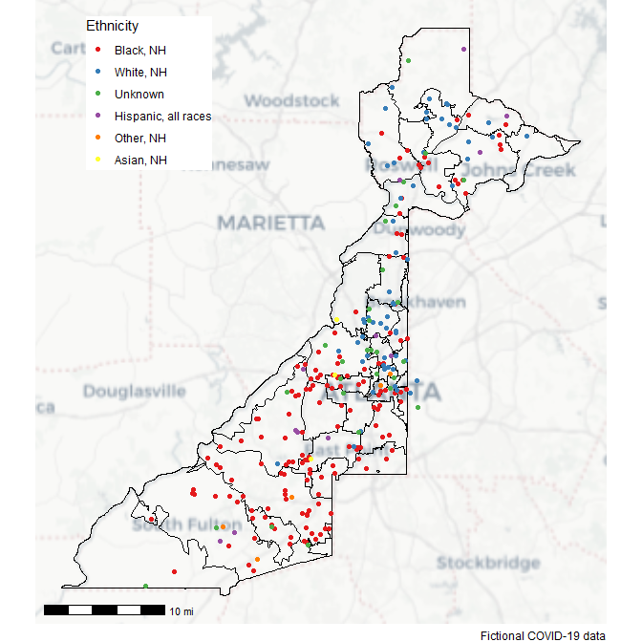

Figure : COVID-19 case incidence (per 100,000) by Zip Code (06/10-06/23) in Fulton County

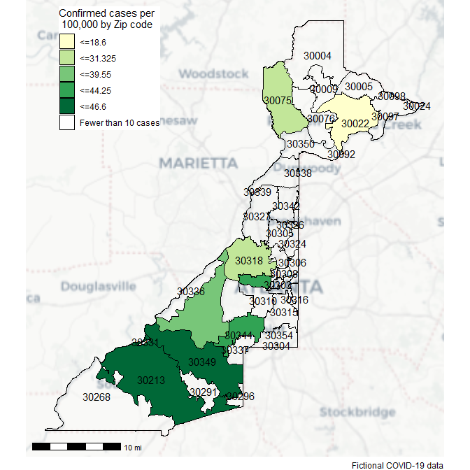

Figure : COVID-19 case incidence (per 100,000) by proportion of ethnic minority cases and Zip Code (06/10-06/23) in Fulton County

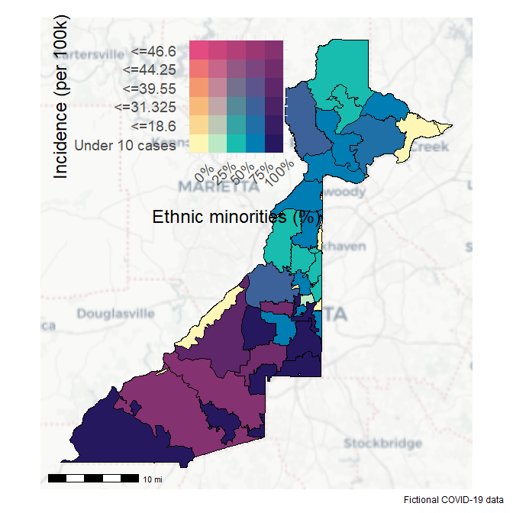

Figure : Density map - New COVID-19 cases (06/10-06/23) in Fulton County

