Situation Report

Ebola outbreak in Sierra Leone

(Your name or agency here)

2022-03-17

# Executive summary

The outbreak of Ebola continues, although reported cases are decreasing in all districts following the surge in contract-tracing support provided by international partners.

“As of 23 November, 2014 there had been 624 confirmed cases reported.”

Table of partners involved in the response

| Partner | Arrived | Activities |
| --- | --- | --- |
| Doctors without Borders (MSF) - Belgium | 20 July | Treatment centers |
| World Health Organization (WHO) | 22 July | Surveillance and analytics |
| Red Cross (ICRC) | 1 August | Community-based surveillance |

## Person

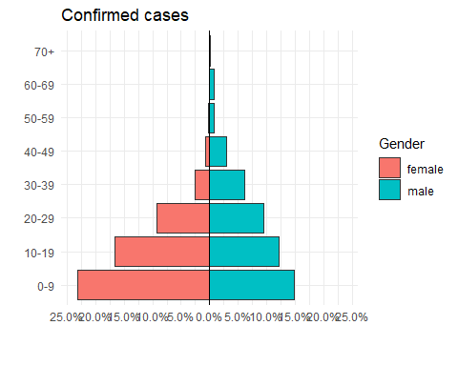

## Time

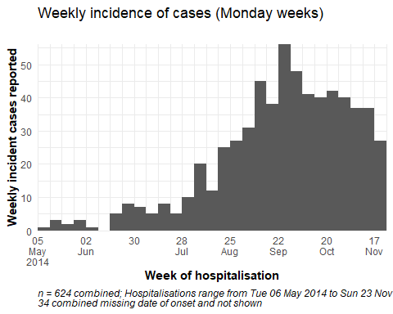

## Place

| district | n | percent |
| --- | --- | --- |
| Mountain Rural | 193 | 31% |
| West II | 116 | 19% |
| West III | 107 | 17% |
| East II | 71 | 11% |
| Central II | 42 | 7% |
| Central I | 34 | 5% |
| East I | 30 | 5% |
| West I | 17 | 3% |
| East III | 12 | 2% |
| Missing | 2 | 0% |