Covid-19 outbreak situation report

Case study exercise for Applied Epi R course

30 June 2021

# Summary

* As of June 23 2021, Fulton County has recorded 89959 confirmed cases of COVID-19.
* As of June 23 2021, Fulton County has recorded 1870 (2.1%) deaths.
* Among all confirmed cases of COVID-19 in Fulton County, 5875 (6.5%) required hospitalization.

# Demographics

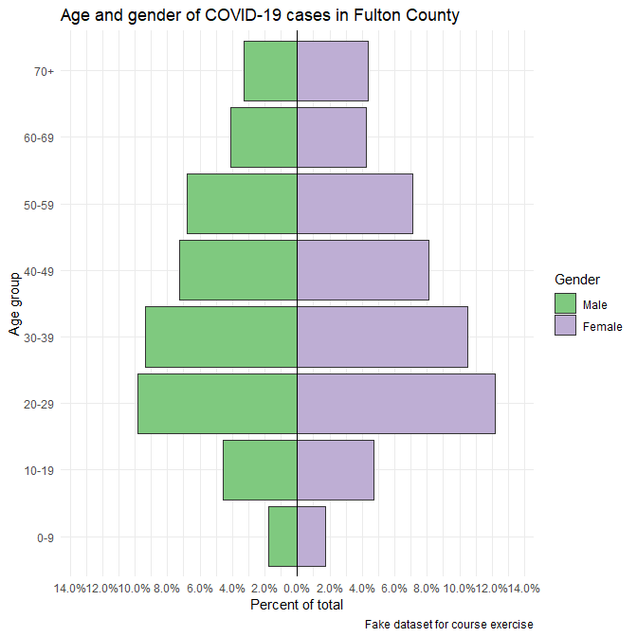

# Weekly epidemic curve by city

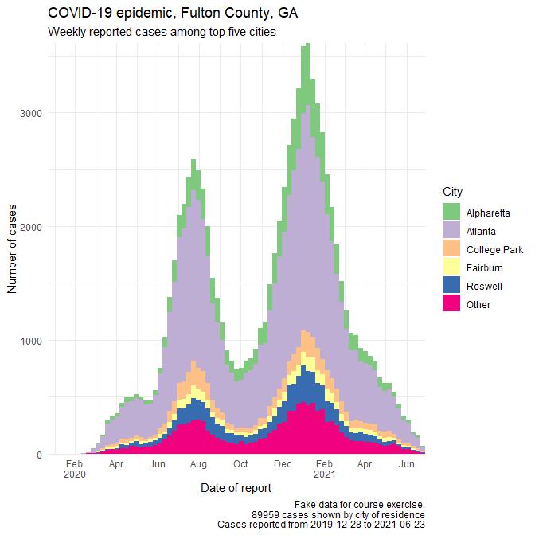

# Cumulative case incidence by city, per 10,000 population

| City | Total cases | Cases in last 14 days | Cumulative incidence per 10,000 |
| --- | --- | --- | --- |
| College Park | 5,685 | 34 | 4,081.1 |
| Fairburn | 3,293 | 9 | 1,997.8 |
| Hapeville | 1,187 | 4 | 1,811.4 |
| Alpharetta | 11,725 | 32 | 1,781.4 |
| Palmetto | 628 | 1 | 1,238.4 |
| Atlanta | 51,666 | 188 | 1,036.0 |
| Union City | 2,189 | 10 | 815.9 |
| Roswell | 6,745 | 15 | 726.6 |
| East Point | 2,561 | 11 | 667.7 |
| Duluth | 1,365 | 1 | 428.3 |
| Sandy Springs | 2,915 | 5 | 269.7 |

## Table of Race and hospitalization (Yes/No)

| Characteristic | No, N = 48,6561 | Yes, N = 5,8751 | p-value2 |
| --- | --- | --- | --- |
| race |  |  | <0.001 |
| Ai/An | 48 (96%) | 2 (4.0%) |  |
| Asian | 2,056 (95%) | 110 (5.1%) |  |
| Black | 21,292 (85%) | 3,868 (15%) |  |
| Other | 3,280 (91%) | 318 (8.8%) |  |
| White | 20,214 (93%) | 1,490 (6.9%) |  |
| Unknown | 1,766 | 87 |  |
| 1n (%) | | | |
| 2Pearson's Chi-squared test | | | |