Untitled

## Test

Warning: There were 2 warnings in `mutate()`.  
The first warning was:  
ℹ In argument: `admission = mdy(admission)`.  
Caused by warning:  
! 213 failed to parse.  
ℹ Run `dplyr::last_dplyr_warnings()` to see the 1 remaining warning.

Warning: There was 1 warning in `mutate()`.  
ℹ In argument: `date_outcome = ymd(date_outcome)`.  
Caused by warning:  
! All formats failed to parse. No formats found.

Warning: There was 1 warning in `mutate()`.  
ℹ In argument: `date_of_birth = ymd(date_of_birth)`.  
Caused by warning:  
! 4 failed to parse.

cholera_pcr_positive n percent  
 0 16 0.3902439  
 1 25 0.6097561

cholera_pcr_positive n percent valid_percent  
 0 16 0.01920768 0.3902439  
 1 25 0.03001200 0.6097561  
 NA 792 0.95078031 NA

region Unclear Suspected Probable Confirmed  
 Bexar 59 63 181 12  
 Keda 50 6 0 0  
 Liora 82 11 0 0  
 Nelos 106 9 1 0  
 New Arden 2 1 0 0  
 Sorel 60 12 1 0  
 Taris 5 2 33 13  
 Varek 73 4 1 0  
 West Morin 36 10 0 0

Warning: Removed 187 rows containing non-finite outside the scale range  
(`stat_count()`).

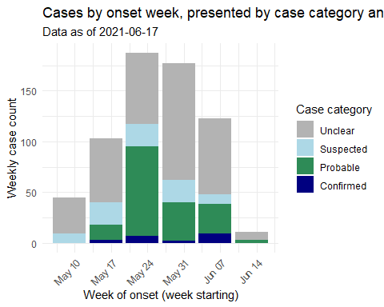

Warning: Removed 187 rows containing non-finite outside the scale range  
(`stat_count()`).

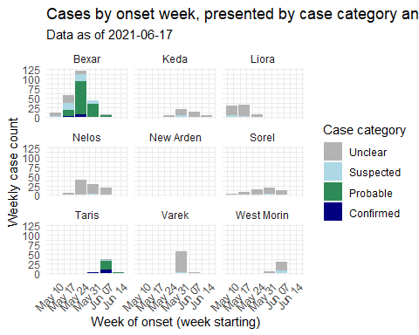

# A tibble: 9 × 7  
 region `Abdominal pain` Dehydration Diarrhea Fever Nausea Vomiting  
 <chr> <int> <int> <int> <int> <int> <int>  
1 Bexar 48 170 222 34 23 163  
2 Keda 19 7 30 8 33 33  
3 Liora 30 15 38 12 56 55  
4 Nelos 53 14 62 17 76 82  
5 New Arden 1 1 3 1 0 3  
6 Sorel 22 18 44 33 13 25  
7 Taris 10 24 37 5 6 30  
8 Varek 33 12 31 17 38 47  
9 West Morin 12 13 25 19 8 21

| **region** | **Unclear** | **Suspected** | **Probable** | **Confirmed** |
| --- | --- | --- | --- | --- |
| Bexar | 18.7% (59) | 20.0% (63) | 57.5% (181) | 3.8% (12) |
| Keda | 89.3% (50) | 10.7% (6) | 0.0% (0) | 0.0% (0) |
| Liora | 88.2% (82) | 11.8% (11) | 0.0% (0) | 0.0% (0) |
| Nelos | 91.4% (106) | 7.8% (9) | 0.9% (1) | 0.0% (0) |
| New Arden | 66.7% (2) | 33.3% (1) | 0.0% (0) | 0.0% (0) |
| Sorel | 82.2% (60) | 16.4% (12) | 1.4% (1) | 0.0% (0) |
| Taris | 9.4% (5) | 3.8% (2) | 62.3% (33) | 24.5% (13) |
| Varek | 93.6% (73) | 5.1% (4) | 1.3% (1) | 0.0% (0) |
| West Morin | 78.3% (36) | 21.7% (10) | 0.0% (0) | 0.0% (0) |
| **Total** | **56.8% (473)** | **14.2% (118)** | **26.1% (217)** | **3.0% (25)** |

| **region** | **Cases** | | **Deaths** | |
| --- | --- | --- | --- | --- |
| Total | Reported in past 7 days | No. deaths | % deaths |
| Bexar | 315 | 7 | 23 | 7.3% |
| Keda | 56 | 21 | 1 | 1.8% |
| Liora | 93 | 0 | 2 | 2.2% |
| Nelos | 116 | 22 | 3 | 2.6% |
| New Arden | 3 | 3 | 0 | 0.0% |
| Sorel | 73 | 16 | 1 | 1.4% |
| Taris | 53 | 44 | 3 | 5.7% |
| Varek | 78 | 4 | 1 | 1.3% |
| West Morin | 46 | 33 | 1 | 2.2% |
| **Total** | **833** | **150** | **35** | **-** |