
Jarvis AI - Business Analyst

A PROJECT REPORT

Submitted by

T.S VISHNU PRASANTH (310824622023)

in partial fulfillment for the award of the degree
of

MASTER OF COMPUTER APPLICATIONS

JEPPIAAR ENGINEERING COLLEGE: CHENNAI 600 119
ANNA UNIVERSITY: CHENNAI 600 025
JULY 2026


INTERNSHIP CERTIFICATE



ANNA UNIVERSITY: CHENNAI 600 025

BONAFIDE CERTIFICATE

Certified that this project report, Jarvis AI - Business Analyst, is the bonafide work of VISHNU PRASANTH TS (310824622023) who carried out the project under my supervision.

SIGNATURE
Dr. J.S. PRAVEEN, MCA, M.Phil., Ph.D.
HEAD OF THE DEPARTMENT,
Master of Computer Applications,
Jeppiaar Engineering College,
Jeppiaar Nagar, Rajiv Gandhi Salai,
Chennai – 600 119.

SIGNATURE
Ms. A.J. AJAYLIN MAHIBA, MCA.,
SUPERVISOR ASSISTANT PROFESSOR,
Master of Computer Applications,
Jeppiaar Engineering College,
Jeppiaar Nagar, Rajiv Gandhi Salai,
Chennai – 600 119.

CERTIFICATE FOR EVALUATION

Batch No | Names of the  Student(s) who have completed this project | Title of the Project | Name of the  Supervisor with  Designation
 | VISHNU PRASANTH TS  (310824622023) | Jarvis AI - Business Analyst | Ms. A.J. AJAYLIN  MAHBA  ASSISTANT  PROFESSOR

The project report submitted by the above student, in partial fulfilment of the requirements for the award of the Master of Computer Applications degree at Anna University, Chennai, has been duly evaluated.

INTERNAL EXAMINER EXTERNAL EXAMINER

ACKNOWLEDGEMENT

I express my profound gratitude to our beloved founder (Late) Hon’ble Dr. J. JEPPIAAR, M.A., B.L., Ph.D., whose vision and dedication laid the foundation for providing me the opportunity to undertake this project.

I express my sincere thanks and deep sense of gratitude to our Chairman and Managing Director Dr. REGEENA J. MURALI, B.Tech., M.B.A., Ph.D., for providing the necessary facilities and continuous support to carry out this project work in our institution.

I am extremely thankful to our Principal Dr. K. SENTHIL KUMAR, M.E., Ph.D., FIE., MISHREA., MISTE., for providing all the necessary facilities and encouragement to successfully undertake and complete this project.

I express my deep sense of gratitude and heartfelt thanks to our Head of the Department, Master of Computer Applications, Dr. J.S. PRAVEEN, MCA., M.Phil., Ph.D., for his valuable suggestions, expert guidance, and constant encouragement which paved the way for the successful completion of my project work.

I am deeply indebted to my Project Supervisor Ms. A.J. AJAYLIN MAHIBA, MCA., Assistant Professor, Master of Computer Applications, for her valuable guidance, constructive suggestions, and continuous support throughout the course of this project work. I also extend my sincere thanks to all the faculty members and staff of the Master of Computer Applications for their cooperation and assistance in completing this project successfully.

Finally, I express my heartfelt thanks to my beloved parents, family members and friends for their constant encouragement, moral support, and motivation which helped me to accomplish this project successfully.

T.S.VISHNU PRASANTH
310824622023

ABSTRACT
Jarvis AI is a secure AI-powered retail intelligence platform developed using Python Flask that assists store owners and entrepreneurs in analyzing business performance, customer behavior, and inventory trends through advanced artificial intelligence. While many e-commerce platforms provide basic sales management capabilities, they often lack intelligent decision-support mechanisms, real-time business insights, and proactive fraud detection features. This project addresses these limitations by integrating business analytics, customer behavior monitoring, and AI-driven recommendations into a unified platform.
The system supports two primary user roles: Customer and Administrator, each equipped with dedicated functionalities and controlled access privileges. Customers can browse products, place orders, track purchases, and interact with an AI assistant for personalized support. Administrators can manage products, monitor sales performance, analyze customer activities, and generate business reports through a centralized dashboard. Powered by Google Gemini AI, Jarvis AI transforms raw business data into actionable insights, enabling informed decision-making and strategic planning.
Security and accountability are fundamental aspects of the platform. User authentication, role-based access control, activity tracking, and automated behavioral analysis ensure secure operations. The system also incorporates AI-driven return request evaluation and anomaly detection to identify suspicious user behavior. Developed using the MVC architectural pattern with Flask, SQLite, SQLAlchemy, and Gemini AI integration, Jarvis AI demonstrates how artificial intelligence can function as a virtual business analyst, delivering intelligent automation, operational efficiency, and data-driven business growth.

சுருக்கம்
Jarvis AI என்பது புதிய தொழில்முனைவோர் மற்றும் சில்லறை வணிக உரிமையாளர்களுக்காக உருவாக்கப்பட்ட செயற்கை நுண்ணறிவு (AI) அடிப்படையிலான வணிக பகுப்பாய்வு தளமாகும். பல வணிக உரிமையாளர்கள் தங்களின் விற்பனை, இருப்பு மற்றும் வாடிக்கையாளர் தொடர்பான தரவுகளை சேகரித்தாலும், அவற்றை பயனுள்ள வணிக முடிவுகளாக மாற்றுவதில் சிரமப்படுகின்றனர். இந்தப் பிரச்சினைக்கு தீர்வாக Jarvis AI உருவாக்கப்பட்டுள்ளது.
இந்த அமைப்பு விற்பனைத் தரவுகள், வாடிக்கையாளர் நடத்தை மற்றும் இருப்பு நிலைகளை பகுப்பாய்வு செய்து, வணிக வளர்ச்சிக்கான நுண்ணறிவு பரிந்துரைகளை வழங்குகிறது. வாடிக்கையாளர்கள் தயாரிப்புகளை உலாவுதல், வாங்குதல் மற்றும் ஆர்டர்களை கண்காணித்தல் போன்ற வசதிகளைப் பெறுகின்றனர். நிர்வாகிகள் விற்பனை அறிக்கைகள், பயனர் செயல்பாடுகள் மற்றும் தயாரிப்பு செயல்திறனை ஒருங்கிணைந்த கட்டுப்பாட்டு பலகையின் மூலம் கண்காணிக்க முடியும்.
Google Gemini API மூலம் செயல்படும் AI உதவியாளர், இயல்பான மொழியில் கேட்கப்படும் கேள்விகளுக்கு பதிலளித்து வணிக ஆலோசனைகளையும் வழங்குகிறது. மேலும், சந்தேகத்திற்கிடமான திருப்பி அனுப்பும் (Return) நடவடிக்கைகளை கண்டறியும் தன்னாட்சி பாதுகாப்பு அம்சமும் இதில் உள்ளது.
Python Flask, SQLite மற்றும் SQLAlchemy ஆகிய தொழில்நுட்பங்களைப் பயன்படுத்தி உருவாக்கப்பட்ட இந்த தளம், சிறு மற்றும் நடுத்தர வணிகங்களுக்கு 24/7 AI வணிக ஆலோசகராக செயல்படுகிறது.
மொத்தத்தில், Jarvis AI என்பது ஒரு சாதாரண மின்னணு வணிக தளமாக இல்லாமல், வணிக உரிமையாளர்களுக்கு தரவுகளை செயல்படுத்தக்கூடிய வணிக நுண்ணறிவாக மாற்றி வழங்கும், 24/7 செயற்கை நுண்ணறிவு வணிக ஆலோசகராக செயல்படும் ஒரு முழுமையான Retail Intelligence Platform ஆகும்.

TABLE OF CONTENTS
CHAPTER TITLE PAGE NO NO
ABSTRACT i
LIST OF ABBREVIATIONS vi
LIST OF FIGURES vii
LIST OF TABLES viii
1 INTRODUCTION 1
1.1 Project Overview 1
1.2 Motivation 2
1.3 Problem Statement 3
1.4 Objectives of the Project 3
1.5 Scope of the Project 4
1.6 About the Technology
2 LITERATURE SURVEY 6
2.1 Evolution of Retail Analytics 6
2.2 Artificial Intelligence in Retail 7
2.3 Analysis of Existing Systems 8
2.4 Proposed Innovations
- SYSTEM ANALYSIS 11
3.1 Existing System 11
3.1.1 The Existing System: Manual Data 11
Interpretation
3.1.2 The Proposed System: Jarvis AI 12
(AI Business Analyst)
3.2 Feasibility Study 13
3.2.1 Technical Feasibility 13
3.2.2 Economic Feasibility 14
3.2.3 Operational Feasibility 14
3.3 Requirement Specification 14
3.3.1 Functional Requirements 14
3.3.2 Non- Functional Requirements 15
3.4 Use Case Analysis 15
- DEVELOPMENT ENVIRONEMENT 17
4.1 Hardware Requirements 17
4.2 Software Requirements 18
4.3 Language Review 19
4.3.1 Introduction to Python 19
4.3.2 Features of Python 19
4.3.3 Flask 20
4.3.4 Features of Flask 20
5 SYSTEM DESIGN 21
5.1 System Architecture 21
5.1.1 Presentation Layer 21
5.1.2 Application and Intelligence Layer 22
5.1.3 Data Persistence Layer 22
5.2 Database Design 23
5.2.1 Entity Relationship Analysis 23
5.2.2 ER Diagram Representation 24
5.3 Data Flow Diagrams 25
5.3.1 Level 0: Context Diagram 25
5.3.2 Level 1: Functional Decomposition 26
5.4 UI/UX Design Principles 27
5.4.1 Core Design Principles 28
6 IMPLEMENTATION 29
6.1 Technology Stack 29
6.2 System Module Description 30
6.2.1 Consumer Marketplace Module 30
6.2.2 Jarvis AI Business Analyst Module 30
6.2.3 Behavioral Monitoring and Intervention Module 31
6.2.4 Admin Command Center Module 31
6.3 Core Algorithm Implementation 31
6.3.1 Strategic Synthesis Algorithm 31
6.3.2 Behavioral Risk Scoring Mechanism 32
6.4 Python Modules and Libraries 32
6.4.1 Flask Framework 32
6.4.2 SQLAlchemy 33
6.4.3 Requests and JSON Modules 33
6.4.4 Flask-Bcrypt 34
6.4.5 Flask-Login 34
6.4.6 Authlib 35
6.4.7 Flask-Mail 35
6.4.8 Razorpay Python SDK 36
6.4.9 Utility Modules 36

7 RESULTS AND DISCUSSION 37
7.1 AI Report Analysis 37
7.1.1 Synthesis of Transactional and Behavioral Data 37
7.1.2 Qualitative Evaluation of AI Justification 38
7.2 Performance Metrics 38
7.2.1 AI Orchestration Latency 38
7.2.2 Database Throughput and ORM Efficiency 39
7.2.3 Frontend Rendering Performance 39
7.2.4 Security and Authentication Performance 39
7.3 Discussion 40
8 TESTING 41
8.1 Unit Testing 41
8.2 Integration Testing 42
8.3 Test Cases 43
8.4 Testing Summary 44
9 CONCLUSION AND FUTURE ENHANCEMENT 45
9.1 Conclusion 45
9.2 Future Enhancements 45
10 APPENDIX 47
10.1 Appendix 1 47
10.1.1 Sample Screens 47
10.2 Code Snippets 55
11 BIBLIOGRAPHY 70
JOURNAL CERTIFICATION 71

LIST OF ABBREVIATIONS
S.NO | ABBREVIATION | FULL FORM
1 | AI | Artificial Intelligence
2 | LLM | Large Language Model
3 | API | Application Programming Interface
4 | GUI | Graphical User Interface
5 | UI | User Interface
6 | UX | User Experience
7 | MVC | Model View Controller
8 | DB | Database
9 | SQL | Structured Query Language
10 | ORM | Object Relational Mapping
11 | CRUD | Create Read Update Delete
12 | OAuth | Open Authorization
13 | SMTP | Simple Mail Transfer Protocol
14 | JSON | JavaScript Object Notation
15 | HTTP | HyperText Transfer Protocol
16 | HTTPS | HyperText Transfer Protocol Secure
17 | IP | Internet Protocol
18 | OTP | One Time Password
19 | IDE | Integrated Development Environment
20 | KPI | Key Performance Indicator
21 | BI | Business Intelligence
22 | SME | Small and Medium Enterprise
23 | AIBI | Artificial Intelligence Business Intelligence
24 | NLP | Natural Language Processing
25 | RAG | Retrieval-Augmented Generation

LIST OF FIGURES
FIGURE NO. | TITLE | PAGE NO.
Figure 3.4 | Use Case Diagram | 16
Figure 5.1 | System Architecture Diagram | 19
Figure 5.2 | ER Diagram | 21
Figure 5.3.1 | Context Diagram | 22
Figure 5.3.2 | Functional Decomposition Diagram | 23
Figure 10.1.1 | User Login Screen | 43
Figure 10.1.2 | Client Screen | 43
Figure 10.1.3 | AI Chat Window Screen | 44
Figure 10.1.4 | Product Cart Screen | 44
Figure 10.1.5 | Payment Confirmation Screen | 45
Figure 10.1.6 | Payment Success Screen | 45
Figure 10.1.7 | Orders Screen | 46
Figure 10.1.8 | Jarvis AI Chat Screen | 46
Figure 10.1.9 | Jarvis Admin Login Screen | 47
Figure 10.2.0 | Admin Dashboard Overview Screen | 47
Figure 10.2.1 | User Management Screen | 48
Figure 10.2.2 | Inventory Management Screen | 48
Figure 10.2.3 | Jarvis AI Return Requests Screen | 49
Figure 10.2.4 | Jarvis AI Interventions Screen | 49
Figure 10.2.5 | Jarvis AI Return Analysis Screen | 50
Figure 10.2.6 | Jarvis AI Business Consultant Screen | 50
Figure 10.2.7 | Jarvis AI Report Generation Screen | 50

LIST OF TABLES
TABLE NO. | TITLE | PAGE NO.
Table 3.1 | Comparative Summary | 13
Table 4.2 | Software and its Purpose | 18
Table 8.1 | Unit Testing Results | 38
Table 8.2 | Integration Testing Results | 39
Table 8.3 | Functional Test Cases | 39

CHAPTER 1
INTRODUCTION

The rapid advancement of digital technologies, particularly in the domains of artificial intelligence and data analytics, has significantly transformed the landscape of modern commerce. The emergence of the Fourth Industrial Revolution has introduced intelligent automation, real-time data processing, and adaptive systems into traditional business models. Among these, the e-commerce sector has experienced one of the most profound evolutions, shifting from static online storefronts to highly dynamic, user-centric ecosystems.

Despite this transformation, many existing e-commerce platforms still operate with limited intelligence. They primarily serve as transactional systems that facilitate product discovery and purchase, while lacking deeper analytical capabilities that can support strategic decision-making. At the same time, the exponential growth of user-generated data, transactional logs, and behavioral metrics has created an environment where businesses are rich in data but poor in actionable insights.

In this context, the integration of Generative Artificial Intelligence (GenAI) into e-commerce systems presents a significant opportunity to redefine how businesses operate and interact with customers. Intelligent systems are no longer confined to automation; they are increasingly capable of reasoning, pattern recognition, anomaly detection, and strategic recommendation.

The Jarvis AI: AI Business Analyst project is conceived as a response to these emerging needs. It aims to bridge the gap between raw data and intelligent decision-making by embedding an AI-driven analytical layer within an e-commerce platform. The system is designed not only to enhance customer experience but also to empower business administrators with real-time insights, predictive analysis, and automated recommendations. By doing so, it represents a shift toward a new paradigm of “intelligent commerce,” where systems are capable of understanding, learning, and evolving alongside business operations.

1.1 Project Overview
Jarvis AI: AI Business Analyst is an advanced e-commerce platform that integrates Generative Artificial Intelligence into its core architecture to deliver both enhanced user experiences and intelligent business insights. Unlike traditional systems that function primarily as digital catalogs or transaction handlers, Jarvis AI operates as a comprehensive, autonomous intelligence platform designed to assist both customers and administrators.

For end users, the system provides a seamless and premium shopping experience tailored to individual preferences and behaviors. Through intelligent recommendation mechanisms and responsive design, users can navigate products efficiently while receiving insights into their own purchasing patterns. For administrators, the system introduces a powerful analytical component referred to as the “Silicon Consultant,” which continuously evaluates business performance and generates strategic reports.

The platform is built using a modern and efficient technology stack. The backend is developed using Python and the Flask framework, ensuring modularity and scalability. Data is securely managed using SQLite in combination with SQLAlchemy for object-relational mapping. At the core of the system lies Google Gemini 2.0 Flash, a high-performance Large Language Model that enables real-time reasoning and contextual analysis.

A defining feature of Jarvis AI is its intelligent backend module, which continuously monitors multiple data streams, including transactional records, user behavior logs, and inventory status. These heterogeneous data sources are analyzed collectively to generate coherent insights and recommendations. Instead of presenting raw data in the form of charts or tables alone, the system translates complex datasets into structured, human-readable reports, thereby enabling faster and more informed decision-making.

1.2 Motivation
The development of Jarvis AI is primarily motivated by the challenges associated with information overload in modern e-commerce environments. Small and medium-sized enterprises (SMEs), in particular, face significant difficulties in leveraging the vast amounts of data generated by their platforms. While data is readily available, extracting meaningful insights from it often requires specialized knowledge in data science and analytics, which many businesses lack.

This disconnect results in underutilization of valuable information, where critical patterns and trends remain hidden within large datasets. Consequently, business decisions are frequently made based on intuition rather than empirical evidence, leading to inefficiencies and missed opportunities.

Jarvis AI addresses this issue by promoting the concept of democratized Business Intelligence. The system is designed to make advanced analytical capabilities accessible to all users, regardless of their technical expertise. By leveraging the power of Large Language Models, it transforms raw data into actionable insights, enabling business owners to understand trends, identify risks, and make informed decisions in real time.

Another key motivation behind the project is the increasing complexity of user behavior and the rise of fraudulent activities in e-commerce platforms. Traditional systems often fail to detect subtle behavioral anomalies, such as repeated return abuse or suspicious browsing patterns. Jarvis AI introduces an intelligent monitoring mechanism that not only tracks user activity but also interprets behavioral intent, thereby enhancing security and operational integrity.

Ultimately, the project is driven by the vision of creating an intelligent, adaptive, and self-analytical retail ecosystem that enhances both efficiency and user satisfaction.

1.3 Problem Statement
Despite significant advancements in e-commerce technologies, existing systems continue to exhibit several limitations that hinder their effectiveness. One of the primary challenges is analytical latency, where data is presented in static formats such as tables and basic graphs. Interpreting this data and translating it into actionable strategies requires manual effort, resulting in delayed responses to changing market conditions.

Furthermore, most platforms focus on descriptive analytics, providing information about past events without offering insights into underlying causes or potential solutions. This lack of prescriptive intelligence limits the ability of businesses to proactively address issues or capitalize on emerging opportunities.

Another major issue is the fragmentation of data across multiple systems. Inventory records, user interactions, transaction histories, and return logs are often stored separately, preventing a unified analysis. This siloed approach restricts the ability to identify correlations and patterns that could provide valuable insights.

Security vulnerabilities also pose a significant concern. Many systems lack the capability to detect complex and non-linear behavioral patterns associated with fraudulent activities. As a result, businesses incur financial losses due to return abuse, fake transactions, and other malicious behaviors.

In addition, the user interface design of many e-commerce platforms remains generic and uninspiring. This not only affects user engagement but also fails to reflect the premium nature of certain product categories, leading to reduced customer retention and brand value.

1.4 Objectives of the Project
The primary objective of the Jarvis AI project is to design and develop an intelligent e-commerce platform that integrates advanced AI capabilities for enhanced decision-making and user experience. A key goal is to implement an autonomous analytical system capable of processing complex datasets and generating comprehensive business reports in a structured and interpretable format.

The project also aims to incorporate a proactive behavioral monitoring system that captures and analyzes user interactions in real time. This enables the detection of anomalies and potential risks, thereby improving system security and reliability.

Another important objective is to create a modern and visually appealing user interface that aligns with the premium nature of the platform. By utilizing Glassmorphism design principles and responsive layouts, the system ensures a seamless and engaging user experience across devices.

In addition, the integration of dynamic data visualization tools is a critical objective, allowing administrators to interpret complex data through interactive charts and graphs. The project also focuses on automating security interventions, including account restriction mechanisms based on AI-driven risk assessments.

Finally, ensuring secure and scalable authentication is a fundamental requirement. The system incorporates modern authentication protocols such as OAuth 2.0 along with encrypted password storage mechanisms to maintain data integrity and user privacy.

1.5 Scope of the Project
The scope of Jarvis AI extends across multiple dimensions of an intelligent e-commerce ecosystem, encompassing both front-end user interactions and back-end administrative functionalities. On the consumer side, the platform offers a feature-rich marketplace with advanced search capabilities, category filtering, real-time stock updates, and a persistent cart system.

The system also includes AI-driven user profiling, which analyzes individual behavior to provide personalized insights and recommendations. This enhances user engagement and enables a more tailored shopping experience.

From an administrative perspective, the platform provides a comprehensive command center that enables real-time monitoring of business metrics, inventory management, and access to AI-generated analytical reports. The inclusion of a behavioral and risk analysis engine allows for continuous monitoring of user activity, evaluation of return requests, and management of account restrictions.

Additionally, the system incorporates an automated communication pipeline that handles notifications such as order confirmations, alerts, and account-related updates. A simulated financial integration module is also included to replicate real-world payment workflows, ensuring the system’s readiness for deployment in practical scenarios.

1.6 About the Technology
The technological architecture of Jarvis AI is designed to ensure efficiency, scalability, and seamless integration of its components. The backend is developed using Python and the Flask framework, which provides a lightweight yet powerful environment for building modular web applications.

The cognitive capabilities of the system are powered by Google Gemini 2.0 Flash, a state-of-the-art Large Language Model that enables advanced reasoning, contextual understanding, and real-time analysis. This forms the core intelligence layer of the platform.

Data persistence is managed using SQLite in conjunction with SQLAlchemy, allowing for structured data storage and efficient handling of complex relationships between entities such as users, products, and transactions.

The front-end design is implemented using Vanilla CSS with Glassmorphism styling techniques, resulting in a visually appealing and performance-optimized user interface. For data visualization, ApexCharts is utilized to create interactive and dynamic graphical representations of key business metrics.

Authentication is handled using Authlib and OAuth 2.0 protocols, ensuring secure and user-friendly access to the system. Additionally, Flask-Mail is integrated to support automated communication, enabling the system to send notifications and updates efficiently.

CHAPTER 2
LITERATURE SURVEY
2.1 Evolution of E-Commerce
The evolution of electronic commerce represents one of the most significant technological transformations in modern business history. Since its inception in the early 1990s, e-commerce has undergone multiple stages of development, each characterized by advancements in technology, user interaction, and business intelligence. In its earliest phase, often referred to as E-commerce 1.0, systems were primarily built upon Electronic Data Interchange (EDI) and static web pages that functioned as digital replicas of physical product catalogs. These platforms were largely transactional in nature, offering minimal interactivity and limited user engagement.
Pioneering companies such as Amazon and eBay played a crucial role in establishing consumer trust and demonstrating the viability of online commerce. Their focus was on scalability, logistics, and secure payment systems rather than personalization or intelligence. As a result, early e-commerce systems were linear, with users following predefined navigation paths and experiencing little to no customization.
The emergence of Web 2.0 marked the transition to E-commerce 2.0, introducing dynamic content, asynchronous communication, and user-generated data. This era witnessed the integration of customer reviews, ratings, and social media elements, significantly enhancing user engagement and decision-making processes. Platforms such as Shopify and Magento democratized online retail by providing modular and customizable solutions for small and medium-sized enterprises (SMEs). While these systems improved accessibility and scalability, they also led to an exponential increase in data generation.
As the volume and complexity of data grew, businesses began facing the challenge of information overload, where extracting meaningful insights became increasingly difficult. This challenge paved the way for the next phase, often aligned with Industry 4.0 and referred to as E-commerce 4.0. In this stage, the emphasis shifts from transactional efficiency to intelligent decision-making, hyper-personalization, and predictive analytics.
Modern e-commerce systems are no longer limited to facilitating transactions; they are expected to understand user behavior, anticipate demand, and optimize operations in real time. This paradigm shift has created the foundation for intelligent platforms such as Jarvis AI, which extend beyond traditional web applications into autonomous systems capable of self-analysis and adaptive decision-making. By integrating artificial intelligence at the core, these systems represent the next evolutionary step in digital commerce.

2.2 Artificial Intelligence in Retail
Artificial Intelligence has emerged as a transformative force in the retail industry, fundamentally altering how businesses interact with customers, manage operations, and derive strategic insights. Initially, AI applications in retail were limited to basic recommendation systems based on collaborative filtering techniques. These systems analyzed user behavior patterns to suggest products, thereby enhancing cross-selling and upselling opportunities. However, their capabilities were constrained by limited contextual understanding and reliance on historical data.
Recent advancements in deep learning and Large Language Models (LLMs), such as Google Gemini, have significantly expanded the scope of AI in retail. Contemporary AI systems operate across multiple dimensions, enabling more sophisticated and context-aware applications.
One of the primary applications is predictive analytics, where machine learning algorithms analyze historical sales data, seasonal trends, and external factors to forecast future demand. This allows businesses to optimize inventory management, reduce operational costs, and improve supply chain efficiency. Another critical application is Natural Language Processing (NLP), which has revolutionized customer interaction through intelligent chatbots and virtual assistants. These systems can understand complex queries, provide detailed product information, and even perform sentiment analysis to gauge customer satisfaction.
In addition, computer vision technologies have enabled innovations such as visual search, automated checkout systems, and quality control in warehouse environments. These advancements contribute to a more seamless and efficient retail experience.
A significant shift in AI-driven retail is the transition from descriptive analytics to prescriptive analytics. While traditional systems focus on explaining past events, modern AI systems are capable of recommending actionable strategies based on data analysis. This evolution is particularly important for decision-making processes, as it reduces reliance on human interpretation and accelerates response times.
The Jarvis AI: AI Business Analyst system builds upon this progression by leveraging LLMs not only for customer interaction but also as strategic tools for business analysis. By processing structured datasets and generating high-level insights, the system redefines the role of AI in retail, transforming it from a support tool into an active decision-making partner.
2.3 Analysis of Existing Systems
A detailed analysis of existing e-commerce platforms, including Shopify, WooCommerce, and BigCommerce, reveals several inherent limitations that restrict their ability to meet the demands of modern digital enterprises.
One of the most prominent challenges is the presence of data silos. In many systems, different types of data—such as inventory records, sales transactions, and user behavior logs—are stored and processed independently. This fragmentation prevents a unified analysis and requires administrators to manually aggregate data from multiple sources. Such processes are not only time-consuming but also prone to errors, limiting the effectiveness of decision-making.
Another significant limitation is the reliance on static dashboards. While modern platforms provide visually appealing charts and graphs, these tools are inherently passive. They present data without offering meaningful interpretations or recommendations. For instance, a graphical representation of declining sales does not inherently explain the cause or suggest corrective actions, leaving the burden of analysis on the user.
Security mechanisms in existing systems are also largely reactive in nature. Most platforms employ rule-based approaches, such as blocking users after multiple failed login attempts. However, these methods are insufficient for detecting complex behavioral patterns associated with fraud or policy abuse. Subtle forms of misuse, such as repeated product returns or abnormal browsing behavior, often go unnoticed due to the lack of intelligent analysis.
Furthermore, achieving advanced analytical capabilities typically requires the use of external Business Intelligence (BI) tools such as Tableau or Microsoft Power BI. These tools, while powerful, are often expensive and require specialized expertise, making them inaccessible to many SMEs.
Collectively, these limitations highlight the need for an integrated, intelligent system that can unify data, automate analysis, and provide actionable insights without requiring extensive technical knowledge.
2.4 Proposed Innovations
The Jarvis AI: AI Business Analyst system introduces a set of innovative features designed to address the limitations of existing e-commerce platforms and redefine the role of intelligence in digital commerce.
At the core of the system is the concept of autonomous strategic reporting. The “Ask Jarvis” engine leverages the capabilities of the Google Gemini model to process real-time data from the system’s database. Through advanced prompt engineering techniques, the AI generates structured management reports in a human-readable format. This eliminates the need for manual data interpretation and significantly reduces analytical latency.
Another key innovation is the implementation of an AI-driven behavioral monitoring and intervention system. Unlike traditional reactive security mechanisms, Jarvis AI continuously tracks granular user activities, including clickstreams, search queries, and interaction patterns. By analyzing this data, the system can proactively identify high-risk behaviors and take appropriate actions, such as restricting accounts or flagging suspicious activities.
The project also introduces a novel user interface design based on Frosted Glassmorphism principles. This design approach moves away from conventional flat interfaces and incorporates elements such as translucency, depth, and neon accents to create a visually engaging and premium user experience. This not only enhances aesthetic appeal but also improves usability and user retention.
In addition, the system incorporates prescriptive inventory management logic. By analyzing sales velocity, restocking patterns, and product performance, Jarvis AI provides actionable recommendations regarding inventory replenishment and promotional strategies. This enables businesses to optimize stock levels and reduce losses associated with unsold inventory.
Finally, the system includes a validated appeal mechanism to ensure fairness in automated decision-making. Users who are flagged or restricted by the system can submit appeals, which are then evaluated by the AI based on contextual and technical validity. This ensures that automated actions are balanced with accountability and transparency, enhancing user trust in the system.

CHAPTER 3
SYSTEM ANALYSIS
System analysis is a fundamental phase in the Software Development Life Cycle (SDLC) that focuses on understanding existing systems, identifying their limitations, and defining the requirements for an improved solution. It serves as the foundation for designing an efficient, scalable, and intelligent system that aligns with both user needs and business objectives.
In the context of the Jarvis AI: AI Business Analyst project, system analysis emphasizes the transformation of traditional e-commerce platforms into intelligent, data-driven ecosystems. The primary goal is to bridge the gap between raw data collection and strategic decision-making by integrating artificial intelligence into the core architecture. This chapter provides a comprehensive evaluation of the existing system, introduces the proposed solution, and examines feasibility, requirements, and system interactions in detail.
3.1 Existing System vs Proposed System
3.1.1 The Existing System: Manual Data Interpretation
Traditional e-commerce platforms widely used by small-to-medium enterprises (SMEs) primarily function as transactional systems designed to facilitate product listing, order processing, and basic inventory management. While these systems are reliable in handling day-to-day operations, they exhibit several inherent limitations that restrict their effectiveness in a competitive digital environment.
One of the major shortcomings of existing systems is their reliance on passive analytics. Data is typically presented in the form of static tables, charts, and dashboards, which require manual interpretation by administrators. These systems lack an intelligent layer capable of analyzing data and providing meaningful insights. As a result, administrators must invest significant time and effort in understanding trends, identifying issues, and formulating strategies.
Another critical limitation is the latency in reporting and decision-making. In order to derive actionable insights, administrators often need to export data to external tools such as spreadsheets or business intelligence software. This process introduces delays and increases the likelihood of errors, thereby reducing the efficiency of business operations.
Security mechanisms in traditional systems are also largely rule-based and reactive. They are typically limited to basic measures such as password validation and IP blocking. Such approaches are insufficient for detecting complex behavioral patterns associated with fraudulent activities, including repeated product returns or unusual browsing behavior. Consequently, these systems remain vulnerable to subtle forms of misuse and financial loss.
Furthermore, the user interface design of many existing platforms is generic and lacks a distinctive visual identity. This not only affects user engagement but also fails to convey the premium nature of high-end electronic products, ultimately impacting customer retention and brand perception.
3.1.2 The Proposed System: Jarvis AI
The proposed Jarvis AI system introduces a transformative approach to e-commerce by embedding an autonomous cognitive layer within the platform. Unlike traditional systems, Jarvis AI is designed to actively analyze data, generate insights, and support decision-making processes without requiring manual intervention.
A key feature of the proposed system is autonomous strategic reporting. The “Jarvis” engine leverages advanced AI capabilities to process structured data from the database and generate comprehensive management reports. These reports not only summarize business performance but also provide actionable recommendations, enabling administrators to respond quickly to market changes.
In addition to analytical capabilities, the system incorporates real-time behavioral monitoring. Every user interaction, including clicks, searches, and navigation patterns, is recorded and analyzed. This allows the system to identify anomalous behavior and proactively flag high-risk users. By doing so, Jarvis AI enhances security and reduces the risk of fraud.
The proposed system also emphasizes a superior user experience through the implementation of a Frosted Glassmorphism interface. This modern design approach combines translucency, depth, and vibrant visual elements to create a premium and engaging environment for users. The interface is fully responsive and optimized for performance, ensuring seamless interaction across devices.
Another significant innovation is prescriptive inventory management. Instead of merely displaying stock levels, the system analyzes sales trends and restocking patterns to provide specific recommendations regarding inventory replenishment. This helps businesses optimize stock levels, reduce waste, and maximize profitability.
Comparative Summary
Feature | Traditional E-commerce System | Jarvis AI: AI Business Analyst
Data Role | Descriptive (focus on past data) | Prescriptive (action-oriented)
Reporting | Manual, static dashboards | Automated, AI=generated reports
Security | Reactive, rule-based | Proactive, behaviour-driven
Inventory System | Manual Tracking | AI - driven optimization
Table 3.1 Comparative Summary
3.2 Feasibility Study
The feasibility study evaluates whether the proposed system can be successfully implemented and sustained. It examines the project from technical, economic, and operational perspectives.
3.2.1 Technical Feasibility
The technical feasibility of the Jarvis AI system is highly favorable due to the availability of modern development frameworks and AI technologies. The system is built using Python and the Flask framework, which provide a lightweight and flexible environment for developing scalable web applications. The integration of advanced AI models, such as Google Gemini, enables efficient natural language processing and real-time data analysis.
Furthermore, the use of SQLAlchemy with SQLite ensures secure and structured data management. These technologies are widely supported, well-documented, and compatible with modern development practices, making the implementation process both practical and reliable.
3.2.2 Economic Feasibility
From an economic perspective, the Jarvis AI system offers significant cost advantages compared to traditional approaches. Organizations typically rely on expensive business intelligence tools or professional consultants to perform data analysis. In contrast, Jarvis AI automates these processes using AI, reducing operational costs while maintaining high-quality insights. The use of open-source technologies further minimizes development and deployment expenses. Additionally, the system contributes to cost savings by reducing losses associated with fraud and inefficient inventory management. As a result, the project demonstrates strong potential for a high return on investment (ROI).
3.2.3 Operational Feasibility
Operational feasibility focuses on the ease with which the system can be integrated into existing workflows. Jarvis AI is designed with a strong emphasis on usability and accessibility. The consumer interface follows modern design standards, ensuring intuitive navigation and interaction.
For administrators, the system provides clear and concise AI-generated reports that do not require specialized technical knowledge to interpret. This allows business owners and staff to effectively utilize the system without extensive training. The seamless integration of features such as automated reporting and behavioral monitoring ensures that the system can be adopted with minimal disruption to daily operations.
3.3 Requirement Specification
Requirement specification defines the functional and non-functional aspects of the system, outlining what the system must achieve and how it should perform.
3.3.1 Functional Requirements
The functional requirements describe the core capabilities of the Jarvis AI system. The system must be capable of analyzing transactional data and activity logs to generate comprehensive business reports on a regular basis. It should continuously track user interactions, including searches, filters, and cart activities, and store them for analytical purposes.
The system must also support automated decision-making processes, such as restricting user accounts based on predefined behavioral thresholds. In addition, the frontend interface should implement advanced visual design elements to provide a premium user experience. The administrative dashboard must include dynamic data visualization tools to present key metrics effectively.
3.3.2 Non-Functional Requirements
Non-functional requirements define the quality attributes of the system. Security is a critical requirement, and all sensitive data must be protected using encryption techniques such as Bcrypt hashing, along with role-based access control mechanisms.
Performance is another essential factor, with the system expected to deliver AI-generated insights within a short response time to ensure real-time usability. Scalability must also be considered, allowing the system to handle increasing amounts of data and user activity without degradation in performance.
Usability plays a significant role in ensuring user adoption. The system should provide a consistent and accessible interface across devices, ensuring that reports and features are easily interpretable on both desktop and mobile platforms.
3.4 Use Case Analysis
Use case analysis provides a structured understanding of how different actors interact with the system. It identifies the primary users and outlines their interactions with various system functionalities.
The system involves three primary actors: the customer, the administrator, and the Jarvis AI engine. The customer interacts with the platform by browsing products, managing their cart, and making purchases. The administrator oversees system operations, including inventory management, user monitoring, and report generation. The Jarvis AI engine functions as an autonomous system actor responsible for analyzing data and generating insights.
Several key use cases define the system’s functionality. In the strategic report generation use case, the administrator requests a report, and the AI engine processes transactional data to produce a detailed business strategy. In the behavioral risk assessment use case, the system continuously monitors user activity and flags anomalies for administrative review.
Another important use case is product analysis, where the AI provides detailed insights and comparisons for products viewed by customers. Finally, the validated appeal use case allows users to submit justifications for account restrictions, which are analyzed by the AI to determine their validity and take appropriate action.
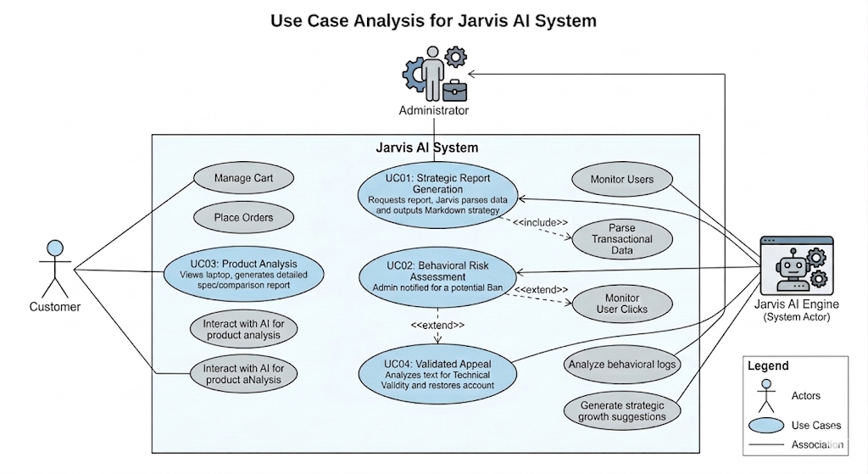

Figure 3.4 Use Case Diagram

CHAPTER 4
DEVELOPMENT ENVIRONEMENT
The development environment provides the necessary hardware and software infrastructure required for designing, developing, testing, and deploying the Jarvis AI – Business Analyst platform. A well-defined development environment ensures efficient development, system stability, and optimal performance throughout the software development lifecycle.

4.1 Hardware Requirements
The Jarvis AI system was developed and tested using standard computing resources. The hardware specifications required for the successful execution of the application are listed below.

Minimum Hardware Requirements
Processor : Intel Core i3 / AMD Equivalent
RAM : 4 GB
Storage : 20 GB Free Disk Space
Internet Connection : Required for Gemini AI API Integration
Display Resolution : 1366 × 768 or Higher

Recommended Hardware Requirements
Processor : Intel Core i5 / AMD Ryzen 5 or Higher
RAM : 8 GB or Above
Storage : 50 GB SSD
Internet Connection : High-Speed Broadband
Display Resolution : 1920 × 1080
These specifications ensure smooth operation of the Flask application, database transactions, and AI-powered report generation functionalities.

4.2 Software Requirements
The software components used in the development of Jarvis AI are listed below.
Software | Purpose
Windows 10/11 | Operating System
Python 3.11 | Programming Language
Flask | Web Application Framework
SQLite | Database Management System
SQLAlchemy | Object Relational Manager
Visual Studio Code | Development Environment
Google Geminin API | Version Control
Razorpay SDK | Payment Gateway Integration
Web Browser | Application Testing and Execution
Table 4.2 Software and its Purpose Table

The combination of these technologies provides a scalable and efficient platform for business analytics and intelligent decision support.

4.3 Language Review
Python was selected as the primary programming language due to its simplicity, extensive library ecosystem, and strong support for Artificial Intelligence and web application development. Flask was chosen as the web framework because of its lightweight architecture and flexibility.

4.3.1 Introduction to Python
Python is a high-level, interpreted, object-oriented programming language developed by Guido van Rossum and first released in 1991. It emphasizes code readability and developer productivity through a simple and expressive syntax.
Python supports multiple programming paradigms, including procedural, object-oriented, and functional programming. Due to its rich ecosystem of libraries and frameworks, Python has become one of the most widely used programming languages in fields such as web development, data science, machine learning, artificial intelligence, and automation.
In the Jarvis AI project, Python is used for implementing business logic, database operations, authentication mechanisms, AI integrations, and server-side processing.

4.3.2 Features of Python
The major features of Python include:
- Simple and Easy-to-Learn Syntax
- Platform Independence
- Object-Oriented Programming Support
- Extensive Standard Library
- Dynamic Typing
- Open Source and Community Driven
- Integration with Artificial Intelligence Frameworks
- Rapid Application Development
- High Scalability and Maintainability
These features make Python an ideal choice for developing intelligent business applications such as Jarvis AI.

4.3.3 Flask
Flask is a lightweight and open-source web framework written in Python. It provides developers with essential tools and libraries required for building web applications while maintaining flexibility and simplicity.
Flask follows a modular architecture that allows developers to integrate only the components required for their applications. It provides routing, request handling, session management, template rendering, and REST API support.
In Jarvis AI, Flask serves as the core backend framework responsible for managing user authentication, product management, business analytics, AI communication, and administrative functionalities.

4.3.4 Features of Flask
The key features of Flask include:
- Lightweight and Minimalistic Framework
- Built-in Development Server
- URL Routing Support
- Jinja2 Template Engine
- RESTful API Development
- Session and Cookie Management
- Extension-Based Architecture
- Database Integration Support
- Easy Deployment and Maintenance
- High Flexibility and Scalability
These features enable Flask to efficiently support the implementation of the Jarvis AI Business Analyst platform while maintaining high performance and ease of development.

CHAPTER 5
SYSTEM DESIGN
System design represents a crucial phase in the Software Development Life Cycle (SDLC), where the abstract requirements identified during system analysis are translated into a structured and implementable technical framework. It acts as the bridge between conceptual understanding and practical implementation, ensuring that the proposed system is not only functional but also efficient, scalable, and secure.
In the case of Jarvis AI: AI Business Analyst, the design phase is particularly significant due to the hybrid nature of the system, which combines traditional database-driven architectures with advanced generative artificial intelligence. The system must efficiently coordinate deterministic processes, such as database queries and transaction handling, with non-deterministic AI-driven outputs generated by models like Google Gemini. This requires careful architectural planning, robust data structuring, and seamless integration between components.
This chapter presents a comprehensive overview of the system design, including architectural structure, database schema, data flow mechanisms, and user interface design principles that collectively define the Jarvis AI ecosystem.
5.1 System Architecture
The architecture of Jarvis AI follows a modern N-tier client-server model, designed to ensure modularity, scalability, and clear separation of concerns. The system is structured into three primary layers, each responsible for a specific set of functionalities while maintaining seamless interaction with the other layers.
5.1.1 Presentation Layer (User Interface Layer)
The presentation layer serves as the visual and interactive interface between the user and the system. It is developed using HTML5, JavaScript, and advanced CSS3 techniques to deliver a responsive and visually rich user experience. A key characteristic of this layer is the implementation of the Frosted Glassmorphism design, which enhances visual depth and modern aesthetics.
This layer is also responsible for rendering dynamic data visualizations using charting libraries such as ApexCharts. Communication with the backend is handled through RESTful API calls using the Fetch API, enabling asynchronous data exchange. This design approach supports a Single Page Application (SPA) experience, where content updates dynamically without requiring full page reloads, thereby improving performance and usability.
5.1.2 Application and Intelligence Layer (Business Logic Layer)
The application layer forms the core of the system and is responsible for processing user requests, enforcing business rules, and managing system operations. It is implemented using the Flask framework in Python, which provides a lightweight yet powerful environment for building scalable web applications.
A distinguishing feature of this layer is the integration of the AI Orchestration Engine. This component acts as an intermediary between the database and the AI model. It retrieves relevant data from the database, structures it into context-rich prompts, and sends it to the Google Gemini API. The generated responses are then processed and formatted into structured outputs, such as management reports or analytical insights.
In addition, this layer handles authentication and session management using secure mechanisms, ensuring that only authorized users can access specific functionalities. It also coordinates various subsystems, including behavioral tracking, inventory management, and reporting modules.
5.1.3 Data Persistence Layer (Database Layer)
The data persistence layer is responsible for storing and managing all system data in a secure and structured manner. It utilizes SQLite as the primary database, along with SQLAlchemy as the Object-Relational Mapping (ORM) tool.
The use of an ORM allows developers to interact with the database using Python objects rather than raw SQL queries, reducing complexity and minimizing the risk of security vulnerabilities such as SQL injection. The database is designed to be ACID-compliant, ensuring reliability through properties such as atomicity, consistency, isolation, and durability.

This layer stores a wide range of data, including user credentials, product details, transaction records, activity logs, and AI-generated interventions. By maintaining a well-structured and normalized database, the system provides a strong foundation for accurate data analysis and efficient AI processing.
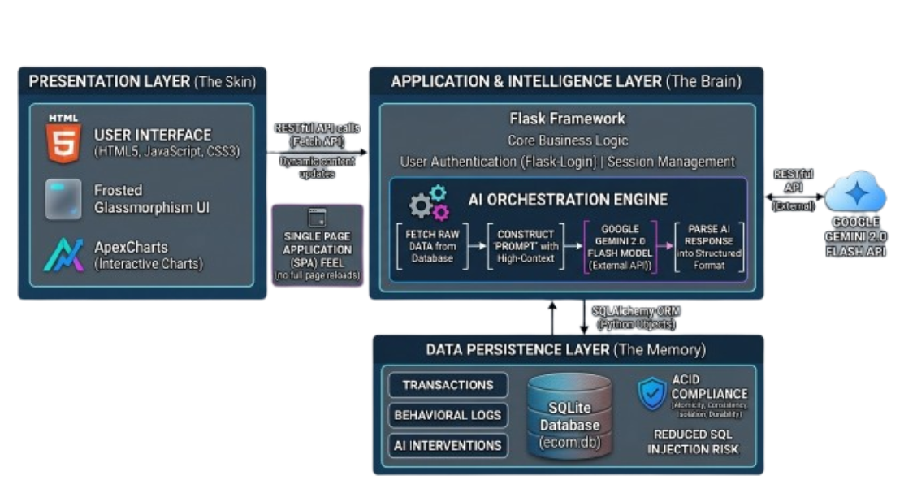Figure 5.1 System Architecture Diagram
5.2 Database Design (ER Model)
The database design of Jarvis AI is based on normalization principles to ensure data integrity, reduce redundancy, and support efficient querying. The system employs a centralized database structure consisting of multiple interconnected entities that represent different aspects of the e-commerce ecosystem.
5.2.1 Entity Relationship Analysis
The relationship between entities is carefully structured to reflect real-world interactions within the system. The Users and Profiles entities maintain a one-to-one relationship, where authentication-related data is separated from personal information to enhance security and modularity.
The relationship between users and orders is one-to-many, as a single user can place multiple orders over time. Similarly, products are linked to restock logs in a one-to-many relationship, enabling the system to track inventory updates and analyze restocking patterns.
User activity is recorded in the Activity Logs table, which maintains a one-to-many relationship with users. This table plays a critical role in behavioral analysis and AI-driven insights. Additionally, the AI Interventions table records actions taken by the system, such as account restrictions, providing transparency and accountability.
5.2.2 ER Diagram Representation
The logical structure of the database can be represented as follows:
- USER is associated with PROFILE in a one-to-one relationship
- USER places multiple ORDERS
- USER generates multiple ACTIVITY_LOG entries
- USER undergoes multiple AI_INTERVENTION events
- PRODUCT is linked to multiple RESTOCK_LOG entries
- PRODUCT is associated with CART_ITEM entries
- USER manages CART_ITEM records
This structured design ensures efficient data retrieval and supports complex analytical operations performed by the AI engine.

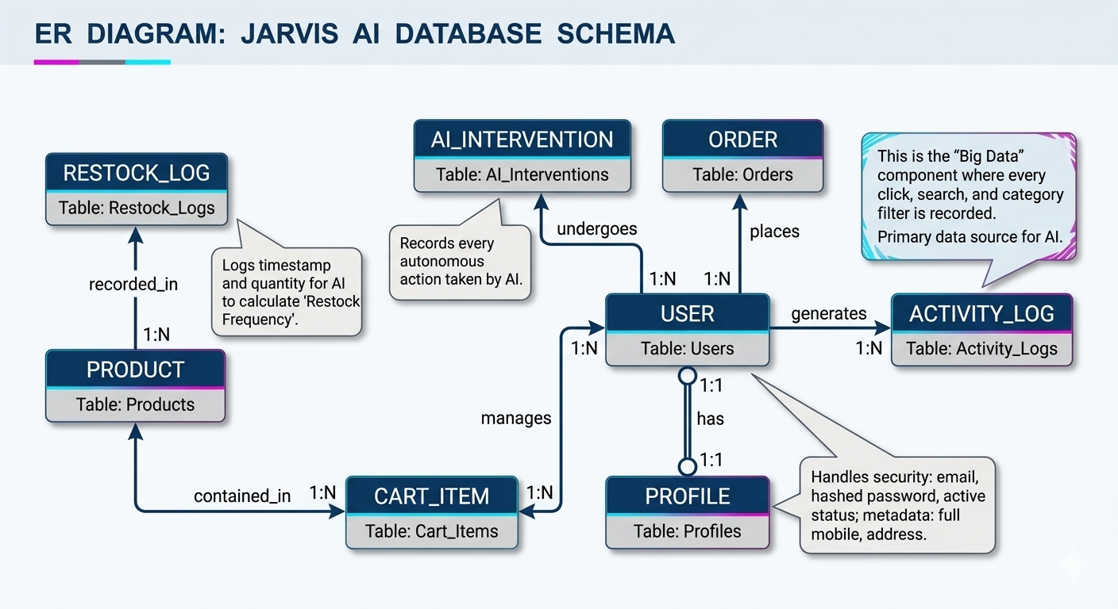
Figure 5.2 ER Diagram
5.3 Data Flow Diagrams (DFD)
Data Flow Diagrams illustrate how data moves through the system, highlighting the interaction between external entities, processes, and data stores.
5.3.1 Level 0: Context Diagram
At the highest level, the Jarvis AI system interacts with three primary external entities: the user, the administrator, and the AI service provider.
The user provides inputs such as login credentials, product searches, and purchase requests, and receives outputs including product information and order confirmations. The administrator interacts with the system by managing inventory and requesting analytical reports, receiving strategic insights in return.
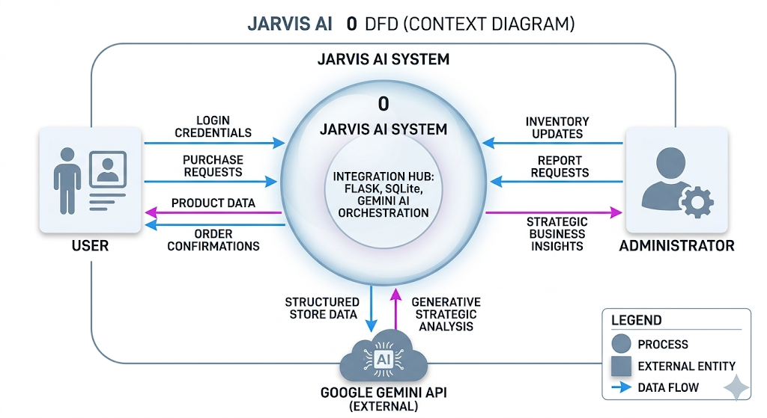
he AI component, powered by Google Gemini, acts as an external service that processes structured data and generates intelligent outputs. This interaction forms the backbone of the system’s analytical capabilities.

Figure 5.3.1 Context Diagram
5.3.2 Level 1: Functional Decomposition
At a more detailed level, the system is divided into several functional processes. The authentication and session management process ensures secure access and maintains user sessions. The transaction and inventory processing module handles cart operations, order placement, and stock updates.
The behavioral logging engine captures real-time user interactions and stores them for analysis. The AI strategic analysis module processes this data and generates actionable insights for administrators. These interconnected processes ensure a seamless flow of data and functionality across the system.

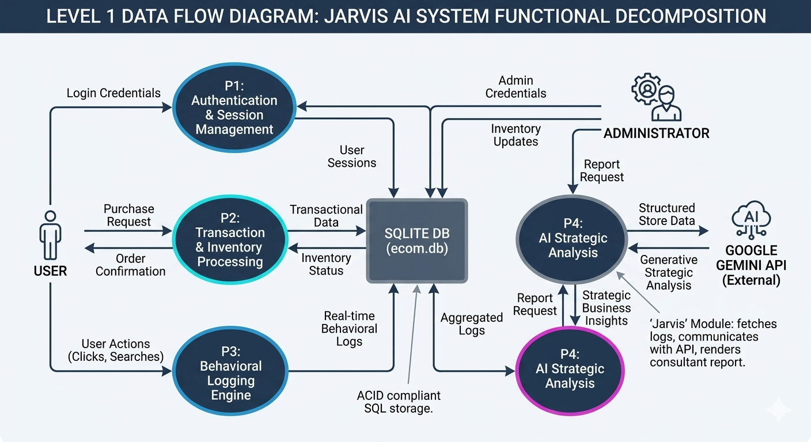
Figure 5.3.2 Functional Decomposition Diagram
5.4 UI/UX Design Principles
The user interface design of Jarvis AI is guided by the concept of “Premium Functionalism,” which combines aesthetic appeal with usability and performance. The system adopts a Frosted Glassmorphism design language to create a futuristic and engaging visual experience.

5.4.1 Core Design Principles
One of the primary design elements is the glassmorphism effect, achieved through the use of blurred backgrounds and semi-transparent layers. This creates a sense of depth and hierarchy, making the interface visually appealing while maintaining clarity.
The system also incorporates a carefully selected color palette that provides meaningful visual feedback. Bright, contrasting colors are used to highlight important information, such as alerts or key performance indicators, ensuring that users can quickly identify critical data.
Another important aspect is the organization of information. The interface is designed to prioritize accessibility and clarity, with a dedicated section for AI-generated insights. This reinforces the system’s role as an intelligent assistant and ensures that users can easily access important information.
Responsiveness is also a key consideration, with the interface designed to adapt seamlessly across different devices and screen sizes. Smooth transitions and subtle animations enhance user interaction, providing a more intuitive and engaging experience.
Finally, the use of Markdown for presenting AI-generated reports ensures that complex information is structured and easy to read. Headings, highlights, and bullet points improve readability, enabling users to quickly understand and act upon the insights provided.

CHAPTER 6
IMPLEMENTATION
The implementation phase represents the realization of the system design, where theoretical concepts, architectural models, and planned workflows are transformed into a fully functional software system. In the Jarvis AI: AI Business Analyst project, this phase involves the development of a high-performance, AI-integrated web application capable of processing large volumes of transactional and behavioral data in real time.
The implementation is particularly complex due to the hybrid nature of the system, which combines deterministic database-driven operations with non-deterministic outputs generated by a generative AI engine. This required careful coordination between backend services, frontend interactions, and external AI APIs.
This chapter presents a detailed overview of the technology stack, system modules, core algorithms, and the Python libraries that collectively enable the intelligent functionality of Jarvis AI.
6.1 Technology Stack
The technology stack of Jarvis AI has been carefully selected to ensure scalability, performance, and seamless integration with artificial intelligence services. Each component contributes to a specific layer of the system architecture while maintaining overall efficiency.
The backend of the system is developed using Python in conjunction with the Flask framework, which provides a lightweight and flexible environment for building web applications. Flask’s modular architecture allows for the development of custom components without unnecessary overhead, making it ideal for integrating AI-driven functionalities.
For data storage, SQLite is used as the primary database due to its serverless architecture and ACID compliance, ensuring reliability and data integrity. SQLAlchemy is employed as the Object-Relational Mapper (ORM), enabling developers to interact with the database using Python objects instead of raw SQL queries, thereby enhancing security and maintainability. The cognitive capabilities of the system are powered by the Google Gemini model, which provides advanced reasoning and natural language processing. This model is utilized to generate business insights and strategic recommendations based on real-time data.
On the frontend, the system is built using HTML5, CSS3, and JavaScript, ensuring compatibility with modern web standards. A key design choice was the use of Vanilla CSS to implement the Frosted Glassmorphism aesthetic, avoiding heavy frameworks to maintain performance. JavaScript is used to handle asynchronous API calls and dynamic content updates.
For data visualization, ApexCharts is integrated into the admin dashboard to provide interactive graphical representations of business metrics. Security is ensured through the use of Bcrypt for password hashing and OAuth 2.0 for secure third-party authentication.
6.2 System Module Description
The Jarvis AI system is structured into multiple functional modules, each responsible for a specific aspect of the application. This modular design ensures maintainability, scalability, and clear separation of responsibilities.
6.2.1 Consumer Marketplace Module
The Consumer Marketplace Module represents the front-facing component of the system, providing users with an interactive platform to browse and purchase electronic products. It includes features such as product listing, advanced search functionality, category-based filtering, and a persistent shopping cart.
The module is designed to deliver a seamless and engaging user experience, enabling users to efficiently explore products while receiving real-time updates on availability and pricing.
6.2.2 Jarvis AI Business Analyst Module
This module serves as the core intelligence component of the system. It is responsible for collecting data from various sources, including orders, products, and activity logs, and transforming it into meaningful insights.
The module constructs context-rich prompts and sends them to the Google Gemini API. The responses generated by the AI are then processed and formatted into structured reports, which are presented to administrators in an easily interpretable format.
6.2.3 Behavioral Monitoring and Intervention Module
The Behavioral Monitoring Module functions as the security and analytics engine of the system. It continuously tracks user interactions, such as product views, searches, and cart actions, and records them in the Activity Log.
By analyzing this data, the system can identify anomalous patterns and detect potentially fraudulent behavior. Based on predefined rules and AI analysis, the module can autonomously flag or restrict user accounts, thereby enhancing system security.
6.2.4 Admin Command Center Module
The Admin Command Center provides administrators with a centralized interface for managing system operations. It integrates data visualization tools, user management features, and AI-generated reports.
Administrators can monitor sales performance, manage inventory, review user activity, and handle account appeals through this module. The integration of AI insights within the dashboard enables informed decision-making and efficient management.
6.3 Core Algorithm Implementation
The intelligent behavior of Jarvis AI is driven by several key algorithmic processes that enable data analysis, decision-making, and user interface rendering.
6.3.1 Strategic Synthesis Algorithm
The generation of business insights follows a structured pipeline. Initially, the system extracts relevant data from the database, including recent sales records, inventory levels, and user behavior patterns.
This data is then transformed into a structured prompt that provides context for the AI model. The prompt is sent to the Google Gemini API, which processes the input and generates a detailed response.
Finally, the response is parsed and formatted into a readable report using Markdown, ensuring clarity and ease of interpretation for administrators.
6.3.2 Behavioral Risk Scoring Mechanism
To mitigate fraudulent activities and policy abuse, the system implements a Behavioral Risk Scoring mechanism. This algorithm evaluates user behavior based on metrics such as the ratio of returns to purchases.
If the calculated risk score exceeds a predefined threshold, the system triggers automated actions, such as account restriction. Additionally, AI-based text analysis is used to evaluate the validity of return requests, distinguishing between legitimate and suspicious claims.
6.4 Python Modules and Libraries
The robustness, scalability, and intelligence of the Jarvis AI: AI Business Analyst system are fundamentally driven by a carefully curated set of Python modules and libraries. These components collectively enable secure data handling, efficient request processing, seamless AI integration, and reliable system operations. Each library has been selected based on its performance, compatibility, and suitability for building a modern AI-powered web application.
6.4.1 Flask Framework
Flask serves as the foundational web framework for the Jarvis AI system, providing a lightweight yet highly flexible environment for developing web applications. As a WSGI-compliant micro-framework, Flask does not impose rigid architectural constraints, allowing developers to design a modular and customized system tailored to specific project requirements.
Within Jarvis AI, Flask is responsible for managing HTTP request-response cycles, routing user requests to appropriate handlers, and rendering dynamic templates using the Jinja2 templating engine. Its minimalistic design ensures low overhead, which is particularly beneficial for maintaining high performance when integrating AI-driven processes that may involve latency-sensitive operations.
Furthermore, Flask facilitates the creation of RESTful API endpoints, which are essential for communication between the frontend interface and backend services. This enables asynchronous data exchange, allowing the system to deliver a seamless Single Page Application (SPA) experience. The extensibility of Flask also allows for easy integration with additional libraries such as Flask-Login and Flask-Bcrypt, making it a central component of the system architecture.
6.4.2 SQLAlchemy (Object-Relational Mapper)
SQLAlchemy plays a crucial role in bridging the gap between object-oriented programming in Python and the relational structure of the SQLite database. It provides an abstraction layer that allows developers to interact with database tables as Python classes, thereby simplifying database operations and improving code readability.
In the Jarvis AI system, SQLAlchemy is used to define database models such as Users, Orders, Products, and Activity Logs. It enables the execution of complex queries using Pythonic syntax, eliminating the need for raw SQL statements. This not only reduces development complexity but also enhances security by preventing SQL injection attacks through parameterized queries.
Additionally, SQLAlchemy supports relationship mapping between tables, allowing the system to efficiently manage one-to-many and one-to-one associations. This is particularly important for analyzing user behavior and transaction patterns, which form the basis of the AI-driven insights. The ORM also handles connection management and transaction control, ensuring data consistency and reliability across the system.
6.4.3 Requests and JSON Modules
The integration of artificial intelligence within Jarvis AI relies heavily on communication with external APIs, specifically the generative AI model. The Requests library serves as the primary tool for making HTTP requests to the AI service, enabling the system to send structured data and receive generated responses.
The JSON module complements this process by handling data serialization and deserialization. It converts complex Python data structures, such as dictionaries containing sales data and user activity logs, into JSON format suitable for API transmission. Similarly, it parses the JSON responses returned by the AI model into usable Python objects.
This combination of Requests and JSON forms the communication backbone of the Jarvis AI system. It enables efficient and reliable data exchange between the application and the AI engine, ensuring that large volumes of data can be processed in real time. The ability to structure and interpret data accurately is essential for generating meaningful insights and maintaining the overall responsiveness of the system.
6.4.4 Flask-Bcrypt (Security and Cryptography)
Security is a critical aspect of any web application, particularly one that handles sensitive user data. Flask-Bcrypt is utilized in the Jarvis AI system to implement secure password hashing mechanisms. It provides an interface to the Bcrypt algorithm, which is widely regarded as one of the most secure hashing techniques available.
Bcrypt incorporates a salting mechanism, which adds random data to each password before hashing. This prevents attackers from using precomputed tables, such as rainbow tables, to reverse-engineer passwords. Additionally, Bcrypt is computationally intensive, making brute-force attacks significantly more difficult.
In Jarvis AI, Flask-Bcrypt ensures that user credentials are stored securely within the database. Even in the event of a data breach, the hashed passwords remain protected, thereby safeguarding user information and maintaining system integrity.
6.4.5 Flask-Login (Session Management)
Flask-Login is employed to manage user authentication and session handling within the system. It provides a simple yet powerful mechanism for tracking logged-in users and controlling access to protected resources.
The library enables the implementation of user session management, including login, logout, and session persistence across multiple requests. It also provides decorators such as login_required, which restrict access to certain routes based on user authentication status.
In the context of Jarvis AI, Flask-Login is particularly important for distinguishing between different user roles, such as customers and administrators. It ensures that only authorized administrators can access sensitive features, such as the AI-generated business reports and user management tools. This enhances both security and usability by maintaining clear access boundaries within the system.
6.4.6 Authlib (OAuth 2.0 Integration)
Authlib is used to implement OAuth 2.0 authentication, enabling users to log in using external identity providers such as Google. This reduces the need for manual account creation and simplifies the onboarding process.
The library handles the complex OAuth workflow, including token exchange, authorization, and secure communication with external authentication servers. By delegating authentication to trusted providers, the system enhances security while improving user convenience.
In Jarvis AI, OAuth integration not only streamlines the login process but also increases user trust and engagement. It ensures that authentication is handled securely without exposing sensitive credentials within the application.
6.4.7 Flask-Mail (Automated Communication)
Flask-Mail is integrated into the system to enable automated email communication. It connects to an SMTP server and allows the application to send emails programmatically.
This functionality is used for various purposes, including order confirmations, security alerts, and account-related notifications. For example, when a user’s account is flagged or restricted due to suspicious activity, the system can automatically send a notification explaining the action.
Flask-Mail plays a vital role in maintaining communication between the system and its users, ensuring transparency and enhancing the overall user experience.
6.4.8 Razorpay Python SDK (Payment Integration)
To simulate real-world e-commerce transactions, the Jarvis AI system integrates the Razorpay Python SDK. This library provides tools for creating and managing payment orders, as well as verifying transaction authenticity.
The integration ensures that all payment-related data is securely processed and validated. It also enables the system to maintain accurate financial records, which are essential for generating reliable business insights.
By incorporating payment verification mechanisms, the system enhances its realism and prepares it for potential real-world deployment.
6.4.9 Utility Modules (python-dotenv and datetime)
Utility modules such as python-dotenv and datetime play a supporting yet essential role in the system. The python-dotenv library is used to manage environment variables, allowing sensitive information such as API keys and secret tokens to be stored securely outside the source code.
The datetime module is used extensively for timestamping user activities, transactions, and system events. Accurate time tracking is crucial for analyzing trends, such as peak sales periods and user behavior patterns.
These utility modules contribute to the overall stability, security, and analytical capabilities of the system, ensuring that it operates efficiently in a real-world environment.

CHAPTER 7
RESULTS AND DISCUSSIONS
The Results and Discussion chapter provides a comprehensive evaluation of the Jarvis AI: AI Business Analyst system by validating its performance in a simulated real-world electronics retail environment. This chapter moves beyond theoretical design and implementation to assess the system’s effectiveness in generating meaningful business insights, handling real-time data processing, and maintaining performance under operational conditions.
The evaluation focuses on two primary aspects: the qualitative analysis of AI-generated strategic reports and the quantitative assessment of system performance metrics. Together, these analyses demonstrate the practical viability of the Jarvis AI platform as an intelligent decision-support system.
7.1 AI Report Analysis
The central innovation of Jarvis AI lies in its ability to convert structured transactional and behavioral data into high-level strategic insights. This transformation is achieved through the integration of a generative AI model, specifically Google Gemini, which processes contextualized prompts constructed from multiple database sources.
7.1.1 Synthesis of Transactional and Behavioral Data
During experimental evaluation, the Jarvis AI engine demonstrated a strong capability to synthesize data across multiple relational tables, including orders, products, activity logs, and return records. Unlike conventional dashboards that present isolated metrics, the system was able to identify cross-domain correlations and derive meaningful conclusions.
For instance, by analyzing user interaction patterns recorded in the Activity Log alongside purchase data, the AI identified a recurring scenario where users frequently applied category filters for laptops but did not proceed to complete purchases. The system inferred that this behavior could be attributed to pricing discrepancies or lack of competitive positioning, highlighting a potential business issue that would not be immediately apparent through static analytics.
The generated output is structured as a comprehensive strategic report, typically organized into multiple sections. The executive summary provides a concise overview of the current business performance, enabling administrators to quickly grasp the overall status of the store. The product performance analysis categorizes items into high-performing products and under-performing inventory, assisting in stock optimization.
A particularly critical component is the risk and return analysis section, where the system evaluates user behavior patterns related to returns. In controlled test scenarios, the AI successfully identified a simulated case of repeated return abuse by analyzing inconsistencies in user-provided return reasons. This demonstrates the system’s ability to interpret not only numerical data but also contextual behavioral patterns.
Finally, the system generates actionable recommendations that are both specific and practical. These recommendations include inventory adjustments, promotional strategies, and operational improvements, thereby enabling administrators to take informed decisions without requiring manual data interpretation.
7.1.2 Qualitative Evaluation of AI Justification
An important aspect of the system’s performance is the quality and reasoning capability of the AI-generated outputs. The evaluation revealed that the Jarvis AI engine is capable of producing contextually accurate and logically coherent justifications for its recommendations.
This was particularly evident in the Appeal Validation Module, where restricted users were allowed to submit justifications for their actions. Instead of relying on simple keyword matching, the AI performed a deeper semantic analysis of the provided explanations. For example, when a user claimed a hardware-related issue, the system evaluated the plausibility of the claim by correlating it with known product characteristics and historical return data.
The results indicated that the AI could effectively differentiate between legitimate technical complaints and vague or inconsistent justifications. This capability enhances the fairness and reliability of automated decision-making processes within the system. It also demonstrates the potential of generative AI to move beyond surface-level text analysis and engage in reasoning-based evaluation.
7.2 Performance Metrics
To ensure that the Jarvis AI system is suitable for deployment in a real-world environment, a series of performance benchmarks were conducted. These benchmarks focused on critical parameters such as response time, database efficiency, frontend rendering performance, and security operations.
7.2.1 AI Orchestration Latency
One of the primary performance considerations for an AI-integrated system is the latency associated with API communication and response generation. The evaluation showed that the Jarvis AI engine was able to generate detailed business reports within an average time range of 2.8 to 4.2 seconds.
This performance is achieved through the efficient use of the Google Gemini model, which is optimized for low-latency inference. Additionally, the backend processing time required for data extraction and prompt construction remained below 150 milliseconds, indicating that the system’s local processing overhead is minimal.
These results demonstrate that the system is capable of delivering near real-time insights, making it suitable for practical administrative use.

7.2.2 Database Throughput and ORM Efficiency
The database layer plays a critical role in supporting the system’s analytical capabilities. The Activity Log table, which records user interactions, represents the highest data throughput component of the system.
Performance testing revealed that the system maintained query response times below 50 milliseconds, even when the number of log entries exceeded 10,000 records. This efficiency is attributed to the use of indexed queries and the optimization capabilities of SQLAlchemy.
Furthermore, the system demonstrated stable performance under concurrent usage scenarios. Simultaneous operations, such as user browsing and administrative report generation, were handled without any database locking issues or performance degradation. This indicates that the system is capable of supporting multi-user environments effectively.
7.2.3 Frontend Rendering Performance
The frontend interface of Jarvis AI incorporates advanced visual effects based on the Glassmorphism design paradigm, which relies on GPU-accelerated rendering techniques. Despite the visual complexity, performance evaluation showed that the system maintained a consistent frame rate of approximately 60 frames per second during user interactions.
In addition, the system achieved a high performance score in Lighthouse testing, with an average score of 94 out of 100. This indicates efficient resource utilization and minimal blocking time during page rendering. The decision to use Vanilla CSS instead of heavy frontend frameworks contributed significantly to this performance optimization.
7.2.4 Security and Authentication Performance
Security-related operations were also evaluated to ensure that they do not introduce significant delays in user interaction. Password hashing using the Bcrypt algorithm was completed within an average time of 300 milliseconds, providing a balance between computational security and user experience.
Similarly, OAuth 2.0 authentication workflows were completed in approximately 1.2 seconds, offering a fast and seamless login experience. These results confirm that the system maintains high security standards without compromising usability.

7.3 Discussion
The results obtained from the evaluation of Jarvis AI demonstrate that the system successfully achieves its primary objective of integrating artificial intelligence into e-commerce analytics. The ability to generate meaningful, context-aware insights from structured data represents a significant advancement over traditional systems.
The combination of low-latency AI processing, efficient database management, and optimized frontend performance ensures that the system is both responsive and scalable. Additionally, the incorporation of intelligent behavioral analysis and automated decision-making enhances security and operational efficiency.
Overall, the system validates the concept of an AI-driven business analyst, demonstrating that generative AI can effectively bridge the gap between raw data and strategic decision-making in modern e-commerce environments.

CHAPTER 8
TESTING
Testing is a critical phase in the Software Development Life Cycle (SDLC) that ensures the reliability, accuracy, security, and performance of a software system before deployment. The primary objective of testing is to identify defects, validate functional requirements, and verify that the system behaves as expected under various operating conditions.
In the Jarvis AI: AI Business Analyst project, testing was conducted at multiple levels to evaluate the correctness of individual modules, the interaction between interconnected components, and the overall stability of the platform. Particular emphasis was placed on validating AI-generated outputs, user authentication mechanisms, database operations, and business analytics functionalities.
The testing process was categorized into Unit Testing, Integration Testing, and Functional Test Case Validation to ensure comprehensive quality assurance across the entire system.

8.1 Unit Testing
Unit testing focuses on verifying the functionality of individual modules in isolation. Each component of the Jarvis AI system was tested independently to ensure that it performs its intended operation without errors.
The authentication module was tested to validate user registration, login, password encryption, session creation, and logout functionality. Password hashing using Bcrypt was verified to ensure secure credential storage.
The product management module was tested to confirm accurate product creation, modification, deletion, inventory updates, and stock validation. Various input combinations were evaluated to ensure data consistency and integrity.
The behavioral monitoring module was tested to verify the recording of user activities such as product views, searches, cart operations, and order placements. Activity logs were examined to ensure accurate timestamp generation and event tracking.
The Jarvis AI Business Analyst module underwent extensive testing to validate prompt generation, API communication with Google Gemini, response processing, and report generation. The module successfully transformed structured database records into meaningful business insights without data loss or formatting issues.
The payment and order management module was tested to ensure successful order creation, transaction recording, inventory deduction, and order history maintenance.

Unit Testing Results
Module | Test Status
User Authentication | Passed
Product Management | Passed
Shopping Cart | Passed
Order Processing | Passed
Activity Logging | Passed
AI Report Generation | Passed
Behavioral Monitoring | Passed
Email Notification | Passed
Table 8.1 Unit Testing Results Table

8.2 Integration Testing
Integration testing evaluates the interaction between multiple modules to ensure that data flows correctly throughout the system. Since Jarvis AI relies on the coordination of several interconnected components, integration testing was essential for validating overall system behavior.

The integration between the frontend interface and Flask backend was tested by performing product searches, cart operations, and order placements. All user actions were successfully reflected in the database and displayed correctly within the interface.
The database integration layer was tested to verify communication between SQLAlchemy models and SQLite. CRUD operations performed through the application were accurately persisted and retrieved without inconsistencies.
The AI integration workflow was tested by generating business reports based on real-time sales and activity data. The system successfully extracted information from multiple database tables, generated structured prompts, transmitted them to the Gemini API, and displayed formatted responses within the administrator dashboard.
The security subsystem was integrated with authentication and behavioral monitoring modules. Suspicious activities triggered appropriate security interventions and administrative notifications without affecting legitimate users.
The notification system was also tested by generating order confirmations and account alerts. Emails were successfully delivered through the SMTP service without failures.

Integration Testing Results
Integration Component | Result
Frontend ↔ Backend | Passed
Backend ↔ Database | Passed
Database ↔ AI Engine | Passed
Authentication ↔ Security Module | Passed
Order Processing ↔ Inventory | Passed
Email Service ↔ Application | Passed
Admin Dashboard ↔ Analytics Engine | Passed

Table 8.2 Integration Testing Results Table
8.3 Test Cases
The following test cases were executed to validate major functionalities of the Jarvis AI platform.
Test Case ID | Test Scenario | Expected Result | Actual Result | Status
TC01 | User Registration | User account created successfully | Successful | Passed
TC02 | User Login | Valid credentials allow access | Successful | Passed
TC03 | Invalid Login | Access denied with error message | Successful | Passed
TC04 | Product Search | Relevant products displayed | Successful | Passed
TC05 | Add to Cart | Product added to cart | Successful | Passed
TC06 | Place Order | Order generated successfully | Successful | Passed
TC07 | Generate AI Report | Business report generated | Successful | Passed
TC08 | Activity Logging | User activity recorded | Successful | Passed
TC09 | Inventory Update | Stock quantity updated | Successful | Passed
TC10 | Return Request Analysis | Risk assessment generated | Successful | Passed
TC11 | Admin Dashboard Access | Dashboard displayed correctly | Successful | Passed
TC12 | Email Notification | Notification delivered | Successful | Passed

Table 8.3 Functional Test Cases

8.4 Testing Summary
The testing results indicate that the Jarvis AI system satisfies all functional and non-functional requirements defined during the system analysis phase. Unit testing confirmed the correctness of individual modules, while integration testing validated seamless communication between system components.
The AI-driven analytical engine demonstrated reliable performance in generating business insights from real-time data. Security mechanisms, including authentication, activity tracking, and behavioral monitoring, functioned as expected without introducing significant performance overhead.
Overall, the Jarvis AI platform exhibited high reliability, security, scalability, and operational stability, making it suitable for deployment in modern retail and e-commerce environments.

CHAPTER 9
CONCLUSION AND FUTURE ENHANCEMENT

9.1 Conclusion
The Jarvis AI: AI Business Analyst project successfully demonstrates the integration of Artificial Intelligence into modern e-commerce systems to transform traditional business operations into intelligent, data-driven processes. The primary objective of the project was to bridge the gap between raw business data and strategic decision-making by developing a platform capable of generating meaningful insights through advanced AI technologies.
The system effectively combines e-commerce functionalities with business intelligence capabilities, enabling both customers and administrators to benefit from intelligent automation. Customers are provided with a seamless shopping experience through efficient product management, order processing, and personalized interactions. Administrators, on the other hand, gain access to AI-generated reports, behavioral analytics, inventory insights, and real-time business recommendations.
A significant achievement of the project is the successful integration of the Google Gemini AI model, which transforms structured transactional and behavioral data into actionable business intelligence. The system demonstrates the practical application of Large Language Models in areas beyond conversational AI by utilizing them as analytical and decision-support tools.
The implementation of behavioral monitoring, automated risk assessment, secure authentication mechanisms, and activity tracking further enhances the reliability and security of the platform. The testing results confirmed that the system meets its functional and non-functional requirements while maintaining satisfactory performance and scalability.
Overall, Jarvis AI establishes a new approach to intelligent commerce by transforming an e-commerce platform into a virtual business consultant capable of supporting strategic planning, operational efficiency, and informed decision-making. The project validates the potential of Artificial Intelligence to serve as an active business partner rather than merely a supporting technology.

9.2 Future Enhancements
Although the current implementation of Jarvis AI successfully achieves its objectives, several enhancements can be incorporated in future versions to further improve its capabilities and extend its applicability.
One potential enhancement is the integration of predictive analytics models capable of forecasting future sales trends, customer demand, and inventory requirements. By utilizing historical data and machine learning algorithms, the system could provide more accurate business planning recommendations.
Another significant improvement would be the implementation of a Retrieval-Augmented Generation (RAG) architecture. This would enable the AI engine to retrieve relevant information from internal databases and external knowledge sources before generating responses, thereby increasing the accuracy and contextual relevance of business reports.
Future versions may also incorporate multilingual AI support, allowing administrators and customers to interact with the system in multiple languages. This would enhance accessibility and expand the platform's usability across diverse geographical regions.
The integration of advanced recommendation systems based on deep learning techniques could further improve customer engagement by delivering highly personalized product suggestions. Additionally, real-time sentiment analysis of customer reviews and feedback could provide valuable insights into customer satisfaction and product perception.
From a security perspective, future enhancements may include AI-powered fraud prediction models capable of detecting sophisticated fraudulent activities before they occur. Integration with blockchain technology could also improve transaction transparency and data integrity.
Furthermore, the platform can be migrated from SQLite to enterprise-grade database systems such as PostgreSQL or MySQL to support large-scale deployments. Cloud-native deployment using containerization technologies such as Docker and Kubernetes would enhance scalability, availability, and fault tolerance.
In conclusion, the future scope of Jarvis AI extends far beyond traditional e-commerce systems. With continuous advancements in Artificial Intelligence, Business Intelligence, and predictive analytics, the platform has the potential to evolve into a fully autonomous retail intelligence ecosystem capable of delivering comprehensive strategic guidance for modern businesses.

CHAPTER 10
APPENDIX
10.1 APPENDIX 1
10.1.1 SAMPLE SCREENS
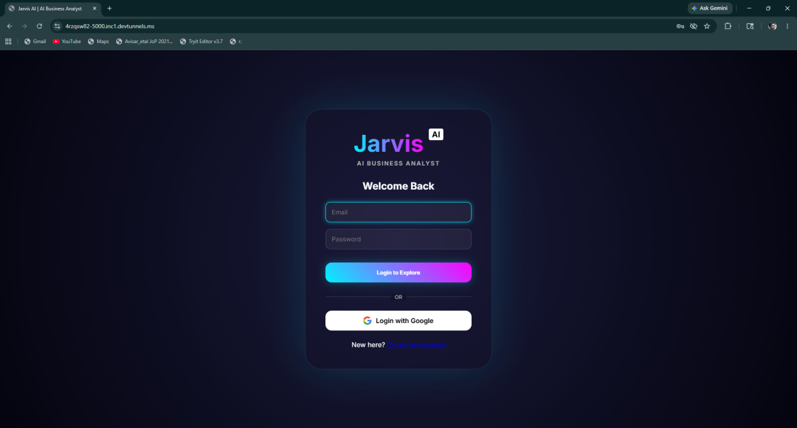

Figure 10.1.1 User Login Screen
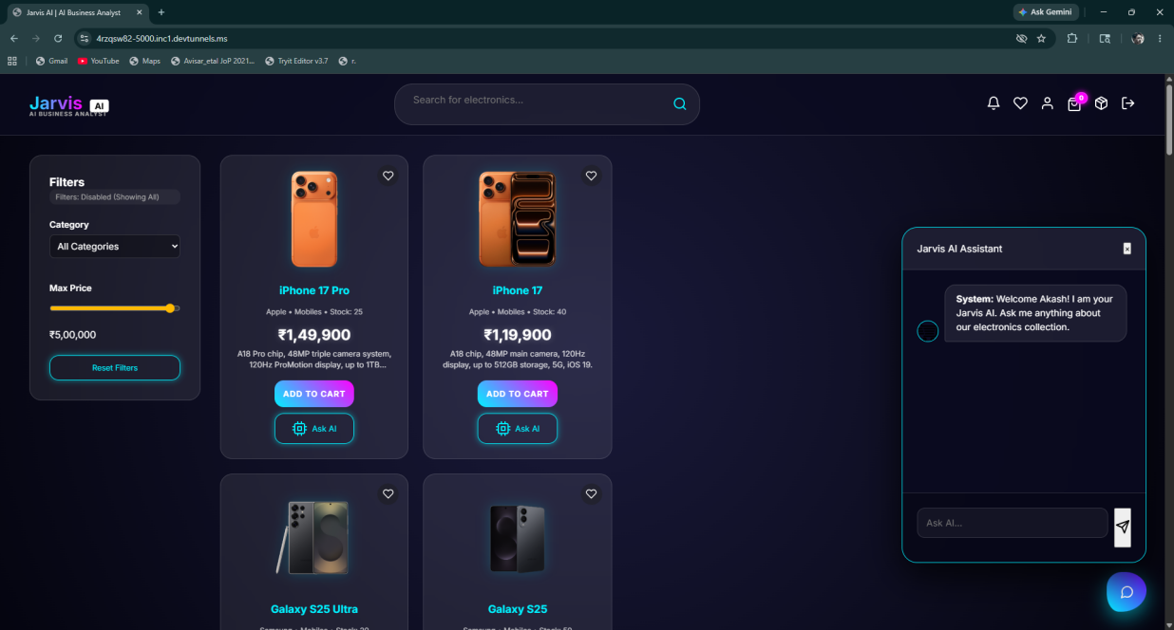

Figure 10.1.2 Client Screen
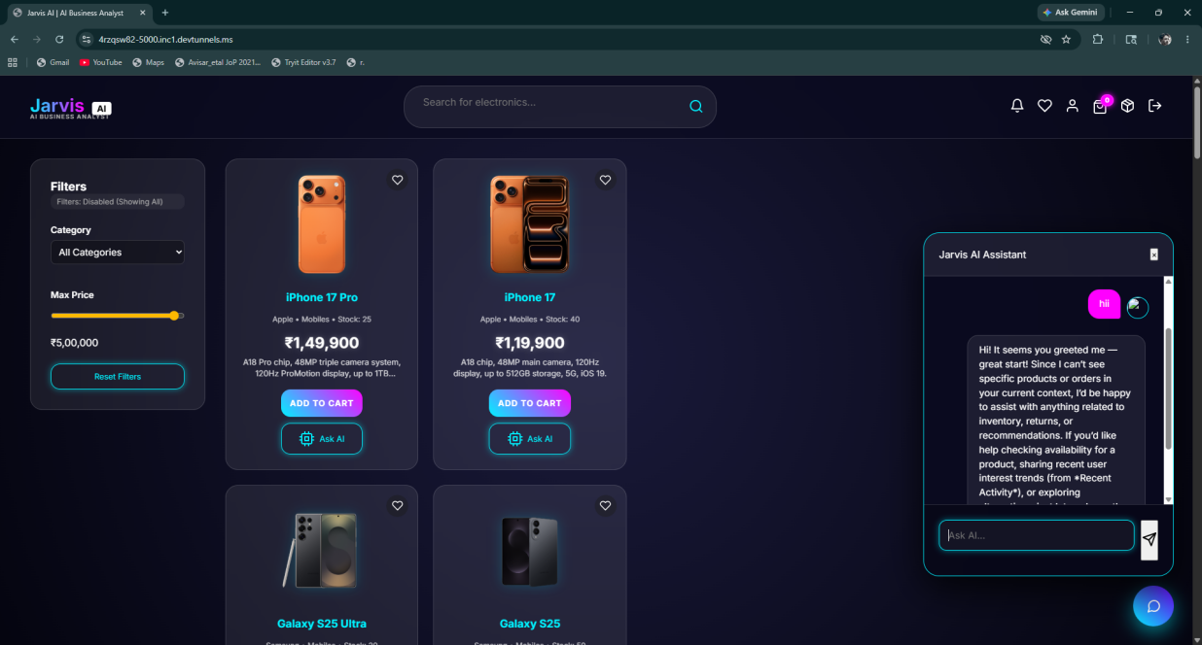

Figure 10.1.3 AI Chat window Screen



Figure 10.1.4 Product cart Screen
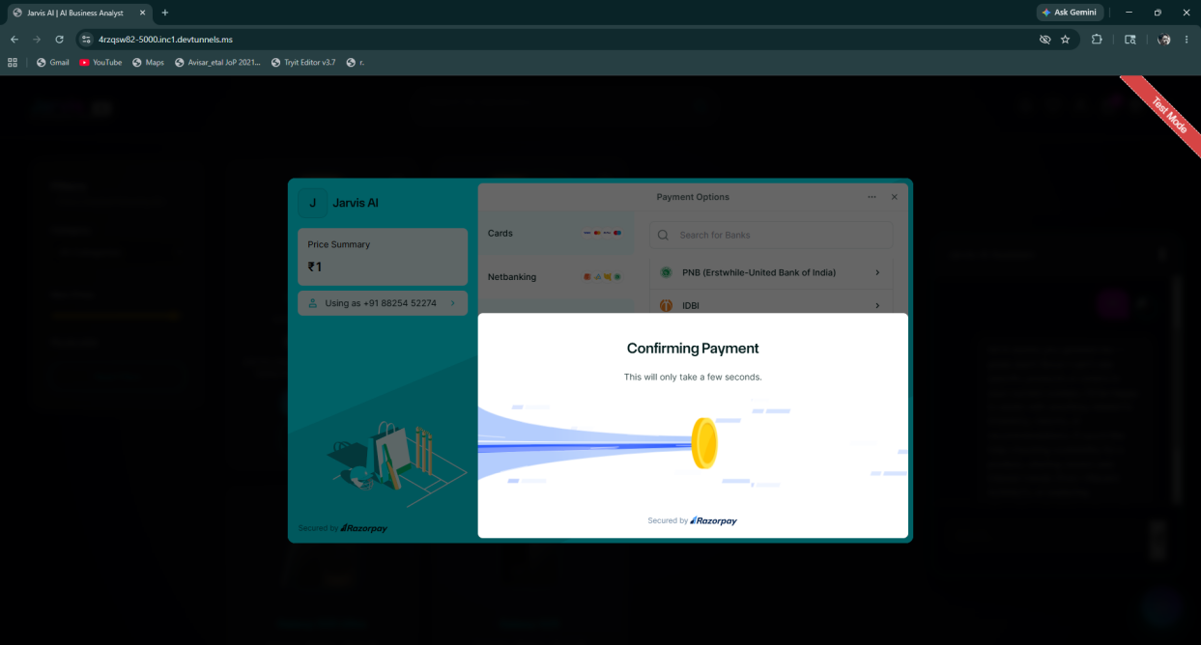

Figure 10.1.5 Payment confirmation Screen


Figure 10.1.6 Payement Success Screen


Figure 10.1.7 Orders Screen

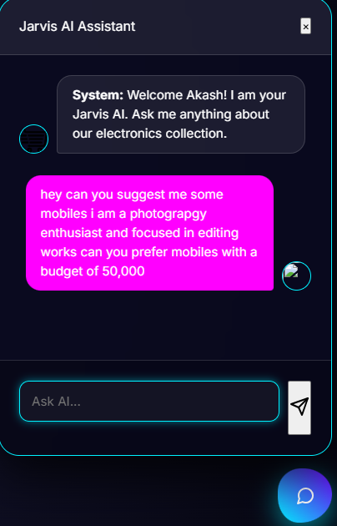

Figure 10.1.8 Jarvis AI Chat Screen
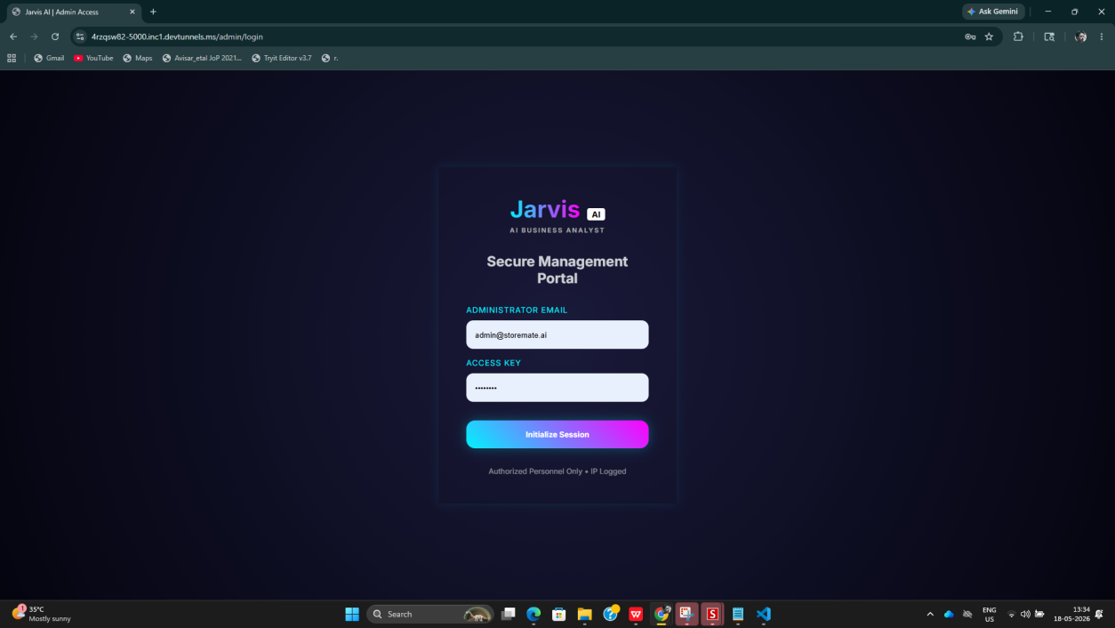

Figure 10.1.9 Jarvis Admin Login Screen

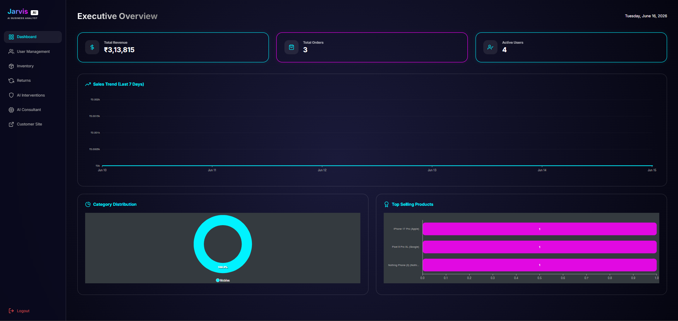
Figure 10.2.0 Admin Dashboard Overview Screen

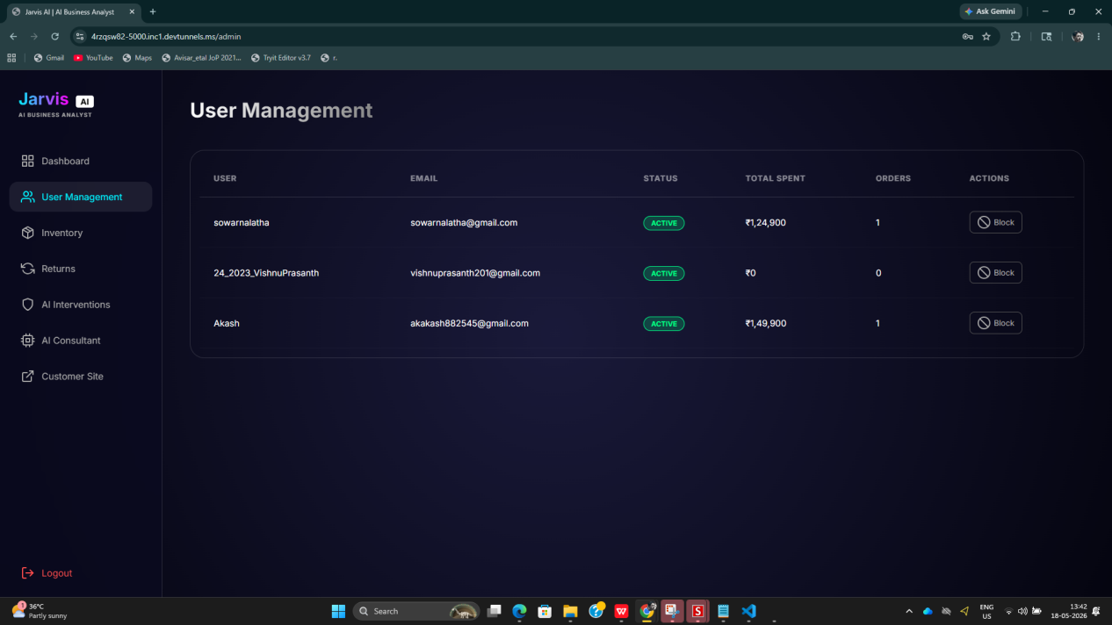

Figure 10.2.1 User Management Screen
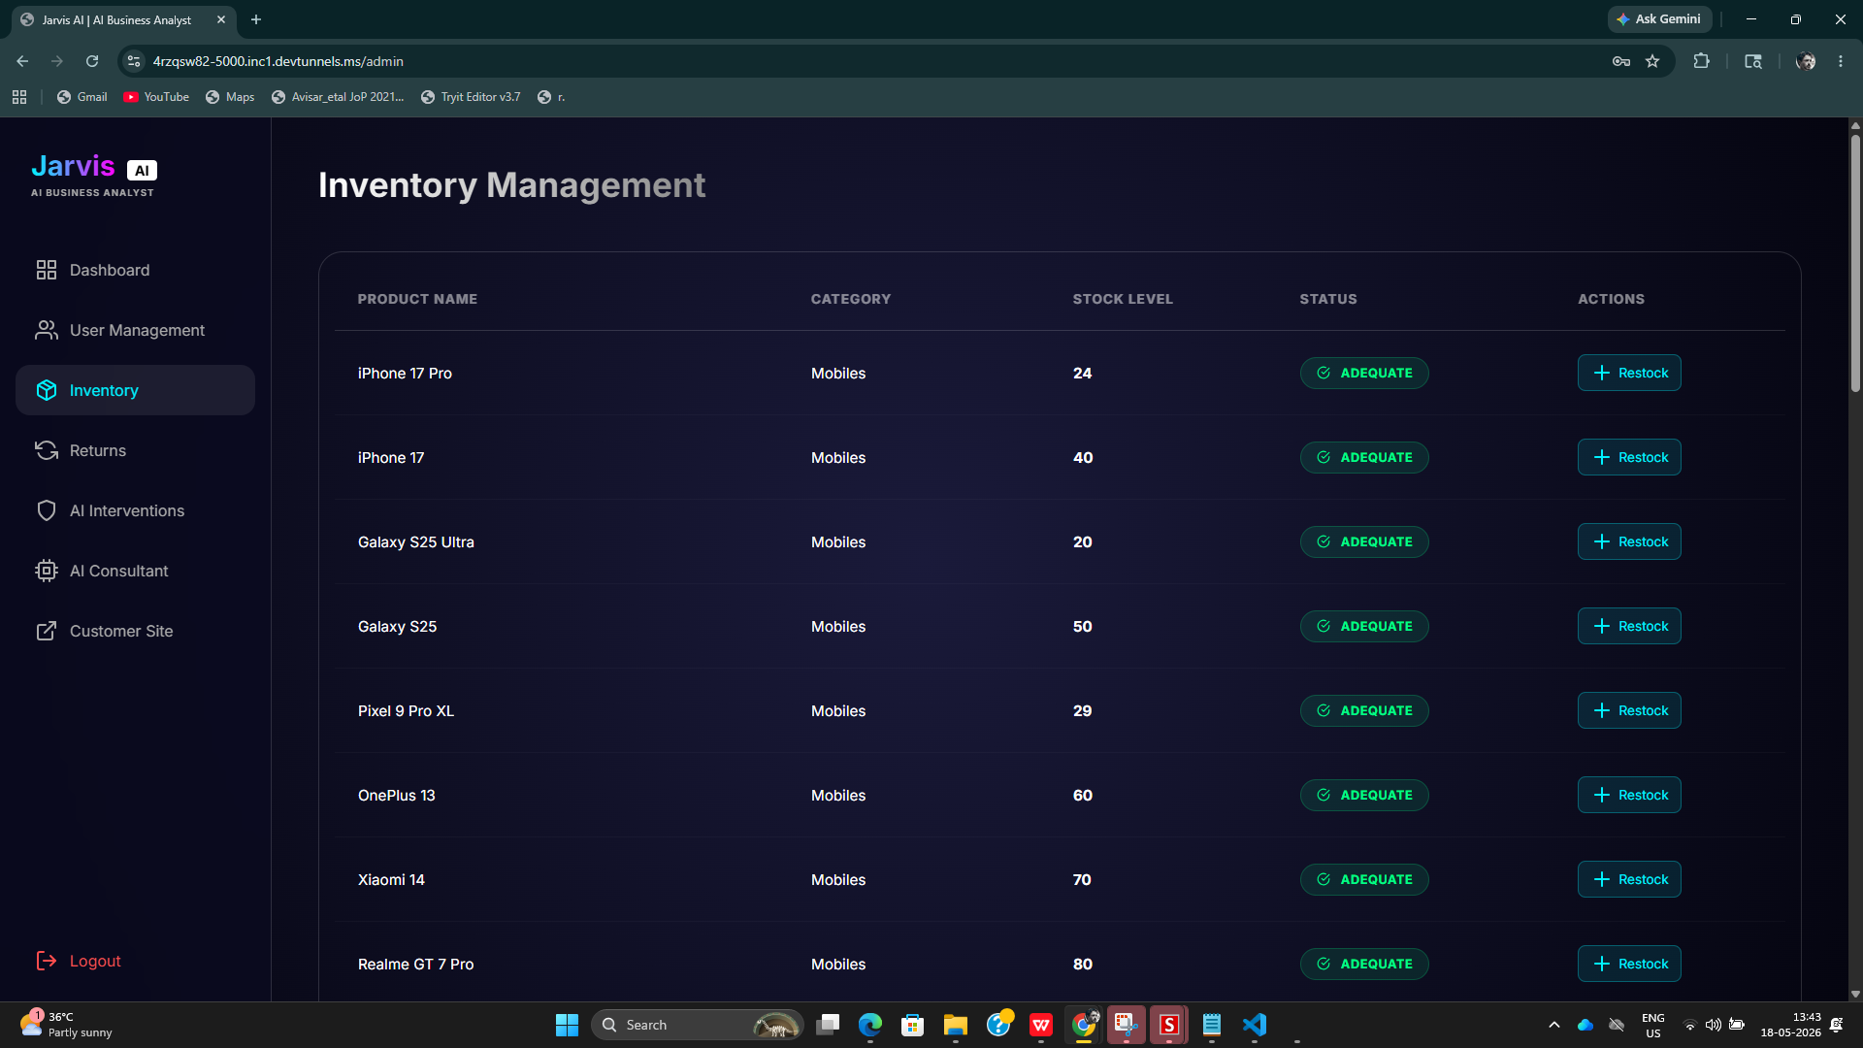
Figure 10.2.2 Inventory Management Screen

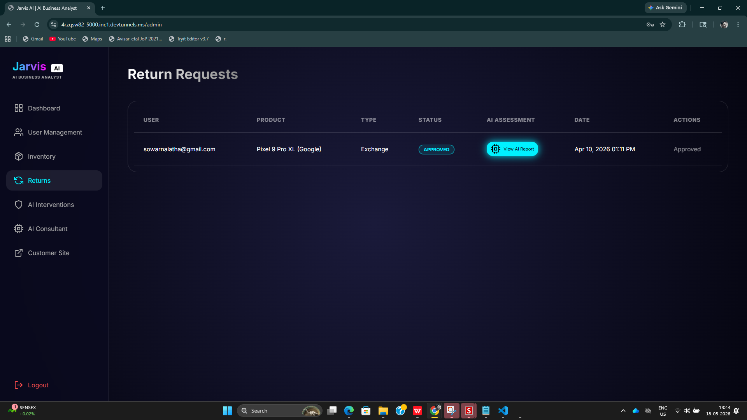

Figure 10.2.3 Jarvis AI Return Requests Screen
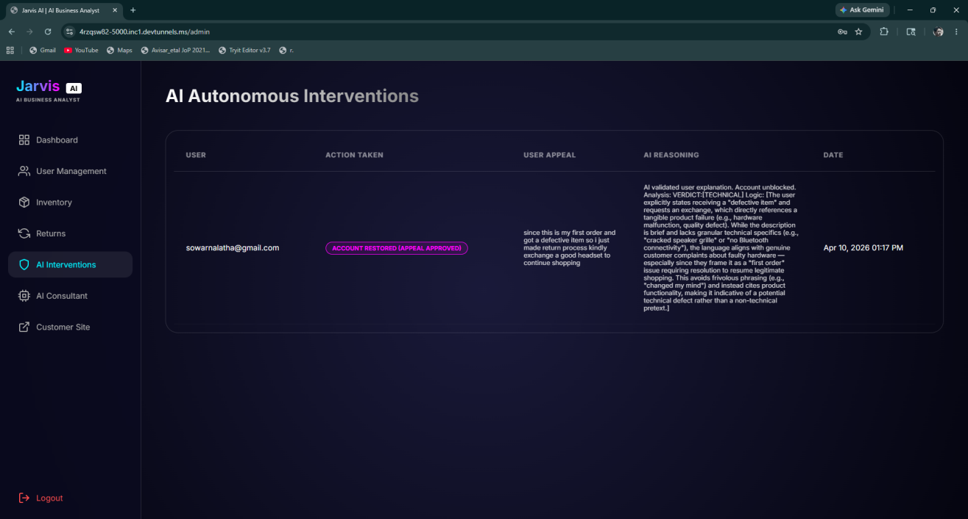
Figure 10.2.4 Jarvis AI Interventions Screen

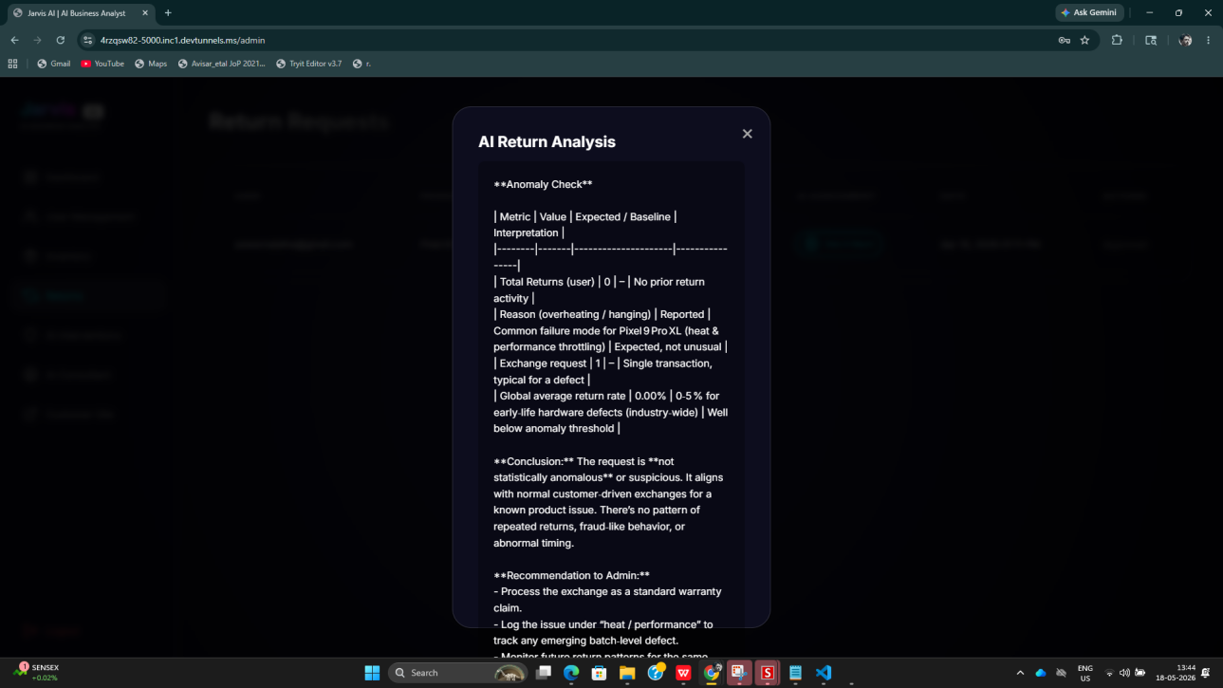
Figure 10.2.5 Jarvis AI Return Analysis Screen
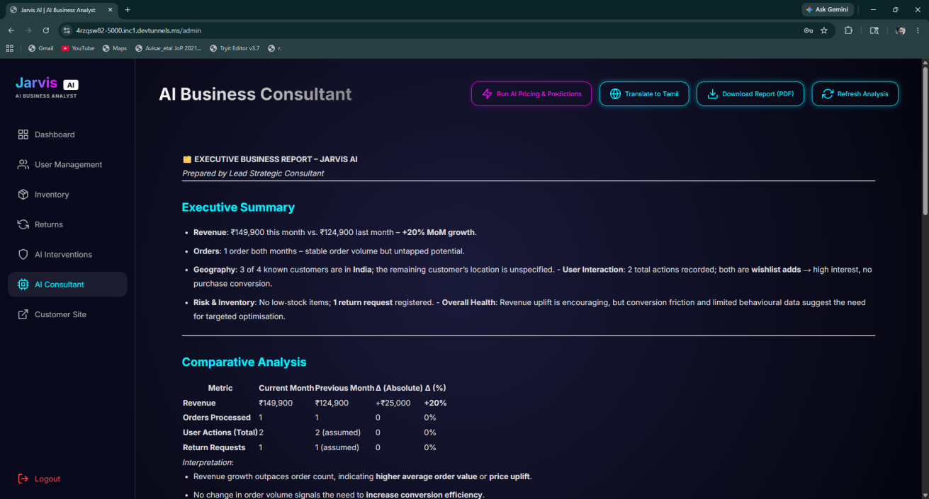

Figure 10.2.6 Jarvis AI Business Consultant Screen

Figure 10.2.7 Jarvis AI Report Generation Screen
10.2 Code Snippets:
main.py
@app.route("/api/login", methods=["POST"])
def api_login():
data = request.json
user_session = SessionLocal()
user = user_session.query(User).filter_by(
email=data.get("email")
).first()
if user and bcrypt.check_password_hash(
user.password,
data.get("password")
):
if not user.is_active:
return jsonify({
"success": False,
"message": f"Your account has been banned. Reason: {user.ban_reason}"
})
login_user(user)
return jsonify({"success": True})
return jsonify({
"success": False,
"message": "Invalid credentials."
})
Purpose: Implements secure user authentication using Bcrypt password verification and session management.

@app.route("/api/track", methods=["POST"])
def track_activity():
if not current_user.is_authenticated:
return jsonify({"status": "ignored"})
data = request.json
log = ActivityLog(
user_id=current_user.id,
action_type=data.get("action"),
details=data.get("details")
)
session.add(log)
Purpose: Records user interactions for behavioral analysis and business intelligence generation.

AI-Powered Return Analysis
prompt = (
f"A user wants to return/exchange {order.product_name}.\n"
f"Reason: {data.get('reason')}\n"
f"Type: {data.get('type')}\n"
f"User Total Returns so far: {return_count}\n"
f"Global Average Returns: {avg_returns:.2f}\n"
"Analyze if this behavior is statistically anomalous "
"or suspicious. Provide a recommendation and risk score."
)
assessment = generate_gemini_text(prompt)
Purpose: Uses Google Gemini AI to evaluate return requests and identify suspicious behavior patterns.
Autonomous AI Intervention.
elif return_count >= 3:
reason = (
f"Autonomous block triggered by AI. "
f"User exceeded return threshold "
f"(Count: {return_count+1})."
)
user = session.query(User).get(current_user.id)
user.is_active = False
user.ban_reason = (
"System Suspended: Excessive/Suspicious "
"return patterns detected by AI."
)
session.add(
AIIntervention(
user_id=current_user.id,
action_taken="Autonomous Account Block",
reason=reason
)
)
Purpose: Automatically restricts accounts exhibiting suspicious return behavior.
prompt = (
"You are the Lead Strategic Consultant for Jarvis AI.\n\n"
f"Current Month Revenue: ₹{curr_month_sales:,.2f}\n"
f"Previous Month Revenue: ₹{prev_month_sales:,.2f}\n"
f"Total User Actions: {total_logs}\n"
f"Low Stock Items: {low_stock}\n"
f"Total Return Requests: {total_returns}\n\n"
"Generate an Executive Business Report "
"with recommendations."
)
Purpose: Collects sales, inventory, and customer behavior data and converts it into an AI-generated business strategy report.
Admin Analytics Dashboard
curr_month_sales = session.query(
func.sum(Order.price_at_purchase)
).filter(
Order.created_at >= this_month_start
).scalar() or 0
curr_month_orders = session.query(
Order
).filter(
Order.created_at >= this_month_start
).count()
total_logs = session.query(
ActivityLog
).count()
Purpose: Generates real-time business metrics for the administrative dashboard.

Style.css:
document.addEventListener("DOMContentLoaded", async () => {
await checkSession();
fetchProducts();
fetchCartCount();
setupMainListeners();
});

async function checkSession() {
const res = await fetch("/api/session");
const data = await res.json();

if (data.is_authenticated) {
currentUser = data;
updateUIForUser();
}
}

function updateUIForUser() {
if (currentUser) {
document.getElementById("messages").innerHTML = `
<div class="msg bot">
Welcome ${currentUser.full_name}!
I am your Jarvis AI Assistant.
</div>`;
}
}

async function fetchProducts() {
const res = await fetch("/api/products");
const products = await res.json();

document.getElementById("product-grid").innerHTML =
products.map(p => `
<div class="product-card">
<h3>${p.name}</h3>
<div>₹${p.price}</div>
<button onclick="addToCart(${p.id})">
Add to Cart
</button>
</div>
`).join("");
}

async function addToCart(productId) {
await fetch("/api/cart/add", {
method: "POST",
headers: {
"Content-Type": "application/json"
},
body: JSON.stringify({
product_id: productId
})
});

fetchCartCount();
}

function setupMainListeners() {
document.getElementById("chat-send")
?.addEventListener("click", sendChatMessage);

document.getElementById("cart-btn")
?.addEventListener("click", openCart);

document.getElementById("orders-btn")
?.addEventListener("click", openOrders);
}

Gemini.py:
import os
import requests
from dotenv import load_dotenv

load_dotenv()

OPENROUTER_API_KEY = os.getenv("OPENROUTER_API_KEY")

def generate_gemini_text(prompt: str) -> str:
try:
url = "https://openrouter.ai/api/v1/chat/completions"

headers = {
"Authorization": f"Bearer {OPENROUTER_API_KEY}",
"Content-Type": "application/json",
}

data = {
"model": "openrouter/free",
"messages": [
{"role": "user", "content": prompt}
]
}

response = requests.post(url, headers=headers, json=data)
result = response.json()

if "error" in result:
print("OpenRouter Error:", result["error"]["message"])
return "AI is busy right now. Try again in a moment."

return result["choices"][0]["message"]["content"].strip()

except Exception as e:
print("Exception:", e)
return "Something went wrong while connecting to AI."

Models.py
from sqlalchemy import Column, Integer, String, Float, DateTime, Text, Boolean, ForeignKey, JSON
from sqlalchemy.orm import declarative_base, relationship
from datetime import datetime
from flask_login import UserMixin

Base = declarative_base()

class User(Base, UserMixin):
__tablename__ = "users"
id = Column(Integer, primary_key=True)
email = Column(String(120), unique=True, nullable=False, index=True)
password = Column(String(128), nullable=True)
google_id = Column(String(120), unique=True, nullable=True)
is_admin = Column(Boolean, default=False)
is_active = Column(Boolean, default=True)
ban_reason = Column(String(255), nullable=True)
created_at = Column(DateTime, default=datetime.utcnow)

profile = relationship("Profile", back_populates="user", uselist=False)
orders = relationship("Order", back_populates="user")
activity_logs = relationship("ActivityLog", back_populates="user")
preferences = relationship("Preference", back_populates="user", uselist=False)
cart_items = relationship("CartItem", back_populates="user")

class Profile(Base):
__tablename__ = "profiles"
id = Column(Integer, primary_key=True)
user_id = Column(Integer, ForeignKey("users.id"), nullable=False)
full_name = Column(String(120))
profile_pic_url = Column(String(255), default="/static/default-profile.png")

# New Fields
mobile = Column(String(20))
language = Column(String(50), default="English")
country = Column(String(100), default="India")
street = Column(String(200))
area = Column(String(200))
state = Column(String(100))
pincode = Column(String(20))

user = relationship("User", back_populates="profile")

class Product(Base):
__tablename__ = "products"
id = Column(Integer, primary_key=True)
category = Column(String, index=True)
name = Column(String, index=True)
brand = Column(String)
price = Column(Float)
original_price = Column(Float) # The base price for dynamic pricing reference
stock = Column(Integer)
description = Column(Text)
image_url = Column(String(255))
is_promoted = Column(Boolean, default=False)

class Order(Base):
__tablename__ = "orders"
id = Column(Integer, primary_key=True)
user_id = Column(Integer, ForeignKey("users.id"))
product_id = Column(Integer, ForeignKey("products.id"))
product_name = Column(String(120))
quantity = Column(Integer, default=1)
status = Column(String(50), default="Placed")
price_at_purchase = Column(Float)
created_at = Column(DateTime, default=datetime.utcnow)

user = relationship("User", back_populates="orders")
product = relationship("Product")

class WishlistItem(Base):
__tablename__ = "wishlist_items"
id = Column(Integer, primary_key=True)
user_id = Column(Integer, ForeignKey("users.id"), nullable=False)
product_id = Column(Integer, ForeignKey("products.id"), nullable=False)
added_at = Column(DateTime, default=datetime.utcnow)

user = relationship("User")
product = relationship("Product")

class Notification(Base):
__tablename__ = "notifications"
id = Column(Integer, primary_key=True)
user_id = Column(Integer, ForeignKey("users.id"), nullable=True) # Null for Global/Admin notifications
title = Column(String(100))
message = Column(Text)
type = Column(String(50)) # e.g., "price_drop", "restock_alert", "system"
is_read = Column(Boolean, default=False)
timestamp = Column(DateTime, default=datetime.utcnow)

user = relationship("User")

class PriceHistory(Base):
__tablename__ = "price_history"
id = Column(Integer, primary_key=True)
product_id = Column(Integer, ForeignKey("products.id"), nullable=False)
old_price = Column(Float)
new_price = Column(Float)
reason = Column(String(255))
timestamp = Column(DateTime, default=datetime.utcnow)

product = relationship("Product")

class ActivityLog(Base):
__tablename__ = "activity_logs"
id = Column(Integer, primary_key=True)
user_id = Column(Integer, ForeignKey("users.id"), nullable=False)
action_type = Column(String(50))
details = Column(Text)
timestamp = Column(DateTime, default=datetime.utcnow)

user = relationship("User", back_populates="activity_logs")

class RestockLog(Base):
__tablename__ = "restock_logs"
id = Column(Integer, primary_key=True)
product_id = Column(Integer, ForeignKey("products.id"), nullable=False)
quantity_added = Column(Integer, nullable=False)
timestamp = Column(DateTime, default=datetime.utcnow)

product = relationship("Product")

class CartItem(Base):
__tablename__ = "cart_items"
id = Column(Integer, primary_key=True)
user_id = Column(Integer, ForeignKey("users.id"), nullable=False)
product_id = Column(Integer, ForeignKey("products.id"), nullable=False)
quantity = Column(Integer, default=1)

user = relationship("User", back_populates="cart_items")
product = relationship("Product")

class Preference(Base):
__tablename__ = "preferences"
id = Column(Integer, primary_key=True)
user_id = Column(Integer, ForeignKey("users.id"), nullable=False)
interests = Column(JSON)
budget_preference = Column(String(50))

user = relationship("User", back_populates="preferences")

class ReturnRequest(Base):
__tablename__ = "return_requests"
id = Column(Integer, primary_key=True)
user_id = Column(Integer, ForeignKey("users.id"))
order_id = Column(Integer, ForeignKey("orders.id"))
product_name = Column(String(120))
reason = Column(Text)
type = Column(String(50)) # Return or Exchange
status = Column(String(50), default="Pending AI Analysis")
ai_assessment = Column(Text) # Gemini's analysis of the return
user_reply = Column(Text) # User's response to behavioral query
created_at = Column(DateTime, default=datetime.utcnow)

user = relationship("User")
order = relationship("Order")

class AIIntervention(Base):
__tablename__ = "ai_interventions"
id = Column(Integer, primary_key=True)
user_id = Column(Integer, ForeignKey("users.id"))
action_taken = Column(String) # e.g., "Sent Behavioral Query", "Blocked Account", "Restricted Returns"
reason = Column(Text) # AI's logic for the action
appeal_message = Column(Text) # The user's justification for the appeal
user_response_analyzed = Column(Boolean, default=False)

timestamp = Column(DateTime, default=datetime.utcnow)

user = relationship("User")

CHAPTER 11
BIBLIOGRAPHY
[1] Grinberg, M., Flask Web Development: Developing Web Applications with Python, 2nd Edition, O'Reilly Media, 2018.
[2] Google Developers, Gemini API Documentation, Google LLC, 2025.
[3] SQLAlchemy Authors, SQLAlchemy Documentation, Available at: https://www.sqlalchemy.org
[4] SQLite Development Team, SQLite Documentation, Available at: https://www.sqlite.org
[5] Pallets Projects, Flask Documentation, Available at: https://flask.palletsprojects.com
[6] Hardt, D., The OAuth 2.0 Authorization Framework (RFC 6749), Internet Engineering Task Force (IETF), 2012.
[7] Bcrypt Developers, Flask-Bcrypt Documentation, Available at: https://flask-bcrypt.readthedocs.io
[8] Flask-Login Developers, Flask-Login Documentation, Available at: https://flask-login.readthedocs.io
[9] Razorpay Software Pvt. Ltd., Razorpay Python SDK Documentation, Available at: https://razorpay.com/docs
[10] Russell, S. and Norvig, P., Artificial Intelligence: A Modern Approach, 4th Edition, Pearson Education, 2020.
[11] Goodfellow, I., Bengio, Y., and Courville, A., Deep Learning, MIT Press, 2016.

JOURNAL CERTIFICATE




