

ONLINE DJ BOOKING MANAGEMENT SYSTEM

Project Work
Submitted for the Partial fulfillment for the award of the degree of
BACHELOR OF COMPUTER APPLICATION
By

MUKESH KUMAR.K
21105310

ARUN K.S

21105303
Under the guidance of
Dr.Y.KALPANA
Associate Professor
Department of IT

DEPARTMENT OF INFORMATION TECHNOLOGY
SCHOOL OF COMPUTING SCIENCES
VISTAS
PALLAVARAM, CHENNAI-600117

MAY 2024



DECLARATION
I, (Mukesh Kumar.K,) declare that the Project entitled “ONLINE DJ BOOKING MANAGEMENT
SYSTEM” is a record of original work done by me in partial fulfillment of the requirements for the award of the degree of Bachelor of Computer Application under the guidance of Dr.Y.KALPANA for the academic year 2022-23. This project work has not formed the basis for the award of any degree

(Signature of the Candidate)
(MUKESH KUMAR K)



BONAFIDE CERTIFICATE
This is to certify that the project entitled “ONLINE DJ BOOKING MANAGEMENT SYSTEM” is the original record work done by MUKESH KUMAR K (21105310) under my guidance and supervision for the partial fulfillment of the award of the degree of BACHELOR OF COMPUTER APPLICATION, as per syllabus prescribed by VISTAS.

GUIDE HEAD OF THE DEPARTMENT

Submitted for the Viva-Voce examination held on……………………….at VISTAS, Pallavaram,
Chennai.

INTERNAL EXAMINER EXTERNAL EXAMINER

ACKNOWLEDGEMENT

“Let the beauty of the lord fall on us and establish the work of our hands”. At the outset, I thank the ALMIGHTY GOD for his abundant blessings and for giving me the opportunity to carry out this project successfully.
I deeply express my sincere thanks and gratitude to Dr. ISHARI K.GANESH , Founder-Chancellor of VISTAS, Dr. A. JOTHI MURUGAN Pro-Chancellor (Planning & development) VISTAS, Dr. ARTHI GANESH Pro-Chancellor (Academics) VISTAS, Dr.PREETHAA GANESH Vice President VISTAS.
I also extend my heartfelt sincere thanks to Dr. S.SRIMAN NARAYANAN Vice Chancellor and Dr. M.
BHASKARAN Pro-Vice Chancellor, VISTAS, Dr.P.SARAVANAN Registrar &,
Dr.A.UDAYAKUMAR Controller Of Examination of VISTAS. I also extend my heartfelt sincere thanks to Dr.P.MAGESH KUMAR Director, School of Computing Sciences, VISTAS.
I extend my deep sense of gratitude and sincere thanks to the Head of the Department Dr.P.SUJATHA, M.Sc., M.Phil. Ph.D for her continuous support.
I extend my sincere gratitude to my beloved Guide Dr.Y.KALPANA for helping me to do this project work with her valuable suggestions and guidance to complete this project successfully.
I sincerely express my gratitude to MY PARENTS, FRIENDS and our FACULTY MEMBERS for their continuous prayers, supports and constant encouragement to reach the heights of success.
Once again I thank the GOD almighty with whose profound blessings this work has been completed successfully.

TABLE OF CONTENTS
CHAPTER  NO | TITLE | PAGE NO
 | ABSTRACT
1 | CHAPTER 1: SYSTEM STUDY  1.1 Feasibility Study  1.1.1 Operational feasibility  1.1.2 Technical Feasibility  1.1.3 Economical Feasibility  1.2 System Requirements  1.2.1 Hardware Requirements  1.2.2 Software Requirements
2 | CHAPTER 2: SYSTEM ANALYSIS  2.1 Introduction  2.2 Existing System  2.3 Proposed System  2.4 Project Description  - 4.1Module Description  2.5 About the Software
3 | CHAPTER 3: SYSTEM DESIGN  3.1 UML Diagram  3.1.1 Class Diagram  3.1.2 Use Case Diagram  3.2 ER Diagram  3.3 Table Structure  3.4 Output Screenshot  3.5 Sample Source Code

4 | CHAPTER 4: SYSTEM TESTING  4.1 Unit Testing  4.2 Integrated Testing  4.3 System Testing  4.4 Basic Path Testing  4.5 Loop Testing
5 | CHAPTER 5: IMPLEMENTATION  5.1 System Implementation
6 | CHAPTER 6: CONCLUSION & FUTURE  6.1 Conclusion & Future
 | References

ONLINE DJ BOOKING MANAGEMENT

ABSTRACT
Online DJ booking management system project is a web application which is developed in PHP platform. This is used for easy online booking and contacting through online without any problems .In future generations ,it is used so much because of developed networks through online .we can make so many bookings at same time in our website and also there are so many offers for time to time .we can also fix your timings according to your comfort and also your favourite song list that you can make yourself .There is lot of options like birthdays , parties ,weddings ,farewell etc…

CHAPTER 1 SYSTEM STUDY 1.1 FEASIBILITY STUDY

A feasibility study is a high-level capsule version of the entire System analysis and Design Process. The study begins by classifying the problem definition. Feasibility is to determine if it’s worth doing. Once an acceptance problem definition has been generated, the analyst develops a logical model of the system. A search for alternatives is analyzed carefully. There are 3 parts in feasibility study.

1.1.1 OPERATIONAL FEASIBILITY

Question that going to be asked are Will the system be used if it developed and implemented.

If there was sufficient support for the project from the management and from the users. Have the users been involved in planning and development of the Project.

1.1.2 TECHNICAL FEASIBILITY

Does the necessary technology exist to do what is been suggested Does the proposed equipment have the technical capacity for using the new system? Are there technical guarantees of accuracy, reliability and data security? The project is developed on Pentium III with 12 8 MB RAM. The environment required in the development of system is any windows platform.

The observer pattern along with factory pattern will update the results eventually. The language used in the development is PHP, Apache Server and database as MySQL.

1.1.3 ECONOMICAL FEASIBILITY

To decide whether a project is economically feasible, to consider various factors as cost benefit analysis, long-term returns and maintenance costs.

1.2 SYSTEM REQUIREMENTS

1.2.1 HARDWARE REQUIREMENTS:

Processor | : | Intel P-IV based system
Processor Speed | : | 2.0. GHz
RAM | : | 1GB
Hard Disk : 40GB to 80GB

1.2.2 SOFTWARE REQUIREMENTS:

Database | : | MySQL
Server | : | Apache
Frontend | : | HTML
Scripting language | : | Java Script
IDE | : | Sublime
Technology | : PHP

Backend : MySQL Version 5.6

CHAPTER 2 SYSTEM ANALYSIS

2.1 INTRODUCTION

The objective of this application is to develop a system that effectively manages all the data related to the various DJ events that take place in a function. The purpose is to maintain a centralized database of all DJ event related information. The goal is to support various functions and processes necessary to manage the data efficiently.

2.2 EXISTING SYSTEM

This existing system is not providing secure registration and profile management of all the users properly. This system is not providing on-line Help. This system doesn’t provide tracking of users activities and their progress. This manual system gives us very less security for saving data and some data may be lost due to mismanagement. This system is not providing event management through internet. This system is not providing proper events information. The system is giving manual information through the event management executer.

2.3 PROPOSED SYSTEM

The development of this new system contains the following activities, which try to automate the entire process keeping in the view of database integration approach. This system maintains user’s personal, and contact details. This system will provide on line help and search capabilities. User friendliness is provided in the application with various controls provided by system rich user interface. Authentication is provided for this application only registered users can access. DJ event information files can be stored in centralized database which can be maintained by the system. This system provides the users to manage the DJ events systematically.

2.4 PROJECT DESCRIPTION

2.4.1 MODULES DESCRIPTION

The system after careful analysis has been identified to be presented with the following
modules:

Online DJ Management System Module
In ODJMS project we use PHP and MySQL database. It has two modules.
1.Admin Module
2.User Module

ADMIN MODULE

- Dashboard: In this section, admin can see all detail in brief like the total services, Total unread queries, Total read queries, Total new booking, Total Approved booking, Total Cancelled Booking and Total Event Type
- DJ Services: In this section, admin can manage services (add/delete).
- Type of Event: In this section, admin can manage event type (add/delete).
- Pages: In this section, the admin can manage about us and contact us pages.
- Booking: In this section, admin can view new, approved, cancelled bookings and also give a remark.
- Contact us Queries: In this section, admin can view and maintain the Queries.
- Reports: In this section, admin can view booking in a particular period.
Search: In this section, admin can search booking details and user queries with the help of name, mobile number and booking id
Admin can also update his profile, change password and recover password.

USER:
user can view the website and check out the information about ODJMS services and they can
also inquiry and book DJ.

2.5 About The Software

FRONTEND HTML :

Hypertext Markup Language (HTML) is the standard markup language for documents designed to be displayed in a web browser. It can be assisted by technologies such as Cascading Style Sheets (CSS) and scripting languages such as JavaScript.

Web browsers receive HTML documents from a web server or from local storage and render the documents into multimedia web pages. HTML describes the structure of a web page semantically and originally included cues for the appearance of the document.

BACKEND MySQL :

MySQL is an open source relational database management system (RDBMS) based on
Structured Query Language (SQL). It is one part of the very popular LAMP platform consisting of Linux, Apache, My SQL, and PHP. Currently My SQL is owned by Oracle. My SQL database is available on most important OS platforms.

It runs on BSD Unix, Linux, Windows, or Mac OS. Wikipedia and YouTube use My SQL. These sites manage millions of queries each day. My SQL comes in two versions: My SQL server system and My SQL embedded system.

Scripting Language JavaScript :

JavaScript is a high-level ,interpreted scripting language that conforms to the ECMAScript specification. JavaScript has curly-brackets syntax, dynamic typing, protype-based object orientation , and first- class functions. Alongside HTML and CSS , JavaScript is one of the core technologies of the World Wide Web.

Java Script enables interactive web pages and is an essential part of web applications. The vast majority of websites use it , and major web browser have a dedicated JavaScript engine it As a multi-paradigm language, JavaScript supports event-driven, functional, and imperative(including objectoriented and protype-based)programming styles.

CHAPTER 3 SYSTEM DESIGN

3.1 UML DIAGRAMS

The unified modelling language allows the software engineer to express an analysis model
using the modelling notation that is governed by a set of syntactic semantic and pragmatic rules.

3.1.1 CLASS DIAGRAM:

The class diagram shows a set of classes, interfaces, collaborations and their relationships.

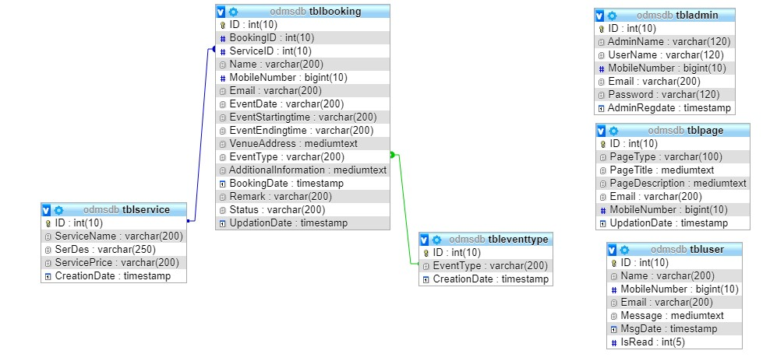

3.1.2 USE CASE DIAGRAMS:

Use case diagram consists of actors, use cases and their relationships. These diagrams are
especially important in organizing and modelling the behaviours of a system.

USER

Visit Website

View Service
Detail

Enquiries

Book DJ

Use case diagram for user

Admi
n

Sign in

Dashboard

My Profile

Change Password

Manage
Services

(
Add / Delete
)

Manage Event
Type

)
Add / Delete
(

Manage Bookings

(
Approved

/ Cancelled)

Generate Report

Website Settings

Manage Queries

Se
arch
Booking/Queries

Use case diagram for Administrator

3.2 ER-DIAGRAM
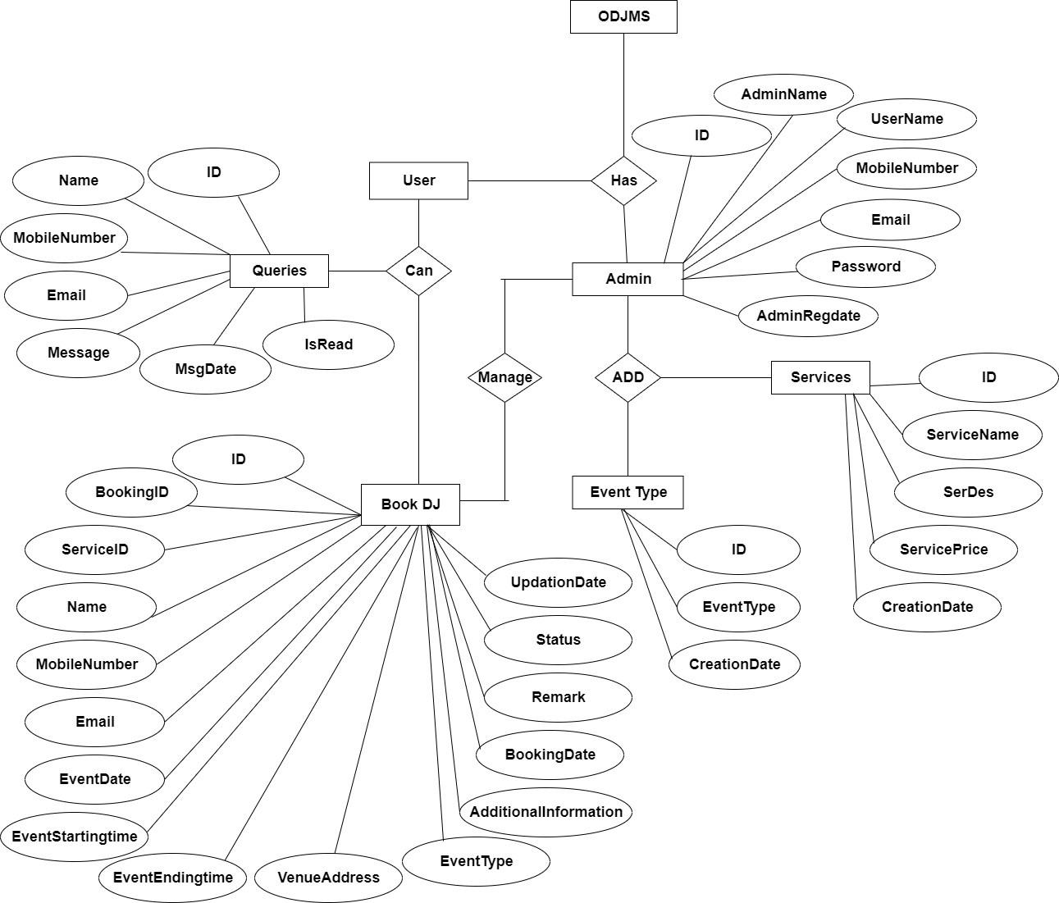

ER diagram for Online DJ Booking management System

3.3 TABLES STRUCTURE

The data in the system has to be stored and retrieved from database. Designing the database is part of system design. Data elements and data structures to be stored have been identified at analysis stage. They are structured and put together to design the data storage and retrieval system.

A database is a collection of interrelated data stored with minimum redundancy to serve many
users quickly and efficiently. The general objective is to make database access easy, quick, inexpensive and flexible for the user. Relationships are established between the data items and unnecessary data items are removed. Normalization is done to get an internal consistency of data and to have minimum redundancy and maximum stability. This ensures minimizing data storage required, minimizing chances of data inconsistencies and optimizing for updates. The MySQL Access database has been chosen for developing the relevant databases.
Online DJ Management System (ODJMS) contains 6 MySQL tables: ADMIN : This table store the admin login details

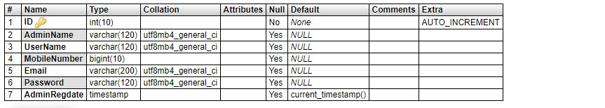

BOOKING: This table store the booking details.
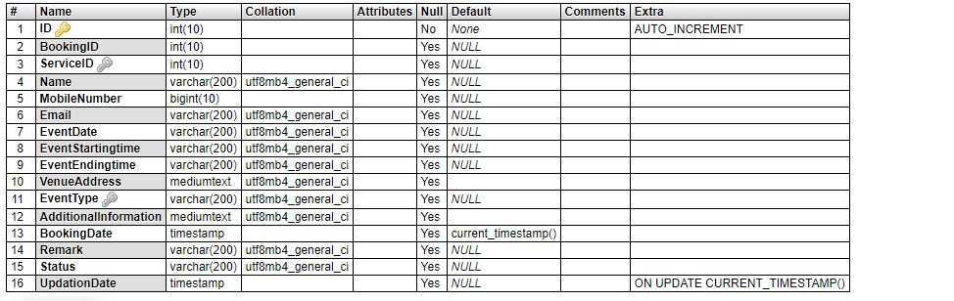

EVENTTYPE: This table store the type of event details.

PAGE: This table about us and contact us detail.
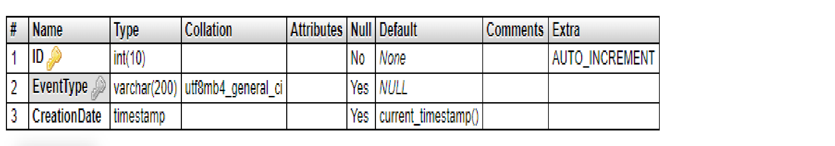
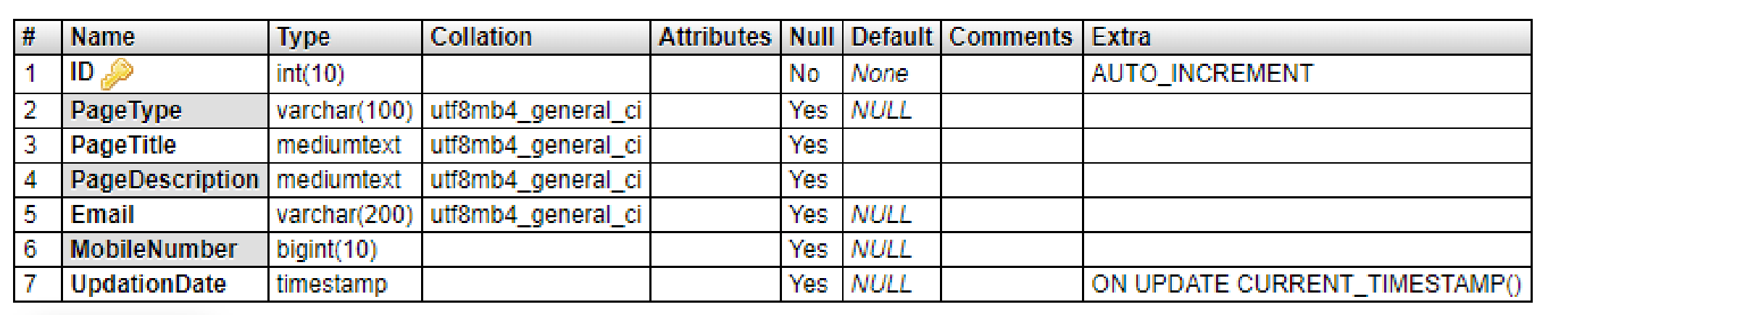

SERVICE: This table store the details of DJ services.

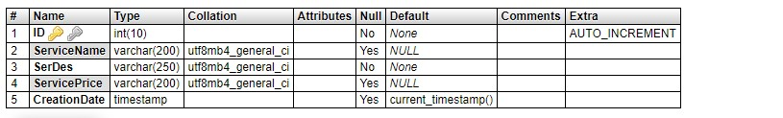

BOOKINGS: This table store the event booking details.

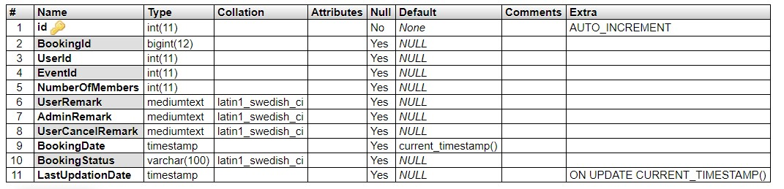

USER: This table store the details user queries.

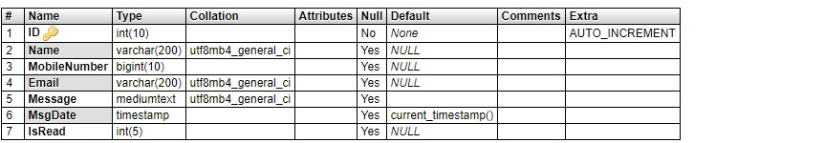

3.4 OUTPUT SCREEN ADMIN MODULE SCREENS SIGN IN

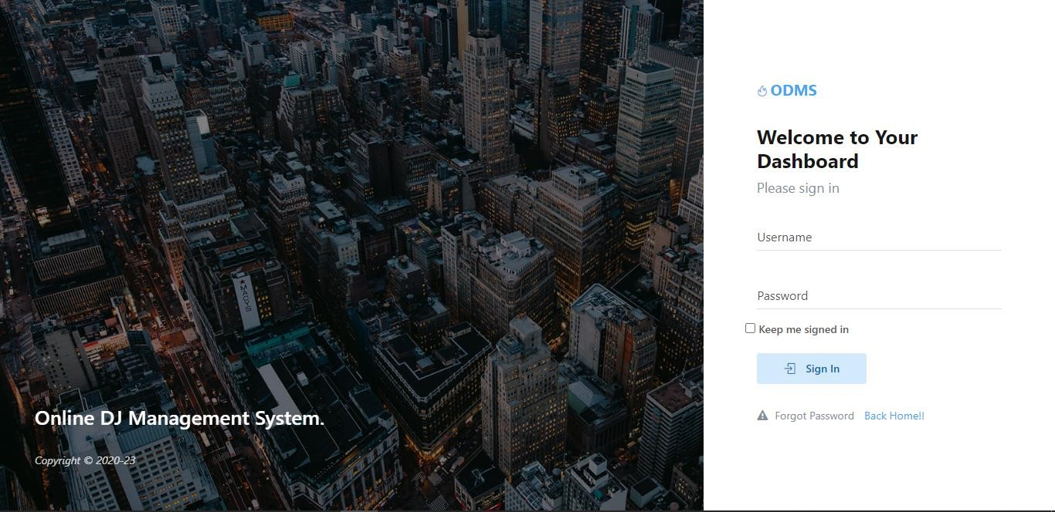

DASHBOARD
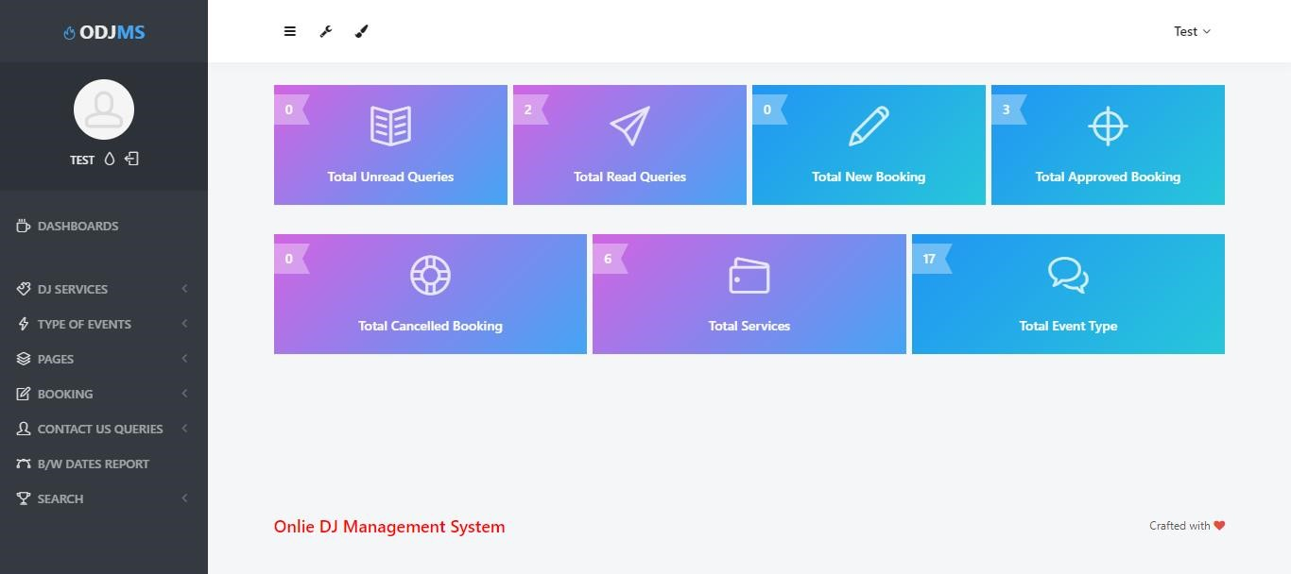

PROFILE
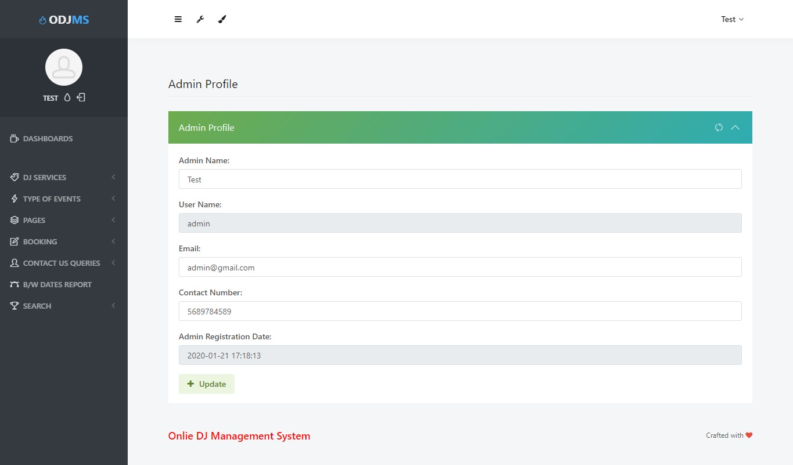

CHANGE PASSWORD
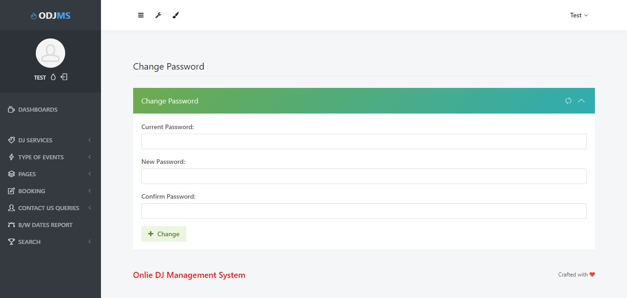

ADD SERVICES
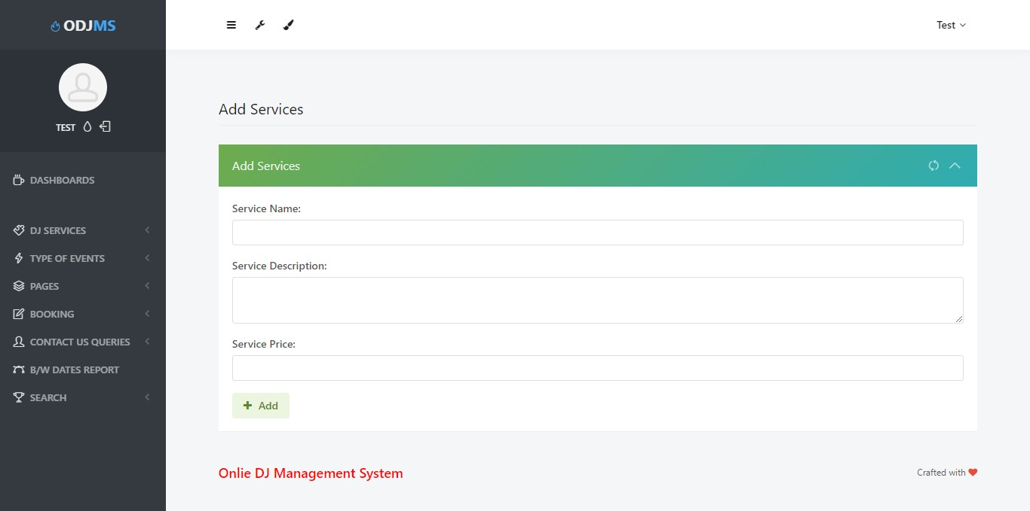

MANAGE SERVICES
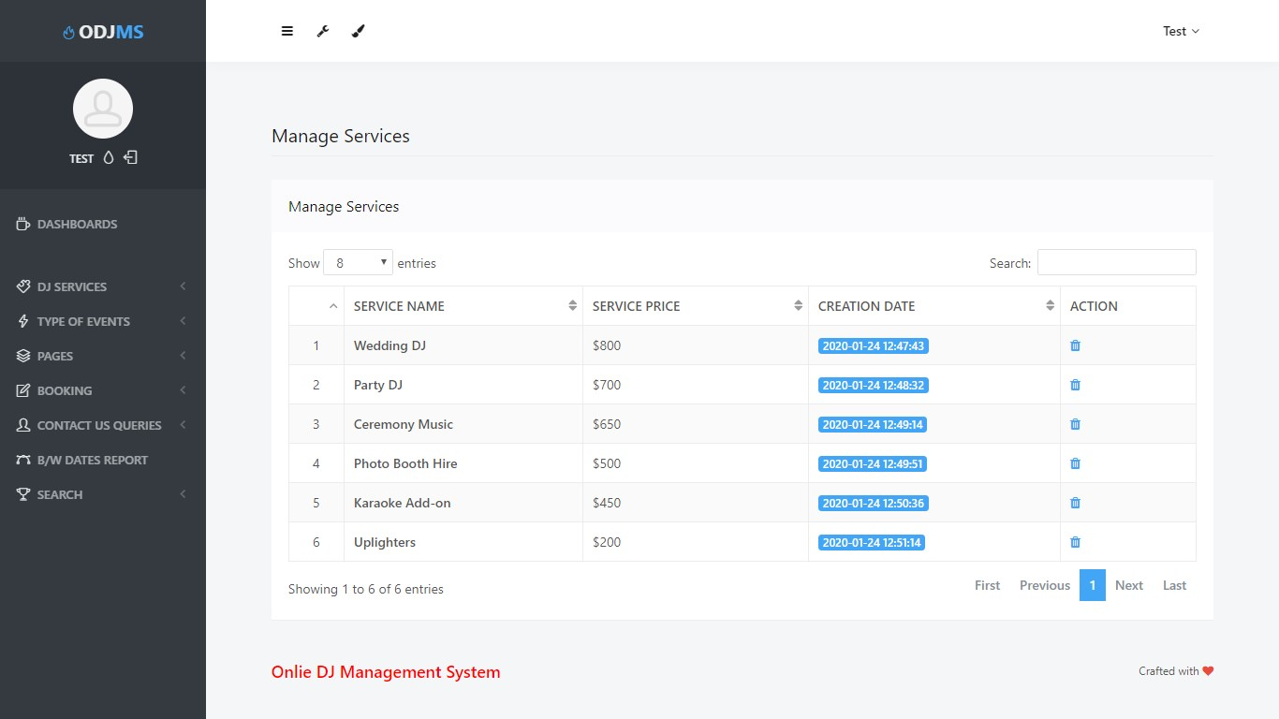

ADD EVENT TYPE
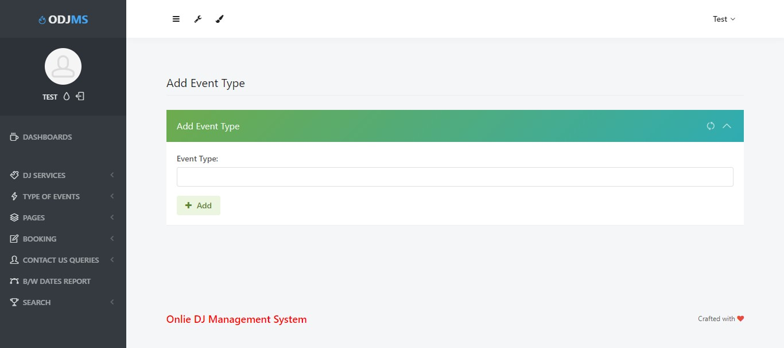

MANAGE EVENT TYPE
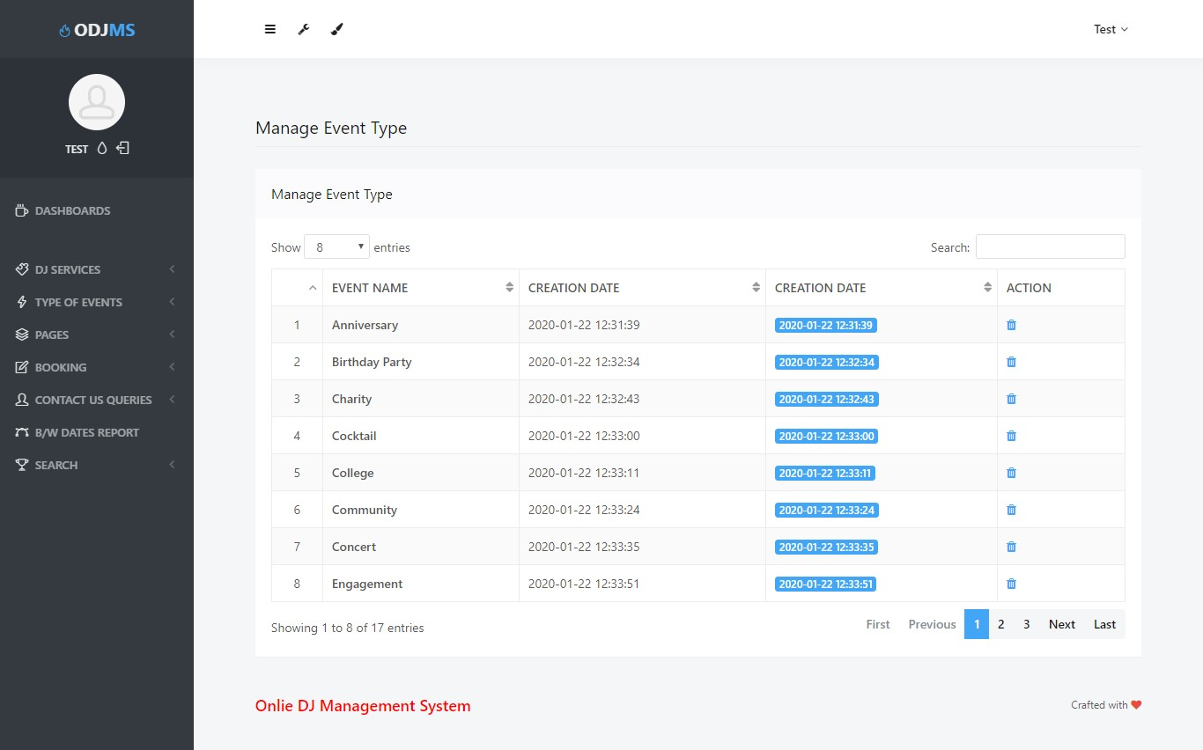

UPDATE ABOUT US
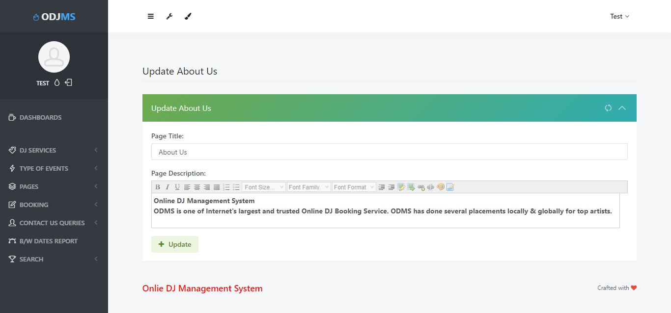

UPDATE CONTACT US
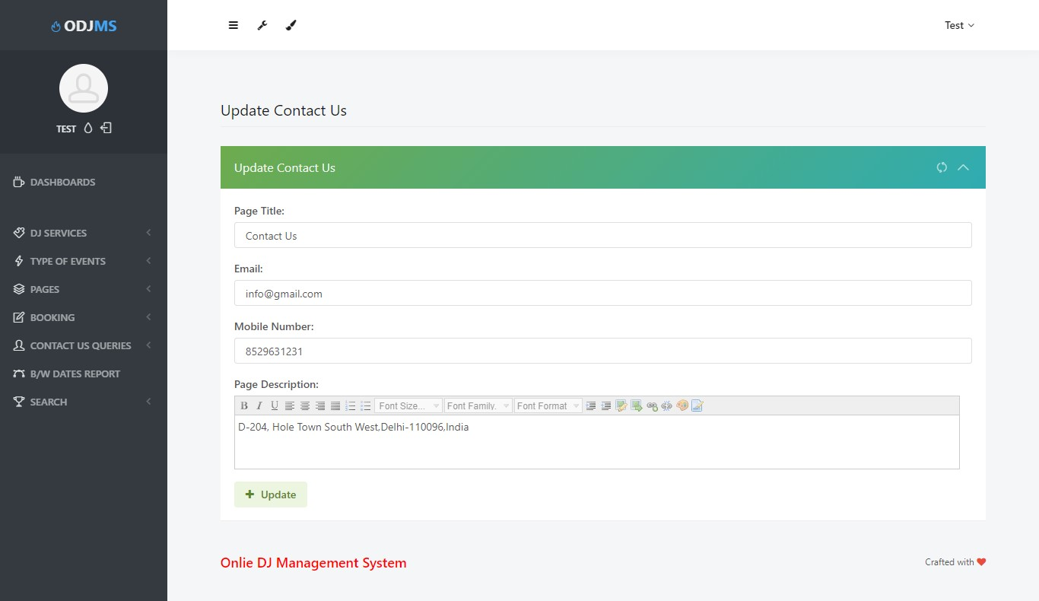

NEW BOOKING
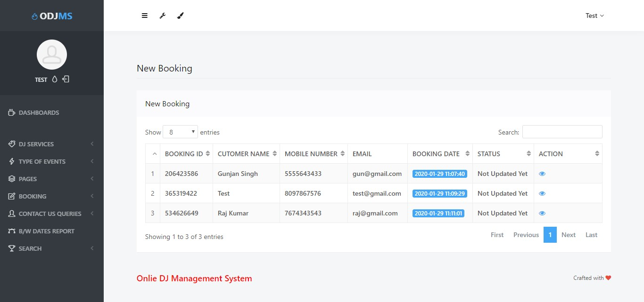

VIEWBOOKING
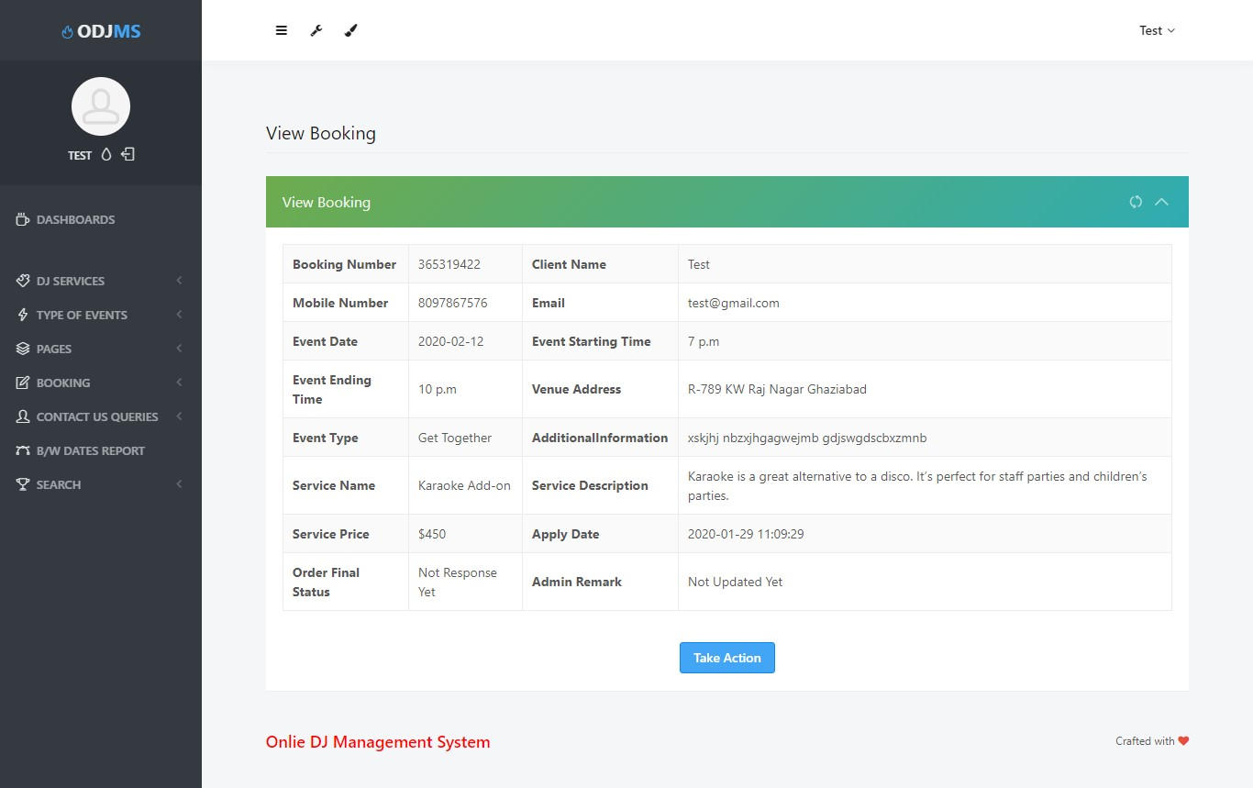

UPDATE REMARK
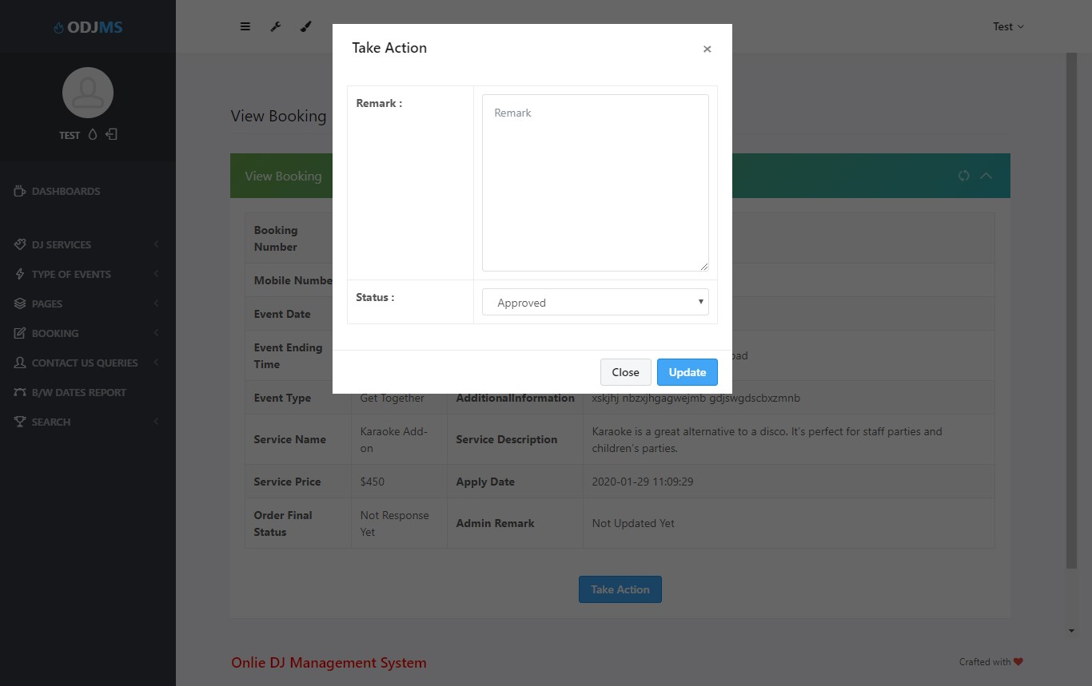

APPROVED BOOKING
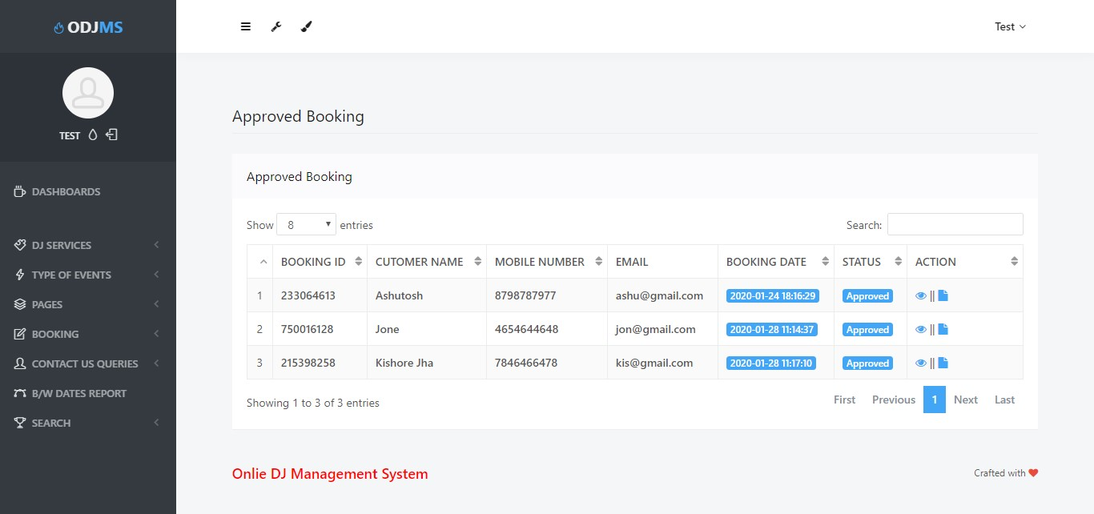

VIEW APPROVED BOOKING
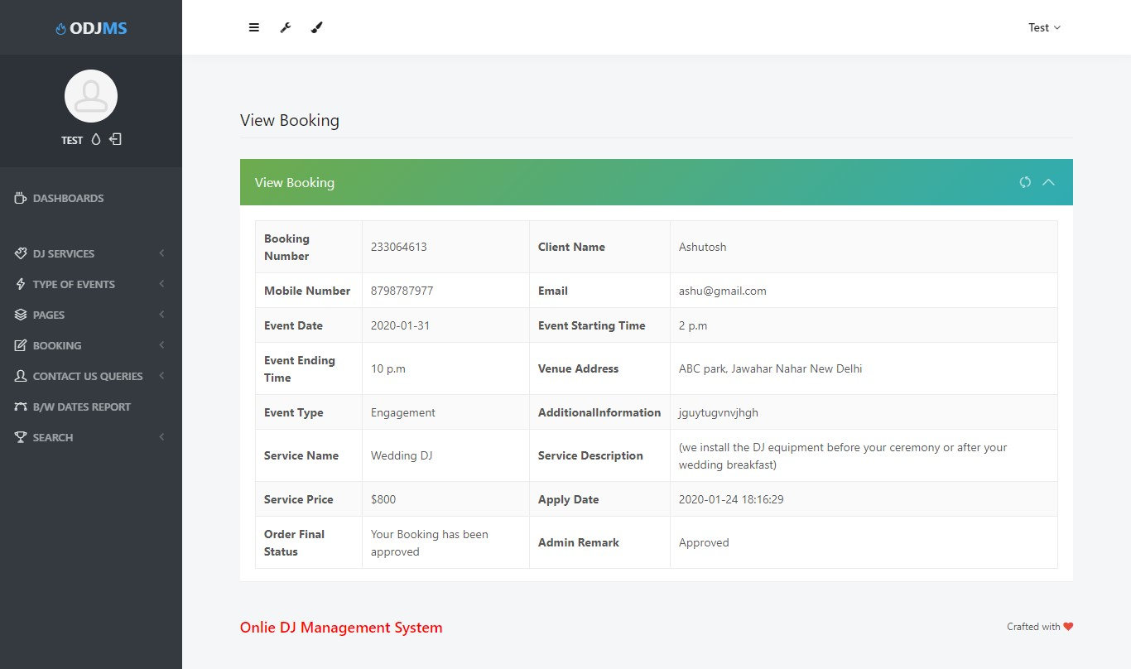

VIEW INVOICE
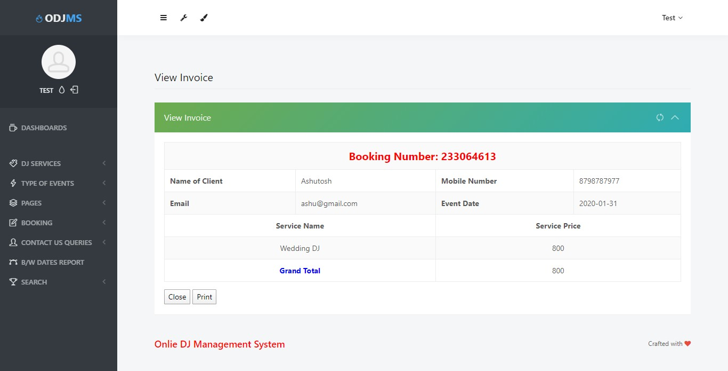

CANCELLED BOOKING
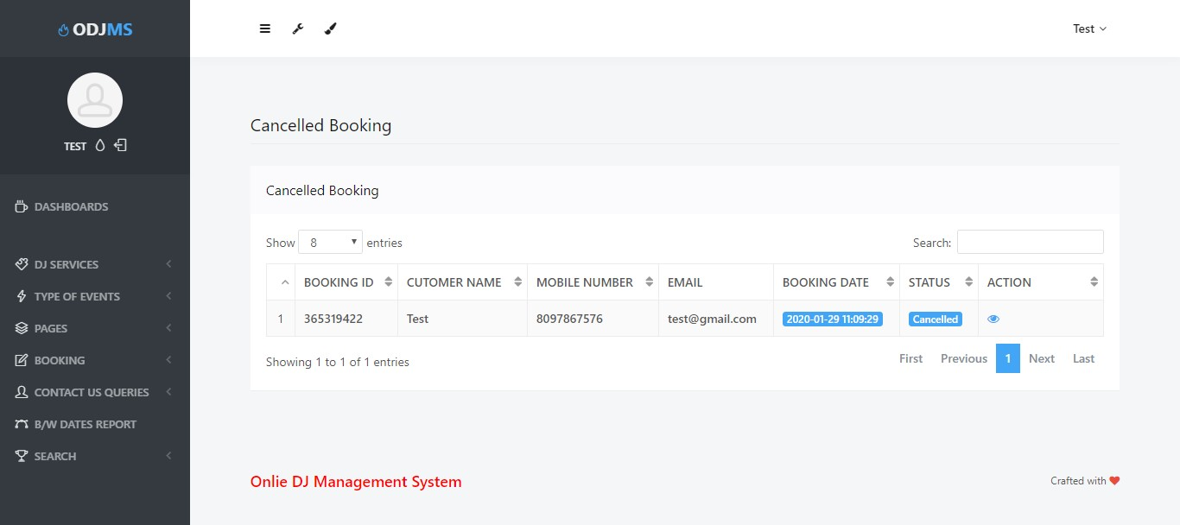

VIEW CANCELLED BOOKING
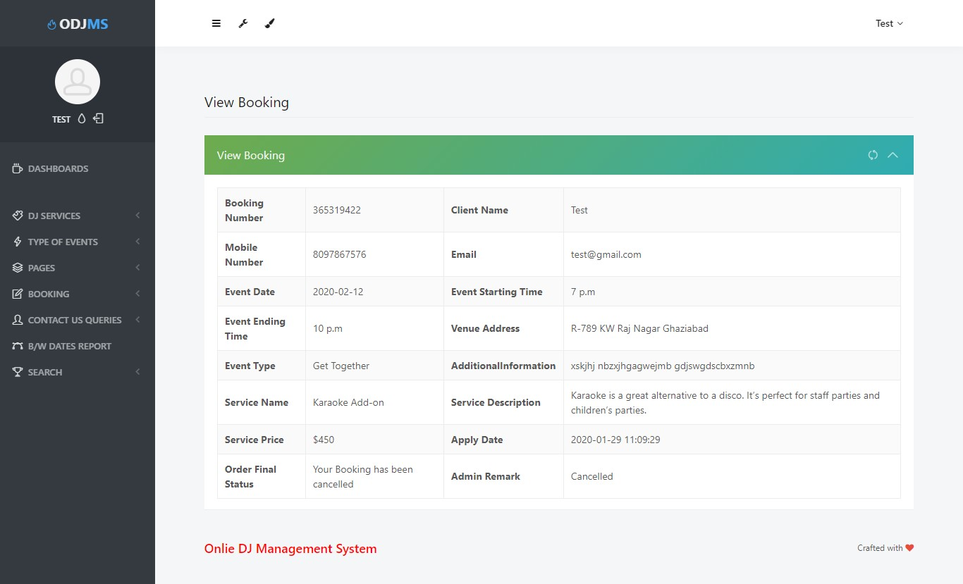

ALL BOOKING
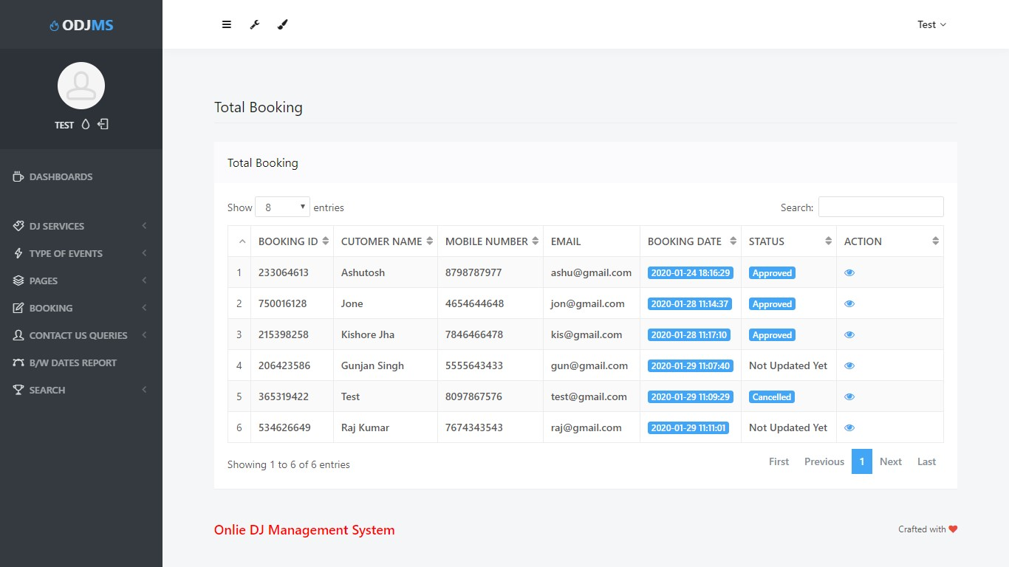

UNREAD QUERIES
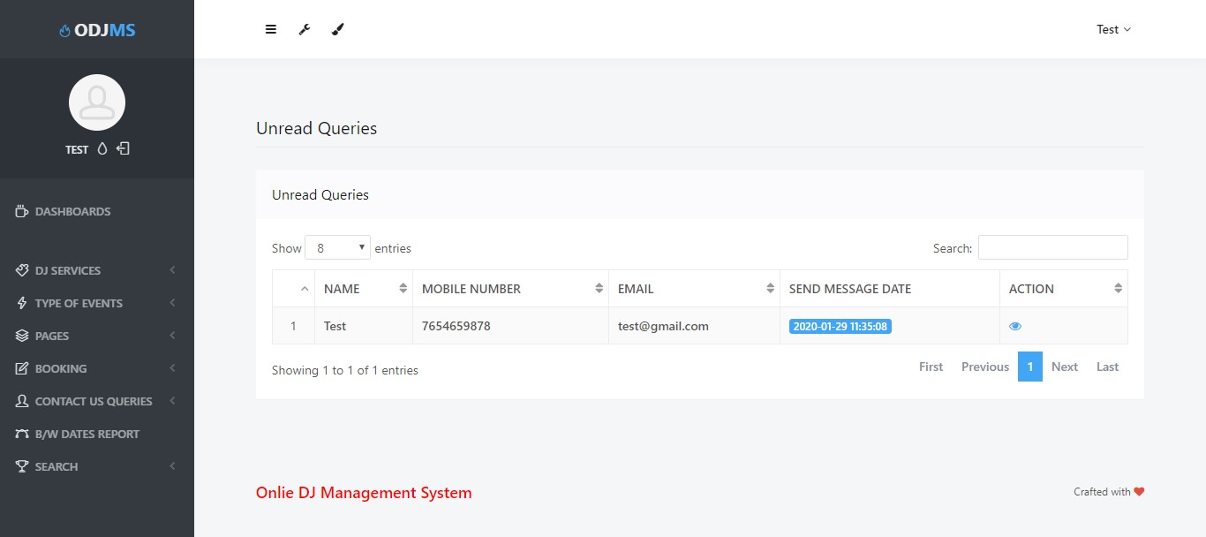

READ QUERIES
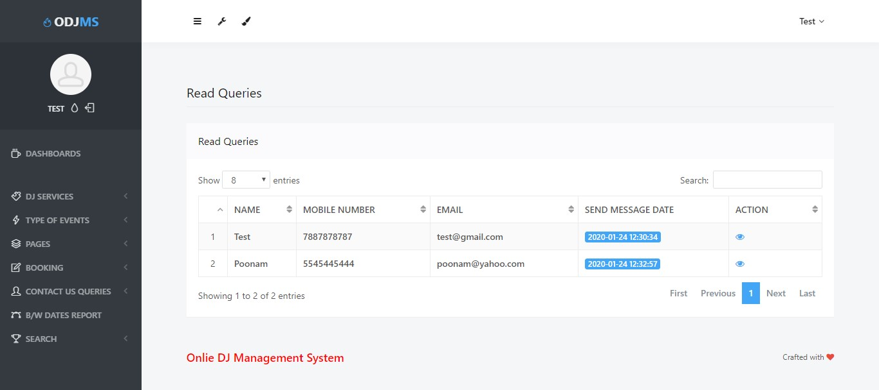

VIEW QUERIES
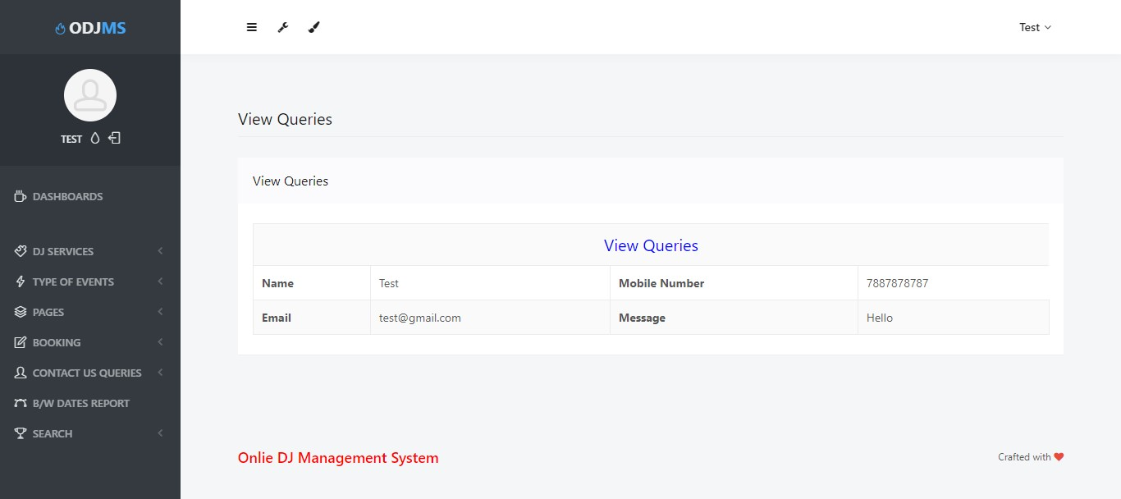

BETWEEN DATES REPORT
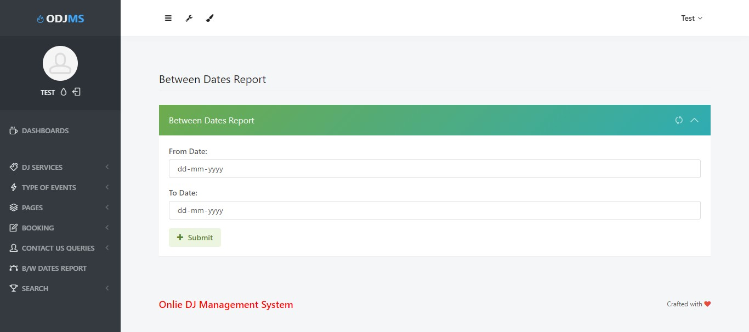

BETWEEN DATES REPORT DETAILS
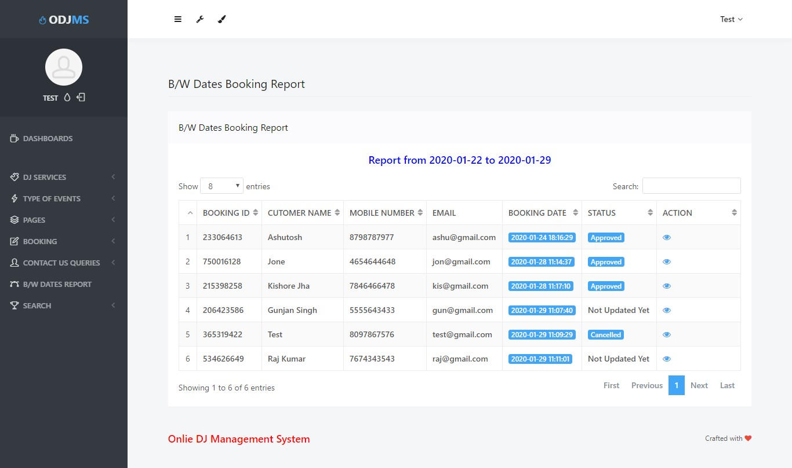

USER QUERIES SEARCH
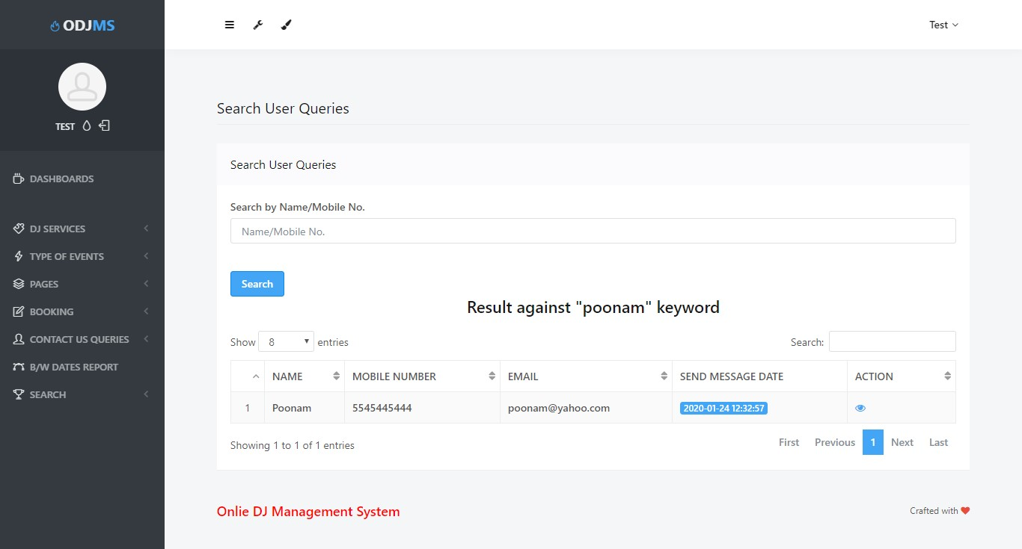

SEARCH BOOKING
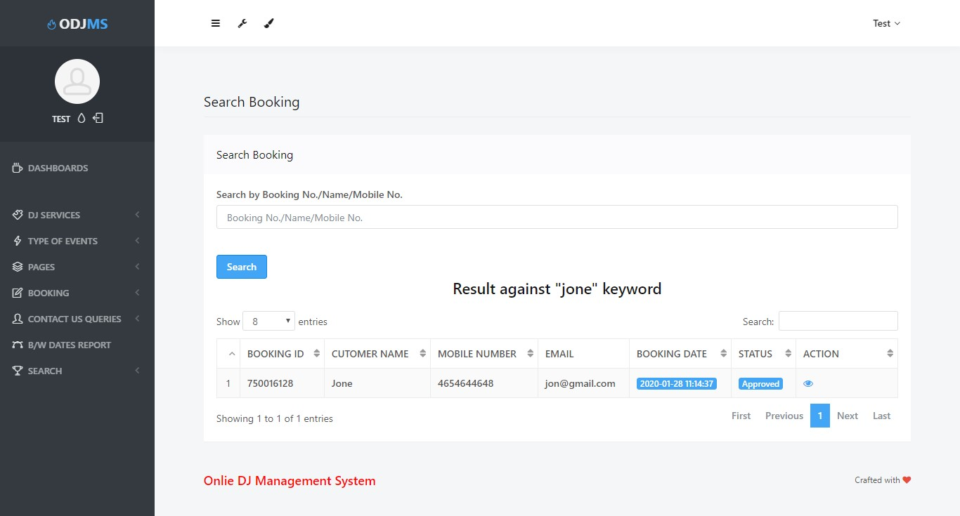

FORGOT PASSWORD

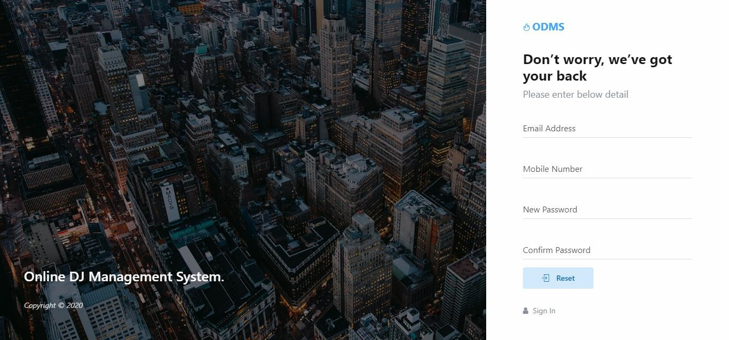

USER MODULE HOME PAGE

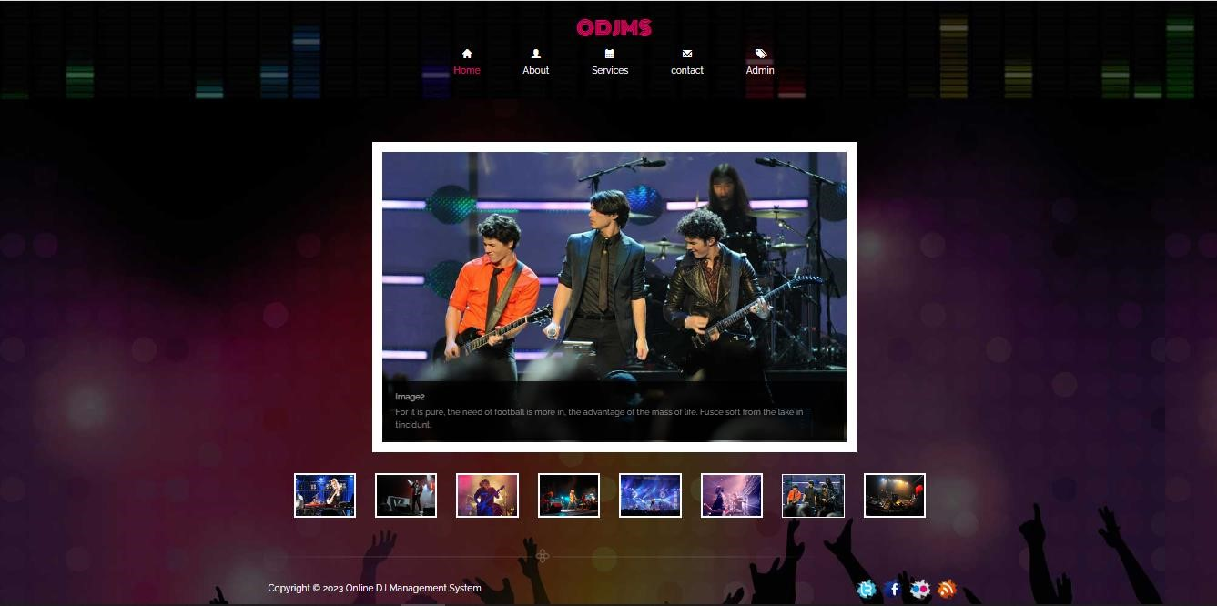

ABOUT US
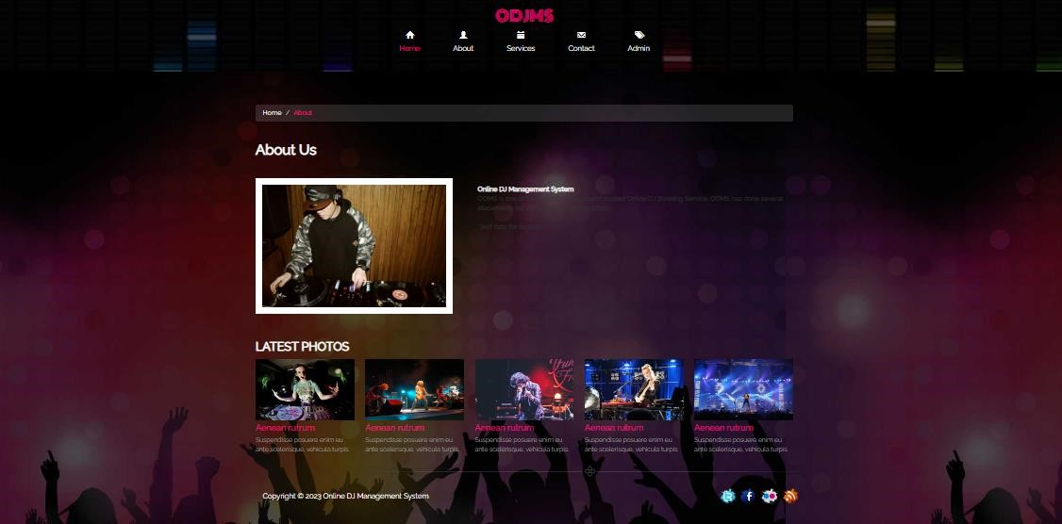

CONTACT US
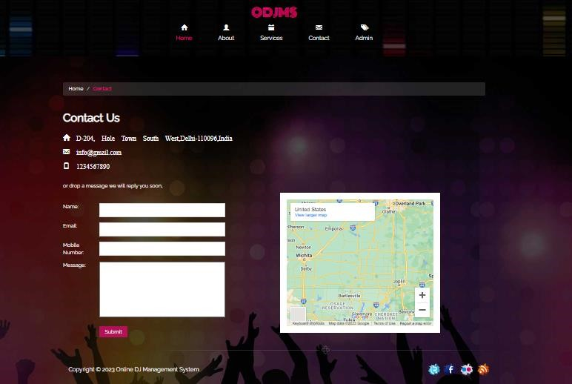

SERVICESPAGE
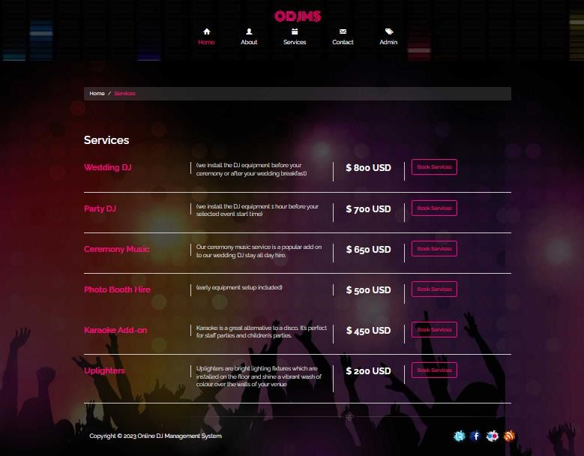

BOOK SERVICES
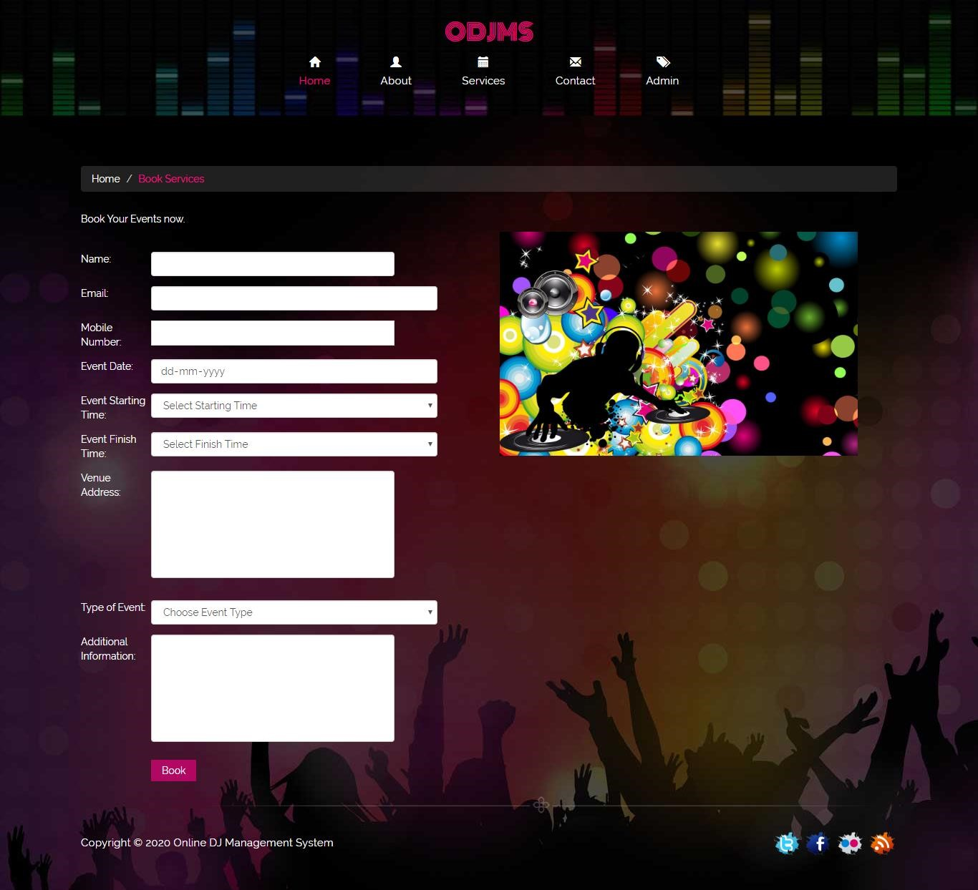

3.5 SAMPLE SOURCE CODE
Index:

<!DOCTYPE html>
<html>
<head>
<title>Online DJ Management System||Home Page</title>
<link href="css/bootstrap.css" rel='stylesheet' type='text/css' />
<!-- jQuery (Bootstrap's JavaScript plugins) -->
<script src="js/jquery.min.js"></script>
<script type="application/x-javascript"> addEventListener("load", function() { setTimeout(hideURLbar, 0); }, false); function hideURLbar(){ window.scrollTo(0,1); } </script>
<!-- Custom Theme files -->
<link href="css/style.css" rel="stylesheet" type="text/css" media="all" />

<link href='http://fonts.googleapis.com/css?family=Monoton' rel='stylesheet' type='text/css'> <link href='http://fonts.googleapis.com/css?family=Raleway' rel='stylesheet' type='text/css'> </head>
<body>
<!---->
<?php include_once('includes/header.php');?> <!---->
<script src="js/responsiveslides.min.js"></script> <script>
// You can also use "$(window).load(function() {"
$(function () {
$("#slider").responsiveSlides({ auto: true,
manualControls: '#slider3-pager',
});
});
</script>
<div class="content">
<div class="container">
<div class="slider">
<!-- Slideshow 3 -->
<ul class="rslides" id="slider">
<li><img src="images/7.jpg" alt="">
<div class="caption">
<h1>Image1</h1>
<p>Nam est purus, egestas eu varius in, commodo vitae massa. Fusce mollis a lacus in tincidunt.</p>
</div>
</li>
<li><img src="images/2.jpg" alt="">
<div class="caption">
<h1>Image2</h1>
<p>Nam est purus, egestas eu varius in, commodo vitae massa. Fusce mollis a lacus in tincidunt.</p>
</div>
</li>
<li><img src="images/10.jpg" alt="">
<div class="caption">
<h1>Image3</h1>
<p>Nam est purus, egestas eu varius in, commodo vitae massa. Fusce mollis a lacus in tincidunt.</p>
</div>
</li>
<li><img src="images/5.jpg" alt="">
<div class="caption">
<h1>Image1</h1>
<p>Nam est purus, egestas eu varius in, commodo vitae massa. Fusce mollis a lacus in tincidunt.</p>
</div>
</li>
<li><img src="images/8.jpg" alt="">
<div class="caption">
<h1>Image2</h1>
<p>Nam est purus, egestas eu varius in, commodo vitae massa. Fusce mollis a lacus in tincidunt.</p>
</div>
</li>
<li><img src="images/1.jpg" alt="">
<div class="caption">
<h1>Image3</h1>
<p>Nam est purus, egestas eu varius in, commodo vitae massa. Fusce mollis a lacus in tincidunt.</p>
</div>
</li>
<li><img src="images/13.jpg" alt="">
<div class="caption">
<h1>Image2</h1>
<p>Nam est purus, egestas eu varius in, commodo vitae massa. Fusce mollis a lacus in tincidunt.</p>
</div>
</li>
<li><img src="images/3.jpg" alt="">
<div class="caption">
<h1>Image3</h1>
<p>Nam est purus, egestas eu varius in, commodo vitae massa. Fusce mollis a lacus in tincidunt.</p>
</div>
</li>
</ul>
<!-- Slideshow 3 Pager --></br></br>
<ul id="slider3-pager">
<li><a href="#"><img src="images/77.jpg" alt=""></a></li>
<li><a href="#"><img src="images/22.jpg" alt=""></a></li>
<li><a href="#"><img src="images/1010.jpg" alt=""></a></li>
<li><a href="#"><img src="images/55.jpg" alt=""></a></li>
<li><a href="#"><img src="images/88.jpg" alt=""></a></li>
<li><a href="#"><img src="images/11.jpg" alt=""></a></li>
<li><a href="#"><img src="images/1313.jpg" alt=""></a></li>
<li><a href="#"><img src="images/33.jpg" alt=""></a></li>
</ul>
<div class="clearfix"></div>
</div>
</div>
<?php include_once('includes/footer.php');?>
</div>
<!---->

<!---->
</body> </html>
Header:
<div class="header">
<div class="container">
<div class="logo">
<a href="index.php"><h1>ODJMS</h1></a>
</div>
<div class="top-menu">
<ul>
<li class="active"><a href="index.php"><span class="glyphicon glyphicon-home" ariahidden="true"></span>Home</a></li>
<li><a href="about.php"><span class="glyphicon glyphicon-user" ariahidden="true"></span>About</a></li>
<li><a href="services.php"><span class="glyphicon glyphicon-calendar" ariahidden="true"></span>Services</a></li>
<li><a href="contact.php"><span class="glyphicon glyphicon-envelope" ariahidden="true"></span>Contact</a></li>
<li><a href="admin/login.php"><span class="glyphicon glyphicon-tags" ariahidden="true"></span>Admin</a></li>
</ul>
</div>
<div class="clearfix"></div>
</div>
</div>
Footer:
<div class="footer">
<div class="container">
<div class="strp">
<img src="images/ftr.png" alt=""/>
</div>
<div class="copywrite">
<p>Copyright © 2020 Online DJ Management System </p>
</div>
<div class="social-icons">
<a href="#"><i class="twitter"></i></a>
<a href="#"><i class="facebook"></i></a>
<a href="#"><i class="flicker"></i></a>
<a href="#"><i class="wifi"></i></a>
</div>
<div class="clearfix"></div>
</div>
</div>
Book service: <?php
session_start(); error_reporting(0);
include('includes/dbconnection.php');

if(isset($_POST['submit']))
{
$bid=$_GET['bookid'];

$name=$_POST['name'];
$mobnum=$_POST['mobnum'];
$email=$_POST['email'];
$edate=$_POST['edate'];
$est=$_POST['est'];
$eetime=$_POST['eetime'];
$vaddress=$_POST['vaddress'];
$eventtype=$_POST['eventtype'];
$addinfo=$_POST['addinfo'];
$bookingid=mt_rand(100000000, 999999999);
$sql="insert into tblbooking(BookingID,ServiceID,Name,MobileNumber,Email,EventDate,EventStartingtime,EventEndingti me,VenueAddress,EventType,AdditionalInformation)values(:bookingid,:bid,:name,:mobnum,:email,:edate,:
est,:eetime,:vaddress,:eventtype,:addinfo)";
$query=$dbh->prepare($sql);
$query->bindParam(':bookingid',$bookingid,PDO::PARAM_STR);
$query->bindParam(':bid',$bid,PDO::PARAM_STR);
$query->bindParam(':name',$name,PDO::PARAM_STR);
$query->bindParam(':mobnum',$mobnum,PDO::PARAM_STR);
$query->bindParam(':email',$email,PDO::PARAM_STR);
$query->bindParam(':edate',$edate,PDO::PARAM_STR);
$query->bindParam(':est',$est,PDO::PARAM_STR);
$query->bindParam(':eetime',$eetime,PDO::PARAM_STR);
$query->bindParam(':vaddress',$vaddress,PDO::PARAM_STR);
$query->bindParam(':eventtype',$eventtype,PDO::PARAM_STR);
$query->bindParam(':addinfo',$addinfo,PDO::PARAM_STR);

$query->execute();
$LastInsertId=$dbh->lastInsertId(); if ($LastInsertId>0) {
echo '<script>alert("Your Booking Request Has Been Send. We Will Contact You Soon")</script>'; echo "<script>window.location.href ='services.php'</script>";
} else
{
echo '<script>alert("Something Went Wrong. Please try again")</script>';
}

}

?>
<!DOCTYPE html>
<html>
<head>
<title>Online DJ Management System || Contact Us</title>
<link href="css/bootstrap.css" rel='stylesheet' type='text/css' />
<!-- Custom Theme files -->
<link href="css/style.css" rel="stylesheet" type="text/css" media="all" />
<link rel="stylesheet" href="css/touchTouch.css" type="text/css" media="all" />
<!-- Custom Theme files -->
<script src="js/jquery.min.js"></script>

<script type="application/x-javascript"> addEventListener("load", function() { setTimeout(hideURLbar, 0); }, false); function hideURLbar(){ window.scrollTo(0,1); } </script>
<!--webfont-->
<link href='http://fonts.googleapis.com/css?family=Monoton' rel='stylesheet' type='text/css'>
<link href='http://fonts.googleapis.com/css?family=Raleway' rel='stylesheet' type='text/css'> <!---//End-css-style-switecher----->
<script type="text/javascript" src="js/jquery.fancybox.js"></script>
<link rel="stylesheet" type="text/css" href="css/jquery.fancybox.css" media="screen" /> <script type="text/javascript">
$(document).ready(function() {
/*
* Simple image gallery. Uses default settings
*/

$('.fancybox').fancybox();

});
</script>

</head>
<body>
<?php include_once('includes/header.php');?>
<div class="contact content">
<div class="container">
<ol class="breadcrumb">
<li><a href="index.php">Home</a></li>
<li class="active">Book Services</li>
</ol>

<div class="contact-grids">
<div class="col-md-6 contact-left">
<p>Book Your Events now. </p>
<form method="post">

<ul>
<li class="text-info">Name: </li> <li><input type="text" class="form-control" name="name" required="true"></li>
</ul>

<ul>
<li class="text-info">Email: </li>
<li><input type="email" class="form-control" name="email" required="true"></li>
</ul>
<ul>
<ul>
<li class="text-info">Mobile Number: </li> <li><input type="text" class="text" name="mobnum" required="true" maxlength="10" pattern="[0-9]+"></li>
 |  |  |  | </ul>
 |  |  |  | <li class="text-info">Event Date: </li>
name="edate" required="true"></li> |  |  |  | <li><input type="date" class="form-control"
 |  |  |  | </ul>
 |  |  |  | <ul>
 |  |  |  |  | <li class="text-info">Event Starting Time:</li>
name="est" required="true"> |  |  |  |  | <li><select type="text" class="form-control"
Time</option> |  |  |  |  |  | <option value="">Select Starting
 |  |  |  |  |  | <option value="1 a.m">1 a.m</option>
 |  |  |  |  |  | <option value="2 a.m">2 a.m</option>
 |  |  |  |  |  | <option value="3 a.m">3 a.m</option>
 |  |  |  |  |  | <option value="4 a.m">4 a.m</option>
 |  |  |  |  |  | <option value="5 a.m">5 a.m</option>
 |  |  |  |  |  | <option value="6 a.m">6 a.m</option>
 |  |  |  |  |  | <option value="7 a.m">7 a.m</option>
 |  |  |  |  |  | <option value="8 a.m">8 a.m"</option>
 |  |  |  |  |  | <option value="9 a.m">9 a.m</option>
 |  |  |  |  |  | <option value="10 a.m">10 a.m</option>
 |  |  |  |  |  | <option value="11 a.m">11 a.m</option>
 |  |  |  |  |  | <option value="12 p.m">12 a.m</option>
 |  |  |  |  |  | <option value="1 p.m">1 p.m</option>
 |  |  |  |  |  | <option value="2 p.m">2 p.m</option>
 |  |  |  |  |  | <option value="3 p.m">3 p.m</option>
 |  |  |  |  |  | <option value="4 p.m">4 p.m</option>
 |  |  |  |  |  | <option value="5 p.m">5 p.m</option>
 |  |  |  |  |  | <option value="6 p.m">6 p.m</option>
 |  |  |  |  |  | <option value="7 p.m">7 p.m</option>
 |  |  |  |  |  | <option value="8 p.m">8 p.m</option>
 |  |  |  |  |  | <option value="9 p.m">9 p.m</option>
 |  |  |  |  |  | <option value="10 p.m">10 p.m</option>
 |  |  |  |  |  | <option value="10 p.m">10 p.m</option>
 |  |  |  |  |  | <option value="12 a.m">12 a.m</option>
 |  |  |  |  | </select></li>
 |  |  |  | </ul>
 |  |  |  | <ul>
 |  |  |  | <li class="text-info">Event Finish Time:</li>
 |  |  |  | <li><select type="text" class="form-control"
name="eetime" required="true">
 |  |  |  | <option value="">Select Finish Time</option> <option value="1 a.m">1 a.m</option>
<option value="2 a.m">2 a.m</option>
<option value="3 a.m">3 a.m</option>
<option value="4 a.m">4 a.m</option>
<option value="5 a.m">5 a.m</option>
<option value="6 a.m">6 a.m</option>
<option value="7 a.m">7 a.m</option>
<option value="8 a.m">8 a.m"</option>
<option value="9 a.m">9 a.m</option>
<option value="10 a.m">10 a.m</option>
<option value="11 a.m">11 a.m</option>
<option value="12 p.m">12 a.m</option>
<option value="1 p.m">1 p.m</option>
<option value="2 p.m">2 p.m</option>
<option value="3 p.m">3 p.m</option>
<option value="4 p.m">4 p.m</option>
<option value="5 p.m">5 p.m</option>
<option value="6 p.m">6 p.m</option>
<option value="7 p.m">7 p.m</option>
<option value="8 p.m">8 p.m</option>
<option value="9 p.m">9 p.m</option>
<option value="10 p.m">10 p.m</option>
<option value="10 p.m">10 p.m</option>
<option value="12 a.m">12 a.m</option>
</select></li>
</ul>
<ul>
<li class="text-info">Venue Address:</li> <li><textarea type="text" class="form-control" name="vaddress" required="true" ></textarea></li>
</ul>
<ul>
<li class="text-info">Type of Event:</li> <li><select type="text" class="form-control" name="eventtype" required="true" >
<option value="">Choose Event Type</option>
<?php

$sql2 = "SELECT * from tbleventtype ";
$query2 = $dbh -> prepare($sql2);
$query2->execute();
$result2=$query2->fetchAll(PDO::FETCH_OBJ);

foreach($result2 as $row)
{
?>
<option value="<?php echo htmlentities($row->EventType);?>"><?php echo htmlentities($row>EventType);?></option>
<?php } ?>
</select></li>
</ul>
<ul>
<li class="text-info">Additional Information:</li>
<li><textarea type="text" class="form-control"
name="addinfo" required="true"></textarea></li>
</ul>
<input type="submit" name="submit" value="Book">

</form>
</div>
<div class="col-md-6 contact-right">
<div class="contact-map">
<img src="images/431427.jpg" class="img-responsive" height="900" width="500" alt=""/>
</div>
</div>
<div class="clearfix"></div>
</div>
</div>
<?php include_once('includes/footer.php');?>
</div>
</div>
<!---->

<!---->
</body> </html>
Contact: <?php
session_start(); error_reporting(0);
include('includes/dbconnection.php');

if(isset($_POST['submit']))
{
$name=$_POST['name'];
$mobnum=$_POST['mobnum'];
$email=$_POST['email'];
$msg=$_POST['message'];
$sql="insert into tbluser(Name,MobileNumber,Email,Message)values(:name,:mobnum,:email,:msg)"; $query=$dbh->prepare($sql);
$query->bindParam(':name',$name,PDO::PARAM_STR);
$query->bindParam(':mobnum',$mobnum,PDO::PARAM_STR);
$query->bindParam(':email',$email,PDO::PARAM_STR);
$query->bindParam(':msg',$msg,PDO::PARAM_STR);
$query->execute();
$LastInsertId=$dbh->lastInsertId(); if ($LastInsertId>0) {
echo '<script>alert("Your Message Has Been Send. We Will Contact You Soon")</script>'; echo "<script>window.location.href ='contact.php'</script>";
} else
{
echo '<script>alert("Something Went Wrong. Please try again")</script>';
}
}

?>
<!DOCTYPE html>
<html>
<head>
<title>Online DJ Management System || Contact Us</title>
<link href="css/bootstrap.css" rel='stylesheet' type='text/css' />
<!-- Custom Theme files -->
<link href="css/style.css" rel="stylesheet" type="text/css" media="all" />
<link rel="stylesheet" href="css/touchTouch.css" type="text/css" media="all" />
<!-- Custom Theme files -->
<script src="js/jquery.min.js"></script>

<script type="application/x-javascript"> addEventListener("load", function() { setTimeout(hideURLbar, 0); }, false); function hideURLbar(){ window.scrollTo(0,1); } </script>
<!--webfont-->
<link href='http://fonts.googleapis.com/css?family=Monoton' rel='stylesheet' type='text/css'>
<link href='http://fonts.googleapis.com/css?family=Raleway' rel='stylesheet' type='text/css'> <!---//End-css-style-switecher----->
<script type="text/javascript" src="js/jquery.fancybox.js"></script>
<link rel="stylesheet" type="text/css" href="css/jquery.fancybox.css" media="screen" /> <script type="text/javascript">
$(document).ready(function() {
/*
* Simple image gallery. Uses default settings
*/

$('.fancybox').fancybox();

});
</script>

</head>
<body>
<?php include_once('includes/header.php');?>
<div class="contact content">
<div class="container">
<ol class="breadcrumb">
<li><a href="index.php">Home</a></li>
<li class="active">Contact</li>
</ol>
<?php
$sql="SELECT * from tblpage where PageType='contactus'";
$query = $dbh -> prepare($sql);
$query->execute();
$results=$query->fetchAll(PDO::FETCH_OBJ);

$cnt=1;
if($query->rowCount() > 0) {
foreach($results as $row)
{ ?>
<h2><?php echo htmlentities($row->PageTitle);?></h2>
<div class="contact-main">
<h4 style="color: white"><span class="glyphicon glyphicon-home" ariahidden="true"> <?php echo htmlentities($row->PageDescription);?></h4>
<br>
<h4 style="color: white"><span class="glyphicon glyphicon-envelope" ariahidden="true"> <?php echo htmlentities($row->Email);?></h4>
<br>
<h4 style="color: white"><span class="glyphicon glyphicon-phone"
aria-hidden="true"> <?php echo htmlentities($row->MobileNumber);?></h4>
<?php $cnt=$cnt+1;}} ?>

<div class="contact-grids">
 | <div class="col-md-6 contact-left">
 |  | <p>or drop a message we wiil reply you soon, </p>
 |  | <form method="post">
 |  |  | <ul>
 |  |  | <li class="text-info">Name: </li>
required="true" ></li> |  |  | <li><input type="text" class="text" name="name"
 |  |  | </ul>
 |  |  | <ul>
 |  |  | <li class="text-info">Email: </li>
required="true"></li> |  |  | <li><input type="text" class="text" name="email"
 |  |  | </ul>
 |  |  | <ul>
 |  |  | <li class="text-info">Mobile Number: </li>
 |  |  | <li><input type="text" class="text" name="mobnum"
required="true" maxlength="10" pattern="[0-9]+"></li>
</ul>
<ul>
<li class="text-info">Message:</li>
<li><textarea value="Write here" name="message" required="true"></textarea></li>
</ul>
<input type="submit" name="submit" value="Submit">

</form>
</div>
<div class="col-md-6 contact-right">
<div class="contact-map">
<iframe
src="https://www.google.com/maps/embed?pb=!1m18!1m12!1m3!1d1578265.0941403757!2d-
98.9828708842255!3d39.41170802696131!2m3!1f0!2f0!3f0!3m2!1i1024!2i768!4f13.1!3m3!1m2!1s0x54e ab584e432360b%3A0x1c3bb99243deb742!2sUnited+States!5e0!3m2!1sen!2sin!4v1407515822047"> </iframe>
</div>
</div>
<div class="clearfix"></div>
</div>
</div>
<?php include_once('includes/footer.php');?>
</div>
</div>
<!---->

<!---->
</body> </html>
Service: <?php
session_start();
error_reporting(0);

include('includes/dbconnection.php');
?>
<!DOCTYPE html>
<html>
<head>
<title>Online DJ Management System || DJ Services</title>
<link href="css/bootstrap.css" rel='stylesheet' type='text/css' />
<link rel="stylesheet" href="css/touchTouch.css" type="text/css" media="all" />
<!-- Custom Theme files -->
<link href="css/style.css" rel="stylesheet" type="text/css" media="all" />
<!-- Custom Theme files -->
<script src="js/jquery.min.js"></script>

<script type="application/x-javascript"> addEventListener("load", function() { setTimeout(hideURLbar, 0); }, false); function hideURLbar(){ window.scrollTo(0,1); } </script>
<!--webfont-->
<link href='http://fonts.googleapis.com/css?family=Monoton' rel='stylesheet' type='text/css'>
<link href='http://fonts.googleapis.com/css?family=Raleway:400,900,800,700,600,500,300,100,200' rel='stylesheet' type='text/css'>
<script type="text/javascript" src="js/jquery.fancybox.js"></script>
<link rel="stylesheet" type="text/css" href="css/jquery.fancybox.css" media="screen" /> <script type="text/javascript">
$(document).ready(function() {
/*
* Simple image gallery. Uses default settings
*/

$('.fancybox').fancybox();

});
</script>

</head>
<body>
<?php include_once('includes/header.php');?>
<div class="event content">
<div class="container">
<ol class="breadcrumb">
<li><a href="index.php">Home</a></li>
<li class="active">Services</li>
</ol>
<h2>Services</h2>
<div class="event-main">
<?php
$sql="SELECT * from tblservice";
$query = $dbh -> prepare($sql);
$query->execute();
$results=$query->fetchAll(PDO::FETCH_OBJ);

$cnt=1;
if($query->rowCount() > 0)
{
foreach($results as $row)
{ ?>
<div class="event-grids">
 |  | <div class="col-md-3 event-grid">
 |  | <ul>
>ServiceName);?></li> |  | <li class="hedding"><?php echo htmlentities($row-
 |  | </ul>
 |  | <div class="clearfix"> </div>
 |  | </div>
 |  | <div class="col-md-4 event-grid small-text">
 |  | <p><?php echo htmlentities($row->SerDes);?></p>
 |  | </div>
 |  | <div class="col-md-2 event-grid large-text">
 |  | <p class="text">$ <?php echo htmlentities($row-
>ServicePrice);?> USD</p>
 |  | </div>
 |  | <div class="col-md-3 event-grid text-button">
 |  | <ul>
 |  | <li class="button yellow"><a href="book-
services.php?bookid=<?php echo $row->ID;?>">Book Services</a></li>
</ul>
</div>
<div class="clearfix"> </div>
</div>
<?php $cnt=$cnt+1;}} ?>

</div>

<?php include_once('includes/footer.php');?>
</div>
</div>
<!---->

<!---->
</body> </html> Login: <?php
session_start(); error_reporting(0);
include('includes/dbconnection.php');

if(isset($_POST['login']))
{
$username=$_POST['username'];
$password=md5($_POST['password']);
$sql ="SELECT ID FROM tbladmin WHERE UserName=:username and Password=:password"; $query=$dbh->prepare($sql);
$query-> bindParam(':username', $username, PDO::PARAM_STR);
$query-> bindParam(':password', $password, PDO::PARAM_STR);
$query-> execute();
$results=$query->fetchAll(PDO::FETCH_OBJ);
if($query->rowCount() > 0)
{
foreach ($results as $result) {
$_SESSION['odmsaid']=$result->ID;
}

if(!empty($_POST["remember"])) {
//COOKIES for username
setcookie ("user_login",$_POST["username"],time()+ (10 * 365 * 24 * 60 * 60));
//COOKIES for password
setcookie ("userpassword",$_POST["password"],time()+ (10 * 365 * 24 * 60 * 60));
} else {
if(isset($_COOKIE["user_login"])) { setcookie ("user_login",""); if(isset($_COOKIE["userpassword"])) { setcookie ("userpassword","");
}
}
}
$_SESSION['login']=$_POST['username'];
echo "<script type='text/javascript'> document.location ='dashboard.php'; </script>";
} else{
echo "<script>alert('Invalid Details');</script>";
}
}

?>
<!doctype html>
<html lang="en" class="no-focus"> <!--<![endif]-->
<head>
<title>Onlind DJ Management System - Login Page</title>
<link rel="stylesheet" id="css-main" href="assets/css/codebase.min.css"> </head>
<body>

<div id="page-container" class="main-content-boxed">
<!-- Main Container -->
<main id="main-container">
<!-- Page Content -->
<div class="bg-image" style="background-image: url('assets/img/photos/photo34@2x.jpg');"> <div class="row mx-0 bg-black-op">
<div class="hero-static col-md-6 col-xl-8 d-none d-md-flex align-items-md-end">
<div class="p-30 invisible" data-toggle="appear"> <p class="font-size-h3 font-w600 text-white"> Online DJ Management System.
</p>
<p class="font-italic text-white-op">
Copyright &copy; <span class="js-year-copy">2020</span>
</p>
</div> </div>
<div class="hero-static col-md-6 col-xl-4 d-flex align-items-center bg-white invisible" datatoggle="appear" data-class="animated fadeInRight">
<div class="content content-full">
<!-- Header -->
<div class="px-30 py-10">
<a class="link-effect font-w700" href="login.php">
<i class="si si-fire"></i>
<span class="font-size-xl">ODMS</span>
</a>
<h1 class="h3 font-w700 mt-30 mb-10">Welcome to Your Dashboard</h1>
<h2 class="h5 font-w400 text-muted mb-0">Please sign in</h2>
</div>

<form class="js-validation-signin px-30" method="post">
<div class="form-group row">
<div class="col-12">
<div class="form-material floating">
<input type="text" class="form-control" required="true" name="username"
value="<?php if(isset($_COOKIE["user_login"])) { echo $_COOKIE["user_login"]; } ?>">
<label for="login-username">Username</label>
</div>
</div>
</div>
<div class="form-group row">
<div class="col-12">
<div class="form-material floating">
<input type="password" class="form-control" name="password"
required="true" value="<?php if(isset($_COOKIE["userpassword"])) { echo $_COOKIE["userpassword"]; } ?>">
<label for="login-password">Password</label> </div>
</div>
</div>
<div class="form-group row">
<div class="checkbox checkbox-primary">
<input type="checkbox" id="remember" name="remember" <?php if(isset($_COOKIE["user_login"])) { ?> checked <?php } ?> /> <label for="keep_me_logged_in">Keep me signed in</label>
</div>
</div>
<div class="form-group">
<button type="submit" class="btn btn-sm btn-hero btn-alt-primary" name="login">
<i class="si si-login mr-10"></i> Sign In
</button>
<div class="mt-30">

<a class="link-effect text-muted mr-10 mb-5 d-inline-block" href="forgotpassword.php">
<i class="fa fa-warning mr-5"></i> Forgot Password
</a>
<a href="../index.php">Back Home!!</a>
</div>
</div>
</form>
<!-- END Sign In Form -->
</div>
</div>
</div>
</div>
<!-- END Page Content -->
</main>
<!-- END Main Container -->
</div>
<!-- END Page Container -->

<!-- Codebase Core JS -->
<script src="assets/js/core/jquery.min.js"></script>
<script src="assets/js/core/popper.min.js"></script>
<script src="assets/js/core/bootstrap.min.js"></script>
<script src="assets/js/core/jquery.slimscroll.min.js"></script>
<script src="assets/js/core/jquery.scrollLock.min.js"></script>
<script src="assets/js/core/jquery.appear.min.js"></script>
<script src="assets/js/core/jquery.countTo.min.js"></script>
<script src="assets/js/core/js.cookie.min.js"></script>
<script src="assets/js/codebase.js"></script>

<!-- Page JS Plugins -->
<script src="assets/js/plugins/jquery-validation/jquery.validate.min.js"></script>

<!-- Page JS Code -->
<script src="assets/js/pages/op_auth_signin.js"></script>
</body>
</html>
Dashboard:
<!doctype html>
<html lang="en" class="no-focus"> <!--<![endif]-->
<head>
<title>Online DJ Management System - Admin Dashboard</title>
<link rel="stylesheet" id="css-main" href="assets/css/codebase.min.css"> </head>
<body>
<div id="page-container" class="sidebar-o sidebar-inverse side-scroll page-header-fixed main-contentnarrow">

<?php include_once('includes/sidebar.php');?>

<?php include_once('includes/header.php');?>

<!-- Main Container -->
<main id="main-container">
<!-- Page Content -->
<div class="content">
<div class="row gutters-tiny invisible" data-toggle="appear"> <!-- Row #1 -->
<div class="col-6 col-md-4 col-xl-3">
<a class="block text-center" href="unread-queries.php">
<div class="block-content ribbon ribbon-bookmark ribbon-crystal ribbon-left bg-gddusk">
<?php
$sql ="SELECT ID from tbluser where IsRead is null ";
$query = $dbh -> prepare($sql);
$query->execute();
$results=$query->fetchAll(PDO::FETCH_OBJ);
$totalunreadquery=$query->rowCount();
?>
<div class="ribbon-box"><?php echo htmlentities($totalunreadquery);?></div> <p class="mt-5">
<i class="si si-book-open fa-3x text-white-op"></i>
</p>
<p class="font-w600 text-white">Total Unread Queries</p>
</div>
</a>
</div>
<div class="col-6 col-md-4 col-xl-3">
<a class="block text-center" href="read-queries.php">
<div class="block-content ribbon ribbon-bookmark ribbon-crystal ribbon-left bg-gddusk">
<?php
$sql ="SELECT ID from tbluser where IsRead='1'";
$query = $dbh -> prepare($sql);
$query->execute();
$results=$query->fetchAll(PDO::FETCH_OBJ);
$totalreadquery=$query->rowCount(); ?>
<div class="ribbon-box"><?php echo htmlentities($totalreadquery);?></div> <p class="mt-5">
<i class="si si-paper-plane fa-3x text-white-op"></i> </p>
<p class="font-w600 text-white">Total Read Queries</p>
</div>
</a>
</div>
<div class="col-6 col-md-4 col-xl-3">
<a class="block text-center" href="new-booking.php">
<div class="block-content ribbon ribbon-bookmark ribbon-crystal ribbon-left bg-gdsea">
<?php
$sql ="SELECT ID from tblbooking where Status is null ";
$query = $dbh -> prepare($sql);
$query->execute();
$results=$query->fetchAll(PDO::FETCH_OBJ);
$totalnewbooking=$query->rowCount();
?>
<div class="ribbon-box"><?php echo htmlentities($totalnewbooking);?></div> <p class="mt-5">
<i class="si si-pencil fa-3x text-white-op"></i> </p>
<p class="font-w600 text-white">Total New Booking</p>
</div>
</a>
</div>
<div class="col-6 col-md-4 col-xl-3">
<a class="block text-center" href="approved-booking.php">
<div class="block-content ribbon ribbon-bookmark ribbon-crystal ribbon-left bg-gdsea">
<?php
$sql ="SELECT ID from tblbooking where Status='Approved' ";
$query = $dbh -> prepare($sql);
$query->execute();
$results=$query->fetchAll(PDO::FETCH_OBJ);
$totalappbooking=$query->rowCount();
?>
<div class="ribbon-box"><?php echo htmlentities($totalappbooking);?></div> <p class="mt-5">
<i class="si si-target fa-3x text-white-op"></i> </p>
<p class="font-w600 text-white">Total Approved Booking</p>
</div>
</a>
</div>

<!-- END Row #1 -->
</div>

</div>
<div class="content">
<div class="row gutters-tiny invisible" data-toggle="appear">
<!-- Row #1 -->
<div class="col-6 col-md-4 col-xl-4">
<a class="block text-center" href="cancelled-booking.php">
<div class="block-content ribbon ribbon-bookmark ribbon-crystal ribbon-left bg-gddusk">
<?php
$sql ="SELECT ID from tblbooking where Status='Cancelled' ";
$query = $dbh -> prepare($sql);
$query->execute();
$results=$query->fetchAll(PDO::FETCH_OBJ);
$totalcanbooking=$query->rowCount();
?>
<div class="ribbon-box"><?php echo htmlentities($totalcanbooking);?></div> <p class="mt-5">
<i class="si si-support fa-3x text-white-op"></i> </p>
<p class="font-w600 text-white">Total Cancelled Booking</p>
</div>
</a>
</div>
<div class="col-6 col-md-4 col-xl-4">
<a class="block text-center" href="manage-services.php">
<div class="block-content ribbon ribbon-bookmark ribbon-crystal ribbon-left bg-gddusk">
<?php
$sql ="SELECT ID from tblservice";
$query = $dbh -> prepare($sql);
$query->execute();
$results=$query->fetchAll(PDO::FETCH_OBJ);
$totalserv=$query->rowCount();
?>
<div class="ribbon-box"><?php echo htmlentities($totalserv);?></div> <p class="mt-5">
<i class="si si-wallet fa-3x text-white-op"></i> </p>
<p class="font-w600 text-white">Total Services</p>
</div>
</a>
</div>
<div class="col-6 col-md-4 col-xl-4">
<a class="block text-center" href="manage-event-type.php">
<div class="block-content ribbon ribbon-bookmark ribbon-crystal ribbon-left bg-gdsea">
<?php
$sql ="SELECT ID from tbleventtype";
$query = $dbh -> prepare($sql);
$query->execute();
$results=$query->fetchAll(PDO::FETCH_OBJ);
$totaleventtype=$query->rowCount(); ?>
<div class="ribbon-box"><?php echo htmlentities($totaleventtype);?></div> <p class="mt-5">
<i class="si si-bubbles fa-3x text-white-op"></i> </p>
<p class="font-w600 text-white">Total Event Type</p>
</div>
</a>
</div>

<!-- END Row #1 -->
</div>

</div>
<!-- END Page Content -->
</main>
<!-- END Main Container -->

<?php include_once('includes/footer.php');?>
</div>
<!-- END Page Container -->

<!-- Codebase Core JS -->
<script src="assets/js/core/jquery.min.js"></script>
<script src="assets/js/core/popper.min.js"></script>
<script src="assets/js/core/bootstrap.min.js"></script>
<script src="assets/js/core/jquery.slimscroll.min.js"></script>
<script src="assets/js/core/jquery.scrollLock.min.js"></script>
<script src="assets/js/core/jquery.appear.min.js"></script>
<script src="assets/js/core/jquery.countTo.min.js"></script>
<script src="assets/js/core/js.cookie.min.js"></script>
<script src="assets/js/codebase.js"></script>

<!-- Page JS Plugins -->
<script src="assets/js/plugins/chartjs/Chart.bundle.min.js"></script>

<!-- Page JS Code -->
<script src="assets/js/pages/be_pages_dashboard.js"></script>
</body>
</html>
View user: <?php
session_start(); error_reporting(0); include('includes/dbconnection.php'); if (strlen($_SESSION['odmsaid']==0)) {
header('location:logout.php');
} else{

?>
<!doctype html>
<html lang="en" class="no-focus"> <!--<![endif]-->
<head>
<title>Onlind DJ Management System - Search User Queries</title>

<link rel="stylesheet" href="assets/js/plugins/datatables/dataTables.bootstrap4.min.css">

<link rel="stylesheet" id="css-main" href="assets/css/codebase.min.css">

</head>
<body>

<div id="page-container" class="sidebar-o sidebar-inverse side-scroll page-header-fixed main-contentnarrow">

<?php include_once('includes/sidebar.php');?>

<?php include_once('includes/header.php');?>

<!-- Main Container -->
<main id="main-container">
<!-- Page Content -->
<div class="content">
<h2 class="content-heading">Search User Queries</h2>

<!-- Dynamic Table Full Pagination -->
<div class="block">
<div class="block-header block-header-default">
<h3 class="block-title">Search User Queries</h3>
</div>
<div class="block-content block-content-full">
<!-- DataTables init on table by adding .js-dataTable-full-pagination class, functionality initialized in js/pages/be_tables_datatables.js -->
<form id="basic-form" method="post">
<div class="form-group">
<label>Search by Name/Mobile No.</label>
<input id="searchdata" type="text" name="searchdata" required="true" class="formcontrol" placeholder="Name/Mobile No."></div>

<br>
<button type="submit" class="btn btn-primary" name="search" id="submit">Search</button>
</form>
<?php
if(isset($_POST['search']))
{

$sdata=$_POST['searchdata'];
?>
<h4 align="center">Result against "<?php echo $sdata;?>" keyword </h4>
<table class="table table-bordered table-striped table-vcenter js-dataTable-fullpagination">
<thead>
<tr>
<th class="text-center"></th>

<th class="d-none d-sm-table-cell">Name</th>
<th class="d-none d-sm-table-cell">Mobile Number</th>
<th class="d-none d-sm-table-cell">Email</th>
<th class="d-none d-sm-table-cell">Send Message Date</th>
<th class="d-none d-sm-table-cell" style="width: 15%;">Action</th>
</tr>
</thead>
<tbody>
<?php
$sql="SELECT * from tbluser where Name like '$sdata%' || MobileNumber like '$sdata%'"; $query = $dbh -> prepare($sql);
$query->execute();
$results=$query->fetchAll(PDO::FETCH_OBJ);

$cnt=1;
if($query->rowCount() > 0)
{
foreach($results as $row)
{ ?>
<tr>
<td class="text-center"><?php echo htmlentities($cnt);?></td>
<td class="font-w600"><?php echo htmlentities($row->Name);?></td>
<td class="font-w600"><?php echo htmlentities($row->MobileNumber);?></td> <td class="font-w600"><?php echo htmlentities($row->Email);?></td> <td class="font-w600">
<span class="badge badge-primary"><?php echo htmlentities($row>MsgDate);?></span>
</td>

<td class="d-none d-sm-table-cell"><a href="view-userqueries.php?viewid=<?php echo htmlentities ($row->ID);?>"><i class="fa fa-eye" ariahidden="true"></i></a></td>
</tr>

</tbody>
<?php
$cnt=$cnt+1;
} } else { ?>
<tr>
<td colspan="8"> No record found against this search</td>

</tr>
<?php } }?>
</table>
</div>
</div>
<!-- END Dynamic Table Full Pagination -->

<!-- END Dynamic Table Simple -->
</div>
<!-- END Page Content -->
</main>
<!-- END Main Container -->

<?php include_once('includes/footer.php');?>
</div>
<!-- END Page Container -->

<!-- Codebase Core JS -->
<script src="assets/js/core/jquery.min.js"></script>
<script src="assets/js/core/popper.min.js"></script>
<script src="assets/js/core/bootstrap.min.js"></script>
<script src="assets/js/core/jquery.slimscroll.min.js"></script>
<script src="assets/js/core/jquery.scrollLock.min.js"></script>
<script src="assets/js/core/jquery.appear.min.js"></script>
<script src="assets/js/core/jquery.countTo.min.js"></script>
<script src="assets/js/core/js.cookie.min.js"></script>
<script src="assets/js/codebase.js"></script>

<!-- Page JS Plugins -->
<script src="assets/js/plugins/datatables/jquery.dataTables.min.js"></script>
<script src="assets/js/plugins/datatables/dataTables.bootstrap4.min.js"></script>

<!-- Page JS Code -->
<script src="assets/js/pages/be_tables_datatables.js"></script> </body> </html>
<?php } ?>
New booking: <?php
session_start(); error_reporting(0); include('includes/dbconnection.php'); if (strlen($_SESSION['odmsaid']==0)) { header('location:logout.php');
} else{

?>
<!doctype html>
<html lang="en" class="no-focus"> <!--<![endif]--> <head>
<title>Onlind DJ Management System - New Booking</title>

<link rel="stylesheet" href="assets/js/plugins/datatables/dataTables.bootstrap4.min.css">

<link rel="stylesheet" id="css-main" href="assets/css/codebase.min.css">

</head>
<body>

<div id="page-container" class="sidebar-o sidebar-inverse side-scroll page-header-fixed main-contentnarrow">

<?php include_once('includes/sidebar.php');?>

<?php include_once('includes/header.php');?>

<!-- Main Container -->
<main id="main-container">
<!-- Page Content -->
<div class="content">
<h2 class="content-heading">New Booking</h2>

<!-- Dynamic Table Full Pagination -->
<div class="block">
<div class="block-header block-header-default">
<h3 class="block-title">New Booking</h3>
</div>
<div class="block-content block-content-full">
<!-- DataTables init on table by adding .js-dataTable-full-pagination class, functionality initialized in js/pages/be_tables_datatables.js -->
<table class="table table-bordered table-striped table-vcenter js-dataTable-fullpagination">
<thead>
<tr>
<th class="text-center"></th>
<th>Booking ID</th>
<th class="d-none d-sm-table-cell">Cutomer Name</th>
<th class="d-none d-sm-table-cell">Mobile Number</th>
<th class="d-none d-sm-table-cell">Email</th>
<th class="d-none d-sm-table-cell">Booking Date</th>
<th class="d-none d-sm-table-cell">Status</th>
<th class="d-none d-sm-table-cell" style="width: 15%;">Action</th>
</tr>
</thead>
<tbody>
<?php
$sql="SELECT * from tblbooking where Status is null";
$query = $dbh -> prepare($sql);
$query->execute();
$results=$query->fetchAll(PDO::FETCH_OBJ);

$cnt=1;
if($query->rowCount() > 0)
{
foreach($results as $row)
{ ?>
<tr>
<td class="text-center"><?php echo htmlentities($cnt);?></td>
<td class="font-w600"><?php echo htmlentities($row->BookingID);?></td>
<td class="font-w600"><?php echo htmlentities($row->Name);?></td>
<td class="font-w600"><?php echo htmlentities($row->MobileNumber);?></td> <td class="font-w600"><?php echo htmlentities($row->Email);?></td> <td class="font-w600">
<span class="badge badge-primary"><?php echo htmlentities($row>BookingDate);?></span>
</td>
<?php if($row->Status==""){ ?>

<td class="font-w600"><?php echo "Not Updated Yet"; ?></td> <?php } else { ?>
<td class="d-none d-sm-table-cell">
<span class="badge badge-primary"><?php echo htmlentities($row>Status);?></span>
</td>
<?php } ?>
<td class="d-none d-sm-table-cell"><a href="view-booking-
detail.php?editid=<?php echo htmlentities ($row->ID);?>&&bookingid=<?php echo htmlentities ($row>BookingID);?>"><i class="fa fa-eye" aria-hidden="true"></i></a></td>
</tr>
<?php $cnt=$cnt+1;}} ?>

</tbody>
</table>
</div>
</div>
<!-- END Dynamic Table Full Pagination -->

<!-- END Dynamic Table Simple -->
</div>
<!-- END Page Content -->
</main>
<!-- END Main Container -->

<?php include_once('includes/footer.php');?>
</div>
<!-- END Page Container -->

<!-- Codebase Core JS -->
<script src="assets/js/core/jquery.min.js"></script>
<script src="assets/js/core/popper.min.js"></script>
<script src="assets/js/core/bootstrap.min.js"></script>
<script src="assets/js/core/jquery.slimscroll.min.js"></script>
<script src="assets/js/core/jquery.scrollLock.min.js"></script>
<script src="assets/js/core/jquery.appear.min.js"></script>
<script src="assets/js/core/jquery.countTo.min.js"></script>
<script src="assets/js/core/js.cookie.min.js"></script>
<script src="assets/js/codebase.js"></script>

<!-- Page JS Plugins -->
<script src="assets/js/plugins/datatables/jquery.dataTables.min.js"></script>
<script src="assets/js/plugins/datatables/dataTables.bootstrap4.min.js"></script>

<!-- Page JS Code -->
<script src="assets/js/pages/be_tables_datatables.js"></script>
</body>
</html>
<?php } ?>
View booking details:
<?php
session_start(); error_reporting(0); include('includes/dbconnection.php'); if (strlen($_SESSION['odmsaid']==0)) { header('location:logout.php');
} else{
if(isset($_POST['submit']))
{

$eid=$_GET['editid'];
$bookingid=$_GET['bookingid'];
$status=$_POST['status'];
$remark=$_POST['remark'];

$sql= "update tblbooking set Status=:status,Remark=:remark where ID=:eid";
$query=$dbh->prepare($sql);
$query->bindParam(':status',$status,PDO::PARAM_STR);
$query->bindParam(':remark',$remark,PDO::PARAM_STR);
$query->bindParam(':eid',$eid,PDO::PARAM_STR);

$query->execute();

echo '<script>alert("Remark has been updated")</script>'; echo "<script>window.location.href ='new-booking.php'</script>"; }

?>
<!doctype html>
<html lang="en" class="no-focus"> <!--<![endif]--> <head>
<title>Onlind DJ Management System - View Booking</title>
<link rel="stylesheet" id="css-main" href="assets/css/codebase.min.css">

</head>
<body>
<div id="page-container" class="sidebar-o sidebar-inverse side-scroll page-header-fixed main-contentnarrow">

<?php include_once('includes/sidebar.php');?>

<?php include_once('includes/header.php');?>

<!-- Main Container -->
<main id="main-container">
<!-- Page Content -->
<div class="content">

<!-- Register Forms -->
<h2 class="content-heading">View Booking</h2>
<div class="row">
<div class="col-md-12">
<!-- Bootstrap Register -->
<div class="block block-themed">
<div class="block-header bg-gd-emerald">
<h3 class="block-title">View Booking</h3>
<div class="block-options">
<button type="button" class="btn-block-option" data-toggle="block-option" dataaction="state_toggle" data-action-mode="demo">
<i class="si si-refresh"></i>
</button>
<button type="button" class="btn-block-option" data-toggle="block-option" dataaction="content_toggle"></button>
</div>
</div>
<div class="block-content">

<?php
$eid=$_GET['editid'];

$sql="SELECT
tblbooking.BookingID,tblbooking.Name,tblbooking.MobileNumber,tblbooking.Email,tblbooking.EventDat e,tblbooking.EventStartingtime,tblbooking.EventEndingtime,tblbooking.VenueAddress,tblbooking.EventTy pe,tblbooking.AdditionalInformation,tblbooking.BookingDate,tblbooking.Remark,tblbooking.Status,tblboo king.UpdationDate,tblservice.ServiceName,tblservice.SerDes,tblservice.ServicePrice from tblbooking join tblservice on tblbooking.ServiceID=tblservice.ID where tblbooking.ID=:eid";
$query = $dbh -> prepare($sql);
$query-> bindParam(':eid', $eid, PDO::PARAM_STR);
$query->execute();
$results=$query->fetchAll(PDO::FETCH_OBJ);

$cnt=1;
if($query->rowCount() > 0)
{
foreach($results as $row)
{ ?>
<table border="1" class="table table-bordered table-striped table-vcenter js-dataTable-fullpagination">
<tr>
<th>Booking Number</th>
<td><?php echo $row->BookingID;?></td>
<th>Client Name</th>
<td><?php echo $row->Name;?></td>
</tr>

<tr>
<th>Mobile Number</th>
<td><?php echo $row->MobileNumber;?></td>
<th>Email</th>
<td><?php echo $row->Email;?></td>
</tr>
<tr>

<th>Event Date</th>
<td><?php echo $row->EventDate;?></td>
<th>Event Starting Time</th>
<td><?php echo $row->EventStartingtime;?></td> </tr>
<tr>

<th>Event Ending Time</th>
<td><?php echo $row->EventEndingtime;?></td>
<th>Venue Address</th>
<td><?php echo $row->VenueAddress;?></td>
</tr>
<tr>

<th>Event Type</th>
<td><?php echo $row->EventType;?></td>
<th>AdditionalInformation</th>
<td><?php echo $row->AdditionalInformation;?></td> </tr>
<tr>

<th>Service Name</th>
<td><?php echo $row->ServiceName;?></td>
<th>Service Description</th>
<td><?php echo $row->SerDes;?></td>
</tr>
<tr>
<th>Service Price</th>
<td>$<?php echo $row->ServicePrice;?></td>
<th>Apply Date</th>
<td><?php echo $row->BookingDate;?></td>
</tr>

<tr>

<th>Order Final Status</th>

<td> <?php $status=$row->Status;

if($row->Status=="Approved")
{
echo "Your Booking has been approved";
}

if($row->Status=="Cancelled")
{
echo "Your Booking has been cancelled";
}

if($row->Status=="")
{
echo "Not Response Yet";
}

;?></td>
<th >Admin Remark</th>
<?php if($row->Status==""){ ?>

<td><?php echo "Not Updated Yet"; ?></td>
<?php } else { ?> <td><?php echo htmlentities($row->Status);?>
</td>
<?php } ?>
</tr>

<?php $cnt=$cnt+1;}} ?>

</table>
<?php

if ($status==""){
?>
<p align="center" style="padding-top: 20px">
<button class="btn btn-primary waves-effect waves-light w-lg" data-toggle="modal" datatarget="#myModal">Take Action</button></p>

<?php } ?>
<div class="modal fade" id="myModal" tabindex="-1" role="dialog" arialabelledby="exampleModalLabel" aria-hidden="true">
<div class="modal-dialog" role="document">
<div class="modal-content"> <div class="modal-header">
<h5 class="modal-title" id="exampleModalLabel">Take Action</h5>
<button type="button" class="close" data-dismiss="modal" arialabel="Close">
<span aria-hidden="true">&times;</span>
</button>
</div>
<div class="modal-body">
<table class="table table-bordered table-hover data-tables">

<form method="post" name="submit">

<tr>
<th>Remark :</th>
<td>
<textarea name="remark" placeholder="Remark" rows="12" cols="14" class="form-control wd-450" required="true"></textarea></td>
</tr>

<tr>
<th>Status :</th>
<td>

<select name="status" class="form-control wd-450" required="true" >
<option value="Approved" selected="true">Approved</option>
<option value="Cancelled">Cancelled</option>
</select></td>
</tr>
</table>
</div>
<div class="modal-footer">
<button type="button" class="btn btn-secondary" data-dismiss="modal">Close</button>
<button type="submit" name="submit" class="btn btn-primary">Update</button>

</form>

</div>
</div>
<!-- END Bootstrap Register -->
</div>

</div>
</div>
<!-- END Page Content -->
</main>
<!-- END Main Container -->

<?php include_once('includes/footer.php');?>
</div>
<!-- END Page Container -->

<!-- Codebase Core JS -->
<script src="assets/js/core/jquery.min.js"></script>
<script src="assets/js/core/popper.min.js"></script>
<script src="assets/js/core/bootstrap.min.js"></script>
<script src="assets/js/core/jquery.slimscroll.min.js"></script>
<script src="assets/js/core/jquery.scrollLock.min.js"></script>
<script src="assets/js/core/jquery.appear.min.js"></script>
<script src="assets/js/core/jquery.countTo.min.js"></script>
<script src="assets/js/core/js.cookie.min.js"></script>
<script src="assets/js/codebase.js"></script>
</body>
</html>
<?php } ?>
Manage service: <?php
session_start(); error_reporting(0); include('includes/dbconnection.php'); if (strlen($_SESSION['odmsaid']==0)) {
header('location:logout.php');
} else{

// Code for deleting product from cart if(isset($_GET['delid']))
{
$rid=intval($_GET['delid']);
$sql="delete from tblservice where ID=:rid";
$query=$dbh->prepare($sql);
$query->bindParam(':rid',$rid,PDO::PARAM_STR);
$query->execute();
echo "<script>alert('Data deleted');</script>"; echo "<script>window.location.href = 'manage-services.php'</script>";

}

?>
<!doctype html>
<html lang="en" class="no-focus"> <!--<![endif]-->
<head>
<title>Onlind DJ Management System - Manage Services</title>

<link rel="stylesheet" href="assets/js/plugins/datatables/dataTables.bootstrap4.min.css">

<link rel="stylesheet" id="css-main" href="assets/css/codebase.min.css">

</head>
<body>

<div id="page-container" class="sidebar-o sidebar-inverse side-scroll page-header-fixed main-contentnarrow">

<?php include_once('includes/sidebar.php');?>

<?php include_once('includes/header.php');?>

<!-- Main Container -->
<main id="main-container">
<!-- Page Content -->
<div class="content">
<h2 class="content-heading">Manage Services</h2>

<!-- Dynamic Table Full Pagination -->
<div class="block">
<div class="block-header block-header-default">
<h3 class="block-title">Manage Services</h3>
</div>
<div class="block-content block-content-full">
<!-- DataTables init on table by adding .js-dataTable-full-pagination class, functionality initialized in js/pages/be_tables_datatables.js -->
<table class="table table-bordered table-striped table-vcenter js-dataTable-fullpagination">
<thead>
<tr>
<th class="text-center"></th>
<th>Service Name</th>
<th class="d-none d-sm-table-cell">Service Price</th>
<th class="d-none d-sm-table-cell">Creation Date</th>
<th class="d-none d-sm-table-cell" style="width: 15%;">Action</th>
</tr> </thead>
<tbody>
<?php
$sql="SELECT * from tblservice";
$query = $dbh -> prepare($sql);
$query->execute();
$results=$query->fetchAll(PDO::FETCH_OBJ);

$cnt=1;
if($query->rowCount() > 0)
{
foreach($results as $row)
{ ?>
<tr>
<td class="text-center"><?php echo htmlentities($cnt);?></td>
<td class="font-w600"><?php echo htmlentities($row->ServiceName);?></td> <td class="d-none d-sm-table-cell">$<?php echo htmlentities($row>ServicePrice);?></td>
<td class="d-none d-sm-table-cell">
<span class="badge badge-primary"><?php echo htmlentities($row>CreationDate);?></span>
</td>
<td class="d-none d-sm-table-cell"><a href="manage-services.php?delid=<?php echo ($row->ID);?>" onclick="return confirm('Do you really want to Delete ?');"><i class="fa fa-trash fadelete" aria-hidden="true"></i></a></td>
</tr>
<?php $cnt=$cnt+1;}} ?>

</tbody>
</table>
</div>
</div>
<!-- END Dynamic Table Full Pagination -->

<!-- END Dynamic Table Simple -->
</div>
<!-- END Page Content -->
</main>
<!-- END Main Container -->

<?php include_once('includes/footer.php');?>
</div>
<!-- END Page Container -->

<!-- Codebase Core JS -->
<script src="assets/js/core/jquery.min.js"></script>
<script src="assets/js/core/popper.min.js"></script>
<script src="assets/js/core/bootstrap.min.js"></script>
<script src="assets/js/core/jquery.slimscroll.min.js"></script>
<script src="assets/js/core/jquery.scrollLock.min.js"></script> <script src="assets/js/core/jquery.appear.min.js"></script>
<script src="assets/js/core/jquery.countTo.min.js"></script>
<script src="assets/js/core/js.cookie.min.js"></script> <script src="assets/js/codebase.js"></script>

<!-- Page JS Plugins -->
<script src="assets/js/plugins/datatables/jquery.dataTables.min.js"></script>
<script src="assets/js/plugins/datatables/dataTables.bootstrap4.min.js"></script>

<!-- Page JS Code -->
<script src="assets/js/pages/be_tables_datatables.js"></script> </body>
</html>
<?php } ?> Invoice:
<?php
session_start(); error_reporting(0); include('includes/dbconnection.php'); if (strlen($_SESSION['odmsaid']==0)) {
header('location:logout.php');
} else{

?>
<!doctype html>
<html lang="en" class="no-focus"> <!--<![endif]-->
<head>
<title>Onlind DJ Management System - View Invoice</title>
<link rel="stylesheet" id="css-main" href="assets/css/codebase.min.css">
<script language="javascript" type="text/javascript"> function f2()
{
window.close();
}
function f3()
{
window.print();
}
</script>
</head>
<body>
<div id="page-container" class="sidebar-o sidebar-inverse side-scroll page-header-fixed main-contentnarrow">

<?php include_once('includes/sidebar.php');?>

<?php include_once('includes/header.php');?>

<!-- Main Container -->
<main id="main-container">
<!-- Page Content -->
<div class="content">

<!-- Register Forms -->
<h2 class="content-heading">View Invoice</h2>
<div class="row">
<div class="col-md-12">
<!-- Bootstrap Register -->
<div class="block block-themed">
<div class="block-header bg-gd-emerald">
<h3 class="block-title">View Invoice</h3>
<div class="block-options">
<button type="button" class="btn-block-option" data-toggle="block-option" dataaction="state_toggle" data-action-mode="demo">
<i class="si si-refresh"></i> </button>
<button type="button" class="btn-block-option" data-toggle="block-option" dataaction="content_toggle"></button>
</div>
</div>
<div class="block-content">

<?php
$invid=$_GET['invid'];

$sql="SELECT
tblbooking.BookingID,tblbooking.Name,tblbooking.MobileNumber,tblbooking.Email,tblbooking.EventDat e,tblbooking.EventStartingtime,tblbooking.EventEndingtime,tblbooking.VenueAddress,tblbooking.EventTy pe,tblbooking.AdditionalInformation,tblbooking.BookingDate,tblbooking.Remark,tblbooking.Status,tblboo king.UpdationDate,tblservice.ServiceName,tblservice.SerDes,tblservice.ServicePrice from tblbooking join tblservice on tblbooking.ServiceID=tblservice.ID where tblbooking.ID=:invid";
$query = $dbh -> prepare($sql);
$query-> bindParam(':invid', $invid, PDO::PARAM_STR);
$query->execute();
$results=$query->fetchAll(PDO::FETCH_OBJ);

$cnt=1;
if($query->rowCount() > 0)
{
foreach($results as $row)
{ ?>
<table border="1" class="table table-bordered table-striped table-vcenter js-dataTable-fullpagination">
<tr>
<th colspan="5" style="text-align: center;color: red;font-size: 20px">Booking Number: <?php echo $row->BookingID;?></th>
</tr>

<tr>
<th>Name of Client</th>
<td><?php echo $row->Name;?></td>
<th>Mobile Number</th>
<td><?php echo $row->MobileNumber;?></td>
</tr>
<tr>
<th>Email</th>
<td><?php echo $row->Email;?></td>
<th>Event Date</th>
<td><?php echo $row->EventDate;?></td>
</tr>

<tr>
<th style="text-align: center;" colspan="2">Service Name</th>
<th style="text-align: center;" colspan="2">Service Price</th> </tr>
<tr>
<td style="text-align: center;" colspan="2"><?php echo $row->ServiceName;?></td>
<td style="text-align: center;" colspan="2"><?php echo $total= $row->ServicePrice;?></td>

</tr>
<?php
$grandtotal+=$total;
$cnt=$cnt+1;} ?>
<tr>
<th colspan="2" style="text-align:center;color: blue">Grand Total </th>
<td colspan="2" style="text-align: center;"><?php echo $grandtotal;?></td> </tr>

<?php $cnt=$cnt+1;} ?>

</table>
<p >
<input name="Submit2" type="submit" class="txtbox4" value="Close" onClick="return f2();" style="cursor: pointer;" /> <input name="Submit2" type="submit" class="txtbox4" value="Print" onClick="return f3();" style="cursor: pointer;" /></p>

</div>
</div>
<!-- END Bootstrap Register -->
</div>

</div>
</div>
<!-- END Page Content -->
</main>
<!-- END Main Container -->

<?php include_once('includes/footer.php');?>
</div>
<!-- END Page Container -->

<!-- Codebase Core JS -->
<script src="assets/js/core/jquery.min.js"></script>
<script src="assets/js/core/popper.min.js"></script>
<script src="assets/js/core/bootstrap.min.js"></script>
<script src="assets/js/core/jquery.slimscroll.min.js"></script>
<script src="assets/js/core/jquery.scrollLock.min.js"></script>
<script src="assets/js/core/jquery.appear.min.js"></script>
<script src="assets/js/core/jquery.countTo.min.js"></script>
<script src="assets/js/core/js.cookie.min.js"></script>
<script src="assets/js/codebase.js"></script>
</body>
</html> <?php } ?> Cancelled: <?php
session_start();
error_reporting(0); include('includes/dbconnection.php'); if (strlen($_SESSION['odmsaid']==0)) {
header('location:logout.php');
} else{

?>
<!doctype html>
<html lang="en" class="no-focus"> <!--<![endif]-->
<head>
<title>Online DJ Management System - Cancelled Booking</title>

<link rel="stylesheet" href="assets/js/plugins/datatables/dataTables.bootstrap4.min.css">

<link rel="stylesheet" id="css-main" href="assets/css/codebase.min.css">

</head>
<body>

<div id="page-container" class="sidebar-o sidebar-inverse side-scroll page-header-fixed main-contentnarrow">

<?php include_once('includes/sidebar.php');?>

<?php include_once('includes/header.php');?>

<!-- Main Container -->
<main id="main-container">
<!-- Page Content -->
<div class="content">
<h2 class="content-heading">Cancelled Booking</h2>

<!-- Dynamic Table Full Pagination -->
<div class="block">
<div class="block-header block-header-default">
<h3 class="block-title">Cancelled Booking</h3>
</div>
<div class="block-content block-content-full">
<!-- DataTables init on table by adding .js-dataTable-full-pagination class, functionality initialized in js/pages/be_tables_datatables.js -->
<table class="table table-bordered table-striped table-vcenter js-dataTable-fullpagination">
<thead>
<tr>
<th class="text-center"></th>
<th>Booking ID</th>
<th class="d-none d-sm-table-cell">Cutomer Name</th>
<th class="d-none d-sm-table-cell">Mobile Number</th>
<th class="d-none d-sm-table-cell">Email</th>
<th class="d-none d-sm-table-cell">Booking Date</th>
<th class="d-none d-sm-table-cell">Status</th>
<th class="d-none d-sm-table-cell" style="width: 15%;">Action</th>
</tr>
</thead>
<tbody>
<?php
$sql="SELECT * from tblbooking where Status='Cancelled'";
$query = $dbh -> prepare($sql);
$query->execute();
$results=$query->fetchAll(PDO::FETCH_OBJ);

$cnt=1;
if($query->rowCount() > 0)
{
foreach($results as $row)
{ ?>
<tr>
<td class="text-center"><?php echo htmlentities($cnt);?></td>
<td class="font-w600"><?php echo htmlentities($row->BookingID);?></td>
<td class="font-w600"><?php echo htmlentities($row->Name);?></td>
<td class="font-w600"><?php echo htmlentities($row->MobileNumber);?></td> <td class="font-w600"><?php echo htmlentities($row->Email);?></td> <td class="font-w600">
<span class="badge badge-primary"><?php echo htmlentities($row>BookingDate);?></span>
</td>
<?php if($row->Status==""){ ?>

<td class="font-w600"><?php echo "Not Updated Yet"; ?></td> <?php } else { ?>
<td class="d-none d-sm-table-cell">
<span class="badge badge-primary"><?php echo htmlentities($row>Status);?></span>
</td>
<?php } ?>
<td class="d-none d-sm-table-cell"><a href="view-booking-
detail.php?editid=<?php echo htmlentities ($row->ID);?>&&bookingid=<?php echo htmlentities ($row>BookingID);?>"><i class="fa fa-eye" aria-hidden="true"></i></a></td>
</tr>
<?php $cnt=$cnt+1;}} ?>

</tbody>
</table>
</div>
</div>
<!-- END Dynamic Table Full Pagination -->

<!-- END Dynamic Table Simple -->
</div>
<!-- END Page Content -->
</main>
<!-- END Main Container -->

<?php include_once('includes/footer.php');?>
</div>
<!-- END Page Container -->

<!-- Codebase Core JS -->
<script src="assets/js/core/jquery.min.js"></script>
<script src="assets/js/core/popper.min.js"></script>
<script src="assets/js/core/bootstrap.min.js"></script>
<script src="assets/js/core/jquery.slimscroll.min.js"></script>
<script src="assets/js/core/jquery.scrollLock.min.js"></script>
<script src="assets/js/core/jquery.appear.min.js"></script>
<script src="assets/js/core/jquery.countTo.min.js"></script>
<script src="assets/js/core/js.cookie.min.js"></script> <script src="assets/js/codebase.js"></script>

<!-- Page JS Plugins -->
<script src="assets/js/plugins/datatables/jquery.dataTables.min.js"></script>
<script src="assets/js/plugins/datatables/dataTables.bootstrap4.min.js"></script>

<!-- Page JS Code -->
<script src="assets/js/pages/be_tables_datatables.js"></script> </body>
</html>
<?php } ?> About : <?php
session_start();
error_reporting(0);

include('includes/dbconnection.php');
?>
<!DOCTYPE html>
<html>
<head>
<title>Online DJ Management System || About Us</title>
<link href="css/bootstrap.css" rel='stylesheet' type='text/css' />
<!-- Custom Theme files -->
<link href="css/style.css" rel="stylesheet" type="text/css" media="all" />
<link rel="stylesheet" href="css/touchTouch.css" type="text/css" media="all" />
<!-- Custom Theme files -->
<script src="js/jquery.min.js"></script>
<script type="application/x-javascript"> addEventListener("load", function() { setTimeout(hideURLbar, 0); }, false); function hideURLbar(){ window.scrollTo(0,1); } </script>
<!--webfont-->
<link href='http://fonts.googleapis.com/css?family=Monoton' rel='stylesheet' type='text/css'>
<link href='http://fonts.googleapis.com/css?family=Raleway' rel='stylesheet' type='text/css'> <!---//End-css-style-switecher----->
<script type="text/javascript" src="js/jquery.fancybox.js"></script>
<link rel="stylesheet" type="text/css" href="css/jquery.fancybox.css" media="screen" />
<script type="text/javascript">
$(document).ready(function() {
/*
* Simple image gallery. Uses default settings
*/

$('.fancybox').fancybox();

});
</script>

</head>
<body>
<!---->
<?php include_once('includes/header.php');?>
<div class="about content">
<div class="container">
<ol class="breadcrumb">
<li><a href="index.php">Home</a></li>
<li class="active">About</li>
</ol>
<?php
$sql="SELECT * from tblpage where PageType='aboutus'";
$query = $dbh -> prepare($sql);
$query->execute();
$results=$query->fetchAll(PDO::FETCH_OBJ);

$cnt=1;
if($query->rowCount() > 0)
{
foreach($results as $row)
{ ?>
<h2><?php echo htmlentities($row->PageTitle);?></h2>
<div class="about-main">
<div class="col-md-6 abt-pic">
<img src="images/abt.jpg" class="img-responsive" alt=""/>
</div>
<div class="col-md-6 abt-pic-info">

<p style="color:#fff"><?php echo $row->PageDescription;?>.</p>

</div>
<?php $cnt=$cnt+1;}} ?>
<div class="clearfix"></div>
</div>

<div class="latest">
<h3>LATEST PHOTOS</h3>
<div class="pic start">
<a class="fancybox" href="images/4.jpg" data-fancybox-group="gallery"
title="Lorem ipsum dolor sit amet"><img src="images/4.jpg" class="img-style row6" alt=""><span> </span></a>
<h4><a href="event.html">Aenean rutrum</a></h4>
<p>Suspendisse posuere enim eu ante scelerisque, vehicula turpis.</p>
</div>
<div class="pic">
<a class="fancybox" href="images/5.jpg" data-fancybox-group="gallery"
title="Lorem ipsum dolor sit amet"><img src="images/5.jpg" class="img-style row6" alt=""><span> </span></a>
<h4><a href="event.html">Aenean rutrum</a></h4>
<p>Suspendisse posuere enim eu ante scelerisque, vehicula turpis.</p>
</div>
<div class="pic">
<a class="fancybox" href="images/6.jpg" data-fancybox-group="gallery"
title="Lorem ipsum dolor sit amet"><img src="images/6.jpg" class="img-style row6" alt=""><span> </span></a>
<h4><a href="event.html">Aenean rutrum</a></h4>
<p>Suspendisse posuere enim eu ante scelerisque, vehicula turpis.</p>
</div>
<div class="pic">
<a class="fancybox" href="images/7.jpg" data-fancybox-group="gallery"
title="Lorem ipsum dolor sit amet"><img src="images/7.jpg" class="img-style row6" alt=""><span> </span></a>
<h4><a href="event.html">Aenean rutrum</a></h4>
<p>Suspendisse posuere enim eu ante scelerisque, vehicula turpis.</p>
</div>
<div class="pic">
<a class="fancybox" href="images/8.jpg" data-fancybox-group="gallery"
title="Lorem ipsum dolor sit amet"><img src="images/8.jpg" class="img-style row6" alt=""><span> </span></a>
<h4><a href="event.html">Aenean rutrum</a></h4>
<p>Suspendisse posuere enim eu ante scelerisque, vehicula turpis.</p>
</div>
<div class="clearfix"></div>
</div>
<?php include_once('includes/footer.php');?>
</div>
</div>
<!---->

<!---->
</body>
</html>
Add event type: <?php
session_start(); error_reporting(0); include('includes/dbconnection.php'); if (strlen($_SESSION['odmsaid']==0)) {
header('location:logout.php');
} else{
if(isset($_POST['submit']))
{

$etype=$_POST['eventtype'];
$serprice=$_POST['serprice'];

$sql="insert into tbleventtype(EventType)values(:etype)";
$query=$dbh->prepare($sql);
$query->bindParam(':etype',$etype,PDO::PARAM_STR);

$query->execute();

$LastInsertId=$dbh->lastInsertId(); if ($LastInsertId>0) { echo '<script>alert("Event Type has been added.")</script>'; echo "<script>window.location.href ='add-event-type.php'</script>";
} else
{
echo '<script>alert("Something Went Wrong. Please try again")</script>';
}

}

?>
<!doctype html>
<html lang="en" class="no-focus"> <!--<![endif]-->
<head>
<title>Onlind DJ Management System - Add Event Type</title>
<link rel="stylesheet" id="css-main" href="assets/css/codebase.min.css">

</head>
<body>
<div id="page-container" class="sidebar-o sidebar-inverse side-scroll page-header-fixed main-contentnarrow">

<?php include_once('includes/sidebar.php');?>

<?php include_once('includes/header.php');?>

<!-- Main Container -->
<main id="main-container">
<!-- Page Content -->
<div class="content">

<!-- Register Forms -->
<h2 class="content-heading">Add Event Type</h2> <div class="row">
<div class="col-md-12">
<!-- Bootstrap Register -->
<div class="block block-themed">
<div class="block-header bg-gd-emerald">
<h3 class="block-title">Add Event Type</h3>
<div class="block-options">
<button type="button" class="btn-block-option" data-toggle="block-option" dataaction="state_toggle" data-action-mode="demo">
<i class="si si-refresh"></i>
</button>
<button type="button" class="btn-block-option" data-toggle="block-option" dataaction="content_toggle"></button>
</div>
</div>
<div class="block-content">

<form method="post">

<div class="form-group row">
<label class="col-12" for="register1-email">Event Type:</label> <div class="col-12">
<input type="text" class="form-control" name="eventtype" value="" required='true'>
</div>
</div>

<div class="form-group row">
<div class="col-12">
<button type="submit" class="btn btn-alt-success" name="submit">
<i class="fa fa-plus mr-5"></i> Add
</button>
</div>
</div>
</form>
</div>
</div>
<!-- END Bootstrap Register -->
</div>

</div>
</div>
<!-- END Page Content -->
</main>
<!-- END Main Container -->

<?php include_once('includes/footer.php');?>
</div>
<!-- END Page Container -->

<!-- Codebase Core JS -->
<script src="assets/js/core/jquery.min.js"></script>
<script src="assets/js/core/popper.min.js"></script>
<script src="assets/js/core/bootstrap.min.js"></script>
<script src="assets/js/core/jquery.slimscroll.min.js"></script>
<script src="assets/js/core/jquery.scrollLock.min.js"></script>
<script src="assets/js/core/jquery.appear.min.js"></script>
<script src="assets/js/core/jquery.countTo.min.js"></script>
<script src="assets/js/core/js.cookie.min.js"></script>
<script src="assets/js/codebase.js"></script>
</body>
</html>
<?php } ?>

CHAPTER 4
SYSTEM TESTING

INTRODUCTION
The purpose of testing is to discover errors. Testing is the process of trying to discover every conceivable fault or weakness in a work product. It provides a way to check the functionalities of components, sub assemblies, and/or a finished product it is the process of exercising software with the intent of ensuring that the software system meets its requirements and user expectations and does not fail in an unacceptable manner. There are various types of tests. Each test type addresses a specific testing requirement.

TYPES OF TESTING 4.1 UNIT TESTING

Unit testing focuses verification effort on the smallest unit of software design, the module. The unit testing, we have is white box oriented and some modules the steps are conducted in parallel.

4.2 INTEGRATION TESTING

Testing is done for each module. After testing all the modules, the modules are integrated
and testing of the final system is done with the test data, specially designed to show that the system will operate successfully in all its aspects conditions. Thus the system testing is a confirmation that all is correct and an opportunity to show the user that the system works. The purpose of integration verify functional, performance and reliability requirements placed on major design
items. These "design items", i.e. assemblages (or groups of units), are exercised through their interfaces using black box testing, success and error cases being simulated v parameter and data inputs. Simulated usage of shared data areas and intertested and individual subsystems are exercised through their input interface.
Test cases are constructed to test that all components within
for example across procedure calls or process activations, and this is done after testing individual

testing is to
ia appropriate process communication is

assemblages interact correctly,
modules, i.e. unit testing.

4.3 SYSTEM TESTING

System testing ensures that the entire integrated software system meets requirements. It tests a configuration to ensure known and predictable results. An example of system testing is the configuration oriented system integration test. System testing is based on process descriptions and flows, emphasizing pre-driven process links and integration points.

WHITE BOX TESTING

This type of testing ensures that
All independent paths have been exercised at least once
All logical decisions have been exercised on their true and false sides
All loops are executed at their boundaries and within their operational bounds All internal data structures have been exercised to assure their validity.

To follow the concept of white box testing we have tested each form .we have created independently to verify that Data flow is correct, All conditions are exercised to check their validity, All loops are executed on their boundaries.

4.4 BASIC PATH TESTING

Established technique of flow graph with Cyclometer complexity was used to derive test cases for all the functions. The main steps in deriving test cases were:

Use the design of the code and draw correspondent flow graph.

CONDITIONAL TESTING

In this part of the testing each of the conditions were tested to both true and false aspects. And all the resulting paths were tested. So that each path that may be generate on particular condition is traced to uncover any possible errors.

DATA FLOW TESTING

This type of testing selects the path of the program according to the location of definition and use of variables. This kind of testing was used only when some local variable were declared. The definition-use chain method was used in this type of testing. These were particularly useful in nested statements.

4.5 LOOP TESTING

In this type of testing all the loops are tested to all the limits possible. The following exercise was adopted for all loops: All the loops were tested at their limits, just above them and just below them. All the loops were skipped at least once. For nested loops test the inner most loop first and then work outwards. For concatenated loops the values of dependent loops were set with the help of connected loop. Unstructured loops were resolved into nested loops or concatenated loops and tested as above. Each unit has been separately tested by the development team itself and all the input have been validated.

CHAPTER 5 IMPLEMENTATION

INTRODUCTION:

Implementation is the stage of the project when the theoretical design is turned out into a working system. Thus, it can be considered to be the most critical stage in achieving a successful new system and in giving the user, confidence that the new system will work and be effective. The implementation stage involves careful planning, investigation of the existing system and its constraints on implementation, designing of methods to achieve changeover and evaluation of changeover methods.

TECHNOLOGIES USED

Programming Language

PHP

- PHP stands for PHP: Hypertext Preprocessor

- PHP is a server-side scripting language, like ASP
- PHP scripts are executed on the server
- PHP supports many databases (MYSQL, Informix, Oracle, Sybase, Solid, Generic ODBC, etc.)

- PHP is an open source software
- PHP is free to download and use

MYSQL

- MYSQL is a database server

- MYSQL is ideal for both small and large applications
- MYSQL supports standard SQL
- MYSQL compiles on a number of platforms
- MYSQL is free to download and use

CSS

- Cascading Style Sheets (CSS)
- Simple mechanism
- Easy for adding style (e.g., fonts, colors, spacing) to Web documents.

CHAPTER 6 CONCLUSION

The “Online DJ Management System” was successfully designed and is tested for accuracy

and quality. During this project we have accomplished all the objectives and this project

meets the needs of the organization. The developed will be used in searching, retrieving

and generating information for the concerned requests.

GOALS ACHIVIED
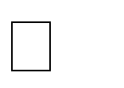






Reduced entry work
Easy retrieval of information
Reduced errors due to human intervention
User friendly screens to enter the data Portable and flexible for further enhancement Web enabled.
Fast finding of information request

REFERENCES

- www.w3schools.com
- php.net
- en.wikipedia.org/wiki/PHP
- www.hotscripts.com/category/php/
- www.apache.org
- www.mysql.com/click.php?e=35050

