Requirement Analysis and Deployment Approach for a GPU-Accelerated HPC Cluster on Microsoft Azure
GPU Infrastructure Engineering Group
Abstract
Deploying GPU-accelerated infrastructure for large-scale AI training and high-performance computing (HPC) requires a structured requirement-analysis process that jointly considers compute, power, cooling, networking, storage, physical facilities, and operational cost. This report documents an end-to-end approach for sizing and deploying a GPU cluster built on NVIDIA Hopper- and Ada Lovelace-class GPUs (H200, H100, A100, L40S, L4) using Microsoft Azure ND H100 v5 virtual machines, NVIDIA Quantum-2 InfiniBand in a non-blocking spine–leaf topology, and Azure Kubernetes Service (AKS) for workload orchestration. The methodology covers workload characterization and numerical-precision selection, FLOPs-based compute sizing, power and cooling strategy, network and storage architecture, deployment and validation procedures, monitoring practice, and total-cost-of-ownership (TCO) analysis. Worked sizing calculations are re-derived and cross-checked against published GPU specifications; two arithmetic inconsistencies present in the original planning material — an under-counted CUDA-core FLOPs formula and a unit error in a large-language-model training-compute estimate — are identified and corrected, with the corrected figures shown alongside the original assumptions for transparency.
Index Terms—GPU cluster, HPC, InfiniBand, NVLink, GPUDirect RDMA, NCCL, spine–leaf topology, Azure AKS, ND H100 v5, total cost of ownership.

I. Introduction
Graphics processing units (GPUs) have become the primary computational substrate for AI training, AI inference, and many classes of HPC workloads, owing to their large numbers of parallel execution units, high-bandwidth memory (HBM), and specialized Tensor Core arithmetic. Realizing this capability at cluster scale, however, requires deliberate planning across several interdependent layers: GPU and memory selection, power delivery and cooling, node-to-node and rack-to-rack networking, shared and archival storage, physical rack and data-center space, and cluster-management software.
This report presents a requirement-analysis methodology and reference deployment approach for a GPU-accelerated HPC cluster hosted on Microsoft Azure. The structure follows the order in which these decisions are typically made in practice: workload and precision assessment (Section II); hardware selection and sizing (Section III); power and cooling strategy (Section IV); networking architecture (Section V); storage planning (Section VI); physical space and rack configuration (Section VII); deployment and validation (Section VIII); monitoring and optimization (Section IX); and budget/TCO analysis (Section X). Detailed calculations, CLI/YAML deployment artifacts, and extended technical tables are provided in Appendices A–C, with a glossary of abbreviations at the end of the report.
II. Workload and Use Case Assessment
The first step in sizing GPU infrastructure is to characterize the target workloads — model complexity, batch size, data throughput, and whether the workload is AI training, AI inference, HPC simulation, or a mixed environment serving several of these concurrently. Each of these dimensions affects the required GPU memory capacity, memory bandwidth, interconnect bandwidth, and numerical precision, and therefore drives the hardware selection in Section III.
A. Numerical Precision Requirements
Modern GPU workloads are rarely run in a single fixed precision; the choice of floating-point format is itself a sizing parameter because it trades numerical accuracy against memory footprint, memory bandwidth, and achievable throughput.
FP16 (half precision) uses 16 bits — 1 sign bit, 5 exponent bits, and 10 mantissa bits. It offers reduced numeric range and precision but substantially lowers memory footprint and bandwidth demand, and is widely used for deep-learning inference and other memory-constrained scenarios.
FP32 (single precision) uses 32 bits — 1 sign bit, 8 exponent bits, and 23 mantissa bits — and provides a balanced mix of precision and efficiency. It remains the default numerical format for most general-purpose GPU computing, computer graphics, and many machine-learning frameworks.
FP64 (double precision) uses 64 bits — 1 sign bit, 11 exponent bits, and 52 mantissa bits — and delivers the highest available precision and dynamic range. It is required for scientific simulation, computational engineering, and financial modeling workloads where rounding error must be tightly controlled, at the cost of higher memory and compute demand.
In practice, FP16 (or BF16) is preferred where efficiency and memory savings dominate, FP32 remains the standard for general AI and graphics workloads, and FP64 is reserved for applications that demand the highest numerical accuracy. Mixed-precision training — computing in FP16/BF16 while accumulating in FP32 — is the common approach for large-scale LLM training on Tensor Core hardware.
III. Hardware Selection and Sizing
GPU selection is driven by the dominant workload identified in Section II. Table I summarizes five representative GPU classes spanning the NVIDIA Hopper and Ada Lovelace generations, together with their architecture, memory configuration, memory bandwidth, and representative FP64/FP16 throughput.

GPU | Architecture | Memory | Bandwidth | FP64 Perf. | FP16/BF16 Perf. | Ideal Use Cases
H200 | Hopper | 141 GB HBM3e | 4.8 TB/s | 67 TFLOPS | 1.5 PFLOPS (sparse) | LLM training, HPC, massive datasets
H100 | Hopper | 80 GB HBM2e/HBM3* | 2.0–2.04 TB/s | 48 TFLOPS | 1.6 PFLOPS (sparse) | AI training/inference, MIG flexibility
A100 | Ampere | 40/80 GB HBM2 | ~2.0 TB/s | 19.5 TFLOPS | 312 TFLOPS (dense, BF16) | Mixed workloads (AI + HPC)
L40S | Ada Lovelace | 48 GB GDDR6 | 864 GB/s | — | — | Video analytics, 3D rendering
L4 | Ada Lovelace | 24 GB GDDR6 | 300 GB/s | — | — | Edge AI, real-time inference
TABLE I. GPU HARDWARE COMPARISON (REPRESENTATIVE SPECIFICATIONS)
*The SXM variant of H100 uses 80 GB HBM3 at approximately 3.35 TB/s; the PCIe variant uses HBM2e at approximately 2.0 TB/s. The lower bandwidth figure applies to the PCIe form factor referenced for this deployment.
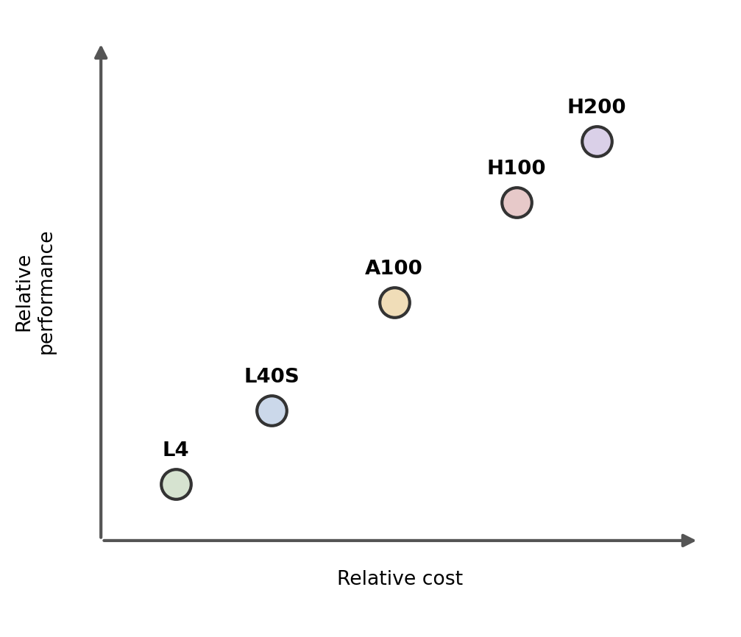
Fig. 6. Qualitative performance-versus-cost positioning of the evaluated GPU classes. Axes are relative, not absolute measurements.

A. Performance-Cost Trade-off
As Fig. 6 illustrates, the five GPU classes occupy a roughly monotonic performance-cost curve: H200 delivers the highest performance at the highest cost; H100 sits close behind H200 in capability at a still-premium price point and is the recommended default for large-scale LLM training given its market availability and mature software ecosystem; A100 offers a balanced mid-range option for mixed AI/HPC workloads; L40S targets rendering and video-analytics workloads rather than large-model training; and L4 minimizes cost for lightweight, latency-sensitive inference at the edge.
B. Compute Sizing Methodology
Cluster size is derived from the total floating-point operations (FLOPs) required by the target workload divided by the sustained FLOPs delivered per GPU, scaled by the number of GPUs per node and the intended wall-clock training time. The full derivation, including a corrected worked example for training a 175-billion-parameter language model, is provided in Appendix A. As a summary: for a representative 8-GPU A100 node type and a 30-day training window, the corrected analysis in Appendix A indicates on the order of several tens of nodes are required at full utilization — not the several-thousand-node figure obtained from an un-corrected unit error in the source planning estimate. Sizing must additionally account for realistic GPU utilization (typically 40–70% of theoretical peak in distributed training, per the cross-layer bottleneck considerations discussed in related work), which increases the practical node count proportionally.
C. Reference Server Configuration
The reference compute node for this deployment is the Azure ND H100 v5 virtual machine (Standard_ND96isr_H100_v5), configured with 8× NVIDIA H100 GPUs (80 GB HBM per GPU), 96 Intel Sapphire Rapids vCPUs, and approximately 1,900 GiB of system RAM. Each node provides NVLink 4.0 for intra-node GPU-to-GPU bandwidth and an aggregate of 3.2 Tb/s of NVIDIA Quantum-2 InfiniBand bandwidth (8× 400 Gb/s CX7 links, one per GPU) for inter-node scale-out. This VM family is intended for large language model training, generative-AI workloads, and tightly coupled HPC applications that rely on NCCL-based collective communication across nodes.
IV. Power and Cooling Strategy
GPU-dense nodes such as the ND H100 v5 draw substantially more power per rack unit than conventional CPU-only servers, and the power and cooling design must be sized accordingly rather than assumed from legacy rack profiles.
• Provision 208–240 V circuits with 30–60 A capacity per rack to support high-density GPU deployments, consistent with typical 30–40 kW rack power draws for 8-GPU H100/H200 nodes.
• For air-cooled deployments, maintain strict cold-aisle/hot-aisle containment with front-to-back airflow and blanking panels; most H100 configurations use passive heatsinks and depend on adequate facility airflow rather than onboard fans.
• Plan for liquid or immersion cooling where rack power density or facility airflow limits would otherwise cause thermal throttling; this is increasingly the default for H100/H200-class deployments rather than an exception.
• Include N+1 power redundancy and a defined PUE (power usage effectiveness) target as part of the facility design review, since GPU racks materially change a data center's overall power and cooling profile.
V. Networking Architecture
Distributed GPU training and tightly coupled HPC workloads are communication-bound as often as they are compute-bound, so network architecture is treated as a first-class sizing decision rather than an afterthought. Azure exposes several distinct networking building blocks; Table II summarizes the options considered for this deployment.

Option | Purpose | Key Benefit | Typical Use Case
Virtual Network (VNet) | Foundational connectivity for all Azure compute | Subnets, NSGs, Private Link integration | Baseline connectivity for any GPU VM or cluster
Accelerated Networking | Low-latency, high-throughput I/O via SR-IOV | Reduced jitter and CPU overhead | AI training/inference on N-series VMs or AKS GPU nodes
InfiniBand (RDMA) | High-bandwidth, low-latency GPU-to-GPU fabric | GPUDirect RDMA between nodes | Multi-node GPU clusters for large-scale training (ND-series)
AKS Networking (CNI Overlay) | Pod networking for containerized GPU workloads | Efficient IP usage at cluster scale | Containerized AI workloads with GPU scheduling
ExpressRoute / VPN | Private connectivity from on-premises to Azure | Secure, predictable hybrid bandwidth | Enterprises spanning on-prem and Azure GPU capacity
Load Balancers / Private Endpoints | Traffic distribution and secure service access | Resilient multi-node service exposure | Multi-GPU inference services, distributed training control planes
TABLE II. AZURE NETWORKING BUILDING BLOCKS EVALUATED FOR THE GPU CLUSTER

A. Selected Networking Components
This deployment selects InfiniBand (RDMA) as the GPU-to-GPU data-path fabric and AKS CNI Overlay networking as the control-plane and pod-networking layer. InfiniBand is required because tightly coupled multi-node training depends on GPUDirect RDMA to avoid CPU-mediated data copies; CNI Overlay is preferred over the legacy kubenet plugin because it offers near-VM network performance with substantially lower IP-address pressure at cluster scale, and because kubenet is scheduled for retirement.
B. Spine–Leaf Topology
Node-to-node communication is carried over a non-blocking spine–leaf InfiniBand fabric (Fig. 1). Leaf switches connect directly to groups of ND H100 v5 nodes; spine switches aggregate multiple leaves to allow horizontal scaling to clusters of hundreds or thousands of GPUs while keeping worst-case hop count low and latency predictable. Each GPU is given a dedicated 400 Gb/s InfiniBand link (via a paired CX7 adapter), and NCCL collective operations — all-reduce, reduce-scatter, all-gather — are configured to use this fabric directly rather than traversing the front-end Ethernet network.
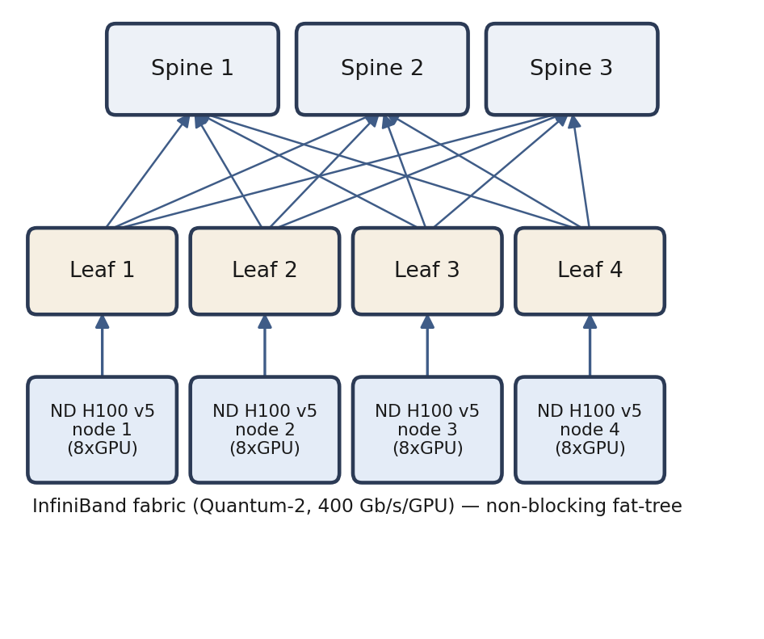
Fig. 1. Spine–leaf InfiniBand network topology connecting groups of ND H100 v5 nodes through leaf switches to an aggregating spine layer.
C. Intra-Node GPU Interconnect
Within each ND H100 v5 node, the eight H100 GPUs are connected through an NVLink 4.0 / NVSwitch mesh delivering approximately 900 GB/s of bidirectional bandwidth per GPU (Fig. 3), which is used for local gradient aggregation before any traffic crosses the inter-node InfiniBand fabric. Each GPU is additionally paired with a dedicated PCIe Gen5 path to the host CPU and its own 400 Gb/s CX7 InfiniBand NIC, enabling GPUDirect RDMA transfers directly between GPU memory and the network without staging through host memory.
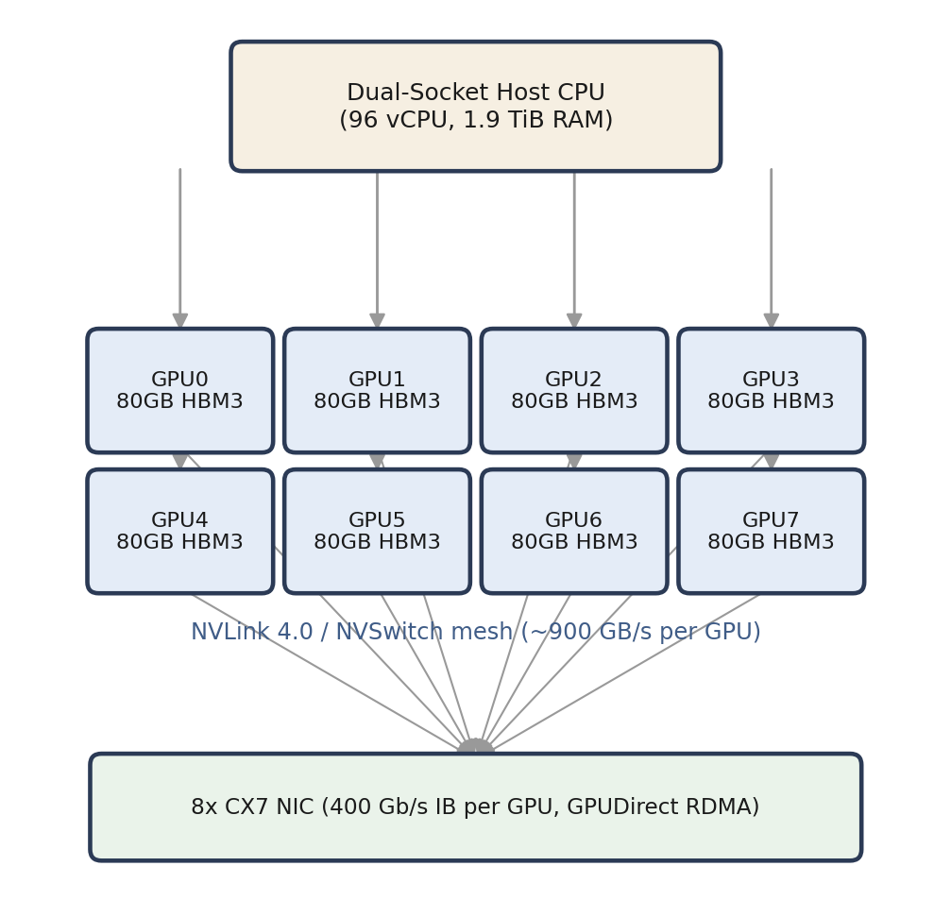
Fig. 3. Intra-node GPU interconnect: eight H100 GPUs joined by an NVLink 4.0/NVSwitch mesh, each with a dedicated PCIe path to the host CPU and a dedicated InfiniBand NIC.
D. End-to-End Infrastructure View
Fig. 2 summarizes the full stack as a layered system: a compute layer of ND H100 v5 GPU nodes; a network layer combining the InfiniBand data path with a separate 100 GbE front-end for control-plane and AKS traffic; a storage layer spanning local NVMe, shared parallel storage, and archival object storage (Section VI); and a management/monitoring layer comprising the AKS control plane, NVIDIA DCGM, and Prometheus. Separating the GPU data path from the front-end control network is deliberate: it prevents management and orchestration traffic from competing with latency-sensitive collective-communication traffic during training.
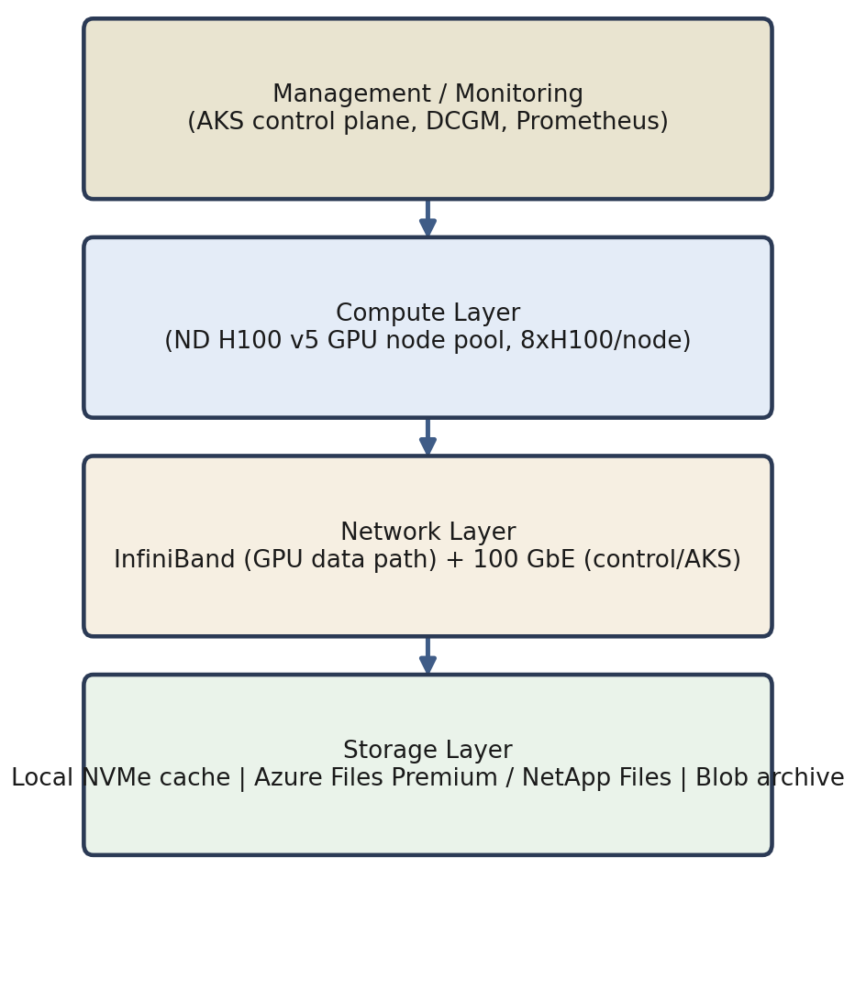
Fig. 2. End-to-end GPU infrastructure layout spanning compute, network, storage, and management/monitoring layers.
VI. Storage Planning
Training throughput is only as fast as the slowest stage feeding the GPUs, so storage is tiered by access pattern rather than provisioned as a single homogeneous volume (Fig. 5): local NVMe on each compute node serves as scratch space and in-flight checkpoint staging; a shared parallel file system — Azure Files Premium or Azure NetApp Files, both supporting ReadWriteMany access — serves training datasets to all nodes concurrently; and Azure Blob Storage provides cost-effective, durable archival for completed checkpoints and final model artifacts.
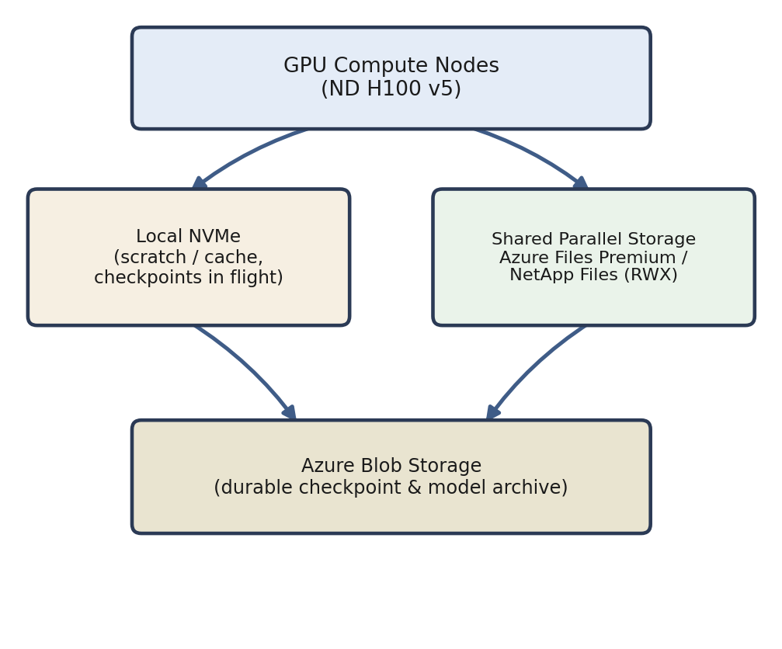
Fig. 5. Storage tiering architecture: local NVMe scratch, shared parallel storage for active datasets, and Blob Storage for durable archival.

Storage Type | Performance Profile | Access Mode | Recommended Use
Premium SSD Managed Disk | High IOPS, low latency | ReadWriteOnce (per node) | Node OS disk; single-node local caching
Ultra Disk | Extreme performance, up to 160,000 IOPS | ReadWriteOnce (per node) | Mission-critical, heavy read/write AI workloads
Azure Files Premium | High-throughput SMB/NFS shares | ReadWriteMany (shared) | Sharing datasets across multiple GPU nodes
Azure NetApp Files | Enterprise-grade, low-latency shared storage | ReadWriteMany (shared) | Distributed training (e.g., PyTorch DDP, Horovod)
Azure Blob Storage | Cost-effective object storage | Archival / batch access | Checkpoint and model-weight archival
TABLE III. STORAGE OPTIONS EVALUATED FOR AI TRAINING WORKLOADS

VII. Physical Space and Rack Configuration
Racks hosting GPU nodes must be reinforced for the additional weight of dense compute and cabling, and sized to the taller chassis common to 8-GPU servers; standard 42U enclosures may need to be substituted with taller or reinforced-floor variants. Rack layouts should reserve contiguous space for future expansion and hardware-refresh cycles, since GPU generations typically refresh on a two-to-three-year cadence and mixed-generation racks complicate power and cooling planning.
VIII. Deployment and Validation
Deployment proceeds incrementally rather than as a single cluster-wide rollout: a pilot deployment (a single GPU or small node group) is validated first, then progressively scaled to the full production cluster. Fig. 4 summarizes the deployment workflow used for this Azure Kubernetes Service (AKS) based cluster; the corresponding CLI commands and an example GPU pod specification are provided in Appendix B.
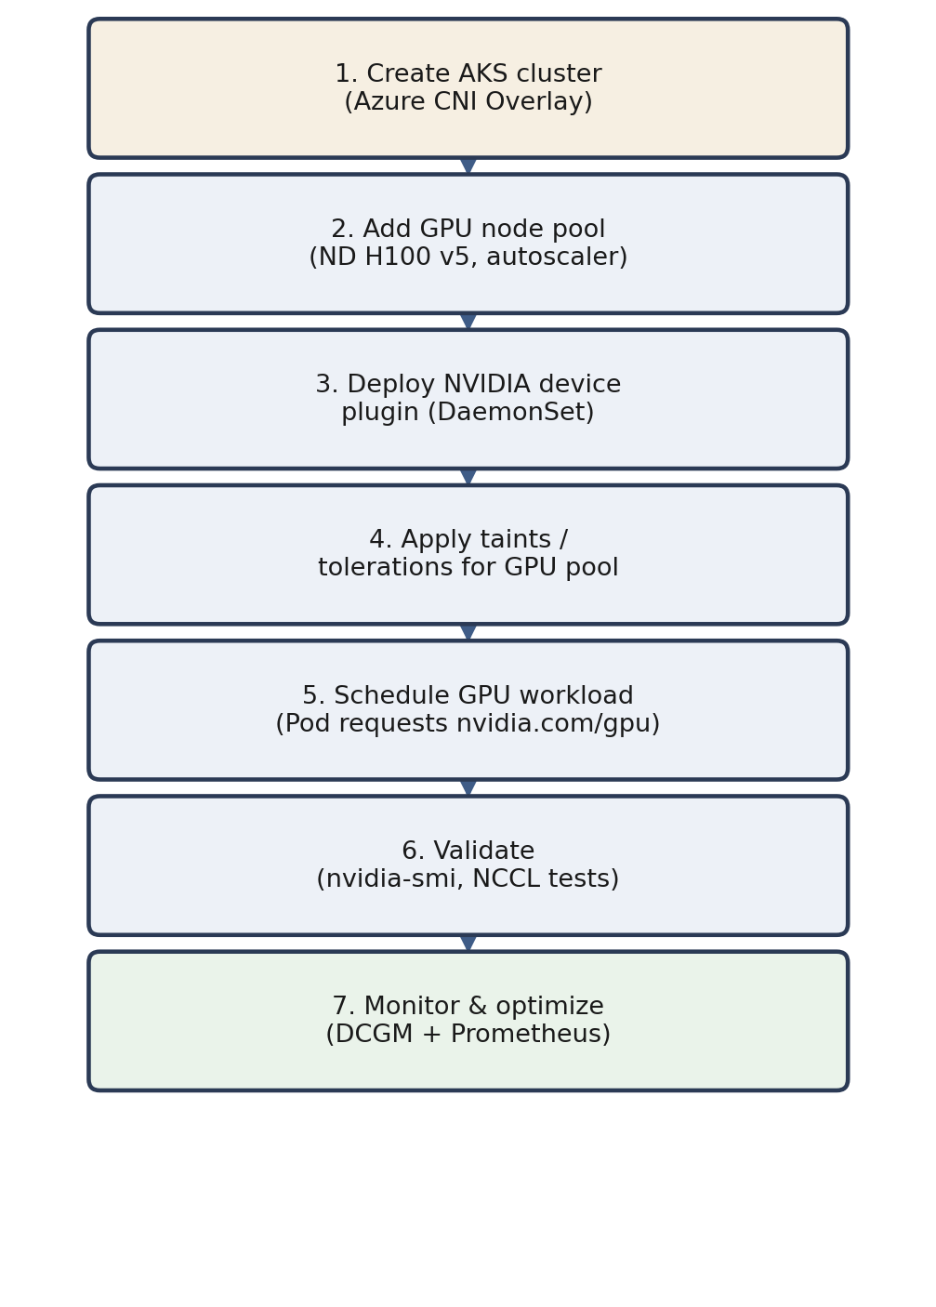
Fig. 4. AKS-based GPU cluster deployment workflow, from cluster creation through GPU workload validation and monitoring.
Validation combines Kubernetes-level checks (confirming that GPU nodes advertise the nvidia.com/gpu resource and that pods are scheduled onto tainted GPU node pools) with hardware- and communication-level checks using the NVIDIA Validation Suite and NCCL tests, which exercise the full InfiniBand fabric and NVLink interconnect before a node is accepted into production.
IX. Monitoring and Optimization
Once deployed, GPU nodes are continuously monitored for temperature, memory utilization, power draw, SM/Tensor Core occupancy, and workload distribution across the fleet, using NVIDIA DCGM as the collection layer and Prometheus/Grafana for aggregation, alerting, and visualization. Infrastructure changes are applied through infrastructure-as-code rather than manual configuration, so that node pools, taints, and networking configuration remain consistent and reproducible as the cluster scales or is redeployed in a new region.
X. Budget and TCO Analysis
Total cost of ownership for a GPU cluster extends well beyond the sticker price of the GPUs themselves; Table IV consolidates the principal sizing and cost drivers identified in Sections III–VII into a single specification summary.

Requirement | Typical Specification | Notes
Power per GPU | 350–700 W | Higher for H100/H200-class parts
Rack power | 30–40 kW | Requires 208–240 V, 30–60 A circuits
Cooling | Liquid or immersion preferred | Airflow optimization is critical even where air cooling is retained
Networking | 100 Gb/s+ with RDMA | Required for distributed training
Storage | 10+ GB/s parallel throughput, local NVMe | For large datasets and checkpoint I/O
Physical space | Reinforced, taller racks | High-density 8-GPU systems need custom rack design
Deployment model | Cloud or on-premises | Cloud favors flexibility; on-premises favors long-run cost control
TABLE IV. GPU INFRASTRUCTURE REQUIREMENT AND COST-DRIVER SUMMARY

Cloud deployment (as used in this report's Azure ND H100 v5 reference architecture) trades a higher marginal hourly rate for elimination of capital expenditure, facility build-out time, and hardware-refresh risk; on-premises deployment can lower long-run per-GPU-hour cost for sustained, predictable utilization but requires the power, cooling, and physical-space investments summarized above and in Sections IV and VII. The choice is workload- and organization-dependent and should be revisited whenever sustained utilization or model scale changes materially.
XI. Summary and Recommendations
This report has presented a cross-layer requirement-analysis approach for a GPU-accelerated HPC cluster: workload and precision assessment drive hardware selection; hardware selection drives power, cooling, and rack design; and the networking and storage architecture are sized to keep the selected GPUs fed with data and gradients rather than idle. The following recommendations follow directly from this analysis:
• Select H100 (or H200 where budget allows) for large-scale LLM training, reserving A100 for balanced mixed AI/HPC workloads and L40S/L4 for rendering and edge inference respectively.
• Treat InfiniBand and NVLink topology, not just raw GPU count, as first-class sizing parameters — GPU-to-NIC and GPU-to-GPU affinity materially affect achieved (as opposed to theoretical) throughput.
• Size power and cooling for 30–40 kW per rack from the outset; retrofitting liquid cooling after deployment is far more disruptive than planning for it up front.
• Validate every node with NCCL and InfiniBand fabric tests before production acceptance, and re-validate after any firmware, driver, or topology change.
• Recompute cluster-sizing calculations independently rather than reusing vendor rules of thumb verbatim — Appendix A shows how a single unit error can overstate required node count by more than an order of magnitude.

Appendix A. Compute: GPU Requirement Analysis
This appendix derives the FLOPs-based node-sizing methodology summarized in Section III-B and re-checks two calculations from the original planning material against published GPU specifications.
A.1 GPU Peak FLOPs and a Corrected Formula
Theoretical peak FLOPs for a GPU is commonly approximated as:
Peak FLOPs = (Number of Cores) × (FLOPs per clock per core) × (Clock Speed).
For an H100 with 132 streaming multiprocessors (SMs) and 128 FP32 cores per SM (4 sub-partitions × 32 ALUs), the core count is 16,896. Each FP32 core executes one fused multiply-add (FMA) per clock, which counts as two FLOPs, so the FLOPs-per-clock-per-core term is 2, not 1. Using the GPU's boost clock (≈ 1.98 GHz):
16,896 cores × 2 FLOPs/FMA × 1.98 GHz ≈ 66.9 TFLOPS (FP32, non-Tensor).
Correction: the commonly circulated formula “132 × 4 × 32 × 1.59 GHz = 26.9 TFLOPS” omits the ×2 FMA factor and uses the base rather than boost clock, understating throughput by roughly half. Including the FMA factor and boost clock reproduces the figure of approximately 66 TFLOPS commonly published for H100 FP32 CUDA-core throughput, which is the value used elsewhere in this report.
H100 Tensor Cores additionally provide approximately 990 TFLOPS of dense BF16/FP16 throughput (roughly double with structured sparsity), which is the figure relevant to Tensor-Core-accelerated training and is consistent with the vendor-published specification used in Table I.
A.2 GPU Count from a Fixed Workload FLOPs Target
Given a workload's required sustained FLOPs/s, the minimum GPU count follows directly from dividing by a single GPU's sustained FLOPs/s, and is then inflated by the inverse of the expected utilization fraction, since no distributed training workload sustains 100% of peak throughput in practice (Table V).

Workload (FLOPs/s) | GPU Model | Peak FLOPs/s | GPUs (ideal) | GPUs (50% util.)
1000 TFLOPS/s | H100 | 100 TFLOPS/s* | 10 | 20
500 TFLOPS/s | A100 | 312 TFLOPS/s | 2 | 4
TABLE V. ILLUSTRATIVE GPU COUNT FROM A FIXED SUSTAINED-FLOPS WORKLOAD TARGET
*This row uses a conservative, workload-specific FLOPs/s figure rather than the H100's full Tensor Core peak, to illustrate the method; substitute the actual sustained per-GPU throughput measured for the target workload.

A.3 Training-Time-Based Node Sizing
An alternative and more common sizing method starts from a target wall-clock training duration rather than an assumed steady-state FLOPs/s target:
• Estimate total training compute (FLOPs) required by the model and dataset.
• Identify the sustained FLOPs/s of the selected GPU (mixed-precision/Tensor Core figure for AI training).
• Choose a target training time and convert it to seconds.
• Compute per-node compute capacity: GPU FLOPs/s × GPUs per node × training time in seconds.
• Divide total required FLOPs by per-node compute capacity to obtain the required node count.
A.4 Worked Example: 175-Billion-Parameter Model
Total training compute is estimated using the widely cited approximation FLOPs ≈ 6 × N × D, where N is the parameter count and D is the number of training tokens [7]. For N = 175 × 10⁹ and a representative D ≈ 300 × 10⁹ tokens:
FLOPs ≈ 6 × 175×10⁹ × 300×10⁹ ≈ 3.15 × 10²³ FLOPs (≈314 exaFLOPs, i.e., ≈ 0.314 zettaFLOPs).
Correction: the original planning estimate of “≈364 zettaFLOPs” for this model is roughly three orders of magnitude too large — the correct order of magnitude is ≈ 0.3 zettaFLOPs (≈314 exaFLOPs), consistent with published GPT-3-scale training-compute estimates. Because required node count scales linearly with this figure, the error propagates directly into a grossly inflated node estimate if left uncorrected.
Using an 8× A100 node (312 TFLOPS/s per GPU, mixed precision) and a 30-day training window (2,592,000 s):
Node compute = 312×10¹² × 8 × 2,592,000 ≈ 6.47×10²¹ FLOPs (≈ 6.47 zettaFLOPs) per node.
Required nodes (ideal, 100% utilization) = 3.15×10²³ / 6.47×10²¹ ≈ 49 nodes.
At a realistic model FLOPs utilization (MFU) of 40% — typical for large-scale distributed training once communication, pipeline-bubble, and data-loading overhead are accounted for — the required node count scales to approximately 49 / 0.4 ≈ 123 nodes. Both corrected figures (≈49 and ≈123 nodes) are dramatically smaller than the original planning document's figure of ≈56,400 nodes, which resulted from carrying forward the unit error described above. This example illustrates why every cluster-sizing calculation should be independently re-derived rather than propagated from an unverified estimate, given the direct cost impact of node count on the budget analysis in Section X.
A.5 Reference Virtual Machine
The reference compute node selected for this deployment is Azure Standard_ND96isr_H100_v5: 8× NVIDIA H100 GPUs (80 GB HBM3 each), 96 Intel Sapphire Rapids vCPUs, approximately 1,900 GiB RAM, NVLink 4.0 intra-node interconnect, and 3.2 Tb/s aggregate InfiniBand for inter-node scale-out. Published on-demand pricing at the time the source planning material was prepared was approximately US$98/hour for the 8-GPU configuration; current pricing should always be re-verified against the Azure pricing calculator before budget approval, since GPU VM pricing changes more frequently than most other Azure SKUs.
A.6 GPU Server Configuration Checklist
Bringing up an H100 server (or validating an Azure ND H100 v5 image) involves, in order:
• Base OS installation and current NVIDIA GPU driver installation.
• CUDA toolkit installation matching the driver and framework versions in use.
• Mellanox OFED installation for InfiniBand, with GPUDirect RDMA enabled.
• NVIDIA Fabric Manager installation and startup for NVLink/NVSwitch topologies.
• Local NVMe storage configuration for scratch and checkpoint staging.
• NVIDIA Container Toolkit (NVIDIA Docker runtime) installation for containerized workloads.
• Optional HPC/AI framework installation (PyTorch, NCCL-enabled build).
• Monitoring agent installation — NVIDIA DCGM exporter with Prometheus scraping.
• Security hardening — host firewall configuration and disabling of unnecessary services.

Appendix B. Network: GPU Requirement Analysis
This appendix provides the spine–leaf design principles and the AKS command-line and Kubernetes manifest artifacts used to provision the GPU node pool described in Section V and Fig. 4.
B.1 Spine–Leaf Design Principles
• Each ND H100 v5 node exposes 8× NVIDIA H100 GPUs interconnected via NVLink 4.0 (≈900 GB/s per GPU) for intra-node bandwidth.
• Inter-node communication uses NVIDIA Quantum-2 InfiniBand at 8× 400 Gb/s per VM (one 400 Gb/s link per GPU), giving 3.2 Tb/s aggregate bandwidth per node.
• Leaf switches connect directly to nodes via InfiniBand CX7 adapters; spine switches aggregate multiple leaves for horizontal scale-out to hundreds or thousands of GPUs.
• The topology is designed as non-blocking to minimize oversubscription and to support NCCL-based collective operations for multi-node training with predictable latency.
• The front-end network (100 GbE) carries control-plane and AKS traffic separately from the InfiniBand GPU data path, and is provisioned at roughly 1 GB/s of bandwidth per 10 GFLOPS of GPU compute as a starting planning ratio.
• AKS pod networking uses Azure CNI Overlay; GPU workloads rely on the InfiniBand fabric directly for NCCL all-reduce rather than routing collective traffic through the Kubernetes pod network.

B.2 AKS Cluster and GPU Node Pool Provisioning
Cluster and node-pool creation (region must have ND H100 v5 quota and capacity):
RG=rg-aks-ndh100
CLUSTER=aks-ndh100
LOC=eastus # region with ND H100 v5 capacity
VNET=vnet-aks
SUBNET_NODE=subnet-nodes

az group create -n $RG -l $LOC

az network vnet create -g $RG -n $VNET -l $LOC \
--address-prefixes 10.10.0.0/16 \
--subnet-name $SUBNET_NODE --subnet-prefixes 10.10.0.0/24

az aks create -g $RG -n $CLUSTER -l $LOC \
--network-plugin azure --network-plugin-mode overlay \
--node-count 3 --node-vm-size Standard_D8s_v5 \
--enable-managed-identity

az aks nodepool add -g $RG --cluster-name $CLUSTER \
-n gpuh100 --node-vm-size Standard_ND96isr_H100_v5 \
--node-count 1 --enable-cluster-autoscaler \
--min-count 0 --max-count 10

az aks get-credentials -g $RG -n $CLUSTER
Deploy the NVIDIA device plugin (DaemonSet) so nodes advertise nvidia.com/gpu:
kubectl apply -f https://raw.githubusercontent.com/
NVIDIA/k8s-device-plugin/<version>/deployments/
static/nvidia-device-plugin.yml
B.3 Example GPU Pod Specification
Corrected, schema-valid manifest (the original planning document's YAML omitted the required nesting under metadata: and spec:, which would fail to parse):
apiVersion: v1
kind: Pod
metadata:
name: h100-test
spec:
tolerations:
- key: "sku"
operator: "Equal"
value: "gpu"
effect: "NoSchedule"
nodeSelector:
agentpool: gpuh100
containers:
- name: trainer
image: nvcr.io/nvidia/pytorch:24.08-py3
resources:
limits:
nvidia.com/gpu: 8
volumeMounts:
- name: scratch
mountPath: /scratch
volumes:
- name: scratch
emptyDir:
medium: ""
Verification:
kubectl get nodes -o wide
kubectl describe node <gpu-node> | grep -i -E \
"nvidia.com/gpu|Capacity|Allocatable"
kubectl exec -it h100-test -- nvidia-smi

B.4 Operational Checklist
• AKS version is supported by the GPU device-plugin version deployed.
• Azure CNI Overlay configured with a pod CIDR that does not overlap the VNet or peered networks.
• System and GPU node pools are isolated; GPU pools carry taints and workloads carry matching tolerations.
• Cluster autoscaler is tuned; pod disruption budgets, readiness/liveness probes, and --max-surge are set for safe rolling upgrades.
• Ephemeral local NVMe is mounted for cache/scratch; checkpoints are persisted to durable storage before any node is recycled.
Appendix C. Storage: GPU Requirement Analysis
AI training workloads on AKS are highly data-intensive and require low-latency access to large, frequently re-read datasets, so storage planning is treated as a distinct design activity rather than a default choice.
C.1 Recommended Architecture
• Node OS disks: Premium SSD (512 GiB or larger) for each GPU node.
• Training data: Azure Files Premium or Azure NetApp Files, mounted via the corresponding CSI driver, for ReadWriteMany access across all nodes in a training job.
• Model checkpoints: Azure Blob Storage for cost-effective, durable archival separate from the hot training-data tier.
• Ephemeral storage: node-local ephemeral OS disks for faster pod start-up where the VM SKU supports it.
C.2 Performance Recommendations
• Co-locate storage resources in the same Azure region as the AKS cluster to minimize latency.
• Enable accelerated networking on GPU nodes to reduce storage-access latency contention with training traffic.
• For multi-node distributed training, ensure InfiniBand or equivalent high-bandwidth networking is available for inter-node data and checkpoint transfer, not only for gradient synchronization.
C.3 Summary Recommendation
• Single-node training: Premium SSD Managed Disk is generally sufficient.
• Multi-node distributed training: Azure NetApp Files or Azure Files Premium for shared, concurrently accessed datasets.
• Archival and checkpoints: Azure Blob Storage in all cases, regardless of the hot-tier choice above.

Glossary
SDN — Software Defined Network.
SLB — Software Load Balancer.
MSEE — Microsoft Enterprise Edge.
SNAT — Source Network Address Translation.
NVA — Network Virtual Appliance; also encountered as Azure Virtual Network Manager (AVNM) in Azure-native designs.
NCCL — NVIDIA Collective Communications Library; implements multi-GPU and multi-node communication primitives optimized for NVIDIA GPUs and networking.
References
[1] NVIDIA Corporation, “NVIDIA H100 Tensor Core GPU architecture,” NVIDIA corporate whitepaper, 2022.
[2] NVIDIA Corporation, “NCCL: NVIDIA Collective Communications Library documentation,” NVIDIA Developer Documentation, 2024.
[3] Microsoft Corporation, “ND H100 v5 series,” Azure Virtual Machines documentation, Microsoft Learn, 2024.
[4] Microsoft Corporation, “Use GPUs on Azure Kubernetes Service (AKS),” Microsoft Learn, 2024.
[5] Microsoft Corporation, “Baseline architecture for an AKS cluster,” Microsoft Learn, 2024.
[6] InfiniBand Trade Association, “InfiniBand architecture specification,” release 1.5, 2023.
[7] J. Kaplan, S. McCandlish, T. Henighan, T. B. Brown, B. Chess, R. Child, S. Gray, A. Radford, J. Wu, and D. Amodei, “Scaling laws for neural language models,” arXiv:2001.08361, 2020.

