Cross-Layer Performance Optimization of GPU-Accelerated HPC Clusters for Large-Scale LLM Training
Systems and HPC Performance Engineering Research Group
Abstract
Large Language Model (LLM) training places extreme computational demands on GPU-accelerated High Performance Computing (HPC) clusters. Although modern GPUs offer very high peak throughput through Tensor Cores and high-bandwidth memory, sustained effective utilization during distributed training is frequently far below peak capability. GPUs remain idle for reasons that span the full training stack: kernel inefficiency, memory-bandwidth stalls, collective-communication overhead, network latency, CPU/NUMA topology mismatches, data-loader starvation, storage latency, load imbalance, and suboptimal cluster scheduling. This paper presents a cross-layer performance optimization framework that treats effective GPU utilization as a system-level property rather than an isolated hardware metric. The framework spans GPU computation and memory, NVLink/NVSwitch and PCIe interconnects, NCCL collective communication, InfiniBand/RDMA networking, CPU/NUMA affinity, storage and data pipelines, and SLURM-based cluster scheduling. A bottleneck-detection methodology is proposed to identify the dominant source of GPU idle time before an optimization strategy is selected, and a set of quantitatively grounded optimization techniques—including gradient compression, hierarchical all-reduce, ZeRO-3 sharding, pipeline parallelism with gradient accumulation, kernel fusion, CUDA Graphs, and memory-efficient attention—is analyzed with corrected, topology-dependent bandwidth and memory calculations rather than fixed universal percentages. An experimental methodology is defined around measurable metrics, including GPU and Tensor Core utilization, NCCL communication time, InfiniBand throughput, iteration time, training throughput, GPU idle time, and scaling efficiency, to evaluate baseline, single-layer, multi-layer, and fully cross-layer optimized configurations. The study argues that maximizing useful work per GPU-second, rather than maximizing a single utilization percentage, is the correct objective for large-scale distributed LLM training.
Index Terms—GPU optimization, HPC, large language models, distributed training, InfiniBand, RDMA, NCCL, NVLink, CUDA, SLURM, GPU utilization, cross-layer optimization, ZeRO, pipeline parallelism.

I. INTRODUCTION
The rapid growth of Large Language Models (LLMs) has substantially increased the computational and communication requirements of modern artificial intelligence workloads. Training state-of-the-art models requires billions of parameters to be processed across many GPUs and, in most production settings, across many compute nodes. GPU-accelerated HPC clusters therefore provide the computational and communication substrate on which large-scale distributed training depends.
Modern GPUs deliver high theoretical throughput through Tensor Cores, high-bandwidth memory (HBM), and high-speed interconnects such as NVLink and NVSwitch. In practice, however, the theoretical computational capability of a GPU does not translate directly into equivalent application performance. During distributed training, a GPU frequently spends a measurable fraction of wall-clock time waiting—for data, for synchronization with peer GPUs, for memory operations, or for communication to complete—rather than performing useful floating-point work.
Distributed data-parallel training requires gradients computed independently on each GPU to be synchronized through collective operations such as all-reduce, reduce-scatter, and all-gather. These operations introduce both communication and synchronization overhead. Communication within a node can exploit high-bandwidth NVLink or NVSwitch fabrics, whereas inter-node communication typically depends on PCIe, network interface cards (NICs), and an InfiniBand or RoCE fabric using RDMA.
Consequently, GPU performance cannot be assessed from a single utilization percentage alone. Low reported utilization may originate from communication overhead, CPU data-loader starvation, storage latency, PCIe bottlenecks, memory-bandwidth limitations, synchronization stalls, kernel-launch overhead, pipeline bubbles, or workload imbalance across GPUs. This motivates a cross-layer analysis that traces the complete data and computation path:
Application → CUDA kernels → GPU → memory → PCIe/NVLink → NIC → InfiniBand/RDMA → storage/CPU → scheduler
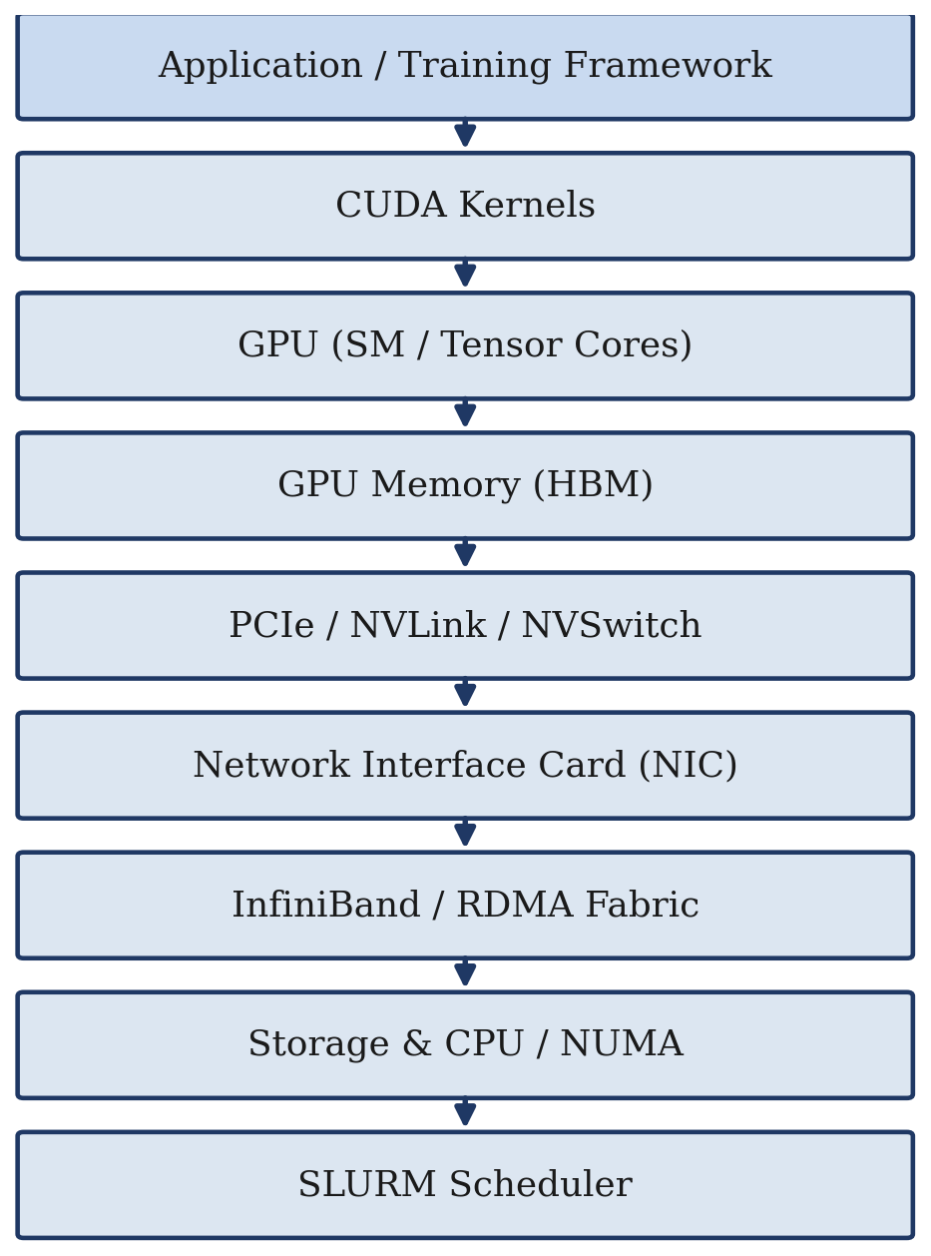
Fig. 1. Cross-layer path traced by the proposed framework, from the training application down to the cluster scheduler.
The objective of this research is therefore not to maximize a reported GPU-utilization percentage in isolation, but to maximize useful work performed per GPU-second while minimizing communication, synchronization, memory stalls, data starvation, and scheduling overhead.

II. RELATED WORK AND RESEARCH GAP
Existing GPU optimization approaches typically address a single layer of the training stack in isolation. Kernel-optimization work focuses on computation; communication libraries such as NCCL focus on collective operations; memory-optimization techniques focus on GPU memory footprint and bandwidth; and cluster schedulers focus on resource allocation policy. Optimizing any single layer independently does not necessarily optimize the training system as a whole.
For example, increasing inter-node network bandwidth does not resolve a bottleneck caused by inefficient CUDA kernels or low Tensor Core occupancy. Likewise, increasing GPU memory capacity does not resolve CPU data-loader starvation, and aggressive communication optimization can itself introduce additional GPU-side computation or synchronization overhead—for example, gradient compression trades communication volume for extra compute cycles, and ZeRO-style sharding trades reduced per-GPU memory for additional parameter- and gradient-communication traffic.
The research gap addressed by this work is the absence of a unified, bottleneck-aware methodology that evaluates GPU efficiency jointly across computation, memory, communication, data movement, system topology, and scheduling, rather than treating these components as independently optimizable subsystems.

III. PROBLEM STATEMENT
The primary problem addressed by this research is the inefficient utilization of GPU resources during distributed large-scale LLM training. A GPU with substantial peak computational capability can nonetheless alternate between useful computation and waiting states:
Computation → Communication → Synchronization → Waiting → Computation
The resulting performance loss can occur at multiple layers simultaneously. The major sources of inefficiency considered in this research are: (1) inefficient CUDA kernel execution; (2) low Tensor Core utilization; (3) GPU memory-bandwidth limitations; (4) excessive GPU-to-GPU communication; (5) NCCL collective-communication overhead; (6) inter-node communication latency and bandwidth limitations; (7) CPU-to-GPU data-transfer overhead; (8) CPU data-loader starvation; (9) PCIe and NUMA topology inefficiencies; (10) storage and dataset access latency; (11) pipeline bubbles and synchronization stalls; (12) load imbalance between GPUs; and (13) inefficient GPU allocation and scheduling.
The research problem can therefore be formulated as follows: how can GPU idle time be reduced and useful computation increased by jointly analyzing and optimizing computation, memory, communication, data movement, system topology, and scheduling layers in an HPC cluster used for distributed LLM training?

IV. RESEARCH OBJECTIVES
The primary objective of this work is to develop and evaluate a cross-layer methodology for improving effective GPU utilization during distributed LLM training. The specific objectives are:
- Identify the major sources of GPU idle time in distributed LLM training.
- Develop a methodology for detecting whether the dominant bottleneck originates from computation, memory, communication, data movement, or scheduling.
- Evaluate CUDA kernel and Tensor Core efficiency.
- Analyze GPU-to-GPU communication using NVLink/NVSwitch and NCCL.
- Analyze inter-node communication using InfiniBand/RDMA.
- Investigate communication–computation overlap strategies.
- Evaluate CPU, NUMA, PCIe, and GPU–NIC affinity.
- Optimize data loading and storage access paths.
- Investigate GPU-aware SLURM scheduling policies.
- Compare baseline and optimized configurations using measurable performance metrics.

V. PROPOSED SYSTEM ARCHITECTURE
The proposed architecture treats GPU performance as a multi-layer system spanning the training framework, GPU compute/memory/communication subsystems, the GPU interconnect and network fabric, the CPU/NUMA and storage subsystem, and cluster-level scheduling. A bottleneck-monitoring stage sits between the training framework and the underlying hardware layers, continuously collecting metrics that are later used to classify the dominant source of inefficiency.
The framework consists of four stages. Stage 1, Performance Monitoring, collects system- and GPU-level metrics during training. Stage 2, Bottleneck Identification, analyzes the collected metrics to determine whether the workload is primarily limited by computation, memory, communication, data movement, or scheduling. Stage 3, Optimization Selection, chooses an optimization strategy appropriate to the identified bottleneck. Stage 4, Performance Validation, re-executes the workload and compares the resulting performance against the baseline.
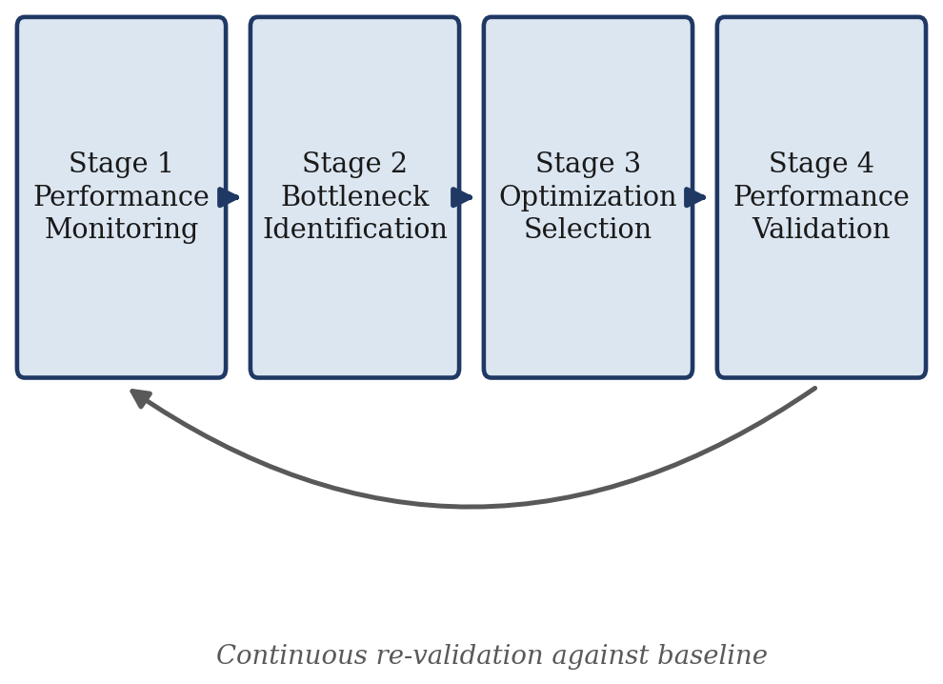
Fig. 2. Four-stage bottleneck-aware optimization pipeline used by the proposed architecture.

VI. CROSS-LAYER OPTIMIZATION METHODOLOGY

A. GPU Computation Optimization
The first layer focuses on maximizing useful computation performed by the GPU. CUDA kernels can suffer from low occupancy, warp divergence, uncoalesced memory access, unnecessary global-memory traffic, and excessive kernel-launch overhead. The proposed approach investigates kernel optimization, memory coalescing, warp efficiency, streaming-multiprocessor (SM) occupancy, Tensor Core utilization, kernel fusion, CUDA Graphs, and appropriate numerical precision. Kernel fusion combines multiple operations into fewer kernel launches, reducing synchronization and memory traffic; CUDA Graphs reduce repeated kernel-launch and framework-scheduling overhead for workloads with repetitive execution patterns, which is characteristic of LLM training and inference.

B. GPU Memory Optimization
GPU computation can be limited by memory bandwidth rather than by compute throughput. The methodology analyzes HBM utilization, memory bandwidth, cache behavior, memory-access patterns, attention memory requirements, and data movement across memory levels. Memory-efficient attention techniques, such as FlashAttention-style algorithms, reduce unnecessary movement between HBM, shared memory/SRAM, and registers, which is often a larger contributor to attention throughput than additional network bandwidth.

C. Intra-Node Communication Optimization
When multiple GPUs reside within the same server, high-speed interconnects such as NVLink or NVSwitch can be used before any traffic crosses the network. A hierarchical communication strategy aggregates gradients locally over NVLink/NVSwitch, performs inter-node reduction over InfiniBand/RDMA, and then distributes the reduced result back within each node. This reduces the volume of traffic that must cross the lower-bandwidth, higher-latency inter-node fabric.

D. Inter-Node Communication Optimization
Distributed LLM training requires communication between GPUs on different nodes. The methodology evaluates NCCL communication time, all-reduce/reduce-scatter/all-gather time, InfiniBand bandwidth, network latency, GPU-to-NIC topology, GPUDirect RDMA, and NIC affinity. NCCL configuration and cluster topology can materially influence distributed performance; GPU/NIC affinity, PCIe topology, NVLink topology, GPUDirect RDMA, NUMA affinity, and NCCL runtime configuration are treated as first-class tuning parameters rather than defaults to be left unexamined.

E. Communication–Computation Overlap
A primary goal of the methodology is to avoid sequential execution of computation and communication. A poorly overlapped iteration executes compute, then communication, then an idle wait, then the next compute phase. The proposed approach instead structures execution so that communication for one portion of the model proceeds concurrently with computation on another portion, using asynchronous NCCL operations, CUDA streams, gradient bucketing, and overlapped reduce-scatter/all-gather operations. The underlying principle is that communication should occur while the GPU is performing useful computation whenever the workload permits it.

F. CPU and NUMA Optimization
GPU performance is influenced by CPU and system topology. The methodology analyzes CPU affinity, NUMA locality, GPU-to-CPU mapping, GPU-to-NIC mapping, data-loader thread placement, and network-interrupt placement. In a representative dual-socket topology, GPUs 0–1 and NIC 0 are attached to NUMA node 0 while GPUs 2–3 and NIC 1 are attached to NUMA node 1; the objective is to minimize unnecessary CPU and PCIe hops between GPUs, NICs, and memory by aligning process and thread placement with this physical topology.

G. Data Pipeline Optimization
A GPU cannot perform useful computation if training data is not available when needed. The methodology investigates DataLoader worker counts, prefetching, pinned memory, dataset sharding, parallel decoding, local NVMe caching, asynchronous I/O, and GPUDirect Storage where applicable, with the objective of preparing the next training batch while the GPU processes the current one.

H. Precision Optimization
Modern LLM training can use reduced numerical precision, such as BF16 or FP8, where supported by the model and hardware. Lower precision reduces memory consumption, memory-bandwidth requirements, and communication volume, and can increase Tensor Core throughput. Precision is treated as an additional optimization dimension rather than assuming FP32 as the default computation mode, while recognizing that reduced precision can affect convergence behavior and must be validated against model accuracy.

I. Parallelism Optimization
Large-scale LLM training can combine data parallelism, tensor parallelism, pipeline parallelism, sequence parallelism, expert parallelism, and fully sharded data parallelism (FSDP). The methodology evaluates the relationship between the selected parallelism strategy and resulting communication overhead; the goal is to select the strategy appropriate to the model, cluster topology, and workload rather than assuming any single strategy is universally optimal.

J. Cluster Scheduling Optimization
At the cluster level, SLURM allocates GPU resources to workloads. The methodology investigates GPU-aware scheduling, GPU affinity, gang scheduling, job packing, backfilling, right-sized GPU allocation, and resource-aware job placement. The objective is to avoid situations in which GPUs are nominally allocated but not effectively utilized—a cluster can report 70% of GPUs allocated while achieving only 40% actual utilization when workloads are poorly scheduled or poorly packed.

VII. QUANTITATIVE OPTIMIZATION STRATEGIES
This section presents the individual optimization strategies with corrected, topology-dependent quantitative reasoning. Reported percentage improvements throughout this section are workload- and topology-dependent and are presented as expected ranges rather than guaranteed outcomes.

A. Gradient Compression
Gradient compression reduces the volume of data transferred during collective communication. For a 70-billion-parameter model, the uncompressed gradient tensor in BF16/FP16 (2 bytes per parameter) occupies approximately 140 GB. Reducing precision to 8-bit compression yields approximately 70 GB (a 2× reduction relative to BF16), and reducing to 4-bit compression yields approximately 35 GB (a 4× reduction). These two compression levels are not equivalent, and 35 GB should not be attributed to 8-bit compression.
Dividing gradient size by peak link bandwidth (e.g., 140 GB over a 400 Gbps fabric) yields only a theoretical serialization time, not the achieved all-reduce time. Actual all-reduce duration depends on the number of communication phases, network topology, the NCCL algorithm selected (ring versus tree), the number of participating GPUs, per-link utilization, message size, and the degree of overlap with computation. Gradient compression additionally introduces extra GPU-side computation for quantization and dequantization, and its net benefit depends on whether communication is actually the dominant bottleneck for the workload in question; it can also affect convergence or numerical accuracy and should be validated empirically.

B. Hierarchical All-Reduce
Hierarchical all-reduce aggregates gradients within a node using NVLink/NVSwitch, performs inter-node reduction over InfiniBand/RoCE, and then distributes the reduced result back within each node. This reduces pressure on the inter-node network relative to a flat, non-hierarchical all-reduce. An improvement in the range of approximately 30–50% in effective communication time has been observed in comparable topologies, but this range is workload- and topology-dependent and should be reported as an expected range rather than a guaranteed figure.

C. ZeRO-3 / Fully Sharded Training
ZeRO-3 shards model parameters, gradients, and optimizer states across data-parallel ranks, reducing per-GPU memory requirements. The magnitude of memory reduction is a function of the number of ranks over which state is sharded and is not a fixed multiplier that applies universally; a commonly cited memory reduction (e.g., on the order of 8×) corresponds to a specific rank count and should be qualified accordingly rather than presented as universal. ZeRO-3 also increases communication volume—particularly parameter all-gather and gradient reduce-scatter traffic—so the technique should be described as reducing per-GPU memory substantially at the cost of additional communication, rather than as simultaneously reducing communication.

D. Pipeline Parallelism with Gradient Accumulation
Pipeline parallelism partitions the model across stages, and gradient accumulation increases the amount of computation performed between synchronization points. The combined goal is to overlap communication with computation:
Computation → Communication → Computation (overlapped)
Reported pipeline efficiency in the 80–90% range is directionally reasonable but is not guaranteed; achieved efficiency depends heavily on the number of pipeline stages, the micro-batch count, batch size, the resulting pipeline-bubble fraction, network bandwidth and latency, model architecture, and kernel efficiency. Efficiency figures should therefore be reported per experimental configuration rather than as a fixed constant.

E. Kernel Optimization, Fusion, and CUDA Graphs
Kernel-level optimization increases SM occupancy, reduces warp divergence, improves memory coalescing, reduces unnecessary global-memory accesses, exploits shared memory, and targets Tensor Cores where applicable, using profiling tools such as Nsight Compute and Nsight Systems. Kernel fusion combines sequences such as bias-plus-activation, LayerNorm, attention sub-operations, and GEMM-plus-epilogue into fewer kernel launches, reducing memory traffic and synchronization overhead, which is particularly beneficial for smaller operations. CUDA Graphs reduce kernel-launch overhead, CPU-to-GPU synchronization overhead, and framework-scheduling overhead for workloads with repetitive execution patterns, increasing the fraction of GPU time spent on useful computation.

F. Memory-Efficient Attention
FlashAttention-style techniques reduce unnecessary data movement between HBM and shared memory/registers during attention computation, improving memory efficiency, attention throughput, and overall GPU utilization. For LLM workloads, this optimization is frequently more consequential than adding raw network bandwidth, because attention computation is often memory-bandwidth bound rather than network bound.

G. Batch and Micro-Batch Tuning
Excessively small batch sizes leave GPUs underutilized. Increasing batch size increases GPU work per iteration and improves Tensor Core utilization, up to limits imposed by GPU memory capacity, latency requirements, communication overhead, and diminishing returns. Gradient accumulation can effectively increase the batch size without requiring all samples to reside simultaneously in GPU memory.

H. Data Pipeline and CPU–GPU Transfer Optimization
GPU idle time can result from data not arriving fast enough. Mitigations include optimized CPU preprocessing, additional DataLoader workers, prefetching, pinned memory, dataset sharding, parallel data decoding, local NVMe caching, and GPUDirect Storage where applicable; a characteristic symptom is periodic GPU utilization dropping to near zero while waiting for input. CPU–GPU transfer optimization minimizes unnecessary CPU–GPU–CPU data movement using pinned memory, asynchronous transfers (cudaMemcpyAsync), multiple CUDA streams, GPUDirect RDMA, and GPUDirect Storage, with the objective of transferring data while the GPU is computing rather than while it is idle.

I. NCCL and GPU–NIC–NUMA Affinity
NCCL configuration—including algorithm selection (ring versus tree), channel count, NIC selection, GPU/NIC affinity, PCIe topology, NVLink topology, GPUDirect RDMA, and NUMA affinity—can materially affect multi-GPU performance and should be tuned based on measurement (e.g., using NCCL_DEBUG, NCCL_SOCKET_IFNAME, NCCL_IB_HCA, NCCL_NET_GDR_LEVEL, NCCL_CROSS_NIC) rather than applied blindly. Correct GPU–NIC–NUMA affinity places each GPU, its nearest PCIe root complex, and its nearest NIC on the same NUMA node; a mismatched topology, in which a GPU's traffic must cross to a NIC attached to a different NUMA node, introduces additional PCIe and CPU-hop latency. Topology can be inspected using nvidia-smi topo -m, lspci, numactl, and hwloc, and application threads, data-loader threads, NCCL processes, and network interrupts should be pinned to the NUMA node matching the associated GPU.

J. Load Balancing and GPU Clock/Power Behavior
In synchronous distributed training, the slowest GPU determines iteration completion time; a single straggler GPU can force all other GPUs to wait even when the remaining GPUs complete their local work well ahead of it. Candidate causes include uneven data distribution, thermal throttling, differing GPU clocks, PCIe irregularities, network imbalance, CPU contention, and kernel performance differences across otherwise identical GPUs. High reported GPU utilization does not necessarily indicate high performance, since a GPU can report high utilization while operating at a reduced SM or memory clock; SM clock, memory clock, power consumption, temperature, and throttling reasons should be monitored using tools such as nvidia-smi and NVIDIA DCGM.

K. Mixture-of-Experts (MoE) Optimization
For MoE architectures, expert routing, token dispatch, expert load balancing, all-to-all communication, and expert capacity require explicit optimization. A poorly balanced MoE workload can produce substantial per-GPU utilization skew—for example, one GPU near saturation while another remains lightly loaded—because some experts receive disproportionately more routed tokens than others.

L. Storage and Scheduling Optimization
Storage-layer mitigations include local NVMe caching, parallel filesystems, GPUDirect Storage, read-ahead, dataset sharding, and asynchronous checkpointing, with the objective of overlapping I/O with GPU computation rather than blocking on it. Scheduling-layer mitigations include SLURM GPU-aware scheduling, gang scheduling, GPU affinity, Multi-Instance GPU (MIG) partitioning where appropriate, job packing, backfilling, right-sized GPU allocation, and preemption policy, with the objective of closing the gap between allocated GPU capacity and actually utilized GPU capacity.
Table III summarizes the quantitative optimization techniques introduced in this section together with their expected benefit ranges and primary trade-offs.
Technique | Expected Benefit (Range) | Primary Trade-off
Gradient Compression (8-/4-bit) | ~2x / ~4x payload reduction | Extra quant./dequant. compute; possible accuracy impact
Hierarchical All-Reduce | ~30-50% lower comm. time (topology-dependent) | Requires NVLink/NVSwitch-aware placement
ZeRO-3 / FSDP Sharding | Substantial per-GPU memory reduction (rank-dependent) | Increased all-gather / reduce-scatter traffic
Pipeline Parallelism + Grad. Accum. | ~80-90% pipeline efficiency (config.-dependent) | Sensitive to stage count, micro-batch size, bubbles
Kernel Fusion / CUDA Graphs | Reduced launch & sync overhead | Effective mainly for repetitive execution patterns
Memory-Efficient (FlashAttention-style) Attention | Reduced HBM traffic, higher attention throughput | Depends on kernel/hardware support
NCCL / GPU-NIC-NUMA Affinity Tuning | Lower cross-NUMA latency, fewer PCIe hops | Requires per-cluster topology inspection
Data Pipeline Optimization | Reduced GPU starvation / idle time | Added CPU, memory, and storage resource demand
TABLE III. SUMMARY OF QUANTITATIVE OPTIMIZATION TECHNIQUES

VIII. BOTTLENECK DETECTION MODEL
The central concept of the proposed framework is bottleneck detection: classifying observed GPU inefficiency into a discrete category before selecting a remedy, rather than assuming that any single metric represents the complete performance state. Table I summarizes the classification used by the framework.
Bottleneck | Symptom | Optimization
Compute | Low SM/TC efficiency | Kernel opt., fusion, CUDA Graphs
Memory | High mem.-BW pressure | Mem.-efficient attention
Comm. | High NCCL time | Hierarchical/overlap comm.
Network | Low inter-node throughput | InfiniBand/RDMA, NIC affinity
CPU | GPU waits on CPU | CPU/NUMA affinity
Data | Periodic GPU starvation | Data-pipeline optimization
Storage | I/O or checkpoint delay | NVMe/GDS, async I/O
Sync. | GPUs wait for peers | Overlap, parallelism choice
Scheduling | Poor allocation efficiency | SLURM GPU-aware scheduling
Imbalance | One GPU slower than rest | Workload/expert balancing
TABLE I. BOTTLENECK CLASSIFICATION AND ASSOCIATED SYMPTOMS
The recommended diagnostic sequence begins from a low reported GPU-utilization observation and proceeds through: (1) GPU SM utilization; (2) NCCL communication time; (3) PCIe/NVLink throughput; (4) InfiniBand/RoCE bandwidth; (5) CPU and data-pipeline behavior; (6) storage latency; concluding with a determination of whether the GPU is computing, communicating, transferring data, or waiting. This sequence deliberately avoids the overly strong heuristic that any single utilization threshold (e.g., utilization below 50%) implies a specific single cause such as network saturation, since the same symptom can arise from at least ten distinct root causes.
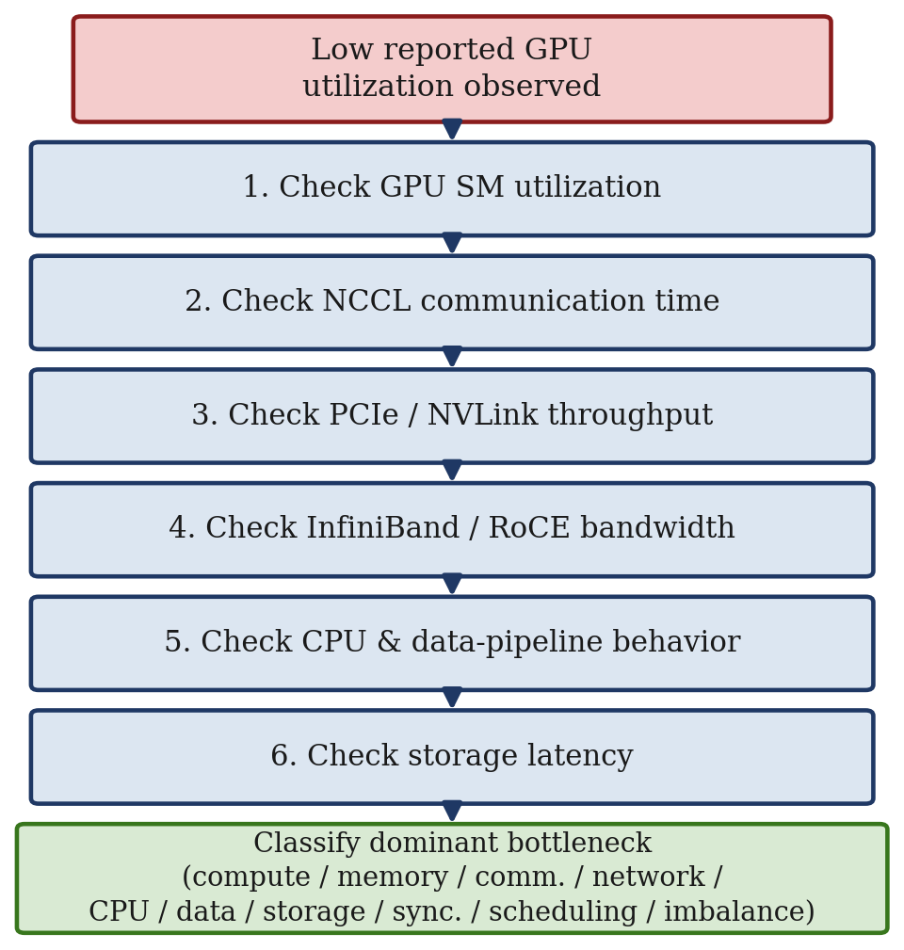
Fig. 3. Diagnostic sequence used to classify the dominant source of GPU inefficiency before an optimization strategy is selected.

IX. PERFORMANCE MODEL
Training iteration time is modeled as the sum of compute, communication, and synchronization time, less the portion of communication successfully overlapped with computation:
T_iteration = T_compute + T_communication + T_synchronization − T_overlap (1)
A complementary decomposition of GPU idle time attributes idle periods to six contributing sources:
T_idle = T_compute-inefficiency + T_memory-stalls + T_communication + T_synchronization + T_data-starvation + T_system-overhead (2)
The optimization objective of the proposed framework is therefore:
maximize (Useful Work / GPU-second) (3)
subject to minimizing both T_idle in (2) and T_iteration in (1). This framing keeps the optimization target aligned with delivered training throughput rather than with an instrumentation artifact such as reported utilization percentage.

X. EXPERIMENTAL METHODOLOGY
The proposed framework will be evaluated on a GPU-enabled HPC cluster spanning the hardware and software components described below.

A. Hardware
- Multiple NVIDIA GPUs across multi-GPU compute nodes.
- NVLink/NVSwitch intra-node interconnect where available.
- InfiniBand network fabric and high-speed NICs.
- Defined CPU and NUMA topology per node.
- Local and/or shared parallel storage.

B. Software
- Linux operating system with current NVIDIA GPU drivers.
- CUDA toolkit and PyTorch training framework.
- NCCL collective-communication library.
- InfiniBand/RDMA software stack.
- SLURM workload manager.
- GPU monitoring and profiling tools (e.g., Nsight Systems/Compute, DCGM).

C. Workload
A representative LLM training workload will be executed across multiple GPUs and, where available, multiple nodes. The evaluation compares a non-optimized baseline configuration against progressively optimized configurations, isolating the contribution of each layer before combining them.

XI. EXPERIMENTAL CONFIGURATIONS
Table II summarizes the five experimental configurations used to isolate and then combine optimization layers.
Config. | Layer | Optimizations Introduced
A | Baseline | None (reference measurement)
B | Communication | Hierarchical comm., NCCL tuning, GPU-NIC affinity, GPUDirect RDMA
C | Computation | Kernel opt./fusion, CUDA Graphs, Tensor Core tuning
D | Data pipeline | Pinned memory, prefetch, multi-worker, sharding, caching
E | Cross-layer | B–D combined per detected bottleneck (Sec. VIII)
TABLE II. EXPERIMENTAL CONFIGURATIONS
Configuration A establishes reference measurements for GPU utilization, SM utilization, memory utilization, NCCL time, iteration time, and training throughput. Configurations B, C, and D each isolate one layer of optimization. Configuration E combines the optimizations indicated by the bottleneck-detection model in Section VIII rather than applying every optimization unconditionally, producing the comparison sequence: baseline → single-layer optimization → multi-layer optimization → cross-layer optimization. This structure is intended to determine whether jointly optimizing multiple layers yields additional benefit beyond optimizing individual components in isolation.
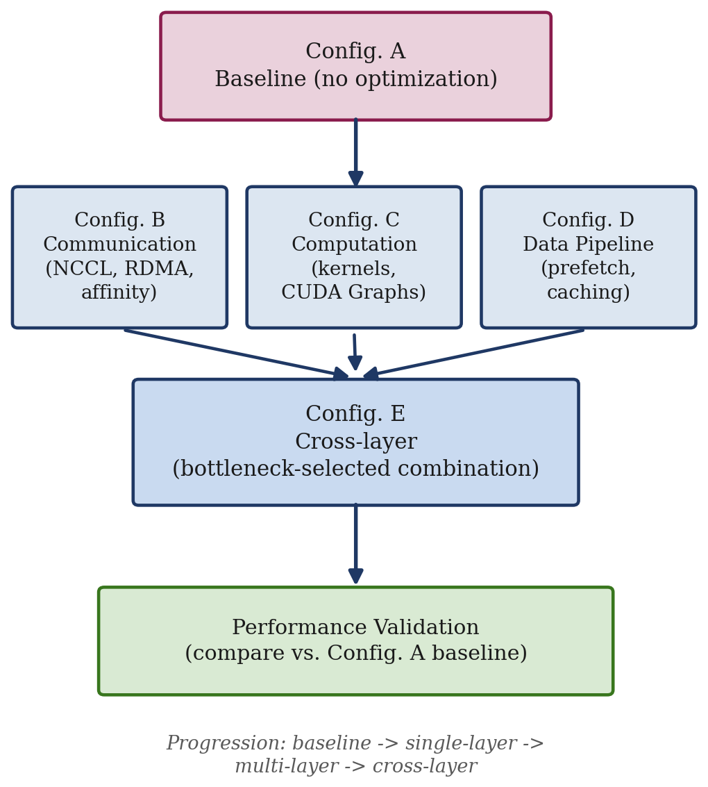
Fig. 4. Progression of experimental configurations from an unoptimized baseline to the fully cross-layer optimized system.

XII. EVALUATION METRICS

A. GPU Metrics
- GPU utilization and SM utilization.
- Tensor Core utilization.
- GPU memory utilization and HBM bandwidth.
- GPU clock frequency and power consumption.

B. Communication Metrics
- NCCL communication time (all-reduce, reduce-scatter, all-gather).
- NVLink bandwidth and PCIe throughput.
- InfiniBand bandwidth and network latency.

C. Training Metrics
- Iteration time.
- Samples/second and tokens/second.
- Training throughput and scaling efficiency.
- GPU idle time.

D. System Metrics
- CPU utilization and NUMA locality.
- Data-loader wait time.
- Storage throughput and I/O latency.
- GPU allocation efficiency.

XIII. EXPECTED RESULTS
Because experimental evaluation has not yet been completed, this paper does not claim fixed performance improvements. The expected outcome of the proposed cross-layer approach is that it will: (1) identify the dominant bottleneck affecting GPU performance; (2) reduce unnecessary GPU idle periods; (3) improve computation/communication overlap; (4) reduce avoidable communication and synchronization overhead; (5) improve data delivery to GPUs; (6) improve GPU-to-NIC communication efficiency; (7) improve distributed training throughput; and (8) improve scaling efficiency as the GPU count increases.
Actual percentage improvements will be determined experimentally. This distinction matters because optimization benefit depends on workload, model architecture, GPU type, network topology, batch size, GPU count, and software configuration; the ranges cited in Section VII (e.g., 30–50% for hierarchical all-reduce, 80–90% pipeline efficiency) should be treated as illustrative expectations rather than universal guarantees, consistent with the corrected, topology-dependent framing established earlier in this paper.

XIV. DISCUSSION
The proposed framework treats GPU utilization as a system-level metric rather than an isolated hardware metric. Low reported GPU utilization does not necessarily indicate a GPU hardware problem; the GPU may be waiting on another GPU, on network communication, on CPU processing, on storage, on memory, on synchronization, or on another pipeline stage. Conversely, high reported GPU utilization does not necessarily indicate optimal performance, since a GPU can report high utilization while operating at reduced clock frequency or while executing inefficient kernels.
The proposed approach therefore focuses on distinguishing whether the GPU is computing, communicating, transferring data, or waiting, which provides a more actionable basis for optimization than a single aggregate percentage.

XV. LIMITATIONS
- Optimization effectiveness depends on the specific hardware topology; a technique effective on one GPU architecture or interconnect generation may yield different results on another.
- Communication optimization can introduce additional GPU-side computation or synchronization overhead, partially offsetting the intended benefit.
- Reduced numerical precision may affect model accuracy or convergence depending on the workload and must be validated rather than assumed safe.
- Advanced features such as GPUDirect RDMA, NVLink/NVSwitch, and GPUDirect Storage depend on specific hardware and software support and may not be available on all clusters.
- The framework requires accurate profiling data; misinterpreted performance metrics can lead to optimizing a non-dominant bottleneck while the true bottleneck remains unaddressed.

XVI. FUTURE WORK
Future work can extend the framework toward an automated, closed-loop performance-optimization system that continuously monitors GPU, memory, NCCL, InfiniBand, CPU/NUMA, storage, and SLURM layers, and automatically determines the dominant bottleneck. Such a system could recommend or automatically apply configuration changes, following the loop: monitor → detect bottleneck → select optimization → run workload → measure performance → compare → retain the better configuration. Iterated over time, this closed loop could form the basis of an adaptive GPU-cluster optimization framework that requires progressively less manual tuning.

XVII. CONCLUSION
This paper has presented a cross-layer approach for improving the efficiency of GPU-accelerated HPC clusters used for large-scale LLM training. The central observation is that GPU inefficiency cannot be attributed to a single component: computation, memory, communication, synchronization, CPU processing, storage, network topology, and scheduling can all contribute to GPU idle time, often simultaneously.
The proposed methodology analyzes the complete training stack, from CUDA kernels and GPU memory through NVLink, PCIe, NICs, InfiniBand/RDMA, and NCCL, to CPU/NUMA, storage, and SLURM scheduling, and applies a bottleneck-aware optimization strategy rather than optimizing every layer unconditionally. Quantitative reasoning throughout the framework—gradient-compression sizing, hierarchical all-reduce benefit, ZeRO-3 memory/communication trade-offs, and pipeline-parallelism efficiency—is presented as topology- and workload-dependent rather than as fixed universal constants, reflecting the corrected analysis developed in Section VII.
The central performance objective is to maximize useful work performed per GPU-second while minimizing communication, synchronization, memory stalls, data starvation, and system overhead. The proposed experimental evaluation will compare baseline and optimized configurations using GPU utilization, SM utilization, communication time, network throughput, iteration time, training throughput, and scaling efficiency. Ultimately, this research aims to demonstrate that efficient LLM training on HPC clusters requires system-level optimization rather than isolated GPU optimization, and that coordinating computation, memory, communication, data movement, and scheduling makes better use of expensive GPU resources across the entire distributed training system.

REFERENCES
[1] J. Rasley, S. Rajbhandari, O. Ruwase, and Y. He, "DeepSpeed: System optimizations enable training deep learning models with over 100 billion parameters," in Proc. 26th ACM SIGKDD Int. Conf. Knowledge Discovery & Data Mining, 2020, pp. 3505–3506.
[2] S. Rajbhandari, J. Rasley, O. Ruwase, and Y. He, "ZeRO: Memory optimizations toward training trillion parameter models," in Proc. Int. Conf. High Performance Computing, Networking, Storage and Analysis (SC), 2020, pp. 1–16.
[3] T. Dao, D. Y. Fu, S. Ermon, A. Rudra, and C. Re, "FlashAttention: Fast and memory-efficient exact attention with IO-awareness," in Proc. Adv. Neural Inf. Process. Syst. (NeurIPS), 2022.
[4] D. Narayanan et al., "Efficient large-scale language model training on GPU clusters using Megatron-LM," in Proc. Int. Conf. High Performance Computing, Networking, Storage and Analysis (SC), 2021, pp. 1–15.
[5] NVIDIA Corporation, "NCCL: NVIDIA Collective Communications Library documentation," NVIDIA Developer Documentation, 2024.
[6] NVIDIA Corporation, "NVIDIA DCGM (Data Center GPU Manager) documentation," NVIDIA Developer Documentation, 2024.
[7] NVIDIA Corporation, "CUDA C++ programming guide," NVIDIA Developer Documentation, 2024.
[8] SchedMD, "Slurm workload manager documentation," SchedMD LLC, 2024.
[9] InfiniBand Trade Association, "InfiniBand architecture specification," IBTA, release 1.5, 2023.
[10] S. Shoeybi et al., "Megatron-LM: Training multi-billion parameter language models using model parallelism," arXiv:1909.08053, 2019.

