**USER MANUAL**

*Android Mobile*

*Application*

**Go Mommy**

*Pregnancy Companion*

Presented by:

Group 5 – Applife

*Baroto, Maria Bernadete*

*De Vega, Christian Kevin*

*Esguerra, Adrian*

*Palahang, Sunshine Richmer*

Presented to:

*Engr. Frank Anthony Chin*

BSCOE 2-6

**Table of Contents**

1. General Information……………………………………………………………………………..3
   1. Application Overview…………………………………………………………………...
   2. Organization of the Manual……………………………………………………………
2. System Summary……………………………………………………………………………….
   1. Hardware and Software Requirement……………………………………………….
   2. User Access…………………………………………………………………………….
3. How to download the application……………………………………………………………..
   1. Google Play Store……………………………………………………………………..

4.0 How to use the application

* 1. Registered User - PRIVELEGES………………………………………………
     1. New User Registration…………………………………………………
     2. Sign In………………………………………………………………
     3. Homepage (Dashboard)……………………………………………
     4. Calendar………………………………………………..
     5. Hospital Near Me (Map)…………………………………………
     6. Tips and Advice…………………………………………………
     7. Profile……………………………………………………………….
     8. About Us page……………………………………………………………
     9. Log-out……………………………………………………………

1. **General Information**

General Information section explains in general terms the Go Mommy application overview and the sections of the user manual.

**1.1 Application Overview**

"Go Mommy" is a comprehensive mobile application designed to support and guide expecting parents throughout their incredible journey of pregnancy.

This app aims to be a trusted companion, offering valuable information, tools, and resources to help expectant mothers and their partners make informed decisions, stay healthy, and embrace this transformative phase of life.

Go Mommy is packed with features to help you stay informed, healthy, and connected during this special time in your life.

**1.2 Organization of the Manual**

The user manual consists of the following four section:

1. General Information
2. System Summary
3. How to download the application
4. Registered User – PRIVELEGES

**General Information** section explains in general terms the overview of Go Mommy App and the sections of the user manual.

**System Summary** section explains the Hardware and Software requirements of the app and how users will be able to access it.

**How to download** section discuss how to download the application in your mobile phone.

**How to use the application** section provides detailed description of the functionalities of Go Mommy Application

1. **System Summary**

System Summary section explains the Hardware and Software requirements of the app and how users will be able to access it.

**2.1 Hardware and Software Requirements**

Requires a smart phone with Android Operating System (OS)

The minimum android version should be Android 7 Nougat above to avail all the features and for the application to work properly

To download and use the functionalities of Go Mommy mobile app, you require an internet connection on your mobile device.

**2.2 User Access**

To access Go Mommy mobile app, one must be a Registered User.

Registered User is one who registers himself/herself in Go Mommy mobile app by filling all the data needed in new user registration process. Registered user has the privileges of enjoying all the functionality of the app.

1. **How to download the application**

How to downloadsection discuss how to download the application in your mobile phone.

Go Mommy app can be downloaded through Google Play Store.

* 1. **Google Play Store**

Steps:

1. Open Play Store application on your mobile by clicking on the Play Store icon as shown in the image below.
2. Click on the Google Play text at the top and enter the text "Go Mommy" in the search bar.
3. Click on the Go Mommy application icon from the search result. Now below page will open which asks to install the application.
4. Click on the "INSTALL" button to install the application

**4.0 How to use the application**

How to use the application section provides detailed description of the functionalities of Go Mommy Application

**4.1 Registered Users – PRIVELEGES**

The following are the privileges can be availed by the Registered Users.

* View Homepage (Dashboard)
* Access calendar
* View and access map
* View near hospital near me
* View tips and advice section
* View user profile section

**4.1.1 New User Registration**

It is recommended to register by filling up the data needed in the process for Go Mommy app to provide a more accurate and personalized service.

A user can register in Go Mommy application using the “Log In” option available in the screen once you installed the app. If you are a new user, select “Create Account” to register. Fill all the required details in order to create account. On successful validation user will be registered.

**4.1.2 Sign In**

To **Sign In** into the application click on the “Sign In”. Enter email and password to log in. On successful login, the user is redirected to home page screen.

**4.1.3 Homepage (Dashboard)**

The **Dashboard** contains the image of the fetus/baby on the screen. Below the image is the info section where mommy’s changes and baby’s changes are located. Below this section is where you can see the overview of all other features. Remaining days is also displayed on screen.

**Mommy’s Changes** section explains the details of the changes happening on the mother or the user on the stage of pregnancy.

**Baby’s Changes** section explains the details of the changes happening on the fetus/baby on the stage of pregnancy.

**4.1.4 Calendar**

**Calendar** section contains the calendar view. The date and the expected due date of the baby. Drop down buttons contains the months and the years. First day of pregnancy is marked in the calendar with encircled solid color while the days passed is marked with circle dash line. A screenshot of a calendar

**4.1.5 Hospital Near Me (Map)**

**Hospital Near Me** sections contains the map. Location access request will be sent on the user’s android device. The user must permit location request so the app can locate the user location and provide details on the hospitals nearby.

**4.1.6 Tips and Advice**

**Tips and Advice** section contains reliable information about pregnancy.

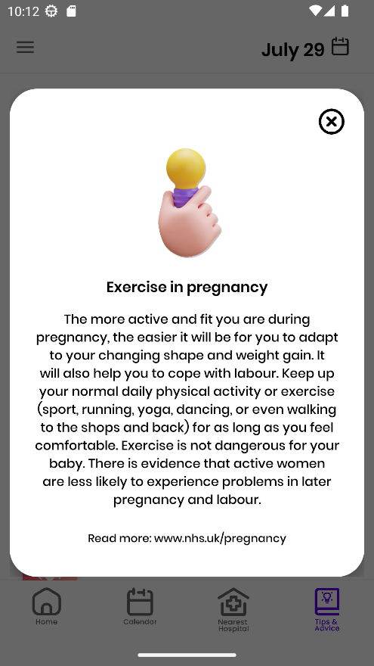

* + 1. **User Profile**

**User Profile** section contains all the saved information about the user including the user’s name and the expected due date. User Profile is located on the navigation drawer.

* + 1. **About Us**

About Us section contains the developer’s information. It will display overview about the company and the inspiration behind Go Mommy mobile app. About Us section is located on the navigation drawer.

**4.1.9 Log-Out**

To **Log out** in the application click the “Log out” button located on the navigation drawer below the User Profile and About Us sections.