Had the board of directors been made aware of the regulatory changes earlier,they would have rejected the expansion proposal before investing millions into the project.
- will reject (b)would have rejected (c)would reject (d) had rejected

原句:if the board of directors had been made aware of ..
->if+had been pp +would/could/should/might+have pp(與過去事實相反的假設語氣)
Ans: (b)would have rejected
be aware of 意識到、regulatory .adj 管理的/規則的 、million 數百萬

Mr.Vance requested that every department manager submit a revised operational schedule to the human resources team prior to the quarterly audit
- submitted (B)submitting (c) submit (d)will submit
request that +s+v
Ans: submit
audit v.n. 審計

The chief financial officer, together with the senior financial analysts,was present at the press conference and addressed concerns regarding the recent stock decline.
(A)was(B)were(C)are(D)is
addressed過去式，因此(c)、(d)不是，together with the senior financial analysts(介係詞片語可忽略)，因此主詞是The chief financial officer(單數)，因此答案是was
Ans:was
addressed v 處理、stock n庫存/股票、press n媒體

Given no further delay from the primary supplier, the construction of the new logistics terminal should be completed well ahead of the October deadline.
- Provided (B)Given(c)Because(D)Unless
關鍵字->no further修飾delay(n)、from the primary supplier(介係詞片語，可省略)，因此這個句子缺s+v,不能選(a)、(c)也不行,because+s+v,(d)也不行，Unless+s+v，Unless表示前後文相反才會用到，因此要選Given，Given可以當介係詞->Given+N
Ans: Given
no further 沒有進一步, primary adj. 主要的/基本的, well ahead of 遠遠領先於

Hardly had we concluded the contract negotiations when news of the unexpected corporate acquisition was leaked to the media. (A)Seldom(B)Scarcely(C)only if (D)Hardly
had we(助動詞+主詞) ->倒裝，因此要用否定副詞，(D)hardly幾乎不，比較符合句意
Ans: hardly
concluded v. 得出結論、acquisition n.收購、leaked v. 洩漏
scarcely adv. 很少、hardly adv 幾乎不

The newly appointed chief executive officer is widely respected by employees,being known for her decisive leadership style and attention to detail.
- doing(B)being(c)having(D)whose
is、known，需要對等連接詞,原句=and(被省略) she is known for ->簡化 ->be動詞變ing ->being
Ans: being
newly appointed 新被指派、widely adv廣泛、decisive adj 果斷/明確

The legal team spent several weeks debating whether the proposed clause would be enforceable under state law (A)whether(B)which(C)that(D)What
(c)不行，that後面的內容會更明確，因此要選whether無論/是否
但如果是which ->which +part of ….
Ans: (A)whether
legal adj 合法/法律, debate n.討論, clause n.條款、enforceable adj.可執行的

Before the authority issued its final ruling on the merger,the draft proposal had been scrutinized by the independent compliance committee for over six months.(A)has been scrutinizing (B)was being scrutinized(C)was scrutinizing(D)had been scrutinized
關鍵字是before,issued,for over six months,for+一段時間不能用進行式，所以(b)、(c)不行，issued(過去式)-> had been scrutinized
Ans: had been scrutinized
Authority n.權威/官方、scrutinize v.詳細審查、compliance n.遵守、

The annual supplier conference was attended by hundreds of attendees. (A)attended 過去簡單(主動)(B)had been attending 過去完成進行(主動)(C)was attended 過去簡單(被動)(D)will be attending未來進行(主動)
By ->被動語態 -> was attended
Ans: was attended
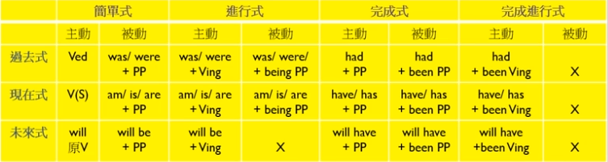
1.主詞動詞一直性
2.時間(現在?過去?未來?)
3.語氣(主動?被動)
4.狀態(簡單?進行?完成?完成進行?)

Revenues of M&H Apparels have dropped by 11% since the beginning of this year.
- dropped (B)drop (C)Have dropped (D)Had dropped
apparel n 服裝、revenue n 收入
關鍵字是since，since:自從，S+have/has pp + since N或(S+Ved)
Ex:I have taught English since 10 years ago 我自從10年前就開始教英文到現在

Had pp搭配Ved 區分先(had pp)後(Ved)
Ex:I had closed the door when I drove 先關車門再開車

因此要選(C)Have dropped
Ans: Have dropped

