【習題4.7.1】
有無使用暫時脫離連結之模型 | 無dropout | 有dropout
訓練資料之目標函數值 | 0.3814 | 0.7617
訓練資料之目標準確度 | 0.8634 | 0.7315
驗證資料之目標函數值 | 1.3370 | 0.7514
驗證資料之目標準確度 | 0.6689 | 0.7425

(1)
問題:試由最終已訓練之模型隊訓練資料及測試資料的目標函數值及準確度之估測值來檢視暫時脫離連結是否有能力減輕過度學習之風險?清楚說明原因。

答:依據結果，使用暫時脫離連結明顯有能力減輕過度學習之風險。因為比較有無使用暫時脫離連結的模型驗證資料之目標函數值有明顯下降，驗證資料之目標準確度也有上升

(2)
問題:試由訓練過程中對訓練資料及測試資料的目標函數值及準確度之軌跡來檢視暫時脫離連結是否有能力減輕過度學習之風險?清楚說明原因。

答:依據結果，使用暫時脫離連結有能力減輕過度學習之風險。因為原本沒有使用暫時脫離連結的情況下驗證資料的loss曲線原本會由下降又轉為上升但是使用暫時脫離連結後則穩定下降，反之準確度則是從沒有使用時的到0.65附近停止上升變成可以繼續上升到0.7以上

未使用暫時脫離連結之模型
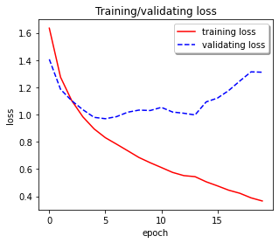
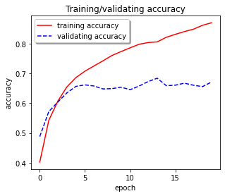

使用暫時脫離連結之模型
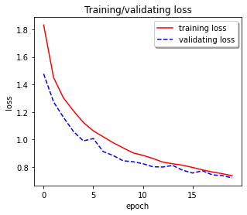
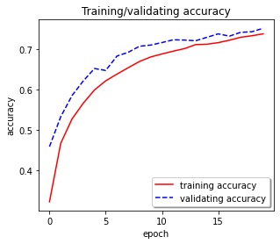

【習題4.7.1】程式碼如下:
seed = 543
from numpy import random
random.seed(seed)
from tensorflow.random import set_seed
set_seed(seed)
import numpy as np
import matplotlib.pyplot as plt
from keras.datasets import cifar10
from keras.models import Sequential # for model
from keras.layers import Conv2D, MaxPooling2D # layers
from keras.layers import Dense, Flatten # layers
from keras.utils import to_categorical
from keras.layers import Dropout
# Load cifar10 dataset.
(X_train, y_train), (X_test, y_test) = cifar10.load_data()
X_train.shape # (50000, 32, 32, 3)
y_train.shape # (50000, 1)
np.unique(y_train)
np.bincount(y_train[:, 0])
np.unique(y_train, return_counts = True)

X_test.shape # (10000, 32, 32, 3)
y_test.shape # (10000, 1)
np.unique(y_test)
np.bincount(y_test[:, 0])
np.unique(y_test, return_counts = True)

# Normalize inputs from 0-255 (uint8) to 0.0-1.0 (float).
X_train = X_train / 255.0
X_test = X_test / 255.0
# one hot encoding outputs for classification problem
y_train = to_categorical(y_train)
y_test = to_categorical(y_test)
y_train.shape # (50000, 10), 10 classes
y_test.shape # (10000, 10), 10 classes
np.unique(y_train)
np.unique(y_test)
for i in range(2):
# Build the model.
model = Sequential()
model.add(Conv2D(filters = 16, kernel_size = (3, 3), input_shape = (32, 32, 3), padding = 'same', activation = 'relu'))
model.add(Conv2D(filters = 16, kernel_size = (3, 3), activation = 'relu', padding = 'same'))
model.add(MaxPooling2D(pool_size = (2, 2)))
model.add(Conv2D(filters = 32, kernel_size = (3, 3), activation = 'relu', padding = 'same'))
model.add(Conv2D(filters = 32, kernel_size = (3, 3), activation = 'relu', padding = 'same'))
model.add(MaxPooling2D(pool_size = (2, 2)))
model.add(Flatten())
if(i==0):
model.add(Dense(units = 100, activation = 'relu'))#沒有dropout
if(i==1):
model.add(Dropout(rate = 0.4))#有dropout
model.add(Dense(units = 100, activation = 'relu'))
model.add(Dropout(rate = 0.4))
model.add(Dense(units = 100, activation = 'relu'))
model.add(Dense(units = 10, activation = 'softmax'))
model.summary()
# Compile the model.
model.compile(loss = 'categorical_crossentropy', optimizer = 'adam', metrics = ['accuracy'])
history = model.fit(X_train, y_train, validation_data = (X_test, y_test), epochs = 20, batch_size = 200, verbose = 2)
# Evaluate the model on testing data.
scores = model.evaluate(X_test, y_test, verbose = 0)
print("Accuracy for the testing data: %.2f%%" % (scores[1] * 100))

plt.figure('Figure model(left)', figsize = (4.8, 4.0))
plt.plot(history.history['loss'], "r-")
plt.plot(history.history['val_loss'], "b--")
plt.title('Training/validating loss')
plt.xlabel('epoch')
plt.ylabel('loss')
plt.legend(['training loss', 'validating loss'], loc = "best", shadow = True)
plt.show()

plt.figure('Figure model(right)', figsize = (4.8, 4.0))
plt.plot(history.history['accuracy'], "r-")
plt.plot(history.history['val_accuracy'], "b--")
plt.title('Training/validating accuracy')
plt.xlabel('epoch')
plt.ylabel('accuracy')
plt.legend(['training accuracy', 'validating accuracy'], loc = "best", shadow = True)
plt.show()

